An Dan Dai Dao Religion
Prisoners of Conscience and Victims of Arbitrary Detention in Vietnam
Compiled by BPSOS and Coalition for a Free and Democratic Vietnam
March 15, 2021

In South Vietnam, a non-Communist country aligned with the West, Mr. Phan Van Thu founded a Buddhist sect named An Doan Dai Dao in 1969. Along with several disciples, he led a monastic life in a Buddhist temple built with the group’s own resources. Their version of Buddhism placed greater emphasis on the worship of GuanYin, the female bodhisattva known as Avalokiteśvara. She was first given the appellation of "Goddess of Mercy" by Jesuit missionaries in China. After a number of years, the sect grew to several thousand adherents and 14 temples with monks and nuns by April 1975, in part because the adherents’ kindness, compassion and self-sacrifice were a major draw for new followers.
In the spring of 1975, Communist North Vietnam invaded South Vietnam. Subsequently, the regime banned most religious organizations unless they were established and totally controlled by the Communist Party of Vietnam. Like many other religious organizations, beginning in August 1975, ADDD temples were seized or demolished, monks and nuns expelled or arrested, and lay followers had to cease all open worship. Mr. Phan Van Thu and his senior disciples were detained for years without a trial and then sentenced to prison terms for “working for the CIA”, a false accusation. Over 200 others were detained and tortured before receiving 2-year prison sentences. An adherent died from torture.
On July 27, 1980, four ADDD monks immolated themselves in protest of the government’s crackdown against their religion.
In May 1983, Mr. Thu and a number of disciples volunteered to resettle in a remote location to develop it in exchange for being released from prison, pursuant to the regime’s policy on New Economic Zones at the time. In November 1984, they escaped from this remote zone to seek more freedom to secretly resume their religious practice. They eventually settled in Phu Yen Province.
In 2003, when the government of Phu Yen Province began to implement a policy aiming to hasten economic development and tourism, the group applied for, and received official approval (by the Phu Yen provincial government) to develop a large area on Da Bia Mountain into a spiritual retreat theme park. The theme park also served as facility for ADDD monks to resume their spiritual functions and for thousands of ADDD adherents to resume their religious practice. This theme park began operation in 2004.
In 2012, the government of Phu Yen Province mounted a surprise raid to arrest Mr. Thu and other religious leaders and had them sentenced to long prison terms for a crime which they did not commit: plotting to overthrow the government. United States nationals who were adherents also invested their money in the theme park project were not charged with any crime and flew back to the United States but lost all their investments because the government confiscated the entire eco-resort/retreat.
After 2013, a number of prisoners required medical treatment, including surgery in some cases, but were not allowed to leave the prison for such a purpose. More recently, the provincial government began working with a developer to make plans for further work on the theme park, taking advantage of the very significant development financed by the victims. Beginning in 2013, the relatives of the prisoners requested the Phu Yen government to review the unjust conviction to no avail.
On May 25, 2015, all imprisoned leaders and members of ADDD filed appeals to the People’s High Court to no avail. One of the prisoners, a Vietnamese citizen, died from kidney failure in prison on October 5, 2019 because the authorities did not allow him to access adequate medical care.
The 22 imprisoned ADDD Sect leaders and followers qualify as human rights defenders because they relentlessly worked to foster the right to religious freedom for all sect members. Building the spiritual retreat around themes reflecting their religious belief, they aimed to replace their 14 temples that had been destroyed by the government in 1975. The heavy prison sentences indicated the government’s determination to exterminate this Buddhist sect.

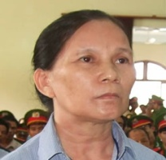 | - Ms. Do Thi Hong: b. 1957. Residence: Binh Thang village, Son Thanh Dong Subdisrict, Tay Hoa District, Phu Yen Province. Her sentence is 13 years in prison and 5 years of probation. Arrested on 2/14/2012, she was last detained in Prison Z30A, Section K5, Xuan Loc, Dong Nai Province. Suffering poor health, she was released early, on November 13, 2020.
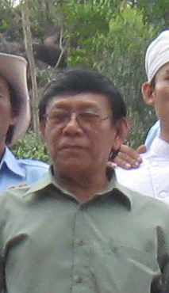 | - Mr. Doan Dinh Nam: b. 1951. Residence: 137/1 Tran Hung Dao Street, 3 District, Tuy Hoa, Phu Yen Province. He was a priest of An Dan Dai Dao. Arrested on 2/6/2012, he was sentenced to 16 years in prison and 5 years of probation. He passed away on October 5, 2019 of kidney failure at K3, T345 in Xuyen Moc, Ba Ria- Vung Tau Province. He had been diagnosed with a failing kidney but could not get daily dialysis as the prison administration refused to take him to a medical clinic on a daily basis and also denied his petition for temporary suspension of his prison sentence for medical treatment.
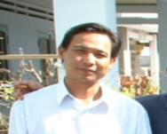 | - Mr. Doan Van Cu: b. 1961. Residence: Dai Binh village, Hoa Quang Nam Subdisrict, Phu Hoa District, Phu Yen Province. Arrested on 2/10/2012, He was sentenced to 14 years in prison and 5 years of probation. He is currently held in Prison K3, T345, Xuyen Moc Subdisrict, Ba Ria, Vung Tau Province.
 | - Mr. Le Duc Dong: b. 1983. Residence: Ke Sung Village, Phu Dien Subdistrict, Phu Vang District, Thua Thien – Hue. Arrested on 2/5/2012, he was sentenced to 12 years in prison and 5 years of probation. He is currently held in prison in An Diem, Dai Hung, Dai Loc, Quang Nam Province.
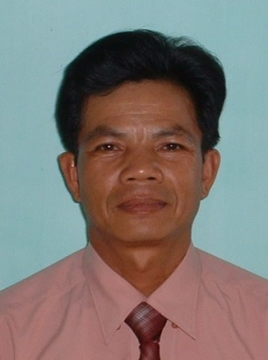 | - Mr. Le Duy Loc: b. 1956. Residence: Khanh Son, Khanh Hai Town, Ninh Hai, Ninh Thuan Province. Arrested on 2/5/2012, he was sentenced to 12 years in prison and 5 years of probation. He is currently held in Section 6, Thanh Chuong, Nghe An Province. His health is poor.
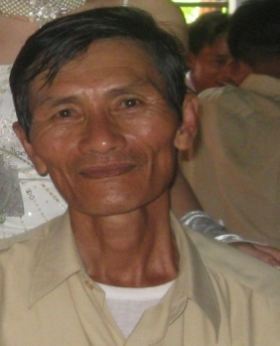 | - Mr. Le Phuc: b. 1951. Residence: 21/32A Thong Nhat Street, Dai Son Subdistrict, Phan Rang-Thap Cham Town, Ninh Thuan Province. Arrested on 2/5/2012, he was sentenced to 15 years in prison and 5 years of probation. He is currently held in Section K3, T345, Xuyen Moc Subdisrict, Ba Ria-Vung Tau Province. He suffers from poor health.
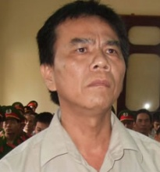 | - Mr. Le Trong Cu:b.10/20/1966. Residence: Quy Hau Village, Hoa Tri Subdisrict, Phu Hoa District. Arrested on 2/5/2012, he was sentenced to 12 years in prison and 5 years of probation. He is currently held in An Diem, Dai Hung, Dai Loc, Quang Nam Province. His health is poor.

 | - Mr. Luong Nhat Quang: b. 1987. Residence: Luong Phuoc, Hoa Phu Subdistrict, Tay Hoa District, Phu Yen Province. Arrested in March 2012, he was sentenced to 12 years in prison and 5 years of probation. He is currently held in Section K3, T345, Xuyen Moc Subdisrict, Ba Ria-Vung Tau Province.
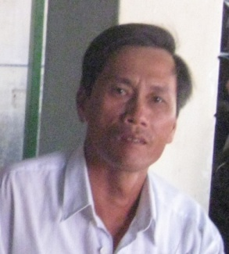 | - Mr. Nguyen Dinh: b. 4/1/1968. Residence: An Nien Village, Hoa An Subdistrict, Phu Hoa District, Phu Yen Province. Arrested on 23/11/2012, he was sentencedto 14 years in prison and 5 years of probation. He is currently held in Section 2, K2, Xuan Loc, Dong Nai Province.
 | - Mr.Nguyen Ky Lac: b. 1/1/1951. Residence: Trieu Son Dong, Xuan Dai Subdistrict, Song Cau Town, Phu Yen Province. Arrested on 2/6/2012, his sentence is 16 years in prison and 5 years of probation. He is currently held in Section 2, K2, Xuan Loc, Dong Nai Province.
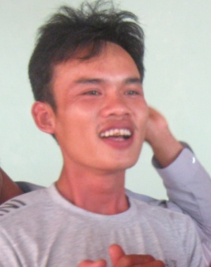 | - Mr. Nguyen Thai Binh: b. 1986. Residence: Thanh Hai Subdistrict, Phan Rang - Thap Cham, Ninh Thuan Province. Arrested on 11/23/2012, he was sentenced to 12 years in prison and 5 years of probation. He is currently held in prison in An Diem, Dai Hung, Dai Loc, Quang Nam Province.

 | - Mr. Phan Thanh Tuong: b. 1987. Residence: My Thanh Trung, Hoa Phong Subdistrict, Tay Hoa District, Phu Yen Province. Arrested on3/8/2012, he was sentenced to 10 years in prison and 5 years of probation. He is currently held in Section 2, Xuan Loc District, Dong Nai Province. He completed his prison sentence on October 8, 2020.
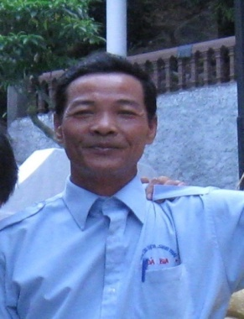 | - Mr. Phan Thanh Y: b. 1948. Residence: My Thanh Trung, Hoa Phong Subdistrict, Tay Hoa. Arrested on 11/23/2012, he was sentenced to 14 years in prison and 5 years of probation. He is currently held in Section K3, T345 in Xuyen Moc District, Ba Ria – Vung Tau Province.
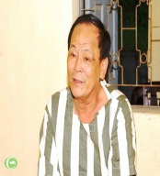 | - Mr. Phan Van Thu: b. 1948. Residence: Section 646, Tran Phu Street, An Nhon Town, Binh Dinh Province. He founded the Buddhist Sect titled An Dan Dai Dao in 1969. Arrested on 2/5/2012, he was sentenced to life in prison. He is currently in An Phuoc Prison in Phu Giao District, Binh Duong Province, and suffers from poor health.
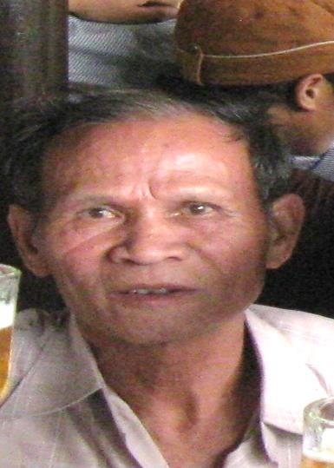 | - Mr. Ta Khu: b. 1947. Residence: Binh Thang, Son Thanh Dong Subdistrict, Tay Hoa District, Phu Yen Province. Arrested on 2/6/2012, he was sentenced to 16 years in prison and 5 years of probation. He is currently in Prison K3, T345 in Xuyen Moc Prison, Ba Ria- Vung Tau. His health is poor.

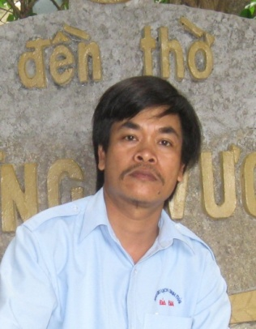 |  | - Mr. Tran Phi Dung: b. 1966. Residence: Phu Nhien, Hoa My Dong, Tay Hoa. Arrested on 2/10/2012, he was sentenced to 13 years in prison and 5 years of probation. He is currently held in Prison Z30A, Section 2, in Xuan Loc District, Dong Nai Province.
 |  | - Mr. Tran Quan: b. 1984. Residence: Lam Tuyen, Dran, Don Duong, Lam Dong Province. Arrested on 2/10/2012, he was sentenced to 13 years in prison and 5 years of probation. He is currently in Prison Z30A, Section 2, in Xuan Loc District, Dong Nai Province.
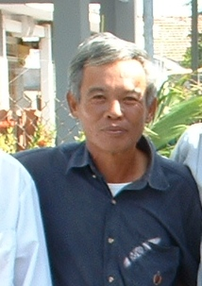 | - Mr. Tu Thien Luong: b. 1950. Residence: Section 3, Duc Nghia Subdistrict, Phan Thiet, Binh Thuan Province. Arrested on 11/23/2012, he was sentenced to 16 years in prison and 5 years of probation. He is currently in prison in An Diem, Dai Hung, Dai Loc, Quang Nam Province.
 | - Mr. Vo Ngoc Cu: b. 1951. Residence: Trieu Son Dong. Xuan Dai Subdistrict, Song Cau Town. Arrested on 2/6/2012, he was sentencedto 16 years in prison and 5 years of probation. He is currently in Prison K3, T345 in Xuyen Moc, Ba Ria- Vung Tau. His health is poor.
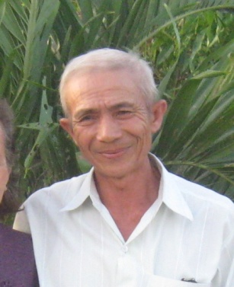 | - Mr. Vo Thanh Le: b. 1955. Residence: Phuoc Loc 2, Hoa Thanh Subdistrict, Dong Hoa, Phu Yen. Arrested on 2/5/2012, he was sentenced to 16 years in prison and 5 years of probation. He is currently in Prison K3, T345 in Xuyen Moc Prison, Ba Ria - Vung Tau. His health is poor.
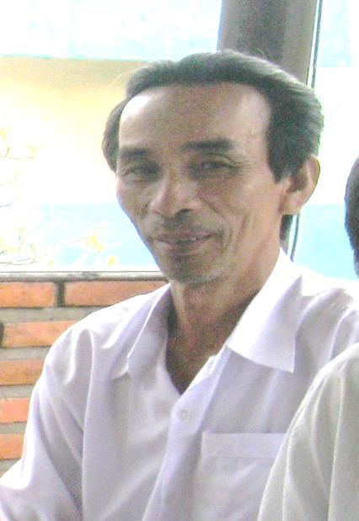 | - Mr. Vo Tiet: b. 1952. Residence: Ngo Gia Tu St., Area 5, Phu Dong Subdistrict, Tuy Hoa Town, Phu Yen Province. Arrested on 2/5/2012, he was sentenced to 16 years in prison and 5 years of probation. He is currently held inPrison Z30A, Section 2, in Xuan Loc District, Dong Nai Province.
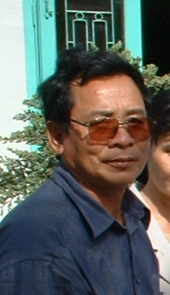 | - Mr. Vuong Tan Son:b. 1953. Residence: Thanh Lam Village, Hoa Quang Bac, Phu Hoa. Arrested on 2/10/2012, he was sentenced to 17 years in prison and 5 years of probation. He is currently in Prison K3, T345 in Xuyen Moc, Ba Ria-Vung Tau Province.

