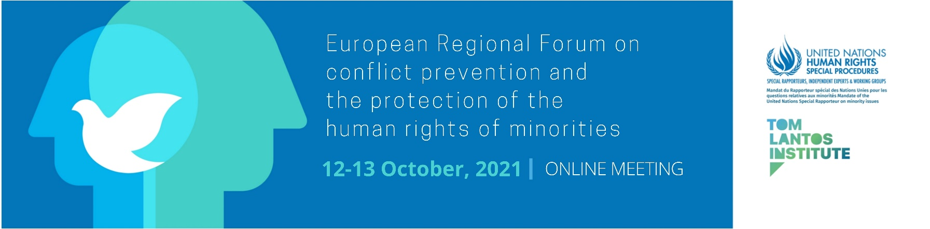

Supported by
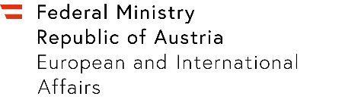
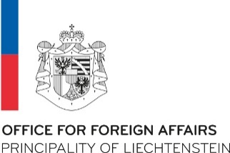
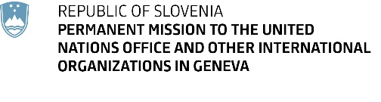
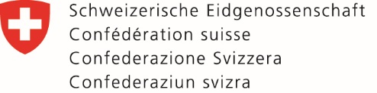

In cooperation with




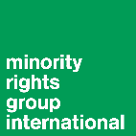
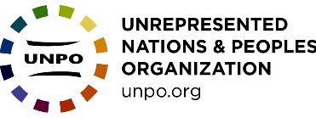

Programme of Work
(draft and subject to change)

**The times indicated refer to Geneva/Central European Summer Time (CEST or GMT +02:00)

Day 1 Tuesday 12th October 2021
09:00-10:00 Opening Session
Welcoming remarks
Anna-Mária Bíró, Director of the Tom Lantos Institute

Opening Remarks

H.E. Mr. Alexander Schallenberg, Minister of Foreign Affairs Austria

Kairat Abdrakhmanov, OSCE High Commissioner on National Minorities

Ryszard Komenda, Regional Representative, Office of the United Nations High Commissioner for Human Rights, Regional Office for the Central Asia

Armands Pupols, Political Affairs and Human Rights Officer, UN Regional Center for Preventive Diplomacy for Central Asia

Paulo David, Chief of the Indigenous Peoples and Minorities Section, United Nations High Commissioner for Human Rights

Fernand de Varennes, UN Special Rapporteur on minority issues

Rules and Guide to Proceedings
Anna-Mária Bíró, Director of the Tom Lantos Institute, will set-out the process and explain the rules of proceedings for the forthcoming sessions.

10:00-10:15 Technical Break

10:15-11:15 High-Level State Panel
Chair: Mô Bleeker, Special Envoy, Head of the task force for Dealing with the Past and Prevention of Atrocities, Swiss Federal Department of Foreign Affairs
Panel: H.E. Tatiana Molcean, Ambassador, Permanent Mission of the Republic of Moldova to the United Nations Office and other international organizations in Geneva
H.E. Martin Frick, Director of the Office for Foreign Affairs, Principality of Liechtenstein

11:15-11:30 Technical Break

11:30-13:00 Thematic Session 1: Substantive root causes of contemporary conflicts involving minorities

Moderator: Neil Clarke, Head of Legal Programmes and EU Advocacy, Minority Rights Group International
Experts: Jonathan Cohen, Executive Director, Conciliation Resources
Karena Avedissian, Fellow, Royal Society of Arts
Natalia Mirimanova, Senior Political Adviser, OSCE High Commissioner on National Minorities

Interactive dialogue

13:00-14:00 Lunch Break

14:00-15:30 Thematic Session 2: Normative framework: the human rights of minorities and conflict prevention

Moderator: Erzsébet Sándor-Szalay, Deputy Commissioner for Fundamental Rights, Ombudswoman for the Rights of National Minorities
Experts: Francesco Palermo, Comparative Public Law, University of Verona and Director of the Institute for Comparative Federalism, Eurac Research
Nurcan Kaya, human rights lawyer and researcher

Urko Aiartza Azurtza, Senior Advisor, European Institute of Peace

Irina Vlah, Governor of the Autonomous Territorial Unit of Gagauzia, Republic of Moldova

Interactive dialogue

Day 2 Wednesday 13th October 2021

09:00-10:30 Thematic Session 3: Obstacles to implementing the rights of minorities and early effective conflict prevention

Moderator: Vello Pettai, Director, European Centre for Minority Issues
Experts: André Fazi, Lecturer in political science, University of Corsica
Salpy Eskidjian, Executive Director of the Religious Track of the Cyprus Peace Process
Damir Kapidžić, Associate Professor of Comparative Politics at the Faculty of Political Science, University of Sarajevo
Amalur Alvarez, Researcher, Eusko Ikaskuntza

Interactive dialogue

10:30-11:30 Break

11:30 – 13:00 Thematic Session 4: Ways forward towards addressing gaps in human rights mechanisms to protect minorities and prevent conflicts

Moderator: Anina Ciuciu, Director, La Voix des Rroms
Experts: Marina Elbakidze, Project Coordinator, Caucasus Institute for Peace, Democracy and Development
Sardorbek Abdukhalilov, former OHCHR Minority Fellow and lawyer, Spavedlivost Human Rights Organization
Petra Roter, Professor of International Relations at the University of Ljubljana
Vincze Loránt, President, president of the Federal Union of European Nationalities
Interactive dialogue

13:00-14:30 Lunch break

14:30-15:30 Presentation of Recommendations

In this session, the proposed recommendations developed during the four thematic sessions will be made available to participants to consider.
The session will be introduced by Fernand de Varennes, UN Special Rapporteur on minority issues, following which Marcus Oda, Programme Manager at the Tom Lantos Institute, will present the list of recommendations.
Participants can make any final comments on specific recommendations using the Zoom chat function.
Moderator:

15:30-16:00 Concluding remarks

Fernand de Varennes, UN Special Rapporteur on minority issues

Simultaneous interpretation will be provided in English, French, Russian and Romani

