
United Nations Human Rights Council
United Nations High Commissioner
For Human Rights
Easy to read

What people said at a meeting about climate change and the rights of older people

Climate change is about the earth getting warmer and the problems that it is causing for people and the planet we live on.

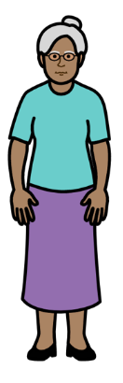
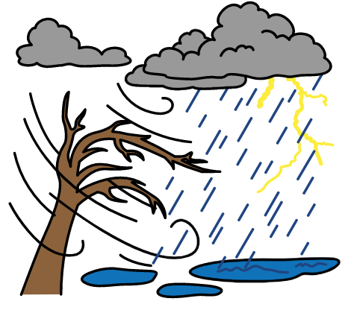

About us
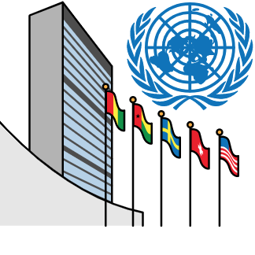

We are called the Office of the High Commissioner for Human Rights.

We are part of the United Nations (UN).

The United Nations is a group of countries that work to make the world better and safer.
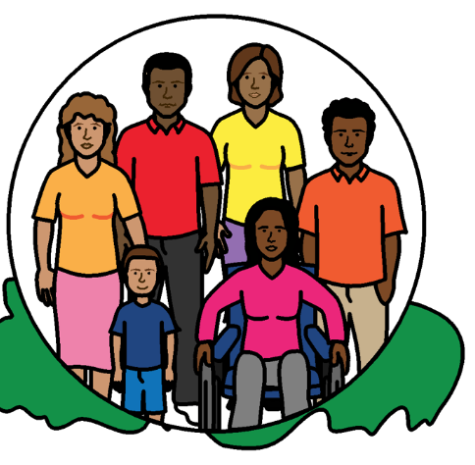

Our job is to make sure that
everyone in the world is treated fairly and gets their human rights.

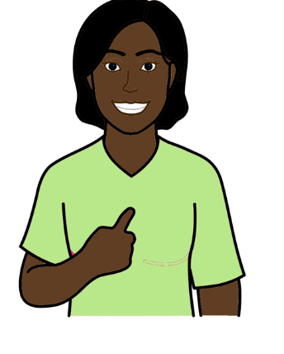
Everyone has human rights.

Human rights are about what should happen to everyone.

For example, everyone has the right to work, go to school and be healthy.

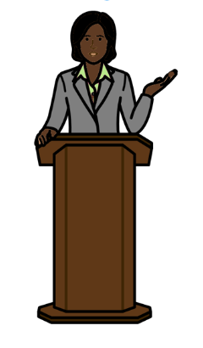
About this report

This report is about a meeting we had about climate change and the rights of older people.

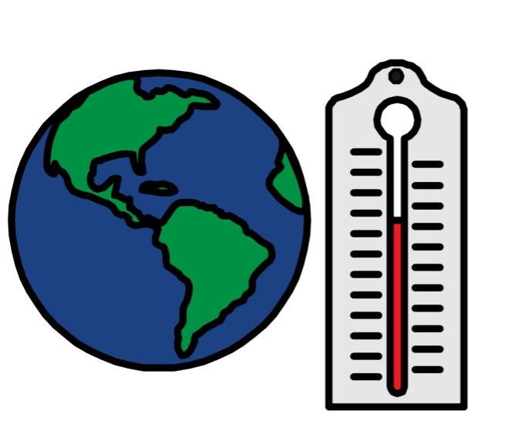

Climate change is about changes to the earth we live on.

The earth is getting warmer.

This is causing big problems for people and the planet we live on.

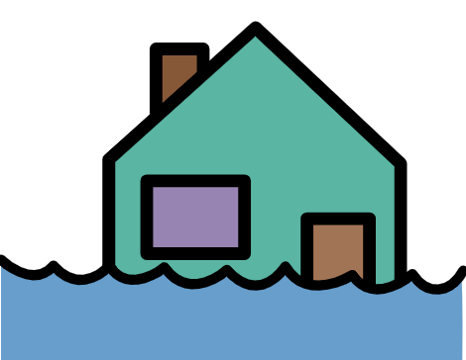

For example, climate change can cause weather problems like floods, too much heat and bad storms.

It can also cause problems for animals and plants.

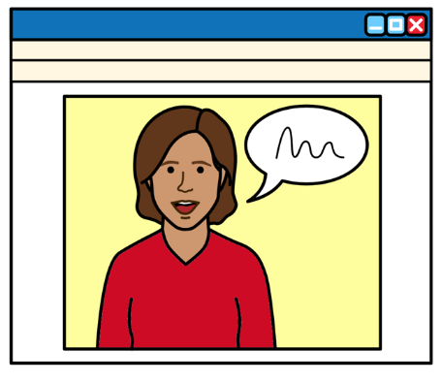

The meeting we had was on 30 June 2021.

People from different countries and organizations talked at the meeting.
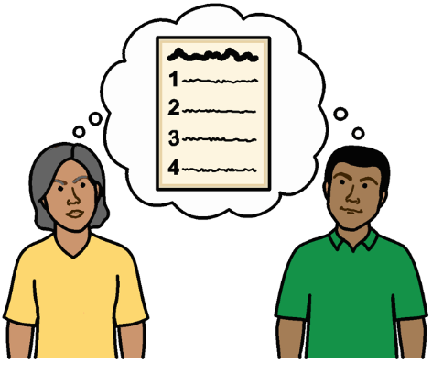
People at the meeting talked about:

- Problems for older people because of climate change.

- What countries and organizations should do about it.

The main things that people said at the meeting
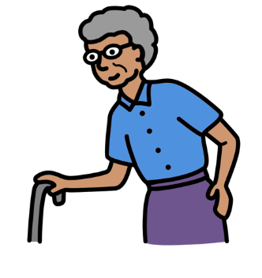

Problems for older people because of climate change

Life is already hard for many older people in the world.
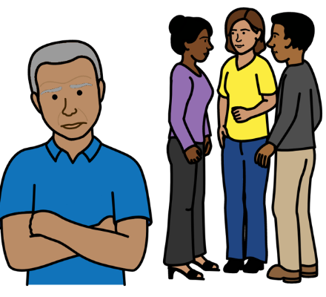

For example, people often have unfair ideas about older people.

That means older people are often left out and treated unfairly.

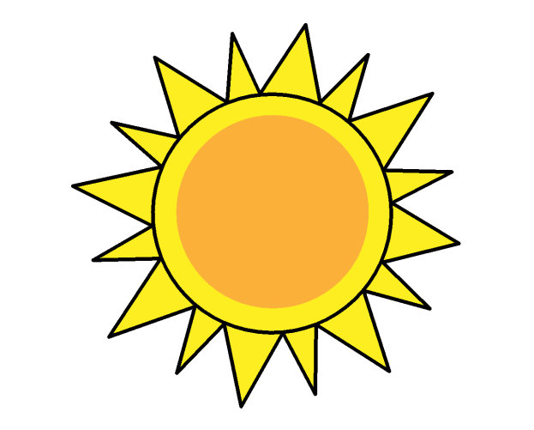
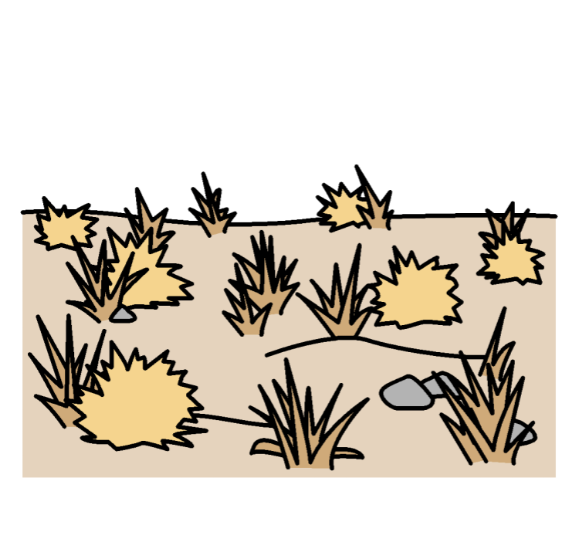
Things can get worse for older people when there are big problems in the world.

This includes climate change problems
like floods, bad storms and too much heat.
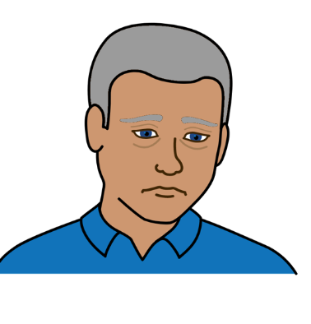

Older people might find it harder to cope with climate change problems.

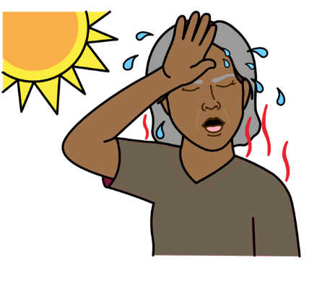

Older people might be more at risk because of climate change.

For example, many older people have died during bad storms, floods and too much heat.
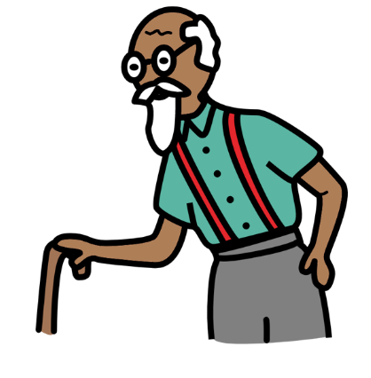

Older people might find it hard to move away if they are in danger.

And transport might be hard for them to use.

It can be hard for many older people to get the things they need because of climate change.

Like food, clean water, money and housing.


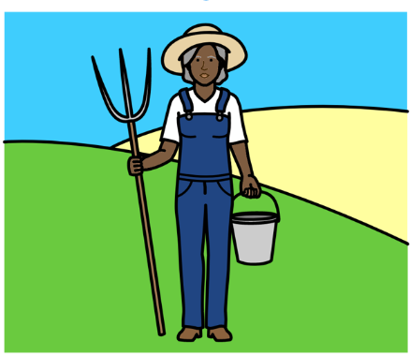

For example, climate change might damage land that older people work on.

This can stop older people from growing food or earning money from the land.
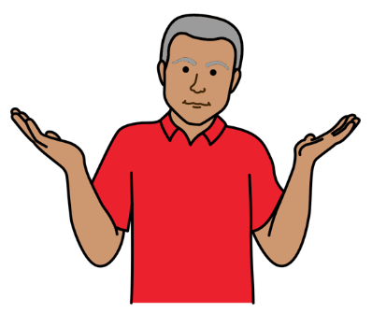

Older people can find it hard to get information about climate change and how to keep safe.

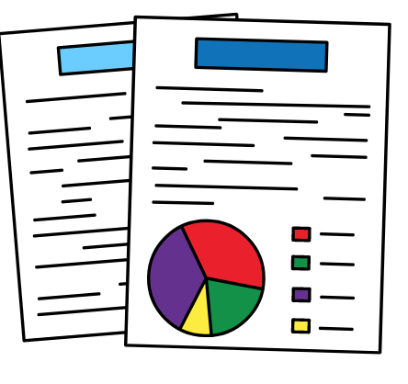

There is not enough information about older people and climate change.

For example, people often do not ask older people what they need.

There are also not enough laws about older people and their rights.
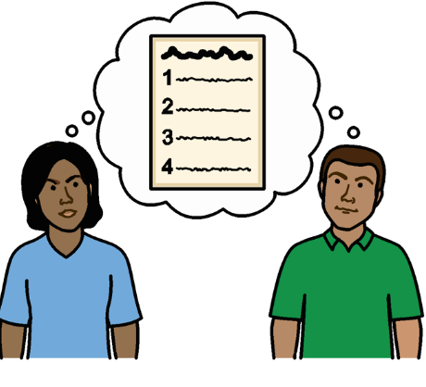
That means older people are often left out of laws and plans about climate change.

Countries might not think about what older people need.

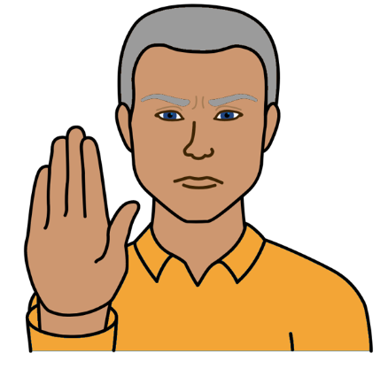

What people at the meeting said should happen

Climate change is stopping many older people from getting their human rights.

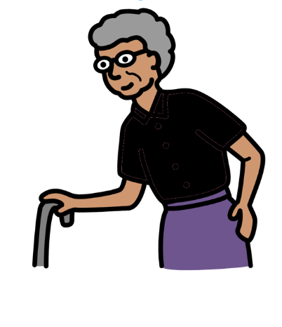

Countries should make sure that
all older people get their human rights.

That includes women and people with disabilities.

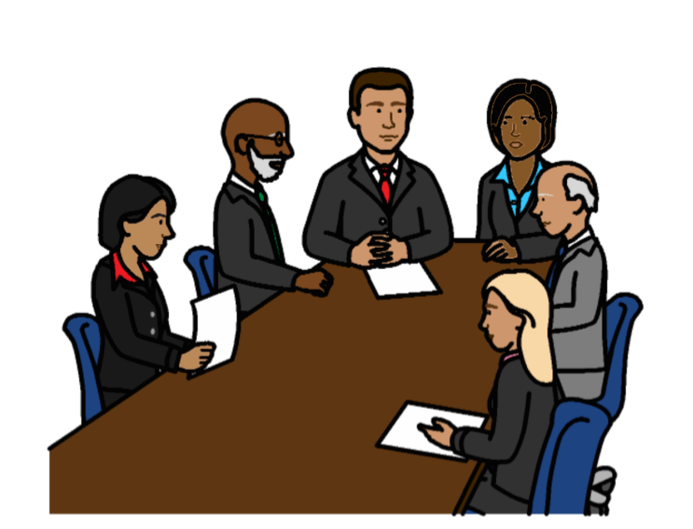
Countries should work harder to stop climate change and the problems it causes.

Countries should work together on that.

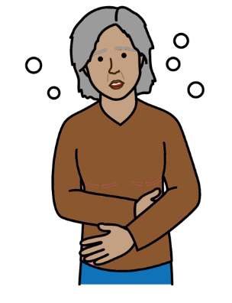

Countries should learn from bad things
that happened to older people during Covid-19.

Covid-19 is an illness that many people in the world have been getting.

Countries should stop the bad things from happening again.
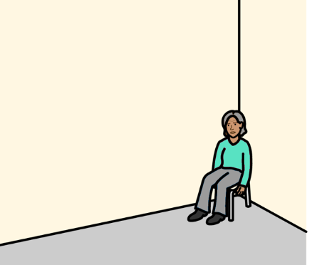

For example, many older people got ill or died during Covid-19.

And many older people were left alone without enough money or support.

Countries should make sure that laws and plans about climate change work well for older people and their rights.
Countries should get better information about what is happening to older people because of climate change.

That will help countries to make good plans.
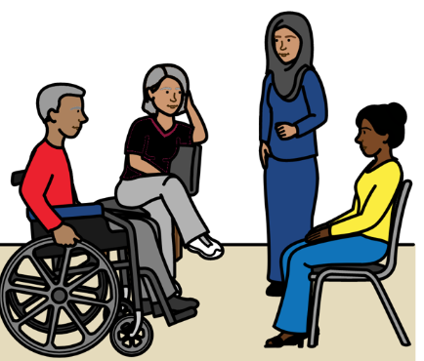

Countries should work with older people to make laws and plans about climate change.

That includes plans about how to get ready for big problems that might happen in the country.

Like floods, too much heat and bad storms.
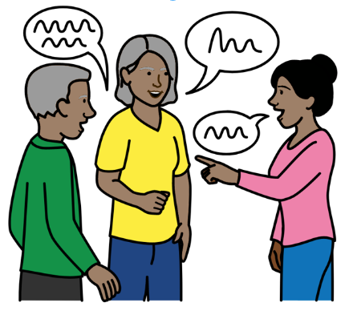

Older people should have a real say in the laws and plans and how they are working.

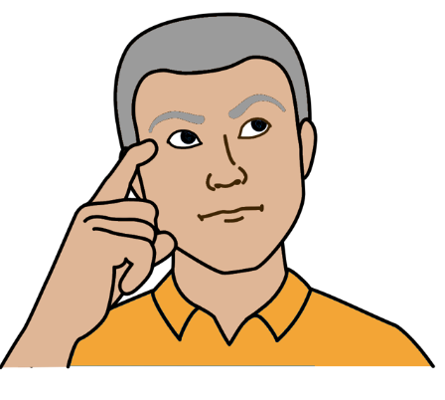
Countries should understand that older people have many important skills.

Older people can help to change things.

For example, older people might have ideas about how to stop climate change.

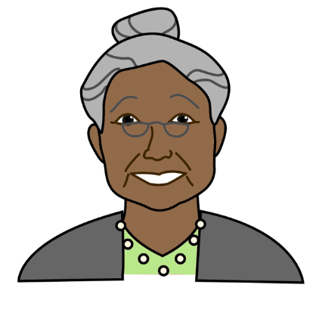

Many older people are already doing important work on climate change.

For example, they are making sure that plans about climate change work for them.

And they are having a say in laws to stop climate change.

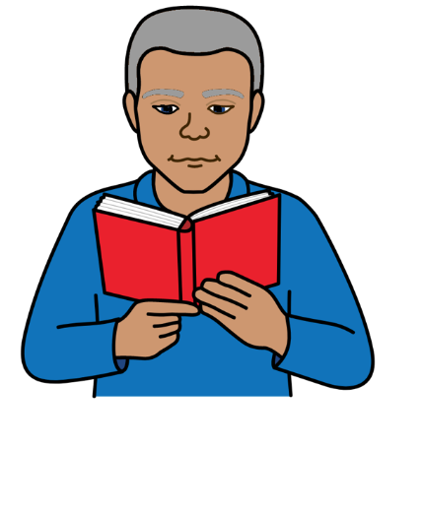

Countries should give older people information they can understand about:

- Climate change and how to keep safe

- How they can take part in climate change work
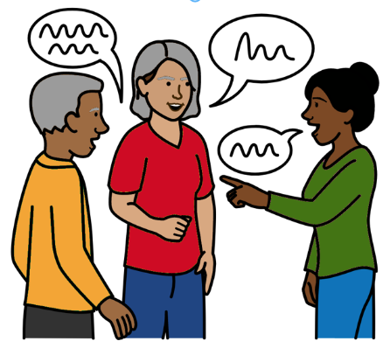
Countries should support older people to get ready for climate change problems and make changes where they need to.

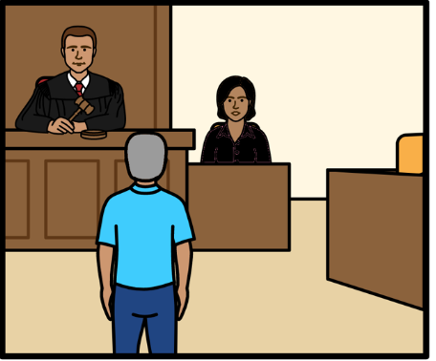

Older people should get support from the courts if climate change stops them from getting their human rights.

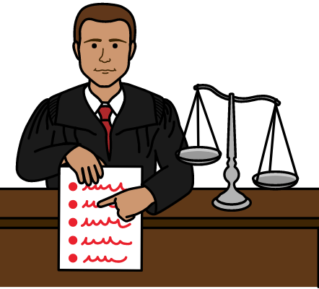

There should be better laws in countries and the world about the rights of older people.



For example, there could be a new law for the whole world about the rights of older people.

This will help older people to get their rights.
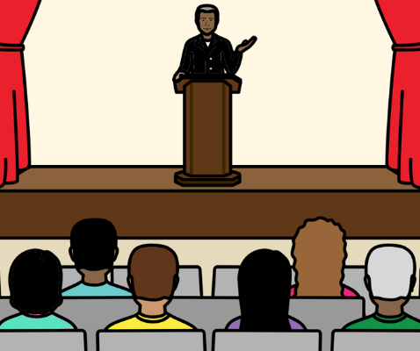
People could talk about the rights of older people at a big meeting about climate change.

Many countries go to the meeting.

The Human Rights Council could do more on climate change and human rights.

The Human Rights Council is part of the United Nations.
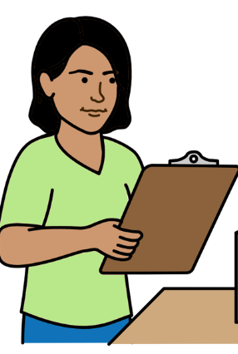

For example, they could get an expert to look at human rights and climate change.

The expert could say what needs to be done.

Some good work that countries are doing

Bangladesh, Mozambique and Luxembourg are making sure that older people are part of their climate change plans.
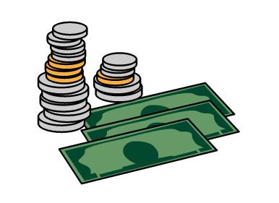

Qatar has promised to give lots of money to countries that need more support to stop climate change.
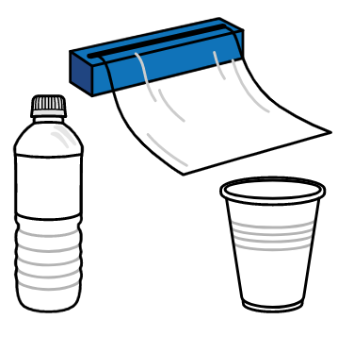

The Maldives has stopped using some types of plastic.
Plastic can cause climate change problems.

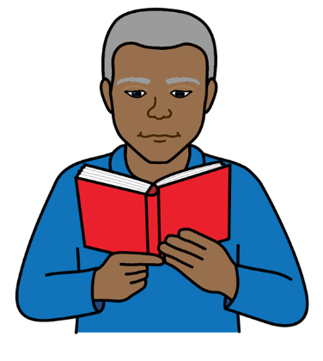

Mauritius, Timor-Leste and Iraq are helping older people to get information about climate change.

Countries must do more work like this to include older people and make sure they get their rights.
Pictures by The Picture Communication Symbols ©1981–2016 by Mayer-Johnson LLC a Tobii Dynavox company. All Rights Reserved Worldwide. Thousands of resources available for free at www.boardmakeronline.com

