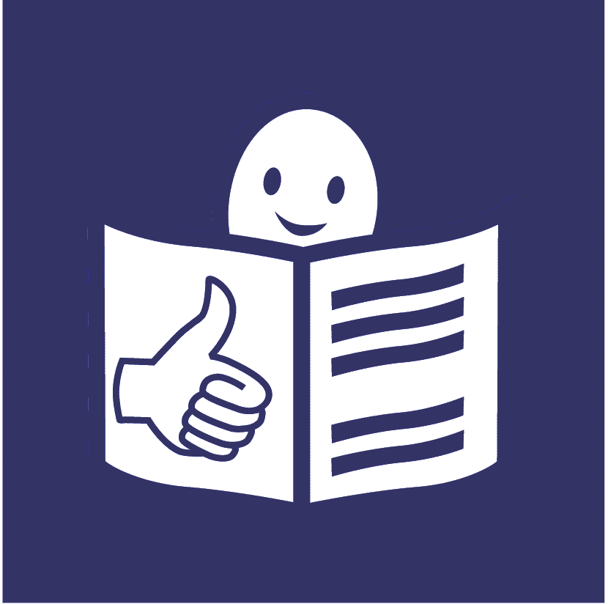
United Nations Human Rights Council
United Nations High Commissioner
For Human Rights
Easy to read

Getting and using information to make life better for people with disabilities

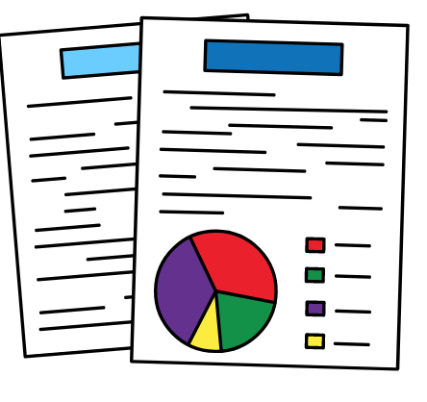
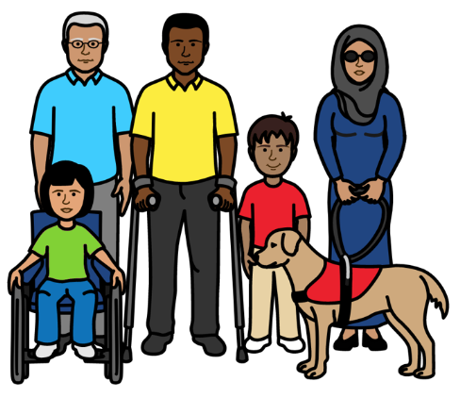

About us
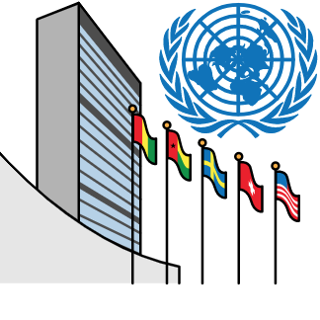

We are called the Office of the High Commissioner for Human Rights.

We are part of the United Nations (UN).

The United Nations is a group of countries that work to make the world better and safer.

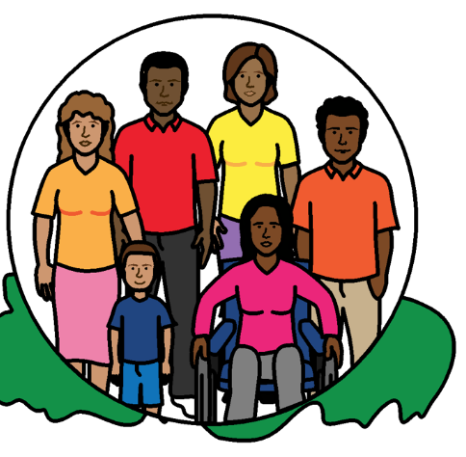

Our job is to make sure that
everyone in the world is treated fairly and gets their human rights.

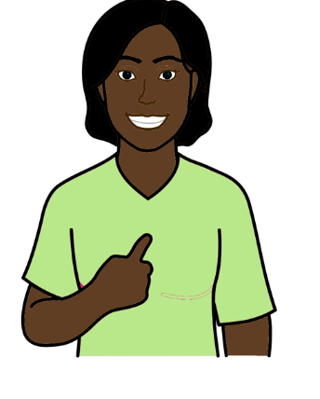

Everyone has human rights.

Human rights are about what should happen to everyone.

For example, everyone has the right to work, go to school and be healthy.

About this report

This report is about getting and using information to make life better for people with disabilities.

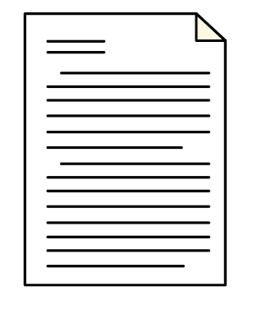

There is an important document about the rights of all people with disabilities in the world.

It is called the Convention on the Rights of Persons with Disabilities.
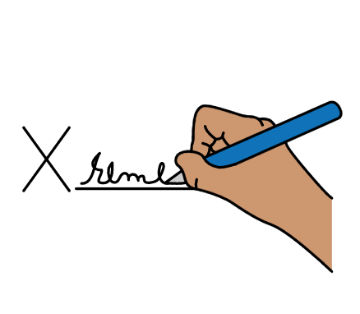

Many countries have promised to do what the document says.

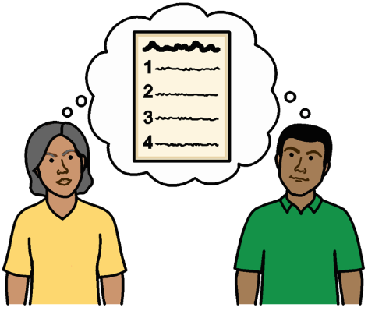
The document says that countries must get good information about people with disabilities.

They must use the information to make sure that people with disabilities get their rights.

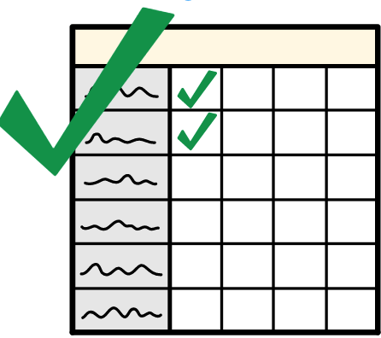
This report is about:

- What countries should be doing

- Some good work that countries and organizations told us they were doing

We asked countries and organizations for their ideas before we made this document.

What do we mean by information?
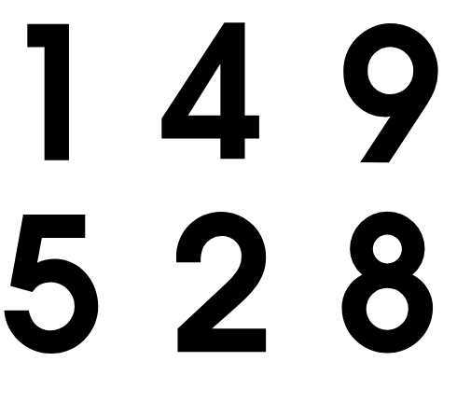

Information can be lots of things, like:

Numbers. For example, the number of people with disabilities who go to school or work.
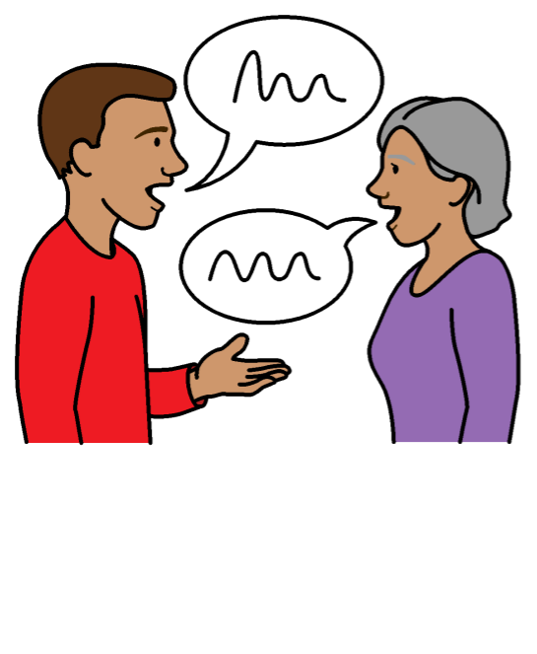

Information to show what people think and feel.

For example, stories, photos and videos about people’s lives.

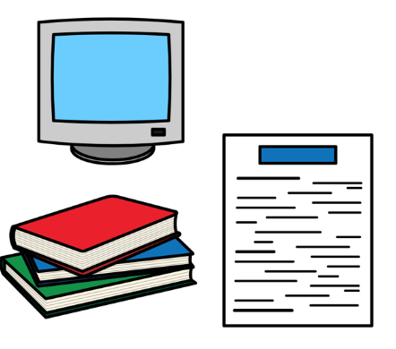
Information can come from many places, like:

- Information that governments and organizations keep about people in the country.

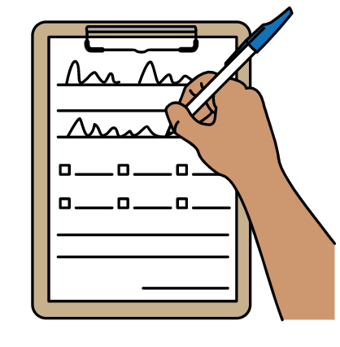
- Reports that organizations write.

- Surveys and interviews where people answer questions about their lives.

- Information that people in the community get themselves.

Information like this is often called data.

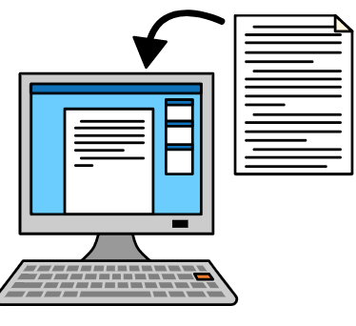
What countries must do

Get better information

Countries must work to get better information about people with disabilities and what they need.

That includes:

- Information about how many people with disabilities there are and the disabilities they have.
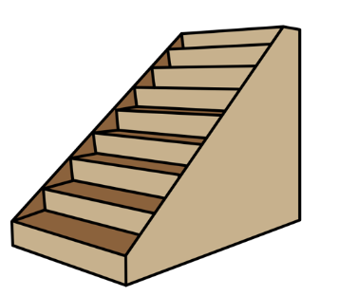
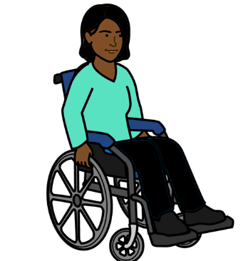

- Information about the problems that stop people with disabilities from getting their rights.

- Information to show which people with disabilities need the most support.

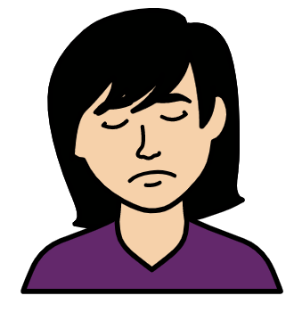

- Information about people who might be treated badly for more than one reason.

For example, women with disabilities might be treated badly because they are women and because they have a disability.
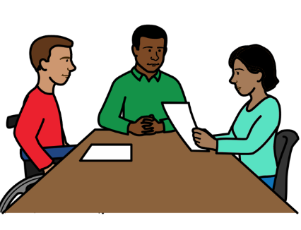

The information will help countries to understand what different groups of people with disabilities need.
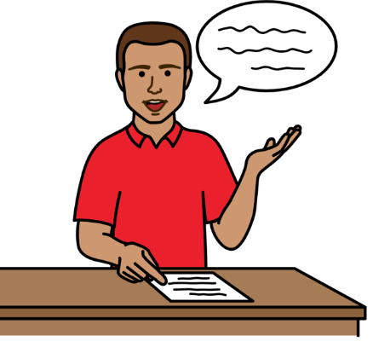
Countries should look at what information they have about people with disabilities first.

Then they should work to get any information that is missing.

For example, countries sometimes ask everyone in the country some questions.

That is to find out more about who is living in the country.

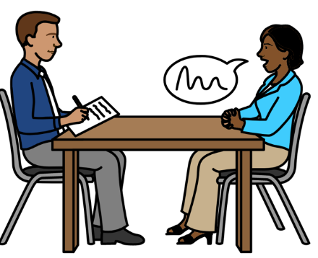

Countries should include questions about disability when they are asking everyone questions.

But they need to do more than that.

Countries must also find out information just about people with disabilities and what they need.

Using the information to make good plans
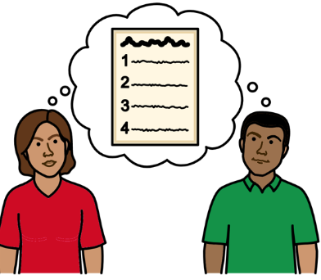

Countries should use the information they get about people with disabilities to make good plans.

The plans should support people with disabilities to get their rights.

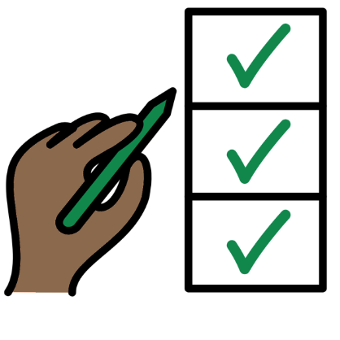

Countries should check how the plans are working.

For example, countries should have a list of things to check.

That will show them if the plans are helping people with disabilities to get their rights.

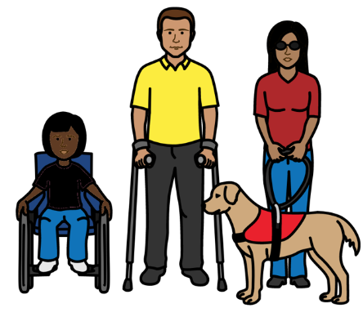

How countries should get and use information

Countries should get and use information in a way that is good for people’s rights.

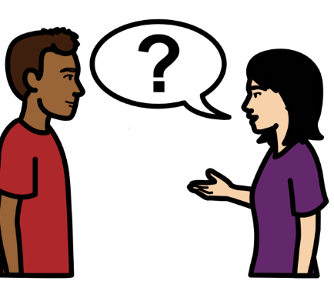
For example, some organizations give people with disabilities support.

The organizations might need to find out if someone has a disability first before they can give them support.

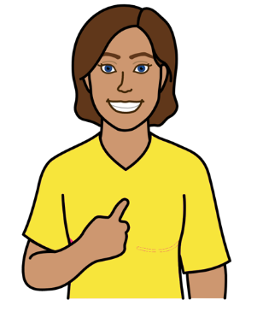

The organizations should find out about people with disabilities in a fair way.

They should support people with disabilities to get their rights.

They should not do anything to stop people with disabilities from getting their rights or taking part in the community.

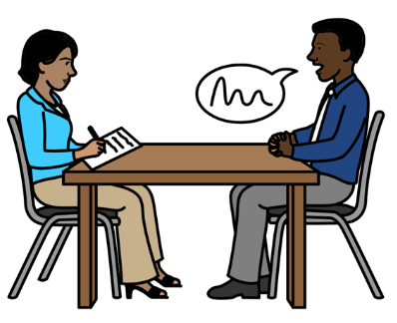

There are some good questions that people can ask to find out
who has a disability and how it affects them.

They are called the Washington Group Questions.

Countries and organizations should use those questions.
Countries and organizations should look at how they can use different types of information together.

For example, questions that people answer.

And stories about people’s lives.

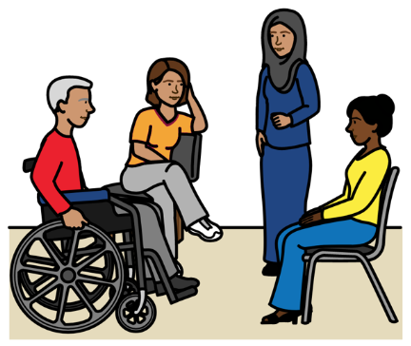
The different types of information should work well together.

Many people and organizations should work together to get good information about people with disabilities.

People with disabilities should be a big part of that work.
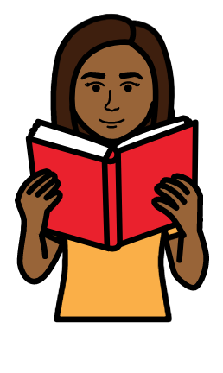

Countries should share the information they have with people with disabilities.

The information should be easy for people with disabilities to use and understand.
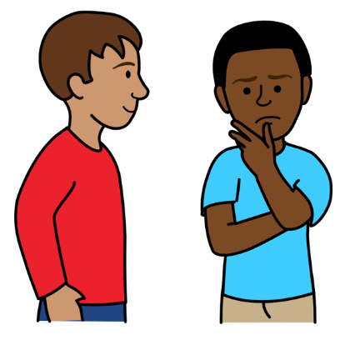

People with disabilities can use the information to check if they are getting their rights.
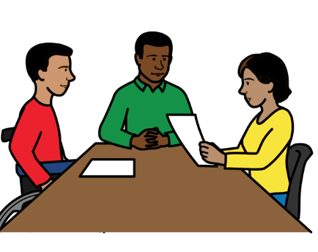
Some people with disabilities have worked to get their own information about people with disabilities and what they need.

Countries should support people with disabilities to get that information.

Keeping information private and safe
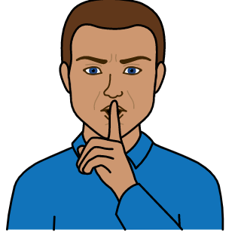


Countries should have good laws about keeping information private and safe.

That includes information about people with disabilities.

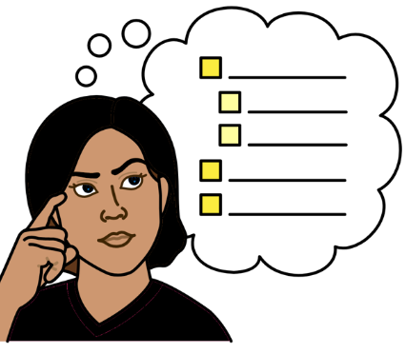
Countries should follow rules in the world about how to use people’s information.

For example, people with disabilities should know what information people are keeping about them.

They should also know how the information is being used.

Some good work that is happening

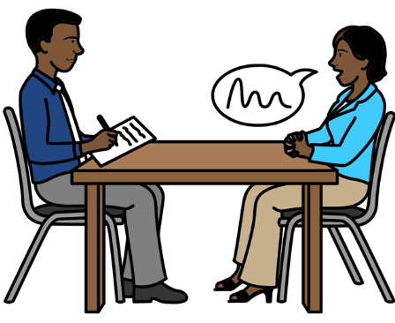

Zimbabwe made some questions to find out why it is hard for people with disabilities to take part in the community.

For example, what stops people with disabilities from using transport, information and health care.
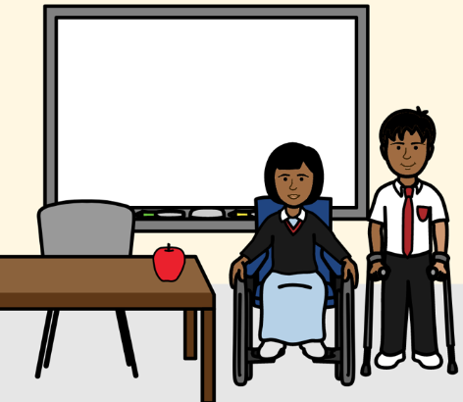

Fiji is getting some good information about children with disabilities in schools.

South Africa is looking at ways to make different types of information work well together.

Many governments are asking people in the country more questions about disability.
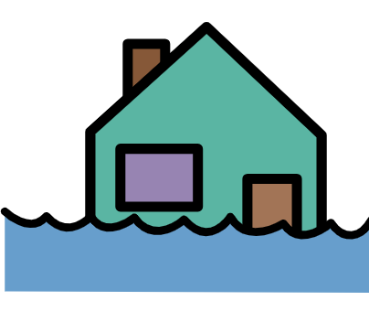
Some organizations in the world support people when there are big problems, like war or floods.
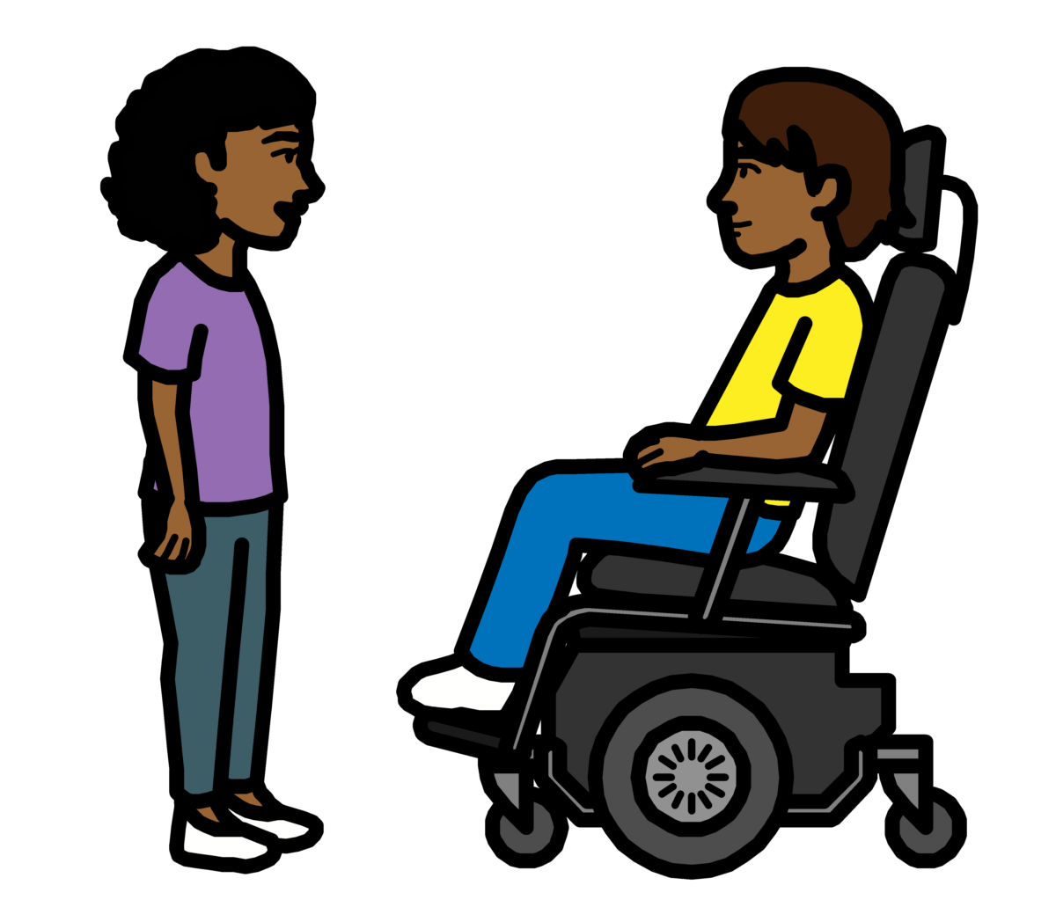

More organizations are now finding out about people with disabilities and what they need.

Some organizations are looking at what information there is about people with disabilities and what is missing.

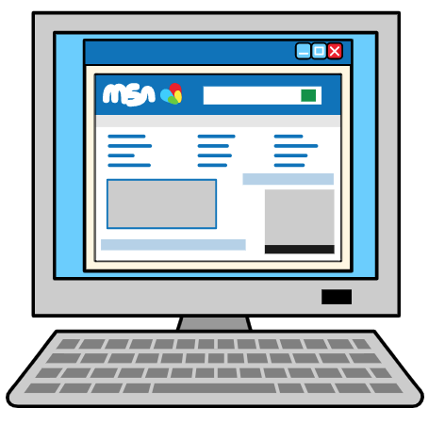

There is a place on the internet to find information about what is happening to people with disabilities in different countries.
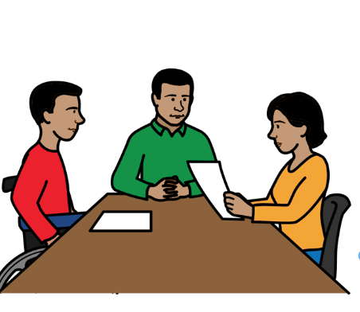

Work is happening in Asia to support people with disabilities to work with governments.
They are working together to get better information about people with disabilities.
Pictures by The Picture Communication Symbols ©1981–2016 by Mayer-Johnson LLC a Tobii Dynavox company. All Rights Reserved Worldwide. Thousands of resources available for free at www.boardmakeronline.com

