Members of the drafting group on a legally binding instrument on the right to development

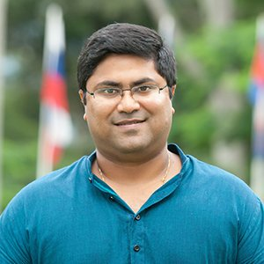
Dr. Mihir Kanade
Dr. Kanade is the Academic Director of the University for Peace (Established by the UN General Assembly), the Head of its Department of International Law and Human Rights and the Director of the UPEACE Human Rights Centre. He holds a LL.B from Nagpur University (India) and a Master degree and Doctorate from UPEACE. He is also an adjunct faculty at Universidad Alfonso X El Sabio (Spain), Cheikh Anta Diop University (Senegal), and Long Island University (United States). His principal area of academic research and study is International Law, Human Rights and Globalization, covering several themes within that interface including trade and investment, sustainable development, forced migration, indigenous peoples’ rights, public health, amongst others. He conducts several trainings for staff of inter-governmental, governmental and non-governmental organizations, as well as professionals, in the field of international law and human rights. He serves on the International Advisory Board of the International Bar Association on the topic of Business and Human Rights. He also co-leads an e-learning project in partnership with the OHCHR and UNU-IIGH on operationalizing the Right to Development in Implementation of the SDGs. Prior to academia, Mihir practiced for several years as a lawyer at the Bombay High Court and at the Supreme Court of India.

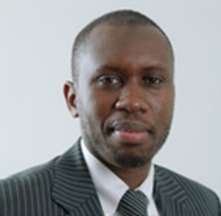
Professor Makane Moïse Mbengue
Prof. Mbengue is a Professor of International Law at the University of Geneva and Affiliate Professor at Sciences Po Paris (School of Law). He has acted and acts as expert for the African Union, the United Nations Economic Commission for Africa, the United Nations Environment Programme, the World Bank, the International Labour Organization, the United Nations Conference on Trade and Development and the International Institute for Sustainable Development, among others. He was also the Lead Expert for the negotiations and drafting of the Pan-African Investment Code in the context of the African Union and is involved in investment negotiations in different African republics and economic organizations. He also teaches international law in courses organized by the United Nations Office of Legal Affairs and by the United Nations Institute for Training and Research. Professor Mbengue holds a PhD in Public International Law from the University of Geneva, a Master’s in Public Law and an LL.M. in economic and commercial law from the University of Saint-Louis (Senegal).


Professor Koen De Feyter
Prof. De Feyter is Professor of International Law, Spokesperson of the Research Group on Law and Development and Academic Coordinator of the Master of Laws program at the University of Antwerp (Belgium). He chairs the Executive Committee of the global Law and Development Research Network (LDRn), is a Board Member of Picture People (UK), and a regular contributor to the European Master of Human Rights and Democratization (Venice). His main research areas are international law and sustainable development, and human rights in non-Western contexts. He has taught on these issues at universities in Africa, Asia and Latin America.

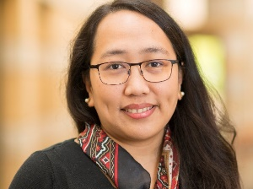
Prof. Dr. Diane Desierto (JSD, Yale) is Professor of Law and Global Affairs, Faculty Director of the LLM in International Human Rights Law, at Notre Dame Law School, with a joint appointment as full professor at the Keough School of Global Affairs, University of Notre Dame, where she also holds five Faculty Fellow appointments (Klau Center for Civil and Human Rights, Kellogg Institute of International Studies, Liu Institute for Asia and Asian Studies, Pulte Institute of Global Development, Nanovic Institute of European Studies) and is the Co-Principal Investigator of the Notre Dame Reparations Design and Compliance Lab. She holds a further appointment as Professor of International Law and Human Rights at the Philippines Judicial Academy of the Supreme Court of the Philippines. Professor Desierto is a Member of the Editorial Boards of the European Journal of International Law, the Journal of World Investment and Trade, and International Law Studies, and two Asian journals of international law. Professor Desierto previously clerked at the International Court of Justice, served as Director of Studies and faculty at the Hague Academy of International Law. She is Academic Council Member of the Institute of Transnational Arbitration, Co-Chair of the Oxford Investment Claims Summer Academy, Listed Arbitrator at the British Virgin Islands Arbitration Centre, and Expert for various international organizations such as the Association of Southeast Asian Nations, the Asian Development Bank, the European Union External Action Service, USAID, among others. To date, she has authored (and/or edited) five books and around 140 law review articles, book chapters, book reviews, and shorter works on international law, international economic law and development, international human rights law, maritime security, ASEAN law, and international arbitration and dispute settlement.

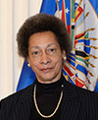
Judge Margarette May Macaulay

Commissioner Margarette May Macaulay was re-elected in June 2019, by the OAS General Assembly, for a second four-year term as Member of the Inter-American Commission on Human Rights, commencing in January 2020. Commissioner Macaulay holds a bachelor of laws degree from the University of London and is currently an attorney in private practice. She serves as Mediator in the Supreme Court of Jamaica and as Associate Arbitrator, as well as serving as Notary Public. She served as a Judge of the Inter-American Court of Human Rights from 2007 to 2012, contributing to the formulation of the Court’s Rules of Procedure. She is an honoured member of the Gender Justice Legacy Wall of notable women’s rights advocates who have brought about important changes, which was launched in December 2017 at the United Nations in New York, during the Assembly of Ministers. She took part in the reform and drafting of laws in Jamaica and is well known as a strong proponent of and authority on women’s rights. She is a citizen of Jamaica.

