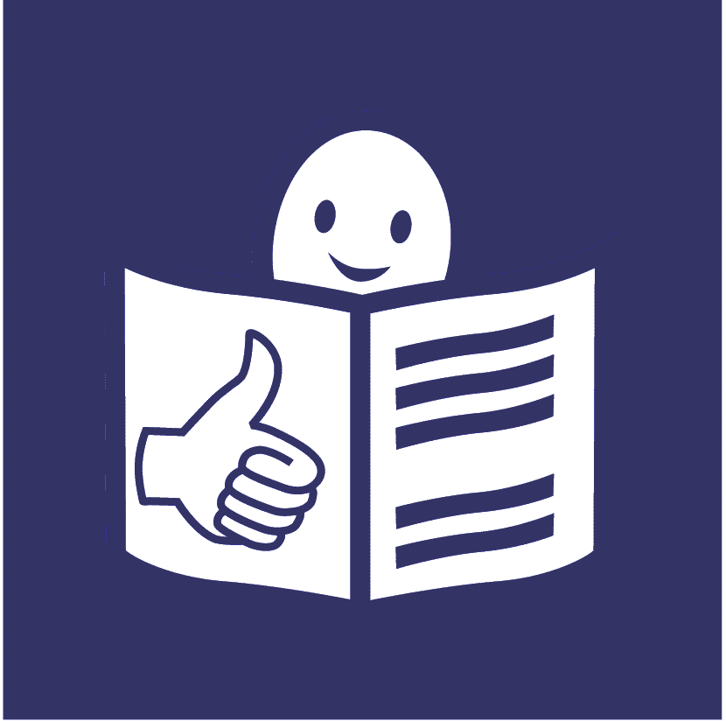
United Nations Office of the
High Commissioner for Human Rights
Easy to read

What our part of the United Nations has done to include people with disabilities in 2021

This is about our work on the United Nations plan to include people with disabilities

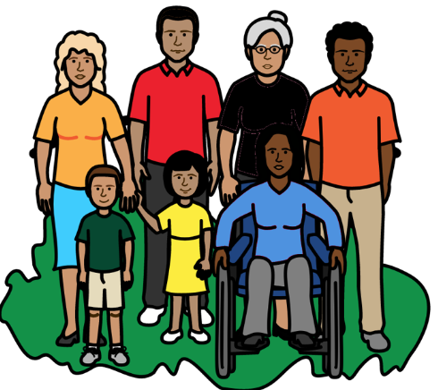

Progress report on the United Nations
Disability Inclusion Strategy

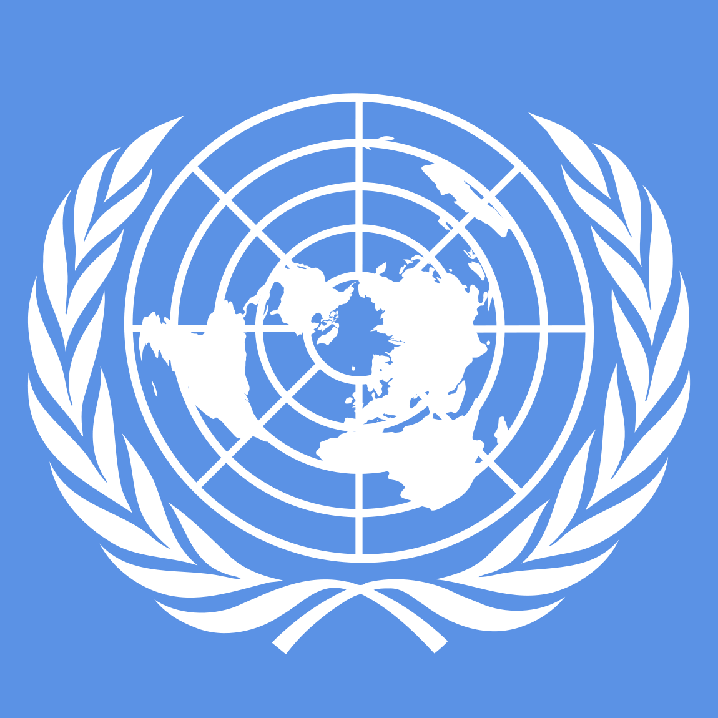
About us

We are called the Office of the High Commissioner for Human Rights (OHCHR).

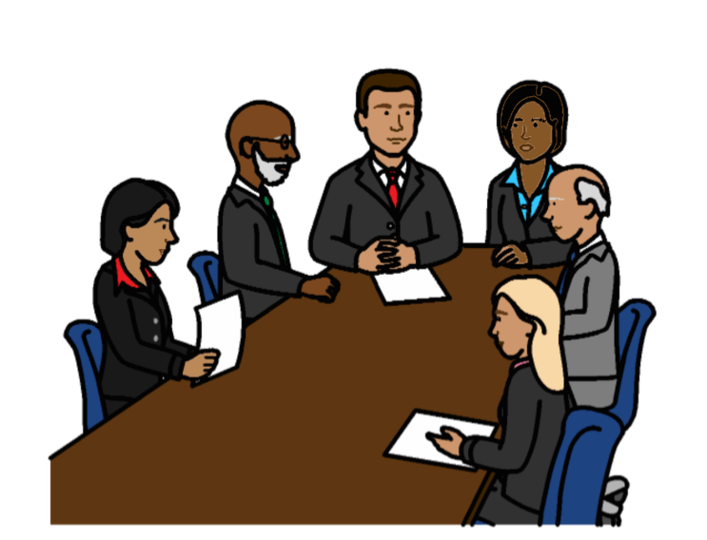

We are part of the United Nations (UN).

The United Nations is a group of countries that work to make the world better and safer.

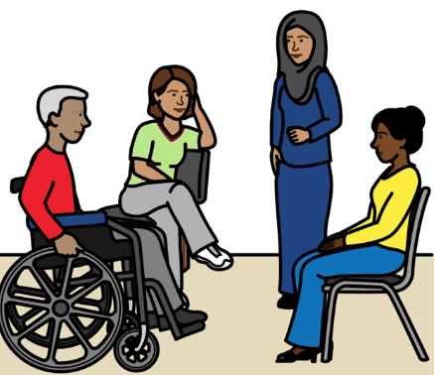
About this report

The United Nations wants people with disabilities to be part of everything it does.

That means people with disabilities should not be left out.
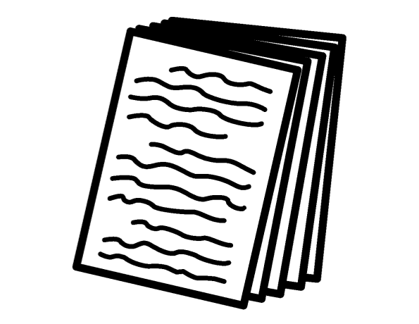

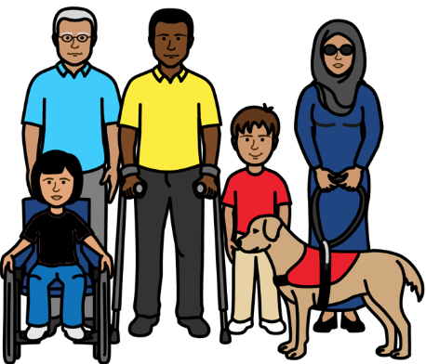
The United Nations has a plan about how to include people with disabilities.

The plan is called the
Disability Inclusion Strategy.

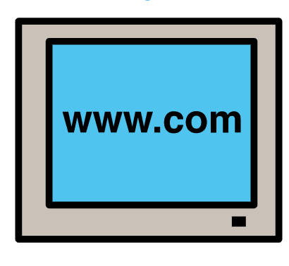
The plan is on this website:
https://www.un.org/en/content/disabilitystrategy/assets/documentation/Easy_to_Read.pdf

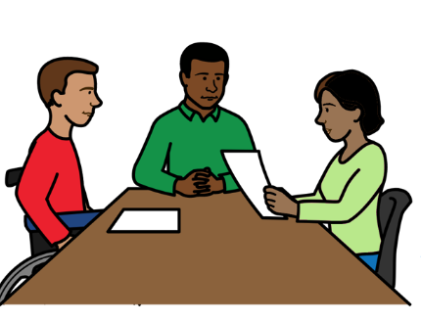

Different parts of the United Nations should say how they are doing with the plan every year.

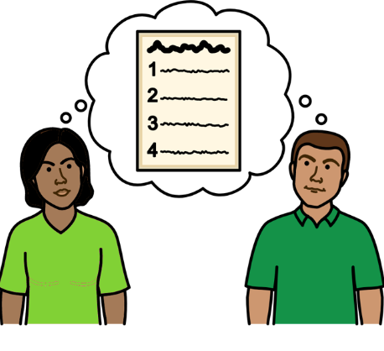

This report tells you what we have done to include people with disabilities
in 2021.

There are 15 areas of work that we had to look at.
We had to say how well we are doing on each area that we work on.
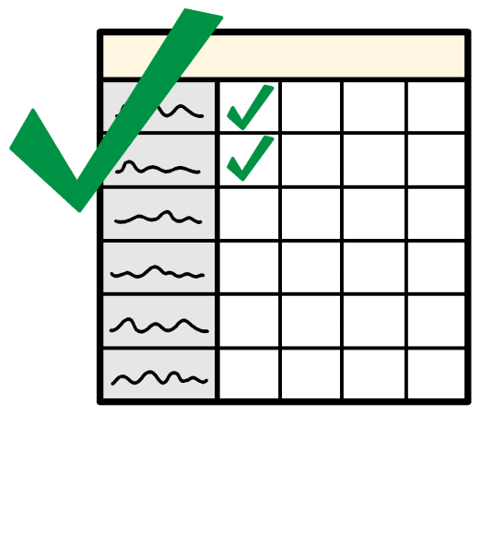

This report tells you more about what we are doing well on.

And what we need to do more on in 2022.
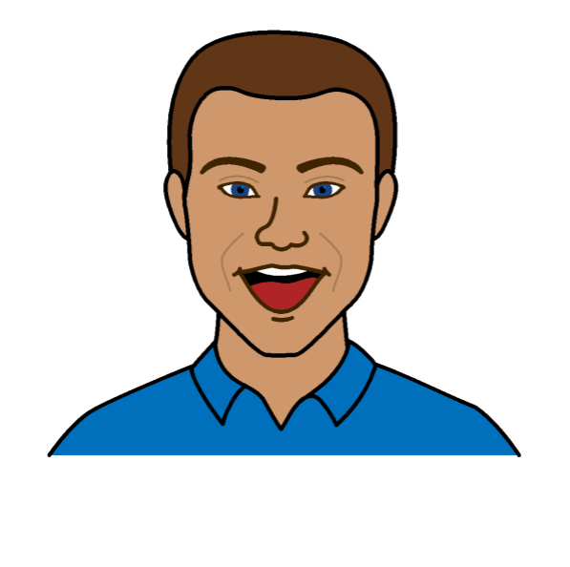
How we are doing so far to include people with disabilities

- We are doing even better than we need to on some things
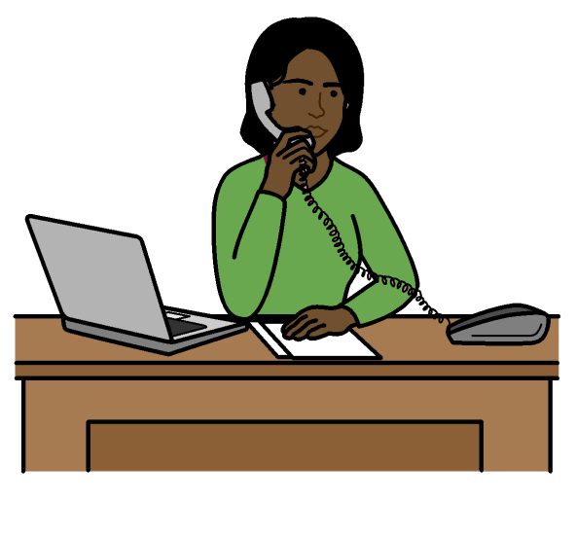

We are doing even better than we need to on the areas of work below:

Making sure that senior managers make the United Nations plan about people with disabilities happen.
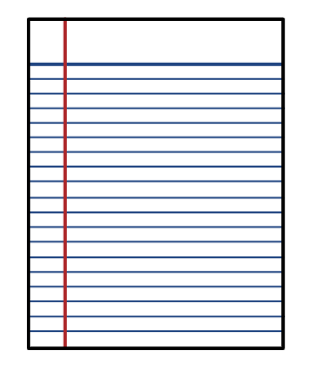

Making sure that we have a plan about how to include people with disabilities.
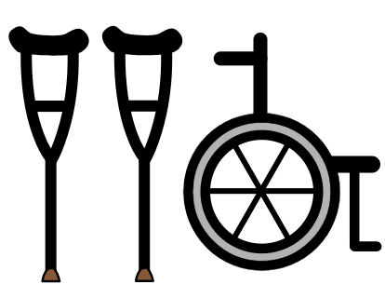

Making sure that people with disabilities get the right support to take part and have their say.

Working with other parts of the United Nations to include people with disabilities.

Some examples of our work:

We made a plan in 2020 about how we will include people with disabilities.

The plan includes work that our senior managers have to do.
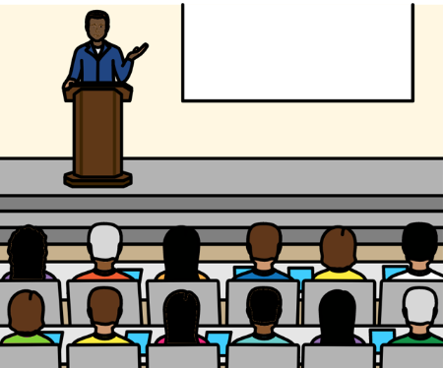

We have senior people in charge of human rights work for the United Nations.

They are doing a lot to support our work about people with disabilities.

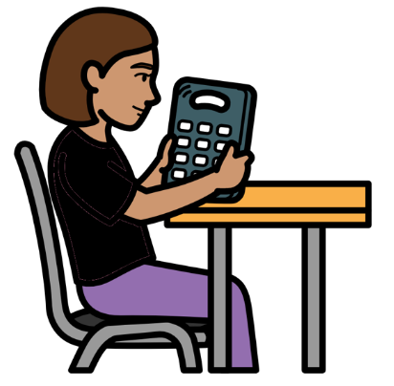

In 2021 we set up a new way to give extra support to people with disabilities if they need it.

For example, people might need equipment or support to travel.

We are checking how this is working.

We have worked a lot with the United Nations and other organizations on the rights of people with disabilities.

For example, we were part of a project about Covid-19 and the rights of people with disabilities.
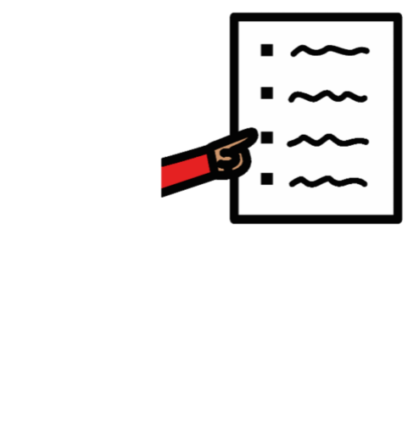
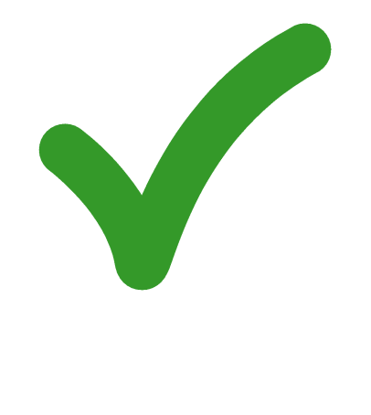
2. We are doing everything we need to on some things

We are doing everything we need to on the areas of work below:
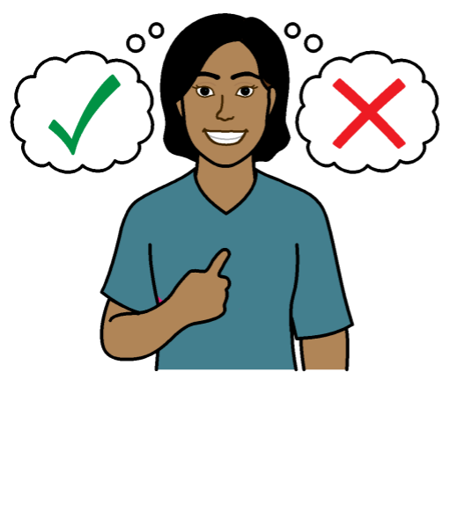

Making sure there are people who know about disability and human rights.

And making sure that people can meet to talk about disability.
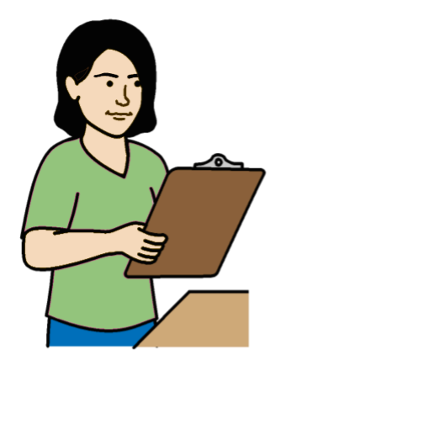

Making sure that people check how projects are working for people with disabilities and their rights.

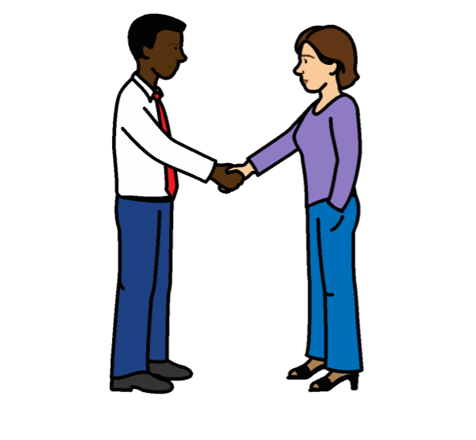
Some examples of our work:

We now have 2 people to make sure that we include people with disabilities in our work.

They work with the United Nations, people with disabilities, governments and other organizations.
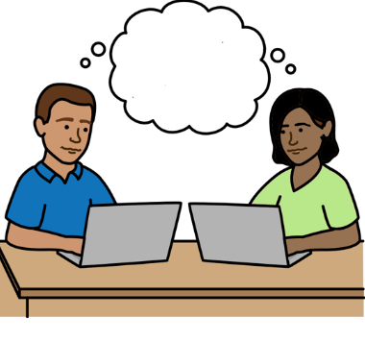
We set up a new way for the United Nations to work together to include people with disabilities.

It means people can share information and training on the rights of people with disabilities.

We will do more work on that in 2022.
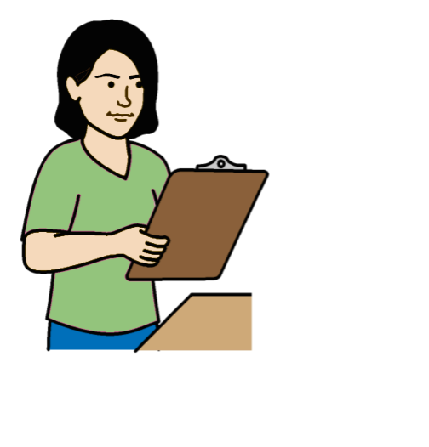

In 2021 we looked at how some of our projects in different countries are working for people with disabilities.

We will check more projects in 2022.

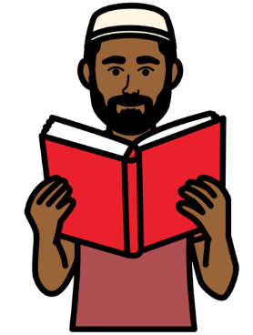

We made some rules about how to check if projects are working for people with disabilities.

The rules will also help other parts of the United Nations to know what to do.

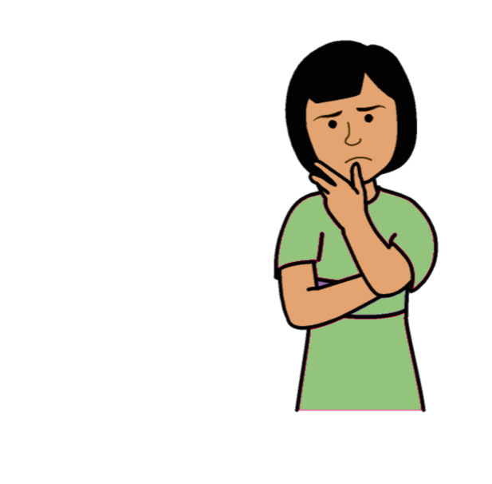
3. We are not doing everything we need to yet on some things

We are not doing everything we need to yet on the areas of work below:

Making sure that the main plan about our work talks about people with disabilities and their rights.
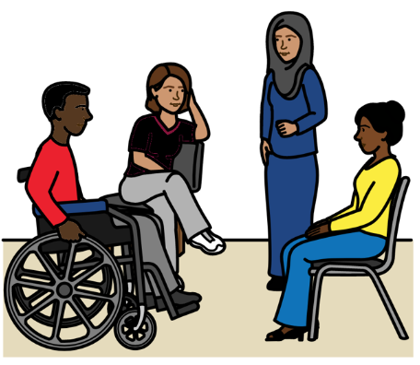

Working with people with disabilities and making sure they can have a say.

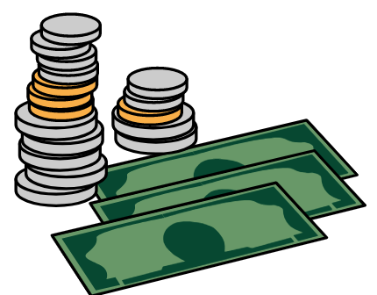

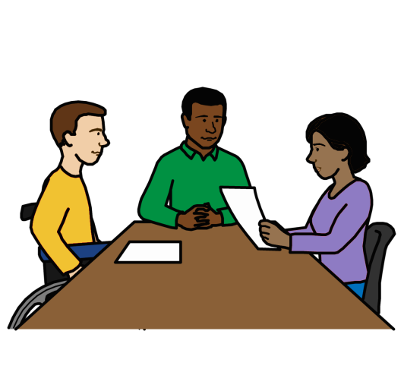
Making sure that new services
and things that we buy work well for people with disabilities.

Helping more people with disabilities to work for the United Nations and do well.
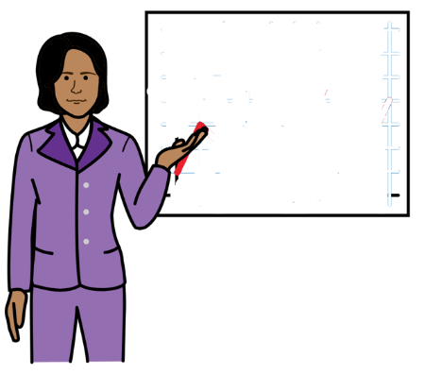

Making sure that staff get information and training about how to include people with disabilities.

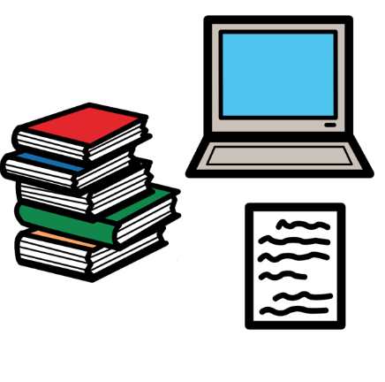
Making sure that the United Nations:

- Talks about people with disabilities in the right way

- Helps people to know about people with disabilities and their rights

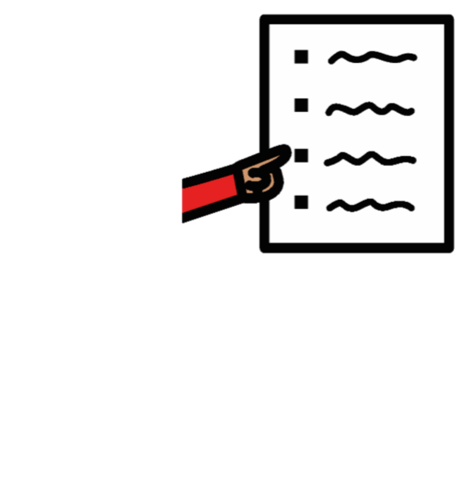
Some examples of our work:

We are looking more closely at the rights of people with disabilities in our work in different countries.

The main plan about our work talks a lot about people with disabilities and their rights.
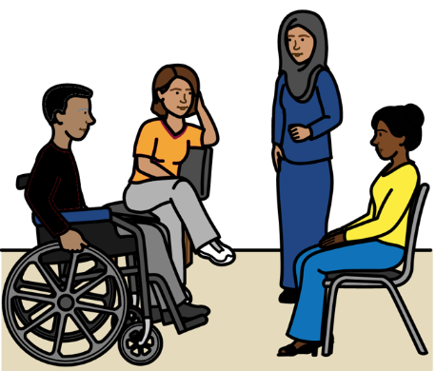

We often work with people with disabilities to find what they think about things to do with disability.

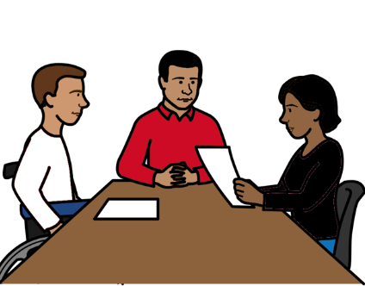

Some staff set up a group to talk about disability in the United Nations.
They are staff with disabilities and staff who support people with disabilities.
Our senior managers met the group to find out what is important to them.
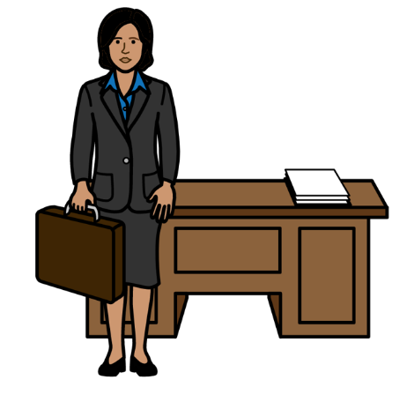
We want many different groups of people to work for us, learn new skills and do well.

That includes people with disabilities.

We will do more on that in 2022.
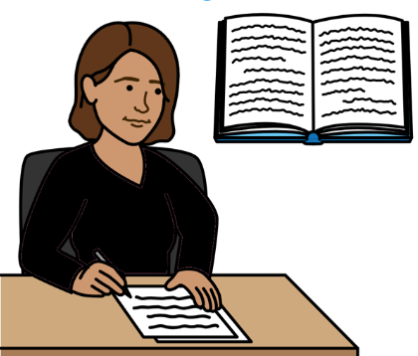

We have a new person to help us know how to include different groups of people.

We also made a new plan about the work we will do on that.

We made some training about the rights of people with disabilities and what organizations need to do.

The training is on our website.

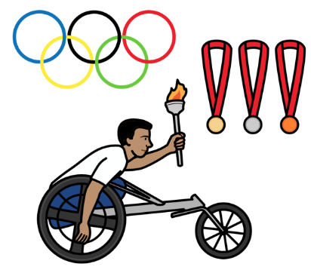
We are working on a project with a big sports organization for people with disabilities.

The project is called We The 15.

The project will help people around the world to know why it is important to include people with disabilities.
But there are more things that we need to do in 2022.
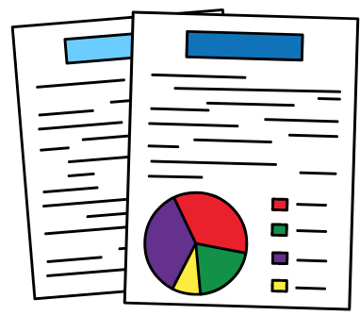

For example:

We will work with other parts of the United Nations to get better information about people with disabilities.
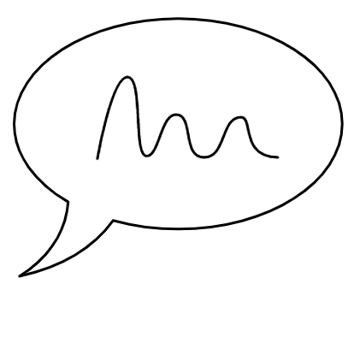
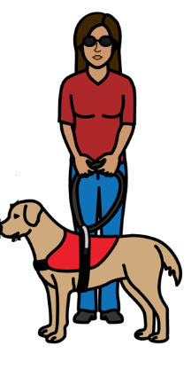

We will find a better way to check how people with disabilities are having a say in our work.

We will look at how to make sure that everything we buy works well for people with disabilities.

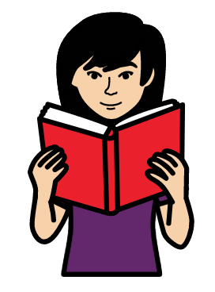

We will give more staff training about how to include people with disabilities.

We will look at the information that we give people.
We will see how to make it better for people with disabilities and their rights.
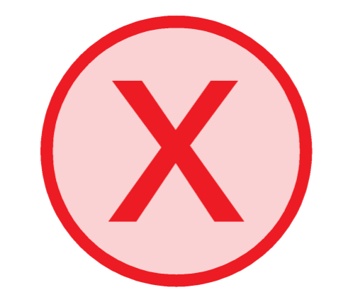
4. We are not doing enough work on some things at the moment

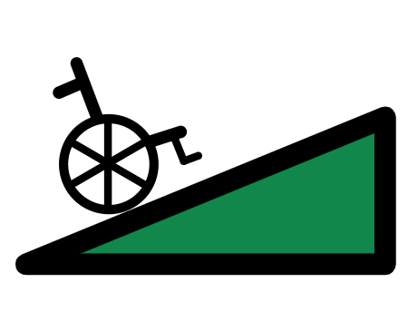
We are not doing enough on the areas of work below:

Making sure that everything is easy for people with disabilities to use and take part in.

Making sure that projects include the rights of people with disabilities and what they need.

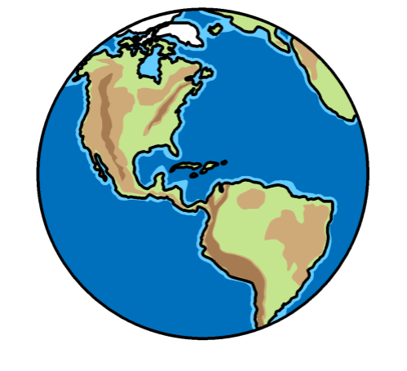

Making sure that we include people with disabilities in our work in different countries.

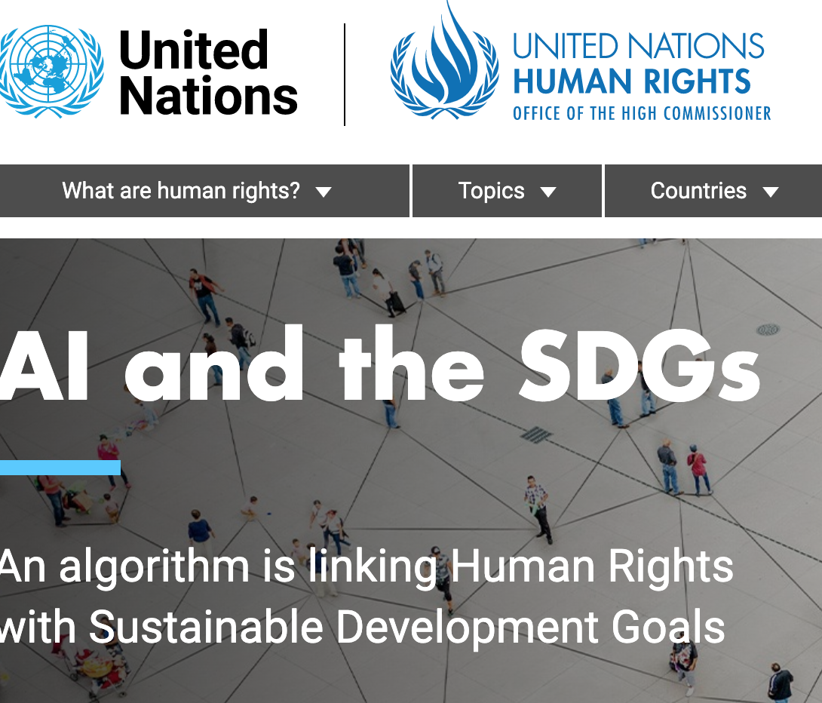
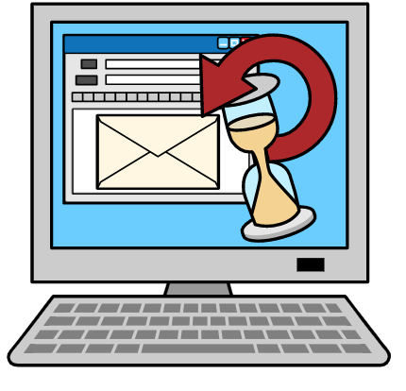
Some examples of our work:

We are making more of our documents easier for people with disabilities to read and understand.

That includes many documents on our website.

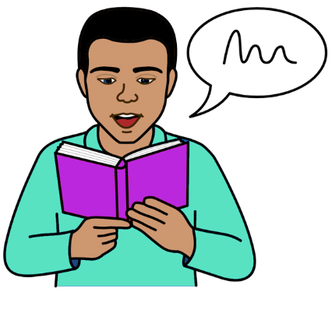

We looked at how we can make more documents easier for people with disabilities to understand.

For example, we looked at how many documents we want to work on. And how much it might cost.

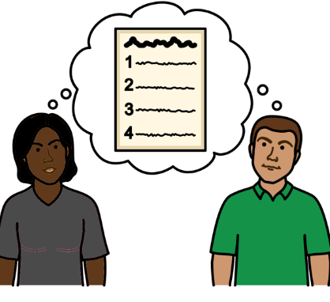

We have a plan about how to make our information easier for people with disabilities to understand.

We check this plan to see what needs to change.

But there are more things that we need to do in 2022.

For example:

We will look at what else we should do to make things easier for people with disabilities to use and take part in.

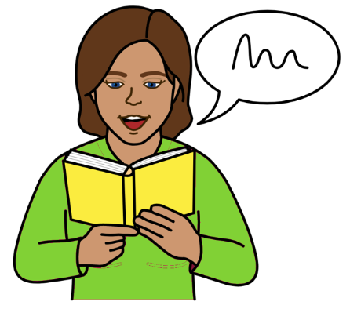

We want to make more documents easier for people with disabilities to understand by the end of 2023.

We will make new rules to make sure that our projects in different countries work well for people with disabilities.

We will work with other parts of the United Nations on the new rules.

Our work on the rights of people with disabilities during Covid-19
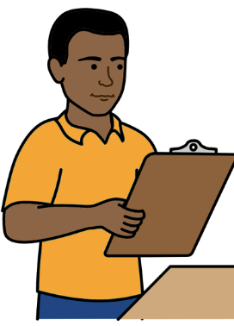
Covid-19 is an illness that many people in the world have been getting.

Some of the main work we have done:

We checked what was happening to people with disabilities and their rights in many countries during Covid-19.
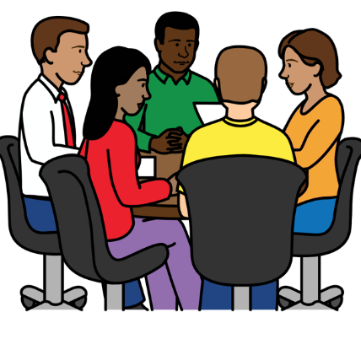

We helped governments and organizations to know about the rights of people with disabilities.

For example, we made some information for governments about what they should do during Covid-19 and after it.

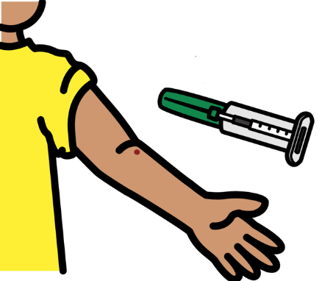
We supported people with disabilities to take part in Covid-19 work.

We are helping more people with disabilities to get vaccines. That will help to keep them safe from Covid-19.
The Picture Communication Symbols ©1981–2016 by Mayer-Johnson LLC a Tobii Dynavox company. All Rights Reserved Worldwide. Thousands of resources available for free at www.boardmakeronline.com

