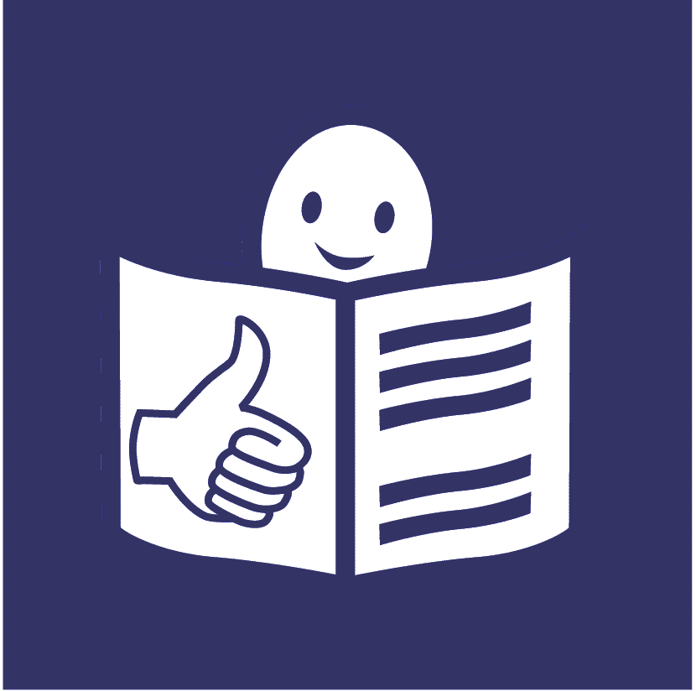
United Nations Human Rights Council
United Nations High Commissioner
for Human Rights

Easy to read

Making support better so that people with disabilities can take part in the community with everyone else
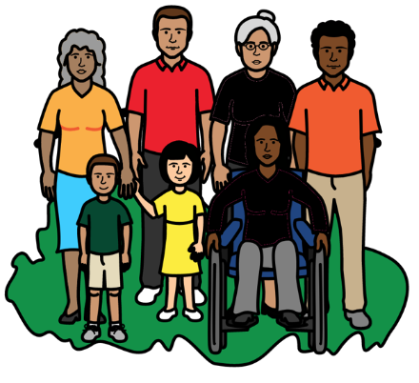

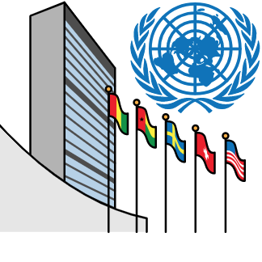
About this report

We are part of the United Nations (UN).

The United Nations is a group of countries that work together to make the world better and safer.
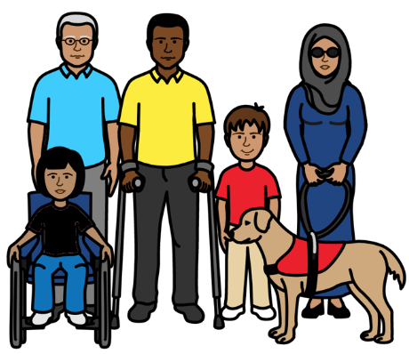

This report is about support that people with disabilities might need to do things every day.
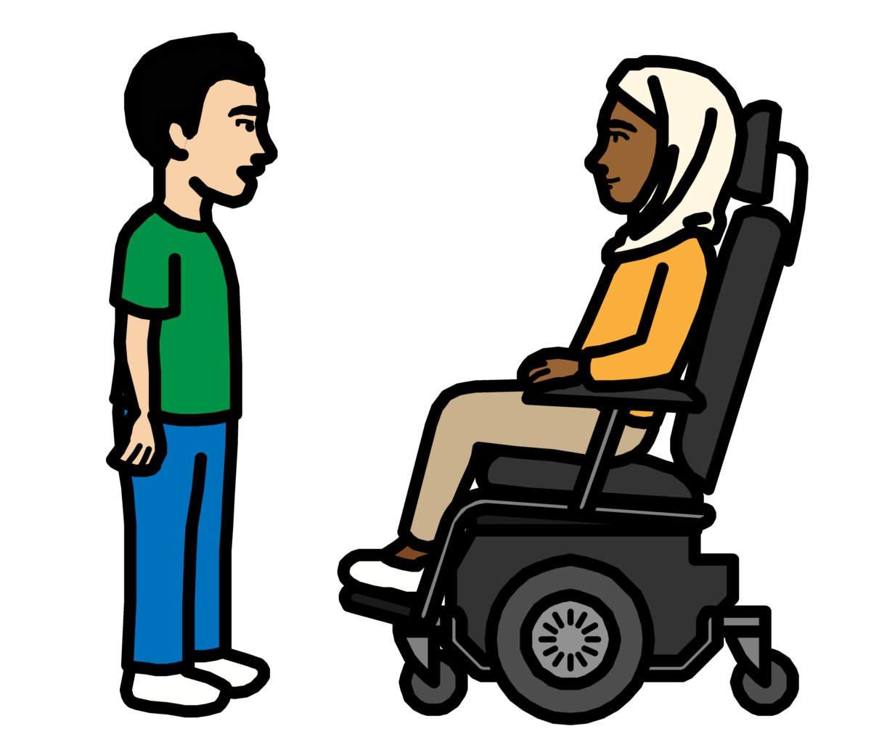

This report is about making support better so that all people with disabilities can take part in the community like everyone else.
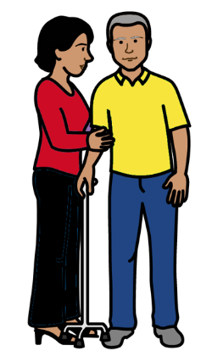

It is also about making sure that people who give support are treated fairly.

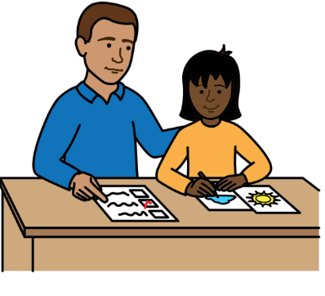
Support is extra help that people with disabilities might need to do things like:
- Live in their own home.
- Make their own choices.
- Go to school, work or other places.
- Understand and share information.
- Have friends, relationships and children.

The support can come from their family, other people or organizations.

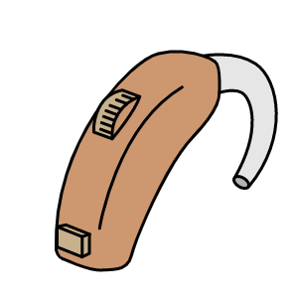

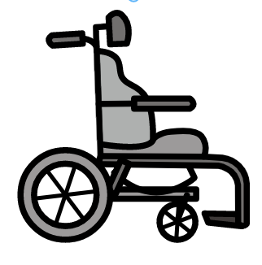

Support could also be equipment to help people with disabilities to take part in things.

Like wheelchairs, glasses or hearing aids.

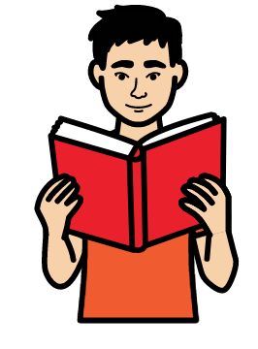

This report looks at:

- Why support is important for people with disabilities and their families.

- How support needs to change to be better for people who get support and people who give support.
Why good support is important for people with disabilities and their families
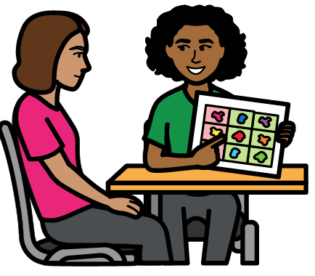

All people with disabilities have the right to take part in the community and make their own choices.

They should get all the support they need to take part.



An important document about the rights of people with disabilities says that.

The document is called the Convention on the Rights of Persons with Disabilities.
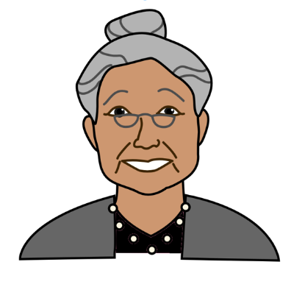

Many countries have promised to do what the document says.

Support is very important to make sure that people with disabilities can take part in the community and have a good life.
Why support for people with disabilities and their families needs to change

Problems with support for people with disabilities
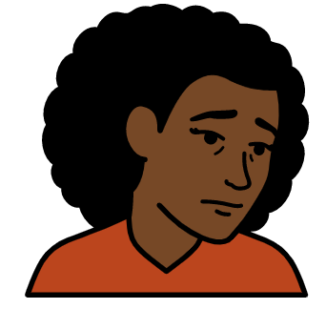

There are big problems with support for people with disabilities at the moment.

For example, there is not enough support for people with disabilities near where they live.

Or the support might not be very good or safe.

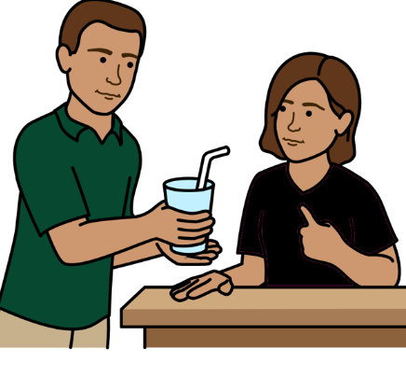
People with disabilities are often just given support.

No one asks them what they want and need.

That means the support they get might be wrong for them.

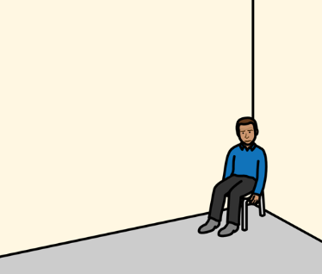
People with disabilities are often taken away from the community to get support.

For example, they might be moved to homes for people with disabilities.

The homes might be far away from their family and friends.

Problems for people who give support


Many countries do not spend enough money on support for people.

And there are not enough support workers with the right skills.

Or the support workers might not get paid much.

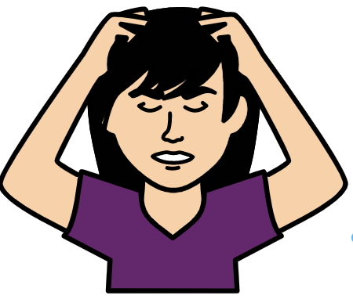

That means many people with disabilities have to get support from their families instead.

But their families often do not get the support or money they need
to care for the person with a disability.
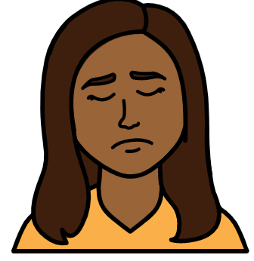
Women and girls give most support to people with disabilities.

They often do not get paid for giving support. Or they do not get paid much.

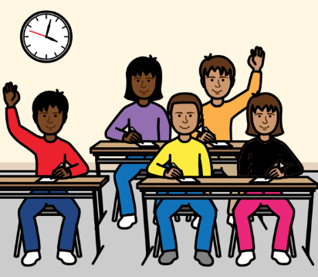


Giving support can also stop women and girls from doing things they want to do.

Like going to school or work.
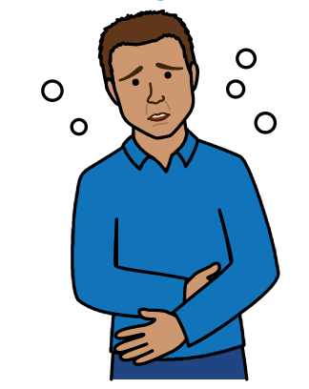

Covid-19 made all these problems worse.

Covid-19 is an illness that many people in the world have been getting.

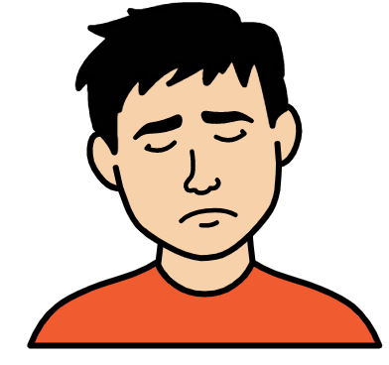
For example, many things stopped during Covid-19.

Like support and health care that people with disabilities usually get.

That made life worse for many people.

Covid-19 has shown people why support needs to change.

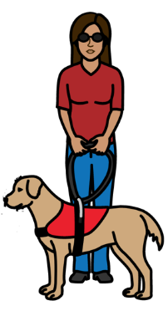
What needs to change to make support better

Many people and organizations have given their ideas about how to change support.

That includes people with disabilities and people who support the rights of women and girls.

It is important that all support now and in the future works well for people with disabilities.

That includes people with disabilities who give support to other people.

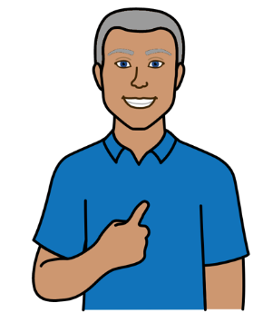

The following things need to happen to make support better:

Make sure that people get their human rights when they get support.

And when they give support.

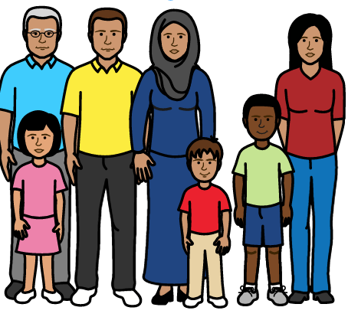
We all have human rights.

Like the right to be treated fairly and to take part in the community.

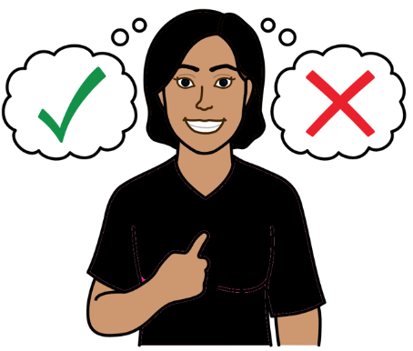

Make sure that people who get support can decide what is best for them.

They should not just be given support.

They should be able to choose what works for them.

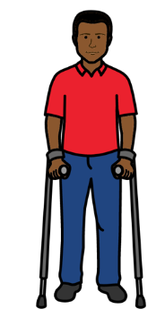

People with disabilities should get the right support all through their lives.

That might include:

- Money to buy the extra things they need for their disability.

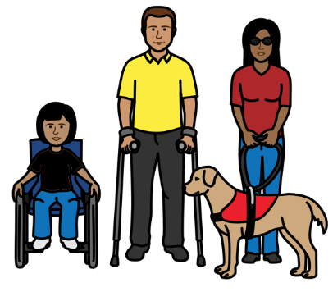
- Wheelchairs, hearing aids and other equipment they need to take part.

- People to support them with living at home, work or other things.

The support should be right for each person with disabilities.
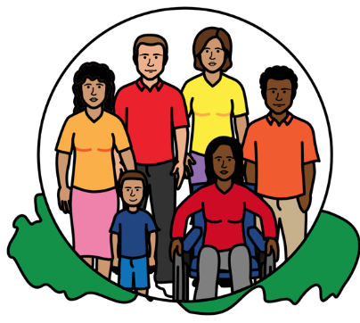
Make sure that support services for everyone work well for people with disabilities.

But there should be support services just for people with disabilities if they need it.

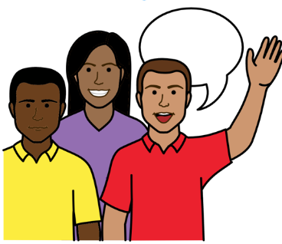

Make sure that everyone knows that support is important.

It should not only be women and girls who give people support.

Many different people and organizations should work together to support people with disabilities.

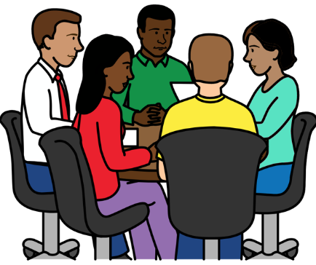
That includes:

- Men, women and families.

- The government and private companies.

- Local people and groups in the community.


Make plans to stop people with disabilities living in homes for people with disabilities.

Spend more money on good support in the community instead.

That will stop many people having to give support for free.

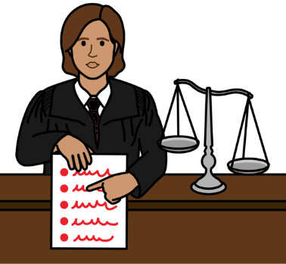

Make good laws and rules that work well for people with disabilities and their families.

That includes laws and rules about support, transport, health, housing and education.

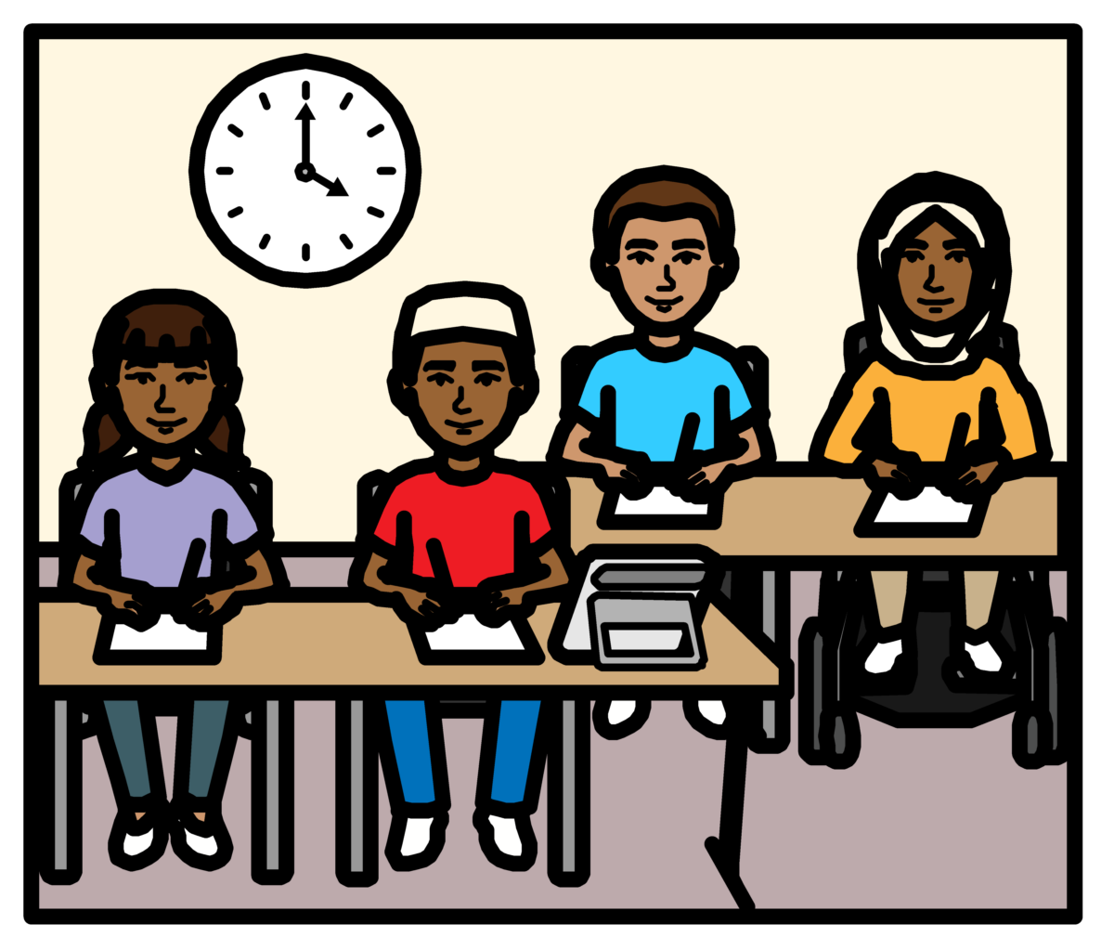
For example, all children with disabilities should be able to go to school.

If they cannot go to school it can stop them from having a good life.

It can also make life worse for the whole family.

For example, the parents might need to stop work to care for their child.

Follow laws in the world about the rights of people with disabilities when making new laws and rules for the country.

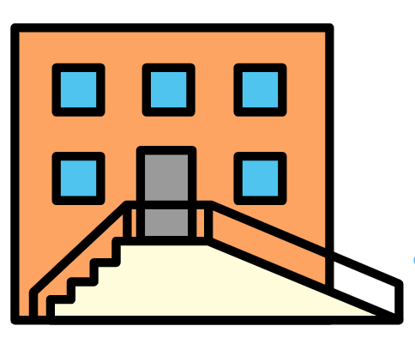
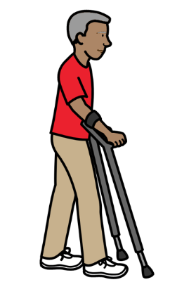
Change other things to make sure that people with disabilities can take part in the community.

For example, make sure that information, buildings and transport are easy to use.

That means people with disabilities might need less support.

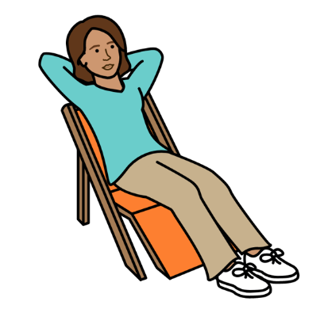

Give more support and training to people who give support for free.

Family members who support a person with a disability might need lots of support.


For example, they might need money or time off from their caring work.

Or they might need to change their working hours to support someone.
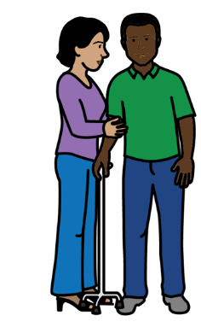
Make sure that people who are paid to give support are treated fairly.

They should be paid fairly and have fair and safe working rules.

That will help more people want to work as support workers.
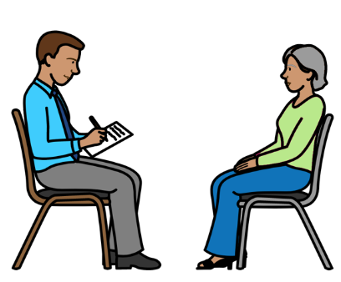

Get better information about the support that different people with disabilities want and need.

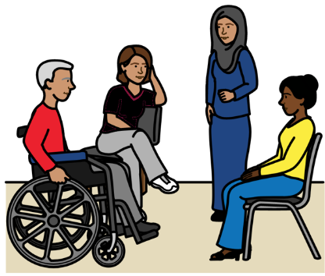

Make sure that people with disabilities and their families can have a real say in decisions about support.

And how the support is working.

That includes children and adults with different disabilities.

Pictures by The Picture Communication Symbols ©1981–2016 by Mayer-Johnson LLC a Tobii Dynavox company. All Rights Reserved Worldwide. Thousands of resources available for free at www.boardmakeronline.com

