United Nations Human Rights Council
United Nations High Commissioner for Human Rights

Climate change and the rights of older people

Climate change is about the earth getting warmer and the problems it causes for people and the planet we live on.

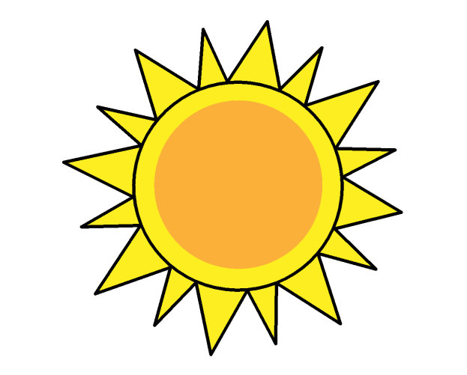

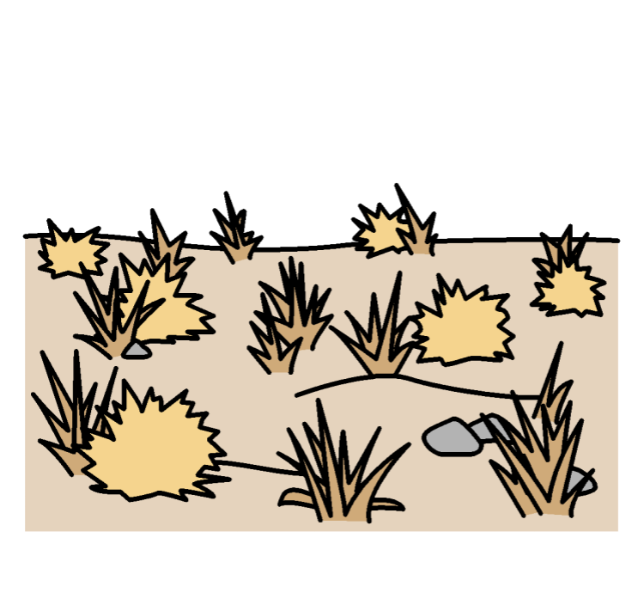
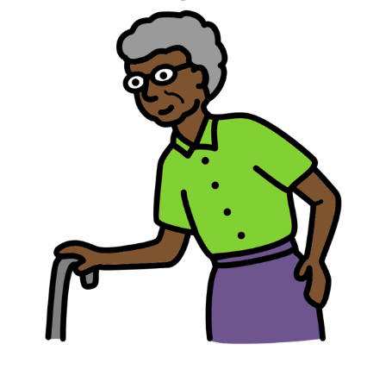


Study on the promotion and protection of the rights of older persons in the context of climate change (A/HRC/47/46)

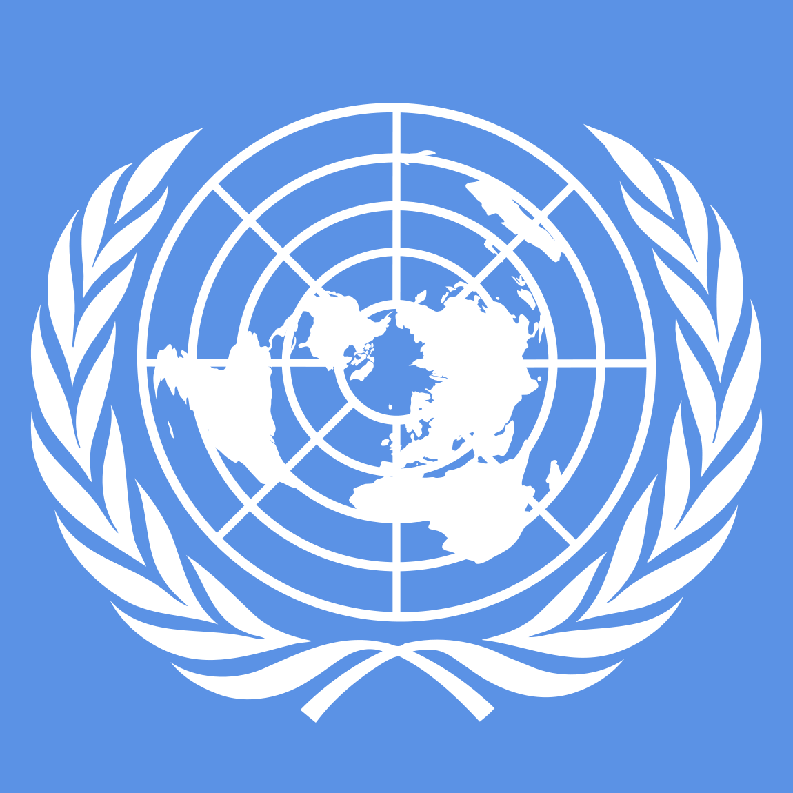
About us

We are called the Office of the High Commissioner for Human Rights.

We are part of the United Nations (UN).
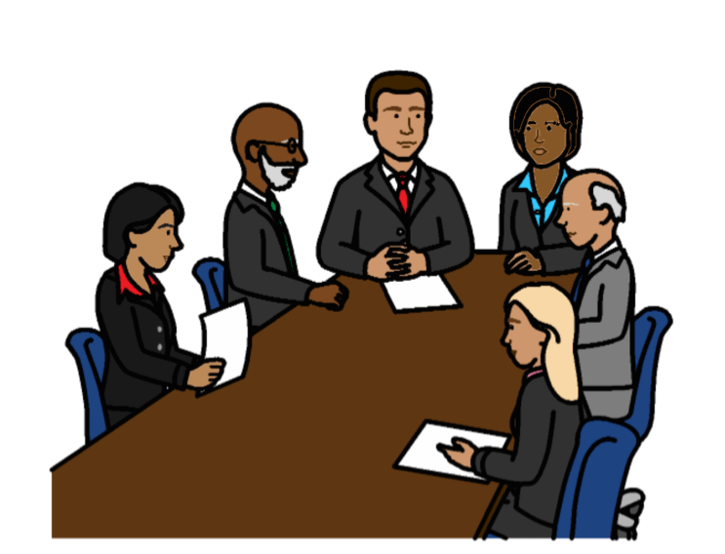

The United Nations is a group of countries that work together to make the world better and safer.

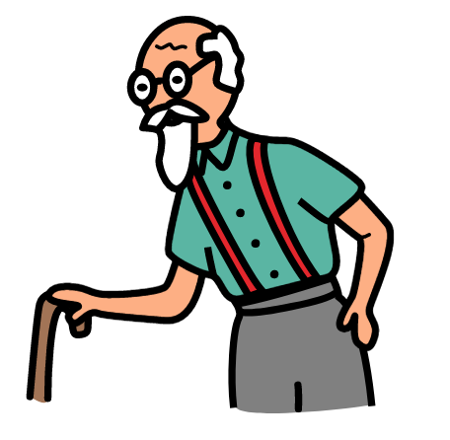
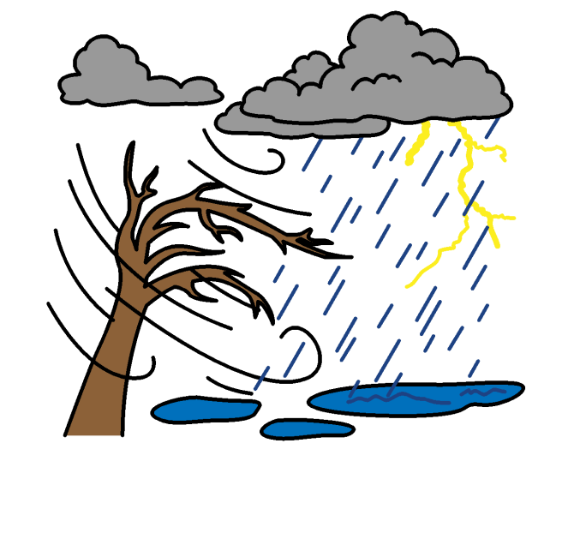
About this report

This report is about climate change and the rights of older people.
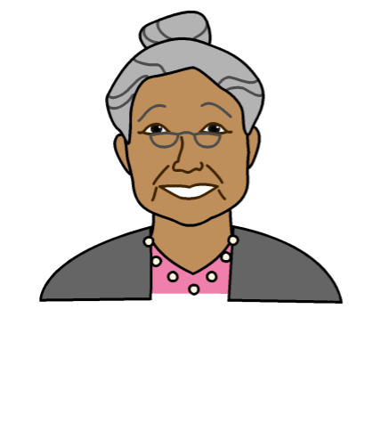

Rights are about what should happen in everyone’s lives.

For example, everyone has the right to be safe and treated fairly.

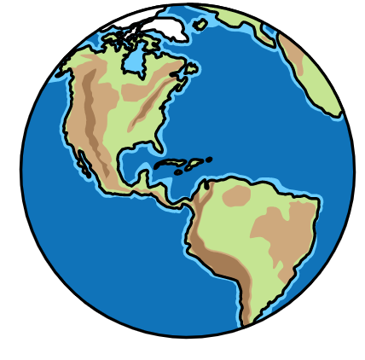
Climate change is about changes to the earth we live on.

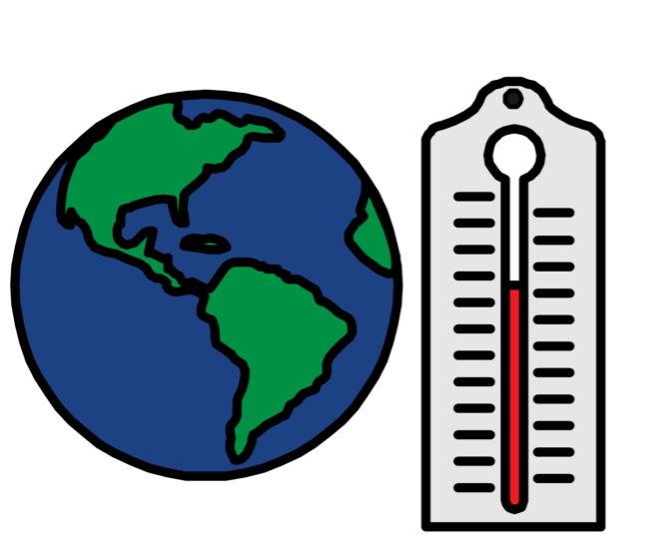

The earth is getting warmer.

This is causing big problems for people and the planet we live on.

For example, climate change can cause:
- Weather problems like floods, too much heat, no rain and bad storms
- Problems for animals and plants


This report is about:
- Problems that climate change is causing for older people and their rights
- What countries and organizations should be doing about it
- Some good work that older people, countries and organizations are doing to fix the problems

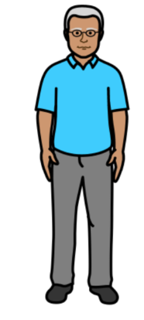
Problems for older people because of climate change

Climate change can cause problems for everyone in the world.

But the problems might be worse for many older people.

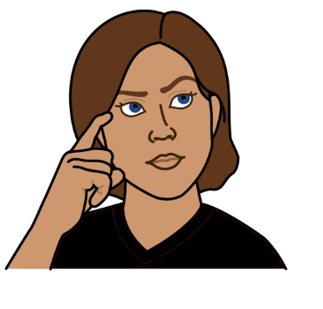
For example:

People often have unfair ideas about older people.

They might think that older people cannot do much or are not very important.

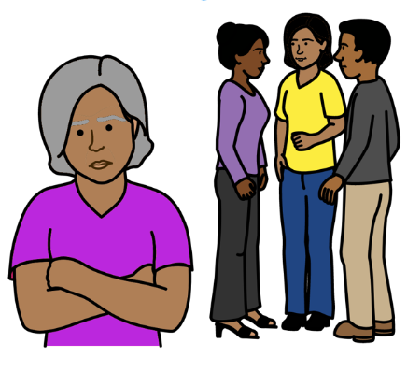

That means that older people are often left out and treated unfairly.

And they might not get the support they need.

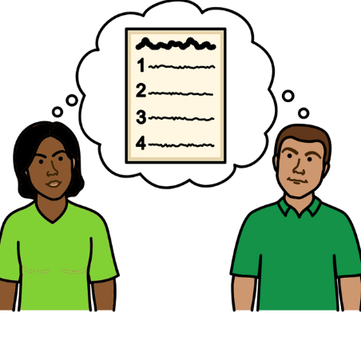
Life might get worse for many older people because of climate change.

For example, older people are often left out of laws and plans about climate change.
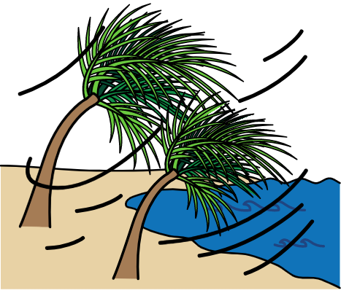

This includes plans about what to do when there are big problems like floods and bad storms.

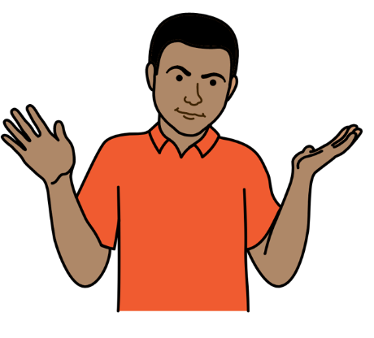

People might not think about what older people need.

That is a problem because climate change can make life very hard for older people.

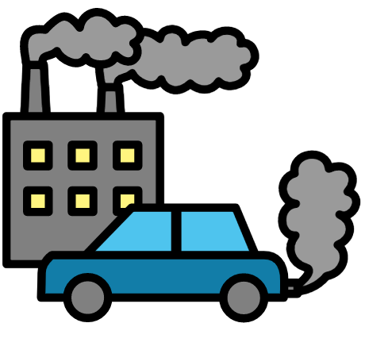
For example:

Climate change might cause big health problems for some older people.

Older people can get very ill from too much heat, cold weather or dirty air.
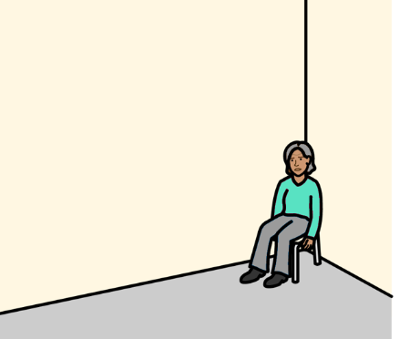
Some health care and support might have to stop during climate change problems.

That means older people might be left without the care and support they need.

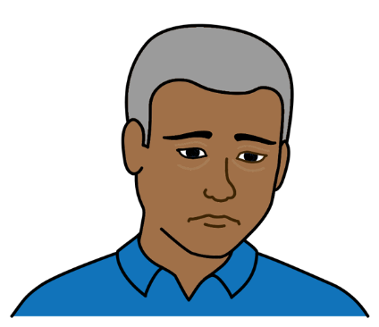

Many older people might feel lonely, worried or sad because of climate change.

For example, it might take them longer to feel better after floods or other climate change problems.

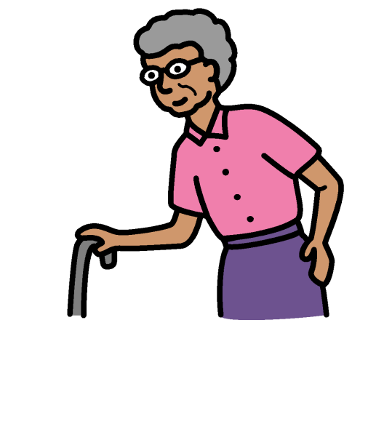

Many older people might be unsafe when there are climate change problems.

For example, many older people find it hard to move around or use transport.

It might be hard for them to leave quickly if they are in danger.


Older people might not get the right information about what is happening and how to be safe.

For example, some older people might not know how to use the internet or mobile phones to get information.

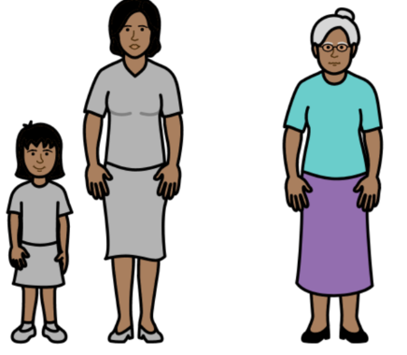
It might be hard for older people to leave their homes if there are big climate change problems.

Their homes and lands might be very important to them to live and be happy.

And they might not have the same family, support or money where they move to.

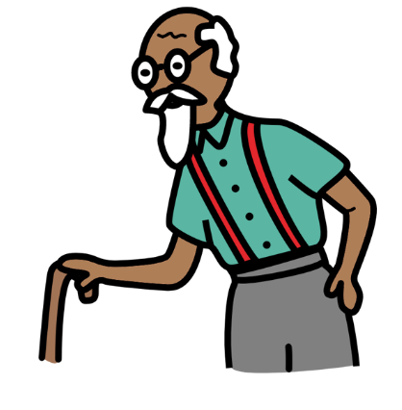
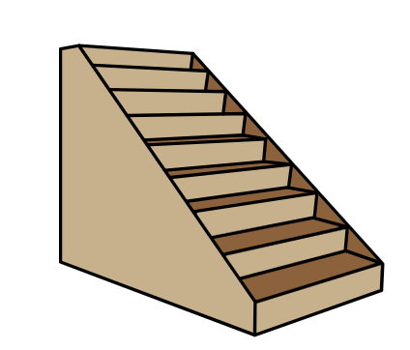

There might be safe places for people to stay in an emergency.

But the places might not be easy for older people to get to and stay in.

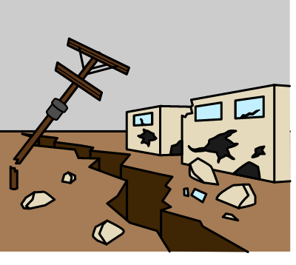
It might be hard for older people to get back home after an emergency.

For example, many older people cannot get the right help or money if their homes need fixing.

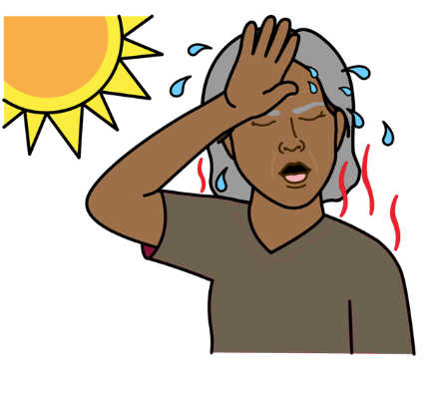

Housing can also be a problem for older people because of climate change.

For example, they might not have cold air for very hot weather.

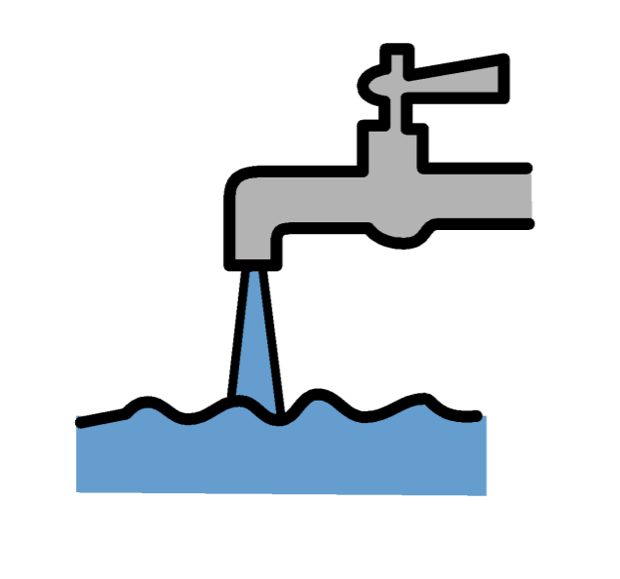

Climate change is causing food and water problems for many people in the world.

For example, some foods might not grow any more because of weather changes.


This can make life very hard for older people.

For example:

Many older people are poor.

They might find it hard to buy food if the cost of food goes up.

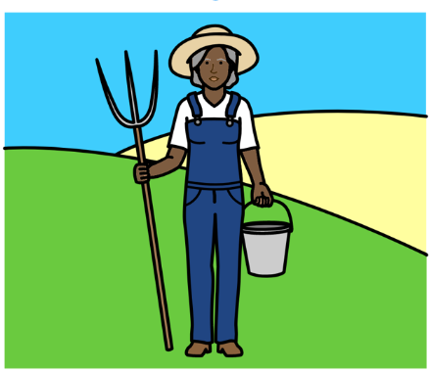

Many older people still have to work.

For example, many older people grow food to earn money.

But their work might have to stop because of climate change.

And they might not get support to find other ways to earn money.

Older people might find it hard to get to food and water places in an emergency.

All these problems can be worse for some older people. For example, older women and older people with disabilities.

What countries and organizations should be doing
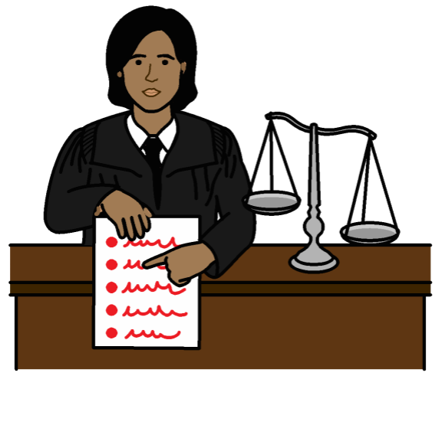

Older people have the same human rights as everyone else.

Countries should follow laws and rules in the world about human rights when they work on climate change.



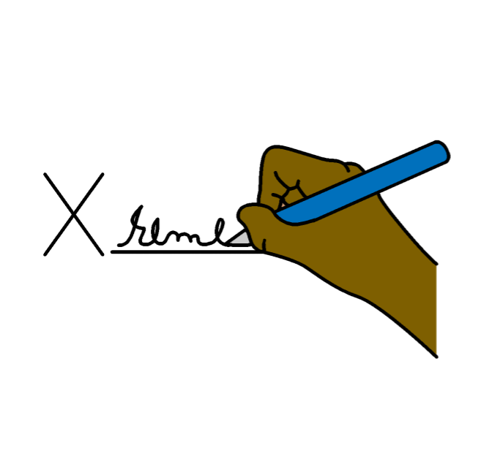
There should be better laws and rules about the rights of older people.

For example, countries could make an agreement together just about the rights of older people.

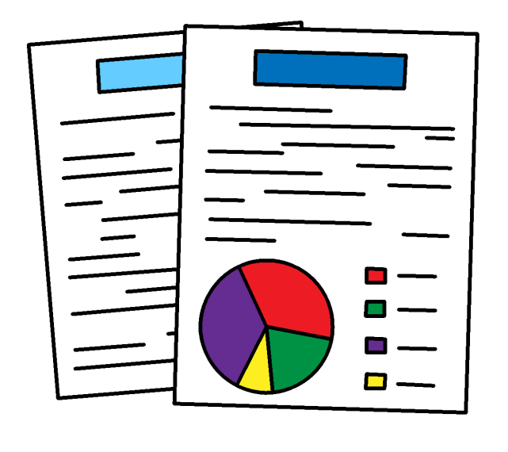
There is no agreement like this at the moment.

Countries should get good information about climate change problems for older people.
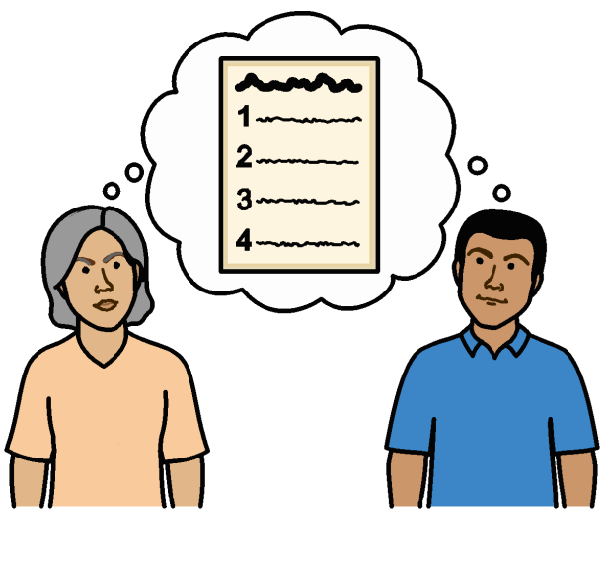
Countries should work straight away to stop climate change getting worse.

For example, by making better plans and working hard to stop climate change.

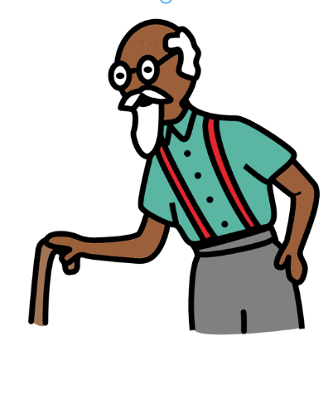

Plans about climate change should work well for all older people.

For example, older women and older people with disabilities.

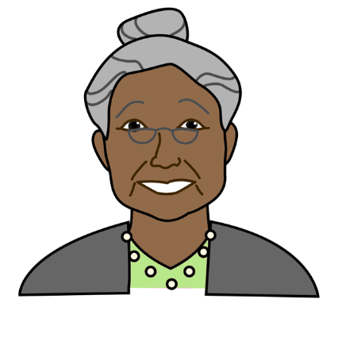


Many older people are already doing important work on climate change.

They have important skills that can help with climate change work.

For example:
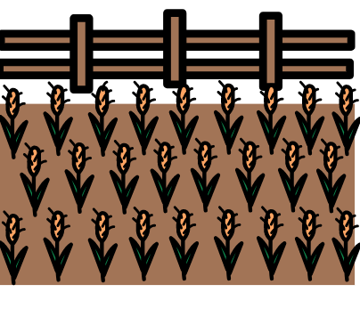
- Older people might know a lot about the local area and how things work.

- Older people might have good ideas about climate change.
For example, how to grow food in a better way. Or how to cope in an emergency.
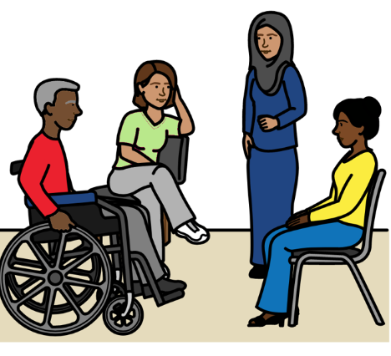
Countries must listen to older people.

They must support older people to take part in climate change work and have their say.

For example, it is good for older people to work with people of all ages on climate change projects.
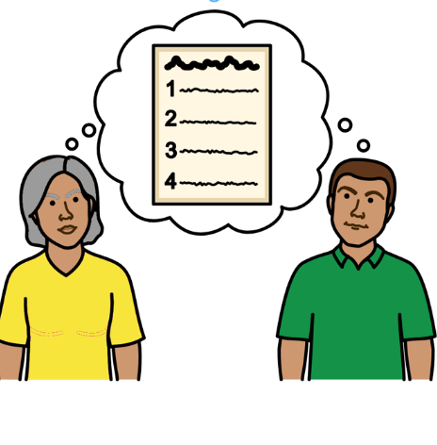

Countries should work with older people on laws and plans about climate change.

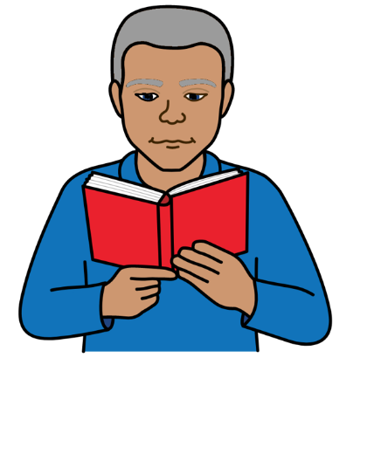
Countries should make sure that older people get everything they need to do with climate change.

For example:
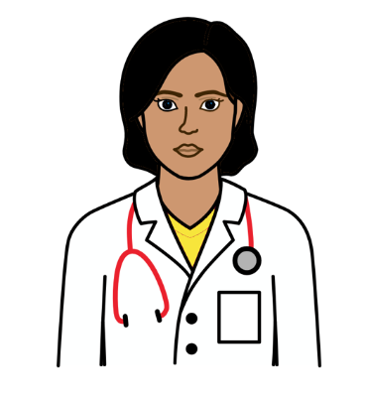
- Good information about climate change and how to keep safe
- Good healthcare
- The right support
- Enough money to live on
- Training and support to earn money if they need it


Some good work that countries and organizations have done on climate change

Finland, Slovakia, Switzerland, Bangladesh and Mexico have climate change plans that include older people.
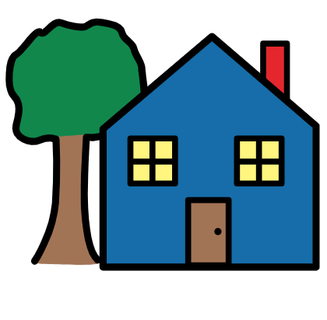

Organizations in Cambodia, El Salvador, Nicaragua, the Philippines and Bangladesh are making plans about what older people need in an emergency.
.

Iraq and Mexico are helping older people to get important information about climate change.

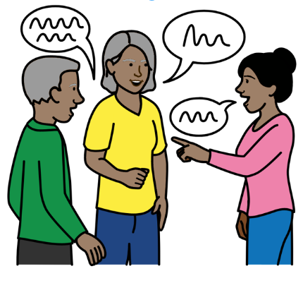

Cambodia has helped older people to get together and speak up about things like climate change.

Countries must do more to stop climate change. They should make sure that older people are part of that work.
Pictures by The Picture Communication Symbols ©1981–2016 by Mayer-Johnson LLC a Tobii Dynavox company. All Rights Reserved Worldwide. Thousands of resources available for free at www.boardmakeronline.com
Document checked by Hackney People First. © European Easy-to-Read Logo: Inclusion Europe. More information at www.easy-to-read.eu.

