Day of general discussion
on “the rights of indigenous women and girls”

Australian Human Rights Commission

Submission to the Committee on the
Elimination of Discrimination against Women (CEDAW)
18 June 2021

Contents

Australian Human Rights Commission 2
Submission to the Committee on the Elimination of Discrimination against Women (CEDAW) 2
1 Introduction 3
2 The Wiyi Yani U Thangani (Women’s Voices) Project 4
2.1 Background and overview 4
2.2 Signposting key parts of the Report 6
3 Rights of Indigenous women and girls 7
3.1 Ensuring an intersectional approach to equality and non-discrimination 7
3.2 Enhancing First Nations women and girls’ leadership and participation in decision-making 8
4 The need for structural change 10
4.1 First Nations gender justice and equality 10
4.2 Developing a National Action Plan to protect the rights of Australia’s First Nations women and girls 11
5 Recommendations 12

Introduction
- The Australian Human Rights Commission (the Commission) is Australia’s ‘A status’ national human rights institution established and operating in full compliance with the Paris Principles. Information about the Commission can be found at: www.humanrights.gov.au.
- The Commission welcomes the opportunity to provide this submission to the day of general discussion on “the rights of the indigenous women and girls” held by the Committee on the Elimination of Discrimination Against Women (CEDAW).
- This submission specifically addresses the two thematic focus areas of the discussion:
  - the need for an intersectional, strengths-based approach in addressing discrimination and inequality; and
  - the need to enhance women and girls’ leadership and participation in decision-making.
- It also outlines the need for structural change to ensure the rights of First Nations women and girls are realised.
- In doing so, this submission highlights the key findings of the Commission’s recent national engagements with Australia’s First Nations women and girls—the Wiyi Yani U Thangani (Women’s Voices) Project—and signposts parts of the Wiyi Yani U Thangani (Women’s Voices): Securing our Rights, Securing our Future 2020 Report (the Report) that address the issues raised in the concept note for the general discussion on the rights of indigenous women and girls (the concept note).
- In making this submission, the Commission aims to raise awareness within the international human rights community—and amongst its indigenous representative in particular—of the Wiyi Yani U Thangani Project as a model for elevating the voices of First Nations women, and of the Report as both a rich source of information providing a First Nations gender-lens to a broad range of issues and policy areas, and as a First Nations female-lead roadmap for structural change.

The Wiyi Yani U Thangani (Women’s Voices) Project

Background and overview
- The Wiyi Yani U Thangani (Women's Voices) Project is a multi-year initiative led by the Aboriginal and Torres Strait Islander Social Justice Commissioner, June Oscar AO. The aim of the project has been to recognise the rights and lives of Aboriginal and Torres Strait Islander women and girls, and to elevate their voices to the spaces of decision-making. Through Wiyi Yani U Thangani, Australia’s First Nations women have been heard as a collective for the first time in over 34 years.
- Throughout 2018, Commissioner Oscar and her team travelled to 50 locations in urban, regional and remote areas across every state and territory. They conducted 106 engagements and met with 2,294 women of all ages, including senior elders, girls from 12 to 17 years of age, women in prison and Lesbian, Gay, Bisexual, Transgender, Queer or Questioning, Intersex, Asexual, Sistergirl and Brotherboy (LGBTQIA+SB). Over 100 submissions and 300 survey responses were also received.
- The Report—which was tabled in the federal Parliament in December 2020—captures what women and girls consider to be their key strengths and concerns, what principles they think ought to be enshrined in the design of policies, programs and services, and what measure they recommend ought to be taken to effectively promote the enjoyment of their human rights into the future.
- The Report sets out a comprehensive plan for structural reform including seven overarching recommendations to address the systemic issues that apply across all aspects of First Nations women and girls lives. Also included are four pathways forward corresponding to each of the Report’s Parts (Supporting strong families and communities, Living and belonging, Healthy and engaged lives, Thriving communities and sustainable economies). These traverse all areas of life from land and country to justice, health, employment and many others.
- Wiyi Yani U Thangani has been guided by key international human rights instruments including the International Covenant on Economic, Social and Cultural Rights (ICESCR), The International Covenant on Civil and Political Rights (ICCPR), CEDAW, the International Convention on All Forms of Racial Discrimination (ICERD), the Convention on the Rights of Persons with Disability (CRPD), the United Nations Convention on the Rights of the Child (UNCROC). And the United Nations Declaration on the Rights of Indigenous Peoples (UNDRIP).
- Underpinning the Report throughout are the following foundational principles which have been drawn from UNDRIP:
- Self-determination: to shape their own lives, including their economic, social, cultural and political futures.
- Participation in decision-making: in matters that affect their rights and through representatives they choose.
- Respect for and protection of culture: to maintain, protect and practise their cultural traditions and cultural heritage. This includes protecting their integrity as distinct cultural peoples, their cultural values, intellectual property and indigenous languages.
- Equality and non-discrimination: to enjoy their human rights without discrimination from individuals, governments and/or external stakeholders.
- Wiyi Yani U Thangani has taken an intersectional approach that recognises that indigenous women and girls experience their human rights, including violations of their rights, in ways that are very different to indigenous men and boys.
- Wiyi Yani U Thangani has taken a strengths-based and grounded-theory approach. There was no set agenda or imposed framework for each engagement and women and girls were encouraged to set the tone and determine the conversation on their terms.
- The Wiyi Yani U Thangani project has provided a platform for First Nations women and girls in Australia to be heard as a collective, many of whose voices are often excluded and ignored. It is worth acknowledging the power of such a process in the empowerment of First Nations women and girls. Since the Report has been published, First Nations women and girls around Australia are organising and gathering, using Wiyi Yani U Thangani as a tool to organise and represent themselves effectively and to demand action from governments.

Signposting key parts of the Report
- The Report is an extensive whole-of-life report that reflects the holistic and interrelated nature of the lives of First Nations women and girls. The Report spans five thematic parts, each with a number of chapters intended to be read in context of one another. Each part details many of the issues raised in the concept note.
- Part One sets out the major themes (Chapter 3) that emerged from the stories of women and girls taken together including the following issues included in the concept note:
- self-determination
- fundamental importance of culture
- intersectional discrimination
- representation.
- Part One also sets out a comprehensive ‘Way Forward’ reform agenda for structural change to address the systemic issues raised throughout the Report. It outlines the principles to guide reform and several overarching recommendations (Attachment A).
- Part Two details the lived experience of women and girls across community safety (chapter 5), law and justice (chapter 6), and child protection (chapter 7) including key issues featuring in the concept note, such as:
- access to justice and equality before the law
- indigenous women in detention
- life free of violence
- Part Three discusses service delivery (chapter 8), housing (chapter 9), disability (chapter 10) and land & country (chapter 11), including the following issues which were covered in the concept note:
- land rights
- cultural rights
- indigenous women and natural disasters and climate change
- Part Four highlights key issues across health (chapter 12), social and emotional wellbeing (chapter 13), and education (chapter 14) which relate to economic, social and cultural rights as raised in the concept note.
- Part Five details women and girls’ engagements with employment (chapter 15) and economic participation (chapter 16), also relevant to economic, social and cultural rights as raised in the concept note.
- Each part sets out a comprehensive ‘Pathway Forward’ with priority actions to address each area.

Rights of Indigenous women and girls

Ensuring an intersectional approach to equality and non-discrimination
- Indigenous women globally have long been a part of advocating for and informing how their rights should be understood and realised. They played an active part in the negotiations to form the Beijing Declaration and Platform to Action (BDPA), Women’s Empowerment Principles (WEPs), CEDAW, the Sustainable Development Goals (SDGs) and the UNDRIP.
- Whilst existing international instruments provide a comprehensive framework for the protection and promotion of the rights of indigenous peoples and of women, there is increasing recognition of the intersectional obstacles faced by indigenous women in securing and realising their rights.
- The 2017 CEDAW Recommendation 35 explicitly references indigenous women as disproportionately impacted by discrimination because of factors marking their identity. It states: … because women experience varying and intersecting forms of discrimination, which have an aggravating negative impact, the Committee acknowledges that gender-based violence may affect some women to different degrees, or in different ways, meaning that appropriate legal and policy responses are needed.
- Despite the international architecture for gender equality-related policy and mechanisms, many states including Australia remain on the backfoot in translating these rights into structures, policies and processes that are responsive to the distinct needs of indigenous women and girls, and which address the gendered dimensions of racism.
- While intersectional discrimination is not a term used frequently by Aboriginal and Torres Strait Islander peoples, the experiences that define intersectional discrimination were described at every Wiyi Yani U Thangani engagement across the country.

Enhancing First Nations women and girls’ leadership and participation in decision-making
- Australia’s governments and institutions have consistently struggled to engage meaningfully with First Nations peoples. First Nations women in particular remain one of the most marginalised and politically disenfranchised groups in Australia. This has fundamentally undermined the lives and rights of First Nations women and girls as the structures built to enable and support them are being designed without them in mind.
- In Wiyi Yani U Thangani, women and girls described how this lack of recognition and marginalisation of their voices traps women, girls and their families in conditions of poverty and powerlessness making them increasingly vulnerable to harm and entrenches intergenerational trauma and inequality.
- The pressing need for Australian First Nations women and girls’ voices be heard about matters that affect their lives is evident in the facts below which are the result of ongoing policy failure:
- Three out of five Aboriginal and Torres Strait Islander women have experienced physical or sexual violence and are 3.1 times more likely to experience violence than non-Indigenous women.
- Aboriginal and Torres Strait Islander women are the fastest growing prison population and are 21.2 times more likely to be incarcerated than non-Indigenous women.
- Aboriginal and Torres Strait Islander women in prison are often victims of violence or abuse, have a disability or be homeless.
- Aboriginal and Torres Strait Islander people are 10 times more likely to be homeless and 19% of Aboriginal and Torres Strait Islander clients of homelessness services report family violence as the reason for accessing the service.
- Aboriginal and Torres Strait Islander women experience anxiety and depression at higher rates than Aboriginal and Torres Strait Islander men, and are more likely to be caring for children and family with 30% of Aboriginal and Torres Strait Islander women caring for someone in need either with disability, a chronic health condition or old age.
- Effective representation and self-determination for Australian First Nations women and girls is critical to overcoming this disadvantage. Throughout the Wiyi Yani U Thangani engagements, women and girls were clear: they have the skills, knowledges and lived experiences to overcome the economic, social and environmental injustices, to heal their families and communities from transmitted trauma, and to address the structural inequalities that trap them in cycles of crisis and harm. Women and girls need to be empowered and supported to do so.
- A key principle of Wiyi Yani U Thangani is that when measures are designed to enhance the enjoyment of human rights by First Nations women and girls, entire communities benefit. When First Nations women are represented, empowered to participate in decision-making and their leadership is embraced, we see more effective, productive and fair laws, policies and programs.
- Wiyi Yani U Thangani identified that a fundamental shift in the way the voices of First Nations women and girls are heard, represented, respected and empowered is needed. First Nations women and girls are calling on all Australian governments to guarantee their participation in the decisions that affect their lives and to invest in their empowerment.
- Throughout Wiyi Yani U Thangani, women and girls described a number of obstacles to their effective representation and participation including the historic privileging of male voices which means their distinct lived experience is conflated with those of First Nations men. Women also described the overwhelming amount of work in looking after families and communities prevents them from coming together and participating. For those able to organise through various structures such as women’s groups or councils, many identified a significant lack of recognition, funding and support—preventing them from establishing a strong presence to be heard and the mechanisms to hold government to account.

The need for structural change
- Wiyi Yani U Thangani provides the evidence that the inequalities experienced by First Nations women and girls are perpetuated and entrenched by mainstream systems and structures that have marginalised the voices of First Nations women and girls for generations.
- A consistent message throughout Wiyi Yani U Thangani is that large-scale structural change and systemic reform is needed to combat and overcome these inequalities.
- This response must take a specific and gendered human-rights based approach. The Wiyi Yani U Thangani project, in its implementation phase of work is defining this as the need to embed First Nations gender justice and equality.

First Nations gender justice and equality
- First Nations gender justice and equality is about centering those who experience intersectional marginalisation in terms of gender, race and other identity markers to achieve justice across all areas of life. It is about the full self-determination and realisation of the rights of First Nations women and girls and ensuring they are equally valued and respected to those of all other peoples in society are not obscured by the rights of others including Indigenous men and non-Indigenous women.
- A First Nations gender justice and equality approach recognises the importance of ensuring the identities of First Nations women and girls are respected and valued in all justice movements from health, to social, economic and land movements. It acknowledges that when justice and equality is guaranteed for First Nations women and girls, all of society benefits—men, women and children.
- As mentioned earlier in this submission, while international human rights instruments provide comprehensive frameworks for the promotion and protection of the rights of Indigenous peoples and of women and girls, for too long there has been a lack of emphasis on the distinct needs of Indigenous women and girls, particularly at the level of implementation by states.

Developing a National Action Plan to protect the rights of Australia’s First Nations women and girls
- Australia does not currently have a nationally consistent or coherent approach to responding to First Nations women and girls, nor the national mechanisms in place to measure and achieve the many dimensions of gender justice and equality.
- For example, of fourteen national policy frameworks that address First Nations and/or gender-based disadvantage either as core elements or as important focus areas, ten explicitly reference gender equality, three define gender, and only two—the Fourth National Action Plan to Reduce Violence Against Women and their Children and the National Action Plan: Women, Peace and Security—define gender equality in full. Nevertheless, both these definitions conflate gender with sex and neither acknowledge conceptions of gender framed around First Nations identities and values.
- It is for this reason that Wiyi Yani U Thangani recommends the development of a National First Nations Women and Girls Action Plan, to be developed at a National Summit and supported by a National First Nations women and girls Advisory Body:
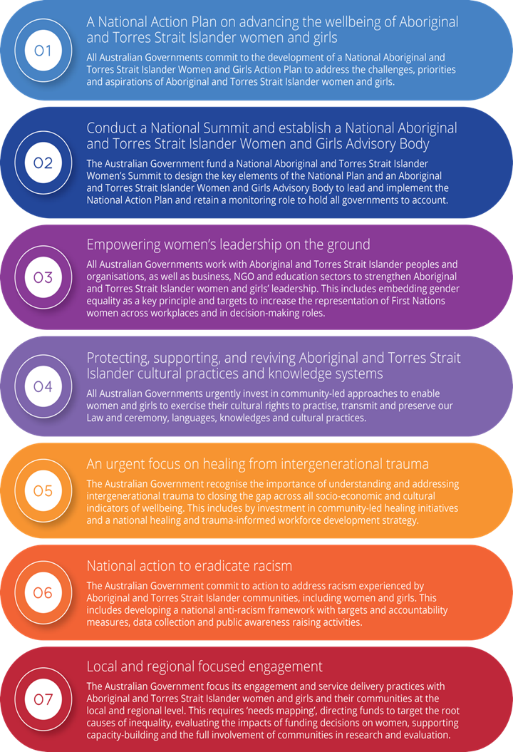

- The National Action Plan will take a gender mainstreaming approach as highlighted by the UN and the OECD through:
‘...the (re)organisation, improvement, development and evaluation of policy processes, so that a gender equality perspective is incorporated in all policies at all levels and at all stages.’
- The goal of this National Action Plan will be to progress First Nations gender justice and equality and to enable a consistent and holistic approach to responding to the rights, needs and aspirations of indigenous women and girls in Australia.

Recommendations
The Commission recommends that:
- the CEDAW Committee and all states consider the findings and recommendations of Wiyi Yani U Thangani, including the proposed National Action Plan model, when designing international and national measures to promote the rights of indigenous women and girls.
- all measures to promote the rights of indigenous women and girls be co-designed with them to ensure that policies, programs and the delivery of services are informed by their distinct experiences and tailored to meet their distinct needs and aspirations.
- all states work with indigenous women and girls within their jurisdictions to support their leadership through measures which embed gender equality, invest in capacity building, and ensure indigenous women and girls’ participation and representation in decision-making at all levels.
- all states invest in and ensure and enabling environment for indigenous women and girls within their jurisdictions to exercise their cultural rights to practice and transmit traditional knowledge, ensuring the expression and continuation of law, language, knowledge and cultural practices.
- all states recognise the importance of and invest in healing from intergenerational trauma for indigenous women and girls and their families within their jurisdictions.
- all states consider the development of national frameworks to promote anti-racism and the inclusion within these frameworks of specific measures to address the intersectional racism experienced by indigenous women and girls within their jurisdictions.
- All states engage with indigenous women and girls within their jurisdictions at the local and regional level and work with them to develop place-based models for decision-making and community-driven development.

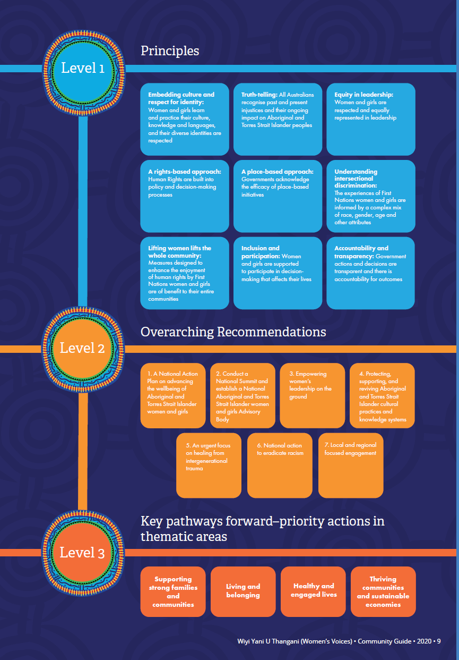
Attachment A

United Nations Office of the Special Adviser on Gender Issues and Advancement of Women and the Secretariat of the United Nations Permanent Forum on Indigenous Issues, Gender and Indigenous Peoples: Overview (2010), Briefing Note No.1 <https://www.un.org/esa/socdev/unpfii/documents/BriefingNote1_GREY.pdf> 1.
Wiyi Yani U Thangani (Women’s Voice): Securing our Rights, Securing our Future (2020), p 132.
Wiyi Yani U Thangani (Women’s Voice): Securing our Rights, Securing our Future (2020), p 129.
Wiyi Yani U Thangani (Women’s Voice): Securing our Rights, Securing our Future (2020), p 43.
Wiyi Yani U Thangani (Women’s Voice): Securing our Rights, Securing our Future, Community Guide (2020), p 12.
Wiyi Yani U Thangani (Women’s Voice): Securing our Rights, Securing our Future, Community Guide (2020), p 15.
Wiyi Yani U Thangani (Women’s Voice): Securing our Rights, Securing our Future, Community Guide (2020), p 20.
Wiyi Yani U Thangani (Women’s Voice): Securing our Rights, Securing our Future, Community Guide (2020), p 24.
Emma Dawson, Tanja Kovac and Abigail Lewis, Measure for Measure: Gender Equality in Australia (Report), March 2020, <https://percapita.org.au/our_work/measure-for-measure-gender-equality-in-australia/> 5.
Commonwealth of Australia, National Plan to Reduce Violence against Women and their Children 2010-2022: Fourth Action Plan 2019-2022, (2019) <https://www.dss.gov.au/women-publications-articles-reducing-violence/fourth-action-plan>.
Department of Prime Minister and Cabinet, Australian National Action Plan on Women, Peace and Security.
Council of Europe, Gender Mainstreaming: Conceptual framework, methodology and presentation of good practices (2004) < https://rm.coe.int/1680596135> 12.

