To the attention of:

Committee on the Rights of Persons with Disabilities
Human Rights Treaties Division
Office of the United Nations High Commissioner
for Human Rights
United Nations Office at Geneva
CH – 1201 Geneva 10

Vienna, 11 July 2011
Ref: 2017-outgoing-001028

Subject: Day of General Discussion on the right of persons with disabilities to equality and non-discrimination
Dear Ms Degener,
The European Union Agency for Fundamental Rights (FRA) very much welcomes the opportunity to contribute to the day of general discussion on the right of persons with disabilities to equality and non-discrimination by providing evidence from its research on the rights of persons with disabilities in the EU. All the publications mentioned in this submission can be downloaded from the FRA website.
Background
FRA has focused extensively on the principles of equality and non-discrimination in its work on the rights of persons with disabilities. In addition to the reports mentioned below, a great deal of information can be found in:
- FRA’s annual Fundamental Rights Report (chapters 1 and 9)
- Paper on Implementing the UN CRPD – An overview of legal reforms in EU Member States
- Opinion on the situation of equality in the European Union 10 years on from initial implementation of the equality directives
FRA has been a member of the EU Framework to promote, protect and monitor the implementation of the CRPD, established under Article 33(2), since 2013. The EU framework complements national monitoring frameworks responsible for promoting, protecting and monitoring the CRPD in EU Member States. It consists of the European Parliament, the European Ombudsman, the European Agency for Fundamental Rights (FRA) and the European Disability Forum. More information on the EU framework’s activities can be found on its webpage.
Comments on the outline for the draft General Comment on Art 5
- Introduction
One of the significant changes prompted by the CRPD is that it introduces equality and non-discrimination principles into areas of law and policy where they were not previously considered. FRA has consistently highlighted the importance to focus on ensuring that people with disabilities are treated on an equal basis with others, in particular in specific processes examined in the Agency’s reports on legal capacity and involuntary placement and treatment.
The introduction to the draft General Comment could therefore highlight that the concept of equality and non-discrimination set out in Articles 3 and 5 of the CRPD requires a shift in traditional approaches in respect to many laws addressing persons with disabilities.
In this vein, FRA suggests that the introduction could also underline that non-discrimination is a general principle of the CRPD as a whole (Article 3), with relevance to all the rights the convention sets out.
- Normative content
Evidence suggests that mental health problems are not automatically considered as disabilities in some legislation. FRA suggests that the General Comment includes reference to the issue of the scope of non-discrimination and reasonable accommodation provisions, including whether they apply equally to all persons with disabilities.
The Committee could draw on FRA’s report on the legal protection of persons with mental health problems under non-discrimination law, which discusses whether persons with mental health problems (psychosocial disabilities) are protected against discrimination on the grounds of disability, specifically in the area of employment. It also highlights that the duty of reasonable accommodation sometimes applies to a different group of persons than the prohibition of discrimination on the grounds of disability, potentially excluding persons with mental health problems.
Reflecting comments on other sections, FRA suggests that this section also highlights the cross-cutting nature of equality and non-discrimination as general principles of the convention.
FRA welcomes the implied focus on multiple and intersectional discrimination.
- Interrelation with specific other articles
As a general principle of the convention, non-discrimination is relevant to all articles of the CRPD. Reflecting this focus, specific references to ‘discriminatory denial’ and ‘on an equal basis with others’ are found throughout the convention.
It would therefore be useful to clarify in the draft General Comment why certain articles are included under this section, while others with a strong non-discrimination element are not.
Proposals for additional articles to be included in the General Comment
In this context, FRA would suggest that the following be considered:
Article 14: liberty and security of person
FRA’s report on involuntary placement and involuntary treatment of persons with mental health problems highlights the major shift in approach to legislation in this area prompted by the non-discrimination approach embedded in Article 14.
Article 25: health
FRA’s report on inequalities and multiple discrimination in access to and quality of healthcare looked at specific barriers experienced by young people with intellectual disabilities and a migrant background. The evidence points to communication and language barriers, leading to indirect discrimination of people with disabilities while also affecting health practitioners’ ability to assess effectively and diagnose correctly patients with disabilities.
Input on articles currently included in the General Comment
Article 7: children
FRA’s report on Violence against children with disabilities highlights the importance of non-discrimination in the context of violence and abuse.
Article 12: equal recognition before the law
FRA’s report on legal capacity of persons with intellectual disabilities and persons with mental health problems explores the intrinsic non-discrimination aspect of equal recognition before the law. It highlights that taking a non-discrimination approach has major implications for legal reforms in this area.
Article 13: access to justice
Evidence collected by FRA consistently highlights the specific barriers that persons with disabilities face in accessing justice, for example: in access to translation, interpretation and information; or related to the complexity of the complaints system. It highlights the importance of support to access justice.
It also highlights the impact of the limited scope of laws prohibiting discrimination on the grounds of disability on opportunities to access justice.
Article 16: freedom from violence, exploitation and abuse
FRA’s paper, Equal protection for all victims of hate crime: The case of persons with disabilities, shows that violence, harassment and abuse are common experiences for many people with disabilities, creating a formidable barrier to their social inclusion and participation in community life. The paper lists a number of suggestions for improving law and policy in this regard.
- State Party obligations
FRA welcomes the specific focus on statistics and research. FRA’s large scale surveys includes aspects related to disability, including the Violence against Women Survey (particularly p. 186), the European Union Minorities and Discrimination Survey, the European LGBT Survey and the forthcoming Fundamental Rights Survey. The data sets from the violence against women and LGBT surveys are available online using FRA’s data visualisation tool.
FRA proposes that, in addition to section V on national monitoring, indicators also be included in this section of the General Comment.
I hope the information provided is useful for the preparation of the draft General Comment on Article 5 of the CRPD. FRA remains at your disposal to provide further information if necessary under disability@fra.europa.eu.
Yours sincerely,
Ioannis Dimitrakopoulos
Head of Equality and Citizens’ Rights Department
cc: OHCHR Regional Office for Europe

FRA reports and information material on
the rights of persons with disabilities
FRA product |  | Short description | Languages
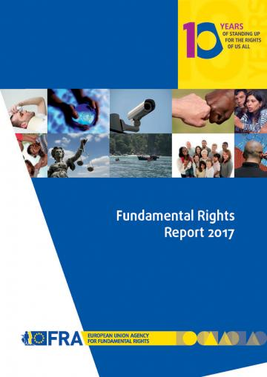 | Fundamental Rights Report 2017  Chapter 9: developments in the implementation of the Convention on the Rights of Persons with Disabilities  May 2017 | Ten years after the adoption of the Convention on the Rights of Persons with Disabilities (CRPD), the convention continues to spur significant legal and policy changes in the EU and its Member States. As attention gradually shifts from the first wave of CRPD-related reforms to consolidating progress made, the recommendations of review and complaints mechanisms are increasingly important in identifying persisting implementation gaps. Monitoring frameworks established under Article 33 (2) of the convention can be essential tools to drive follow-up of these recommendations, but they require independence, resources and solid legal foundations to carry out their tasks effectively. | en (FRA opinions in all EU languages)
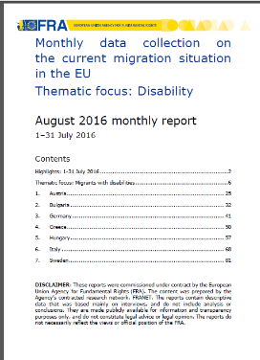 | Monthly data collection on the current migration situation in the EU  Thematic focus: Disability  August 2016 | Persons with disabilities make up around 15% of the global population, and comprise a significant minority of refugees and migrants. In addition to pre-existing physical, sensory, intellectual or psychosocial impairments, people may acquire or develop impairments during the migration process. When identified, these impairments place an obligation on Member States to provide specific support throughout the arrival, registration and asylum process. This thematic focus explores practices in four areas crucial to persons with disabilities and victims of torture in the current migrant situation | en
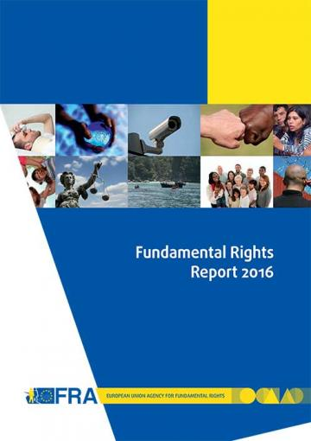 | Fundamental Rights Report 2016  Chapter 8: developments in the implementation of the Convention on the Rights of Persons with Disabilities  May 2016 | Five years on from the EU’s accession to the Convention on the Rights of Persons with Disabilities (CRPD), for the first time in 2015 a United Nations treaty body, the Committee on the Rights of Persons with Disabilities (CRPD Committee), reviewed the EU’s fulfilment of its human rights obligations. In its concluding observations, the CRPD Committee created a blueprint for the additional steps required for the EU to meet its obligations under the convention. At national level, the CRPD is driving wide-ranging change processes as Member States seek to harmonise their legal frameworks with the convention’s standards. | en  (FRA opinions in all EU languages)
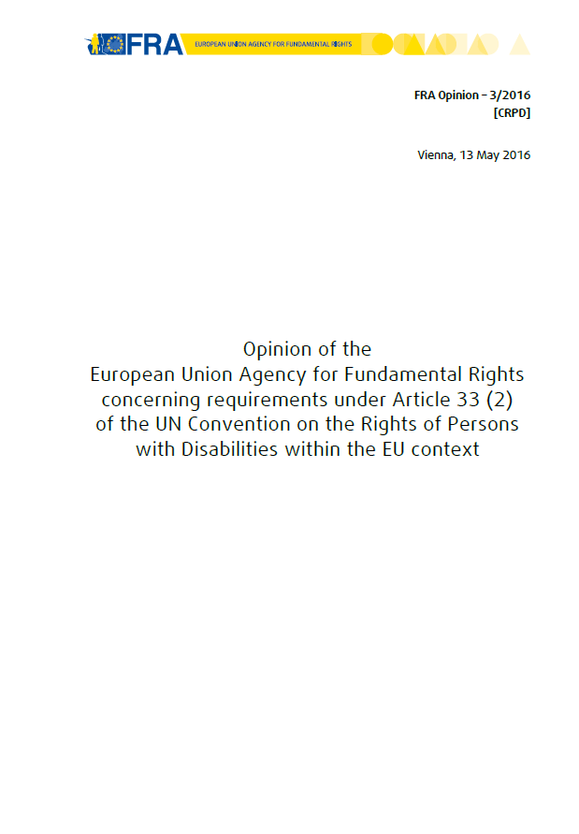 | FRA Opinion concerning requirements under Article 33 (2) of the UN Convention on the Rights of Persons with Disabilities within the EU context  May 2016 | This opinion addresses the designation and operation of a framework established under Article 33 (2) of the CRPD at EU level.  It aims to clarify the requirements of an EU Framework in light of the monitoring practice and jurisprudence of the CRPD Committee and – with regard to the concept of independence – the Committee interpreting the Paris Principles on the establishment of National Human Rights | en
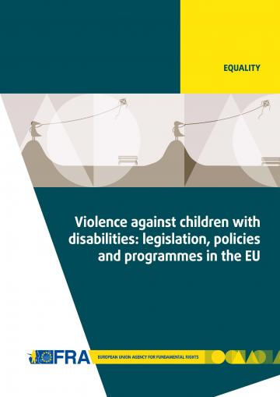 | Violence against children with disabilities: legislation, policies and programmes in the EU  December 2015 | The report outlines relevant international and European standards and reviews national legislation and policies addressing violence against children with disabilities. The report also explores the extent and different causes, settings and forms of such violence, and presents measures and initiatives to prevent it. | en  Summary report available in all EU languages
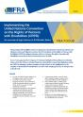 | Implementing the UN CRPD: An overview of legal reforms in EU Member States  May 2015 | The Focus paper outlines how Member States across the EU have reformed their laws and policies to meet their obligations under the CRPD. By bringing together examples of such reforms, it also highlights how the adoption of international commitments can drive wide-ranging processes of change at the national level. | en
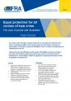 | Equal protection for all victims of hate crime - The case of people with disabilities  March 2015 | The paper discusses the difficulties faced by people with disabilities who become victims of hate crime, and the different legal frameworks in place to protect such victims in the EU’s Member States. It ends by listing a number of suggestions for improving the situation at both the legislative and policy levels. | en
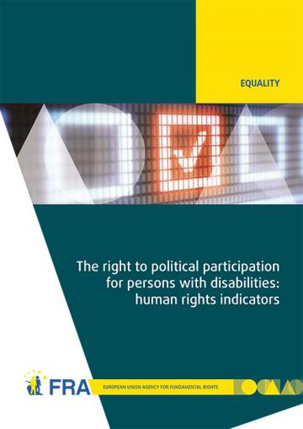 | The right to political participation for persons with disabilities: human rights indicators  May 2014 | The opportunity to be involved in political life, whether by standing for elected office, joining a political party, or following political news stories in the media, is at the heart of what it means to live in a democratic society. The report analyses data from across the 28 EU Member States by the FRA and the European Commission-funded Academic Network of European Disability Experts (ANED).  Data visualisation of the 28 human rights indicators is also available online. | en  Summary report available in all EU languages
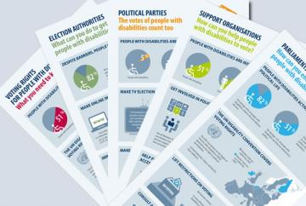 | Infographics on voting rights of people with disabilities  September 2014 | FRA has developed a family of five infographics to help raise awareness of the voting rights of people with disabilities. Each infographic targets a different audience and draws on FRA research into the right to political participation of people with disabilities. | all EU languages
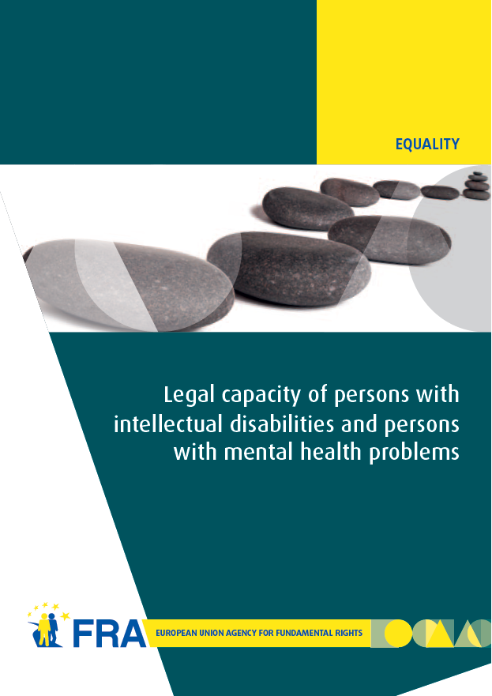 | Legal capacity of persons with intellectual disabilities and persons with mental health problems  July 2013 | Equal recognition of persons before the law is a long-established human rights principle. Nevertheless, legal frameworks in many European Union (EU) Member States allow for the legal capacity of persons with intellectual disabilities and persons with mental health problems to be restricted or removed under certain conditions.  This report analyses the current legal standards on legal capacity across the EU, set against the backdrop of the experiences of interviewees who have had their legal capacity removed or restricted. The FRA report reveals the gap between the promise of the CRPD and the reality those with disabilities face in the EU every day, and, by so doing, hopes to contribute to closing it. | en - de - fr  Factsheet available in all EU languages
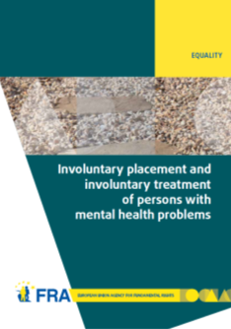 | Involuntary placement and involuntary treatment of persons with mental health problems  June 2012 | Involuntary placement and involuntary treatment of persons with mental health problems affects the most fundamental of rights, including the right to liberty and the right to freedom from torture. Strict safeguards at UN and European level attempt to limit undue interference with such rights. This report analyses the shifting legal panorama and, informed by fieldwork on the experiences of those involuntarily placed and treated and other stakeholders, points to the need for a renewed discussion of compulsory placement and treatment in the EU. | en - de - fr  Factsheet available in all EU languages
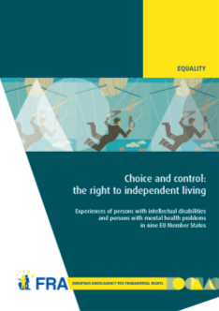 | Choice and control: the right to independent living  June 2012 | Article 19 of the United Nations Convention on the Rights of Persons with Disabilities establishes the right to live independently and be included in the community. Drawing on the findings of interview-based research with persons with mental health problems and persons with intellectual disabilities, this report examines how they experience the principles of autonomy, inclusion and participation in their day-to-day lives. | en - fr – de  Summary report in:  en - fr - de - da - el
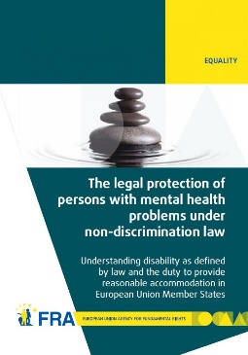 | The legal protection of persons with mental health problems under non-discrimination law  October 2011 | The report examines how disability is defined in international and European law and then explores the obligation to provide reasonable accommodation as contained in international and European standards. The report's findings show that in almost all EU Member States non-discrimination legislation does indeed protect persons with mental health problems. In most cases persons with mental health problems also benefit from reasonable accommodation measures, or other protection measures, in the employment context. | en - de - fr - da
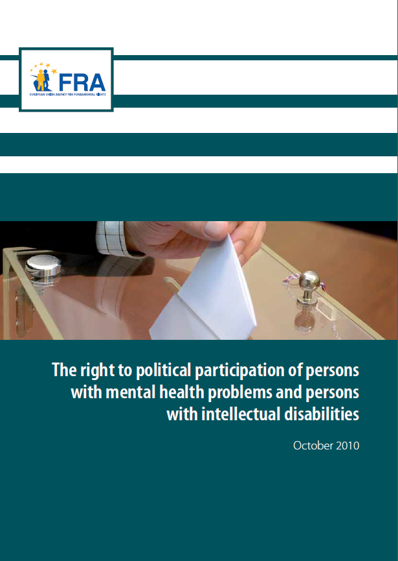 | The right to political participation of persons with mental health problems and persons with intellectual disabilities  November 2010 | This report first recalls the international and European standards favouring the full participation of persons with intellectual disabilities and persons with mental health problems in the electoral process. The comparative law analysis then highlights the diverse approaches adopted in the EU Member States. In a majority of these, persons who have lost their legal capacity are automatically deprived of their right to political participation. | all EU languages
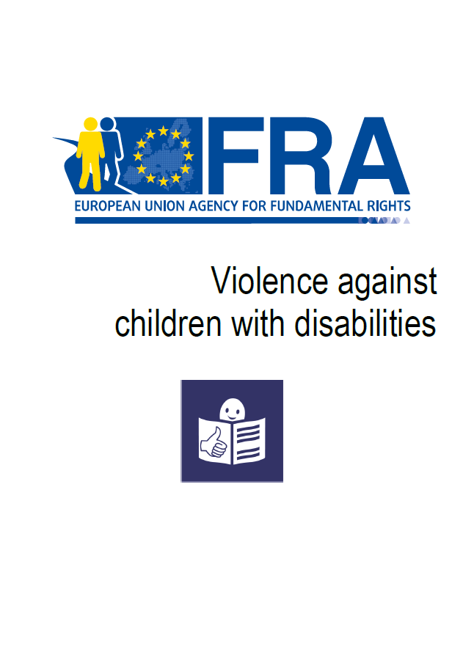 | EASY READ  Violence against children with disabilities  December 2015 | This summary in easy read format looks at violence, where it happens, and why people are violent. It also looks at laws to protect children with disabilities from violence and what countries are doing to prevent this violence. | en
 | EASY READ  Laws about being able to make important decisions for yourself  October 2013 | This summary in easy read format provides information about FRA’s work on the right to equal recognition before the law. | en - de - fr
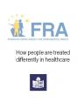 | EASY READ  How people are treated differently in healthcare  March 2013 | This summary in east read format provides information about FRA’s work on how people might be treated differently in healthcare and on multiple discrimination in healthcare. | en
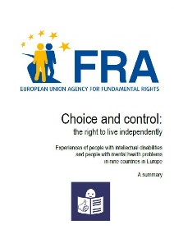 | EASY READ  Choice and control: the right to live independently - Experiences of people with intellectual disabilities  June 2012 | This summary in easy read format provides information about FRA’s work on the right to live independently. | en
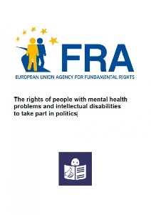 | EASY READ  The rights of people with mental health problems and intellectual disabilities to take part in politics  November 2010 | This summary in easy read format provides information about FRA’s work on the right to vote of persons with intellectual disabilities. | en

To order any of these publications visit:

https://bookshop.europa.eu/

