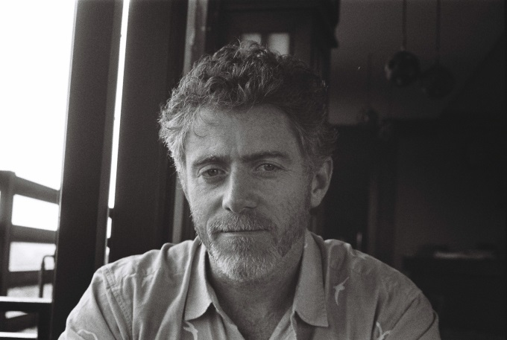

Bio - Dr. Daniel Aguirre
Dr. Daniel Aguirre is an International Legal Advisor for the International Commission of Jurists based in Yangon, Myanmar where he works on access to justice, law reform, investment and human rights. Aside from NGO work, Dr. Aguirre has lectured on international human rights law and published academic research on investment treaties and human rights, including in his book, The Human Right to Development in a Globalized World (Routledge, 2008). For opinion and analysis on business and human rights in Myanmar see: https://businesshumanrightsburma.wordpress.com

