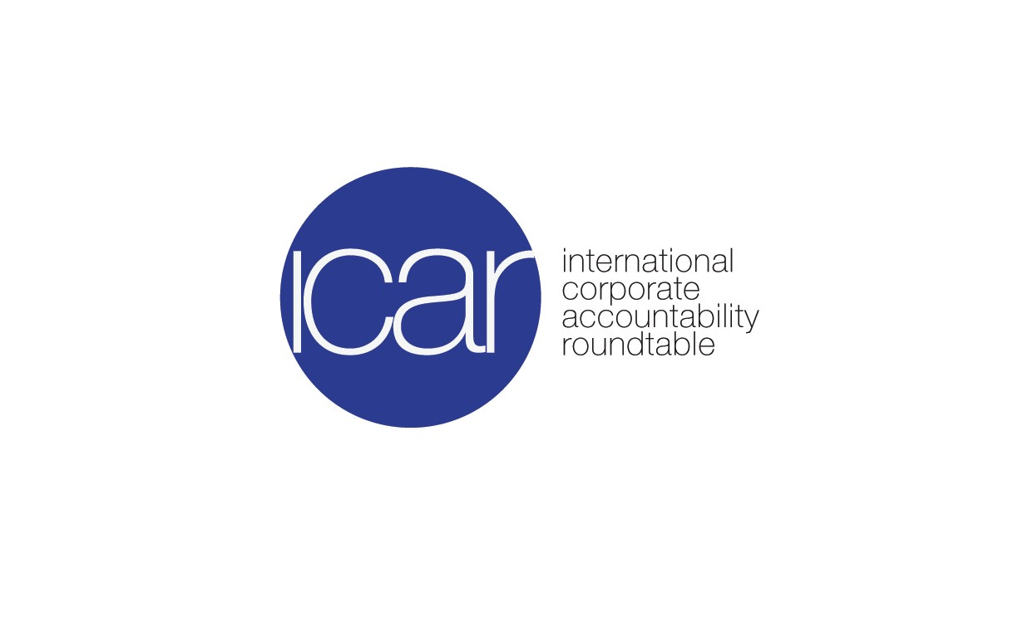
Sixth Submission by the International Corporate Accountability Roundtable to the Open-­‐ Ended Intergovernmental Working Group on Transnational Corporations and Other Business Enterprises with Respect to Human Rights

1 September 2016

The International Corporate Accountability Roundtable is a civil society organization working to ensure that governments create, implement, and enforce laws and policies to protect against business-­‐related human rights abuse.

ICAR appreciates the opportunity to provide input into the process of establishing the scope, nature, form, and content of the proposed international binding instrument to address business-­‐related human rights violations. We believe that this process must develop alongside increasing efforts toward implementing business and human rights frameworks, including the
U.N. Guiding Principles on Business and Human Rights (UNGPs), at the domestic level in the form of National Action Plans (NAPs) on business and human rights. As such, we are encouraged to see continued high-­‐level engagement with the development of NAPs as the OEIWG negotiations continue.

In this, our sixth submission to the OEIWG, we reiterate the content of our previous submissions and outline specific process and content considerations integral for the OEIWG to uphold in the elaboration of an international binding instrument.

Provide for inclusive, meaningful, and informed engagement from a broad range of stakeholder groups

ICAR urges the OEIWG to provide for inclusive, meaningful, and informed engagement across stakeholder groups, including disempowered or at-­‐risk stakeholders, human rights defenders, and non-­‐governmental organization (NGOs) without ECOSOC status. In particular, proactive steps should be taken to ensure that affected rights-­‐holders have a voice in the negotiation process and can participate in the design and implementation of the binding instrument.
Additionally, given the variation of State positions in relation to the binding instrument and the specific contexts of home and host States, ICAR expects the OEIWG to provide for inclusive and respectful dialogue across State parties.

Provide for transparency throughout the treaty process

In order for interested stakeholders and State parties to fully and effectively participate in the creation of the binding instrument, ICAR expects the OEIWG to ensure that the process and timeline of the development of the treaty are clearly and publicly delineated. Additionally, ICAR

urges the OEIGW to ensure that all information produced and contributing to the development of the instrument is made public and accessible to all interested parties. Such transparency promotes accountability by establishing process expectations that can be used as leverage points for stakeholders to ensure compliance and legitimacy. Ultimately, transparency is integral to the building of trust in the process and in the treaty itself.

Ensure that the instrument complements domestic-­‐level implementation of business and human rights frameworks, including the UN Guiding Principles on Business and Human Rights, in the form of National Action Plans

In line with our third submission, ICAR continues to stress that the international binding instrument must complement domestic-­‐level implementation of the UNGPs and other business and human rights frameworks through NAPs. We echo the comments of both the UN High Commissioner for Human Rights and Ambassador María Fernanda Espinosa Garcés, Chair-­‐ Rapporteur at the opening of the first session of the OEIWG on 6 July 2016, which expressed that the intergovernmental process was a complementary step not in conflict or competition with continued advocacy for and implementation of the UNGPs, including in the form of NAPs.1

ICAR has continued to conduct research into how NAPs can be complementary to the current OEIWG process.2 NAPs provide a critical framework for the promulgation of national laws, regulations, and policies integral to a State’s fulfillment of its duty to protect human rights from business-­‐related harm.3 Similarly, National Baseline Assessments (NBAs) and multi-­‐stakeholder consultations conducted during the NAP process provide key insight into how businesses are negatively impacting human rights and what gaps exist in law, policy, and regulation in preventing and redressing corporate human rights abuse.4

As such, ICAR reiterates its request to the OEIWG to: (1) carefully consider current State practice and initiatives that are part of NAPs processes and (2) ensure that the binding instrument considers and responds to existing protection gaps identified through NAPs processes, such as NBAs and multi-­‐stakeholder consultations.

1 See, opening statements of Zeid Ra’ad Al Hussein, UN High Commissioner for Human Rights and Ambassador María Fernanda Espinosa Garcés, Permanent Representative of Ecuador to the UN in Geneva. UN OFFICE OF THE HIGH COMMISSIONER FOR HUMAN RIGHTS, OEIWG ‘First Session-­‐Oral Statements and Presentations’, available at http://www.ohchr.org/EN/HRBodies/HRC/WGTransCorp/Session1/Pages/Statements.aspx (last visited Aug. 2, 2016).
2 INT’L CORPORATE ACCOUNTABILITY ROUNDTABLE (ICAR) & DANISH INST. FOR HUMAN RIGHTS, NATIONAL ACTION PLANS ON BUSINESS
AND HUMAN RIGHTS: A TOOLKIT FOR THE DEVELOPMENT, IMPLEMENTATION, AND REVIEW OF STATE COMMITMENTS TO BUSINESS AND
HUMAN RIGHTS FRAMEWORKS (2014); Sara Blackwell & Nicole Vander Meulen, Two Roads Converged: The Mutual Complementarity of Binding Business & Human Rights Treaty and National Action Plans on Business and Human Rights, 6 NOTRE DAME J. OF INT’L & COMP. L. (forthcoming).
3 Id. at 56.
4 Id. at 1-­‐2.

Ensure that the instrument applies to all enterprises, regardless of their size or geographical scope

As reflected in our first submission, ICAR urges the OEIWG to clarify that the provision “business enterprises that have a transnational character in their operational activities”5 includes all enterprises that engage in transnational commerce or whose operational activities singularly or cumulatively have a substantial effect on transnational commerce.

ICAR also expects the OEIWG to continue to navigate negotiations for an international binding instrument with openness to the inclusion of locally registered businesses under locally relevant law. This consideration is necessary given that domestic businesses may impact human rights through their operations just as severely and on a similarly large scale as transnational corporations.

From a rights-­‐holder’s perspective, the nationality or scope of operations of the responsible business entity is irrelevant. ICAR has previously provided examples of complaints filed against locally registered businesses whose domestic operations have negatively impacted human rights. Situations in which domestic corporations violate human rights at home continue to proliferate, for example:

Americas
  - A pipeline owned by a State-­‐owned Peruvian oil company ruptured and contaminated rivers depended upon by indigenous communities for subsistence.
  - A United States tobacco company purchases from farmers who use local child labor in their South Carolina fields.

Africa & Middle East
  - A Nigerian mining company deceitfully took land from a rural community and polluted their only source of water.
  - A Saudi construction company has delayed paying wages to several of its workers for up to nine months.

Asia & Pacific
  - A Chinese electronics company violated labor rights by firing employees after a strike.

Europe & Central Asia
  - A State-­‐run mining company in Romania is proceeding to expropriate villagers’ homes without fair compensation to make way for a new mining project.

5 Human Rights Council Res. 26/9, U.N. DOC. A/HRC/26/L.22/Rev.1, at 2 (Jun. 26, 2014).

Recognize the State as an economic actor responsible for the actions of enterprises that it contracts with, owns, or operates

The UNGPs affirms the duty of the State to protect against human rights abuses by business entities. This duty extends to situations where “a commercial ‘nexus’ exists between public actors and businesses, such as when government bodies purchase goods and services through public procurement, and in connection with ‘contracting-­‐out’ and privatization.”6 Through extensive research into public purchasing laws, policies, and practices, ICAR has found that most States are currently not taking sufficient steps to prevent human rights abuses linked to their purchasing activities.7

In relation to public procurement, there are a number of key gaps in government law, policy, and practice that must be addressed in order for governments to fulfill their duty to protect. Examples of gaps include: (1) the lack of clear legal requirements and policies that explicitly refer or otherwise give adequate effect to the duty to protect human rights in public procurement and (2) the limited scope of human rights protections provided for in the minority of jurisdictions that do contemplate the State duty to protect within public purchasing.

As such, ICAR urges the OEIWG to ensure that the binding instrument requires States to take human rights into consideration when making purchasing decisions, including by requiring contractors to conduct human rights due diligence and to disclose their supply chains. The binding instrument should also require that the scope of protections within procurement practices include all internationally recognized human rights throughout the supply chain.

Remove legal and practical barriers that prevent victims from accessing effective judicial remedies

The UNGPs identify access to remedy as one of the three essential pillars of the international business and human rights framework. States cannot fulfill their duty to protect individuals from corporate human rights abuse, and corporations cannot uphold their responsibility to respect human rights, if victims of human rights violations do not have full and effective access to judicial remedies. However, as illustrated in ICAR’s report, The Third Pillar: Access to Judicial Remedies for Human Rights Violations by Transnational Business, a multitude of barriers in accessing remedy exist across numerous home State jurisdictions, including the United States, Canada, and major jurisdictions in Europe.8

As such, ICAR reiterated its calls for increased access to judicial remedy in our second and fourth submissions to the OEIWG. Specifically, ICAR urges the OEIWG to design a binding

- INTERNATIONAL LEARNING LAB ON PUBLIC PROCUREMENT AND HUMAN RIGHTS, PUBLIC PROCUREMENT AND HUMAN RIGHTS: A SURVEY OF TWENTY JURISDICTIONS (2016)
- Id; ROBERT STUMBERG, ANITA RAMASASTRY, & MEG ROGGENSACK, TURNING A BLIND EYE? RESPECTING HUMAN RIGHTS IN
GOVERNMENT PURCHASING (2014).
- GWYNNE SKINNER, ROBERT MCCORQUODALE, & OLIVIER DE SCHUTTER, THE THIRD PILLAR: ACCESS TO JUDICIAL REMEDIES FOR
HUMAN RIGHTS VIOLATIONS BY TRANSNATIONAL BUSINESS (2013).

instrument that recognizes the cross-­‐border nature of business activity in an increasingly global economy and identifies the situations in which States have a legal obligation to apply their laws extraterritorially. ICAR also expects the binding instrument to obligate State parties to develop and enhance existing criminal and civil laws relevant to corporate accountability in the human rights context and to remove or limit practical barriers that prevent victims from bringing and prosecuting a case in their courts.

Incorporate clear standards for human rights due diligence and harmonize emerging international approaches

As reflected in our fifth submission, due diligence requirements are crucial in assessing a business enterprise’s respect for human rights and in identifying, preventing, and mitigating human rights abuse caused by business operations. The implementation of due diligence mechanisms to protect human rights is an emerging trend, and many States have begun to impose legal obligations on business enterprises to detect and prevent harm to workers and the public within business enterprise groups, subsidiaries, agents, and subcontractors.9

ICAR continues to urge the OEIWG to ensure policy coherence across State parties by designing a binding instrument that incorporates clear standards for human rights due diligence and that enhances harmonization across international approaches. The instrument should also establish the extraterritorial application of human rights due diligence requirements in order to reach all of the actors that form an enterprise’s value chain. ICAR also continues to stress the need to develop modes of human rights due diligence requirements focused on securities laws, conditioned benefits, and investment, as these are prime subject areas for embedding human rights due diligence principles in State action.10

As constructive deliberations on the content, scope, nature, and form of the future international binding instrument continue, ICAR urges the OIEGW to consider and implement the above recommendations in order to ensure that the development of the instrument is inclusive, transparent, and rights-­‐based while at the same time providing a framework to effectively prevent and redress corporate-­‐related human rights abuses.

Sincerely,

Amol Mehra, Esq.
Director, International Corporate Accountability Roundtable (ICAR) www.icar.ngo

- See, e.g., OLIVIER DE SCHUTTER, ET AL, HUMAN RIGHTS DUE DILIGENCE: THE ROLE OF STATES 50 (2012).
10 For more substantial argumentation on this point, see INTERNATIONAL CORPORATE ACCOUNTABILITY ROUNDTABLE, Fifth Submission by the ICAR to the Open-­‐ended Intergovernmental Working Group on Transnational Corporations and
other Business Enterprises with Respect to Human Rights (June 30, 2015), http://icar.ngo/wp-­‐ content/uploads/2015/06/IGWG-­‐Submission-­‐5-­‐International-­‐Corporate-­‐Accountability-­‐Roundtable.pdf.

