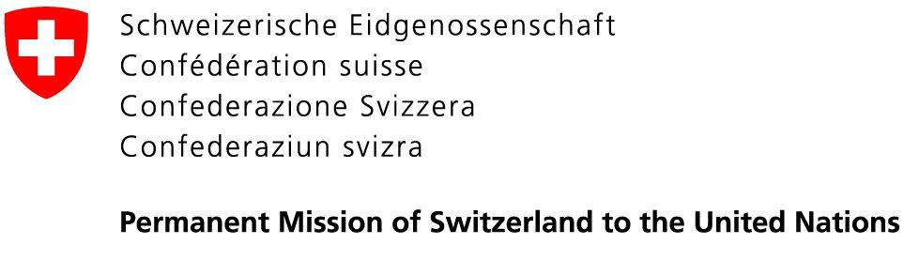 | 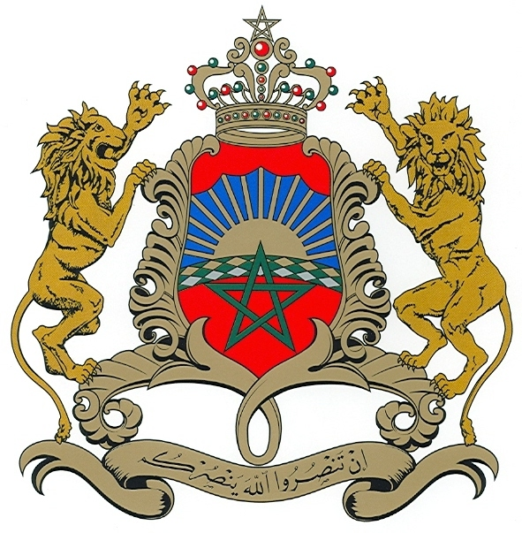  Permanent Mission of the  Kingdom of Morocco to the UN

18 August 2020

Letter addressed to the civil society, National Human Rights Institutions and all other relevant stakeholders regarding the process of the consideration of the state of the
UN human rights treaty body system

Dear Madam, Dear Sir,

In our capacity as co-facilitators of the process of the consideration of the state of the UN human rights treaty body system, we are pleased to share with you further details on the modalities of the informal consultation with representatives of the civil society, National Human Rights Institutions and all other relevant stakeholders, scheduled on Friday, 28 August 2020,
from 03:00 p.m. to 06:00 p.m., in Room XX in the Palais des Nations.

All representatives wishing to participate in the informal consultation either in person in room XX, Palais des Nations, or on-line on webex, are requested to register their participation with the Secretariat through INDICO. Please note that due to COVID-19 physical distancing restrictions in place at UNOG, the capacity of room XX is limited to 101 participants at desks with microphones. Therefore, participation will be limited to one person per organization. If you wish to observe the consultation, i.e. not to take the floor, the meeting will be on webcast and accessible to the public on UN Web TV.

During the meeting, the co-facilitators will make a brief presentation based on the written contributions received after which the floor will be opened for statements. Statements should not exceed 3 minutes. Please note that interpretation in all six UN languages will be provided in room XX, however due to technical reasons interpretation is not possible on webex. Therefore, representatives wishing to speak in another UN language than English are kindly requested to participate in person in room XX. Otherwise, please indicate in advance in which UN language you wish to deliver the statement.

The Office of the High Commissioner for Human Rights will soon circulate a detailed information note in this regard.

Yours sincerely,

Pascale Baeriswyl    Ambassador, Permanent Representative of  Switzerland to the UN | 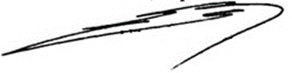  Omar Hilale  Ambassador, Permanent Representative of  The Kingdom of Morocco to the UN

