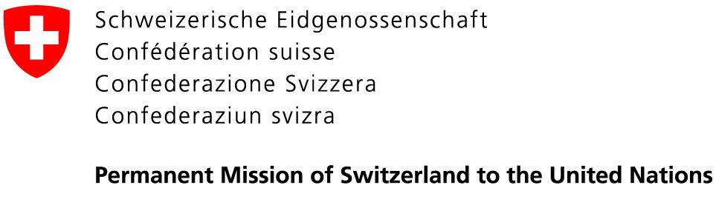 | 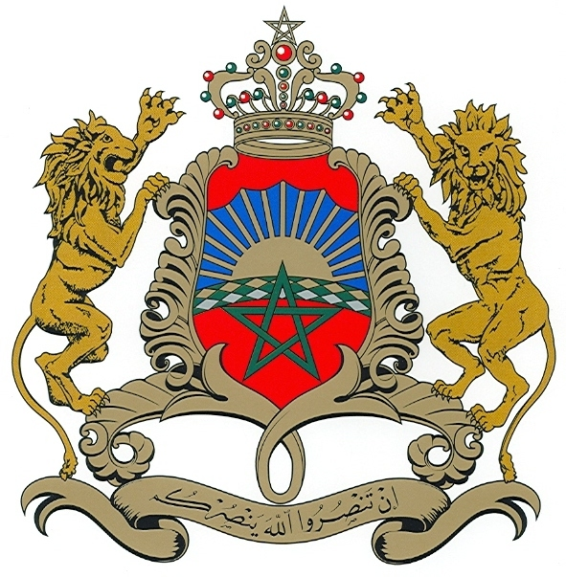  Permanent Mission of the  Kingdom of Morocco to the UN

17 June 2020

Letter addressed to the Office of the High Commissioner for Human Rights, the treaty bodies, civil society, National Human Rights Institutions and all other relevant stakeholders regarding the process of the consideration of the state of the UN human rights treaty body system

Dear Madam, Dear Sir,

In our capacity as co-facilitators of the process of the consideration of the state of the UN human rights treaty body system, we would like to call, as a first step, for written contributions.
Without intending thereby to restrict the nature and scope of the inputs, the issues outlined below - without being exhaustive - can be used as a guide in formulating the submissions:

- The functioning of the treaty body system: its efficiency, effectiveness, strengths and weaknesses; suggestions for its further improvement;
- Implementation of UNGA resolution 68/268 and views on biennial report of the
UN Secretary-General on the status of the treaty body system;
- Good practices and methodologies in relation to working methods and procedural matters, including harmonization and alignment of working methods;
- Coordination and predictability in review cycles and reporting;
- Current reporting system, including common core document, and ways to further improve and simplify reporting for States parties whilst ensuring the substantive quality of the national reports;
- Dialogue between States and treaty bodies both in preparation for and during States reviews as well as in follow-up to the review;
- Assessment of the concluding observations and recommendations;
- Strengthening the engagement with civil society and other relevant stakeholders;
- The capacity-building programme, experiences and impact, in terms of reporting and in terms of national implementation of recommendations;
- Use of new information and communications technologies and its potential to further increase efficiency and accessibility;
- Opportunity of reviews in countries or in regions;
- Preserve and strengthen the independence and impartiality of treaty body members and ensure diversity in terms of gender, geography, background, expertise, representation of different forms of civilization and principal legal systems, as well as the participation of persons with disabilities;
- Enhancement of the coordinating role of treaty bodies Chairpersons;
- Overall coherence of the treaty body system and the collaboration among treaty bodies as well as within the UN system and with regional monitoring bodies;

- Funding of the treaty body system and ensuring that treaty bodies have an adequate allocation of financial and human resources for all their mandated activities;
- Current system of processing individual communications, inter-State communications and urgent actions: its efficiency, effectiveness, strengths and weaknesses; suggestions for its further improvement;
- Accessibility for persons with disabilities and wider accessibility and visibility of the work of the treaty bodies;
- Efficient and effective use of the meetings of States parties.

Submissions should be sent in English as a MS Word Document to the following address treatybodies@gmail.com by 7 July 2020. All submissions will be published on the OHCHR webpage dedicated to the process, where all other information is also available: https://www.ohchr.org/EN/HRBodies/HRTD/Pages/TBStrengthening.aspx

Yours sincerely,

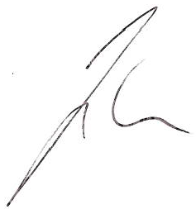  Jürg Lauber  Ambassador, Permanent Representative of  Switzerland to the UN | 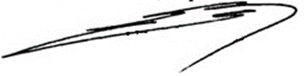  Omar Hilale  Ambassador, Permanent Representative of  The Kingdom of Morocco to the UN

