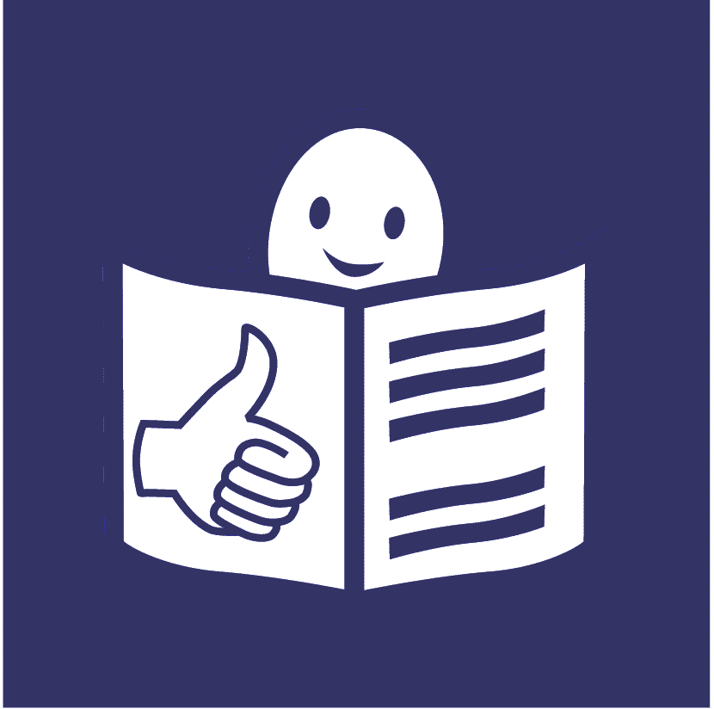
United Nations Human Rights Council
United Nations High Commissioner for
Human Rights. Annual Report

What people said at a meeting about climate change and the rights of people with disabilities

Climate change is about the earth getting warmer and the problems that is causing for people and the planet we live on.

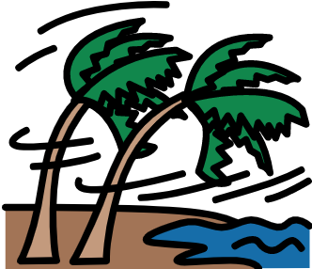
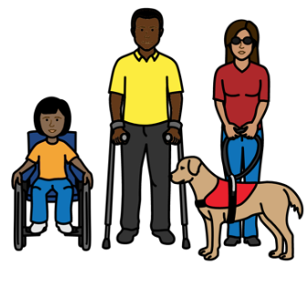

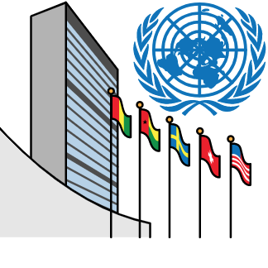
About us

We are part of the United Nations (UN).
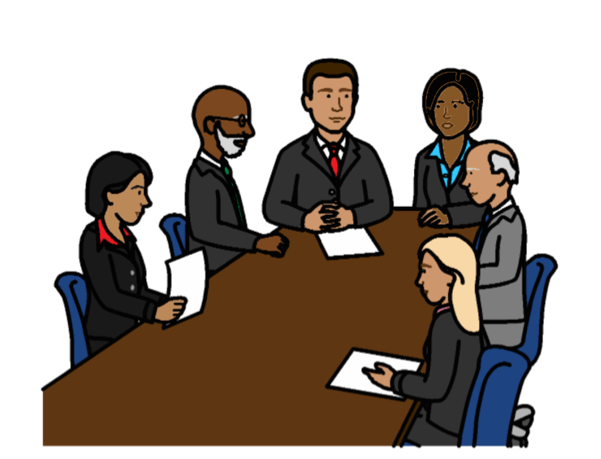

The United Nations is a group of countries that work to make the world better and safer.

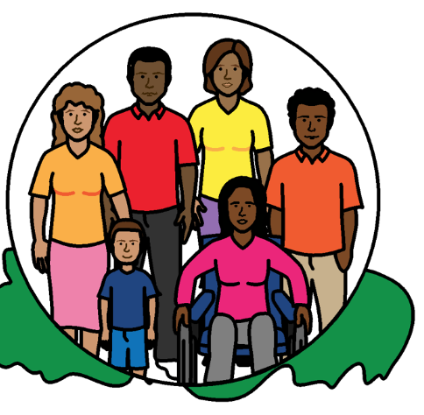

Our job is to make sure that
everyone in the world is treated fairly and gets their human rights.

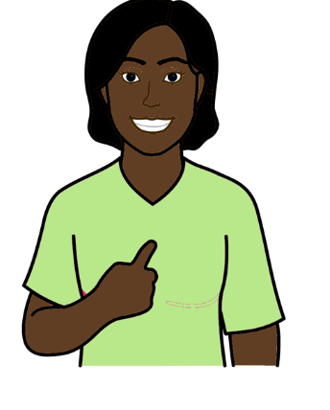

Everyone has human rights.

Human rights are about what should happen in everyone’s lives.

For example, everyone has the right to work, go to school and be healthy.

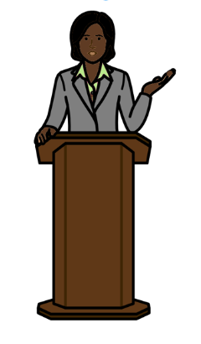
About this report

This report is about a meeting we had about climate change and the rights of people with disabilities.

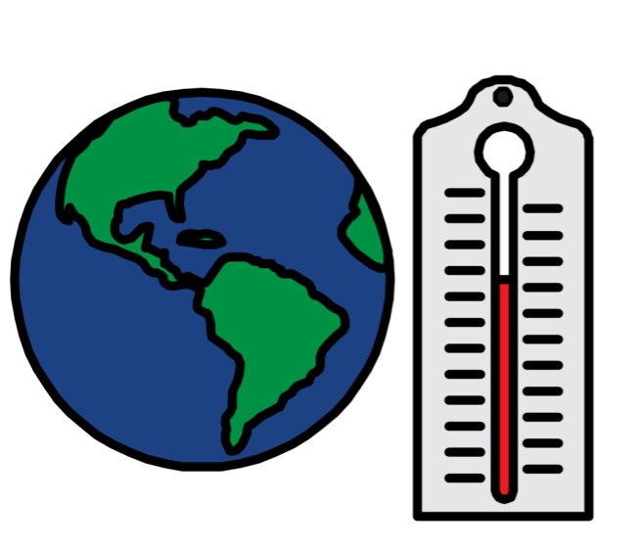

Climate change is about changes to the earth we live on.

The earth is getting warmer.

This is causing big problems for people and the planet.
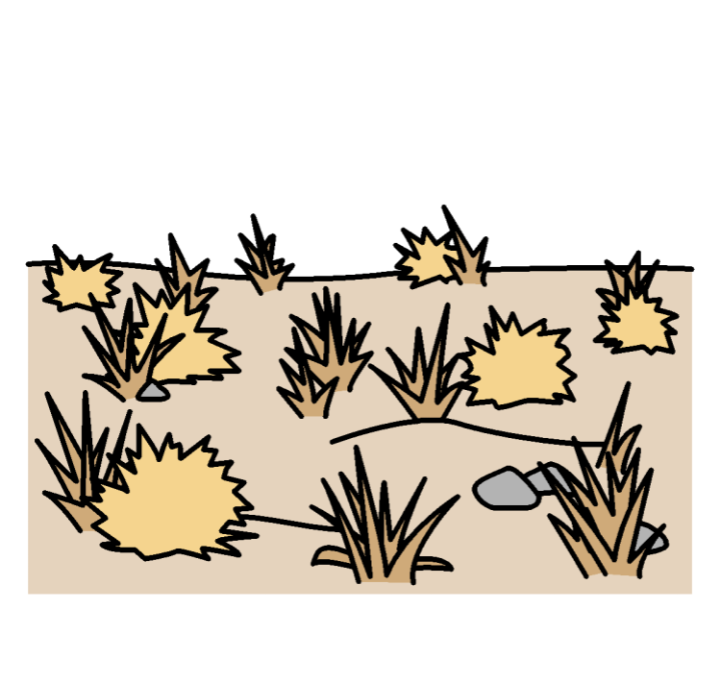
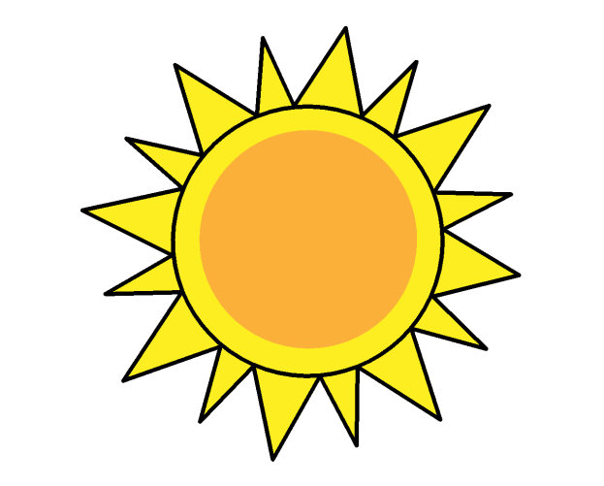
For example, there may be:

- More floods, too much heat, no rain and bad storms

- Problems growing plants and food

- Problems for fish and animals

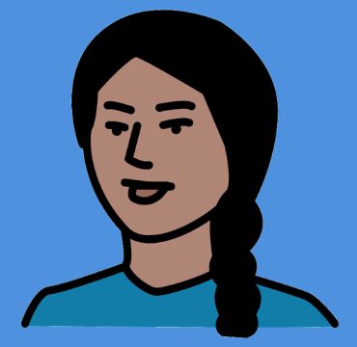

The meeting was on 8 July 2020.

People from different countries and organizations talked at the meeting.
This includes people with disabilities.
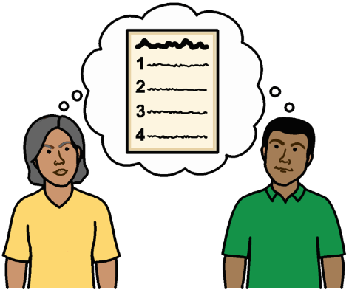
People at the meeting talked about:

- Problems for people with disabilities because of climate change

- What countries and organizations should do about it

The main things that people said at the meeting

Problems for people with disabilities because of climate change
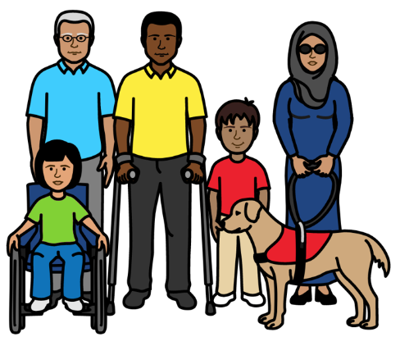

Climate change is making life hard for everyone in the world.

But it is making life harder for people with disabilities.

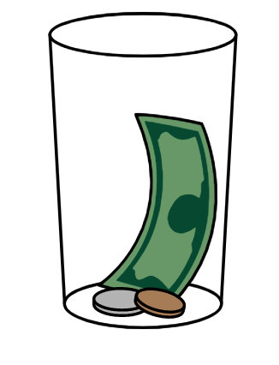
There are many reasons for this.

For example, many people with disabilities are poor.

Climate change problems are often worse for people who are poor.

And climate change can make people poorer.
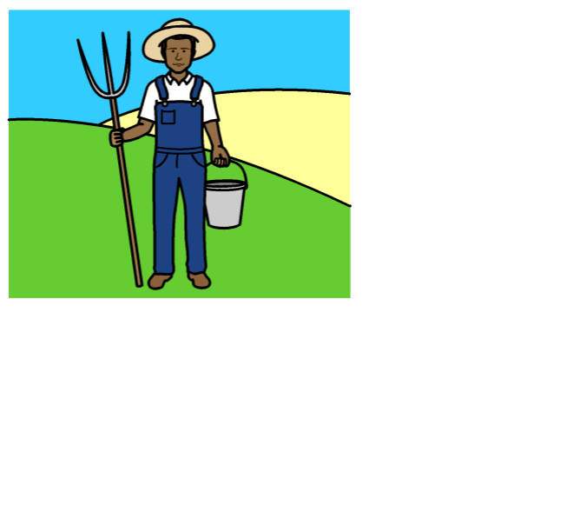

For example:

- Climate change might stop some people with disabilities earning money
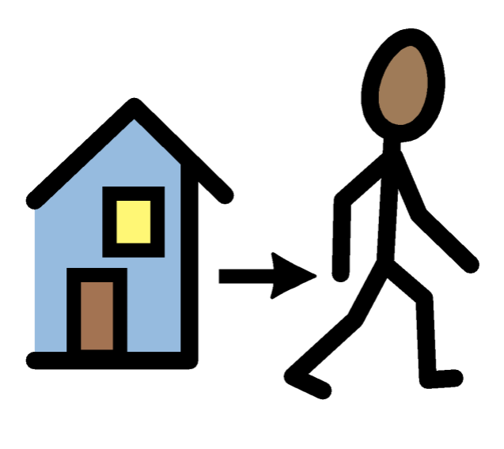

- People with disabilities might have to leave their homes because of climate change problems

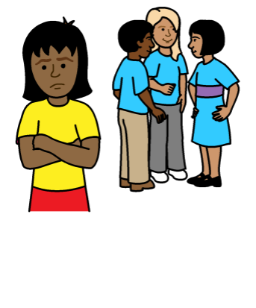

Many people with disabilities are already treated badly and unfairly.

They are often left out.

For example, they are often left out of climate change work.
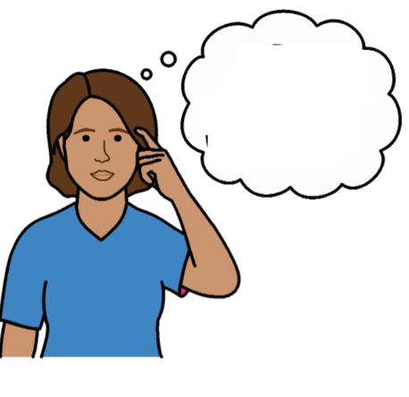
People often have unfair ideas about people with disabilities.

For example, they might think that people with disabilities are less important than other people.
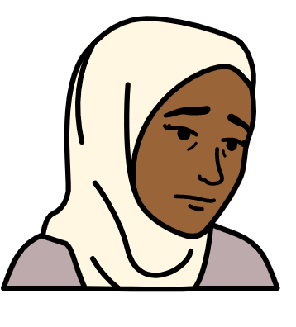

Some people with disabilities are treated badly for more than one reason.

For example, because they are a woman and because they have a disability.

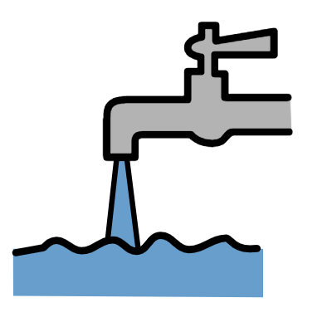

This makes it hard for many people with disabilities to get what they need when climate change problems happen.

For example:

- Food and clean water
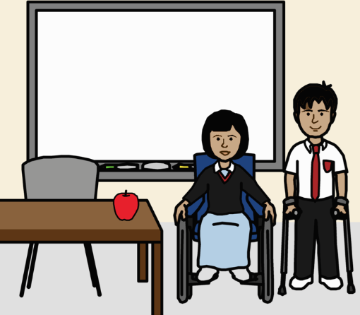
- Medicine and health care

- Information they can understand

- Safe places to live

- Support, work and education
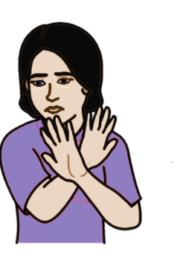
Violence can happen more to people with disabilities when there are big problems in the country.

This is often worse for women and girls.

All of this can put some people with disabilities in danger.

What people at the meeting said should happen

Climate change laws and plans should be about people’s human rights.

The laws and plans should work well for everyone.

This includes people with disabilities.

No one should be left out.

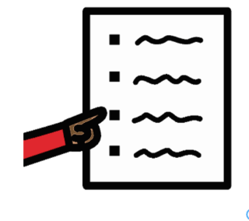
There is work that countries have promised to do on climate change and the rights of people with disabilities.

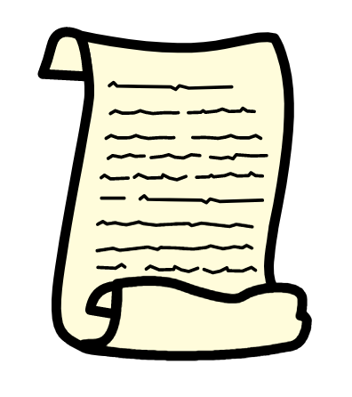

For example, there is an important document about the rights of all people with disabilities in the world.

The document says that countries must:
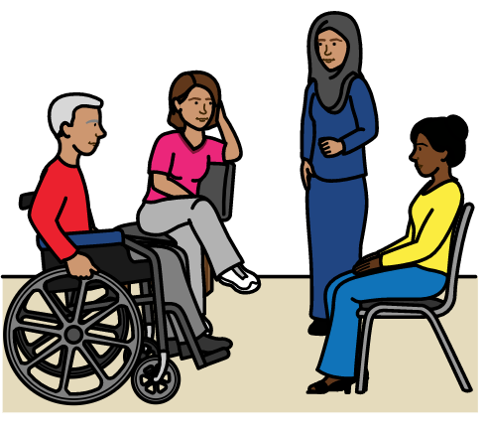
- Make sure that people with disabilities are safe and get their rights

- Make sure that people with disabilities have a say in what happens to them
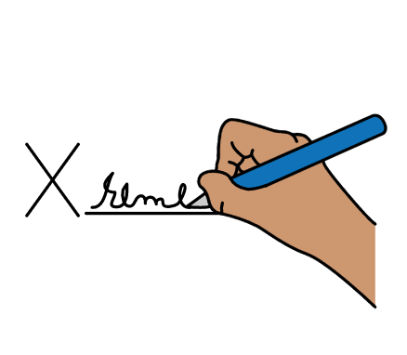

Many countries have promised to do what the document says.

This means that people with disabilities should not be left out of climate change work.

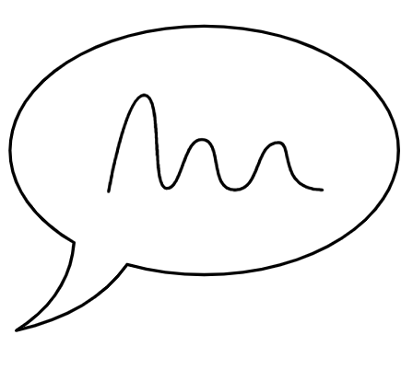
Making sure that people with disabilities have their say
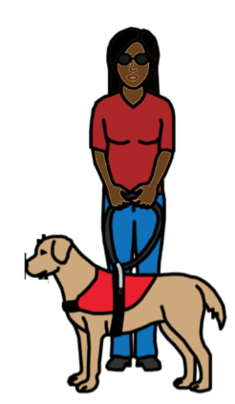

People with disabilities can help to really change things.

They know what they need.

They have good ideas.

Countries should listen to them.
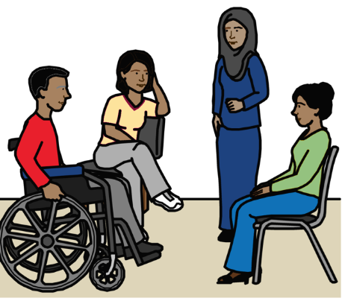

People with disabilities should
help make decisions and plans about climate change.

For example, people with disabilities should have a real say about:

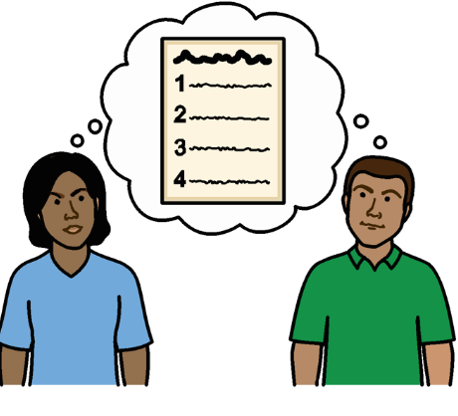
- How to get ready for climate change problems

- What to do about climate change problems and how to stop them getting worse

- How climate change laws and plans are working
People with disabilities should also be part of work on a United Nations plan about climate change.

Countries could make a plan about how to include people with disabilities.

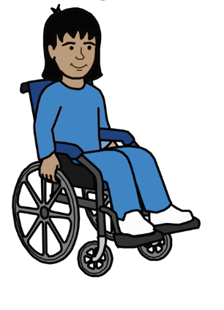

All people with disabilities should have the chance to have a say.

For example:
- People with different disabilities
- Women
- Older people
- Children

People with disabilities should get the support they need to take part in climate change work.
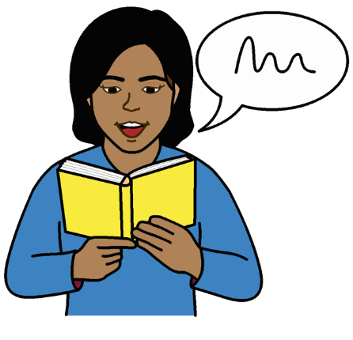
For example, they should get information they can understand about:

- Climate change problems that might happen

- Their rights

- How to have a say in laws and plans about climate change
Making sure that people with disabilities get what they need

Countries should solve the problems that make climate change worse for people with disabilities.

For example, countries must make sure that people with disabilities are treated fairly and get what they need.

This includes:
- Clean water
- Good education and training
- Enough money to live on

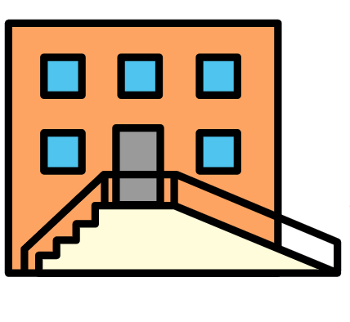

Everything should be easy for people with disabilities to use where possible.
For example:
- Buildings
- Transport
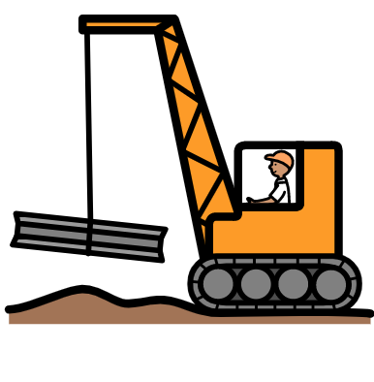
- Computers and other equipment

This includes new things that are built or made in the future.

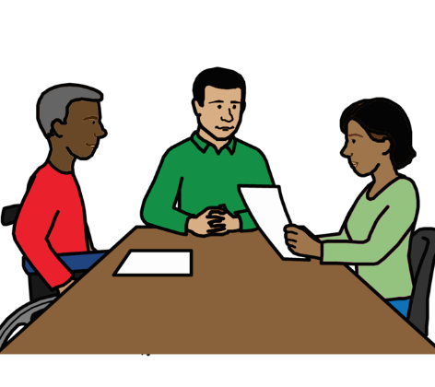
Countries, organizations and people with disabilities should work together on climate change.

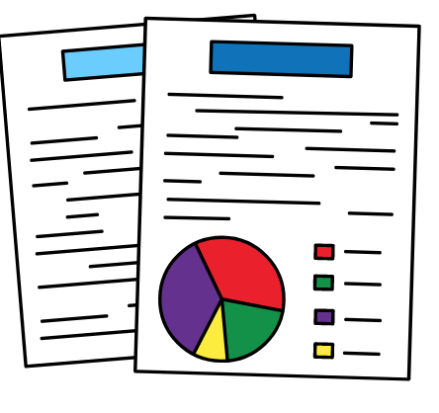
For example, they should:

- Share good ideas about how to include people with disabilities

- Get good information about problems for people with disabilities because of climate change

This will help countries know what to do

The United Nations can also help with this work.

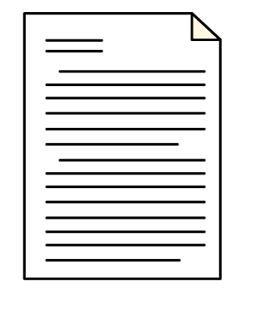

For example, the United Nations has a plan about how to include people with disabilities.

There could also be a United Nations expert who works on climate change and human rights.

Some good work that countries are doing
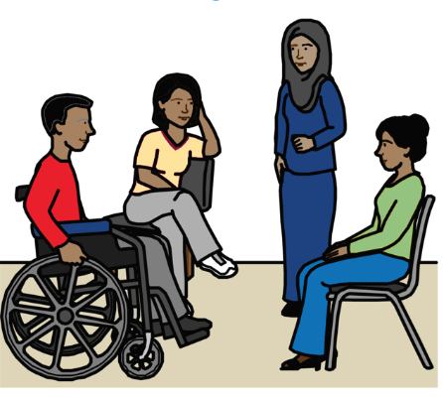

People with disabilities have been part of climate change work in Bangladesh, Nepal and Uganda.

For example, people with disabilities helped to make decisions and support other people in the community.
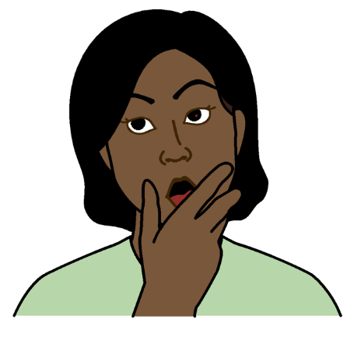

A climate change project in Ethiopia has helped people to change the way they think about people with disabilities.

The Philippines, Ecuador and Indonesia have climate change plans that include the rights of people with disabilities.
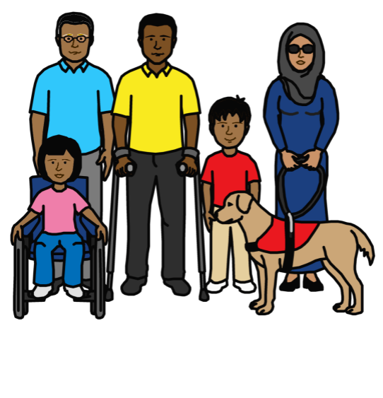

It is important that countries learn from this good work to make the lives of people with disabilities better.
Pictures by The Picture Communication Symbols ©1981–2016 by Mayer-Johnson LLC a Tobii Dynavox company. All Rights Reserved Worldwide. Thousands of resources available for free at www.boardmakeronline.com

