United Nations Human Rights Council
United Nations High Commissioner for Human Rights

Climate change and the rights of people with disabilities

Climate change is about the earth getting warmer and the problems this causes for people and the planet we live on.

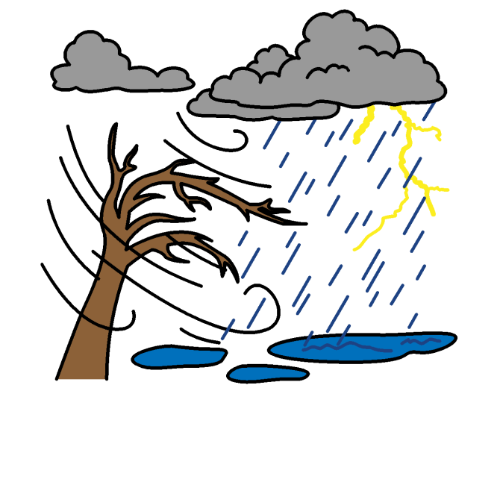

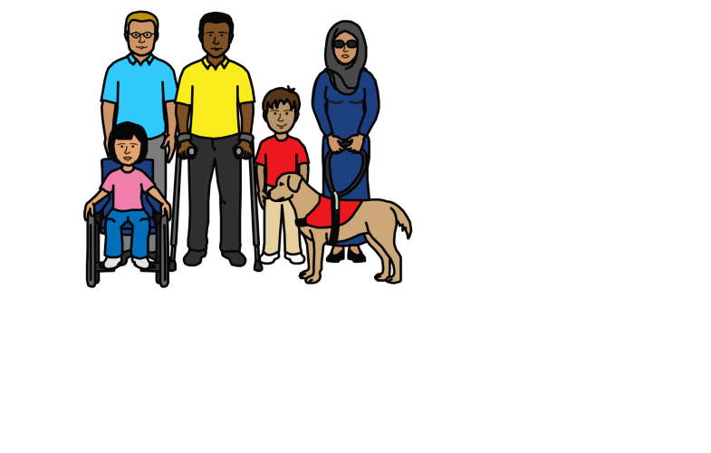

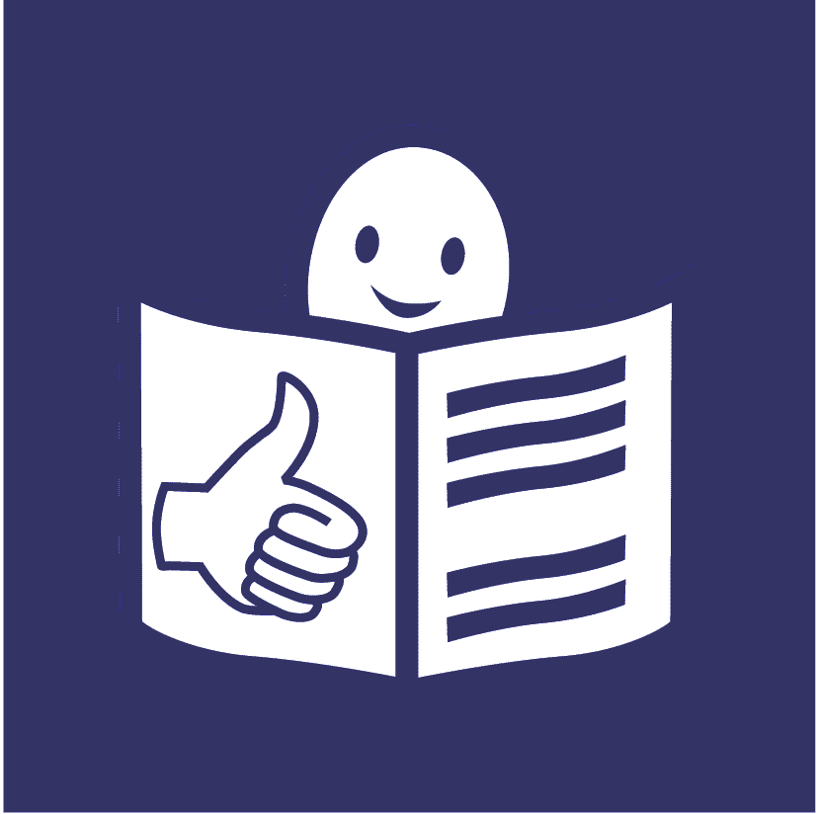
Analytical study on the promotion and protection of the rights of persons with disabilities in the context of climate change (A/HRC/44/30)

About us
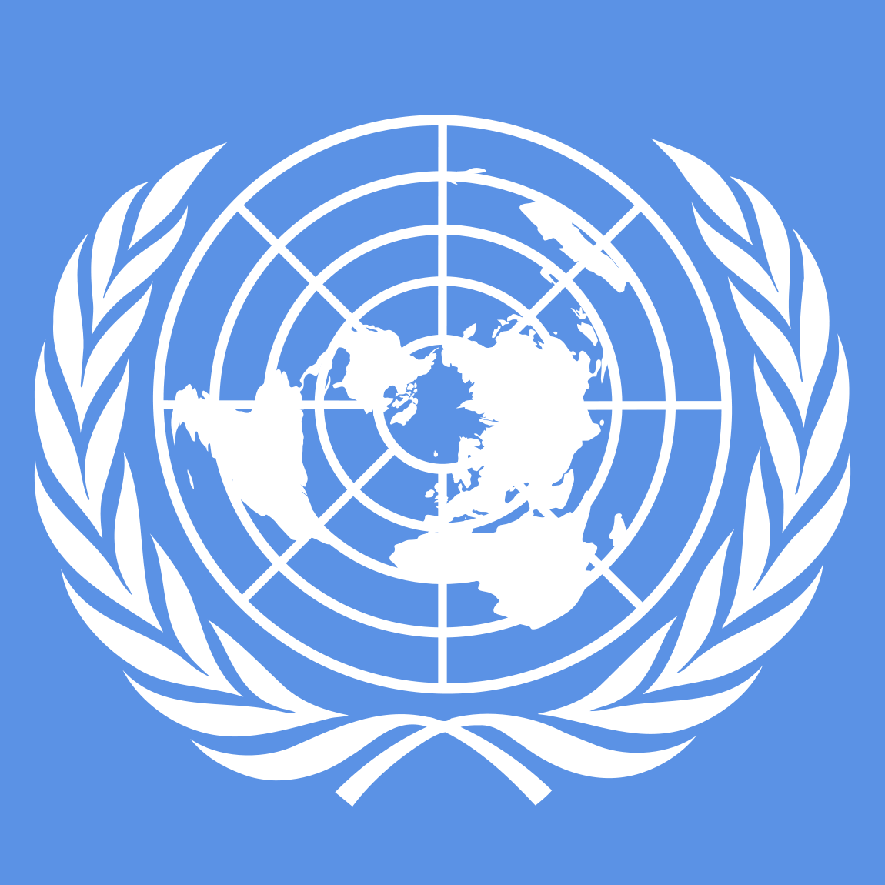

We are called the Office of the High Commissioner for Human Rights.

We are part of the United Nations (UN).
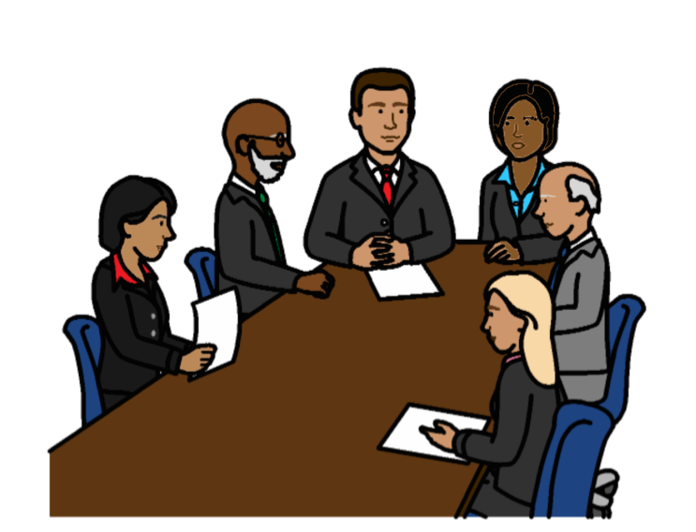

The United Nations is a group of countries that work together to make the world better and safer.

About this report

This report is about climate change and the rights of people with disabilities.

Rights are about what should happen in everyone’s lives.

For example, everyone has the right to be safe and treated fairly.

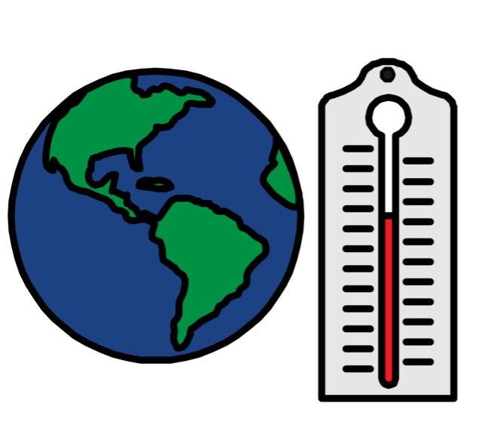
Climate change is about changes to the earth we live on.

The earth is getting warmer.

This causes big problems for people and the planet we live on.

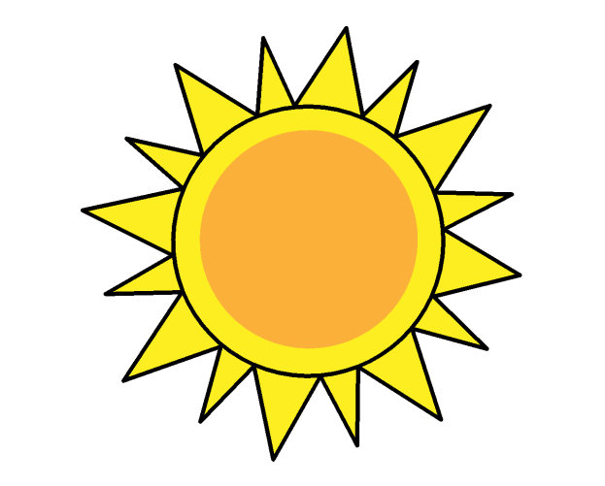
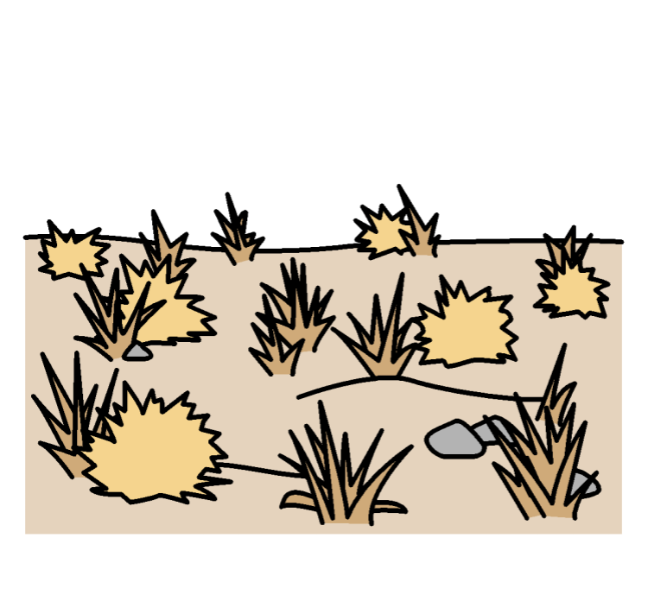
For example, climate change can cause:

- Floods and weather problems, like too much heat, no rain and bad storms

- Problems for fish, animals and plants

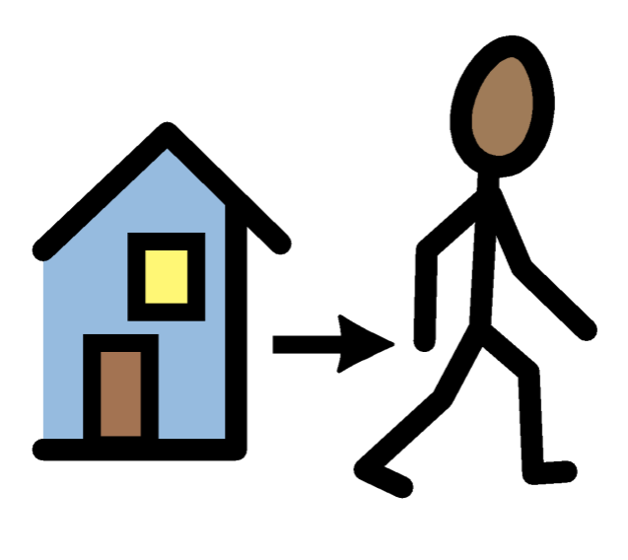
This could mean that:

- More people have to leave their homes because of floods and other climate change problems

- There might be some problems getting food and water

This report is about:

- Problems that climate change has caused for people with disabilities and their rights

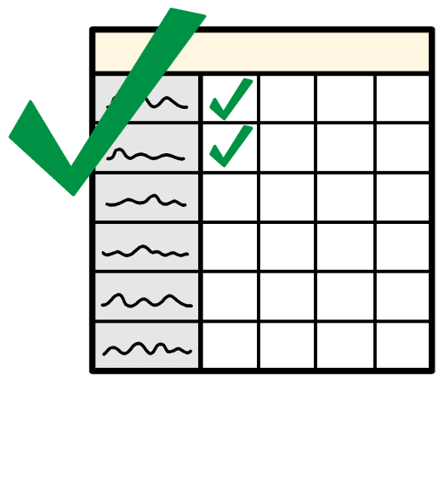

- What countries and organizations should be doing about this

- Some good work that countries and organizations told us they are doing
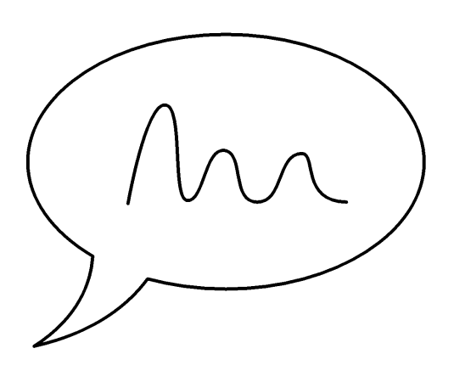
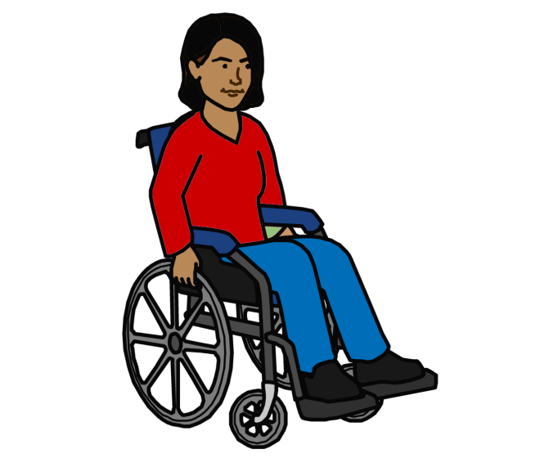

We wrote this report to make sure that people with disabilities have more say in what happens about climate change.

Problems for people with disabilities because of climate change
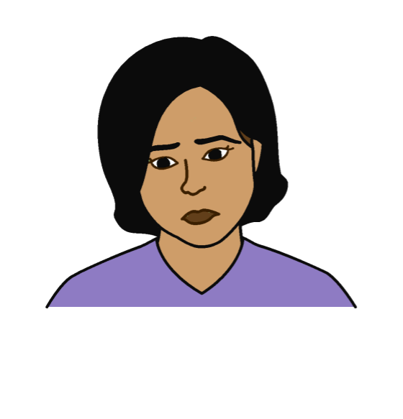

Climate change can cause problems for everyone.

But the problems might be worse for some people with disabilities.

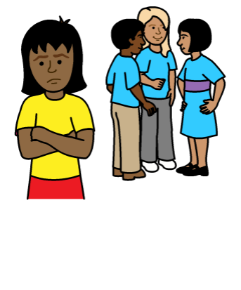
For example, because:

People with disabilities are already left out and treated badly.

They can find it hard to get the things they need.

This includes in an emergency, like floods, storms and not enough rain.
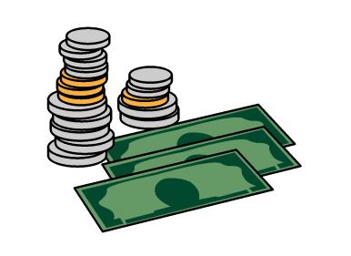


Many people with disabilities are poor.

Climate change can affect poor people more.

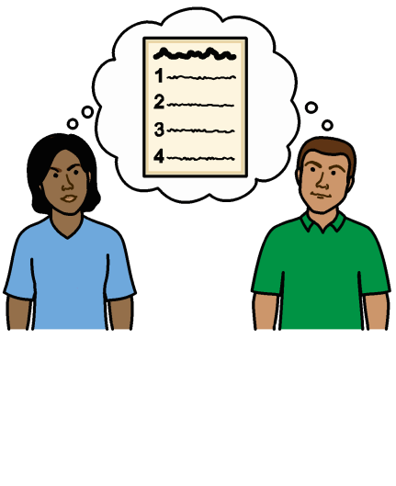
Climate change can make life even worse for people with disabilities.

For example:

- Plans about what to do in an emergency might not include people with disabilities.
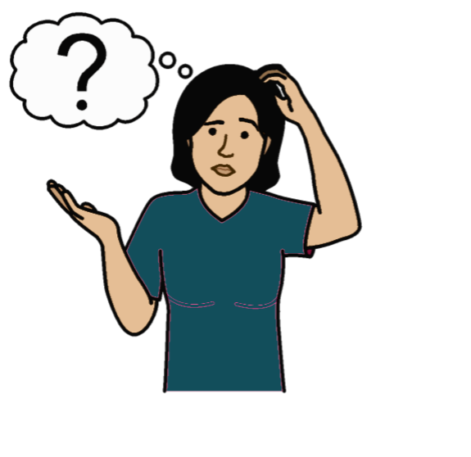



- People with disabilities might not get information they can understand about climate change problems.

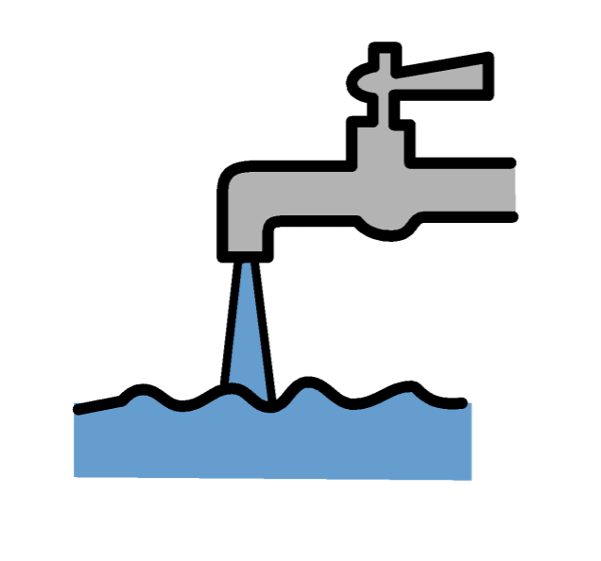

- It can be even harder for people with disabilities to get things they need in an emergency.

Like food, water, health care, housing
and education

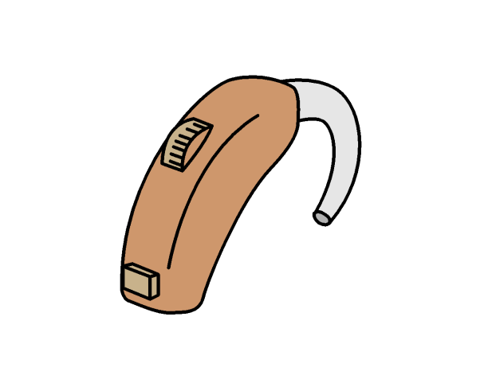
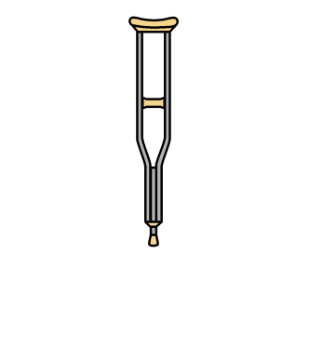
- People with disabilities might need wheelchairs, hearing aids or other things to help them.

They might lose these things if they have to leave home quickly.
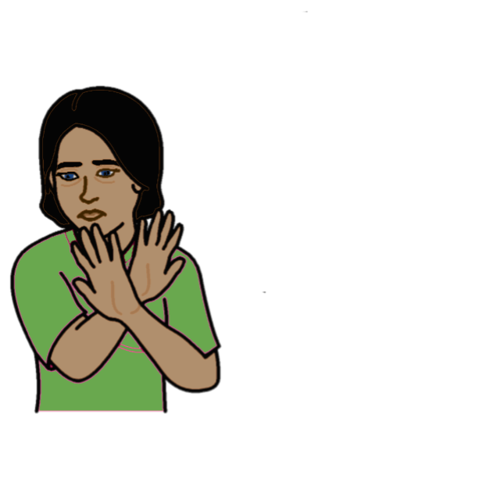
- Violence can happen more to people with disabilities when there are big problems in the country.

This is often worse for women and girls with disabilities.

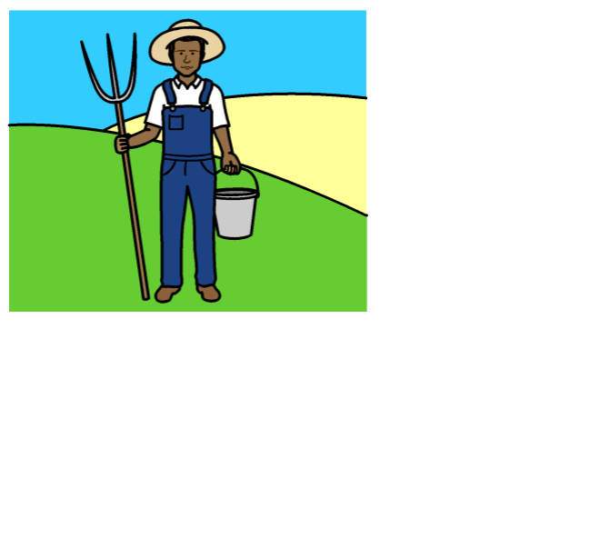
- Some people with disabilities who work might lose their jobs because of climate change.

For example, some people with disabilities might earn money from growing food or fishing.

This could stop because of climate change.
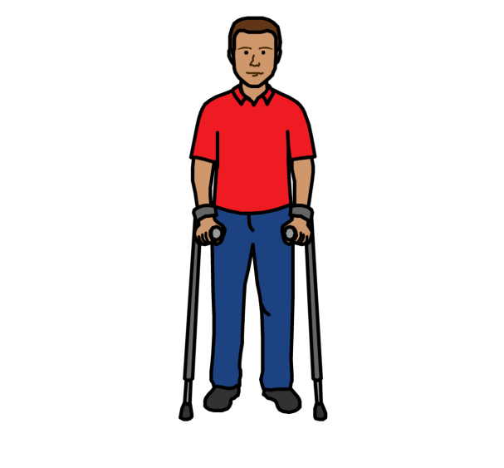

- Some people might have to leave home because of climate change problems.

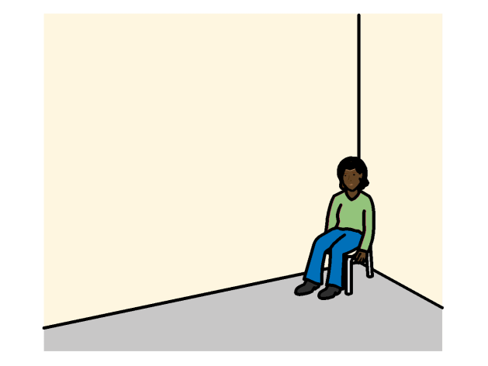
It can be hard for people with disabilities to leave home and move to a safe place.

Some people with disabilities might have
to stay in unsafe places without support.

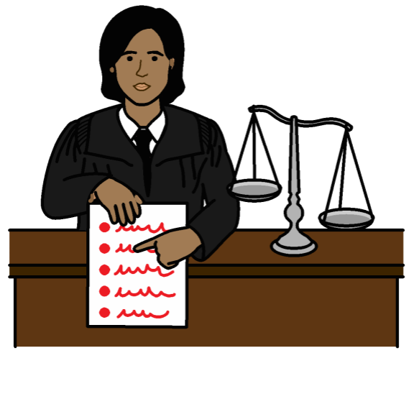
What countries and organizations should be doing

Countries should follow laws in the world about human rights when they work on climate change.

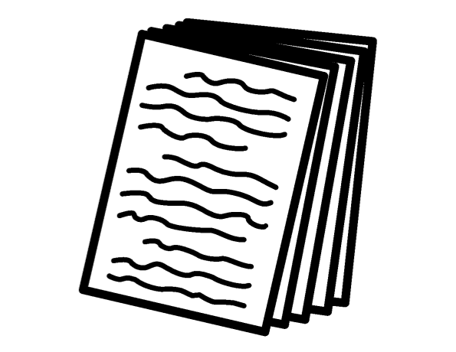

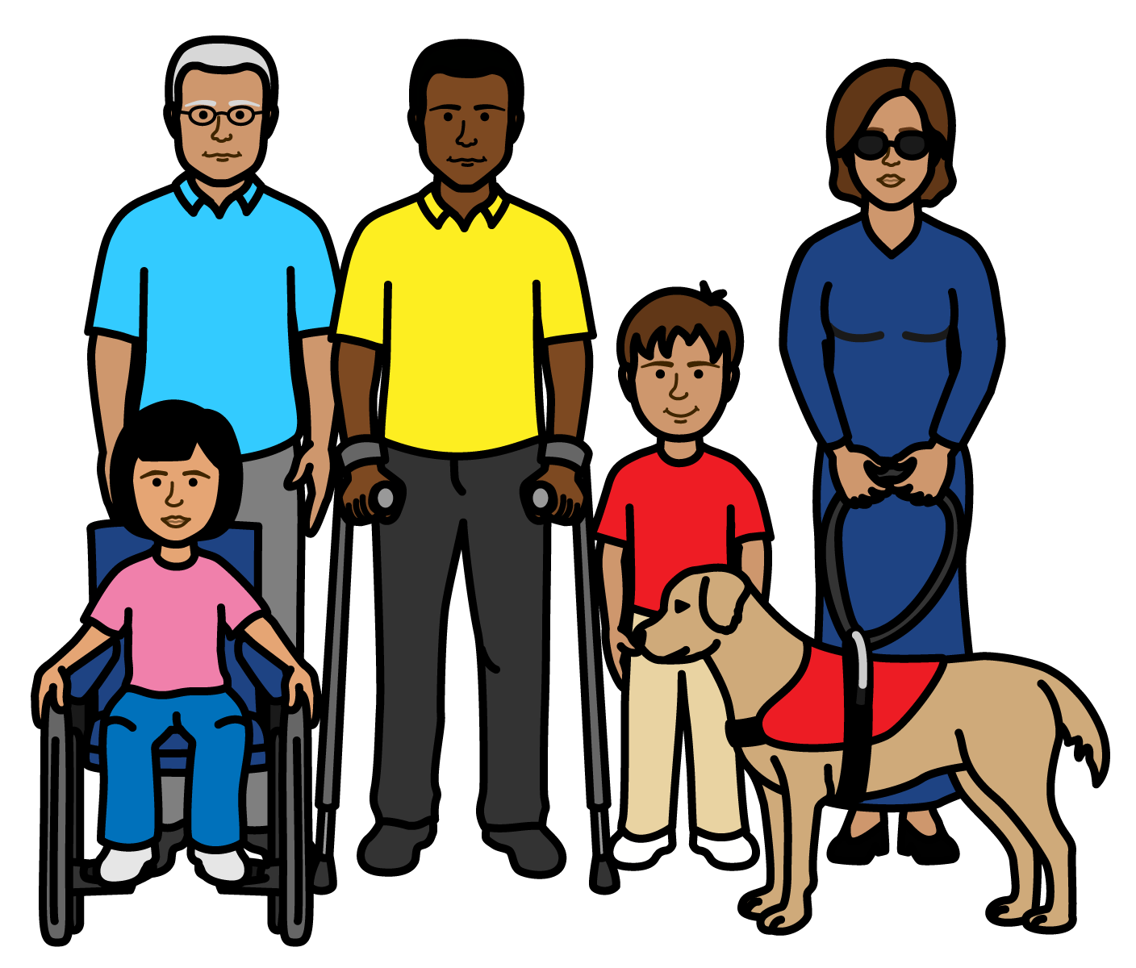
For example, there is a document about the rights of all people with disabilities in the world.

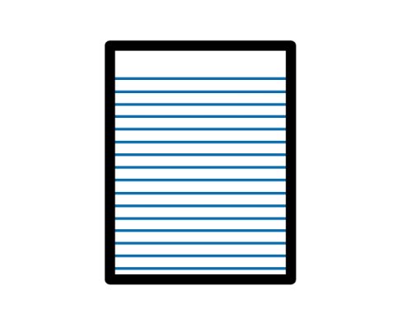
It is called the Convention on the rights of persons with disabilities.

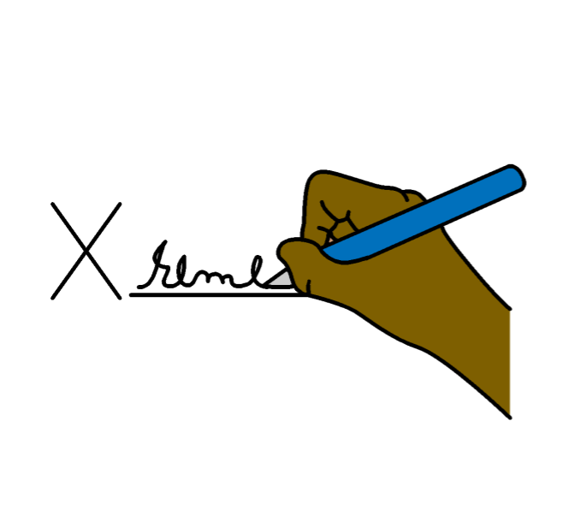
And there are things that countries have agreed together about climate change.

This includes about the rights of people with disabilities.
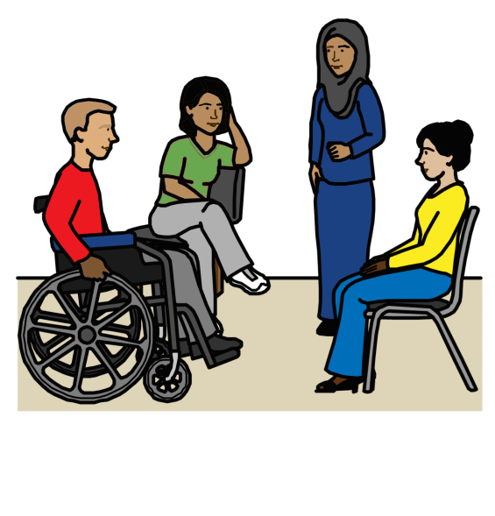

Countries should work with people with disabilities on climate change from the start.
Countries should include people with disabilities in all laws and plans about climate change.

This will make sure that:

- Laws and plans work well for people with disabilities
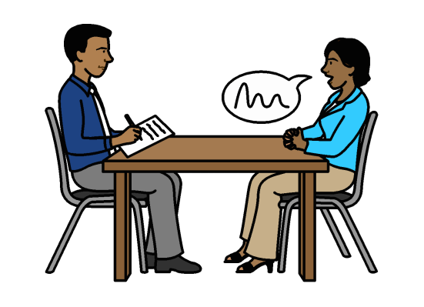

- People with disabilities have a real say in what happens.

They should be able to make important decisions about climate change and help to change things
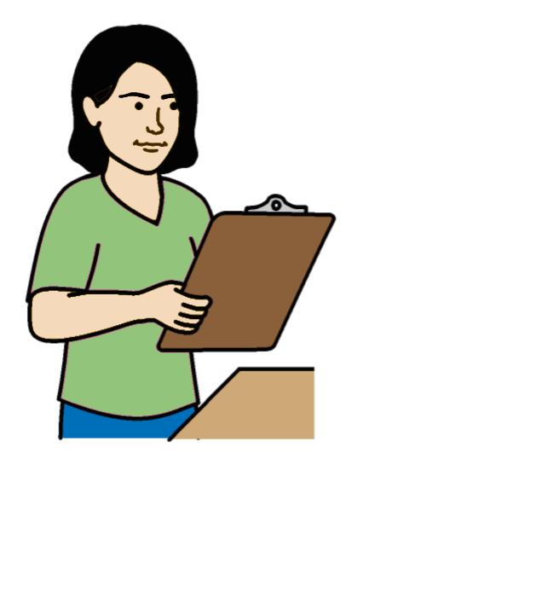

There should be:

- Checks to make sure this happens

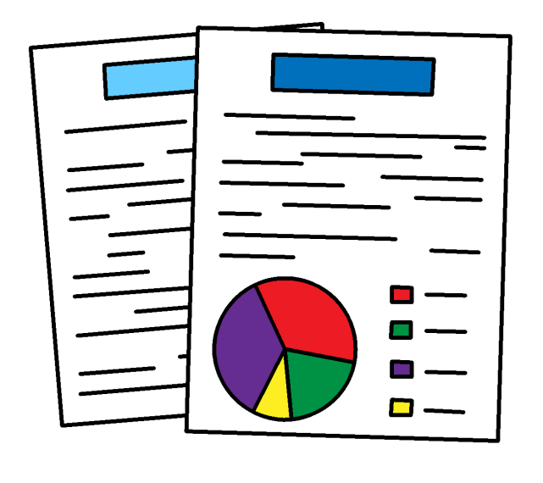
- Good information to show what is happening to people with disabilities because of climate change

- Support for people with disabilities to have their say
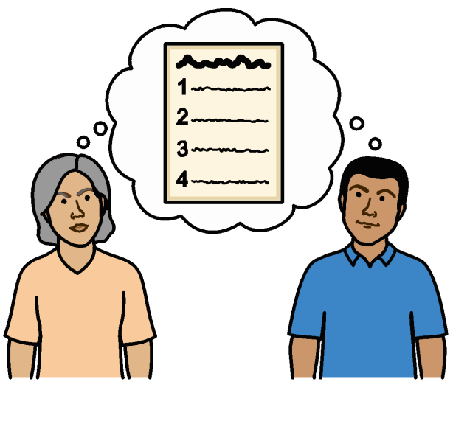
Plans about climate change should say what people with disabilities need.

There may need to be some plans just for people with disabilities.

Countries and organizations should work together to make the following things happen:

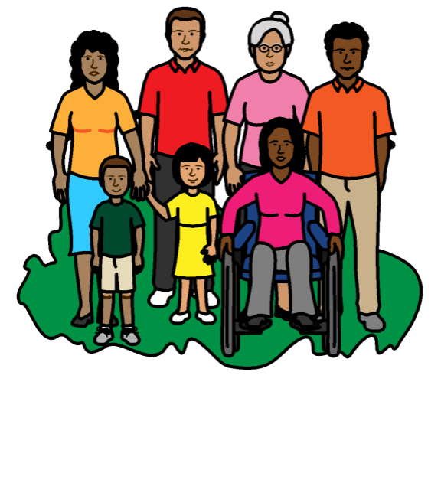

People with disabilities should be treated fairly when work is done on climate change.

They should not be left out or treated badly.

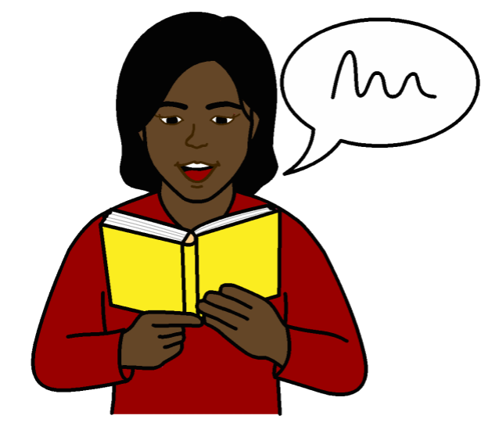
People with disabilities should have information they can understand about climate change.

This will help them know what to do and make decisions about climate change.

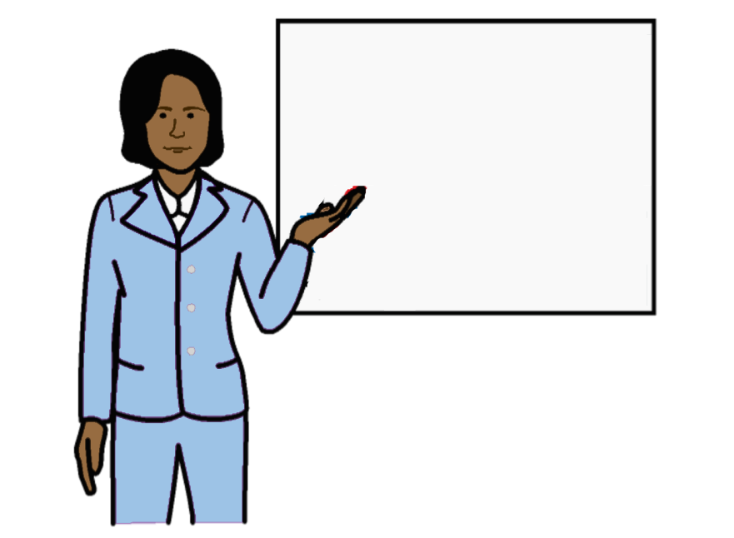
People with disabilities should have the right skills to deal with climate change.

For example, they should be able to get the right education, training and jobs.

This includes new jobs to do with climate change.
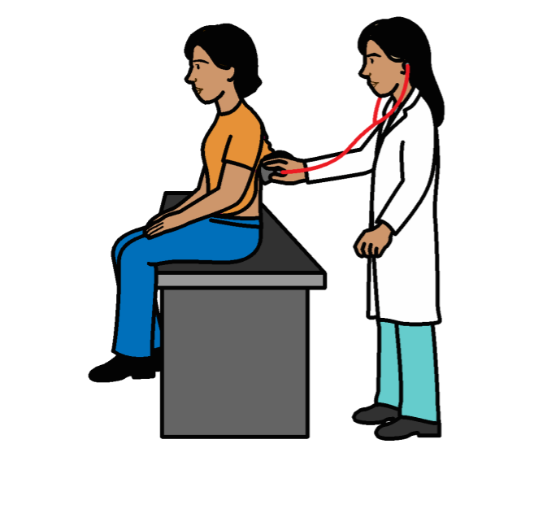

People with disabilities should be able to get and use everything they need.

Like transport, money, health care, education and other services.

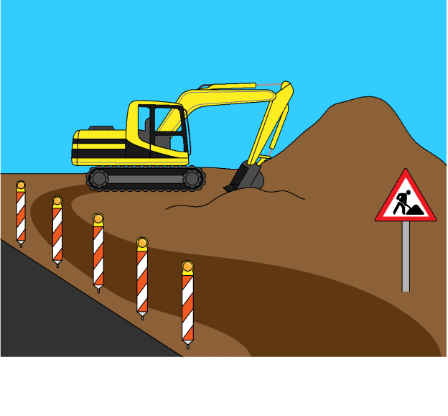

Countries may need new buildings, homes and services after an emergency.
These new things should work well for people with disabilities.

People should know more about people with disabilities, what they need and what they can do.

This includes people who support people in an emergency.

Some good work that countries and organizations have done on climate change

Many countries have laws and plans about climate change that include people with disabilities.

For example, Jordan, India, Spain,
Cuba, Colombia, Armenia, Italy, Sweden, El Salvador and Ghana.

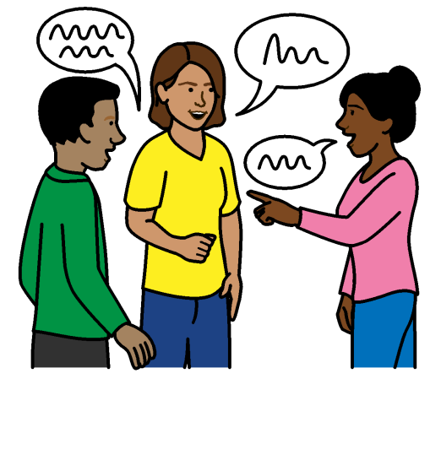

Cuba is making sure that:

- People with disabilities get better information and support with climate change problems

- There is information to show what has been done to support people with disabilities

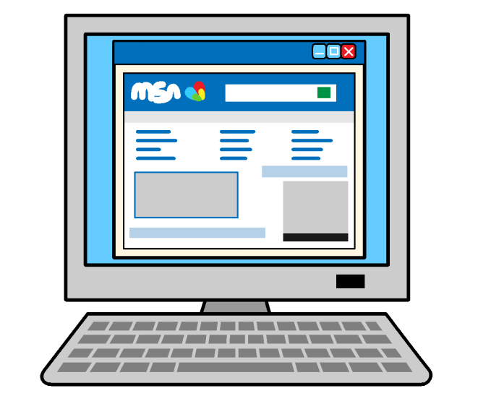
Finland is making information on the internet about climate change easier for people with disabilities to understand.

Organizations in Bangladesh, India and Puerto Rico are working to give people with disabilities better support during floods, storms and other problems.

For example, support with jobs and safe places to stay.

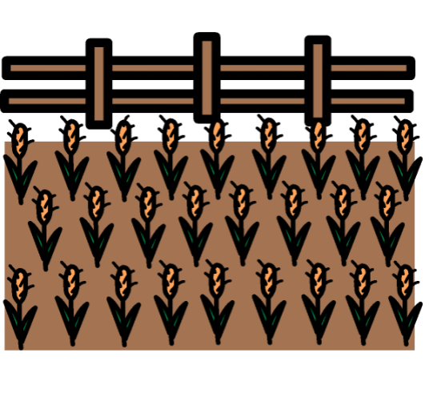

Organizations in Niger are helping people with disabilities to grow food to eat and sell that will be safe in very strong winds.

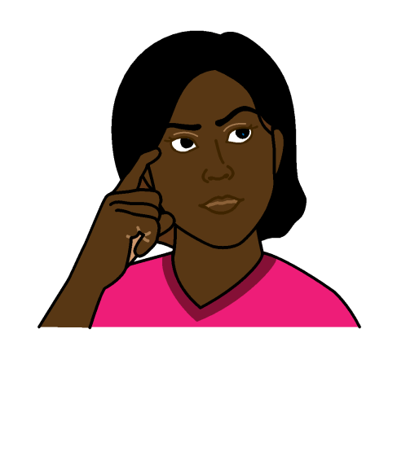
They are also helping people with disabilities to have their say about climate change.

A climate change project in Ethiopia is helping people change the way they think about people with disabilities.

Pictures by The Picture Communication Symbols ©1981–2016 by Mayer-Johnson LLC a Tobii Dynavox company. All Rights Reserved Worldwide. Thousands of resources available for free at www.boardmakeronline.com
The Picture Communication Symbols ©1981–2016 by Mayer-Johnson LLC a Tobii Dynavox company. All Rights Reserved Worldwide. Thousands of resources available for free at www.boardmakeronline.com

