A/HRC/WG.2/19/CRP.5
19 April 2018

Original: English
Human Rights Council
Working Group on the Right to Development
Nineteenth session
Geneva, 23 – 27 April 2018
Item 4 (c) of the provisional agenda
Review of progress in the implementation
of the right to development
International Investment Agreements and Industrialization:
Realizing the Right to Development and the Sustainable
Development Goals
Bhumika Muchhala*
Summary
This paper/study addresses provisions in International Investment Agreements (IIAs), comprised of bilateral investment treaties (BITs) and free trade agreements (FTAs), including the investor-state dispute settlement system (ISDS), and the constraints they pose to achieving the right to development (RTD) through inclusive, equitable and sustainable industrial development, as envisaged by the RTD and emphasized in Sustainable Development Goal 9, which is centered on promoting inclusive and sustainable industrialisation.
The particular set of constraints examined are that of the investor protections within IIAs, which are provided to investors in both countries that sign an IIA and are enforced on States by the investor-state dispute settlement (ISDS) mechanism. Specifically, the challenge examined in this paper is that of the ability of States who are parties to IIAs to carry out industrialisation strategies towards the objective of creating a diversified and dynamic domestic economy.
The cumulative number of IIAs have increased from 72 in 1969, 385 in 1989, 1857 in 1999 and 2750 in 2009. As of February 2018, 2947 bilateral IIAs exist, of which 2364 are in force. Prohibitions on performance requirements within IIAs, or conditions that States design for foreign investors to meet in order to establish or operate a business in their territories, are an important investment protection measure that impacts the ability of States to carry out industrial development policies to realise their RTD. Performance requirements have historically served as important policy tools that facilitate national industrialisation through, for example, augmenting the value of production, productivity rates and employment creation in domestic economic activities; diversifying economic sectors towards a balanced mix of agriculture and raw materials, goods manufacturing and services; creating domestic links between the various stages of manufacturing; regulating national trade balances; and, incentivizing the innovation and development of technology, including clean technology.
The defining feature of investment treaties is the investor-state dispute settlement system (ISDS), through which a foreign investor can bring the host government to an international arbitration tribunal and seek monetary compensation for State measures that impact current or future profits for the investor. Measures that have been subjected to challenge include, for example, human rights, public interest, and environmental regulations such as government bans on harmful chemicals, bans on mining, environmental restrictions on mining, requirements for environmental impact assessments, regulations regarding transport and disposal of hazardous waste, and regulations governing health insurance. Financially, the burden these arbitration disputes can place on States through monetary compensations is significant.
Other investment protection measures include fair and equitable treatment obligation, national treatment obligation and pre-establishment rights, most favoured nation treatment obligation, and binding restrictions on capital account regulations. The fair and equitable and national treatment obligations stipulate that foreign investors and the terms of their investment should be treated no less favourably than domestic investors are treated. The host State’s ability to provide special assistance to domestic firms and investors is thus affected, as is the State’s ability to regulate and control the present and future entry of foreign individuals and entities. This is particularly important to the interest of safeguarding domestic economic sectors, national security and other legitimate concerns such as spurring domestic research and development, innovation capacity and domestic revenue expansion. The most favoured nation treatment obligation allows investors to search for stronger investment protections in all other IIAs its host State has with other States, while requiring the free flow of capital exposes all States to destabilising capital flows, which in turn impacts domestic economic stability.
Women’s rights are implicated in IIAs through the impacts of foreign investment on women workers and entrepreneurs. Small and medium enterprises are particularly important for women’s employment and livelihoods, and labour rights violations are often endemic to export processing zones where over three-quarters of the workforce is typically female. Domestic producers often shift the competitive pressures they face from global investors and buyers onto their predominantly female workforce through trends such as precarious employment, low wages, and extensive working hours.
The principles and elements of the Declaration on the Right to Development (DRTD) mandate national and international development policies to create an enabling environment for development, thus making it an effective human rights tool to address obstacles posed by IIAs. Five key DRTD articles have particular bearing on investment protection provisions within IIAs: Article 2.3 on the right and duty of States to formulate appropriate national development policies; Article 3.1 on the primary responsibility of States to create national and international conditions favourable to the realization of the right to development; Article 3.3 calling on States to cooperate with each other to ensure development and eliminate obstacles to development, based on principles of human rights, sovereign equality, interdependence and mutual interest; Article 4.2 on the importance of sustained action to promote more rapid development of developing countries by providing them with appropriate means and facilities to foster comprehensive development; and, Article 8.1 highlights the need for economic and social reforms to address all social injustices and equality of opportunity for all people, particularly ensuring an active role for women in the development process.
Agenda 2030 also bears direct relevance to the challenges IIAs place on industrial development and economic growth. SDG 9 is focused on achieving inclusive and sustainable industrialization, in part by raising industry’s share of employment and gross domestic product (GDP) by 2030 and to double their share in Least Developed Countries (LDCs). SDG 8 promotes sustained, inclusive and sustainable economic growth, full and productive employment and decent work for all. SDG 17 on the means of implementation underscores in target 17.15 the respect States should have for each other’s national policy space and leadership to implement policies for poverty eradication and sustainable development. Industrial policy is a potent example of a means of implementation, in that it refers to state-led efforts to direct the economy’s production structure towards sectors that are expected to offer growth, employment, productivity and development opportunities. The integral link between industrialisation and development is reaffirmed by various UN processes beyond the SDGs in the Post-2015 Development Agenda, such as the Fourth UN Conference on the LDCs in the 2011 Istanbul Programme of Action and the General Conference of the United Nations Industrial Development Organization (UNIDO) in the 2013 Lima Declaration.
Based on this analytical study, policy recommendations for reforms and actions to investor protection measures within IIAs are proposed bearing in mind the objective of facilitating national industrial development and achieving sustainable development as outlined in the 2030 SDGs framework as well as in the DRTD. Recommendations are addressed to four categories of key stakeholders, which include, IIA amendments, IIA interpretations, options on performance requirements, unilateral termination and human rights impact assessments (HRIAs) of trade and investment agreements for States; information on options and best practices, amendment, interpretation and exit options in IIAs, monitoring developments in IIAs, and data provision on FDI attraction for International Organizations; engaging States in advance of an ISDS process, inclusion of HRIA and women’s rights language in IIAs, and identifying what is not working in IIAs for the Private Sector, or Investors; and, monitoring IIA developments, advocacy and capacity building on industrial development and RTD, and advocacy and capacity building on women’s rights and HRIA for Civil Society.
Contents
Page
I. Introduction 5
II. International Investment Agreements and Constraints to Realizing
the Right to Development 11
III. Constraints on Industrial Development Policies – Impediments to Sustainable
Development Goals and Financing for Development 14
IV. North-South Asymmetries and Differentiated Responsibilities 20
V. Industrial Development, Means of Implementation and Performance Requirements 21
VI. Investor-State Dispute Settlement and Undermining National Laws and Regulations 25
VII. Women’ Rights in the Context of Foreign Direct Investment and Labour 30
VIII. Policy Recommendations 33
IX Conclusion 39
Annexes 42
List of Abbreviations 44
I. Introduction
1. This paper comprises an analytical study of International Investment Agreements (IIAs) in the international economy through three specific frameworks: The 1986 United Nations (UN) Declaration on the Right to Development (DRTD); ‘Transforming our world: the 2030 Agenda and Sustainable Development’, (2030 Agenda) and Sustainable Development Goals (SDGs); and the Addis Ababa Action Agenda (AAAA), the outcome document of the third International Conference for Financing for Development (FfD), held in 2015. Its objective is to identify and unpack the key structural obstacles posed by IIAs to realizing the right to development (RTD), the SDGs and the AAAA particularly in developing countries, which are disproportionately affected by them.
2. The 2030 Agenda states in paragraph 10, that ‘it is guided by the purposes and principles of the Charter of the United Nations, including full respect for international law. It is grounded in the Universal Declaration of Human Rights (UDHR), international human rights treaties, the Millennium Declaration and the 2005 World Summit Outcome. It is informed by other instruments such as the Declaration on the Right to Development.’ In paragraph 35, the Agenda recognizes the need to build peaceful, just and inclusive societies that provide equal access to justice and that are based on respect for human rights (including the right to development), on effective rule of law and good governance at all levels and on transparent, effective and accountable institutions.
3. In establishing the Office of the United Nations High Commissioner for Human Rights, the General Assembly requested the High Commissioner to recognize the importance of promoting a balanced and sustainable development for all people and to protect and promote the realization of the RTD along with all other human rights. Achieving inclusive, equitable and sustainable development in line with human rights norms, standards and principles requires the critical review of challenges and obstacles to development through the normative framework of human rights, including the RTD.
4. This study is framed by the normative framework of the DRTD, aimed specifically at creating an enabling national and international environment for development; and the development policy framework of the 2030 Agenda and the AAAA. Analysis through the RTD lens makes the consideration of all other human rights - civil, political, economic, social and cultural – also inevitable, given the indivisibility and interdependence of all human rights, and the requirement under the DRTD, of a development process which advances all human rights. The scope of this study involves consideration of all human rights through the RTD lens, without embarking on an analysis of IFFs through the human rights framework as a whole, which would entail a much bigger project.
5. This study highlights the importance of analysing IIAs through the normative framework of the RTD, with a view to achieving inclusive, equitable and sustainable development in consonance with human rights norms, standards and principles. It does so by exploring the linkages between the RTD, the SDGs and the AAAA in the context of the 2030 Agenda, with a view to operationalizing the constituent principles of the DRTD in implementing the SDGs and the AAAA.
6. The preamble to the DRTD affirms “that the right to development is an inalienable human right and that equality of opportunity for development is a prerogative both of nations and of individuals who make up nations,” and recognizes “that development is a comprehensive economic, social, cultural and political process, which aims at the constant improvement of the well-being of the entire population and of all individuals on the basis of their active, free and meaningful participation in development and in the fair distribution of benefits resulting therefrom.” The DRTD upholds the key human rights principles of equality, non-discrimination, participation, accountability, transparency, and international cooperation. The DRTD places a special focus on the right of individuals, peoples and nations to realize development and its Articles spell out responsibilities of the State, such as the “right and the duty to formulate appropriate national development policies that aim at the constant improvement of the well-being of the entire population and of all individuals” in Article 2.3, the primary responsibility of the State “for the creation of national and international conditions favourable to the realization of the right to development” in Article 3.1 and the duty of States to “co-operate with each other in ensuring development and eliminating obstacles to development” in Article 3.3.
7. The DRTD builds on the UN Charter which calls for international co-operation in solving international problems; the Universal Declaration of Human Rights which recognizes that everyone is entitled to a social and international order in which all rights and freedoms can be fully realized, the International Covenant on Economic, Social and Cultural Rights, the International Covenant on Civil and Political Rights, the Rio Declaration on Environment and Development, and other international instruments. Among them, the Vienna Declaration and Programme of Action (VDPA), the outcome document of the World Conference on Human Rights in 1993, in Article 10, reaffirmed the right to development, as established in the DRTD, as an integral part of fundamental human rights, and as a universal and inalienable right which must be implemented and realized. The VDPA reiterated the DRTD’s position that the human person is the central subject of development and that States should cooperate with each other in ensuring development and eliminating obstacles to development. It states that the international community should promote an effective international cooperation for the realization of the right to development and the elimination of obstacles to development. Lasting progress towards the implementation of the right to development requires effective development policies at the national level, as well as equitable economic relations and a favourable economic environment at the international level. Both Principle 3 of the Rio Declaration on Environment and Development and paragraph 11 of the VDPA, have long recognized that: “The right to development should be fulfilled so as to meet equitably the developmental and environmental needs of present and future generations.”
8. The principles and elements of the DRTD make it a directly relevant and arguably effective advocacy tool to address obstacles posed by IIAs, not least because it mandates national and international development policies to create an enabling environment for development. The Declaration provides a viable basis for legal cases in the African human rights system where it is justiciable by virtue of its embodiment in Article 22 of the African Charter on Human and Peoples’ Rights and related jurisprudence. Elsewhere, the RTD applies by virtue of the DRTD as well as various regional human rights instruments. While a discussion on the legal status and justiciability of the DRTD specifically or Declarations generally is beyond the scope of this study, it is noted that Declarations can and do give rise to rights and obligations in certain instances, and frequently embody general principles and normative frameworks which comprise the progressive development of international law. Moreover, the DRTD contains several obligations which are legally binding by virtue of their integration in binding treaties and customary international law; and Declarations and their contents can with time, themselves crystallise into customary international law.
9. The DRTD is situated within the interface of human rights law on the one hand and the global political economy of development on the other. Its core ethos and paradigm for proactively creating an enabling international environment for development makes it a prerequisite to achieving the SDGs, in addition to all other human rights. In the context of persistent social and economic inequalities between developed and developing countries that stem from various asymmetries in, for example, aggregate national wealth, resources, access, infrastructure, consumption and production and technological development, the DRTD addresses the critical need for equality of opportunity for inclusive, equitable and sustainable development.
10. The 2030 Agenda for Sustainable Development and its 17 SDGs and their 169 targets establish transformative shifts that reinforce the need to uphold the right to development, such as the following:
- interdependence and indivisibility of the three dimensions of sustainable development - economic, social and environmental;
- all human rights and fundamental freedoms;
- gender equality and the empowerment of all women and girls;
- universality of the goals in applying to countries at all levels of development; and,
- the forging of a new global partnership for sustainable development through integrating the means of implementation to achieve all the SDGs through structural policy reforms, among others.
11. IIAs comprise bilateral investment treaties (BITs) and free trade agreements (FTAs). Provisions contained in IIAs can pose constraints to the RTD particularly in developing countries. SDG 9 aims to promote “inclusive and sustainable industrialisation” in target 9.2, which relates closely to the RTD. Target 9.2 calls for raising industry’s share of employment and gross domestic product (GDP) by 2030 and to double their share in Least Developed Countries (LDCs). Target 9.3 aims for an increase in the access of small-scale industrial and other enterprises, in particular in developing countries, to financial services, including affordable credit, and their integration into value chains and markets. Target 9.4 stipulates that by 2030, infrastructure should be upgraded toward sustainability, with increased resource-use efficiency and greater adoption of clean and environmentally sound technologies and industrial processes, with all countries taking action in accordance with their respective capabilities. Target 9.5 promotes the enhancing of scientific research and upgrading of the technological capabilities of industrial sectors, target 9.b supports domestic technology development, research and innovation in developing countries and indicator 9.5.1 stipulates research and development expenditure as a percentage of GDP. SDG 17 aims to strengthen the means of implementation for realizing all the 17 Goals, and revitalize the global partnership for sustainable development. In Paragraph 63 of the 2030 Agenda and in SDG 17.15, States commit to respecting each other’s national policy space and leadership to implement policies for poverty eradication and sustainable development. States acknowledge that “national development efforts need to be supported by an enabling international economic environment, including coherent and mutually supporting world trade, monetary and financial systems, and strengthened and enhanced global economic governance,” and commit “to pursuing policy coherence and an enabling environment for sustainable development at all levels and by all actors, and to reinvigorating the global partnership for sustainable development.”
12. According to the International Labour Organisation (ILO) and the United Nations Conference on Trade and Development (UNCTAD), economic development is a process of continuous technological innovation, industrial upgrading and structural transformation. Broad-based interventions by States to support national industrial upgrading and economic diversification are critical to the objective of stimulating sustainable national economic growth, create formal sector employment and increase the productivity of the labour force as well as the value of their production. This study looks at SDGs 9 on industrialisation and infrastructure and SDG 17 on means of implementation to assess the ways in which IIAs challenge the RTD in countries through constraints posed to national strategies to spur industrial development. The particular set of constraints examined are that of the investor protections within IIAs, which apply to investors in both countries that sign an IIA and are enforced by the investor-state dispute settlement (ISDS) mechanism. Specifically, this challenge involves the ability of countries to carry out industrialisation strategies towards the objective of creating a diversified and dynamic domestic economy. This is vital to achieving several SDGs, including SDG 8 on sustained, inclusive and sustainable economic growth as well as full and productive employment and decent work for all and SDG 10 on reducing inequality within and among countries. Industrialisation pathways, when approached with careful attention to inclusivity, social and environmental sustainability and economic and social rights of people, including women, have the potential to facilitate the vision of sustainable development, poverty reduction and inclusivity contained in the 2030 Agenda.
13. As the United Nations Division for Sustainable Development affirms, industrialisation strategies facilitate the structural transformation from primary commodities to manufacturing and services, which are positively correlated with GDP and skilled employment. In particular, manufacturing sectors have a multiplication effect in creating jobs. Every one job in manufacturing creates 2.2 jobs in other sectors. As a result the indicators for target 9.2, which promotes inclusive and sustainable industrialization, are focused on increasing manufacturing value added, or in other words the economic value that the manufacturing sector contributes to aggregate national GDP, and employment as a percentage of GDP. In light of the historical linkage between industrialisation and violations to human rights and negative impacts on environmental sustainability, the terms inclusive and sustainable are crucial prerequisites for industrialisation to work towards achieving sustainable development, employment creation, including women’s employment, and sustainable economic growth. A sustainable industrialization requires a decoupling from negative environmental impacts and unregulated use of raw materials, for example; and an inclusive industrialization requires ex-ante attention to preventing the exacerbation of social and economic inequalities, labour rights violations, the formation of monopolies and issues of political influence, corruption and rent-seeking in the process of industrial development.
14. The integral link between industrialisation and development is reaffirmed by various UN processes. The Fourth UN Conference on the LDCs produced a negotiated outcome document in 2011 that reaffirmed the importance of industrialization for economic growth, poverty eradication and the structural transformation of LDC economies. This entails the growth and expansion of domestic productive activities from primarily agricultural commodities and raw materials to manufacturing and service activities that employ greater levels of technology, trade and linkages between the different sectors. The outcome document maintained that sustained economic growth and sustainable development in LDCs requires a mix of industrialisation, infrastructure, technological development and investment that also addresses agriculture, forestry and energy. The General Conference of the United Nations Industrial Development Organization (UNIDO), held in 2013, underscored that “industrialisation is a driver of development.” The Lima Declaration produced by the conference asserted that industrial development increases productivity, job creation and income generation. It contributes to poverty eradication and other development goals while also providing opportunities for social inclusion, gender equality, and creation of decent employment for youth. A virtuous cycle of industrial development is highlighted as one where industrialisation drives an increase of value addition and enhances the application of science, technology and innovation, therefore encouraging greater investment in skills and education, and thus providing the resources to meet broader, inclusive and sustainable development objectives. The Second General Conference of UNIDO in 1975 had stated that every effort should be made by the international community to take measures to encourage the industrialisation of developing countries with a view to increasing their share in world industrial production.
15. In examining the ways in which the DRTD applies to the investment protection provisions within IIAs, several key DRTD articles have particular bearing Article 2.3 stipulates that States have the right and the duty to formulate appropriate national development policies aimed at the constant improvement of human well-being on the basis of their active, free and meaningful participation in development and the fair distribution of its benefits. Article 3.1 declares that “states have the primary responsibility for the creation of national and international conditions favourable to the realization of the right to development.” Article 3.3 calls on States to cooperate with each other to ensure development and eliminate obstacles to development, based on principles of human rights, sovereign equality, interdependence and mutual interest. Article 4.2 stresses the importance of sustained action to promote more rapid development of developing countries by providing them with appropriate means and facilities to foster comprehensive development. Article 8.1 highlights the need for economic and social reforms to address all social injustices and equality of opportunity for all people, particularly ensuring an active role for women in the development process. Article 10 highlights that policy and legislative measures should serve to realize the right to development at both national and international levels.
16. Existing policy guidance recommendations, reforms and recourses within the human rights domain that can respond to the constraints posed by IIAs to industrial development and realization of the RTD, include human rights impact assessments of trade and investment agreements, where specific methodologies have been developed to monitor human rights and sustainability impacts, such as the UN Guiding Principles on Human Rights Impact Assessments of Trade and Investment Agreements. These principles also have the potential to prevent obstacles posed by IIAs. Consequent to these principles, impact assessments must be conducted before approving an investment or trade agreement and continue throughout its implementation. Specific measures must be taken to mitigate negative human rights impacts. These principles guide States in ensuring that their trade and investment agreements are consistent with their obligations under international human rights instruments. Impact assessments can help ensure that States will not make demands or concessions that make it more difficult for them, or for others, to comply with their human rights obligations. They can support companies carrying out human rights due diligence to identify, prevent, mitigate, and account for the human rights impacts of their activities, particularly in the negotiation and conclusion of IIAs. Options by treaty signatory States also permit amending, interpreting or terminating investment treaties.
17. An analysis identifying key impediments to the right to development through sustainable and inclusive industrialisation, and its positive impacts on economic growth, employment and technological innovation, is important because the United Nations has recently acknowledged that the current global trajectory will not deliver the goal of eradicating poverty in all its forms and dimensions by 2030 and that there is an urgent need for concrete and immediate action to create the necessary enabling environment at all levels for the achievement of the 2030 Agenda and to accelerate national and international efforts to implement the Addis Ababa Action Agenda and the Paris Agreement. While key principles of the DRTD are reflected in the SDGs and the AAAA to a considerable extent, actual implementation of the 2030 Agenda should necessarily be linked to an enabling international environment for development. Such action should be underpinned by the DRTD, which aims specifically at creating the necessary enabling environment at all levels. This study highlights the significant linkages and implications of the issues analysed, with Agenda 2030, the SDGs and the AAAA particularly for global, regional and national advocacy and campaigning. It argues that realizing the DRTD requires a rethinking and reimagining of the status quo assumptions and politics of international economic development and the ways in which developing countries integrate into the global economy through export-orientation, trade liberalization, financial and policy deregulation and enterprise privatization.
II. International Investment Agreements and constraints to realizing the right to development
18. The historical context of inter-state treaties that aim to protect cross-border private sector investments goes back to the first bilateral investment treaty (BIT) signed between Germany and Pakistan in 1959. That time period represents the confluence of two major geopolitical fears in Western states, that of the expansion of Soviet communism beyond its post-World War II boundaries and the advent of decolonisation in many countries under colonial rule in the 1960s. The rationale behind investment protection treaties, as proposed by Lord Sawcross, a former Attorney General of the UK, and Herman Abs, Chairman of the Deutsche Bank in Germany, as articulated in the introduction to a 1960 journal publication of the first draft BIT, was the recognition “that major steps must be taken to buttress the economic position of the free-world nations greater protection under international law for private investment takes on added importance.” Since then, the cumulative number of BITs has skyrocketed from 72 in 1969, 385 in 1989, 1857 in 1999 and 2750 in 2009. Several institutional and economic factors stimulated this rise of investment treaties. As of February 2018, 2947 bilateral IIAs exist, of which 2364 are in force.

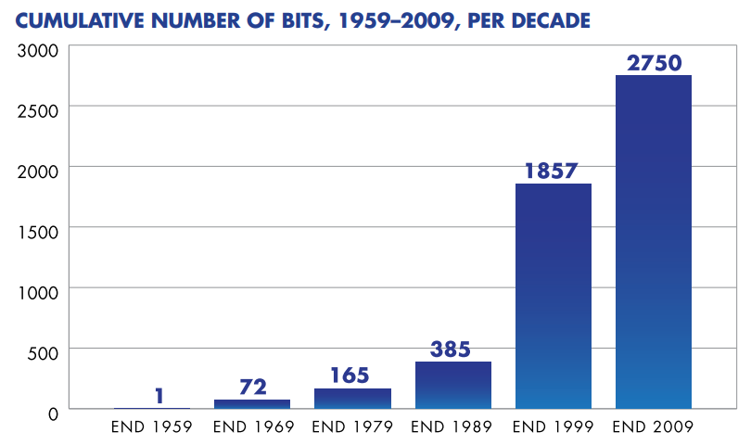
Source: Bernasconi-Osterwalder, Nathalie et al, Investment Treaties & Why They Matter to Sustainable Development: Questions and Answers, Winnipeg, Manitoba, Canada: International Institute for Sustainable Development, 2012, p. 4.
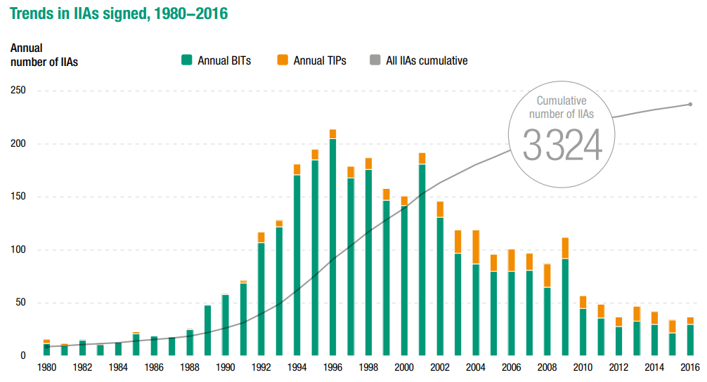
Source: United Nations Conference on Trade and Development, World Investment Report 2017, Geneva, 2017, p. 111.
19. Typically, IIAs have been presented to States as “vital risk-mitigating instruments providing foreign investors with ‘credible commitments’ that their assets will not be expropriated, discriminated against, or otherwise maltreated post-establishment.” Consequently, attracting foreign direct investment (FDI) by the multinational private sector into developing countries becomes linked to the signing of IIAs. However, a significant number of studies and surveys demonstrate that the vast majority of private sector FDI does not consider IIAs when deciding where and how much to invest across borders. IIA negotiators from capital exporting States have reported that investors rarely inquire about IIAs, and when they do it is usually when disputes have emerged and not when they plan their investment strategies. The signing of IIAs also carries little impact as a risk-mitigating instrument, as political risk insurance providers do not factor IIAs into their coverage and pricing policies in a substantive manner. Regression analysis also demonstrates that political risk insurance providers do not significantly factor IIAs into the terms of their insurance, while IIAs do not play a key role in the FDI decisions of US transnational corporations (TNCs). Furthermore, an analysis by the UNCTAD has concluded that IIAs do not “appear to have no effect on bilateral North-South FDI flows.”
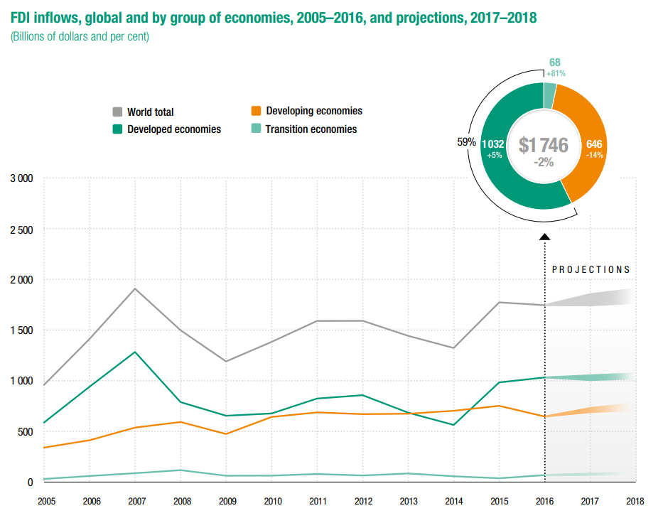
Source: United Nations Conference on Trade and Development, World Investment Report 2017, Geneva, 2017, p. 128.
20. Trade and investment rules affecting aggregate national economic policies are contained within a range of structures. This includes the multilateral Trade-Related Investment Measures (TRIMs) in the WTO on the one hand, and bilateral trade agreements on the other hand. Bilateral trade agreements exist between the European Union (EU) and developing countries, between the US and developing countries, among developing countries (South-South agreements) as well as among developed countries. Bilateral trade agreements, or IIAs, contain various measures that constrain national industrial development policy through investment regulations, intellectual property protection and the prohibition of capital account regulations. Previously, under the now obsolete trade regime of the General Agreement on Trade and Tariffs (GATT), membership in the world trading system had few or no entry requirements for developing countries, and industrial policies could be carried out relatively liberally. Subsequently, the WTO introduced a range of restrictions on various policies such as domestic content requirements, export subsidies and other policies linked to trade, imports and patent laws. Such policies served as integral tools of the industrial development of East Asian countries, such as South Korea and Taiwan, during the 1960s and 1970s.
III. Constraints on industrial development policies - Impediments to RTD, SDGs and FFD
21. The ways in which investment treaties constrain the right to development in developing countries through legal restrictions against the use of industrial development policies are critical to understanding how key parts of the global trade regime work against inclusive, equitable and sustainable industrial development. Investment protections embedded in FTAs deepen and expand legally binding policy protections for investors while absorbing unprecedented levels of policy autonomy away from national governments.
22. While the entirety of the DRTD is applicable to the development obstacles that accompany investment treaties, several key articles have particular bearing. First, Article 3.1 of the DRTD declares that “states have the primary responsibility for the creation of national and international conditions favourable to the realization of the right to development”. Article 3.3 calls on States to cooperate with each other to ensure development and eliminate obstacles to development, based on principles of human rights, sovereign equality, interdependence and mutual interest. Article 4.2 stresses the importance of sustained action to promote more rapid development of developing countries by providing the appropriate means and facilities. Article 8.1 highlights the need for economic and social reforms to address all social injustices and equality of opportunity for all people, particularly women’s active role in the development process. This will be explored in relation to impediments to the RTD through restrictions on industrial policies which impact gender equity and women's rights, especially their economic and social rights. Article 10 highlights that policy and legislative measures should serve to realize the right to development at both national and international levels. The ways in which investment treaty prohibitions on industrial policies impede these DRTD articles are further analysed below.
Investor protections undermine the ability of States to realize DRTD Article 3
23. Investment treaties are composed of a broad set of protections that are to be provided by the State to the investor. These investor protections explicitly challenge the ability of States to realize both Articles 3.1 and 3.3 of the DRTD which affirms the primary responsibility of States to create national and international conditions favourable to the realization of the right to development and calls on States to cooperate with each other to ensure development and eliminate obstacles to development, based on principles of human rights, sovereign equality, interdependence and mutual interest. Typical investment treaty provisions include the following key protections:
- The definition and scope of “investment”;
- Fair and equitable treatment obligation;
- Expropriation clauses;
- National treatment obligation, including pre-establishment rights (giving foreign investors the right to enter a host country and make investments on terms no worse than those applicable to domestic investors that might be considering the same type of investments locally);
- Most favoured nation treatment obligation;
- Binding restrictions on performance requirements;
- Binding restrictions on capital account regulations; and,
- Investor-state dispute settlement system (ISDS).
24. The defining feature of investment treaties is the investor-state dispute settlement system, through which foreign investors can bring the host government to an international arbitration tribunal. The ISDS system caters only to investors as claimants. States may not bring a claim against investors. A State can only bring a counterclaim after an investor has filed its claim, and such counterclaims are usually hard to carry out because many treaties are unclear on the legal grounds pertaining to counterclaims. The tribunal awards a monetary compensation against either the government or the investor. If the compensation is denied, the expropriation of assets can be carried out legally. Through investor–state arbitrations, investors have challenged a broad range of government measures as allegedly violating the investment treaty provisions and harming the investors’ rights to profit, including future potential profits.
25. The measures subjected to challenge include for example:
- Attempts to collect legally owed taxes, changes to domestic fiscal policy that are in the national interest;
- Decisions regarding whether to grant development permits;
- Efforts to renegotiate investment contracts;
- Efforts to resist renegotiation of investment contracts;
- Government bans on harmful chemicals, bans on mining;
- Environmental restrictions on the manner in which mining can take place;
- Requirements for environmental impact assessments, regulations regarding transport and disposal of hazardous waste;
- Regulations governing health insurance;
- Measures aiming to reduce smoking, measures affecting the price and delivery of water, regulations aiming to improve the economic situation of minority populations;
- Measures aiming to increase revenues gained from production and export of sovereign natural resources.
26. Foreign investors have sometimes resorted to use arbitrations to compel governments to alter or abandon public interest and environmental regulations which may negatively impact an investor. Financially, the burden these arbitration disputes can place on governments is significant. Countries have been paying exorbitant legal costs and arbitration compensation awards to investors, averaging over $8 million per dispute, and exceeding $30 million in some cases. At times, the quantum of compensation has been comparable to the annual public expenditure of many developing countries, in critical social sectors such as health and education.
27. The fair and equitable treatment (FET) obligation provided to investors has been interpreted as to require that the host State acts in a manner that does not affect “the basic expectations that were taken into account by the foreign investor to make the investment,” and that the host state’s activities are “free from ambiguity and totally transparent” so that the investor may know all the relevant rules and regulations and their respective goals before investing. While the language seems reasonable, in practice States have been found to be violating the FET obligation if they act in favour of human rights, environmental, social and public interest concerns. For example, in the Tecmed vs. Mexico case in 2003, after a local government in Mexico refused to relicense an operating waste treatment plant after community members found evidence of environmental damage and harm to human health from the plant’s pollution, arbitration tribunals ruled that Mexico was violating its FET.
28. Similar rulings have been made in a number of subsequent cases. In this way, the FET obligation has become a broad clause that investors use against States in response to regulations and actions in the interest of human rights, the environment and development itself. There exists serious concern among human rights and development advocates that States will shy away from the risk of costly and damaging arbitration when considering regulatory changes, even if the changes promote human rights including the RTD. The FET obligation constrains the State in operationalizing the RTD and enabling a democratic economic order as envisaged in Article 3.3 and articulated throughout the DRTD, and in the UDHR vision of a social and international order in which all human rights and fundamental freedoms can be realized for all people. Principle 3 of the Rio Declaration, and Paragraph 11 of the Vienna Declaration which underscore that “the right to development must be fulfilled so as to equitably meet developmental and environmental needs of present and future generations” may also be undermined as many state regulations are made in the interest of safeguarding the health and well-being of the physical environment, and present and future generations.
29. Previously, expropriation used to mean the physical expropriation of a factory, business or production site. Increasingly in recent years, it has been used in a more indirect sense in that any change in national tax laws and regulations constitute an indirect expropriation. Investment treaties allow States to expropriate, but require that compensation be provided to foreign investors. Treaties also require that expropriations must be for a public purpose, in accordance with due process and non-discriminatory; in other words, not targeted at a specific company or nationality. The expansion of the definition of expropriation to include indirect forms of expropriation may include measures taken for public purposes, such as human rights, public health and environmental protection. As with the FET obligation, there is a concern that States will consequently hesitate carrying out public interest regulations due to the liability they will experience if investors interpret the regulations as being harmful to their current or future potential profits. This risk-averse approach dampens the political will and prospects for States to protect the public interest in order to realize the national right to development.
30. The national treatment obligation, which implies that host States will treat foreign investors no less favourably than they will treat domestic investors, is perhaps the most ubiquitous investment treaty provision. The obligation pertains to the “management, maintenance, use, enjoyment or disposal of investments.” For example, a State may require that foreign service providers in health or education services are certified by domestic professional standards. If the foreign service providers decide that the requirement imposes ‘burdens’ on them through additional costs, such a requirement, although designed by the State to regulate and ensure the quality of health services, could arguably violate the national treatment obligation.
31. A further expansion of national treatment is embodied in the investment treaty obligation of pre-establishment rights, which says that potential, as well as current, foreign investors have the right to enter a host country and make investments on terms no worse than those available to domestic investors making the same type of investment. The North American Free Trade Agreement (NAFTA) between the US, Canada and Mexico, which came into effect in 1994, contains the benchmark for pre-establishment rights in Article 1102 of its treaty text. The language in this article clarifies that “(e)ach Party shall accord to investors of another Party treatment no less favourable than that it accords, in like circumstances, to its own investors with respect to the establishment, acquisition, expansion, management, conduct, operation and sale or other disposition of investments”. While pre-establishment rights are excluded from the majority of investment treaties, the US, Canada, Japan and the Association of Southeast Asian Nations (ASEAN)-wide investment treaty continue to incorporate it. Pre-establishment rights directly constrain the development of infant industries in developing countries. The infant industry perspective says that “in order to develop a strong domestic presence in a particular sector, it is sometimes necessary to give that sector temporary support and/or protection – assistance to help compete with, or a shelter behind which to develop free from, the potentially crushing competition of more efficient and/or more powerful foreign producers.”
32. The national treatment obligation and pre-establishment rights can affect the sovereign decision-making autonomy of States. For example, that of the state’s decision and ability to assist domestic economic firms and investors and regulate and control the present and future entry of foreign individuals and entities, particularly in the interest of safeguarding domestic economic sectors, national security and other legitimate concerns such as spurring domestic research and development, innovation capacity and domestic revenue expansion. Constraints to long-term national development ultimately affects the human rights, in particular, the right to development and the economic and social rights of people, often in adverse ways. In response, a number of States have inserted explicit reservations and limitations into their investment treaties to maintain their rights to protect or assist domestic investors, including agreement exceptions to protect indigenous or minority groups, particular sensitive sectors and specific measures. For example, NAFTA has over 100 pages of such exceptions to national treatment.
33. The most favoured nation (MFN) treatment obligation is included in almost all investment treaties and prescribes that treaty-signing States should treat each other’s investors no less favourably than they treat investors from other countries. The MFN obligation allows investors to search for stronger investment protections in all other IIAs its host State has with other States. As of February 2018, 2947 bilateral IIAs exist, of which 2364 are in force. The purpose of doing so for the investor is to identify the most advantageous clauses and protections, and to replace or supplement the protections in the basic treaty with them. For example, in a BIT between Spain and Argentina, an Argentine investor applied the MFN provision to bypass a BIT rule stipulating that any resort to domestic courts must precede international arbitrations in legal cases. This ability to extract and import commitments from a vast range of treaties the host state may have with other States allows investors to bypass the limitations and exceptions of the basic treaty, many of which the State parties carefully negotiated. In this way, the rights of the State to set requirements and regulations that enhance their ability to realize the RTD are significantly weakened by the expanded powers of investors.
34. Investment treaty restrictions against performance requirements, or conditions that States design for investors to meet in order to establish or operate a business in their territories, are perhaps the most salient to the ability of States to implement industrial development policies for realizing the RTD. Performance requirements have historically served as important policy tools that facilitate national industrialisation through, for example, augmenting the value of production , productivity rates and employment creation in domestic economic activities; diversifying economic sectors towards a balanced mix of agriculture and raw materials, goods manufacturing and services; creating domestic links between the various stages of manufacturing; regulating national trade balances; and, incentivizing the innovation and development of technology, including clean technology, which is the foundation of sustainable industrial development. States have traditionally enforced performance requirements as compulsory measures, sometimes accompanied by fiscal incentives or other advantages, such as tax breaks for example, in exchange for investors’ compliance with the requirements.
35. Some examples of performance requirements that States typically enforce in order to promote domestic industrial development, include:
- Requirements to export certain percentages of total sales, or total production;
- Requirements to enter into joint venture arrangements with domestic business partners;
- Requirements to transfer or share technology;
- Requirements that a certain amount of inputs be locally sourced, also known as local content requirements;
- Requirements to expend a certain amount on research and development; and,
- Requirements to hire a certain number or percentage of local employees.
36. In the realm of macroeconomic policy, most IIAs contain binding restrictions against regulations over the free flow of capital in and out of the borders of treaty signatories. While there are differences in the content of this provision, with some IIAs possessing greater degrees of exceptions than others, in many treaties, the free flow of capital is an absolute standard with little or no exceptions. .Free transfers of capital include both productive capital inflows that establish, expand and maintain investments as well as unproductive capital outflows, such as wages, profits, payments to creditors and proceeds from investment sales or liquidation.
37. Mandating the free flow of capital exposes all States to destabilising capital flows, which in turn impacts national currencies, prices of goods and aggregate economic stability and growth. The International Monetary Fund notes that “numerous bilateral and regional trade agreements and investment treaties include provisions that give rise to obligations on capital flows,” and that “most of the current bilateral and regional agreements addressing capital flow liberalization do not take into account macroeconomic and financial stability.” While productive capital flows can boost economic growth in developing countries that lack the savings or financial institutions that help finance economic activity, cross-border capital flows tend to be pro-cyclical. In other words, too much money comes in when times are good, and too much money exits during times of economic downturns. A key characteristic of the 2007-8 global financial crisis and recession was evident in the abrupt outflows of capital from developing to developed countries and reduced access to international capital markets by developing countries. This triggered a depletion of foreign exchange reserves in some countries, and currency depreciation and instability in others, which adversely impacted economic growth and productivity, employment and wages, and subsequently, poverty and inequality. In the decade since the 2007 crisis, “many industrialized nations, including the US, have resorted to loose monetary policy with low interest rates. Relatively higher interest rates and a stronger recovery have triggered yet another surge in capital flows to the developing world. The result has been an increasing concern over currency appreciation, asset bubbles and even inflation.” “Under these circumstances, capital controls help smooth the inflows and outflows of capital and protect developing economies. Most controls target highly short-term capital flows, usually conducted for speculative purposes.” In this sense, the RTD to achieve economic stability and growth is jeopardised by the provision for the free flow of capital in IIAs.
38. It is beyond the scope of this paper to do due justice to the complexity of each distinct investor protection. With regard to sustainable and inclusive industrial development and the RTD, it is the issue of performance requirements and the implications of their restrictions that is most acutely relevant, and will be examined further in the subsequent section related to DRTD Article 4.2.
IV. North-South asymmetries and differentiated responsibilities
39. Differentiation in the responsibilities for developing countries is reflected in the special and differential treatment (SDT) provisions of WTO agreements, which give developing countries special rights and allow other members to treat them more favourably, as well as in Principle 7 of the 1992 Rio Declaration on Environment and Development which recognizes common but differentiated responsibilities (CBDR) in light of the pressures developed country societies “place on the global environment and of the technologies and financial resources they command.” The necessity of SDT and CBDR is evident in the context of international investment treaties as a consequence of the asymmetries between developed and developing countries in bargaining and access to information during treaty negotiations.
40. The imbalance in access to information and negotiation capacity often leads to asymmetries in reciprocity and mutual gain defines North-South investment agreements, in that developed country signatories have significantly more FDI going into developing countries than vice versa. Consequently, developed countries are able to yield more advantages from the strong investment provisions and protections than their counterparts in the developing world. re-establishment rights determine that potential, as well as current, foreign investors have the right to enter a host country and make investments on terms no worse than those faced by domestic investors making the same type of investment. While the provision is notionally reciprocal, in reality many countries have significantly less capacity than more industrialised treaty parties to take advantage of and benefit from cross-border investment opportunities as well as to benefit from the inward foreign investment they may receive.
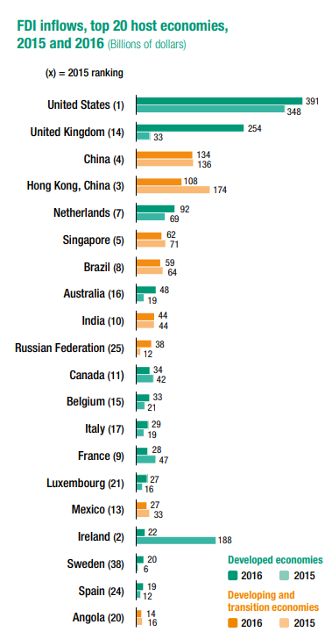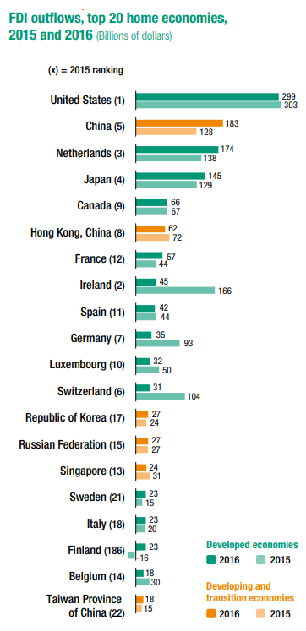
Source: United Nations Conference on Trade and Development, World Investment Report 2017, Geneva, 2017, pp. 12, 14.
V. Industrial development, Means of Implementation and Performance Requirements
41. As stated in article 4.2 of the DRTD, “sustained action is required to promote the more rapid development of developing countries,” and to achieve this, developing countries must be provided “with appropriate means and facilities to foster their comprehensive development.” Almost two decades after the adoption of the DRTD in 1986, the language of the SDGs resonates with article 4.2 in Goal 17, which serves as a foundation to the other 16 SDGs by calling for strengthening the means of implementation and revitalizing the global partnership for sustainable development. Industrial policy is a potent example of a means of implementation, in that it refers to state-led efforts to direct the economy’s production structure towards sectors that generate growth, employment, productivity and development opportunities.
42. Many of the institutions of trade governance are built on the Washington Consensus principle that market efficiency is achieved through the absence of such government interventions. This is compounded by investment protection rules against carrying out performance requirements, which were subject to limits under WTO rules but, prohibited outright under FTAs and BITs. Such prohibitions, enforced by the ISDS tribunal system, removes much of the policy space developing country governments had over the actions and supply choices of foreign investors. Without such requirements, there is no assurance that foreign investors will make policy choices that are mutually beneficial to both their own businesses and their developing country hosts. Since the entry of the NAFTA in 1994, trade and investment agreements by the US and Canada in particular carry binding limitations on the use of performance requirements by developing countries. Out of the 20 US FTAs currently in force, all but two prohibit performance requirements under the investment chapter.
43. The ability of States to require specific provisions, transfers or stipulations from investors enables States to manage foreign investment for the purpose of realizing a core component of the RTD, that of domestic industrial and economic development, including employment creation and technological advancements.
44. Such requirements, include, for example:
- Local content and local processing, or, in other words, obliging foreign investors to source or purchase their production content and input from the domestic economy of the host state. Such cooperation promotes domestic manufacturing capabilities in higher-value added sectors or technology-intensive sectors, creates backward and forward linkages within the domestic economy and supports small and medium-sized enterprises and their contribution to employment creation, among other benefits;
- Technology and production process transfer in order to stimulate the development of endogenous technology, creating environment-friendly methods and products that can contribute to sustainable development;
- Expenditure on research and development facilities and employees in order to boost domestic capacity for innovation and growth;
- Joint venture arrangements with domestic business partners in order to conduct business in the host country, as well as requiring a minimum level of domestic equity participation so that foreign investors provide domestic investors a minimum percentage of their enterprise. Such a requirement boosts the growth and sustainability of domestic businesses toward building a diversified and dynamic domestic economy, while also contributing to decent work and employment creation and the sharing of production and product knowledge;
- Hiring a certain number or percentage of local employees towards the development objective of expanding decent work and employment opportunities;
- Exporting certain percentages of total sales or production, which serves to increase export capacity in cases where national trade deficits would cause reductions in imports. To this end, such an export requirement contributes to balancing trade accounts by increasing national export revenue.
45. This is by no means an exhaustive list of performance requirement examples that have been used by both developing and developed States for the objective of managing foreign investment in order to facilitate industrial development. Industrial development goals include diversifying domestic economic sectors, increasing the economic value of goods produced in the economy, developing national expertise in a given sector, creating upstream and downstream links in a given economic sector, ensuring technology transfer, achieving enhanced environmental or social outcomes, creating decent work opportunities and increasing wages, preserving a significant part of national enterprises in key sectors, or guaranteeing security in the industrial sector.
46. Performance requirements are a vital part of the toolbox that can be implemented in the means of implementation to achieve both SDG 17 and SDG 9 on industrialisation and innovation on one level, and closely linked to these, the RTD on another. Industrialization, innovation, technology and other basic economic elements of development provide the essential material means for realizing the right to development and the economic and social rights of individuals and peoples, the basic public goods to fulfil basic needs including health and education, food and water. States are duty-bound under the International Covenant on Economic, Social and Cultural Rights to use maximum available resources to fulfil their people’s economic, social and cultural rights. Historically, performance requirements were applied by today’s developed countries to promote domestic industrialisation processes, including goals such as promoting the employment of local labour, incorporating local management into foreign investment activities, maintaining headquarters or production facilities locally, transfering technology developed locally by foreign investors, sharing skills and production processes with local employees and firms, requiring that research and development initiatives take place locally.
47. In exchange for the use of such stipulations to ensure local economic development, host States provided to foreign investors physical and communications infrastructure, subsidized or directed credit in key industries and administrative guidance to assist foreign investors in expanding into local markets. However, contemporary investment treaties impose significantly tighter restrictions on the State’s management of industrial development than those established by the TRIMs Agreement under the WTO.
48. Local content and local processing requirements facilitate the specific language in SDG target 9.b to “ensure a conducive policy environment for inter alia industrial diversification and value addition to commodities.” Country-based research demonstrates that many of today’s developed countries extensively required the use of local content in the production processes of foreign investors. For example, the U.S. imposed a 75 percent local content requirement on the Japanese auto company Toyota Camry and the U.K. asked for 90 percent local content on Japanese auto company Nissan Primera.
49. Countries such as Australia, Canada, France, Japan, Norway and Sweden, among others, also imposed local content requirements. Under the WTO negotiating agenda related to the TRIMs Agreement, developing countries have sought flexibility to implement local content requirements in order to boost domestic manufacturing capabilities in higher value-added sectors or technology-intensive sectors; to support small and medium-sized enterprises, which, in developing countries, hire a critical mass of formal and informal sector workers, in particular women workers; and, to promote purchases from disadvantaged regions in order to reduce regional economic and social inequalities.
50. Joint venture and domestic equity requirements have an explicit connection with target 9.2 of SDG 9, which calls for significantly raising industry’s share of employment and GDP by 2030, and in LDCs to double industry’s share of employment. This target refers specifically to formal sector wage employment that can build employee skills and capabilities, domestic purchasing power and national tax revenue. Joint ventures allow local businesses in developing countries to absorb technological development, skills and product or process knowledge from the foreign investor company, as well as have a voice in the direction of the company. The emergence and sustainability of indigenous firms builds the foundation for domestic industrial development. This is very different from the terms of foreign investment in many developing countries today, characterised by a dependence on foreign investors and firms to employ local communities in low-wage and low value-added activities in export processing zones, for example.
51. The South-South trade and investment agreement between the Southern Cone Common Market (MERCOSUR) member countries, Argentina, Brazil, Paraguay and Uruguay, and the Andean Community (CAN) member countries of Bolivia, Colombia, Ecuador and Peru, both customs unions established to promote trade and the fluid movement of goods, people and currency, cover as many trade areas as EU agreements without including the prohibitions established by the EU. In CAN Decision 292, companies must have joint venture ownership of at least 60 percent by domestic investors; while for any country whose investor contributes at least 15 percent of the capital for an enterprise, one of the directors must be a national of that country.
52. Domestic technological development is significant enough to achieving the RTD and is explicitly mentioned in three specific targets of SDG 9. Target 9.4 calls for increased resource use efficiency and greater adoption of clean and environmentally sound technologies and industrial processes; target 9.5 calls for enhancing scientific research and upgrading the technological capabilities of industrial sectors in all countries, particularly developing countries, by 2030, including encouraging innovation and increasing public and private spending on research and development as well as the number of employees hired; and, target 9.b referring to the means of implementation for Goal 9 invokes the need to support domestic technology development, research and innovation in developing countries by ensuring a conducive policy environment. Clearly, the transfer of technology is an important imperative in the SDGs. Similarly, in the AAAA, technology is mentioned numerous times across 18 different paragraphs, starting from paragraph 3 and ending with the establishment of a Technology Facilitation Mechanism in paragraph 123. As outlined in the AAAA, the Technology Facilitation Mechanism is a UN inter-agency task team on science, technology and innovation for the SDGs, and “will promote coordination, coherence and cooperation within the United Nations system on science, technology and innovation related matters, enhancing synergy and efficiency, in particular to enhance capacity-building initiatives.”
53. Technology transfer and research and development (R&D) promotion are typically the most sought after type of foreign investment by states. e Technological development is indispensable to development and the RTD, and is galvanised by the introduction of new economic activities that often require the introduction of new techniques of production and of never-before-used technology. From a historical perspective, the degree of technological development and diffusion accounts for approximately 75 percent of the income divergence between rich and poor countries between 1820 and 2000. When investment treaties limit countries’ rights to mandate or incentivize the transfer of technology, not only is the RTD jeopardized but the prospects for sustainable development through an industrialization that employs environmentally friendly, or clean, technology, impeded.
54. The need for increased access to technology in developing countries is recognised throughout the AAAA outcome document. Paragraph 45 highlights that “government policies can strengthen positive spillovers from foreign direct investment, such as know-how and technology.” A salient reason why technology transfer and research and development (R&D) dissemination is required by States is that the diffusion of technology is crucially dependent on local absorptive capacity and thetechnical skills of the domestic labour force. According to the ILO and UNCTAD, “investment in these collective capabilities ensure a rapid and sustained process of industrial and technological development, the generation of jobs, and the transformation of the employment and occupational structure.”
55. A successful example of technology diffusion and development took place in East Asian countries between 1960-1980, when States such as the Republic of Korea and Taiwan ensured that foreign investors diffused technology, production methods, quality control practices and management procedures, particularly in the electronics sector.
VI. Investor-State Dispute Settlement and undermining national laws and Regulations
56. The defining feature of IIAs is that of investor-state arbitration, or investor-state dispute settlement (ISDS), where investors can legally challenge a wide range of State measures, including laws, regulations, safeguards and administrative decisions in economic sectors. Rather than the route of domestic administrative and judicial channels, private arbitration is employed by investors. The specific nature of ISDS is that only foreign investors, including their subsidiaries and shareholders, are able to initiate claims against States. States are not legally empowered to initiate ISDS claims against investors. It is not that States have accepted the nature of ISDS. Rather, it is that investors are using a dormant legal tool that was elaborated in the early investment treaties of the 1980s, which included a provision allowing for disputes between the host state and the investor of the home state to be resolved in international arbitration.
57. As of November 2017, the aggregate number of publicly known ISDS claims had reached 817. Approximately 109 countries have responded to one or more ISDS known claims. In 2016 investors initiated 62 ISDS cases, and 74 in 2015, while the average between 2006 and 2015 was 49 cases per year. Most of the 62 known cases of 2016 were initiated by developed country investors, predominantly from the Netherlands and the US with 10 cases each, followed by investors from the UK with seven cases. Foreign investors have targeted state policies and regulations on taxation, the environment, tariffs for water and electricity, health services, public safety and health, pharmaceutical import regulations and many other policies.
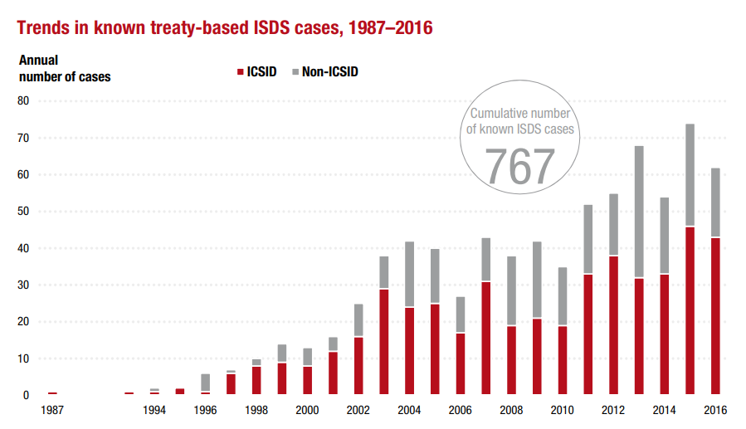
Source: United Nations Conference on Trade and Development, International Investment Agreements, IIA Issues Note, Issue 1, “Investor State Dispute Settlement: Review of Developments in 2016,” Geneva, May 2017, p.2.
58. The ISDS mechanism can undermine the sovereignty and capacity of States to implement Article 10 of the DRTD, which calls for steps to “ensure the full exercise and progressive enhancement of the right to development, including the formulation, adoption and implementation of policy, legislative and other measures at the national and international levels.” The SDGs and the AAAA also underscore “sound policies and enforceable legislation” across various targets and paragraphs, with particular emphasis in SDG 10 on reducing inequality within and among countries and target 10.3 which calls on States to “ensure equal opportunity and reduce inequalities of outcome, including through eliminating discriminatory laws, policies and practices and promoting appropriate legislation, policies and actions in this regard.” The 1992 Rio Declaration on Environment and Development, which is reaffirmed in the 2030 Agenda, stresses effective environmental legislation in Principle 11. Principle 11 is particularly pertinent in light of the numerous examples of national environmental legislation, intended to protect communities and the environment, becoming grounds for investor suits through the ISDS.
59. Some of the key features of the ISDS mechanism are:
- Only foreign investors, including their subsidiaries and shareholders, are able to initiate claims against governments. Governments are not legally empowered to initiate ISDS claims;
- The tribunals in ISDS proceedings are private arbitrators appointed on a case-by-case basis by both parties to the dispute, who decide on the investors’ claims against the government. To date, the financial damages paid by States to investors have included millions of dollars for the breach of investment treaties, as interpreted by private arbitrators. Arbitrators can also order injunctive relief on governments, which mandate what actions the State is allowed to take or not;
- The ISDS mechanism is marked by a lack of accountability on the power of tribunals and their interpretations of the treaties; and,
- There are limited avenues by which States can challenge financial damages determined by arbitrators. Errors of law or fact will not constitute permissible grounds for overturning the decision of the tribunal. If a tribunal issues financial damages to be paid to the investor, national courts are required to enforce them. For example, there is no appellate mechanism by which States can pursue appeals, and there are strong rules on enforcement of financial compensation by the State to the investor.
60. The following types of policy measures by governments were challenged most frequently by ISDS cases in 2016:
- Alleged direct expropriations of private investments by the State (at least 7 cases);
- Legislative reforms in the renewable energy sector (at least 6 cases);
- Tax-related measures such as allegedly unlawful tax assessments or the denial of tax exemptions by the State (at least 5 cases);
- Termination, non-renewal or alleged interference by the State with contracts or concessions made between the State and the investor (at least 5 cases);
- Revocation or denial of licenses or permits (at least 5 cases);
- Other measures that were challenged included the designation of national heritage sites, environmental conservation zones, indigenous protected areas and national parks; and money laundering and anti–corruption investigations.
61. In 2016, one third of the concluded cases were decided in favour of the State (claims were dismissed either on jurisdictional grounds or on the merits), and about one quarter were decided in favour of the investor, with monetary compensation awarded. Of the cases decided in favour of the State, about half were dismissed for lack of jurisdiction. These are cases in which a tribunal found, for example, that the dispute arose before the treaty entered into force or fell outside the scope of the ISDS clause, or that the investor had failed to comply with certain treaty conditions such as the mandatory local litigation requirement. In aggregate, of the decisions by private tribunals that addressed the question whether the challenged government measure breached the investment treaty’s substantive obligations, about 60 percent of cases were decided in favour of the investor and 40 percent in favour of the State.
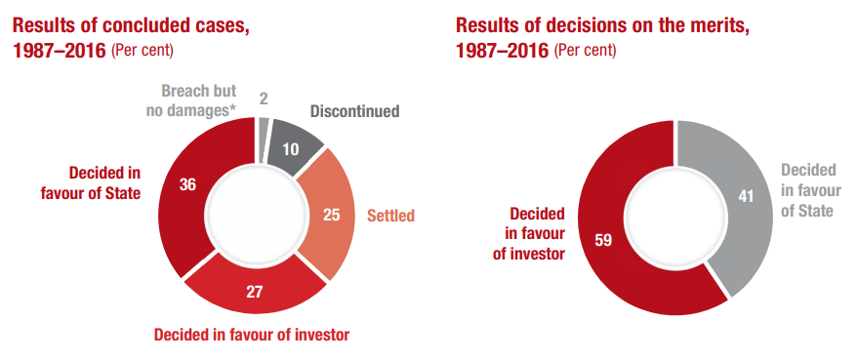
Source: United Nations Conference on Trade and Development, International Investment Agreements, IIA Issues Note, Issue 1, “Investor State Dispute Settlement: Review of Developments in 2016,” Geneva, May 2017, p.5.
62. Financial compensation amounts claimed by private investors ranged from $10 million to $16.5 billion. On average, States were mandated to pay awards of approximately 40 percent of the amounts the investors claimed. In cases decided in favour of the investor, the average amount claimed was $1.4 billion and the median $100 million. The average amount awarded was $545 million and the median $20 million.
How ISDS undermines national legislation
63. The ISDS mechanism circumvents the balance between private and public rights that has evolved in many national contexts by empowering foreign investors to contest and seek compensation for any negative impacts on the security and profitability of their investment, including any potential reduction on future profits, through state court litigation. Both substantive and procedural national laws, including those which have direct bearing on human rights, and national judicial institutions are undermined by the far-reaching power of foreign investors to challenge regulations, domestic court decisions and administrative acts. This in turn may have significant impacts on the State’s fulfillment of human rights including the RTD, for instance, when ISDS rulings challenge regulations that promote and protect public goods, particularly economic social and cultural rights such as the right to food and to water and sanitation.
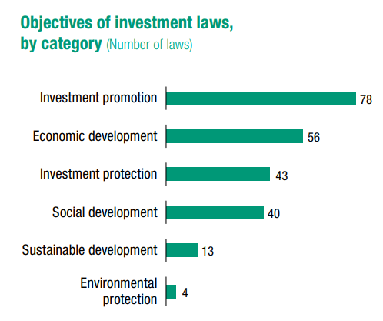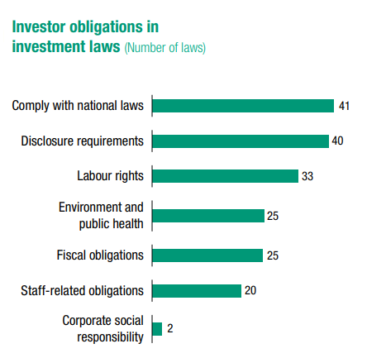
Source: United Nations Conference on Trade and Development, World Investment Report 2017, Geneva, 2017, pp. 106, 109.
64. National laws designed through democratic and accountable processes embody the authority of States to balance the protection of investors’ interests with the regulation of investor activity in order to safeguard the human rights of all people, including their RTD and economic, social and cultural rights. This balance in domestic law is reflected in substantive and procedural rules governing who can bring claims against the government, under what circumstances, through which processes, for what types of harms and in pursuit of which sorts of remedies.
65. Since States are not able to appeal the decisions of private tribunals on the grounds of incorrect interpretation of domestic law, they are subject to the tribunal’s interpretation. As a result, investment treaties afford greater substantive rights to foreign investors than are provided for investors or other actors under domestic law.
Case Study 1: Occidental Petroleum v. Ecuador
66. While numerous ISDS cases provide examples where arbitration tribunals rule against national public interest policies that uphold the rights of people including their right to development, as well as protection of the environment, some of the most significant cases are those in the oil and gas sector. In 2006, Occidental Petroleum Corporation (Oxy), a US corporation, launched a claim against Ecuador under the US-Ecuador BIT after the government terminated an oil concession due to the US oil corporation’s breach of the contract and Ecuadorian law. Oxy illegally sold 40 percent of its production rights to another firm without the Ecuadorian government’s approval, despite a provision in the contract stating that sales of Oxy’s production rights without government pre-approval would terminate the contract. The contract explicitly enforced Ecuador’s hydrocarbons law, which protects the government’s prerogative to vet companies seeking to produce oil in its territory, a serious concern in the environmentally sensitive Amazon region where Oxy was operating.
67. Oxy launched its claim through the ISDS mechanism two days after the Ecuadorian government terminated the oil concession, claiming that the government’s enforcement of the contract terms and hydrocarbons law violated its BIT commitments, including the obligation to provide the firm “fair and equitable treatment.” The majority of members in the tribunal ordered Ecuador to pay Oxy $2.3 billion, including compound interest, making the sum one of the largest investor-state awards to date. To calculate this penalty, the tribunal estimated the amount of future profits that Oxy would have received from full exploitation of the oil reserves it had forfeited due to its legal breach, including profits from not-yet-discovered reserves. Using logic that a dissenting tribunal member described as “egregious,” the tribunal determined that the damages should be based on the entire value of Oxy’s original contract even though the firm had sold a 40 percent share. The tribunal also concluded that Ecuador was 75 percent responsible for the conflict and therefore should pay 75 percent of the projected losses to Oxy. Ecuador filed a request for annulment of the award, raising four specific arguments regarding why the tribunal’s decision to grant jurisdiction over the case in the first instance, and the entire $2.3 billion award to the investor, should be annulled. In 2015, an annulment committee rejected all four of Ecuador’s arguments.
Case Study 2: Archer Daniels Midland (ADM) & Tate & Lyle Ingredients Americas (TLIA) v. Mexico
68. In this ISDS case involving performance requirements, the investor claimants ADM and TLIA challenged a new Mexican tax of 20 percent on soft drinks and syrups sweetened with sweeteners other than sugar that was passed on 31 December 2001. Even though the tax was repealed by Mexico at the outset of 2001 in order to comply with WTO ruling in a case initiated against Mexico by the US government, the claimants persisted with their NAFTA Chapter 11 claim, seeking damages for losses during the period when the tax was in effect. An ISDS tribunal determined that Mexico discriminated against a joint venture, ALMEX, owned by ADM and TLIA, and imposed impermissible performance requirements to the detriment of that joint venture. The ICSID tribunal awarded the claimants $33.5 million, to be paid by Mexico.
VII. Women’s Rights in the Context of Foreign Direct Investment and Labour
69. DRTD Article 8.1 makes an unequivocal call to States to carry out “effective measures to ensure that women have an active role in the development process,” and requires that “appropriate economic and social reforms should be carried out with a view to eradicating all social injustices.” Investment protection, particularly on the scale demanded by BITs, gives rise to significant gender concerns in relation to the impacts of investor protections and consequently compromised policy space of governments on gender equality, women’s rights, women’s empowerment and gender-based outcomes. Shifts in the ability of the State to carry out policies oriented to the RTD create concomitant shifts in women’s multifaceted roles in economic and social activities as individuals, caretakers, heads of households, entrepreneurs and workers.
70. SDG 5 aims to achieve gender equality and to empower all women and girls. Of particular relevance to DRTD Article 8.1, is Target 5.4 which recognizes and values unpaid care and domestic work through the provision of public services, infrastructure and social protection policies, as well as the promotion of shared responsibility within the household and the family. Further, target 5.5 ensures women’s full and effective participation and equal opportunities for leadership at all levels of decision-making in political, economic, and public life. Similarly, the AAAA reaffirms that achieving gender equality, empowering all women and girls, and the full realization of their human rights are essential to achieving sustained, inclusive and equitable economic growth and sustainable development. Investment treaties adversely impact women’s rights and gender equality in many ways. Three specific channels will be examined here, which provide a mere snapshot of the complex landscape of women’s rights in the context of investment and industrial development. They are, first, that of women’s entrepreneurship role in small and medium enterprises (SMEs), second, ISDS cases in the natural resources and extractives sector and third, women’s employment and working conditions.
71. SMEs with full or partial female ownership represent 31 to 38 percent of formal SMEs in middle-income developing countries. As such, supporting the development of domestic SME sectors is crucial for advancing gender equality and women’s rights. SMEs play a major role in most economies, particularly in developing countries where formal SMEs contribute, on average, up to 60 percent of total employment, and up to 40 percent of national income (GDP). On average, over 80 percent of SMEs in developing countries are concentrated in local businesses, whereas only 19 percent focus on exports. In fact, SMEs that are engaged in industrial manufacturing account for over 90 percent of firm activity globally and between 50 and 60 percent of worldwide employment.
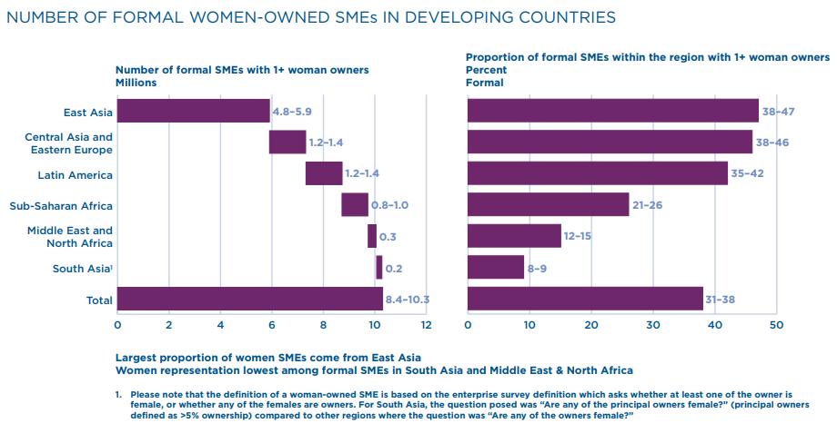
Source: International Finance Corporation, Strengthening Access to Finance for Women-Owned SMEs in Developing Countries, Washington, D.C.: International Finance Corporation, October 2011, p. 13.
72. This makes SMEs especially vulnerable to removals of performance requirements for local content and local processing. Such requirements would allow SMEs to sell their products to foreign firms, become integrated into a production process of greater scale as well as create positive spillovers between SMEs across various sectors through the opportunity to act within the linkages in a production process involving foreign investors.
73. A key challenge to the survival of the small-scale economic sector is the investor protection of national treatment, or equal treatment to foreign and domestic businesses. Unable to compete with foreign firms that have far greater capacity, finances, technology and innovation, markets and production scale, developing country SMEs and firms are disenfranchised. The temporary and strategic protection and assistance they require by States in their infant stages is no longer a possibility, resulting in a dire prospect of deindustrialisation. In the Transatlantic Trade and Investment Partnership, a proposed trade and investment agreement between the EU and the US, which has currently stalled, regulations that protect small businesses will be withdrawn under national treatment. For example, the United Kingdom’s policy of reserving 25 percent of supplier contracts for industrial SMEs may be rendered illegal under the investment agreement.
74. Investment treaties also affect women’s rights through the ISDS system, which creates a chilling effect on state regulations and legislation that uphold women’s rights. Both the SDGs and AAAA underscore the importance of legislation through SDG target 5.c and AAAA paragraph 6 which call for the need to adopt and strengthen “sound policies and enforceable legislation for the promotion of gender equality and the empowerment of all women and girls at all levels.” The majority of known outstanding ISDS cases under US FTAs and BITs, and nearly half of the 129 cases pending before the World Bank’s investment dispute facility, involve natural resources, which women across developing countries traditionally use and depend on.
75. For example, the case Burlington Resources vs. Ecuador, reveals conflicts between government duties to protect human and indigenous rights, on the one hand, and obligations to protect foreign investors, on the other. Public health and environment regulations, areas to which women and children’s health, safety, livelihoods and well-being are critically connected, are also being brought under legal arbitration. For example, in the case of Renco vs. Peru, the lead and zinc smelter operation of Renco Group Inc’s in Peru resulted in the lead poisoning of 162 La Oroyan children. The Peruvian government took measures against the company. However, in return, Renco sued Peru for $800 million under the US-Peru FTA. When the State cannot perform its responsibility to protect and sustain its most vulnerable citizens, including women and children, DRTD Article 8.1 on ensuring that women have an active role in development becomes a distant possibility.
76. Foreign investment has historically created positive employment impacts for women, particularly in the context of gendered labour-intensive special export processing zones where garments, apparel, textiles, footwear and other consumer durables are manufactured for exports within a global value chain and production network. These global networks are characterized by a hierarchy correlated with economic value where foreign investors and buyers are at the top, a chain of contracting suppliers and subcontractors in the middle, and factory workers at the bottom. The gendered nature of low-value added manufacturing is explicit in the sense that over three-quarters of the workforce is typically female. This tiered segmentation is rendered more complex by formal workers, followed by informal workers, who may also be piece workers based out of homes. However, employment created by foreign investors for women have been a matter of persistent concern over poor working conditions, low wages, wide male-female wage gaps, quality of employment and prospects for training and advancement in education, skills upgrade and management and leadership roles.
77. Gendered labour discrimination sustains the production network flexibility that facilitates mass export production under a lean retailing model. Working conditions are defined by precarious employment, or jobs that can be easily terminated and thereby highly vulnerable to unemployment. Precarious employment is rooted in the employers’ entitlement to make quick and often arbitrary, short-term adjustments to labour supply in response to sudden changes and swings in production demand. The segmented production structures are rooted in unequal economic and bargaining power, which plays a large role in degenerating employment stability and quality to the degree that downsizing and subcontracting have become synonymous with the export labour industry. Gendered labour discrimination allows suppliers to protect themselves from the competitive pressures they face from global investors and buyers by shifting the pressure onto a predominantly female factory workforce.
78. Women workers’ rights are routinely denied through employer strategies. Two examples are that of extending women’s working hours without a proportionate increase in wages and lowering or evading the payment of women workers’ wages. Employers manipulate working hours and terms of employment in order to adjust to fluctuating production demand and resource constraints, such as high import costs. The result is often longer hours of work and lower wages. The use of performance-based pay, where wages are contingent on achieving a certain amount of production, often results in lower wages relative to that of a fixed income. Through violations on women worker’s rights, the expansion of foreign investment in developing countries may not expand the rights of women workers, especially their economic and social rights, due to gendered labour flexibility rooted in inequality and violations. In the context of the centrality of cross-border investment in the global economy, proactive policies by the State are necessary in order to address the challenge of gender discrimination in many export sectors, as well as to meaningfully prioritise women’s rights within IIAs.
VII. Policy Recommendations
79. Within the context of a State’s RTD, in order to facilitate national industrial development with a view to achieving sustainable development under the 2030 Agenda, there are specific steps that can be considered and taken by four categories of key stakeholders - States, international organisations, the private sector and civil society. Reassessment and reformulation of investor protection measures in IIAs are imperative to any effort to reform IIAs. Such initiatives are already taking place within UNCTAD as well as policy discussions at regional and national levels. A key priority in such a reassessment of investor protections is ensuring the State’s ability to regulate in the interest of human rights, environmental regulations and legislation necessary for sustainable development.
80. The recommendations are based on the DRTD articles and SDG goals and targets that have the highest relevance to the link between investor protection measures in IIAs, sustainable, inclusive and equitable industrial development and the RTD. They include DRTD Articles 3.1, 3.3, and 4.2; SDGs 8 and 9; and SDG Targets 17.14 and 17.15.
A. Recommendations for States
Amendment
81. States can pursue the amendment of their investment treaties, which essentially requires that all treaty parties agree to renegotiate with the objective of reaching agreement on an amended text. Provisions on an established procedure are often provided in the text of treaties for the purpose of amendment. However, the absence of such provisions should not hinder an amendment process as long as treaty signatories are in agreement. Once the text is re-opened, States can use the opportunity to renegotiate the clauses that have been recognized as problematic. Through pursuing specific amendments to investor protection measures, States have the opportunity to identify which measures are adversely affecting, or have the potential to adversely affect national industrial and technological development.
82. Amendments entail both positive and negative aspects. Positive elements include, for example, the potential for genuine modification of the IIA, and an assurance that the State is willing to change an IIA provision. In comparison to joint interpretations, amendments have a clearer legal force and are not as constrained by the existing IIA text. Negative factors include, for example, the consumption of considerable resources and time, and a lengthy ratification process which could stall or prevent an IIA from coming into force. Amendments comprise a partial approach when compared to replacing the entirety of an IIA with a new treaty. In IIAs with more than one State, an amendment requires the agreement of all States, whereas a State may unilaterally withdraw from an IIA.
B. Interpretations
83. If investment provisions are drafted in terms found to be vague, broad or confusing to either State party, an interpretation or clarification may be sought. This will guide and direct arbitrators who will interpret the treaty in the future. According to the Vienna Convention on the Law of Treaties, interpretative statements can be made both before and after the treaty enters into force. Interpretations are easier than either amendments or termination of treaties since they do not require any form of ratification. They have been used by NAFTA parties (US, Canada and Mexico) and subsequently accepted and applied by NAFTA tribunals.
84. Interpretations have both positive and negative aspects. On the positive side, for example, a ratification process is not needed. An interpretation is perceived as one of the most straight-forward ways to change the text of an IIA. Some treaties contain a mechanism for interpretation that has already proved helpful. Negative aspects include, for example, the lack of clarity regarding the force or legitimacy tribunals will give to joint interpretations. Interpretations do not necessarily align with the goals of sustainable development and RTD, and it is not easy to agree on joint interpretations between States. Interpretations may not be as effective as amendments and those that are too broad may not be useful. Consistency can become an issue if different interpretations of the same provision across various IIAs are debated.
C. Options on performance requirements
85. Legally, there is no obligation under international law to include a clause on performance requirements in IIAs. The most effective approach a State can take is to refrain from prohibitions or limitations to performance requirements when negotiating and agreeing to IIAs. This approach has the advantage of allowing States to retain the flexibility needed to pursue national policies for industrial and sustainable development. Where prohibitions on performance requirements are agreed upon in IIAs, States may decide to make certain stipulations, such as: (a) restrict only mandatory performance requirements rather than all of them; (b) expressly exclude national treatment and most favoured nation treatment from the scope of the prohibition on performance requirements; (c) exempt existing performance requirements in order to be able to maintain them, and safeguard future amendments made to existing measures; (d) create a list of sectors to which prohibitions on performance requirements do or do not apply (such an exercise requires analysis of sensitive and priority sectors for the host State); and, (e) specifically exclude prohibitions on performance requirements from the ISDS mechanism.
D. Exit
86. States can legally terminate their investment treaties without any breach of international law. Unless either party gives written notice of termination, an investment treaty will stay in force for the duration specified in its text, typically 10 to 15 years. After the duration of its enforcement, either party is usually free to terminate the treaty. However, the ‘survival clause’ of a treaty allows it to continue in effect for another given period for existing investments. Often this period extends the enforcement of investment provisions for another 15 to 20 years.
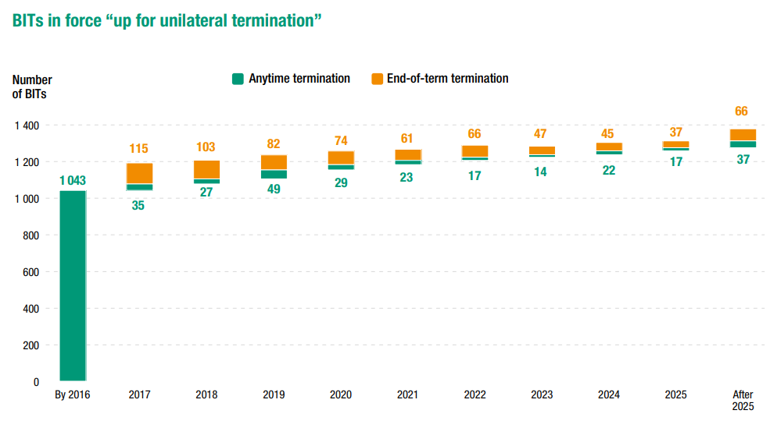
Source: United Nations Conference on Trade and Development, World Investment Report 2017, Geneva, 2017, p. 128.
87. The critical problems associated with investment treaties and the ISDS mechanism in particular have stimulated a wave of actions from both developing and developed countries, with several countries deciding to unilaterally terminate their IIAs with other countries.
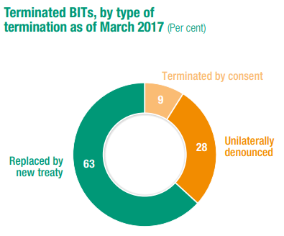
Source: United Nations Conference on Trade and Development, World Investment Report 2017, Geneva, 2017, p. 143.
88. In carrying out the decisions of amendment, interpretation or exit, governments need to bear in mind the MFN clause, which allows investors to ‘treaty shop’ among all other treaties the host State is signatory to. The MFN clause can thus harm the effectiveness of reforms if a country only terminates or amends some of its investment treaties.
E. Human rights impact assessments of trade and investment agreements
89. States can commission human rights impact assessments of the impacts of their IIAs on their human rights obligations at both the international and national levels. The UN Guiding Principles on Human Rights Impact Assessments of Trade and Investment Agreements is a key instrument in this regard. Prior to recognition as a separate form of assessment, HRIAs were considered as aspects of social impact assessments.
90. HRIAs have several advantages over social impact assessments, for example: (a) impact measurement according to legal obligations entrenched in international human rights instruments; (b) the interdependence and inter-relatedness of human rights, helps to assess multiple impacts (e.g. on health, education and housing simultaneously) rather than focus on single elements; (c) pressure on duty-bearers to act to protect the rights of ‘rights-holders’ and provide justifications for their policies in human rights terms; (d) engaging international and national human rights actors; (e) highlighting the importance of transparency, participation and empowerment in the process of conducting HRIAs as well as in the negotiation and implementation of the IIA itself; and, (e) focusing on social impacts on the most vulnerable and disadvantaged persons and groups in society. As such, the HRIA process shifts the focus from aggregate costs and benefits for the State as a whole to the impacts of the IIA on the most vulnerable and insecure groups of people in the State. Various States have carried out HRIAs in a successful manner, providing constructive examples of best practices.
A. Recommendations for International Organisations
1. Information on options and best practices
91. International organisations that provide technical assistance and policy advice to States, in particular developing countries, can supply information on options and best practices to States that are negotiating or amending their IIAs. Such information can focus on the most suitable approaches for States to maintain their ability to pursue industrial development and sustainable development policies in the context of the RTD, particularly through performance requirements on foreign investment. In cases where States choose to limit their choice of industrial and economic policies through prohibitions on the use of performance requirements, international organisations can advise States on the amendments or stipulations they can make in their IIAs.
2. Amendment, interpretation and exit options
92. International organisations that possess expertise on investment law and IIAs should provide technical assistance to States on maneuvering between the options and possibilities in seeking amendments and interpretations to IIA provisions, as well as on unilateral termination decisions.
3. Monitoring developments
93. International organisations should monitor developments relating to States that have terminated their IIAs, as well as States that have successfully pursued substantive amendments and interpretations to their IIAs. Currently, UNCTAD takes the lead on such efforts through its Investment Policy Hub. Data on such developments should be organised and analysed with attention to best practices on IIA amendments, interpretations and terminations by host States.
4. Data provision on FDI attraction
94. International organisations can organise and present the data from studies and surveys demonstrating that the vast majority of private sector FDI does not consider IIAs when deciding where and how much to invest across borders, and that political risk insurance providers do not factor IIAs into their coverage and pricing policies in a substantive manner. A dissemination of thorough data on the lack of linkage between IIAs and the ability to attract increased amounts of FDI could be potentially useful for States as they weigh options and make decisions on their IIAs.
B. Recommendations for the Private Sector
1. Engage with States in advance of an ISDS process
95. Before submitting a dispute with a host State to binding private international arbitration in an ISDS process over perceived limitations to a private sector entity’s investment, the private sector, or investor, may first engage in bilateral discussions with the State. The discussions can be carried out with an openness by the private sector entity to at least consider the host State’s rationale and explanation for the issue in dispute. The eventual goal is for the investor to consider exemptions for a State’s human rights, public interest and environmental legislation and regulations from being grounds for an ISDS process.
2. Inclusion of HRIA and women’s rights language in IIAs
96. The private sector entity, or investor, should be willing to consider the inclusion of language that abides by women’s rights legislation in the host State as well as ex-ante and ex-post HRIAs in the IIA. This includes women’s rights language pertaining to women workers’ rights in export processing zones and extractive sector labour, as well as impacts of the investment activities on women and girls in the host State. On HRIAs, investors should cooperate in the assessment process by supplying information and data as needed.
3. Identifying what is not working in IIAs
97. Investors should participate in bilateral discussions with State parties on amendments, interpretation or IIA termination decisions in order to specifically identify what is not working in the IIA text. Identifying what is not working within the IIA’s measures and provisions may provide clarity on how to effectively reform IIAs in a mutually beneficial manner.
C. Recommendations for Civil Society
1. Monitoring developments
98. Civil society, along with international organisations, should monitor developments on States that have terminated their IIAs, as well as States that have successfully pursued substantive amendments and interpretations to their IIAs. Data on these developments should be organised and analysed with attention to best practices on IIA amendments, interpretations and terminations by host States, with particular attention to cases where industrial development and sustainable development policy choices have been made possible.
2. Advocacy and capacity building on industrial development and RTD
99. Civil society should build internal capacity among themselves and carry out advocacy with States on how investor protection measures in IIAs constrain the policies and strategies States may need to pursue industrial development and sustainable development in line with the SDGs as well as the DRTD.
3. Advocacy and capacity building on women’s rights and HRIA
100. Civil society should build internal capacity among themselves and carry out advocacy with States on the links between investor protection measures in IIAs and women’s rights and gender equality in SDG 5 on achieving gender equality and empowering all women and girls and DRTD Article 8.1 which states that effective measures should be undertaken to ensure that women have an active role in the development process. Particular attention should be placed on how small and medium enterprises are important for women’s employment and livelihoods and on violations of labour rights in export processing zones where over three-quarters of the workforce are typically female. Civil society should also advocate for the inclusion of language for the conduct of ex-ante and ex-post HRIAs in the IIA text.
IX. Conclusion
101. The history of industrial development demonstrates that foreign investment, and in particular productive and direct foreign investment, is important to realizing sustainable development. In the 2030 Development Agenda, States committed to achieve sustainable development through this Agenda and the SDGs and the Addis Ababa Action Agenda, which contributes to the means of implementation necessary to reach the SDGs. This paper highlights the primary constraints to long-term industrial development in the current design of most IIAs. Industrial development facilitates diversification, productivity and value-added in the domestic economy, which generates employment and decent work opportunities as well as sustained economic growth. Thus, industrial development is critical to realizing the RTD and sustainable development. Investor protections such as performance requirements and the enforcement mechanism on States through the ISDS mechanism pose significant challenges to the objective of domestic industrial development. The DRTD and Agenda 2030 provide grounds upon which IIA investor protections should be addressed through policy reforms to recalibrate the impact of IIAs on the ability of States to regulate and enforce legislation and policies that uphold human rights, economic, social and environmental safeguards and the public interest.
102. In their IIA reform efforts, countries can refer to multilateral standards and instruments. Such instruments reflect broad consensus on relevant issues and referencing them will help overcome the fragmentation of IIAs and other bodies of international law and policymaking. IIAs are currently the most prominent tools in foreign investment (at bilateral, regional, plurilateral and multilateral levels). However, international policymaking has also resulted in numerous other standards and instruments that may or may not be binding and – directly or indirectly – concern international investment.
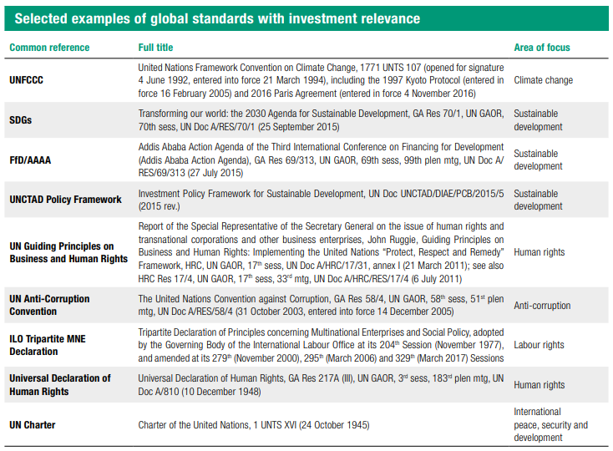
Source: United Nations Conference on Trade and Development, World Investment Report 2017, Geneva, 2017, p. 139.
103. Bearing in mind the brief timeline of 2030 to achieve the SDGs, policy recommendations for reforms and actions to investor protection measures within IIAs are proposed in this paper with the key objective of enabling national industrial development by applying the articles of the DRTD and the targets of the SDGs. Within this process, a range of reforms need to be considered by all four stakeholders of States, International Organisations, Investors and Civil Society. This includes, in particular, assessing options on performance requirement prohibitions, IIA amendments, interpretations or terminations, carrying out HRIAs of trade and investment agreements for States, monitoring developments in IIAs, identifying what is not working in IIAs, and advocacy and capacity building on the linkage between industrial development, SDGs and RTD, including on women’s rights. Such an endeavor to cooperate, assess and reformulate IIAs have the significant potential to facilitate the internationally agreed goals on inclusive and sustainable industrialization as well as the RTD which mandates an enabling policy environment for development.
Annex
Addis Ababa Action Agenda of the Third International Conference on Financing for Development (Addis Ababa Action Agenda) (extracts)
Paragraph 15.
Promoting inclusive and sustainable industrialization. We stress the critical importance of industrial development for developing countries, as a critical source of economic growth, economic diversification, and value addition. We will invest in promoting inclusive and sustainable industrial development to effectively address major challenges such as growth and jobs, resources and energy efficiency, pollution and climate change, knowledge-sharing, innovation and social inclusion. In this regard, we welcome relevant cooperation within the United Nations system, including the United Nations Industrial Development Organization (UNIDO), to advance the linkages between infrastructure development, inclusive and sustainable industrialization and innovation.
Paragraph 16.
Generating full and productive employment and decent work for all and promoting micro, small and medium-sized enterprises. To enable all people to benefit from growth, we will include full and productive employment and decent work for all as a central objective in our national development strategies. We will encourage the full and equal participation of women and men, including persons with disabilities, in the formal labour market. We note that micro, small and medium-sized enterprises, which create the vast majority of jobs in many countries, often lack access to finance. Working with private actors and development banks, we commit to promoting appropriate, affordable and stable access to credit to micro, small and medium-sized enterprises, as well as adequate skills development training for all, particularly for youth and entrepreneurs. We will promote national youth strategies as a key instrument for meeting the needs and aspirations of young people. We also commit to developing and operationalizing, by 2020, a global strategy for youth employment and implementing the International Labour Organization (ILO) Global Jobs Pact.
Paragraph 45.
We will encourage investment promotion and other relevant agencies to focus on project preparation. We will prioritize projects with the greatest potential for promoting full and productive employment and decent work for all, sustainable patterns of production and consumption, structural transformation and sustainable industrialization, productive diversification and agriculture. Internationally, we will support these efforts through financial and technical support and capacity-building, and closer collaboration between home and host country agencies. We will consider the use of insurance, investment guarantees, including through the Multilateral Investment Guarantee Agency, and new financial instruments to incentivize foreign direct investment to developing countries, particularly least developed countries, landlocked developing countries, small island developing States and countries in conflict and post-conflict situations.
Paragraph 46.
We note with concern that many least developed countries continue to be largely sidelined by foreign direct investment that could help to diversify their economies, despite improvements in their investment climates. We resolve to adopt and implement investment promotion regimes for least developed countries. We will also offer financial and technical support for project preparation and contract negotiation, advisory support in investment-related dispute resolution, access to information on investment facilities and risk insurance and guarantees such as through the Multilateral Investment Guarantee Agency, as requested by the least developed countries. We also note that small island developing States face challenges accessing international credit as a result of the structural characteristics of their economies. Least developed countries will continue to improve their enabling environments. We will also strengthen our efforts to address financing gaps and low levels of direct investment faced by landlocked developing countries, small island developing States, many middle-income countries, and countries in conflict and post-conflict situations. We encourage the use of innovative mechanisms and partnerships to encourage greater international private financial participation in these economies.

List of Abbreviations
AAAA Addis Ababa Action Agenda
ASEAN Association of Southeast Asian Nations
BIT Bilateral investment treaty
CAN Andean Community
CBDR Common but differentiated responsibilities
DRTD - United Nations Declaration on the Right to Development
EU European Union
FDI Foreign direct investment
FET Fair and equitable treatment
FfD Financing for Development
FTA Free trade agreement
GA United Nations General Assembly
GATT General Agreement on Trade and Tariffs
GDP Gross Domestic Product
IIA International Investment Agreements
ILO International Labour Organisation
ISDS Investor-state dispute settlement system
LDCs Least Developed Countries
MERCOSUR Southern Cone Common Market
MFN The most favoured nation
NAFTA North American Free Trade Agreement
OHCHR Office of the United Nations High Commissioner for Human Rights
R&D Research and Development
RTD Right to development
SDGs Sustainable Development Goals
SDT Special and differential treatment
SMEs Small and medium enterprises
TNCs Transnational corporations
TRIMs Trade-Related Investment Measures
TSIAs Trade and Sustainability Impact Assessments
UDHR Universal Declaration of Human Rights
UN United Nations
UNCTAD United Nations Conference on Trade and Development
UNIDO United Nations Industrial Development Organization
VDPA Vienna Declaration and Programme of Action
WTO World Trade Organisation

* Ms. Bhumika Muchhala is an Independent Consultant on Finance and Sustainable Development. Previously she worked on finance and development issues for the Third World Network, focusing on the international financial system, macro-policies and international financial institutions. The opinions, findings, interpretations or conclusions expressed in this paper are those of the expert, do not necessarily represent the views of the United Nations and do not commit the United Nations. The designations employed and the presentation of the material in this paper are those of the expert and do not imply the expression of any opinion whatsoever on the part of the United Nations concerning the legal status of any country, territory, city or area of its authorities, or concerning the delimitation of its frontiers or boundaries. The text is reproduced as received.
UN General Assembly, Declaration on the Right to Development, A/RES/41/128, 4 December 1986, available at: http://www.un.org/documents/ga/res/41/a41r128.htm.
UN General Assembly, ‘Transforming our world: the 2030 Agenda for Sustainable Development’, A/RES/70/1, 25 September 2015, available at: http://www.un.org/ga/search/view_doc.asp?symbol=A/RES/70/1&Lang=E.
UN General Assembly, Addis Ababa Action Agenda of the Third International Conference on Financing for Development, A/RES/69/313, 16 July 2015, available at: http://www.un.org/esa/ffd/wp-content/uploads/2015/08/AAAA_Outcome.pdf
UN General Assembly, High Commissioner for the promotion and protection of all human rights: resolution adopted by the General Assembly, A/RES/48/141, 20 December 1993, available at: http://www.un.org/documents/ga/res/48/a48r141.htm.
See OHCHR, “Frequently Asked Questions on the Right to Development”, New York and Geneva, 2016, available at: http://www.ohchr.org/Documents/Publications/FSheet37_RtD_EN.pdf, OHCHR (ed.), Realizing the Right to Development: Essays in Commemoration of 25 Years of the United Nations Declaration on the Right to Development, United Nations, 2013.
United Nations, Charter of the United Nations, 24 October 1945, 1 UNTS XVI, available at: https://treaties.un.org/doc/publication/ctc/uncharter.pdf
UN General Assembly, Universal Declaration of Human Rights, 10 December 1948, 217 A (III), available at: http://www.un.org/en/ga/search/view_doc.asp?symbol=A/RES/217(III).
UN General Assembly, International Covenant on Economic, Social and Cultural Rights, 16 December 1966, United Nations, Treaty Series, vol. 993, p. 3, available at: https://treaties.un.org/doc/Treaties/1976/01/19760103%2009-57%20PM/Ch_IV_03.pdf.
UN General Assembly, International Covenant on Civil and Political Rights, 16 December 1966, United Nations, Treaty Series, vol. 999, p. 171, available at: https://treaties.un.org/doc/publication/unts/volume%20999/volume-999-i-14668-english.pdf.
UN General Assembly, Rio Declaration on Environment and Development, A/CONF.151/26/Rev.1, 31 I.L.M 874 (1992), 3–14 June 1992, available at: http://www.un.org/documents/ga/conf151/aconf15126-1.htm.
UN General Assembly, Vienna Declaration and Programme of Action, 12 July 1993, A/CONF.157/23, available at: http://www.ohchr.org/Documents/ProfessionalInterest/vienna.pdf.
CAB/LEG/67/3 rev. Organization of African Unity, African Charter on Human and Peoples' Rights, CAB/LEG/67/3 rev. 5, 21 I.L.M. 58 (1982), 27 June 1981, available at: https://au.int/sites/default/files/treaties/7770-treaty-0011_-_african_charter_on_human_and_peoples_rights_e.pdf.
The justiciability of the RTD has been upheld by the African Commission on Human and Peoples’ Rights in Centre for Minority Rights Development (Kenya) and Minority Rights Group (on behalf of Endorois Welfare Council) (ACmHPR, Decision 276/03 of 25 November 2009, available at: http://www.achpr.org/files/sessions/46th/comunications/276.03/achpr46_276_03_eng.pdf) and by the African Court on Human and Peoples’ Rights in African Commission on Human and Peoples’ Rights v. Republic of Kenya (AfCHPR, Application No. 006/2012, Judgment of 26 May 2017, available at: http://www.african-court.org/en/images/Cases/Judgment/Application%20006-2012%20-%20African%20Commission%20on%20Human%20and%20Peoples%E2%80%99%20Rights%20v.%20the%20Republic%20of%20Kenya..pdf). For a discussion on the justiciability of the RTD, see OHCHR, “Frequently Asked Questions on the Right to Development”, New York and Geneva, 2016, available at: http://www.ohchr.org/Documents/Publications/FSheet37_RtD_EN.pdf, pp. 8-9.
For example, 1948 Charter of the Organization of American States Arts. 31-33; 1969 American Convention on Human Rights, Art. 26; 2004 Arab Charter on Human Rights, Art.37; 2012 ASEAN Human Rights Declaration Arts. 35-37; 2016 Abu Dhabi Declaration For example, 1948 Charter of the Organization of American States (OAS, Charter of the Organisation of American States, 30 April 1948, available at: http://www.oas.org/en/sla/dil/inter_american_treaties_A-41_charter_OAS.asp), Arts. 31-33; 1969 American Convention on Human Rights (Organization of American States (OAS), American Convention on Human Rights, "Pact of San Jose", Costa Rica, 22 November 1969, available at: https://www.cidh.oas.org/basicos/english/basic3.american%20convention.htm), Art. 26; 2004 Arab Charter on Human Rights (League of Arab States, Arab Charter on Human Rights, 15 September 1994), Art.37; 2012 ASEAN Human Rights Declaration (ASEAN, ASEAN Human Rights Declaration, 18 November 2012, available at: http://www.asean.org/storage/images/ASEAN_RTK_2014/6_AHRD_Booklet.pdf), Arts. 35-37; 2016 Abu Dhabi Declaration, http://www.oic-iphrc.org/en/data/docs/articles_studies/iphrc_abu_dhabi_outcome_2016.pdf (http://www.intosai.org/fileadmin/downloads/downloads/0_news/2016/141216_EN_AbuDhabiDeclaration.pdf.pdf).
Schrijver, N. in “The Role of the United Nations in the Development of International Law”, in Harrod, J., Schrijver, N. (eds.), The UN Under Attack, Gower, Aldershot, 1988, pp. 35-56, states that the description of a UNGA resolution as a ‘Declaration’ is in itself a sign that the instrument is a normative resolution with legal value and relevance.
United Nations Conference on Trade and Development (UNCTAD) and International Labour Organisation (ILO), “Transforming Economies: Making industrial policy work for growth, jobs and development,” Geneva, 2014, available at: http://www.ilo.org/wcmsp5/groups/public/---dgreports/---dcomm/---publ/documents/publication/wcms_242878.pdf, p. 65-66.
United Nations Division for Sustainable Development, “Industry, Innovation and Infrastructure: Why it matters,” 2016, New York, available at: http://www.un.org/sustainabledevelopment/wp-content/uploads/2016/08/9_Why-it-Matters_ Goal-9_Industry_1p.pdf, p.1-2.
Ibid.
See United Nations Industrial Development Organization, “Inclusive and Sustainable Industrialization,” available at: https://isid.unido.org/about-isid.html.
Fourth United Nations Conference on the Least Developed Countries, A/CONF.219/3, “Programme of Action for the Least Developed Countries for the Decade 2011-2020,” Istanbul, Turkey, 9-13 May 2011, available at: http://ldc4istanbul.org/uploads/ipoa.pdf, paras 54 and 101.
Ibid.
United Nations Industrial Development Organization (UNIDO), 15th Session of UNIDO General Conference, “Lima Declaration: Towards inclusive and sustainable industrial development,” Lima, Peru, 2 December 2013, available at: https://www.unido.org/sites/default/files/2014-02/Lima_Declaration_0.pdf, para 2.
Ibid.
Human Rights Council, Report of the Special Rapporteur on the right to food, Olivier De Schutter, Addendum “Guiding principles on human rights impact assessments of trade and investment agreements”, A/HRC/19/59/Add.5, 19 December 2011, available at: http://www.ohchr.org/Documents/HRBodies/HRCouncil/RegularSession/Session19/A-HRC-19-59-Add5_en.pdf, Addendum.
Ibid.
Ibid, Principle 1.1.
Ibid, Principle 3.
United Nations Department of Economic and Social Affairs, “Financing For Development: Progress And Prospects,” Report of the Inter-agency Task Force on Financing for Development, New York, 2017, available at: https://developmentfinance.un.org/sites/developmentfinance.un.org/files/Report_IATF-2017.pdf, p. vii.
Germany - Pakistan BIT, 1959, available at: http://investmentpolicyhub.unctad.org/Download/TreatyFile/1387.
Bernasconi-Osterwalder, Nathalie et al, Investment Treaties & Why They Matter to Sustainable Development: Questions and Answers, Winnipeg, Manitoba, Canada: International Institute for Sustainable Development, 2012, available at: http://www.iisd.org/pdf/2011/investment_treaties_why_they_matter_sd.pdf, p. 4.
Ibid, p. 4.
See United Nations Conference on Trade and Development (UNCTAD), Investment Policy Hub, investmentpolicyhub.unctad.org/IIA.
Poulsen, Lauge, “The Importance of BITs for Foreign Direct Investment and Political Risk Insurance: Revisiting the Evidence”, in Yearbook on International Investment Law & Policy 2009/2010, New York: Oxford University Press, available at: http://discovery.ucl.ac.uk/1471858/1/Poulsen_bits%20pri%20yearbook.pdf, p.5.
Ibid.
Ibid.
Yackee, Jason, “Do Bilateral Investment Treaties Promote Foreign Direct Investment: Some Hints from Alternative Evidence,” Virginia Journal of International Law 51:397, 2010-2011, p. 2; UNCTAD IIA Issues Note “The Impact of International Investment Agreements on Foreign Direct Investment: An Overview of Empirical Studies 1998-2014”, September 2014, available at: http://investmentpolicyhub.unctad.org/Upload/Documents/unctad-web-diae-pcb-2014-Sep%2024.pdf, p.1.
United Nations Conference on Trade and Development (UNCTAD), Trade and Development Report, Geneva, 2014, available at: http://unctad.org/en/PublicationsLibrary/tdr2014_en.pdf, p.159.
Rodrik, Dani, One Economics, Many Recipes: Globalization, Institutions, and Economic Growth, Princeton: Princeton University Press, 2007, p.148.
Johnson, Lise, Sachs, Lisa and Sachs, Jeffrey, “Investor State Dispute Settlement, Public Interest and U.S. Domestic Law,” Columbia Center on Sustainable Investment, Policy Paper, New York, May 2015, available at: http://ccsi.columbia.edu/files/2015/05/Investor-State-Dispute-Settlement-Public-Interest-and-U.S.-Domestic-Law-FINAL-May-19-8.pdf, p.2.
Ibid.
Ibid, p.2-4.
Bernasconi-Osterwalder, Nathalie et al, Investment Treaties & Why They Matter to Sustainable Development: Questions and Answers, Winnipeg, Manitoba, Canada: International Institute for Sustainable Development, 2012, available at: http://www.iisd.org/pdf/2011/investment_treaties_why_they_matter_sd.pdf, p.7.
OECD, “Investor-State Dispute Settlement”, Public Consultation: 16 May - 9 July 2012, available at: http://www.oecd.org/investment/internationalinvestmentagreements/50291642.pdf, p. 18.
Eberhardt, Pia and Olivet, Cecilia, “Profiting from injustice: How law firms, arbitrators and financiers are fuelling an investment arbitration boom,” Transnational Institute and Corporate Europe Observatory, Brussels and Amsterdam, November 2012, available at: https://www.tni.org/files/download/profitingfrominjustice.pdf, p.15 and 26.
Excerpts from Tecnicas Medoambientales Tecmed S.A. v. United Mexican States, ICSID Case No. ARB (AF)/00/2, Award, May 29, 2003, available at: http://icsidfiles.worldbank.org/icsid/ICSIDBLOBS/OnlineAwards/C3785/DC4872_En.pdf, para. 154.
Ibid.
Bernasconi-Osterwalder, Nathalie et al, Investment Treaties & Why They Matter to Sustainable Development: Questions and Answers, Winnipeg, Manitoba, Canada: International Institute for Sustainable Development, 2012, available at: http://www.iisd.org/pdf/2011/investment_treaties_why_they_matter_sd.pdf, p. 12.
South Centre, Investment Treaties: Views and Experiences from Developing Countries, Geneva, 2015, available at: https://www.southcentre.int/product/investment-treaties-views-and-experiences-from-developing-countries/, p. 4.
Ibid, p.29.
Bernasconi-Osterwalder, Nathalie et al, Investment Treaties & Why They Matter to Sustainable Development: Questions and Answers, Winnipeg, Manitoba, Canada: International Institute for Sustainable Development, 2012, available at: http://www.iisd.org/pdf/2011/investment_treaties_why_they_matter_sd.pdf, p.20.
Ibid.
Ibid.
Text of the North American Free Trade Agreement, NAFTA Secretariat, Ottawa, Mexico City and Washington, D.C. 2017, available at: https://www.nafta-sec-alena.org/Home/Texts-of-the-Agreement/North-American-Free-Trade-Agreement?mvid=2, Article 1102(1).
Ibid.
Bernasconi-Osterwalder, Nathalie et al, Investment Treaties & Why They Matter to Sustainable Development: Questions and Answers, Winnipeg, Manitoba, Canada: International Institute for Sustainable Development, 2012, available at: http://www.iisd.org/pdf/2011/investment_treaties_why_they_matter_sd.pdf, p. 23.
Ibid, p.24.
See United Nations Conference on Trade and Development (UNCTAD), Investment Policy Hub, investmentpolicyhub.unctad.org/IIA.
Maffezini v. the Kingdom of Spain,ICSID Case No. ARB/97/7, available at: https://icsid.worldbank.org/en/Pages/cases/casedetail.aspx?CaseNo=ARB/97/7.
Nikièma, Suzy H., “Performance Requirements in Investment Treaties Best Practices Series,” International Institute for Sustainable Development, Winnipeg, Manitoba, Canada, December 2014, available at: http://www.iisd.org/sites/default/files/publications/best-practices-performance-requirements-investment-treaties-en.pdf, p.1-3.
Ibid.
Bernasconi-Osterwalder, Nathalie et al, Investment Treaties & Why They Matter to Sustainable Development: Questions and Answers, Winnipeg, Manitoba, Canada: International Institute for Sustainable Development, 2012, available at: http://www.iisd.org/pdf/2011/investment_treaties_why_they_matter_sd.pdf, p.30.
International Monetary Fund, “The Liberalization and Management of Capital Flows: An Institutional View,” Washington, D.C., November 14, 2012, available at: http://www.imf.org/external/np/pp/eng/2012/111412.pdf, para 8, p.8.
Ibid, para 65, p.33.
South Centre, Investment Treaties: Views and Experiences from Developing Countries, Geneva, 2015, available at: https://www.southcentre.int/product/investment-treaties-views-and-experiences-from-developing-countries/, p.28.
Ibid.
Gallagher, Kevin, “Regaining Control? Capital Controls and the Global Financial Crisis,” Political Economy Research Institute, Workingpaper Series, Number 250, February 2011, available at: https://www.peri.umass.edu/fileadmin/pdf/working_papers/working_papers_201-250/WP250.pdf, p. 1.
Gallagher, Kevin, “Reforming United States trade and investment treaties for financial stability: The case of capital controls”, 5 April 2011, available at: https://www.iisd.org/itn/2011/04/05/reforming-united-states-trade-and-investment-treaties-for-financial-stability-the-case-of-capital-controls/.
UN General Assembly, Rio Declaration on Environment and Development, A/CONF.151/26/Rev.1, 31 I.L.M 874 (1992), 3–14 June 1992, available at: http://www.un.org/documents/ga/conf151/aconf15126-1.htm.
Bernasconi-Osterwalder, Nathalie et al, Investment Treaties & Why They Matter to Sustainable Development: Questions and Answers, (Winnipeg, Manitoba, Canada: International Institute for Sustainable Development, 2012, available at: http://www.iisd.org/pdf/2011/investment_treaties_why_they_matter_sd.pdf, p. 23).
Warwick, K., “Beyond Industrial Policy: Emerging Issues and New Trends”, OECD Science, Technology and Industry Policy Papers, No. 2, OECD Publishing, 2013, available at: http://www.oecd-ilibrary.org/docserver/download/5k4869clw0xp-en.pdf?expires=1522246727&id=id&accname=guest&checksum=AE369F24E94DB7C98511AEE074384122, p. 15.
See Office of the United States Trade Representative, Free Trade Agreements, available at: https://ustr.gov/trade-agreements/free-trade-agreements; and United Nations Conference on Trade and Development, World Investment Report 2014: Investing in the SDGs: An action plan, Geneva: United Nations Conference on Trade and Development, 2014, available at: http://unctad.org/en/PublicationsLibrary/wir2014_en.pdf, p.118.
Nikièma, Suzy H., “Performance Requirements in Investment Treaties Best Practices Series,” International Institute for Sustainable Development, Winnipeg, Manitoba, Canada, December 2014, available at: http://www.iisd.org/sites/default/files/publications/best-practices-performance-requirements-investment-treaties-en.pdf, p.1.
United Nations Conference on Trade and Development (UNCTAD), Foreign Direct Investment and Performance Requirements: New Evidence from Selected Countries, Geneva and New York: United Nations Conference on Trade and Development, 2003, available at: http://unctad.org/en/Docs/iteiia20037_en.pdf, p.9.
Thrasher, Rachel Denae, “Chapter 4: Whither the Developmental State? Industrial Policy and Development Sovereignty,” in Gallagher, Kevin, ed., The Clash of Globalizations: Essays on the Political Economy of Trade and Development Policy, New York and London: Anthem Press, 2013, p.85.
South Centre, Investment Treaties: Views and Experiences from Developing Countries, Geneva,2015, available at: https://www.southcentre.int/product/investment-treaties-views-and-experiences-from-developing-countries/, p.55.
United Nations Conference on Trade and Development (UNCTAD), Elimination of TRIMs: The Experience of Selected Developing Countries, New York and Geneva: United Nations, 2007, available at: http://unctad.org/en/Docs/iteiia20076_en.pdf, p.4-9.
United Nations Conference on Trade and Development, World Investment Report 2014: Investing in the SDGs: An action plan, Geneva: United Nations Conference on Trade and Development, 2014, available at: http://unctad.org/en/PublicationsLibrary/wir2014_en.pdf, p.12-13.
Thrasher, Rachel Denae and Gallagher, Kevin P., “21st Century Free Trade Agreements: Implications for Long-Run Development Policy,” The Pardee Papers, No 2, Boston University, September 2008, available at: https://www.bu.edu/pardee/files/documents/PP-002-Trade.pdf, p. 38.
UN General Assembly, Addis Ababa Action Agenda of the Third International Conference on Financing for Development, A/RES/69/313, 16 July 2015, available at: http://www.un.org/esa/ffd/wp-content/uploads/2015/08/AAAA_Outcome.pdf, para 123.
Comin, Diego and Mestieri, Marti, “If Technology Has Arrived Everywhere, Why Has Income Diverged?,” Dartmouth College, New Hampshire, 20 July 2017, available at: https://www.dartmouth.edu/~dcomin/Publications_files/CM_rev_71917.pdf, p.2-3.
UN General Assembly, Addis Ababa Action Agenda of the Third International Conference on Financing for Development, A/RES/69/313, 16 July 2015, available at: http://www.un.org/esa/ffd/wp-content/uploads/2015/08/AAAA_Outcome.pdf, para 45.
United Nations Conference on Trade and Development (UNCTAD) and International Labour Organisation (ILO), “Transforming Economies: Making industrial policy work for growth, jobs and development,” Geneva, 2014, available at: http://www.ilo.org/wcmsp5/groups/public/---dgreports/---dcomm/---publ/documents/publication/wcms_242878.pdf, p.28.
United Nations Conference on Trade and Development (UNCTAD), Foreign Direct Investment and Performance Requirements: New Evidence from Selected Countries, Geneva and New York: United Nations Conference on Trade and Development, 2003, available at: http://unctad.org/en/Docs/iteiia20037_en.pdf, p.13 and 27.
South Centre, Investment Treaties: Views and Experiences from Developing Countries, Geneva, 2015, available at: https://www.southcentre.int/product/investment-treaties-views-and-experiences-from-developing-countries/, pp.89-90.
United Nations Conference on Trade and Development, International Investment Agreements (IIA) Issues Note, Issue 3, “Special Update on Investor-State Dispute Settlement: Facts and Figures,” Geneva, November 2017, available at: http://unctad.org/en/PublicationsLibrary/diaepcb2017d7_en.pdf, p.2.
United Nations Conference on Trade and Development, International Investment AgreementsIIA) Issues Note, Issue 1, “Investor State Dispute Settlement: Review of Developments in 2016,” Geneva, May 2017, available at: http://unctad.org/en/PublicationsLibrary/diaepcb2017d1_en.pdf, p.1.
Ibid, p. 4.
Ibid, p. 1.
Zbigniew Piotr Grot and others v. Republic of Moldova, ICSID Case No. ARB/16/8, available at: https://icsid.worldbank.org/en/Pages/cases/casedetail.aspx?CaseNo=ARB/16/8, and Görkem Inşaat Sanayi ve Ticaret Limited Şirketi v. Turkmenistan, ICSID Case No. ARB/16/30, available at: https://icsid.worldbank.org/en/Pages/cases/casedetail.aspx?CaseNo=ARB/16/30 (investor state dispute settlement cases).
Cosigo Resources, Ltd., Cosigo Resources Sucursal Colombia, Tobie Mining and Energy, Inc. v. Republic of Colombia, UNCITRAL (investor state dispute settlement case).
United Nations Conference on Trade and Development, International Investment Agreements, IIA Issues Note, Issue 1, “Investor State Dispute Settlement: Review of Developments in 2016,” Geneva, May 2017, available at: http://unctad.org/en/PublicationsLibrary/diaepcb2017d1_en.pdf, p. 5.
Johnson, Lise, Sachs, Lisa and Sachs, Jeffrey, “Investor State Dispute Settlement, Public Interest and U.S. Domestic Law,” Columbia Center on Sustainable Investment, Policy Paper, New York, May 2015, available at: http://ccsi.columbia.edu/files/2015/05/Investor-State-Dispute-Settlement-Public-Interest-and-U.S.-Domestic-Law-FINAL-May-19-8.pdf, p.4.
Occidental Petroleum Corporation and Occidental Exploration and Production Company v. Republic of Ecuador, ICSID Case No. ARB/06/11, available at: https://icsid.worldbank.org/en/Pages/cases/casedetail.aspx?CaseNo=ARB/06/11.
Public Citizen, “Case Studies: Investor-State Attacks on Public Interest Policies,” Washington, D.C., 2012, p. 5.
Ibid, p. 5.
Peterson, Luke Eric, “Ecuador must pay $1.76 billion to Occidental for expropriation of oil investment; largest award ever in Bilateral Investment Treaty case at ICSID,” Investment Arbitration Reporter, 5 October 2012.
Archer Daniels Midland Company and Tate & Lyle Ingredients Americas, Inc. v. United Mexican States, ICSID Case No. ARB(AF)/04/5, available at: https://icsid.worldbank.org/en/Pages/cases/casedetail.aspx?CaseNo=ARB(AF)/04/5.
South Centre, Investment Treaties: Views and Experiences from Developing Countries, South Centre, Geneva, 2015, available at: https://www.southcentre.int/product/investment-treaties-views-and-experiences-from-developing-countries/.
International Finance Corporation, Strengthening Access to Finance for Women-Owned SMEs in Developing Countries, Washington, D.C.: International Finance Corporation, October 2011, available at: https://www.ifc.org/wps/wcm/connect/a4774a004a3f66539f0f9f8969adcc27/ G20_Women_Report.pdf?MOD=AJPERES, p.3.
Bell, Simon, “Small and Medium Enterprises (SMEs) Finance,” World Bank Policy Brief, Washington, D.C., 1 September 2015.
Foon, Ho Wah, “SMES must buck up for TPPA,” The Star No 23, 23 November 2015, available at: https://www.thestar.com.my/metro/smebiz/news/2015/11/23/smes-must-buck-up-for-tppa/.
Kennedy, Lindsey, “The secret business plan that could spell the end for SMEs,” SME Insider, 12 February 2015, available at: http://www.smeinsider.com/2015/02/12/the-secret-business-plan-that-could-spell-the-end-for-smes/.
Ibid.
Burlington Resources, Inc. v. Republic of Ecuador, ICSID Case No. ARB/08/5, available at: https://icsid.worldbank.org/en/Pages/cases/casedetail.aspx?CaseNo=ARB/08/5.
King & Spalding Law Firm, “The Renco Group, Inc., Claimant, v. The Republic of Peru, Respondent,” New York, 29 December 2010, available at: https://www.italaw.com/sites/default/files/case-documents/ita0713.pdf, p.4.
Gereffi, G, “The organisation of buyer-driven global commodity chain,” in Gereffi, G. and Korzeniewicz, M., eds., Commodity Chains and Global Capitalism, Westpoint, CT: Praeger Publishers, 1994, available at: https://dukespace.lib.duke.edu/dspace/bitstream/handle/10161/11457/1994_Gereffi_Role%20of%20big%20buyers%20in%20GCCs_chapter%205%20in%20CC%26GC.pdf?sequence=1&isAllowed=y, p.96-99.
Lang, Andrew, “Trade Agreements, Business and Human Rights: The case of export processing zones,” Corporate Social Responsibility Initiative Working Paper No. 57, John F. Kennedy School of Government, Harvard University, Cambridge, MA, April 2010, available at: https://sites.hks.harvard.edu/m-rcbg/CSRI/publications/workingpaper_57_ lang%20FINAL%20APRIL%202010.pdf, p.3-5.
Ibid.
International Labour Organisation, Labour Practices in the Footwear, Leather, Textiles and Clothing Industries, Geneva: International Labour Organisation, 2000, available at: http://www.ilo.org/public/libdoc/ilo/2000/100B09_189_engl.pdf, p.109.
Ibid, p.30, 33 and 34.
Pearson, R., Feminist Visions of Development: Research Analysis and Policy, London and New York: Routeledge, 1998, p.5.
Ibid.
UN General Assembly, Declaration on the Right to Development, A/RES/41/128, 4 December 1986, available at: http://www.un.org/documents/ga/res/41/a41r128.htm.
UN General Assembly, ‘Transforming our world: the 2030 Agenda for Sustainable Development’, A/RES/70/1, 25 September 2015, available at: http://www.un.org/ga/search/view_doc.asp?symbol=A/RES/70/1&Lang=E.
United Nations Conference on Trade and Development (UNCTAD), Annual High-level IIA Conference: Phase 2 of IIA Reform, 9-11 October 2017, Break-out session 2: Clarifying and modifying treaty content, Monday, 9 October 2017, 16:00-18:00, Room XXV (25), available at: http://investmentpolicyhub.unctad.org/Upload/Documents/BoS%202_agenda%20and%20report%20back.pdf, pp. 2-3.
Ibid.
Bernasconi-Osterwalder, Nathalie et al, Investment Treaties & Why They Matter to Sustainable Development: Questions and Answers, Winnipeg, Manitoba, Canada: International Institute for Sustainable Development, 2012, available at: http://www.iisd.org/pdf/2011/investment_treaties_why_they_matter_sd.pdf, p. 48.
Ibid.
United Nations Conference on Trade and Development (UNCTAD), World Investment Report 2017, Geneva, 2017, available at: http://unctad.org/en/pages/PublicationWebflyer.aspx?publicationid=1782, pp. 133-134; and, United Nations Conference on Trade and Development (UNCTAD), Annual High-level IIA Conference: Phase 2 of IIA Reform, 9-11 October 2017, Break-out session 2: Clarifying and modifying treaty content, Monday, 9 October 2017, 16:00-18:00, Room XXV (25), available at: http://investmentpolicyhub.unctad.org/Upload/Documents/BoS%202_agenda%20and%20report%20back.pdf, pp. 2-3.
Nikièma, Suzy H., “Performance Requirements in Investment Treaties Best Practices Series,” International Institute for Sustainable Development, Winnipeg, Manitoba, Canada, December 2014, available at: http://www.iisd.org/sites/default/files/publications/best-practices-performance-requirements-investment-treaties-en.pdf, p.16.
Ibid.
In May 2017, Ecuador terminated 12 IIAs it had signed with the following countries: China, Chile, Venezuela, the Netherlands, Switzerland, Canada, Argentina, the US, Spain, Peru, Bolivia and Italy. Ecuador is questioning the efficacy of the existing investment treaty regime, and in particular, the ISDS model which has led to extractive companies causing significant harm to its indigenous communities as well as environmental damage (See: DLA Piper LLP, “Ecuador terminates 12 BITs – a growing trend of reconsideration of traditional investment treaties,” Quito, Ecuador, 15 May 2017, available at: https://www.dlapiper.com/en/mexico/insights/publications/2017/05/ecuador-terminates-12-bits-a-growing-trend/.) Indonesia has commenced with the termination of 29 IIAs signed with other States (See: UNCTAD Investment Policy Hub, available at: http://investmentpolicyhub.unctad.org/IIA/CountryBits/97.) Indonesia has experienced a number of ISDS dispute cases involving large sums in claims and potential damages in recent years (See: Price, David, “Indonesia’s Bold Strategy on Bilateral Investment Treaties: Seeking an Equitable Climate for Investment?,” Asian Journal of International Law, Volume 7, Issue 1, January 2017, available at: https://www.cambridge.org/core/journals/asian-journal-of-international-law/article/indonesias-bold-strategy-on-bilateral-investment-treaties-seeking-an-equitable-climate-for-investment/2B196186FE7A415E60E84D57E169803D/core-reader, pp. 124-126.) South Africa has terminated nine IIAs (See: UNCTAD Investment Policy Hub, available at: http://investmentpolicyhub.unctad.org/IIA/CountryBits/195). Developed countries are also expressing discontent with investment treaties. In 2014, Germany announced that it opposes the inclusion of the ISDS in the Transatlantic Trade and Investment Partnership between the EU and the US. Germany’s announcement is a stark reversal of its long-held position in support of a strong ISDS and the fact that it has entered into more BITs than any other nation to date (See: Lovells, Hogan, “Germany reverses its support for Investor-State Dispute Settlement in the Transatlantic Trade and Investment Partnership (TTIP),” ARBlog, International Arbitration News, Trends and Cases, Washington, D.C. and London, 1 April 2014, available at: https://www.hoganlovells.com/en/blogs/focus-on-regulation/germany-reverses-its-support-for-investorstate-dispute-settlement-in-the-transatlantic-trade-and-investment-partnership-ttip.) In 2011, after an ISDS claim against Australia by the Philip Morris company against national anti-smoking health legislation for reducing current and future potential profits from selling its cigarettes, Australia decided that it will no longer include provisions on ISDS in bilateral and regional trade agreements. The new policy is justified by reference to the principles of ‘no greater rights’ for foreign investors and the government’s ‘right to regulate’ to protect the public interest (See: Tienhaara, Kyla and Ranald, Patricia, “Australia’s rejection of Investor-State Dispute Settlement: Four potential contributing factors,” International Institute of Sustainable Development, 12 July 2011, available at: https://www.iisd.org/itn/2011/07/12/australias-rejection-of-investor-state-dispute-settlement-four-potential-contributing-factors/.).
United Nations Human Rights Council, “Guiding Principles on Human Rights Impact Assessments of Trade and Investment Agreements: Report presented at the 19th Session of the Human Rights Council, UN Document A/HRC/19/59/Add.5, UN Special Rapporteur on the Right to Food, Geneva, 2011, available at: https://undocs.org/A/HRC/19/59/Add.5.
Harrison, James, “Human Rights Impact Assessments of Trade Agreements: Reflections on Practice and Principles for Future Assessments,” A Paper for the Expert Seminar on Human Rights Impact Assessments of Trade and Investment Agreements, 23-24 June, 2010, Geneva, available at: https://warwick.ac.uk/fac/soc/law/research/centres/chrp-old/projects/humanrightsimpactassessments/trade/hr_impact_background_paper.pdf, pp.1-2.
Ibid, pp.5-6.
Ibid, p.6.
For example, the European Commission’s Trade and Sustainability Impact Assessments independently evaluate the economic, social, environmental and human rights implications of trade negotiations before they are completed. These assessments have been carried out in the context of the EU’s trade negotiations with Chile, South Korea, India, Morocco, Egypt and currently with the US Transatlantic Trade and Investment Partnership. See: European Commission, “Sustainability Impact Assessments,”, available at: http://ec.europa.eu/trade/policy/policy-making/analysis/policy-evaluation/sustainability-impact-assessments/index_en.htm#_SIAs.
Ibid.
Ibid.

