Hhuy
United Nations Human Rights Council
United Nations High Commissioner for Human Rights

Helping everyone in the community to understand about people with disabilities and their rights

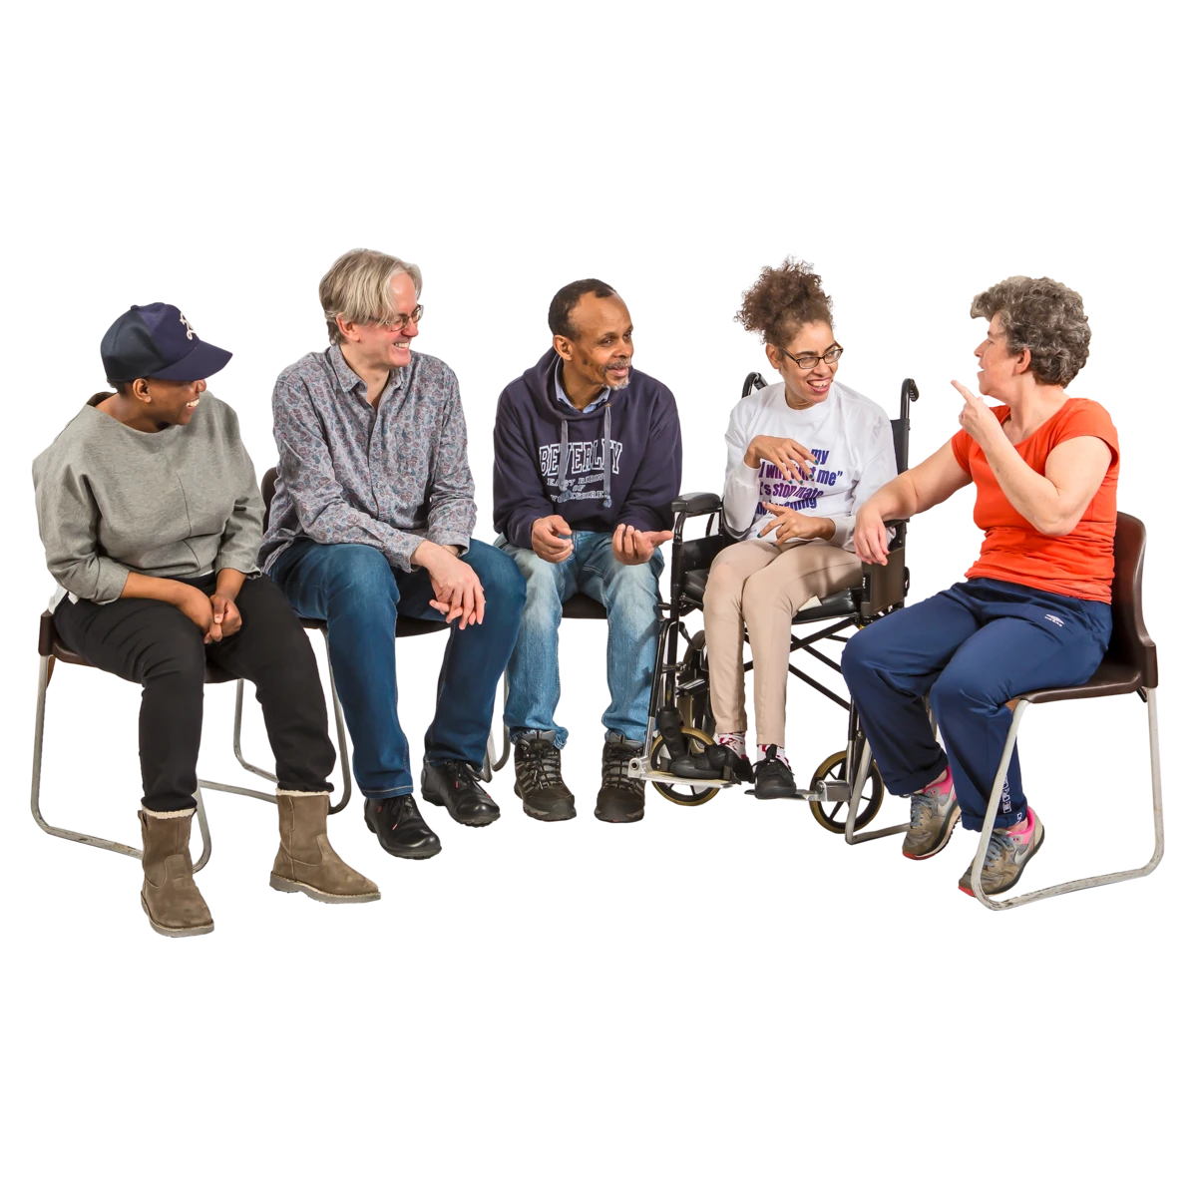

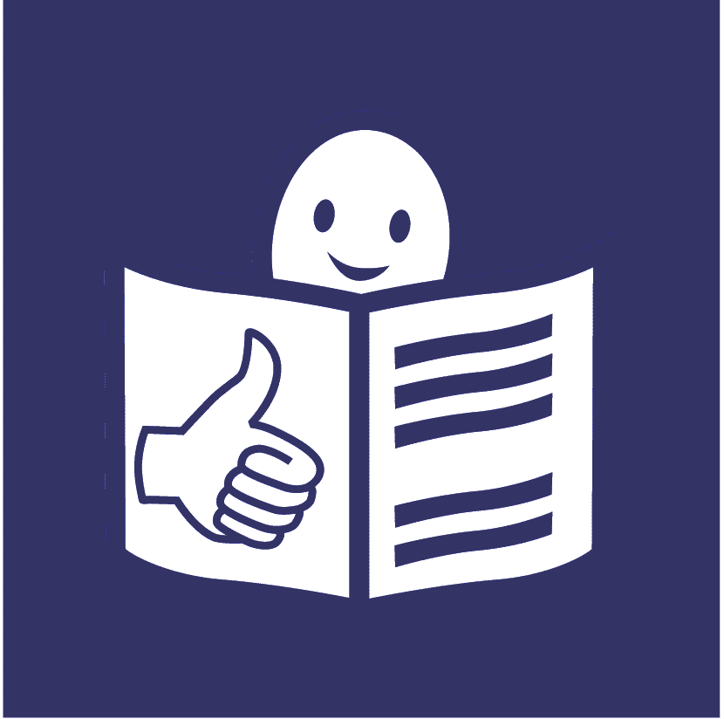

February 2020

Support for people with disabilities to do everyday things on their own, learn important skills and be part of the community in the best way they can

This is called habilitation and rehabilitation

About us

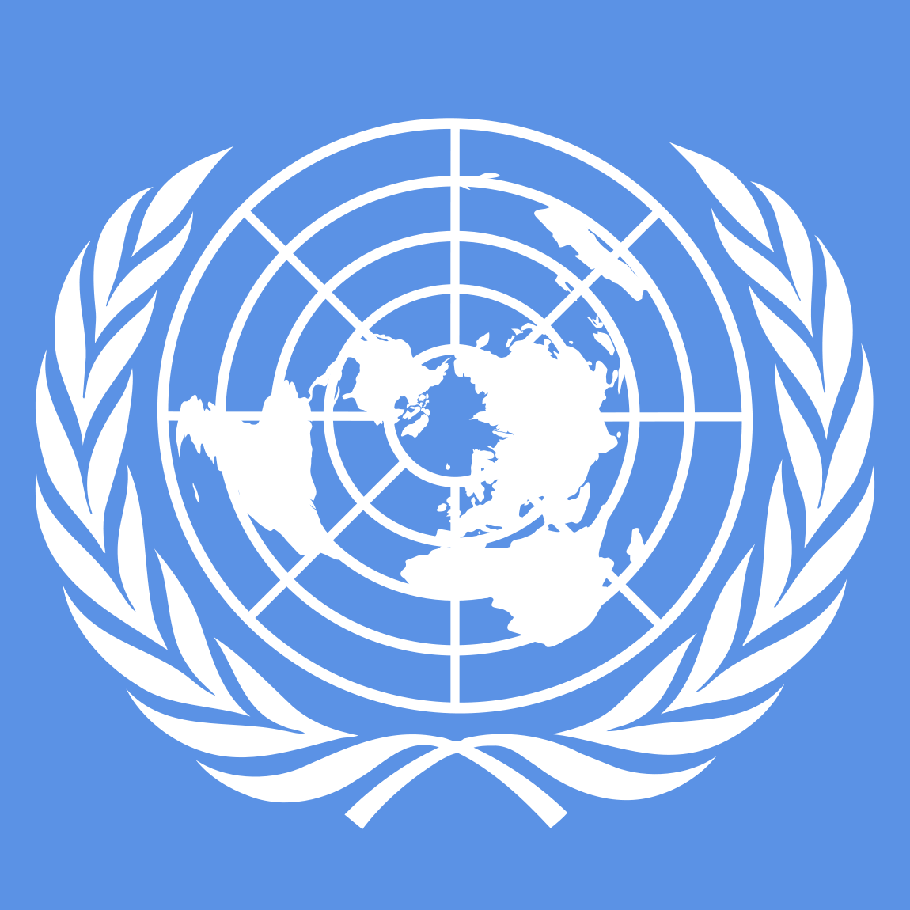
We are called the Office of the High Commissioner for Human Rights.

We are part of the United Nations (UN).

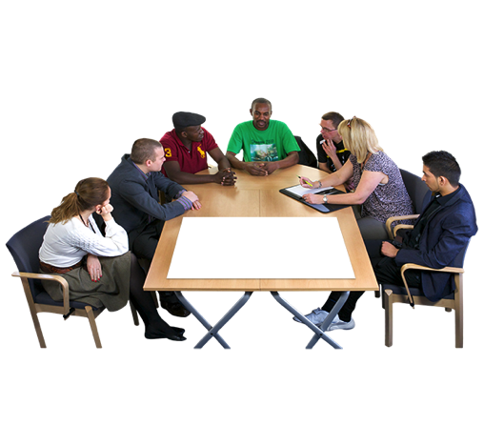

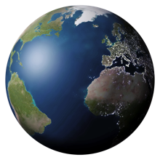
The United Nations is a group of countries that work to make the world a better and safer place.

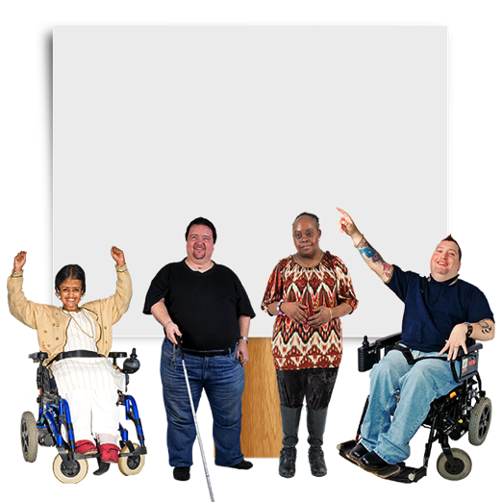

Our job is to make sure that
everyone in the world is treated fairly and gets their human rights.

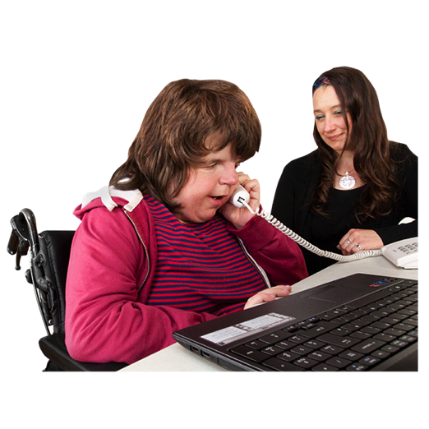

Human rights are rights that everyone has, like the right to:
- go to school
- work
- be healthy

About this report

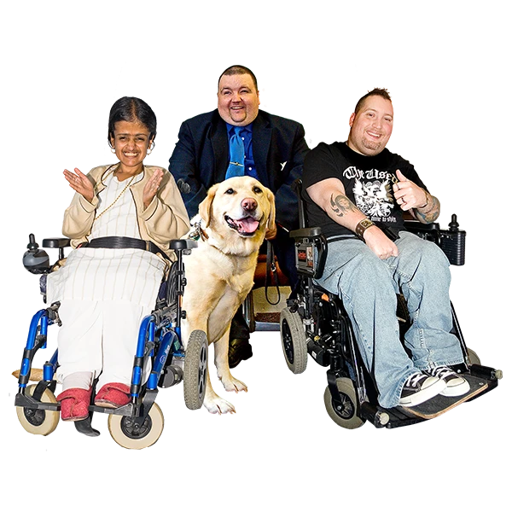
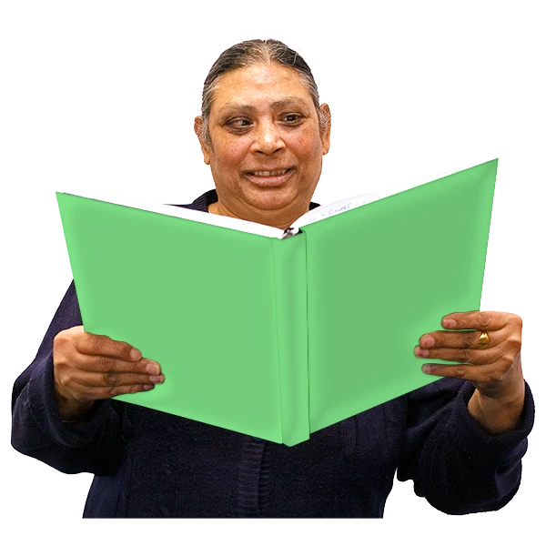
This report is about making sure that countries help everyone to understand about:
- People with disabilities and their rights
- What people with disabilities can do
- Why people with disabilities are just as important as everyone else

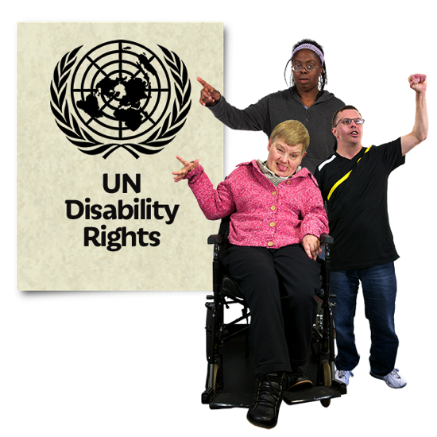
There is a document about the rights of all people with disabilities in the world.

It is called The Convention on the Rights of Persons with disabilities.

Many countries have promised to do what the document says.
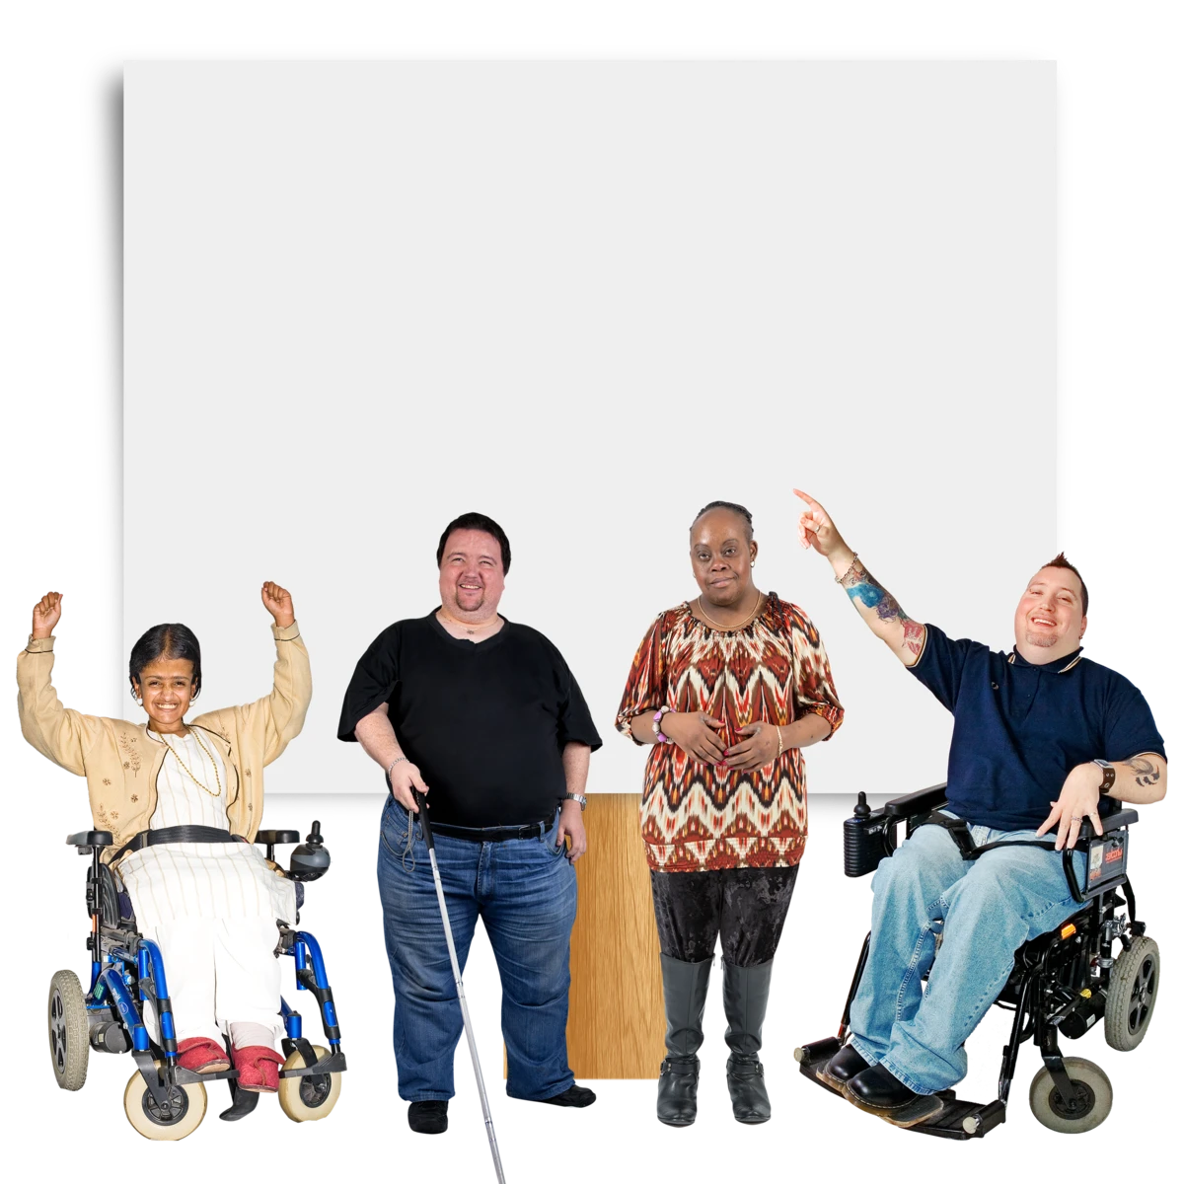

The document says that countries must help everyone to understand about people with disabilities and their rights.

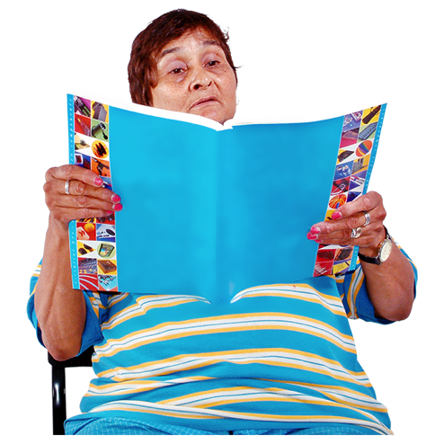
This report is about:
- What countries must do
- Some good work that countries told us they are doing

Why is this work important?

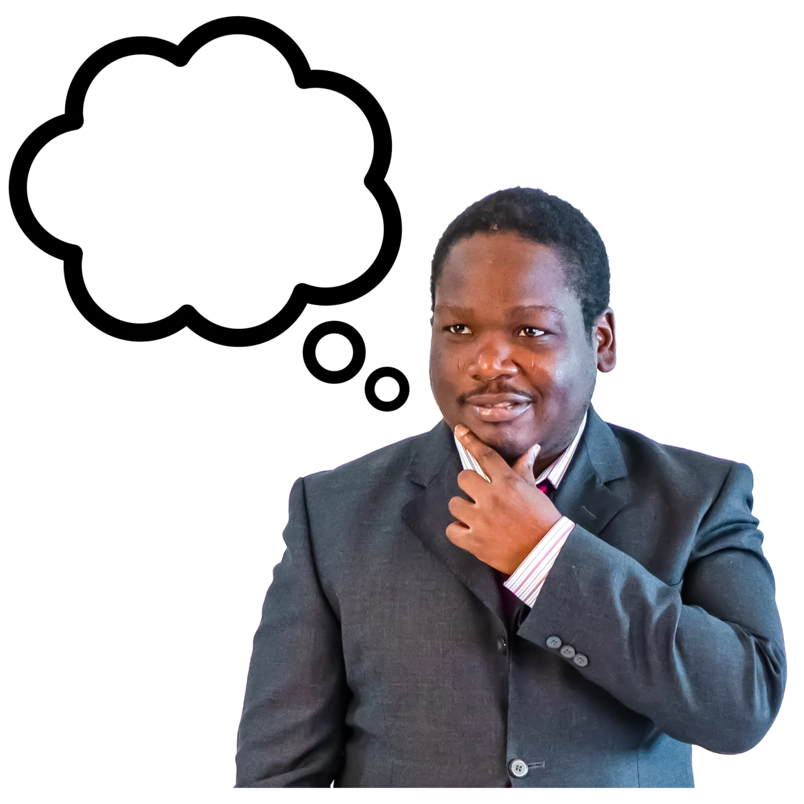

Many people in the world have wrong ideas about people with disabilities.

For example, people may think that:

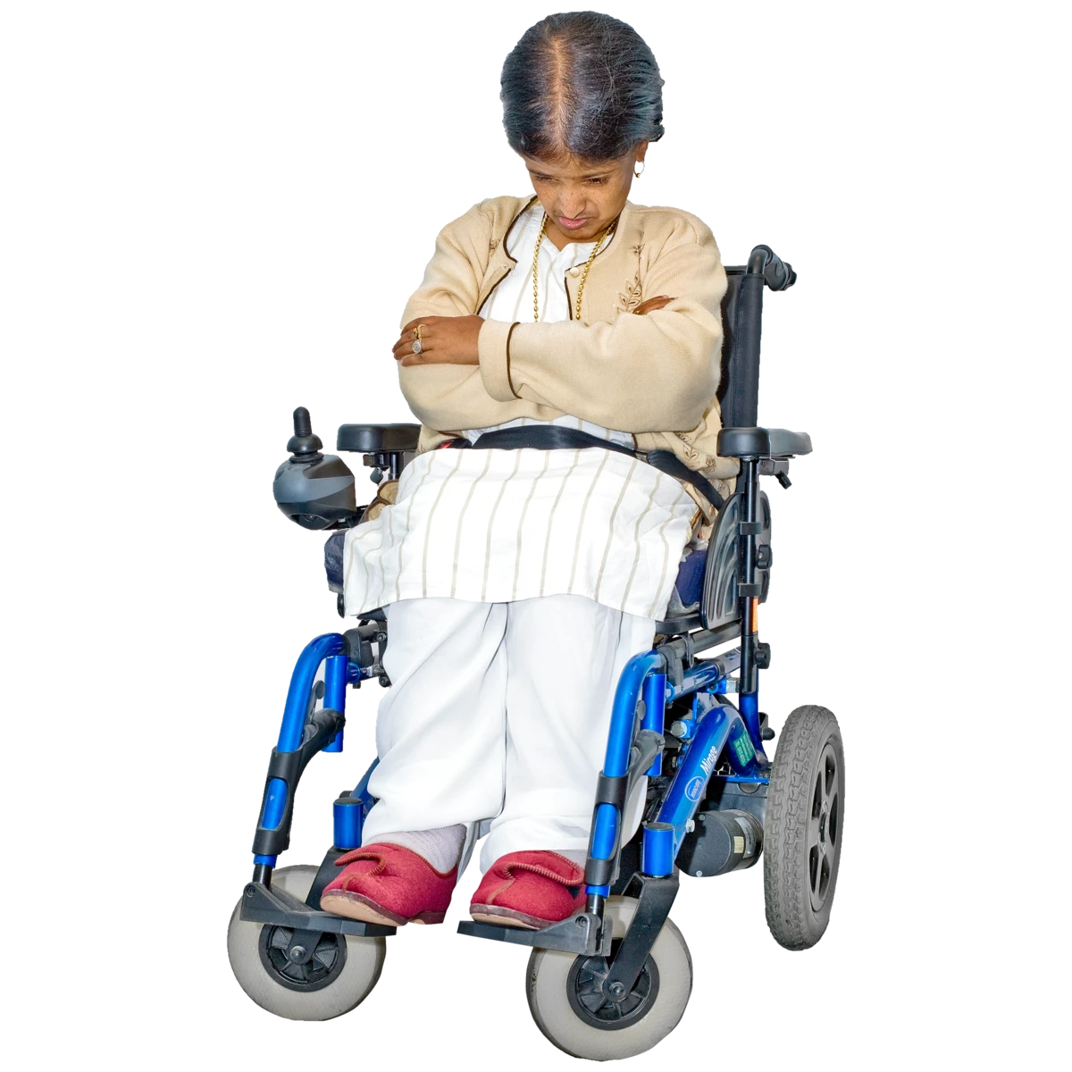
- People with disabilities are less important than other people

- People with disabilities have sad lives that are not worth living

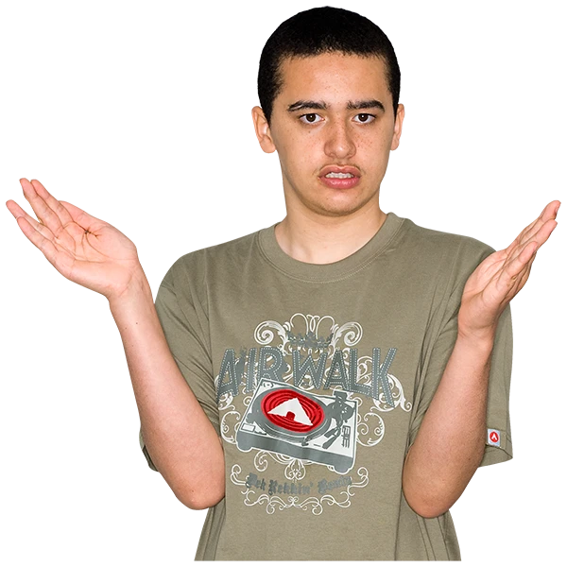
- There is something wrong with people with disabilities or they are dangerous

- People with disabilities cannot do much and need to be looked after
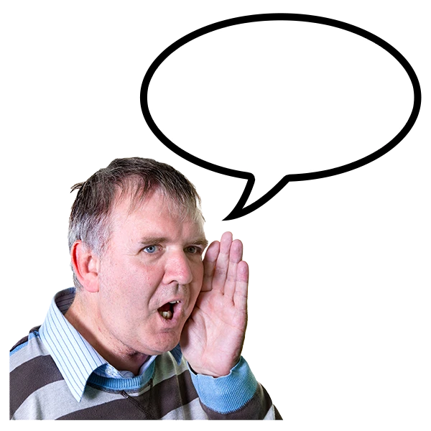
People often treat people with disabilities badly or unfairly because of these ideas.

For example:

- People may use the wrong words to talk about people with disabilities
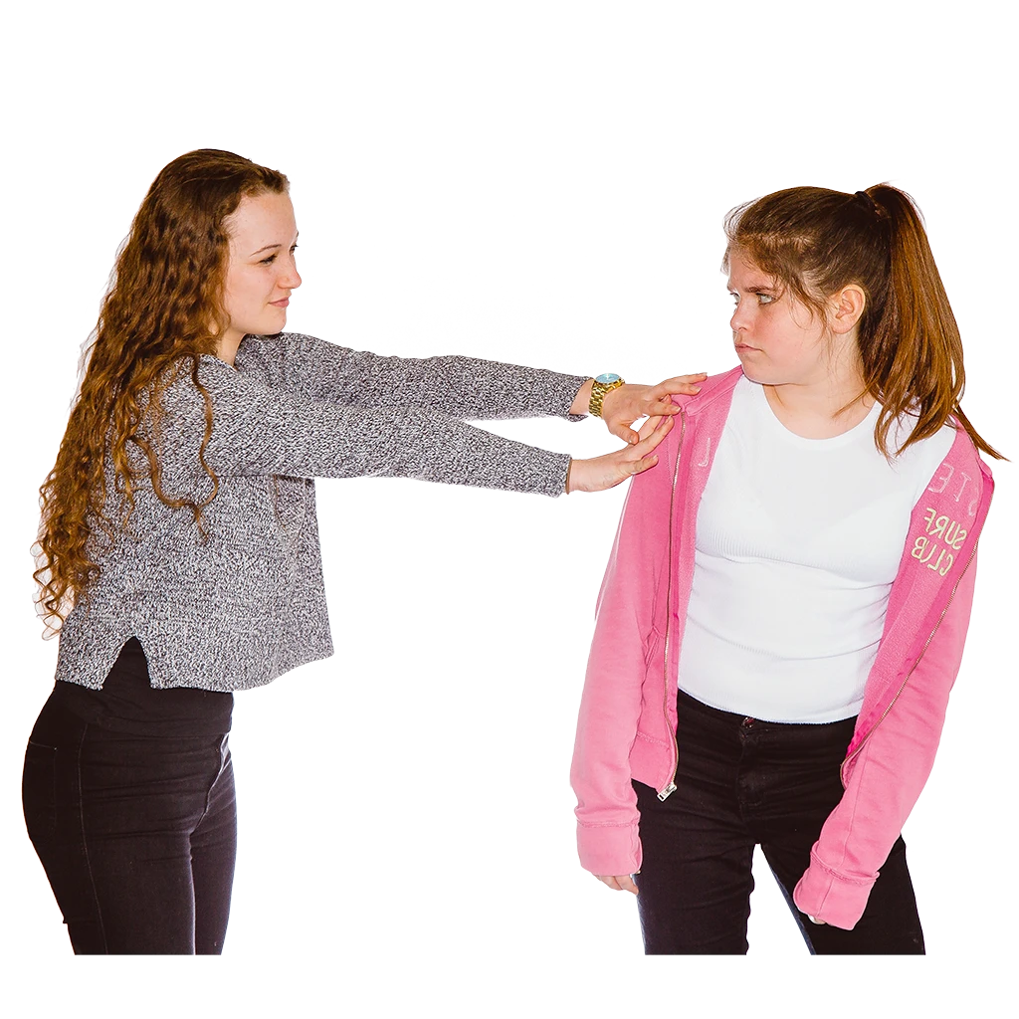

- People may hurt people with disabilities or leave them out
For example, people may be violent to people with disabilities or force them to live far away from other people
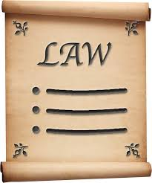

- People may make laws, rules and plans that are unfair to people with disabilities and stop them doing things
For example, laws that stop people with disabilities making their own choices
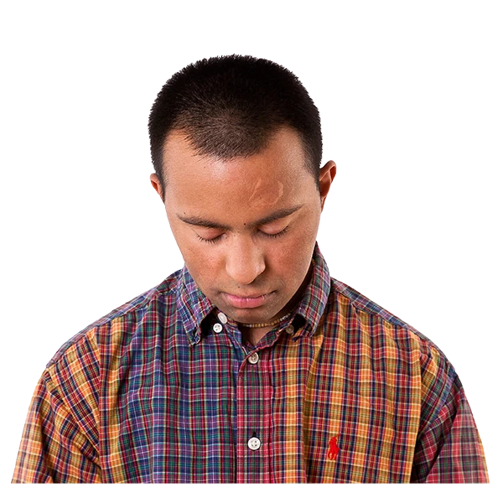
This can stop people with disabilities from:
- Feeling good about themselves
- Taking part in the community
- Doing well in life
Countries should keep helping everyone who lives there to understand about:
- People with disabilities and their lives

- The rights of people with disabilities and why they are important

- What helps people with disabilities to get their rights
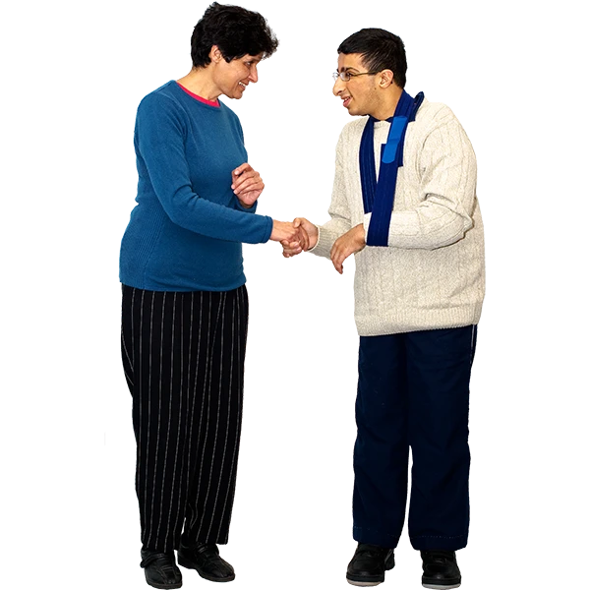

This can help people to:
- Change the way they think and feel about people with disabilities

- Treat people with disabilities more fairly

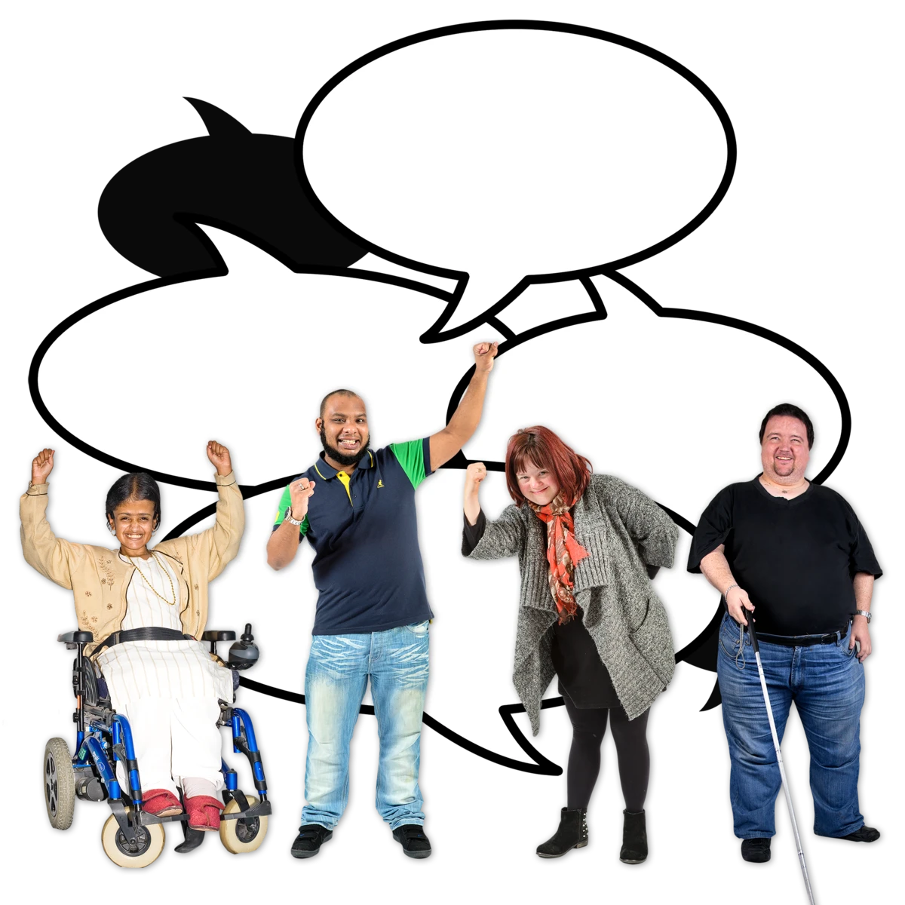
This work will also help people with disabilities to:

- Know their rights and stand up for their rights

- Take part in the community and have their say

What countries must do

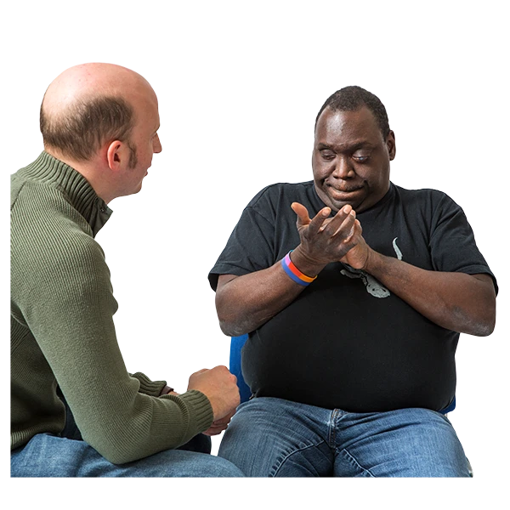

Countries should work straight away to help people understand about people with disabilities and their rights.

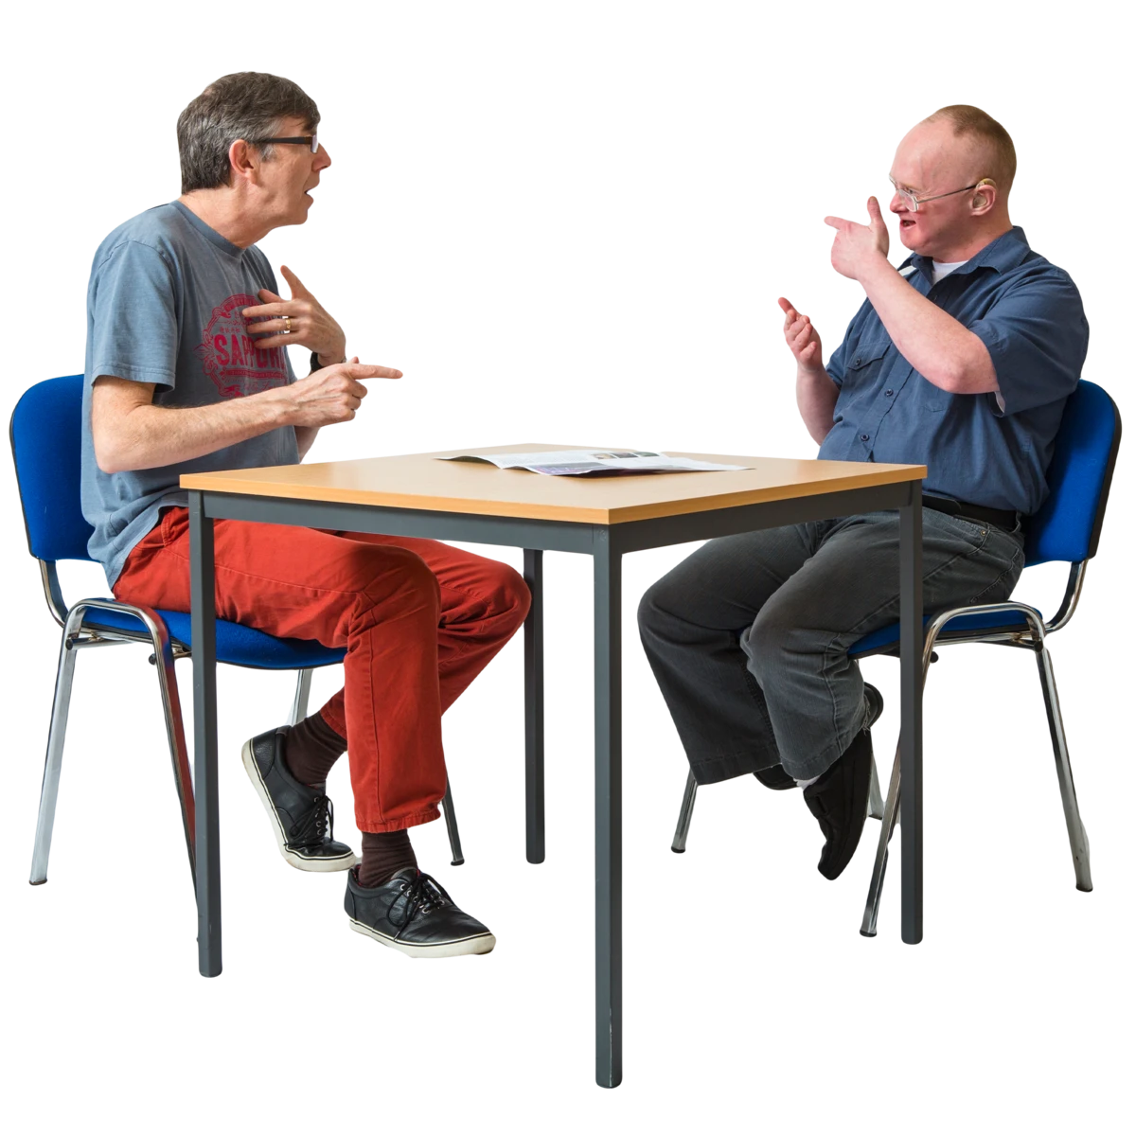

People with disabilities should also get information about their rights and what to do if they are treated badly.

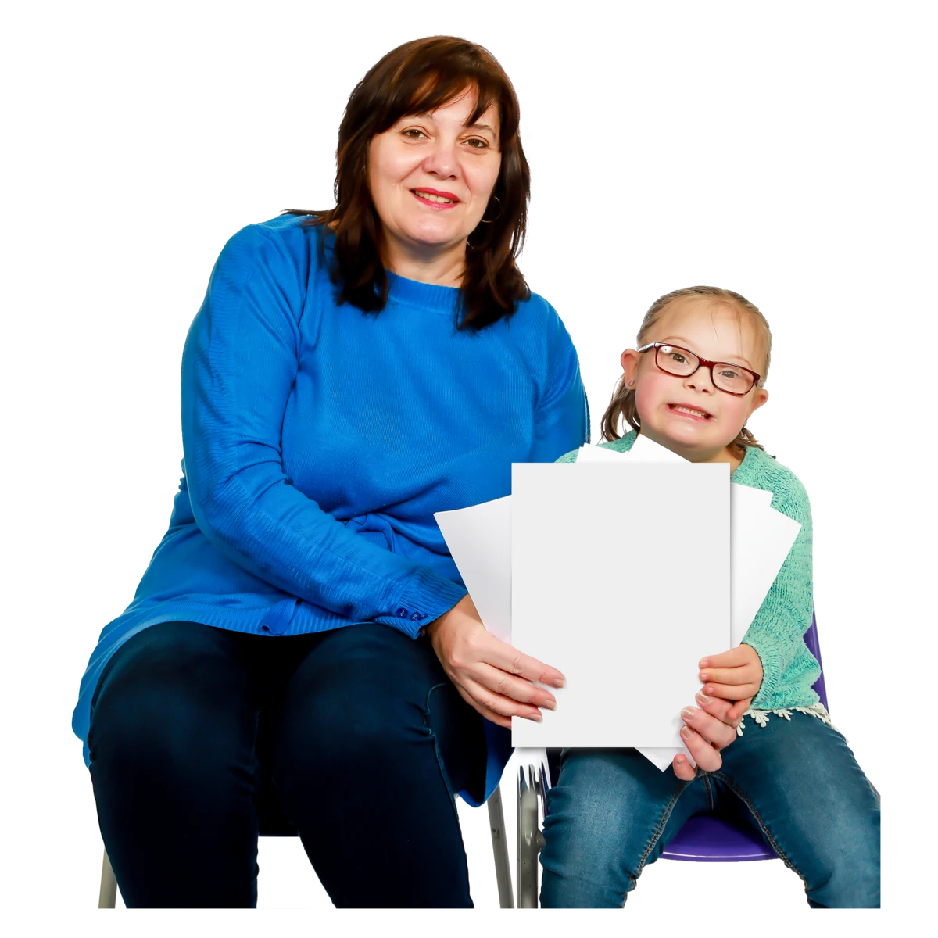
Families of people with disabilities should get information and support as well.

Families are important. They can help people with disabilities to get their rights and feel good about themselves.

There are many ways that countries can help everyone to understand about people with disabilities and their rights:
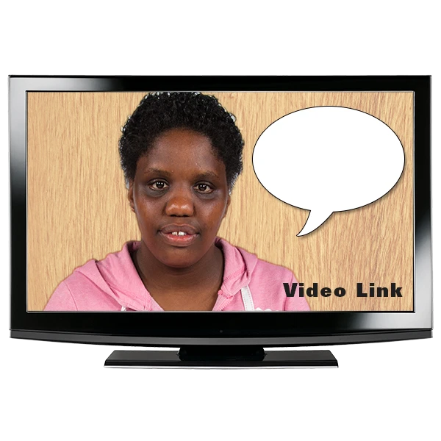

Giving information to the public

This might include:

- Leaflets, posters and videos

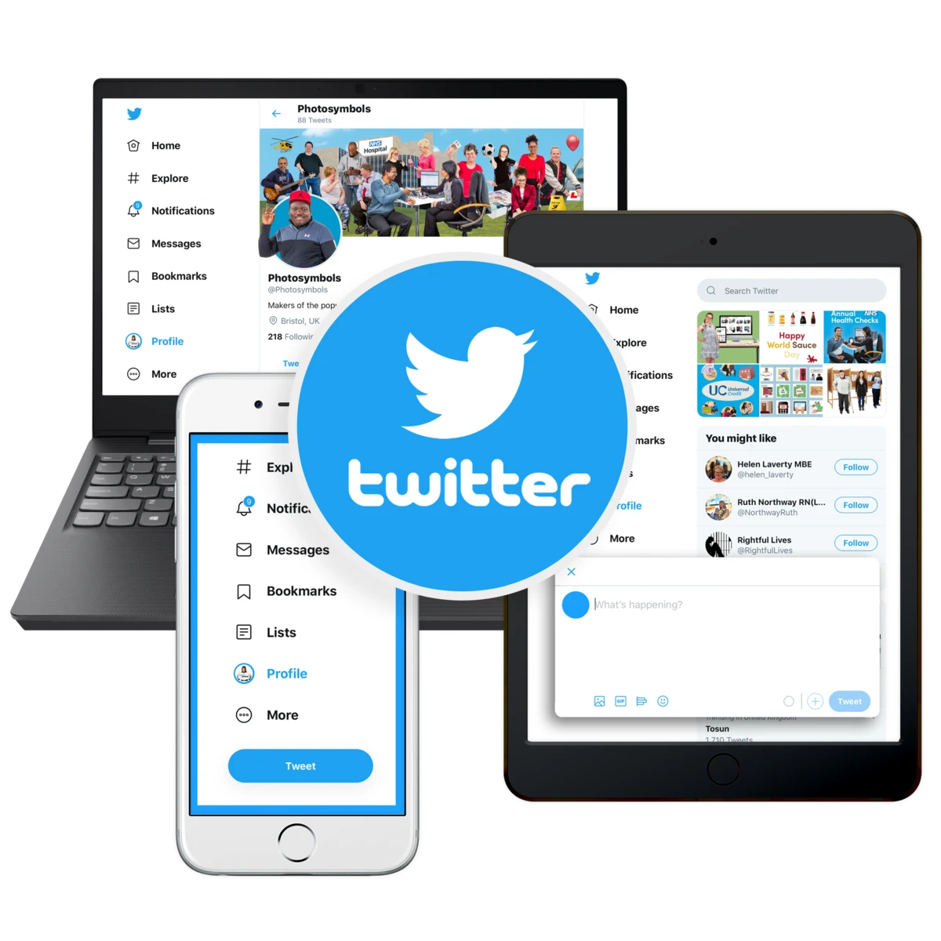
- Information on TV and radio

- Information on social media, like Facebook and Twitter

- Meetings

Training and education
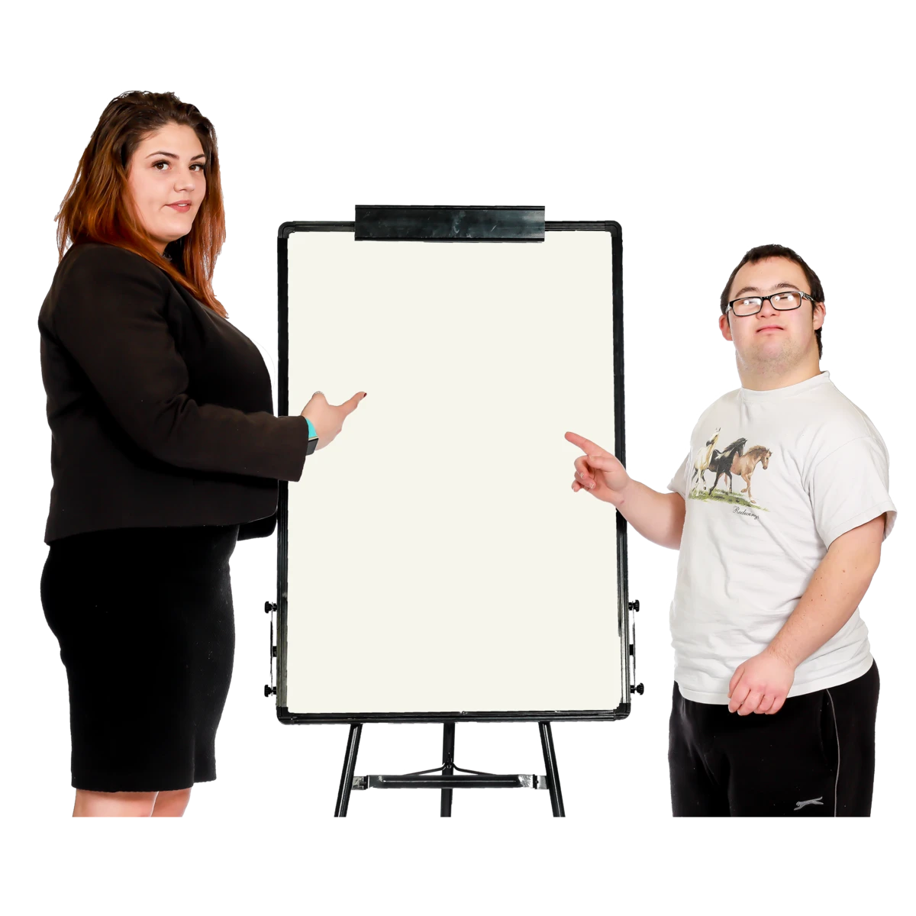
Training can help to change wrong ideas about people with disabilities.
People with disabilities should help give the training.

This will help people see who people with disabilities are and what they can do.
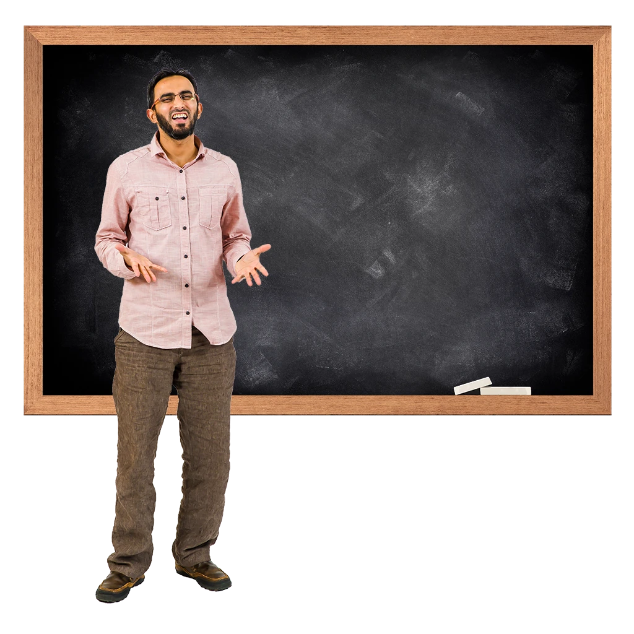
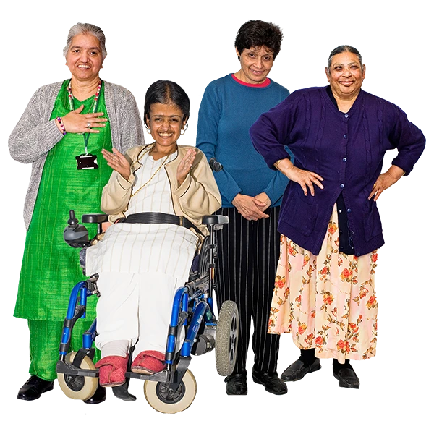

People should also learn about people with disabilities and human rights at school, college and university.

Helping the media to include people with disabilities in the right way

The media is things like TV, radio, newspapers, magazines and news on the internet.


The media can help many people to understand about people with disabilities and their rights.

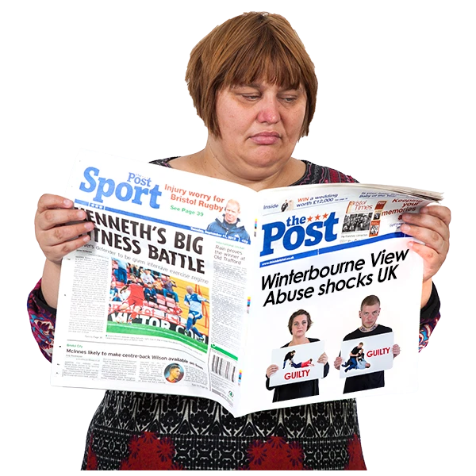
But the media often:

- Leaves people with disabilities out

- Shares wrong ideas about people with disabilities

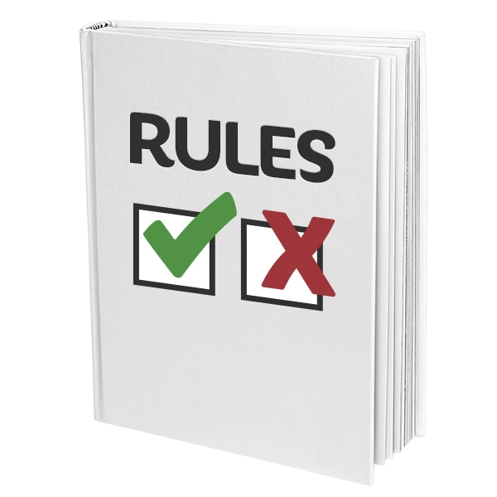
Countries should help the media to change this.

For example, there may be rules for the media to follow.

The rules could help the media to:

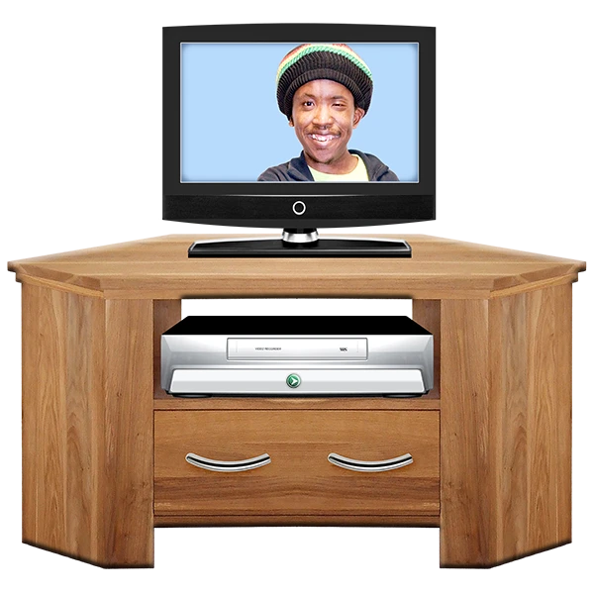
- Talk about people with disabilities in the right way

- Have more people with disabilities in TV shows or working for the media

- Make the media easier for people with disabilities to use

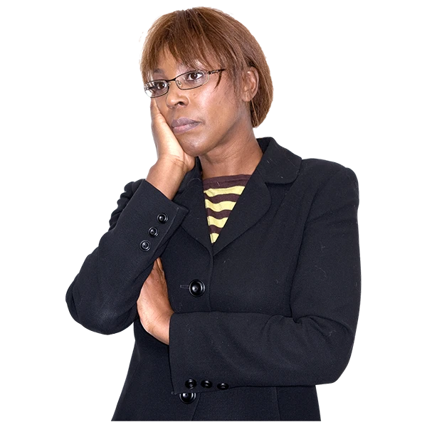
What countries need to think about

Countries should think about what they need to tell people and how to tell them.

This could change at different times.

For example, people might need different information about the rights of:
- People with mental health conditions
- People who use a wheelchair
- Women and girls with disabilities
- People of different ages and religions
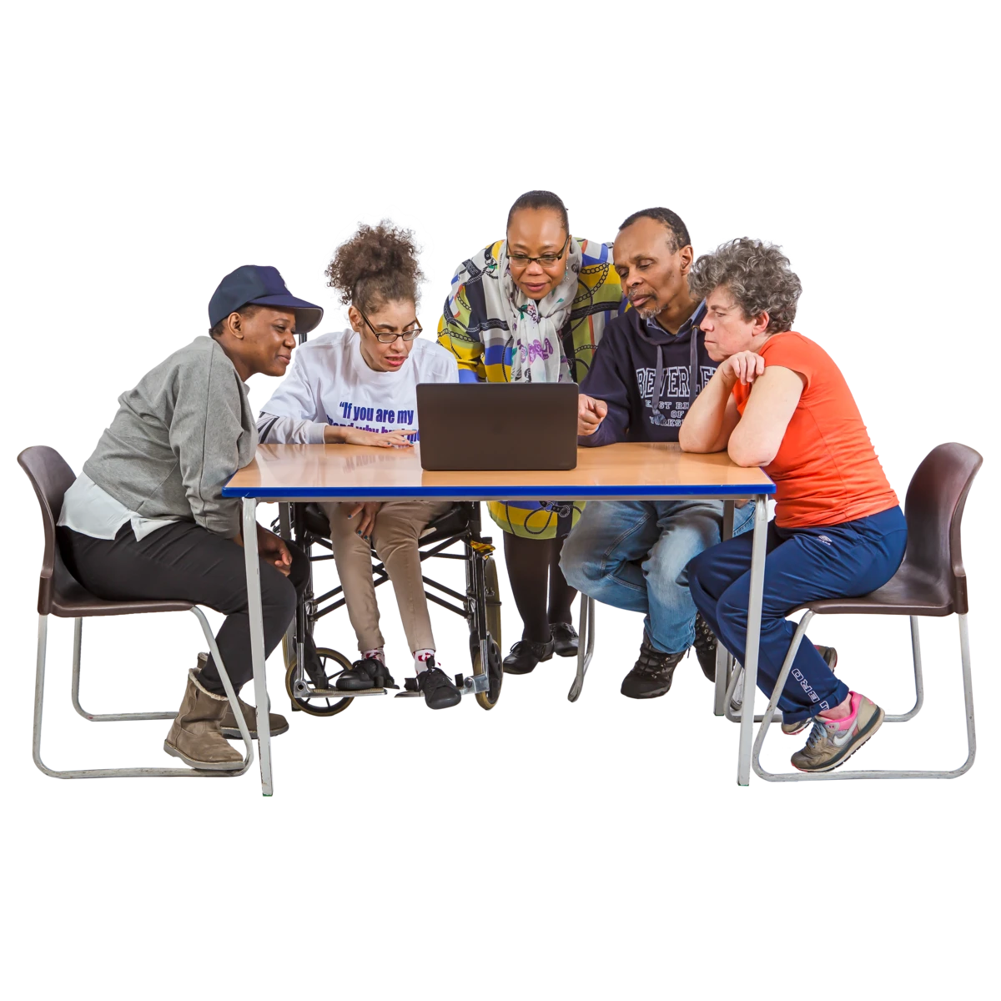
Countries should think about what will help people to:

- Listen to the information and understand it

- Work together to change things for people with disabilities and the whole community

People with different disabilities should take part in the work that countries do.

For example, they should help plan what to do, make new rules for the media and give people training.

This will help to change the way people think about people with disabilities.

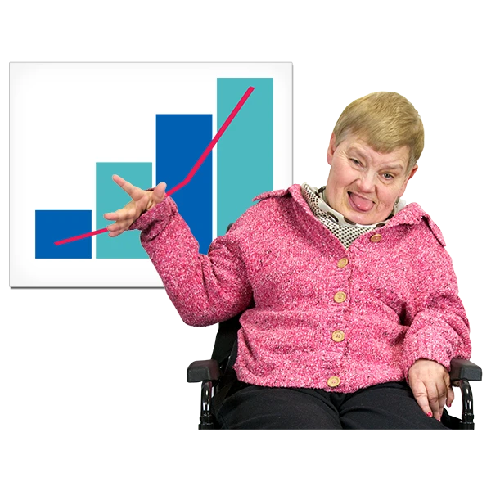
It is also important for countries to:

- Have good information to show what people think about people with disabilities and how this is changing

- Have enough money to do all this work

Some good work that countries are doing

- A TV and radio organization in Spain is helping people to know about people with disabilities and their rights.

- Work is happening in Mexico to stop people saying bad things about people with disabilities on Twitter.

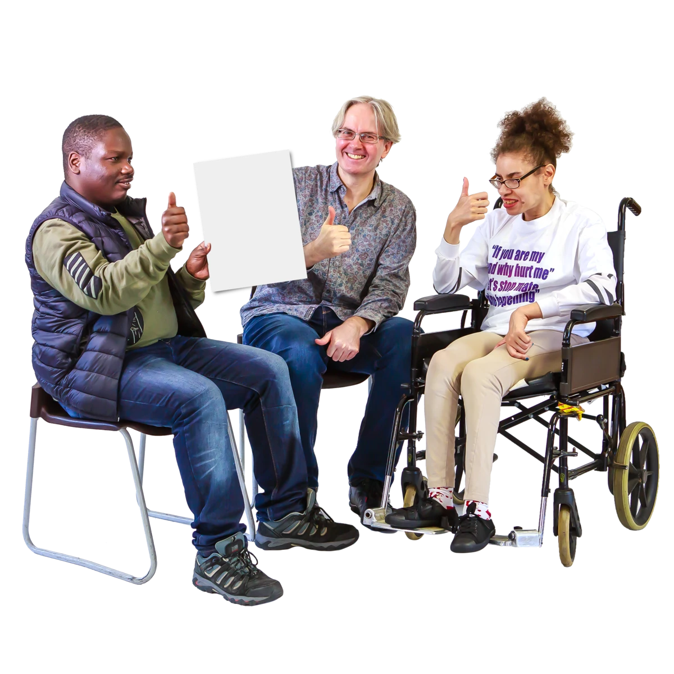

- Organizations of people with disabilities in Germany help make decisions about the media.

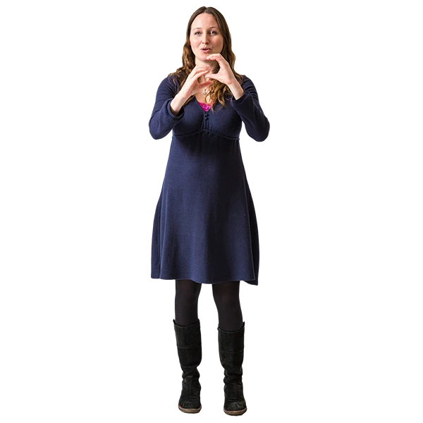
- Argentina is making it easier for people with disabilities to use the media.

For example, by having more words on the screen and sign language.

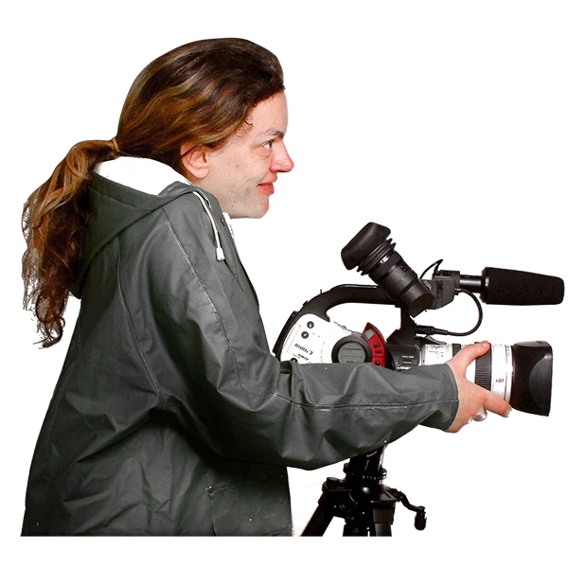
- A project in the UK is helping more people with disabilities to work for TV companies.

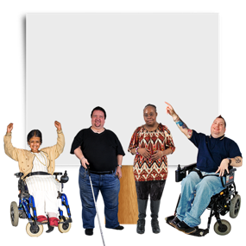
- Slovenia and El Salvador helped the public to know about the rights of people with disabilities and the law.

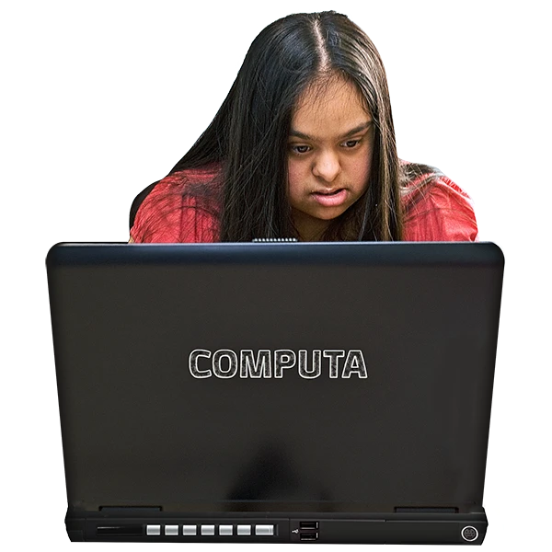

- Ecuador gave people training on the internet about making services easy for people with disabilities to use.

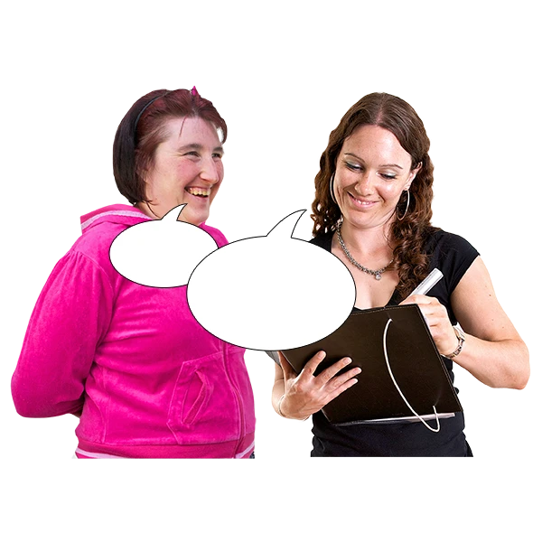

- Moldova, Lithuania and Ireland have looked at what people in the country think about people with disabilities

And how people with disabilities are talked about in public information

Pictures by Photosymbols

