
United Nations Human Rights Council
United Nations High Commissioner for
Human Rights.

Making sure that people with disabilities have the same chances to work as everyone else

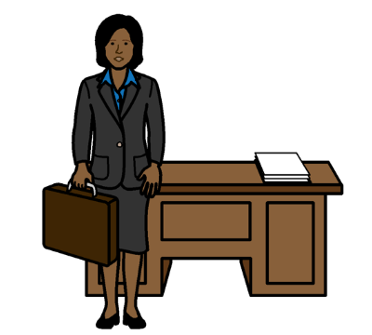

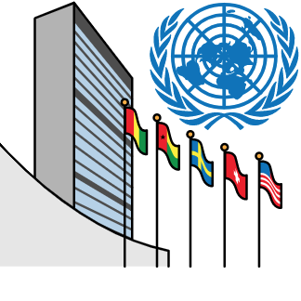
About us

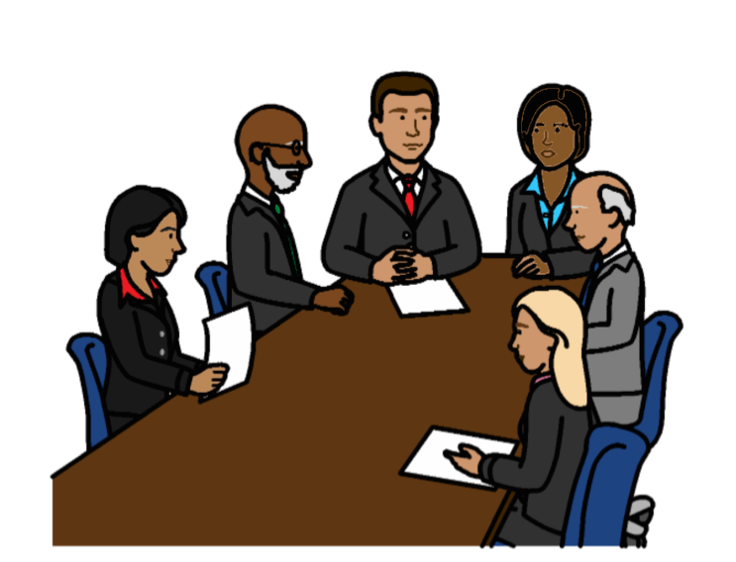
We are part of the United Nations (UN).

The United Nations is a group of countries that work to make the world better and safer.

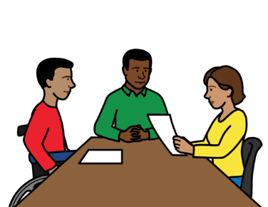

About this report

This report is about the right of people with disabilities to work and earn money.

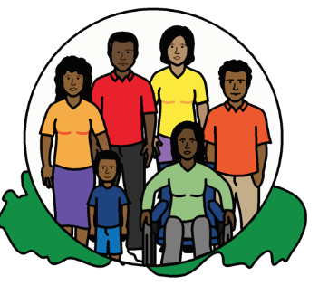

People with disabilities should have the same chances to work as everyone else.

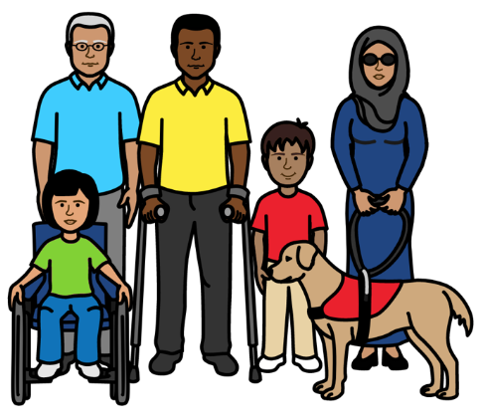
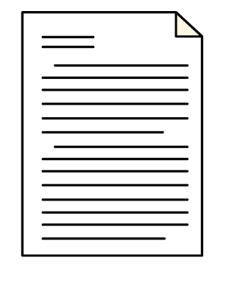
Some important documents talk about the right of everyone to work.

For example, a document about the rights of all people with disabilities.

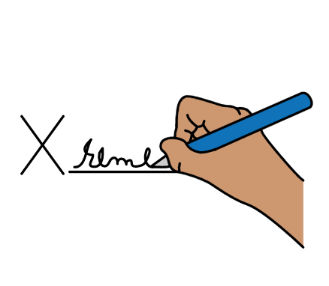
It is called the Convention on the Rights of Persons with Disabilities.

Many countries have promised to do what the documents say.

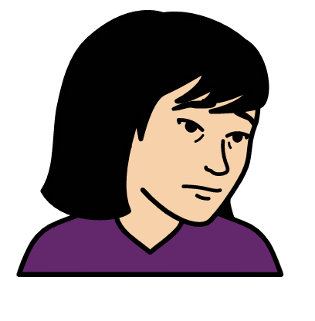

Work can help people to take part in the community and have a good life.

But many people with disabilities do not have the chance to work.

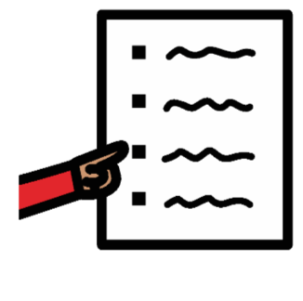
This report is about:

- The problems that people with disabilities have getting work
- What countries must do to solve the problems
We asked countries and organizations for their ideas first.
Why do many people with disabilities find it hard to work?
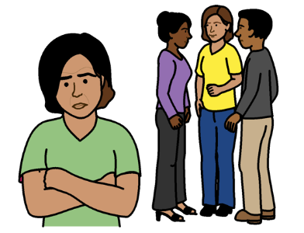

Many people with disabilities in the world are the right age to work.

But many people with disabilities are not in work.

There are many reasons for this.

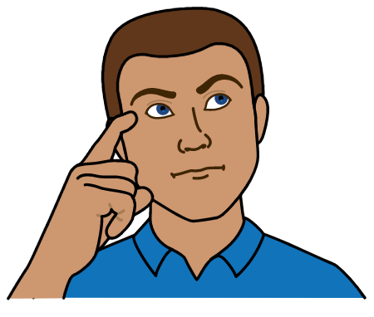
For example:

People often have unfair ideas about people with disabilities.

They might think that people with disabilities cannot work or do much.
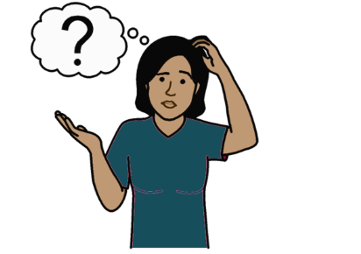

Information about work and getting a job is often hard to understand.

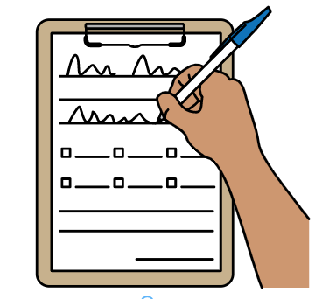
People with disabilities might not get the right support to find and keep a job.

For example, support to apply for a job if they need it.

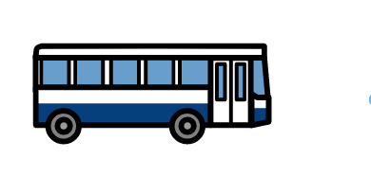
It is hard for many people with disabilities to go to work.

For example:

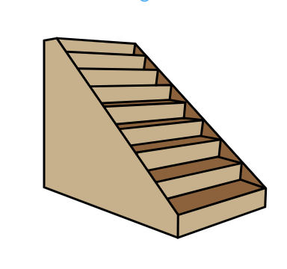
- Transport is often hard to use
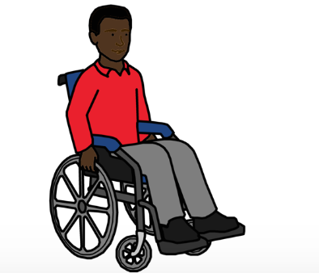

- Many work places are hard to enter and move around in

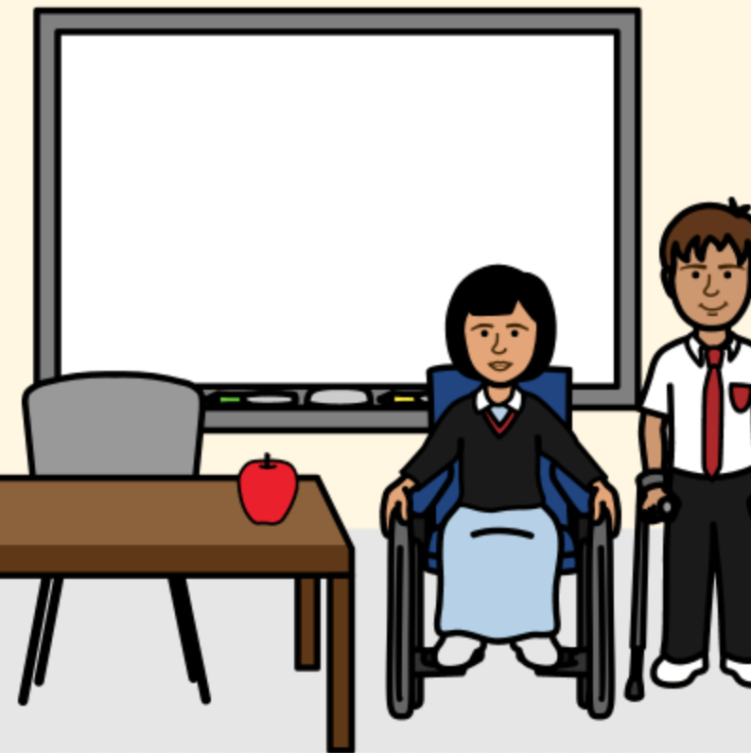
Going to school and university can help people to get a job in the future.

But many people with disabilities do not get a good education.

Some people with disabilities get no education at all.
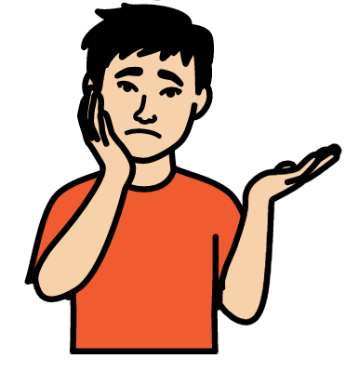
Many young people with disabilities do not get information and training to help them get work in the future.

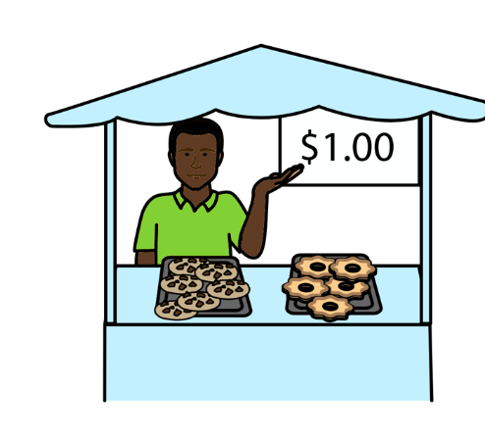
Some people with disabilities have jobs.

But many people do not have jobs that are safe and pay well.

For example, the jobs might not last very long.

Or they might only be for a few days a week.


Many people with disabilities try to work for themselves because it is hard to do other work.
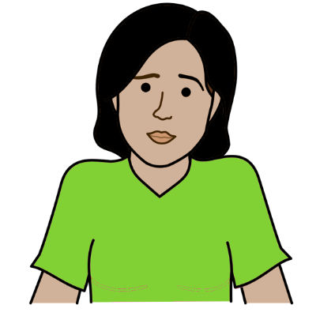

But it is often hard for people with disabilities to work for themselves.

For example, it is often hard to open a bank account.
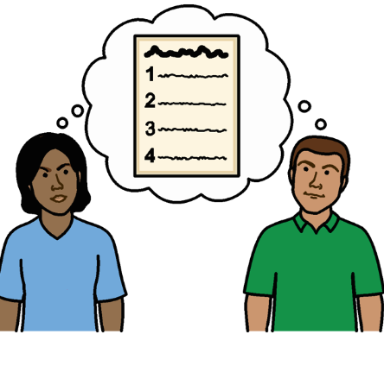
The law might say that other people can make choices for people with disabilities.

For example, choices about work and how to spend their money.

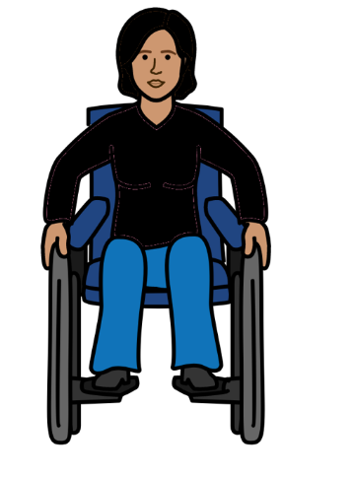

All these problems can be worse for women and girls with disabilities.

They are often treated badly because they are women and girls and because of their disability.
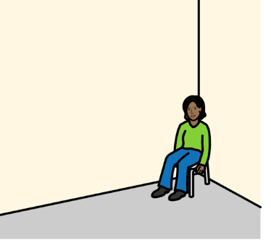

For example, people might think that women and girls with disabilities should not go to school or work.



Women with disabilities who get jobs are often treated unfairly.

For example, they are often paid less than other people.
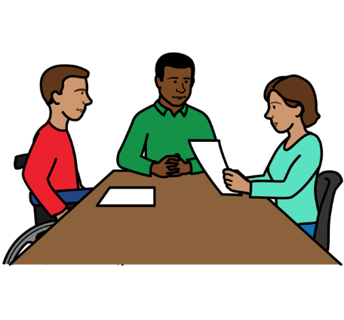
What countries must do to solve the problems

Countries must make sure that people with disabilities have the same chances to work as everyone else.

The work should be safe and healthy.

And people with disabilities should be paid fairly.

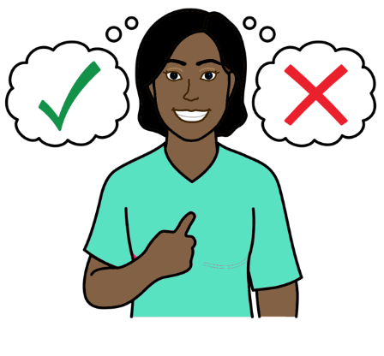

People with disabilities should get support to think about work that is right for them.

They should not be forced to work in jobs.

For example, jobs that are only for people with disabilities.

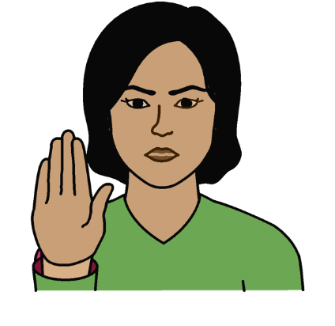
People with disabilities should be treated fairly when they look for work and get work.

Countries should stop laws that treat people with disabilities unfairly.

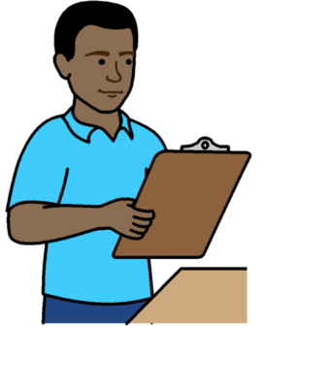

For example, some people with disabilities are forced to take tests to see if they can work.

The tests are unfair. They do not look at what people with disabilities can do.

Countries should take action to help more people with disabilities to get jobs.
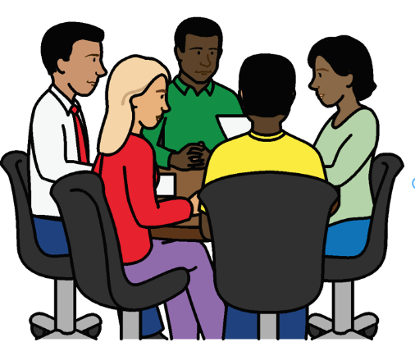
For example, countries should:

- Give companies support, information and training about people with disabilities

- Support companies to give some jobs only to people with disabilities
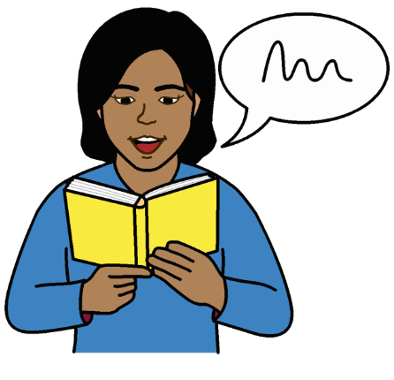
People with disabilities should get the support they need to work and do well at work.

For example, someone with a disability might need:

- Information they can understand to help them get and keep a job
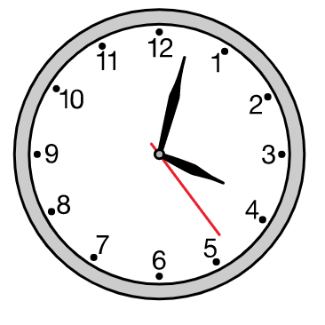

- Different working hours because of their disability

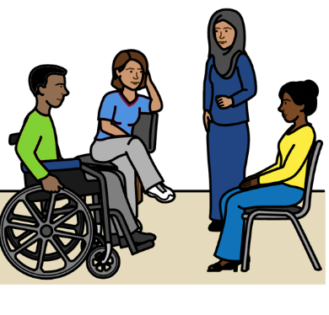
- A new chair or a special computer

- Work training that is easy for them to take part in
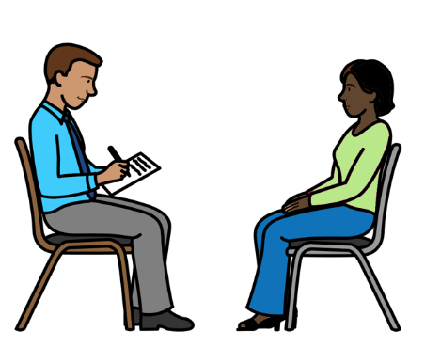

Companies must give people with disabilities the support they need where possible.

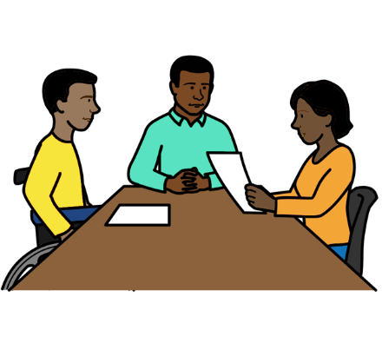
Countries should make laws and rules to help people with disabilities to work.

This includes laws and rules about:

- What companies must do to support people with disabilities
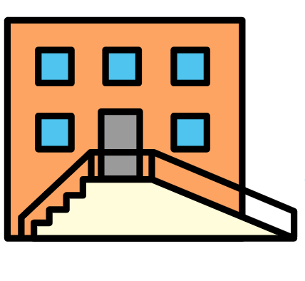

- How to make everything work well for people with disabilities

Like education, transport, information and new buildings

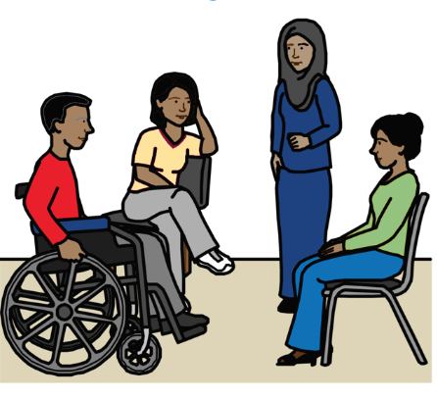

Countries should work with people with disabilities to make laws and rules.

Countries should check that organizations are following the laws and rules.
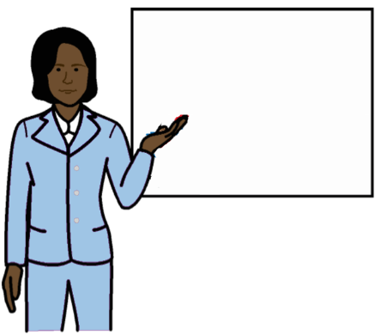

People who work for organizations should have training about people with disabilities.

For example, transport staff and people who plan new buildings.
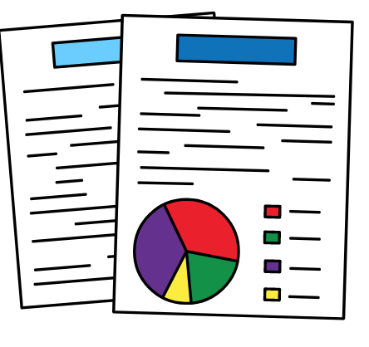
Countries should get good information about people with disabilities and work.

This will help countries know what they need to do.

People with disabilities who are not working should have enough money for them and their families.

This means enough money to live on and buy things for their disability.

But they should still get support to take part in the community and work if they can.

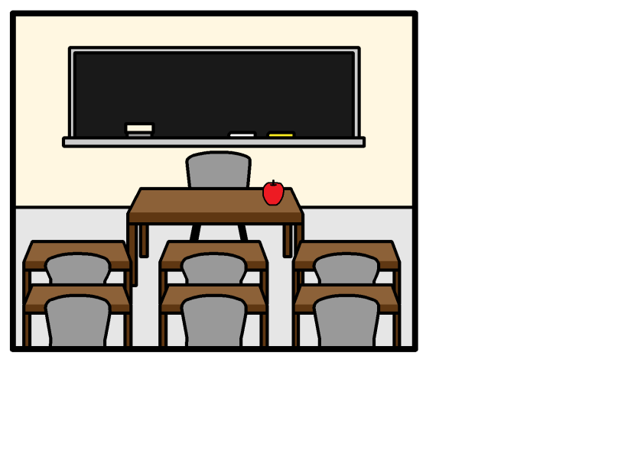

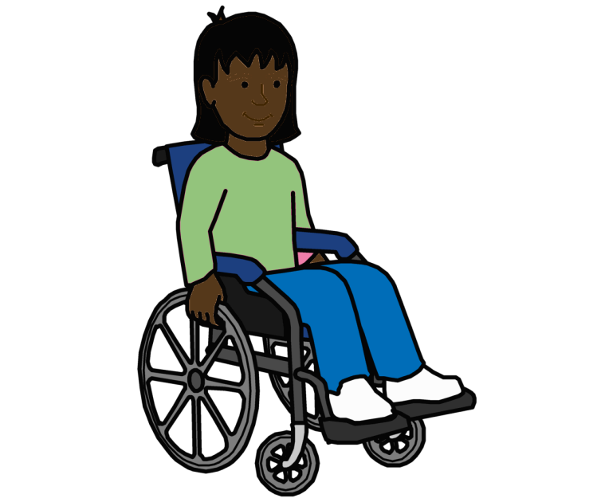
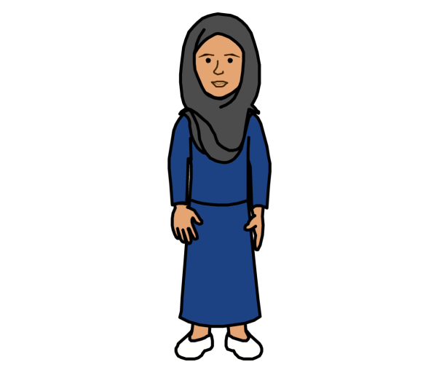
People with disabilities should get good education and training in the same classrooms as people without disabilities.

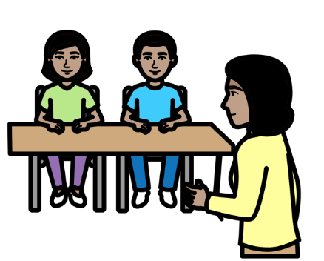
The education and training should help people with disabilities to get ready for work in the future.

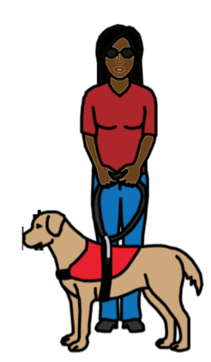

Countries should look at what
women and girls with disabilities need to work and have a good life.

They should not be left out.

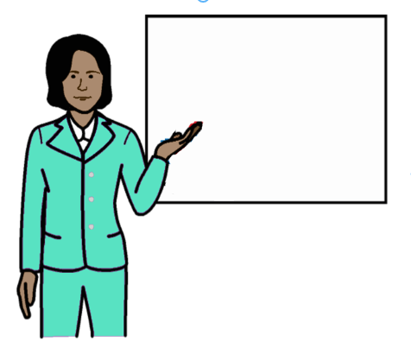

Countries should tell the public about people with disabilities and their right to work.

This will help people change the way they think about people with disabilities.
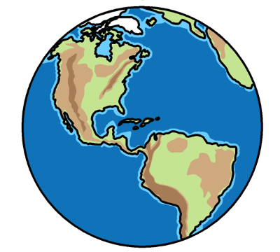

Other countries can help by giving money and support.

Pictures by The Picture Communication Symbols ©1981–2016 by Mayer-Johnson LLC a Tobii Dynavox company. All Rights Reserved Worldwide. Thousands of resources available for free at www.boardmakeronline.com
Document checked by Hackney People First. © European Easy-to-Read Logo: Inclusion Europe. More information at www.easy-to-read.eu.

