Hhuy

Support for people with disabilities to learn important skills so they can do everyday things and take part in the community

This support is called rehabilitation and habilitation

United Nations Human Rights Council
United Nations High Commissioner for Human Rights

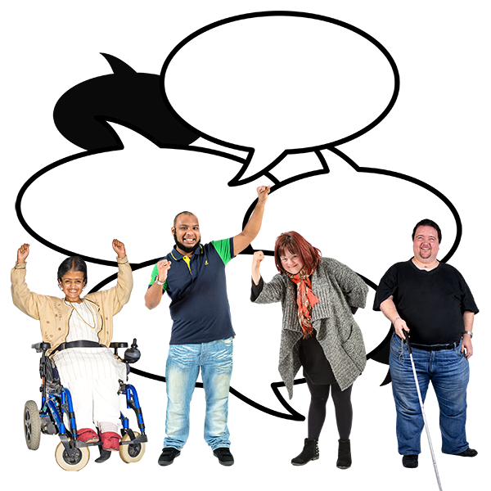

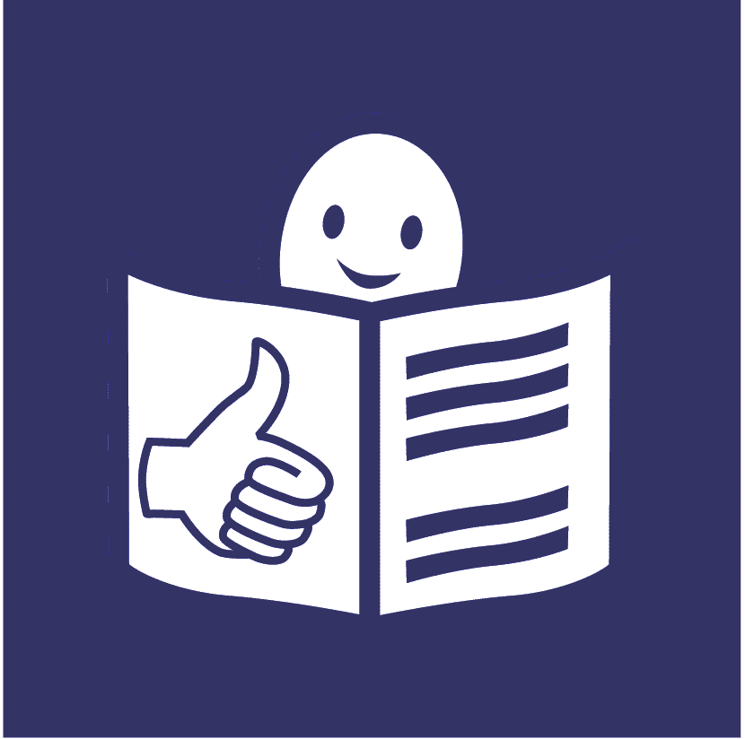

January 2019

Support for people with disabilities to do everyday things on their own, learn important skills and be part of the community in the best way they can

This is called habilitation and rehabilitation

About us


We are called the Office of the High Commissioner for Human Rights.

We are part of the United Nations (UN).

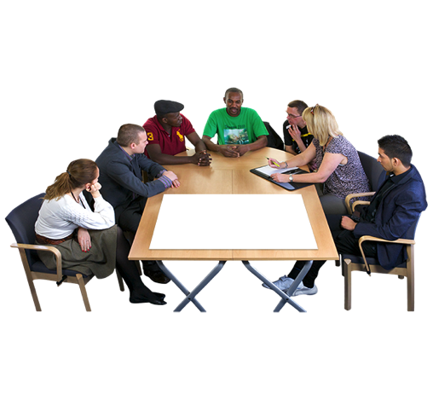


The United Nations is a group of countries that work to make the world a better and safer place.

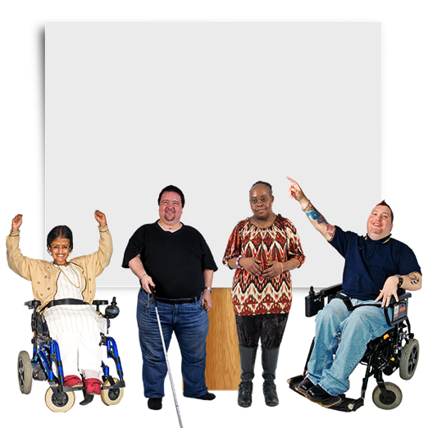

Our job is to make sure that
everyone in the world is treated fairly and gets their human rights.

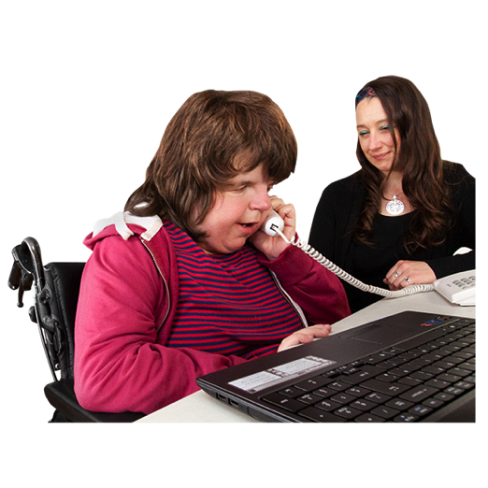

Human rights are rights that everyone has, like the right to:
- go to school
- work
- be healthy

About this report

This report is about support that can help people with disabilities learn important skills so they can do as much as they can by themselves.

The support helps people with disabilities do everyday things and take part in the community in the way they want to.

We will call this support rehabilitation. It can also be called habilitation.

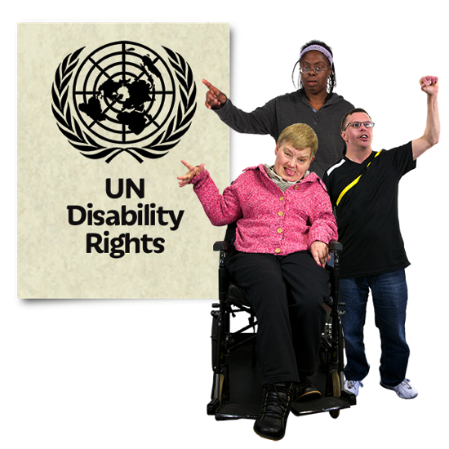
There is a document that talks about the right of people with disabilities to get this support.
It is called The Convention on the Rights of Persons with disabilities.

Many countries have promised to do what the document says.
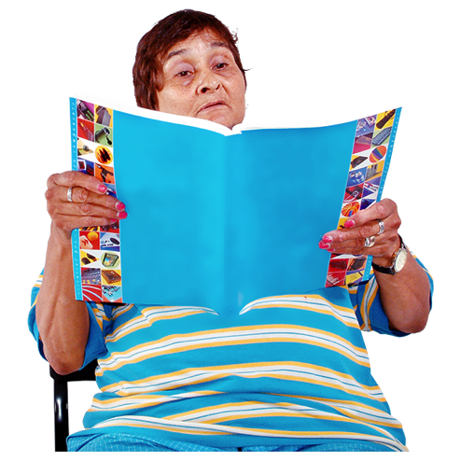

This report is about:
- What countries must do for people with disabilities
- Some good work that countries told us they are doing

What is rehabilitation support?

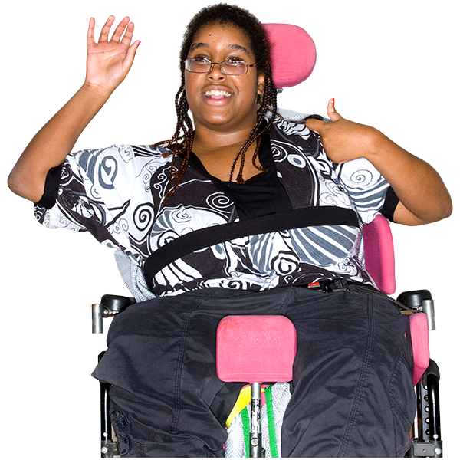
Rehabilitation support can help people with disabilities:

- Do as much as they can by themselves

- Take part in the community and do the things they want to do.

For example, go to school or work

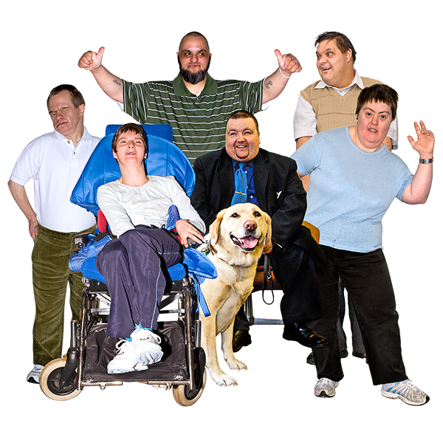
The support can be for:

- People who have had a disability for a very long time or since they were born

- People who have a new disability that they did not have before

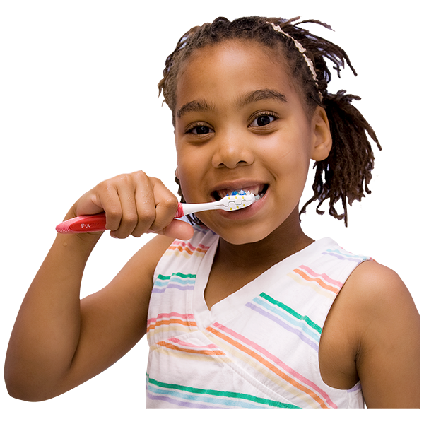
The support can help people do things that they need to do everyday.

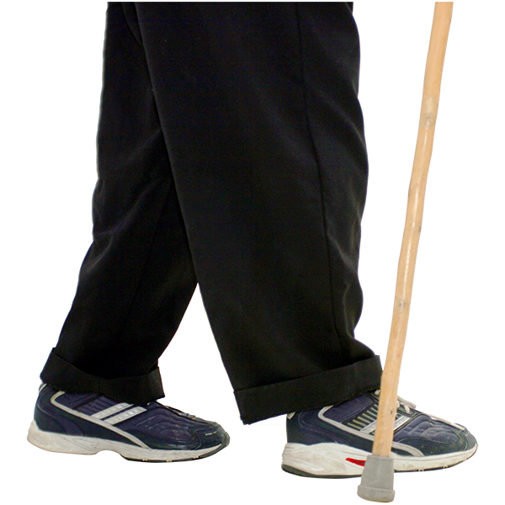
For example, people with disabilities may need support to:

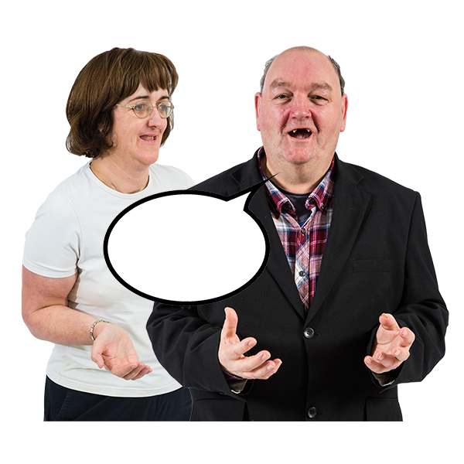
- Learn how to move their legs and walk again after an accident

- Learn how to speak and communicate

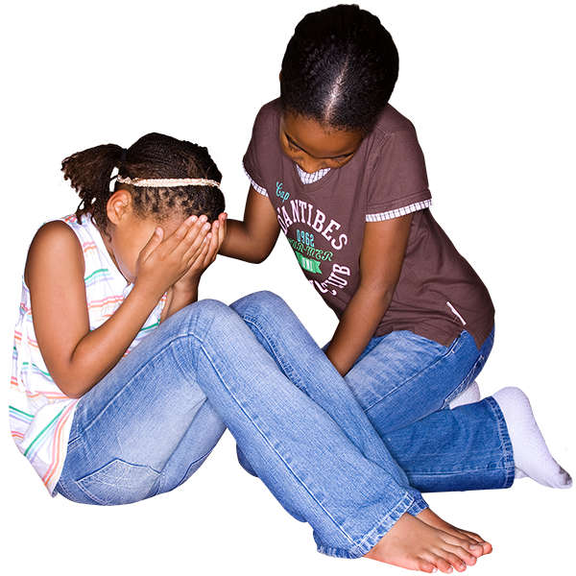
- Cope and feel better after something bad happens like an accident or someone hurting them

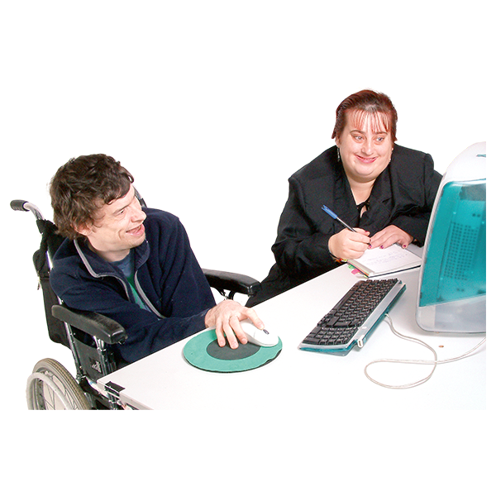

- Learn skills to help them go to work or school

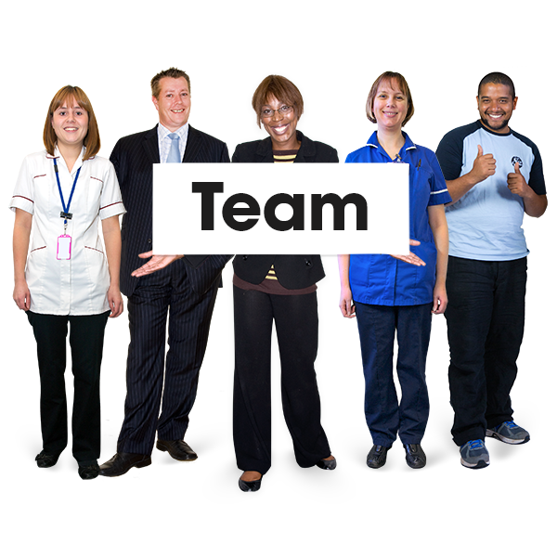

The support could come from lots of people. For example, health and care staff or other people with disabilities.

What countries should be doing

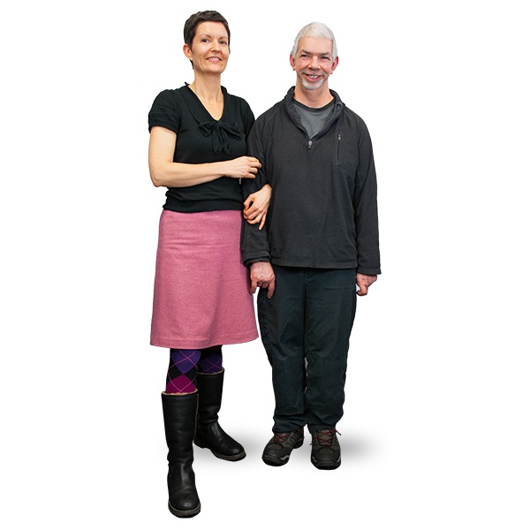
Treating people with disabilities fairly

Countries must make sure that
all people with disabilities can get the rehabilitation support they need.

This is not always happening at the moment.
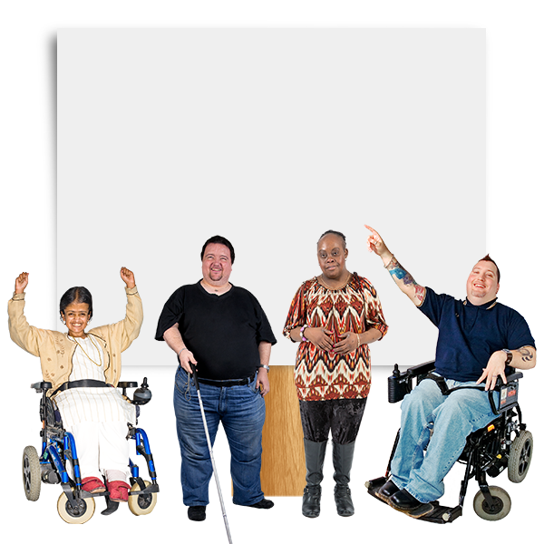

The support should be good.

It should support the rights of people with disabilities.

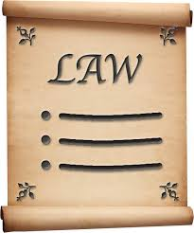
To make this happen, countries should:
- Change unfair laws and rules that stop people with disabilities getting the right support. Or make new laws and rules

- Make sure people with disabilities can do something about it if they do not get their rights
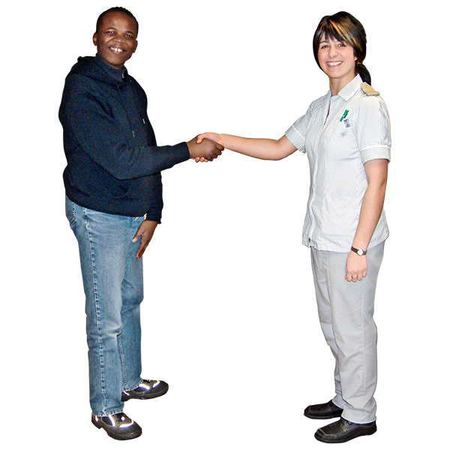
Making rehabilitation services easy to use

Rehabilitation support and equipment should be easy for people with disabilities to get and use.

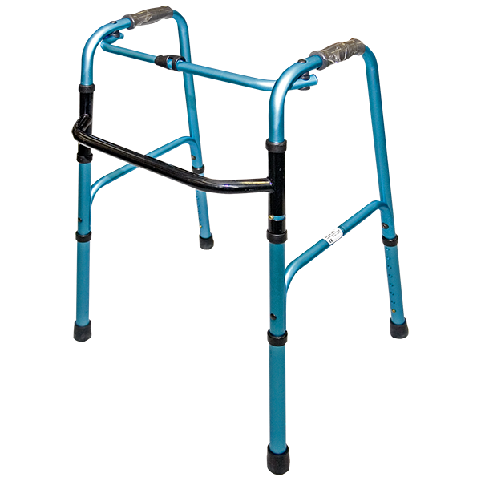
Equipment helps people do things on their own as much as possible.

For example, equipment could be:

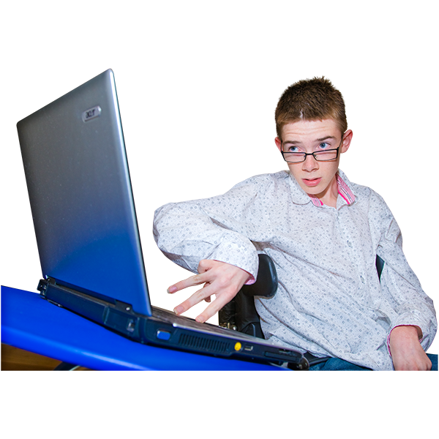
- Wheelchairs, walking frames or other things to help people move around

- Computers that read out words on the screen

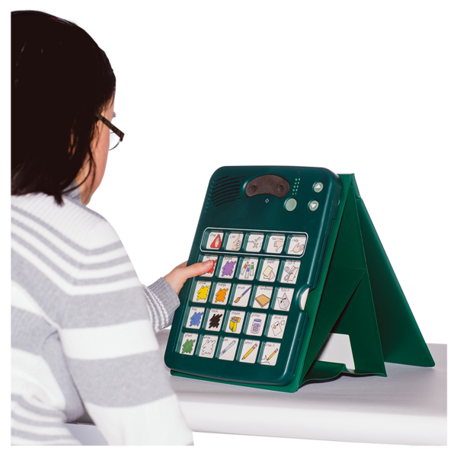

- Pictures that help people choose what they want to do every day
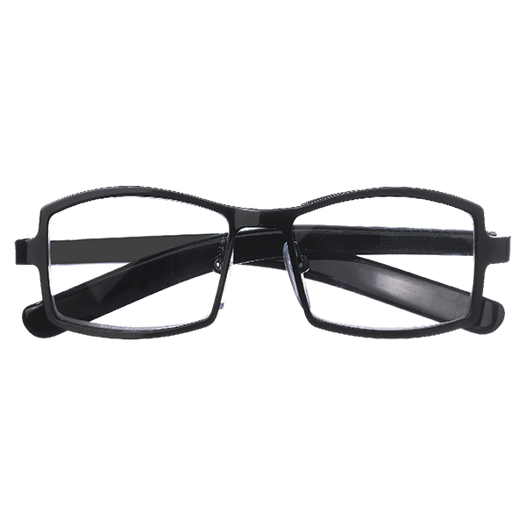

- Glasses and hearing aids to help people see and hear


It should be easy for people with disabilities to:

- Get support and equipment if they need it. For example, it should be free or low cost

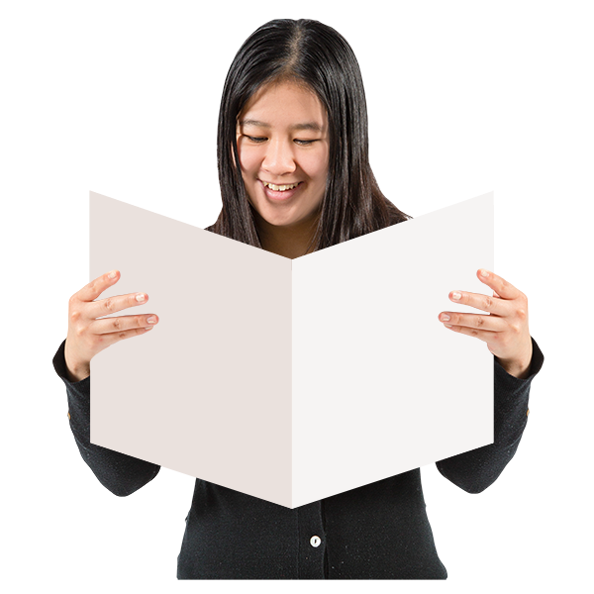

- Get information they can understand about support services and equipment.

For example, how the support might help, what problems there might be and what choices they have

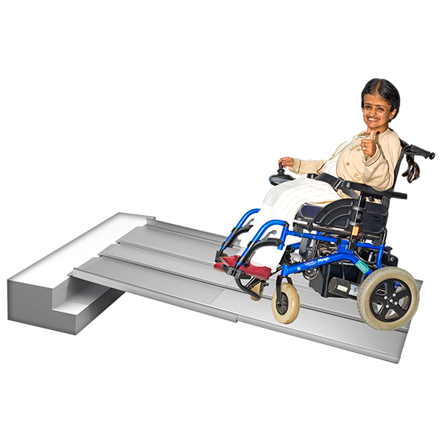

- Use everything in the support service, like buildings and equipment

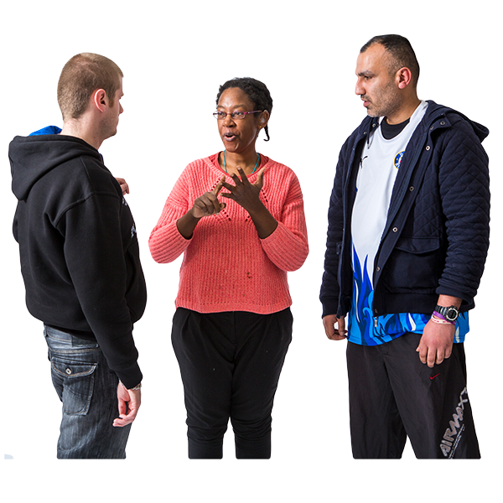
Staff should try to change things if a support service is hard for someone with a disability to use.

For example, someone with a disability may need information in sign language or pictures. Or more time for appointments.

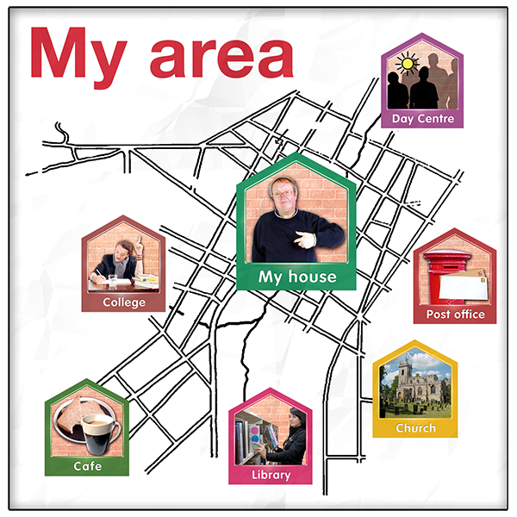
The support should be in people’s homes or near where they live in towns or the countryside.

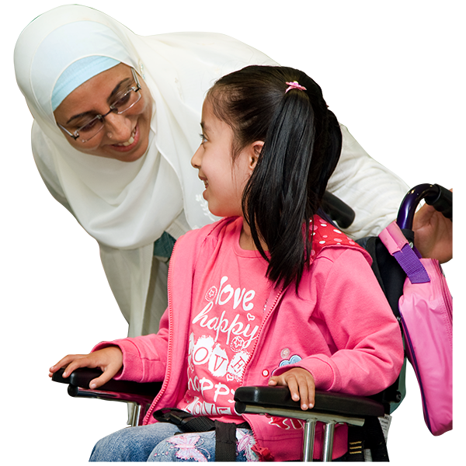

The support should start as soon as possible when people need it.

This is very important for children with disabilities. It will help them do well later on.

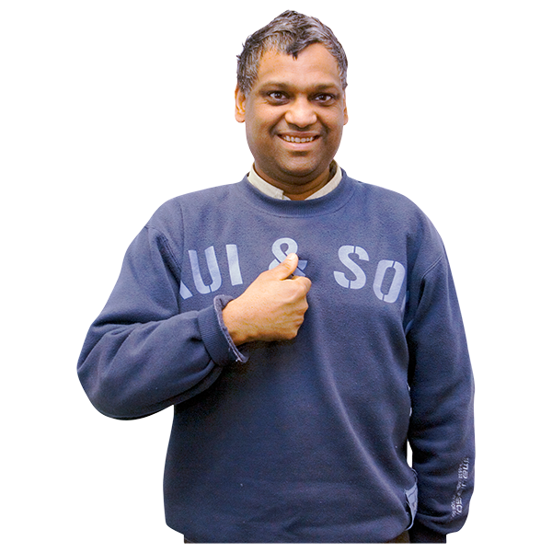
Getting the right support

The support and equipment should be right for each person with disabilities.

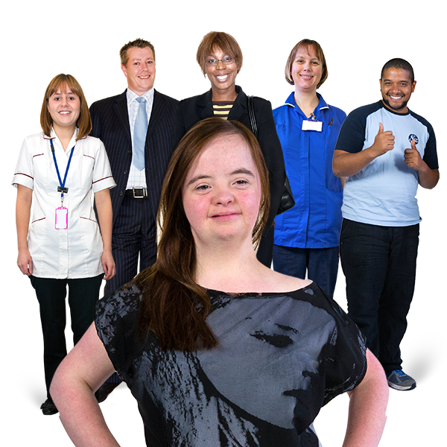
A team of people might work with the person with disabilities to:

- Look at what the person can do

- Look at what the person needs and wants

- Make a plan about this and keep checking the plan
Having a say in what happens
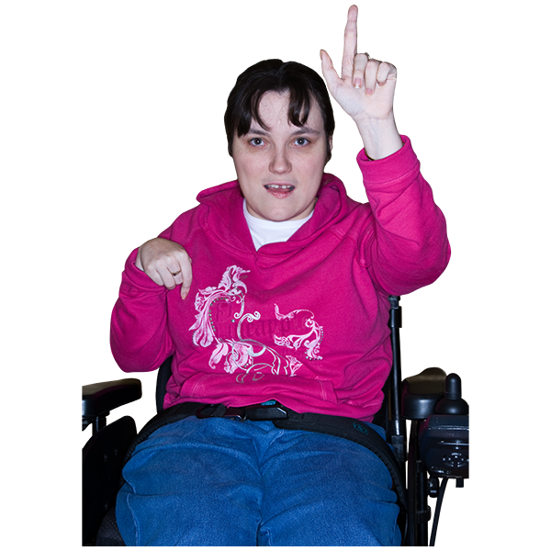

People with disabilities should choose to have the support.

No one should force them or make choices for them.

People with disabilities should get support to make their own choices if they need it.

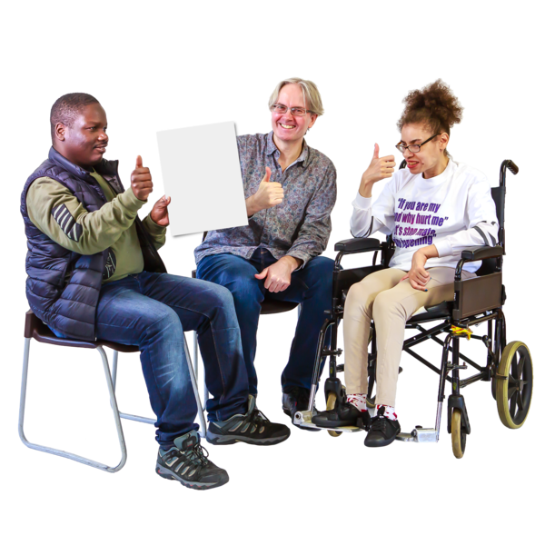
People with disabilities should have a say in:

- Support services and how they work

- New laws, plans and rules about rehabilitation support

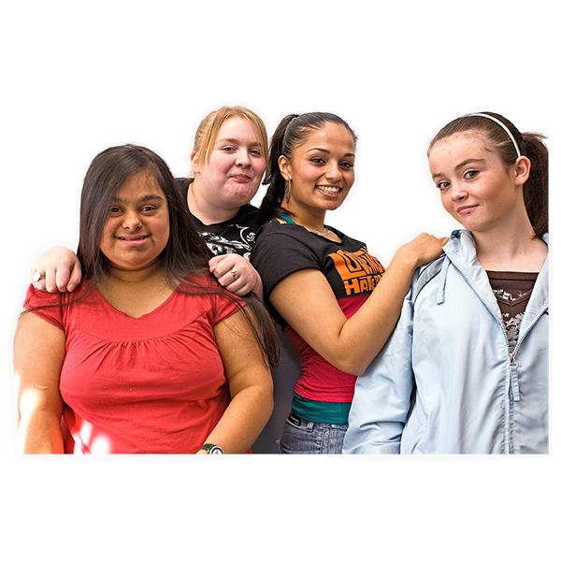

This means all people with disabilities, including:
- Women and girls
- Older people
- Children
- People with intellectual disabilities
- People with mental health conditions

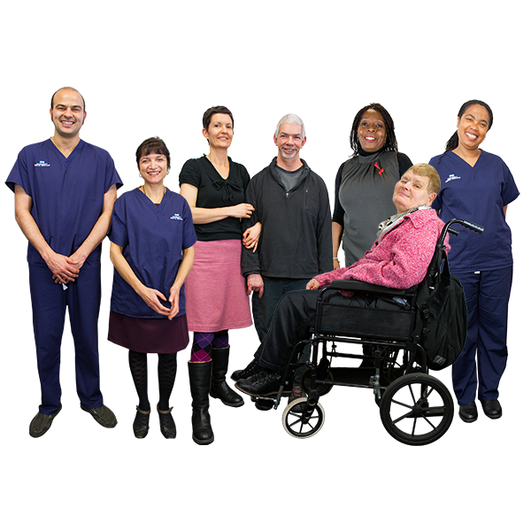
Training for staff

There should be staff with many different skills to support people with disabilities.
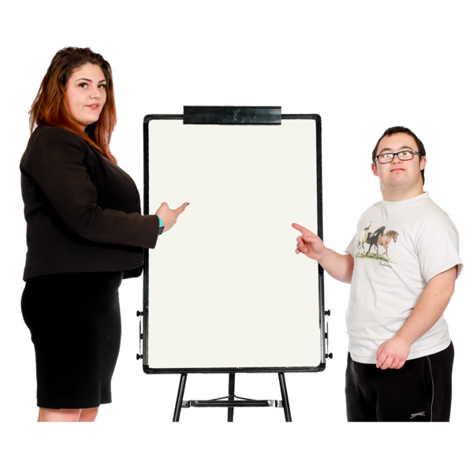

Staff should get the right training now and in the future.

Countries should also:

- Make sure there is enough money for good rehabilitation support

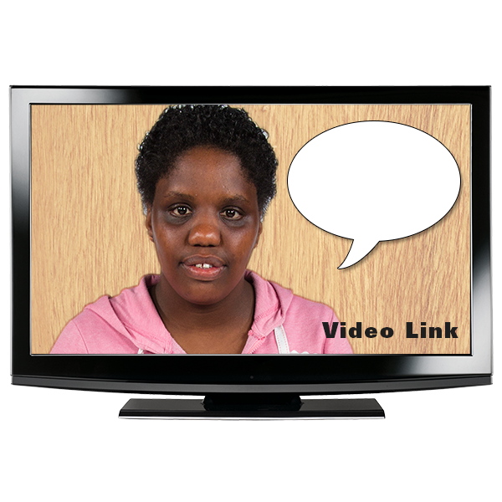

- Help people with disabilities and other people know about the support and their rights

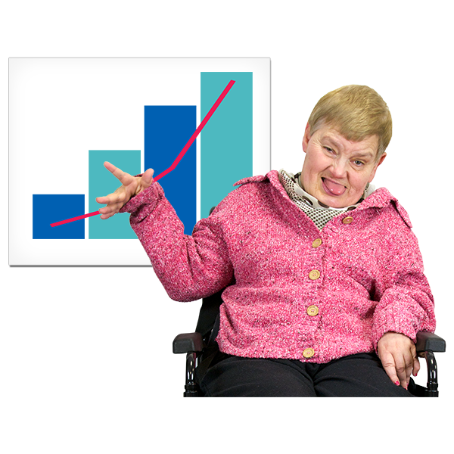

- Get good information about what support people need and how well it is working.

Share this information with the public

Some good work that countries are doing

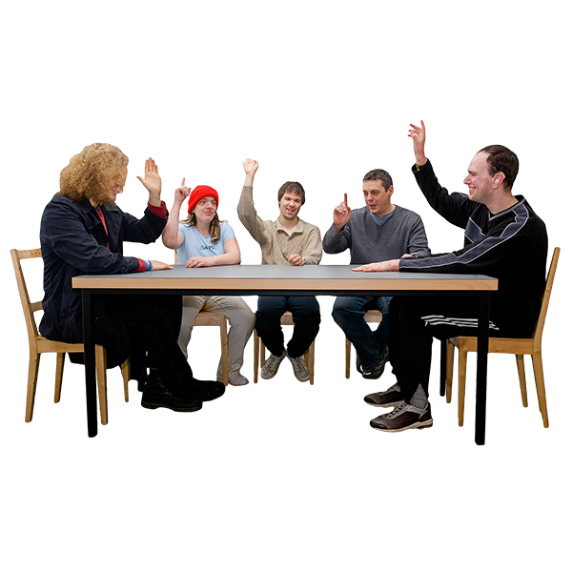

- In Denmark and Germany people with disabilities give organizations advice about laws and rules that affect them

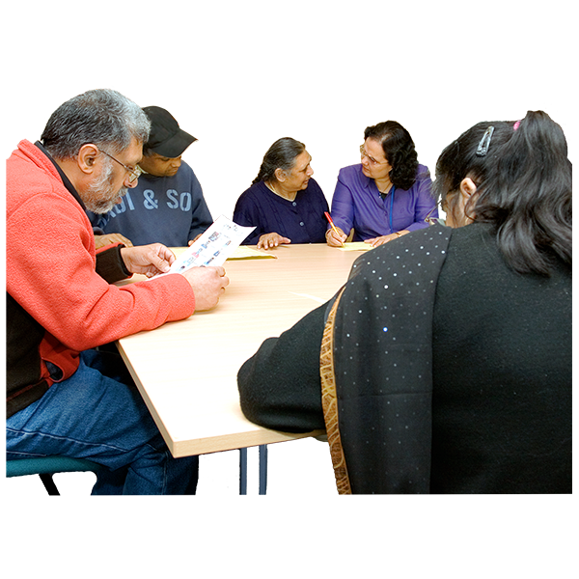

- In many countries people with disabilities are giving each other good rehabilitation support

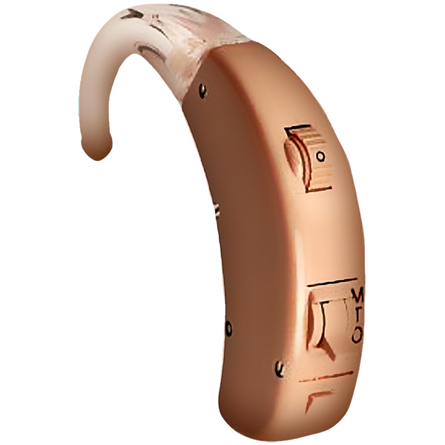

- Slovenia and Ireland have made it easier for people with disabilities to get equipment and support.

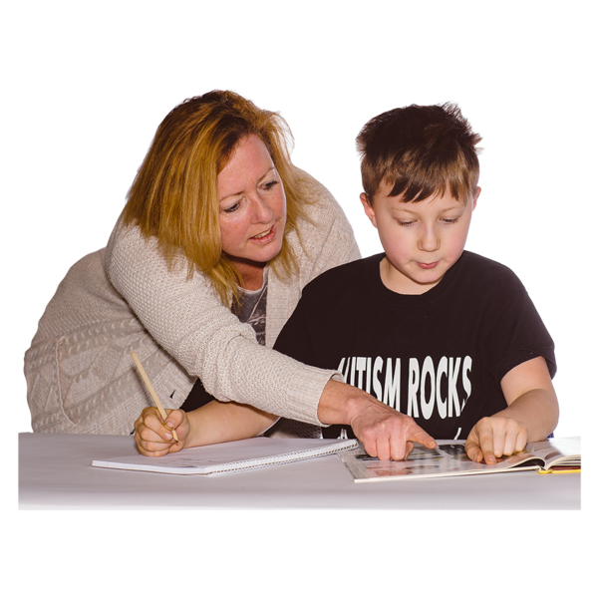
For example, there are some people in schools in Ireland who help children with disabilities learn how to communicate.

They are called speech and language therapists.
Most pictures by Photosymbols

