To the attention of:
Ms. Catalina Devandas-Aguilar
Special Rapporteur on the rights of persons with disabilities
C/o Office of the High Commissioner for Human Rights
United Nations Office at Geneva
Ch-1211 – Geneva 10
Switzerland

Vienna, 29 May 2017
Ref: 2017-outgoing-000775

Subject: Report of Special Rapporteur on the rights of persons with disabilities "Right to liberty and security of persons with disabilities"

Dear Ms Catalina Devandas-Aguilar,
I am pleased to provide you with the EU Agency for Fundamental Rights’ (FRA) contribution to the above-mentioned study.
Question 1: Please provide information in relation to the existence of legislation and policies that are intended to ensure and protect the right to liberty and security of persons, with disabilities.

The EU Agency of Fundamental Rights’ report on involuntary placement and involuntary treatment of persons with mental health problems (2012) analysis the legal and policy framework in the EU Member States and, based on fieldwork in nine EU Member States, reflects on experiences of involuntary placement and involuntary treatment of persons with mental health problems. The report provides an overview of international and European standards relating to the right to liberty (pp. 14-21), provides comparative analysis of national legislative frameworks in the EU Member States (Section 2.1 and 2.2), and examines questions related to procedural rights in the context of the review and appeal process (Section 2.3).
Question 2: Please provide information on relevant legislation and policies related to:

2.1. exercise of legal capacity;

The Agency’s report on the legal capacity of persons with intellectual disabilities and persons with mental health problems analyses international and European legal standards and analysis EU Member States’ laws in the area of legal capacity (chapter 2). The report further contains a table outlining national legislation on legal capacity and latest amendments.

Since the publication of the abovementioned report, the Agency has collected data and followed developments across the EU Member States on relation to Article 12, CRPD, which can be found in the Agency’s Focus paper on the implementation of the United Nations Convention on the Rights of Persons with Disabilities (CRPD) (2015) as well as in FRA’s Fundamental Rights Annual Report 2015 and Fundamental Rights Report 2016.

FRA’s report on the human rights indicators on the right to political participation for persons with disabilities looks at the link between deprivation of legal capacity and the right to political participation, and provides an overview of national legislations to this regard (see indicator 2.2.1).

2.2. the rights of persons with disabilities in institutions including processes of deinstitutionalisation;

FRA is currently implementing a multi-annual project on the right to independent living. In the framework of this project, FRA has, in close cooperation with stakeholders, developed human rights indicators on Article 19 of the CRPD. These are currently being applied with data from all EU Member States and will be available in October 2017. In Data collected across the 28 EU Member States include:
- proportion of persons with disabilities living in private households or social housing compared to the general population;
- the number of persons living in long-stay residential institution;
- the number of places in long-stay residential institutions;
- EU Member States’ commitment to shut down institutions, not to build new institutions and to stop new admissions to institutions;
- strategies/action plans on the transition from institutional care to community based support;
- budget allocated to the implementation of strategies/action plans on the transition from institutional care to community based support.
Preliminary analysis of data collected to apply these indicators show that more than half of EU Member States have either adopted a dedicated strategy on deinstitutionalisation (seven EU Member States), or included measures for deinstitutionalisation in a broader national disability strategy (11 EU Member States).

2.3. involuntary admission to mental health services or other institutions;

FRA’s report on involuntary placement and involuntary treatment of persons with mental health problems (2012) provides specific information on legislation and policies related to involuntary admission to mental health services. Among others, the report provides comparative analysis of national legal frameworks in relation to: criteria for involuntary placement and involuntary treatment, assessment and decision procedures and review and appeal of institutionalisation.

2.5. unfitness to stand trial or unfitness to plead;

Relevant information can be found in section 2.4 on restoration of legal capacity and procedural safeguards in FRA’s report on the legal capacity of persons with intellectual disabilities and persons with mental health problems.

Question 3: Please provide the most recently available data, disaggregated by sex and age if possible, on the number of:

3.2. cases where the state or an organisation has been appointed guardian;

Information in relation to national provisions on who can be appointed as a guardian can be found in section 2.3.3 in FRA’s report on the legal capacity of persons with intellectual disabilities and persons with mental health problems.

3.3. institutions for persons with disabilities;

One aspect of FRA’s multiannual project on the right to independent living of persons with disabilities is a mapping of types of institutional and community-based services in existence in the 28 EU Member States. The mapping is based on information about key characteristics of different types of service, including: age group, typical size of service, category of people with disabilities targeted, level of support, user’s control, typical provider, typical funder, eligibility criteria. The results of the mapping exercise are expected to be published in autumn 2017.
3.4. persons with disabilities placed in institutions;

FRA’s research indicates that there is a lack of comparable and reliable data concerning the number of persons with disabilities living in residential institutions in the EU Member States.
FRA’s human rights indicators on Article 19 of the CRPD, expected to be published in October 2017, aimed to gather data in relation to the following questions:
- How many persons with disabilities were living in long-stay residential institutions annually since 2010?
- How many places were there in long-stay residential institutions annually since 2010?
- How many persons with disabilities have been admitted to long-stay residential institutions annually since 2010?

3.8. existing inpatient mental health facilities;

In the context of the mapping of types of institutional and community-based services in existence in the 28 EU Member States, the Agency has collected relevant information. The results of the mapping exercise are expected to be published in autumn 2017.
Question 4: Please provide information on jurisprudence, complaints or investigations in relation to abuses and violence against persons with disabilities at home.

FRA scrutinised the important but underreported issue of violence against children with disabilities, carrying out desk research and conducting interviews with relevant stakeholders. FRA’s report on violence against children with disabilities: legislation, policies and programmes in the EU outlines relevant international and European standards and reviews national legislation and policies addressing violence against children with disabilities. The report also explores causes, forms and settings – including domestic setting – of such violence, and presents national measures and initiatives to prevent it.

Question 5: Please provide any other relevant information (including information from surveys, censuses, administrative data, reports, studies, and case law) in relation to the right to liberty and security of persons with disabilities in your country. Please also refer to any innovative initiatives that have been taken at the local, regional or national level to promote and ensure the right to liberty and security of persons with disabilities and identify lessons learned from these.

The European Court of Human Rights has produced an extensive body of case law on the detention of persons with mental health problems, but has dealt with fewer cases on persons with intellectual disabilities. These cases have established how the ECtHR understands the concept of “unsound mind” (See, for example: ECtHR, Winterwerp v. the Netherlands, No. 6301/73, 24 October 1979; and ECtHR, Rakevich v. Russia, No. 58973/00, 28 October 2003.) and have defined deprivation of liberty taking into account “a range of criteria such as the type, duration, effects and manner of implementation of the measure in question” (ECtHR, Ashingdane v. the United Kingdom, No. 8225/78, 28 May 1985, para. 41).

The ECtHR has also provided interpretation of one of the essential guarantees of the right to liberty and security; that the lawfulness of the deprivation of liberty must be reviewable by a court. ECtHR case law has expanded on the practical implications of this right. For further information please see FRA’s report on involuntary placement and involuntary treatment of persons with mental health problems (2012).

I enclose a list of FRA publications on the rights of persons with disabilities for your information. Should you need any further information, please consult the thematic page on our website and do not hesitate to contact me.

Yours sincerely,

Nevena Peneva
Equality & Citizens’ Rights Department
European Union Agency for Fundamental Rights (FRA)

Annex of FRA publications on the rights of persons with disabilities

FRA product |  | Short description | Languages
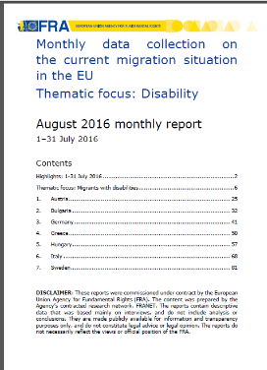 | Monthly data collection on the current migration situation in the EU  Thematic focus: Disability  August 2016 | Persons with disabilities make up around 15% of the global population, and comprise a significant minority of refugees and migrants. In addition to pre-existing physical, sensory, intellectual or psychosocial impairments, people may acquire or develop impairments during the migration process. When identified, these impairments place an obligation on Member States to provide specific support throughout the arrival, registration and asylum process. This thematic focus explores practices in four areas crucial to persons with disabilities and victims of torture in the current migrant situation | en
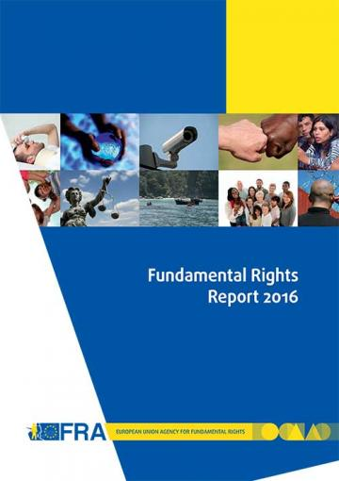 | Fundamental Rights Report 2016  Chapter 8: developments in the implementation of the Convention on the Rights of Persons with Disabilities  May 2016 | Five years on from the EU’s accession to the Convention on the Rights of Persons with Disabilities (CRPD), for the first time in 2015 a United Nations (UN) treaty body, the Committee on the Rights of Persons with Disabilities (CRPD Committee), reviewed the EU’s fulfilment of its human rights obligations. In its concluding observations, the CRPD Committee created a blueprint for the additional steps required for the EU to meet its obligations under the convention. At national level, the CRPD is driving wide-ranging change processes as Member States seek to harmonise their legal frameworks with the convention’s standards. | en  (summary en – fr)
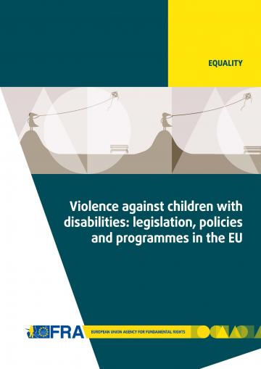 | Violence against children with disabilities: legislation, policies and programmes in the EU  December 2015 | The report outlines relevant international and European standards and reviews national legislation and policies addressing violence against children with disabilities. The report also explores the extent and different causes, settings and forms of such violence, and presents measures and initiatives to prevent it. | en
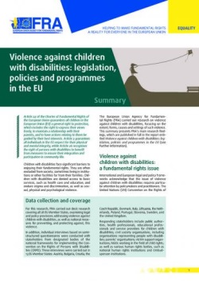 | Summary report:  Violence against children with disabilities: legislation, policies and programmes in the EU  December 2015 | This summary report presents the main research findings identified in the FRA report on Violence against children with disabilities: legislation, policies and programmes in the EU. The report gives a short summary of the key findings and outlines 10 key areas where policymakers and relevant stakeholders should concentrate their efforts to fight violence against children with disabilities, and to effectively protect them from abuse and exclusion across the EU. | bg - cs - da - de - en - fr - hr - it - lt - nl - pl - pt - sl - sv  (et - el - es - lv - hu - ro - sk - fi)
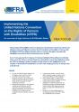 | Implementing the UN CRPD: An overview of legal reforms in EU Member States  May 2015 | The Focus paper outlines how Member States across the EU have reformed their laws and policies to meet their obligations under the CRPD. By bringing together examples of such reforms, it also highlights how the adoption of international commitments can drive wide-ranging processes of change at the national level. | en
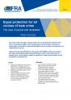 | Equal protection for all victims of hate crime - The case of people with disabilities  March 2015 | The paper discusses the difficulties faced by people with disabilities who become victims of hate crime, and the different legal frameworks in place to protect such victims in the EU’s Member States. It ends by listing a number of suggestions for improving the situation at both the legislative and policy levels. | en
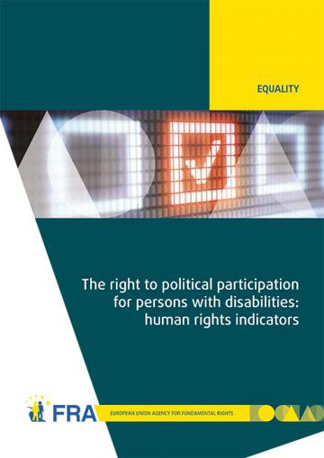 | The right to political participation for persons with disabilities: human rights indicators  May 2014 | The opportunity to be involved in political life, whether by standing for elected office, joining a political party, or following political news stories in the media, is at the heart of what it means to live in a democratic society. The report analyses data on the situation of political participation of persons with disabilities collected from across the 28 EU Member States by the FRA and the European Commission-funded Academic Network of European Disability Experts (ANED).  Data visualisation of the 28 human rights indicators is also available online. | en
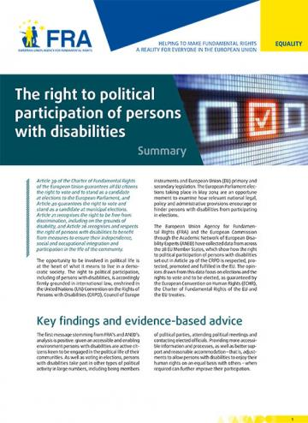 | Summary report:  The right to political participation of persons with disabilities  May 2014 | The human rights indicators presented in the report show that legal and administrative barriers, inaccessible processes and information, and a lack of awareness about political rights can deny persons with disabilities the opportunity to participate in the political lives of their communities. | bg - cs - da - de - en - et - el - es - fr - hr- it - lv - lt - hu - nl - pl - pt - ro - sk - sl - fi - sv
 | Infographics on voting rights of people with disabilities  September 2014 | FRA has developed a family of five infographics to help raise awareness of the voting rights of people with disabilities. Each infographic targets a different audience and draws on FRA research into the right to political participation of people with disabilities. | bg - cs - da - de – en - et - el - es - fr - hr- it - lv - lt - hu - nl - pl - pt - ro - sk - sl - fi - sv
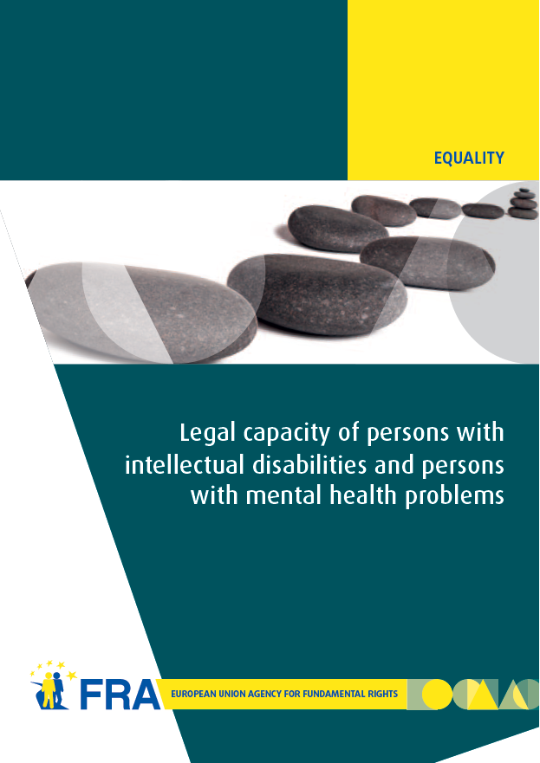 | Legal capacity of persons with intellectual disabilities and persons with mental health problems  July 2013 | Equal recognition of persons before the law is a long-established human rights principle. Nevertheless, legal frameworks in many European Union (EU) Member States allow for the legal capacity of persons with intellectual disabilities and persons with mental health problems to be restricted or removed under certain conditions.  This report analyses the current legal standards on legal capacity across the EU, set against the backdrop of the experiences of interviewees who have had their legal capacity removed or restricted. The FRA report reveals the gap between the promise of the CRPD and the reality those with disabilities face in the EU every day, and, by so doing, hopes to contribute to closing it. | en - de - fr
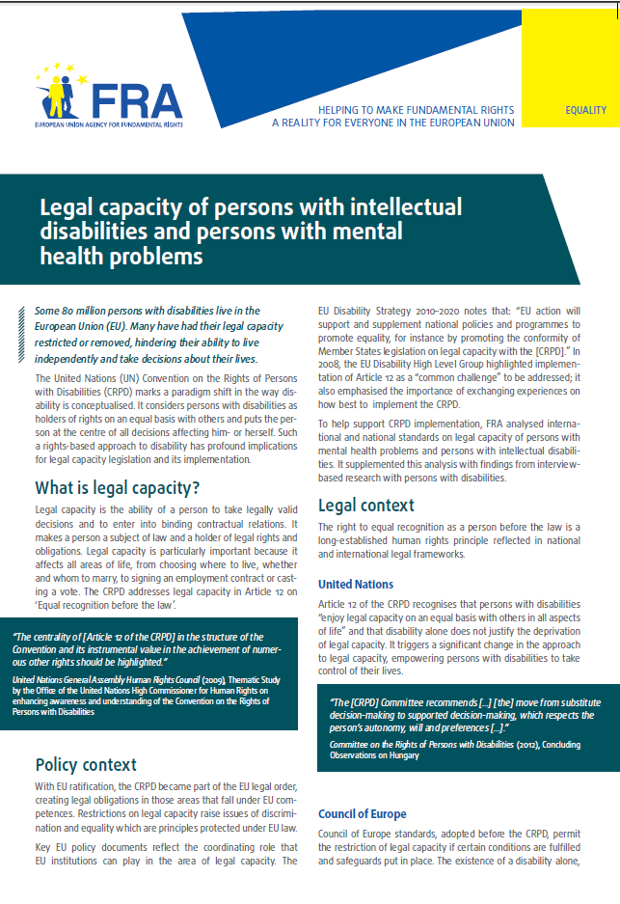 | Factsheet:  Legal capacity of persons with intellectual disabilities and persons with mental health problems  October 2013 | This factsheet presents the key challenges identified by the FRA report on Legal capacity of persons with intellectual disabilities and persons with mental health problems.  The entry into force of the CRPD has prompted discussions about the current legal frameworks governing legal capacity in the EU Member States, aiming at developing models based on supported decision making which promote the independence and autonomy of persons with disabilities. | bg - cs - da - de - en - et - el - es - fr - hr- it - lv - lt - hu - nl - pl - pt - ro - sk - sl - fi - sv
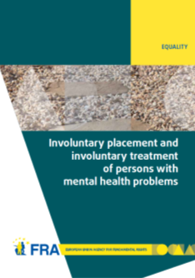 | Involuntary placement and involuntary treatment of persons with mental health problems  June 2012 | Involuntary placement and involuntary treatment of persons with mental health problems affects the most fundamental of rights, including the right to liberty and the right to freedom from torture. Strict safeguards at United Nations and European level attempt to limit undue interference with such rights.  This report analyses the shifting legal panorama and, informed by fieldwork in nine EU Member States on the actual experiences of those involuntarily placed and treated and other stakeholders, points to the need for a renewed discussion of compulsory placement and treatment in the EU. | en - de - fr
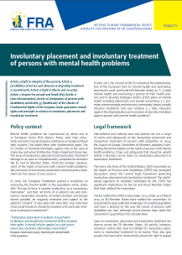 | Factsheet:  Involuntary placement and involuntary treatment of persons with mental health problems  June 2012 | This factsheet presents the key challenges identified by the FRA report on Involuntary placement and involuntary treatment of persons with mental health problems. Mental health problems are experienced by about one in 10 European Union (EU) citizens. Many seek help voluntarily, but some may be placed in institutions or treated without their consent. This might affect their fundamental rights. | en - bg - da - de - el - fr - hu - lv - ro - sv
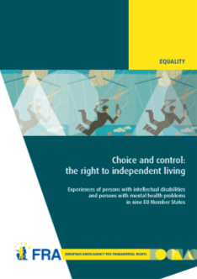 | Choice and control: the right to independent living  June 2012 | Article 19 of the United Nations Convention on the Rights of Persons with Disabilities establishes the right to live independently and be included in the community. Drawing on the findings of interview-based research with persons with mental health problems and persons with intellectual disabilities, this report examines how they experience the principles of autonomy, inclusion and participation in their day-to-day lives. | en - fr - de
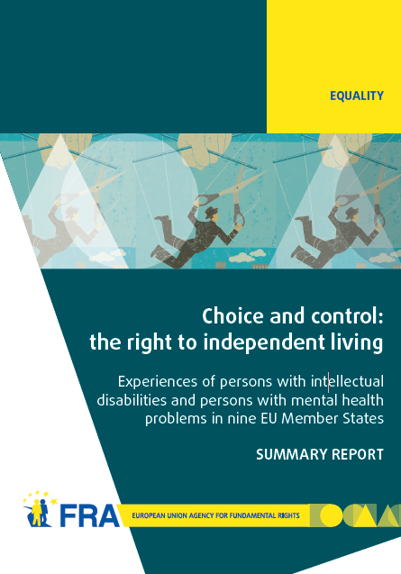 | Summary report: Choice and control: the right to independent living  June 2012 | This summary report presents the key findings identified in the FRA report on Choice and control: the right to independent living. The results show that although much has been done, more efforts are needed to ensure that persons with mental health problems and persons with intellectual disabilities have more choice and control over their lives and are included in the community on an equal basis with others. | en - da - el
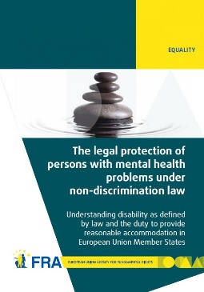 | The legal protection of persons with mental health problems under non-discrimination law  October 2011 | The report examines how disability is defined in international and European law and then explores the obligation to provide reasonable accommodation as contained in international and European standards. The report's findings show that in almost all EU Member States non-discrimination legislation does indeed protect persons with mental health problems. In most cases persons with mental health problems also benefit from reasonable accommodation measures, or other protection measures, in the employment context. | en - de - fr - da
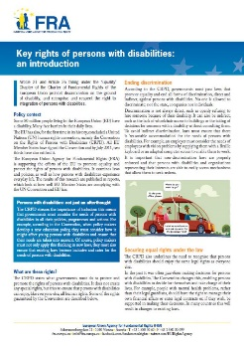 | Factsheet:  Key rights of persons with disabilities: an introduction  August 2011 | This factsheet describes some of the existing rights of people with disabilities, as set out under the UN Convention on the Rights of Persons with Disabilities (CRPD). The factsheet focuses in particular on ending discrimination, equal recognition by law, access to justice, the prevention of inhumane treatment, independent living and the right to political participation. | en - bg - de - el - fr - hu - lv - ro - sv
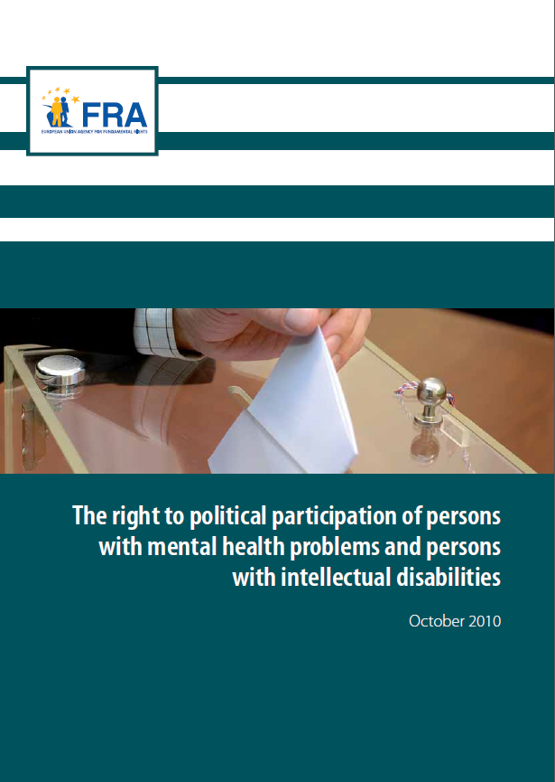 | The right to political participation of persons with mental health problems and persons with intellectual disabilities  November 2010 | This report first recalls the international and European standards favouring the full participation of persons with intellectual disabilities and persons with mental health problems in the electoral process. The comparative law analysis then highlights the diverse approaches adopted in the EU Member States. In a majority of these, persons who have lost their legal capacity are automatically deprived of their right to political participation. | en  de - fr  non-verified language versions:  bg - cs - da - et - el - es - ga - hr- it - lv - lt - hu - mt - nl - pl - pt - ro - sk - sl - fi - sv
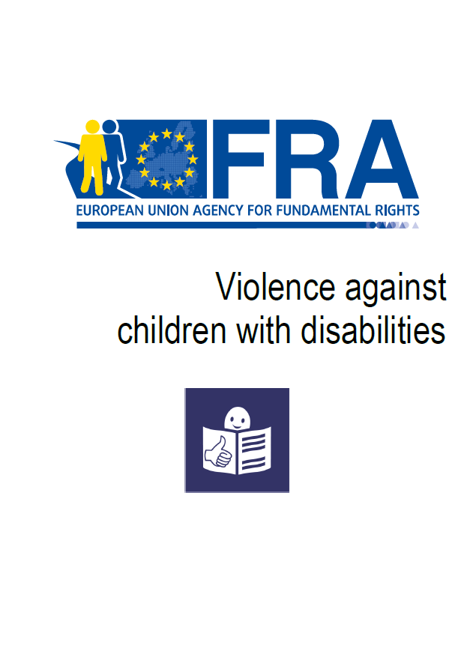 | EASY READ  Violence against children with disabilities  December 2015 | This summary in easy read format looks at violence, where it happens, and why people are violent. It also looks at laws to protect children with disabilities from violence and what countries are doing to prevent this violence. | en
 | EASY READ  Laws about being able to make important decisions for yourself  October 2013 | This summary in easy read format provides information about FRA’s work on the right to equal recognition before the law. | en - de - fr
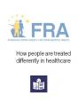 | EASY READ  How people are treated differently in healthcare  March 2013 | This summary in east read format provides information about FRA’s work on how people might be treated differently in healthcare and on multiple discrimination in healthcare. | en
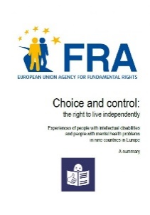 | EASY READ  Choice and control: the right to live independently - Experiences of people with intellectual disabilities  June 2012 | This summary in easy read format provides information about FRA’s work on the right to live independently. | en
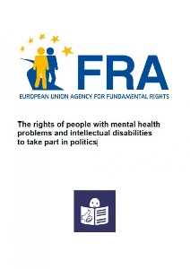 | EASY READ  The rights of people with mental health problems and intellectual disabilities to take part in politics  November 2010 | This summary in easy read format provides information about FRA’s work on the right to vote of persons with intellectual disabilities. | en

