Questionnaire on the rights of older persons with disabilities

Center for Participation Research

Catholic University of Applied Sciences North-Rhine Westphalia

Prof. Dr. Sabine Schäper; Prof. Dr. Friedrich Dieckmann; Anna Roemer; Monika Laumann
Piusallee 89
D-48147 Muenster
Germany
Contact: s.schaeper@katho-nrw.de

- Please provide information on the legislative and policy framework in place in your country to ensure the realization of the rights of older persons with disabilities, including both persons with disabilities who are ageing and older persons who acquire a disability.

The German Federal Government adopted a new law (“Bundesteilhabegesetz”, BTHG) to enhance the possibilities of persons with disability to participate in everyday life according to their own choice. The law indicates a shift from institution-based thinking to person-centred strategies in designing support and services. It will also reform residential settings in the direction of community-based settings. There will be more direct funding of personal assistance, which will no longer be combined with means of subsistence. The realisation will take several years until prescribed in the laws of all German states (“Bundesländer”). The state level also is responsible to reform assessment instruments for person-centred planning procedures.

At the same time, a new care law (“Pflegestärkungsgesetze”) strengthens the rights of persons with dementia, mental health problems and disability since 2017. The care in care homes is improved and caring family members can get more support.
However, these new legislative initiatives do not solve a huge problem attended by the German care system, which is very much separating between different lines. Crossing these lines and mixing up support from different legal spheres often is quite complicated in many individual cases. So support services tend to definitely assigning persons to only one care system. So people with disabilities living in residential homes only get a small amount from the nursing care system to guarantee nursing care inside these residential services, and support services vote for transition into nursing homes. But in nursing homes, people do not have any legal claim for support for social participation any more. This is a special type of discrimination against people with lifelong disabilities in older age.

Current challenges in the course of the demographic change:
* The number of elderly people with intellectual disability is increasing disproportionately (Dieckmann et al. 2015) because of the missing generation of elderly people with intellectual disabilities due to the systematic “Euthanasia”-murders during the Nazi-Regime. Disability services have only short experience with the special needs of elderly persons with intellectual disabilities.
* As already pointed out, care systems for people with disabilities and elderly people are strictly separated in Germany. Therefore, there is a high risk for persons with ID of displacement from disability services and transition to long-term nursing homes. The number of adults with ID living in long-term nursing homes is increasing due to insufficient opportunities to combine resources from both care systems. Networking between socio-political planning strategies for these target groups is underdeveloped in practice on district and local level as well as undertheorized in social sciences and underreported in research (Schäper et al. 2019).

- Please provide information on discrimination against older persons with disabilities in law and practice.

Older persons with lifelong disabilities living in residential settings do not receive full benefits from the nursing care system. At the same time, the need for nursing care is increasing due to rising life expectancy and better support services. The incapacity of disability services to cope with their clients´ changing needs often leads to transitions to nursing homes. The participation of persons with disabilities and their representatives in these cases mostly is insufficient.
Furthermore, there is a lack of alternative settings. There are no options for ageing in a chosen place – as an important principle of autonomous decision-making – although moves in older age should maintain or improve a person´s quality of life.
A quantitative study included data from the regular nursing homes in two districts. The study explored age, duration of residence and reasons for moves of residents by conducting a postal survey in specialized nursing homes in Westphalia (8.3 million inhabitants) in Germany. The results show, that in many cases, also economic interests of the service providers and the funding agency are crucial for the relocation in old age. The results of two research projects (Mätze 2017; Götz et al. 2017) show various organizational procedures and strategies of decision-making. The right to support for participation in everyday life often is ending with this transition. In addition, transitions have a risk of exclusion. The transitions mostly are institution-induced, not induced by choice of the person with disability. Users are in many cases not even asked about their preferences. Transitions take place due to organisational reasons. However, regular nursing homes are often unable to cope with the special needs of persons with lifelong disabilities because of missing knowledge. Therefore, these persons do not get sufficient support.

Figure 1: Typical procedure of transition to nursing homes (Götz et al. 2017)

Figure 2: Age distribution of persons with intellectual disabilities in specialized nursing homes (N=548) (Mätze 2017)

There are 62 specialized nursing homes in Westphalia. 26 of those nursing homes are specialized for persons with intellectual disabilities, 22 of them participated in this survey. In total, the study collected statistic data from about 547 persons with intellectual disabilities. The results show that one third of the residents is younger than sixty years old, which is disproportionately high, compared to the age distribution in general nursing homes. Most persons with intellectual disabilities move into a specialized nursing home when they are at least 50 years old and stay mostly between six and ten years. Living in a nursing home for more than ten years is not uncommon for persons with intellectual disabilities – but quite uncommon in the general public (Mätze 2017): In regular nursing homes almost 70% of residents do not stay longer than three years (Techtmann 2010). This means that (specialized) nursing homes have a different relevance for persons with intellectual disabilities: People with intellectual disabilities move in earlier (1/3 under 60 years old) and stay for a longer time (6-10 years and longer) in (specialized) nursing homes compared to people with age-induced disabilities (Mätze 2017).
The following figure shows moves into (specialized) nursing homes from different residential settings.
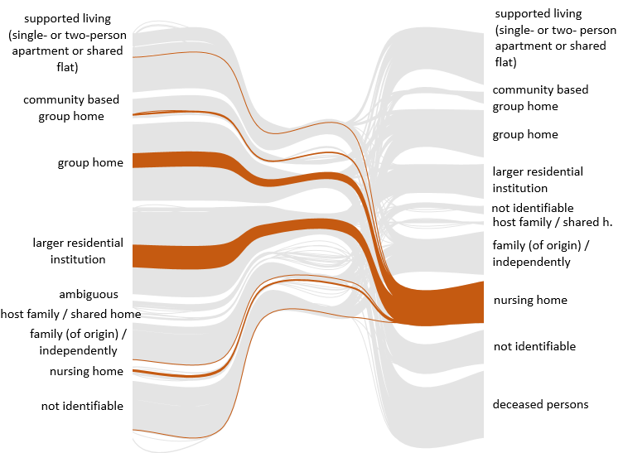Figure 3: Moves to (specialized) nursing homes from different settings of support (Thimm et al. 2018)

The figure shows that most people with intellectual disabilities move from larger residential disability services and group homes into (specialized) nursing homes. In conclusion, counselling and involving elderly persons with intellectual disabilities in decision-making is crucial for respecting their fundamental right to decide for themselves. Concepts to incorporate and improve nursing care in the existing residential services for persons with lifelong disabilities are badly needed.
At the same time, political strategies have to be discussed in the light of human rights for elderly persons with lifelong disabilities. Since the state level is responsible for implementing key policies, the interpretation and transfer of national law can differ in the sixteen states. In some German States (e.g. Saxony), social politics are quite strictly forcing admissions of people with lifelong disabilities from disability services to long-term nursing homes (Freistaat Sachsen, 2011).

* In many domains, legal capacity of persons with (intellectual) disability (Art.12 UN-CRPD) is not recognized, nor even followed by social services. It is quite a great challenge to change attitudes of service providers and staff members to ensure the will of persons with disabilities is well understood and fully respected. In 2015, the National Monitoring Body for the UN Convention on the Rights of Persons with Disabilities recommended a detailed review of this gap between law and practice. They point out that “the supported decision making component in the law and practice of the State Party must be strengthened and further developed by means of adequate measures” (National Monitoring Body German Institute for Human Rights, 19, 2015.).

- Please provide information and statistical data (including surveys, censuses, administrative data, literature, reports, and studies) related to the realization of the rights of older persons with disabilities in general, as well as with particular focus in the following areas:
- Exercise of legal capacity;
- Admission procedures to social or healthcare services, including involuntary admissions;
- Older persons with disabilities living in institutions

Persons with intellectual disabilities older than 50 years predominantly live in stationary services. Older persons with disabilities live less frequently with their family of origin or independently. Aging parents could be a reason for this. Older people with intellectual disabilities also live more frequently in residential institutions. Living in a host family is no important factor at any age (Thimm et al. 2018).

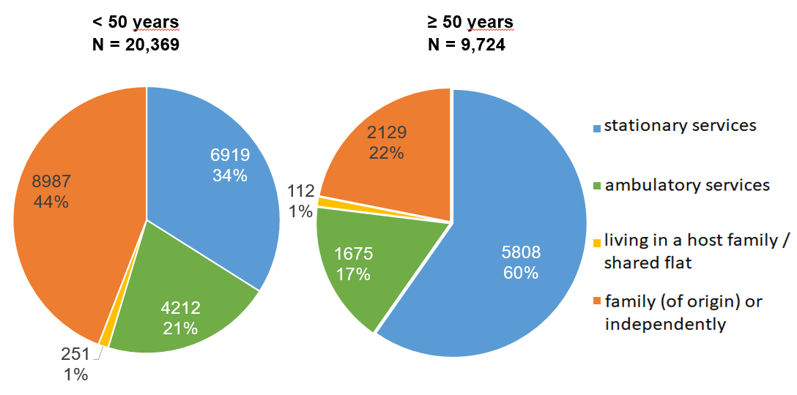
Figure 4: Kinds of residential support of adults with ID with social aid for integration in Westphalia (31.12.2014) (Thimm et al. 2018)
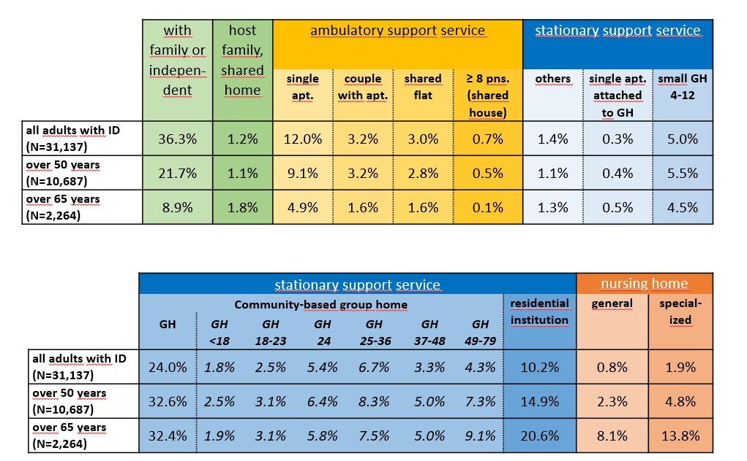
Figure 5: Adults with ID in different types of residential settings in Westphalia (31.12.2014) (Thimm et al. 2018)

- Access to support to live independently in the community
- Access to free or affordable healthcare

Another quantitative study questioned persons with intellectual disability older than 45 years about their individual quality of life. The participants gave information about doctor visits and hospital stays. These results are compared to the total population:

gender | age | sample (441 persons with ID)  General practicioner | total population  general practicioner and medical specialist
female | 45 – 64 years | 85,6 | 90,3
 | 65 years and older | 83,7 | 93,6
male | 45 – 64 years | 79,5 | 84,4
 | 65 years and older | 85 | 90,5
Figure 6: doctor visits from persons with ID and total population older than 45 years (figure in per cent) (Dieckmann and Metzler 2013)
gender | Age | Sample (441 persons with ID older than 45 years) | Total population
female | 45 – 64 years | 23,1 | 14,2
 | 65 years and older | 24,5 | 24,5
male | 45 – 64 years | 27,6 | 15,5
 | 65 years and older | 37,5 | 22,5
Figure 7: hospital stays of persons with ID and total population older than 45 years (figure in per cent) (Dieckmann and Metzler 2013)

In total, persons with intellectual disabilities stay in hospitals more frequently compared to the total population. Female persons with intellectual disabilities younger than 65 years visit a doctor more often compared to male persons with intellectual disabilities. It is the reverse when the persons are older than 65 years.
- Access to free or affordable rehabilitation goods and services;
- Access to social protection schemes; and
- End of life and palliative care.

Regarding the subject of palliative care and end-of-life care for older persons with intellectual disabilities, Germany finds itself in a special situation. Due to the systematic murder of people with ID during Germany’s Nazi Past, the first post-war generation of people with ID is now growing old. Hence, institutions and society in general are not used to providing end-of-life care for people with ID.
The research project “Palliative care for people with intellectual and multiple disabilities” (PiCarDi) aims to explore the current state of palliative care for people with disabilities (see detailed information about the project and first insights under Item 7).
Starting in 2018 the health insurance was supplemented with a new paragraph (§132g SGB V), which provides funding for counselling regarding individual decision making for options in palliative care and anticipated health care issues. Residential care services for elderly people and residential services for people with disabilities are now able to account for about two counselling sessions per Client. If the institution serves enough clients, it can finance a position for this new kind of counselling. Following the new policy, the health insurance and the main associations of service providers agreed on a special qualification for those who take over the counselling at the end of life. Service providers for disability services pointed out the special demands when counselling people with intellectual disabilities. But even persons with severe or multiple disabilities are not expected to being capable for decision making. Practices of substituted decision making in the maximum vulnerable situation at the end of life are very widespread. In the contrary, strategies and instruments for supported decision-making often are lacking at all or not so far developed. Some associations work on this issue, but a broad knowledge base as well as an autonomy-respecting attitude are missing.

- Please provide information on the existence of long-term care services in your country and describe to what extent they promote the autonomy and independence of older persons with disabilities.

- Please describe how access to justice is guaranteed for older persons with disabilities. Please provide information on jurisprudence, complaints or investigations in relation to violence, abuse and neglect against older persons with disabilities.

Starting in 2017 the German Parliament established the Stiftung Anerkennung und Hilfe (Foundation “Acknowledgement and Help”) for people with disabilities who suffered harm and abuse during their accommodation in stationary services for people with disabilities (between 1949 and 1975 in the Federal Republic of Germany and between 1949 and 1990 in the German Democratic Republic). Affected people can get financial reparations. Therefore, they have to contact the Foundation responsible for their region. The measures to confirm the conditions during the time of accommodation in disability services are set low-threshold.

- Please describe to what extent and how are older persons with disabilities involved in the design, planning, implementation and evaluation of policies related to ageing and/or disability.

Disabled peoples organisations are involved into the monitoring process around the UN-CRPD. There is no special focus on elderly people with disabilities in the reports.
The research project “SoPHiA” on inclusive social planning developed participatory means and instruments of planning on a local level to explore the needs of elderly persons with disabilities. The results led to a manual, which describes strategies and instruments of inclusive social planning at the network line between disability services and services for elderly people (Schäper et al 2019).
The organization “Lebenshilfe” is an association on national and local level of relatives of persons with ID. It established groups of self-advocates called “Lebenshilfe-Rat” all over the state. The “Lebenshilfe-Rat”on national level consists of fourteen members with ID. They discuss the living conditions of persons with ID, give advises and speak up for their interests and wishes. The “Lebenshilfe-Rat” on a regional level was part of the research project “MUTIG” (Center for Participation Research, Catholic University North-Rhine Westphalia, Muenster). They discussed innovative ideas for support arrangements for elderly persons with ID, discussed the project results, gave hints and their opinions. These comments are involved in the publications from the project

- Please provide information on any innovative initiatives that have been taken at the local, regional or national level to promote and ensure the rights of older persons with disabilities and identify lessons learned from these.

The research project “MUTIG” described innovative models of support structures for aging people with ID in different living settings in two German states (Westphalia and Bavaria) and three other European countries (the Netherlands, Denmark and Norway). The researchers tried to understand their successful performance in realizing social participation for ageing people with disabilities. Best practice models show that living accommodations need to change structures. Community orientation is helpful and social services for persons with disabilities and older persons should be combined to profit from synergetic effects. Further results will be published in a handbook for residential settings in 2020.

In the research Project “Palliative care for people with intellectual and multiple disabilities” (PiCarDi), a network of researchers focuses on exploring the experience, conditions and challenges in palliative care for people with intellectual and multiple disabilities. The three contributing subprojects focus on different perspectives: the perspective of disability care services, the perspective of palliative care services and the perspective of service users and relatives).

Besides the extensive research projects, the Center for Participation Research encourages Master students at the Catholic University North-Rhine Westphalia to develop smaller research projects within the region. In 2017 the project “Thinking the unthinkable – Attitudes of People with intellectual disabilities living in stationary settings toward dying and death” the students were able to state that the respondents are aware of the universality of dying and death, and that they are able to articulate and in some cases reflect their wishes and needs. The project specified that people with ID depend on various experiences with grief and death to evolve this concept of dying and death (Duchardt et al. 2018).

The following Project “I’m not eternal either! – Reflecting one’s own mortality; Life-long participation of people with intellectual disabilities through education” focussed on the question how people with ID engage in the topic of their own mortality. The project focussed on the idea of a lifelong participation including educational programs focussing the topic of dying and death. The students tried to depict different perspectives. By developing a questionnaire for professionals in the field of stationary and ambulatory services, they collected data about the current situation and conditions at the specific service provider. Besides the collecting of information about the general framework they asked the professionals about their ideas and needs surrounding their role in the support of people with ID regarding the topic of dying and death. The second phase of the project focussed on the perspective of people with ID. The students interviewed people with ID about their wishes and needs according to an individual handling of their own end of life and an adequate preparation through education and counselling (Bischoff et al. 2019)
Both research projects underline the relevance of lifelong participation. They also stated that one main access to the individual reflection of one’s own dying and death is the experience of grief and the confrontation with dying throughout life. The findings show that for people with ID these individual experiences and reflections are a key element to become able to develop own ideas and wishes for the end-of-life phase. Therefore, another main aspect is the openness of the support system to challenge these topics and to work with people with ID over the whole lifespan.

References:
Bischoff, J; Brocke, F; Kemmerling, M; Wolters, J (2019): „Ich bin ja auch nicht ewig." - Auseinandersetzung mit der Endlichkeit als Lebensthema. Lebenslange Teilhabe von Menschen mit geistiger Behinderung durch Bildung zu den Themen Sterben und Tod, Münster.
Dieckmann F; Giovis C; Offergeld J (2015): The Life Expectancy of People with Intellectual Disability in Germany. Journal of Applied Research in Intellectual Disability, 28 (5), 73-82.
Dieckmann, F; Metzler, H (2013): KVJS Forschung. Alter erleben und Lebensqualität und Lebenserwartung von Menschen mit geistiger Behinderung im Alter. Abschlussbericht. Stuttgart.
Duchardt, L; Schulte, A; Uphoff, J (2018): Undenkbares denken – Einstellungen zu Sterben und Tod von älteren Erwachsenen unter dem Einfluss einer mittelgradigen kognitiven Beeinträchtigung in stationären Wohneinrichtungen (Lehrforschungsprojekt), Münster.
Freistaat Sachsen (2011): Sächsisches Gesamtkonzept zur Versorgung älterer Menschen mit Behinderung – Empfehlungen des Landespflegeausschusses Freistaat Sachsen, Freistaat Sachsen, 2011. (Saxon general Concept of Care for older Persons with Disabilities: Recommendations of the regional care Comitee, 2011).
Götz A; Vogt K; Wevering J (2017): Analyse von Umzügen von älteren Menschen mit lebenslanger geistiger Behinderung in spezielle Pflegeeinrichtungen (Master-Thesis), Münster.
Mätze C (2017): Menschen mit geistiger Behinderung in speziellen Pflegeeinrichtungen (Master-Thesis). Münster.
National Monitoring Body for the UN Convention on the Rights of Persons with Disabilities (2015): Parallel Report to the UN Committee on the Rights of Persons with Disabilitiesin the context of the examination of the Initial Report of Germany under Article 35 of the UN Convention on the Rights of Persons with Disabilities, Berlin.
Schäper S; Dieckmann, F; Rohleder, C; Rodekohr, B; (2019): Inklusive Sozialplanung für Menschen im Alter. Ein Manual für die Planungspraxis. Stuttgart.
Techtmann, G (2010): Mortalität und Verweildauer in der stationären Altenpflege. Eine empirische Erhebung als Ausgangspunkt veränderter Handlungsschwerpunkte im Ev. Johanneswerk e.V. (Teil 1). In: Theorie und Praxis der Sozialen Arbeit 61 (5), S. 346-353.
Thimm A et al. (2018): Wohnsituation Erwachsener mit geistiger Behinderung in Westfalen-Lippe und Umzüge im Alter. Münster.

The following institutions and programmes founded the research projects referred to in this paper:


