Questionnaire on the provision of support to persons with disabilities

About Hft:
Hft is a national charity that provides specialist care and support to over 2,500 adults with learning disabilities in order to live with as much independence, choice and control as possible.
We were founded in 1962 by a group of families who believed that, with the right support, their relatives were capable of more than society expected of them.
In the 1960s there was little support for people with learning disabilities once they became adults. To ensure their children would learn, develop and fulfil their potential after leaving school, these visionary parents bought Frocester Manor in Gloucestershire. They turned it into a safe and welcoming home where people with learning disabilities could be supported to lead fulfilling lives.
Today, we still share that same vision. We support people to live independently in their homes through our Supported Living services, alongside Residential Care, and Short Break services. We empower people to make their own choices, including finding a job, building friendships and relationships and taking part in activities.
We operate in sites across England – from Newcastle in the Northeast, to Cornwall in the South West.
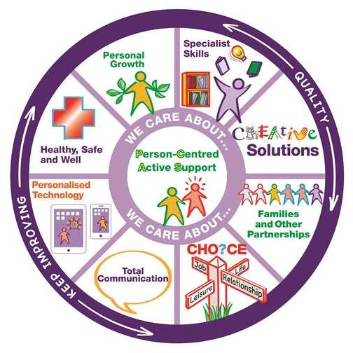
About the Fusion Model of Support:
Hft’s Fusion Model of Support is a different way of supporting someone with a learning disability. The model puts the emphasis on how we provide support, not what support we provide. It contains all of our strengths and all of the elements that we believe are essential to providing high quality, person-centered services. When all of these elements come together, a ‘fusion’ is created – this is when Hft is working at its best.
At the centre of our model, and because they are at the centre of everything we do, are the people we support. Surrounding them are eight segments that reflect all of the specialist skills that we believe are necessary to provide excellent support. These segments also include some of the ethical and moral considerations we take into account when providing services.
Surrounding these segments are three supporting themes: ‘care about’ runs through everything we do, ensuring we provide ‘quality’ services that are ‘continually improving’.

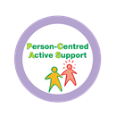
- Person-Centred Active Support (PCAS)
PCAS is a way of supporting people so that they are engaged in meaningful activity and relationships as active participants, exercising more control over their lives and experiencing greater levels of inclusion, independence and choice.

- Specialist Skills
Specialist Skills means using proven expert knowledge and best practice to support people.
This includes providing support with physical, mental, emotional and social needs and also meeting syndrome and time of life specific needs.

- Creative Solutions
Creative Solutions means thinking openly and using imaginative and original ideas to find practical solutions to enhance the lives of the people we support.

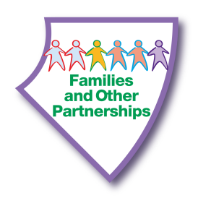
- Families and Other Partnerships
This means helping the people we support to develop and maintain positive relationships with families, friends and other partners involved in their lives.
It means having the skills and understanding of how important it is to work in partnership with the people we support and those involved in their lives. This includes welcoming and valuing what families contribute to giving the best support.

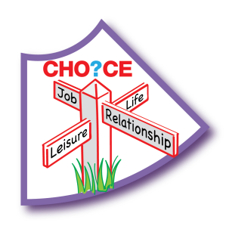
- Choice
Choice means enabling the people we support to have a greater awareness of the range of options available to them, so they can make the choice or decision that is uniquely right for them. This means people are more empowered to make informed decisions, even if these decisions may be considered ‘unwise’ by others.
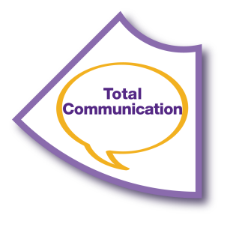
- Total Communication
Total Communication means that all forms of verbal and non-verbal communication are thoroughly explored and embraced for each individual. This includes all body language, facial expressions, gestures, signing, verbalisation, intonation, photographs, drawings and symbols, written words, objects of reference and access to appropriate technology.


- Personalised Technology
Personalised technology means any technology which enhances the lives of the people we support. This includes specialist technology such as telecare, environmental controls and prompting devices, as well as mainstream technology such as quick cooling hobs and mobile phone technology.


- Healthy, Safe and Well
Healthy, Safe and Well involves all aspects of a person’s life including their physical, mental, emotional, social, cultural and spiritual needs. It is a positive concept and means we will proactively work with each individual to find out what this means for them so we can help them to live more fulfilled lives.
This also means that, when necessary, we will support them to take risks to get the lifestyle they want, while also safeguarding them from harm.

- Personal Growth
Personal growth means the people we support will be helped to take control of their lives so they can continue to develop as individuals. This includes embracing new skills and knowledge, widening interests and having new experiences. Everyone we support will have the confidence to express their thoughts and ideas, increasing their self-esteem.

Q.1 “Please provide information on the following services that are available for persons with disabilities in your country, including data on ….. funding and sustainability”
Virtually all of the people we support are funded by Local Authorities. Local Authorities will agree an individual’s support and care package, and then provide service providers such as Hft with the money to deliver that support.
Over 150 Local Authorities currently fund our services, which equates to around £70,000,000 (seventy million pounds) a year to support people.
For every £1 we receive, around:
- 70p is spent on operational wages (e.g. paying for support and care staff)
- 11p is spent on running the properties where we support people
- 9p is spent on central business functions such as IT infrastructure and Human Resources.
- 7p is spent on medical supplies
- 3p is reserved for any contingencies
Since the 2008 global recession, Local Authorities in England have made significant funding cuts for social care services. This has meant that service providers such as Hft have had to make efficiency savings in order to remain financially sustainable and competitive.
Many of our staff were on the National Minimum Wage rate of pay (£6.70 per hour). However, in April 2016, the UK Government announced that companies were required to pay a new National Living Wage rate of £7.20 per hour. However, this compulsory increase in wages has not been factored in to the rates we receive from Local Authorities, which are still set at the National Minimum Wage level.
This has led to a shortfall in available funding. At present, staff costs already account for 70-80% of Hft’s total expenditure. Paying the new National Living Wage added 7.5% to our wage bill in April 2016. By April 2020, that bill will have risen by a further massive 25%, adding a third to our wage bill in just four years.
This is not a situation unique to Hft. We expect to see a sector-wide funding shortfall of £380 million this year, ramping up to £1.3 billion in 2020. If this is not addressed, we will see market failures across the sector, undermining the obligations of the Care Act 2015, which enshrines Local Authorities’ legal obligations to ensure a vibrant choice of quality providers in the local marketplace.

These matters are further exacerbated by the ongoing lack of clarity regarding the payment of sleep-in shifts. Previously, sleep-in shifts had been paid at a flat rate. However, following rulings made in Employment Tribunals and revised guidelines from the Department for Business, Energy and Industrial Strategy, it looks increasingly likely that businesses will be required to pay National Living Wage rate of pay – regardless of whether staff members are asleep or awake. For the financial year 2016-17, if the National Living Wage is required for every hour of a sleep-in shift, this would cost Hft an additional £2,000,000 (two million pounds), immediately putting many of our services into deficit.

Hft does not believe that the Government understands how serious this situation is and no realistic solution has been offered:
In the November 2015 spending review, Local Authorities were given the ability to increase Council Tax bills in their areas by up to 2% (the Social Care Precept) to raise new funding to be spent on adult social care.
However, an Hft study of Local Authorities revealed that, even if some authorities applied the full 2%, they will not be able to raise enough to meet demand. In addition, the shortfall will disproportionally hit those areas of the country that have high levels of demand for learning disability services, but only a small council tax base on which to levy the precept. Lastly, the precept covers all of adult social care and is not ring fenced to learning disabilities specifically.
Furthermore, Government provisions from the Better Care Fund as it is intended to cover both health and social care. It will simply not be enough to address the shortfall faced by both sectors. It’s also unclear whether the Better Care Funds identified are new monies, or how they will be used. At any rate, the increased investment will not come into effect until 2018 which will be far too late for some learning disability services which will have fallen into deficit long before then.

Finally, the Government has also announced a 50% increase to the Employment Allowance rate. Previously, the maximum an organisation could apply for was £2,000 per tax year, which has been increased to a maximum of £3,000. This is a drop in the ocean for a charity the size of ours, with a £3,500,000 (three-and-a-half-million pounds) annual National Insurance bill.

As a charity, Hft also does not benefit from other incentives that would benefit a profit-making entity. Critics argue that the increase in wages would only equate to 1% of any profits. However, as a charity, Hft does not generate a profit, with any budget surpluses being immediately reinvested back in to our services. In any case, as we’ve demonstrated, rising costs will far exceed 1% of any surplus.

A similar argument can also be made to those who suggest that we offset these additional costs with savings made to recent cuts to Corporation Tax. However, as a charity, we are exempt from paying Corporation Tax, so would not benefit from any further cuts in Corporation Tax rates.

Whilst Hft welcomes the introduction of the National Living Wage – which will see our staff paid more for their specialist skills – we have concerns that there is a lack of a coherent plan to fund this increase, which will threaten the future viability of the social care sector.

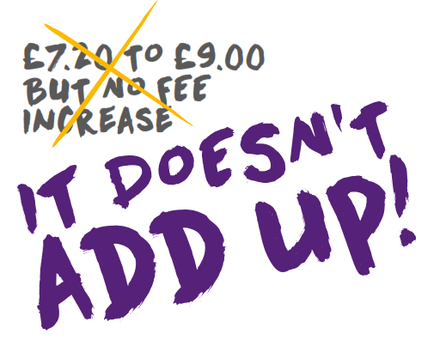
This is why, in January 2016, Hft launched our It Doesn’t Add Up campaign, in order to raise awareness of the challenges being faced by service providers like Hft. Activities have included encouraging staff, trustees and families of the people we support to write to their local MP and to sign a petition via Change.org on the issue. As of the date of submission (Friday 21st October 2016), 128 letters have been sent to MPs and our petition has 3500 signatures from people – including staff members, families, people we support, and other concerned stakeholders – who share our concerns about the impact this unfunded increase in wages will have upon the financial sustainability of service providers such as Hft.
Our concerns were somewhat vindicated in October 2016 with the publication of the CQC (Care Quality Commission) State of Care report. CQC have acknowledged that the adult social care industry “continues to be under pressure from increased demand, coupled with financial strain and difficulties in recruiting and retaining staff”. The report also highlighted that providing costs of services to people with a learning disability was “considerably higher” than providing care for older people. CQC figures show that in 2014/15 the average cost of nursing care was £552 per week for adults aged 65 and over with physical support needs, compared to £1,119 per week to support adults aged 18-64 who have a learning disability.
We fear that these funding cuts will inevitably have an impact on frontline services. However Hft’s charitable statues means we do not have to make a profit, pay corporation tax, or give dividends to shareholders. This means that we can raise charitable funds and use them to pay for extra services that make a huge difference to the lives of the people we support – like Luv2MeetU our friendship and dating service, investing in Personalised Technology and our unique Family Carer Support Service. But while we’re a charity, we always try to think like a business by making sure that our funding is put to the best use.

