Office of the UN High Commissioner for Human Rights
United Nations Office at Geneva
CH - 1211 – Geneva 10
Switzerland
Vienna, 12 May 2017
Ref: 2017-outgoing-000640

Subject: Human Rights Council resolution 31/6

Dear Mr Ayush,
The European Union Agency for Fundamental Rights (FRA) very much welcomes the opportunity to contribute to the preparation of a study on Article 13 of the Convention on the Rights of Persons with Disabilities (CRPD) by providing evidence from its research on the rights of persons with disabilities in the EU. All the publications mentioned in this submission can be downloaded from the FRA website.

Question 1: Do countries in your region have laws, policies or guidelines on access to justice, at any level of government, which ensure persons with disabilities, particularly women and children with disabilities:

- to participate in judicial and administrative proceedings on an equal basis with others in their role as witness, juror, complainant, defendant or other, including through the provision of procedural and age-appropriate accommodations (please identify and share the text of those provisions);

FRA’s handbook on access to justice from 2016 gives an overview of European regulations on access to justice, including access to justice of persons with disabilities (p. 151-157). Under Council of Europe law, persons with disabilities have the right to access justice under Article 6 of the European Convention on Human Rights (ECHR). Article 14 with its references to “other” grounds also protects them against any discrimination in the exercise of their rights. However, Article 14 is not a self-standing right: it prohibits discrimination on disability grounds only in relation to ECHR substantive rights.
Under EU law, Article 47 of the EU Charter of Fundamental Rights sets out the general right of access to justice. Persons with disabilities are also protected against discrimination by Article 20 of the Charter, which confirms that everyone is equal before the law, and by Article 21, which prohibits discrimination on the ground of disability.
Additionally, secondary EU law provides specific rights for persons with disabilities. Victims’ Rights Directive (2012/29/EU) stipulates that victims with disabilities should be able to access the full rights in the directive. The EU has also legislated specific protections for persons with disabilities in criminal proceedings. For example, the Directive on right to information in criminal proceedings (2012/13/EU) obliges Member States to ensure that the information is provided in simple and accessible language, taking into account the particular needs of vulnerable suspects or vulnerable accused persons. The Directive on interpretation and translation in criminal proceedings (2010/64/EU) requires giving appropriate assistance to persons with hearing or speech impediments. The Directive on access to a lawyer (2013/48/EU) requires Member States to ensure that the particular needs of vulnerable suspects and vulnerable accused persons are taken into account in its application. Finally, the Commission adopted a Recommendation in which it recommends procedural safeguards for vulnerable persons suspected or accused in criminal proceedings.

As for age-appropriate accommodations, the European Commission prioritised child-friendly justice in its EU Agenda for the Rights of the Child. Among other efforts, it committed itself to promoting the Council of Europe’s Guidelines on child-friendly justice, which focus on children’s rights to be heard, to be informed, to be protected and safe.

- to have individual legal standing in all administrative and judicial procedures, including the right to be heard as part of their right to fair trial;

FRA's report on Access to justice in Europe: an overview of challenges and opportunities identifies the limits to access justice on a national level (pp. 37-46). It highlights that in ten EU Member States legislation on legal standing, which can be a major barrier to accessing justice, does not enable individuals to bring a claim to a court unless they have full legal capacity (p. 40).
- to have access to effective remedies that are appropriately proportional to the right(s) infringed and which are tailored to their specific situation; and

FRA’s report on Access to justice in cases of discrimination in the EU from 2012 identified factors obstructing effective remedies, including the complexity of the complaints system and a lack of tailored legal advice. It gives an overview of equality bodies at national level, by mandate and “predominant type” i.e. quasi-judicial or promotion (pp. 64-67).
FRA’s handbook on access to justice includes a chapter on non-judicial bodies established by some EU Member States pursuant to specific EU legislative requirements (pp. 48-50). Administrative, non-judicial bodies may also advance access to justice by allowing collective redress or complaints. This permits complainants to join forces so that many individual claims relating to the same case can be combined into a single court action and may allow organisations of persons with disabilities, such as NGOs, to file complaints on behalf of individuals.

FRA’s report on Inequalities and multiple discrimination in access to and quality of healthcare from 2013 dedicated one chapter to a detailed review of hurdles to legal remedies and some of the views and practices of healthcare users, staff of relevant support bodies and lawyers in private practice (chapter 5, pp. 79-95).

- to have effective access to justice in the context of disasters, migration and asylum-seeking, conflict and post-conflict situations and transitional justice, and formal or informal systems of customary, indigenous and community justice, among others.

FRA’s Handbook on European law relating to asylum, borders and immigration from 2014 dedicated a section to the specific position of persons with disabilities in the context of asylum and immigration. Under the ECHR, there is no definition of disability, but the ECtHR has held that Article 14 protects against discrimination based on disability.

Art 27 of the Regulation (EU) No 604/2013 (Dublin III regulation) states that “the exchange of an applicant’s personal data, including sensitive data on his or her health, prior to a transfer, will ensure that the competent asylum authorities are in a position to provide applicants with adequate assistance and to ensure continuity in the protection and rights afforded to them”.

Article 29 of the Asylum Procedure Directive (2008/115/EC) considers the fact that “certain applicants may be in need of special procedural guarantees due, inter alia, to their […] disability, […] or mental disorders” and obliges the Member States to provide these applicants with “adequate support […] in order to access to procedures and for presenting the elements needed to substantiate their application for international protection.”

The Return Directive (2008/115/EC) includes persons with disabilities when defining vulnerable persons. Its Article 13 on Remedies mentions the right to linguistic assistance.

Question 2: Do you have examples from countries in your region on:

- how procedural and age-appropriate accommodations are provided and applied, including protocols or other guidelines;

FRA’s report Choice and control: the right to independent living, published in 2012, indicates a number of barriers to accessing justice for persons with intellectual disabilities and persons with mental health problems. Many respondents said that they refrained from complaining for fear of retribution or that they would not be taken seriously. Others reported negative experiences when trying to secure help from law enforcement officials and the justice system. An important obstacle to obtaining redress was lack of awareness about complaints procedures combined with a lack of formal support, particularly in institutional settings. Where interviewees had accessed justice, they highlighted self-advocacy groups as a crucial support during the process. Based on these findings, FRA identified measures to raise awareness about complaints mechanisms and to support people with disabilities to access justice and participate in judicial procedures as key to securing independent living.

As for age-appropriate accommodations, FRA published two reports on child-friendly justice which drew on interviews with professionals and children who have been involved in judicial proceedings. Both reports highlight the specific situation of children with disabilities throughout.

FRA’s report on violence against children with disabilities from 2015 dedicates a section to measures and initiatives for preventing violence against children with disabilities targeting professionals and institutions (pp. 93-98).

- training programmes on the right of access to justice for persons with disabilities for judges, lawyers, prosecutors, police, social workers, language and sign language interpreters, legal aid centres, other judicial and administrative bodies intervening in judicial or quasi-judicial instances;

FRA’s handbooks on jurisprudence from the European Court of Human Rights and the Court of Justice of the European Union, including on access to justice and on European non-discrimination law, are intended for use in training programmes.

FRA's report on violence against children with disabilities dedicates a section to measures and initiatives for preventing violence against children with disabilities targeting professionals and institutions (pp. 93-98). It highlights a number of guidelines, training and educational programmes in place in the EU Member States.

The Academy of European Law (ERA) offers regular trainings for stakeholders such as legal practitioners, Member State officials, NGO representatives, equality bodies and national human rights institutions and disability rights advocates. See for example this seminar from March 2017 on EU Disability Law and the UN Convention on Rights of Persons with Disabilities.

- legal aid programmes, public and/or private, which include the right of access to justice for persons with disabilities in their practices, including the availability of support and liaison services for courts or other judicial or quasi-judicial instances.

FRA’s handbook on access to justice points out that under the ECHR, rights must be “practical and effective” rather than “theoretical and illusory”. For the right of access to a court to be effective, states may have to provide legal aid, translation or other practical support to enable individuals to access court proceedings. Article 47 of the EU Charter of Fundamental Rights embodies the EU legal principle that Member States must ensure effective judicial protection of an individual’s rights arising from Union law (including Charter rights).

FRA’s report on Access to justice in Europe: an overview of challenges and opportunities includes a chapter on legal aid at national level (pp. 47-54), including information on a case where an applicant for legal aid experienced mental health problems and the European Court of Human Rights identified their mental health problems as one of the factors leading to the requirement of legal aid.

Question 3: Do countries in your region have laws, policies and strategies to ensure the participation of persons with disabilities on an equal basis with others in the judiciary or other judicial or quasi-judicial instances, including in their role as judges, witnesses, jurors, lawyers or any other active party to judicial or quasi-judicial procedures?

The EU directives on equal treatment and non-discrimination require EU Member States to ensure the availability of judicial and/or administrative procedures to people who consider themselves victims of discrimination under the scope of the directives. FRA’s report on Access to justice in cases of discrimination in the EU from 2012 compared justice systems and paths to access justice in eight selected EU Member States (pp. 21-35).

FRA’s report on the Rights of suspected and accused persons across the EU: translation, interpretation and information from November 2016 outlines EU Member States’ legal frameworks and policies regarding the right to interpretation and translation (see Directive on interpretation and translation in criminal proceedings (2010/64/EU) and the right to information (see Directive on right to information in criminal proceedings (2012/13/EU)). The final chapter includes information with respect to persons with physical disabilities (pp. 92-95), persons with intellectual disabilities (pp. 95-97) and children (pp. 97-100).

FRA’s findings show that most Member States’ laws contain general references to the needs of persons with disabilities and children. However, national legislators rarely introduce more detailed rules, and other policy documents provide little guidance on how to accommodate these needs. Examples of promising practices highlighted in the report include: transcribing written materials into braille for individuals with visual impairments; providing pre-prepared audio-files containing the text of the Letter of Rights; offering easy-to-read versions of such letters and of other written information about rights; and using letters of rights that are specifically adapted for children.

Question 4: Do countries in your region monitor and collect disaggregated data with respect to access to judicial or quasi-judicial procedures concerning:

- the participation of persons with disabilities in judicial or quasi-judicial procedures, including the number of complaints submitted, nature of complaints and outcomes;
FRA’s report on the right to political participation of persons with disabilities of persons with disabilities gives an overview of cases related to the right to political participation of persons with disabilities considered by national judicial complaints mechanisms (2000–2013), by EU Member State (Table A3, p. 101-103) as well as of cases related to the right to political participation of persons with disabilities considered by national non-judicial complaints mechanisms (2000–2013), also by EU Member State (Table A4, p. 104).
- persons with disabilities obtaining remedies and the nature of those remedies, whether they are adequate, effective, prompt and appropriate, responding to their specific situation;
FRA’s human rights indicators on the right to political participation of persons with disabilities cover complaint mechanisms concerning the right to political participation of persons with disabilities (p. 57). FRA findings show that in nearly half of EU Member States information on how to complain is not accessible to persons with disabilities.
Additionally, the Choice and control report indicates that many persons with disabilities refrain from lodging complaints due to fear of retribution and that the complaint would not be taken seriously (p. 40 and p. 63).
FRA’s ongoing project on the implementation of Article 19 in the EU will include applying human rights indicators on mechanisms and remedies that persons with disabilities can use to challenge barriers to exercising the right to live independently.
For further investigation, the possibility to search for cases of the Court of Justice of the European Union (CJEU) or documents of the Committee of Petitions (PETI) of the European Parliament concerning persons with disabilities might be considered.
I enclose a list of FRA publications on the rights of persons with disabilities for your information. Should you need any further information, please consult the thematic page on our website and do not hesitate to contact me.

Yours sincerely,

Martha Stickings
Equality & Citizens’ Rights Department
European Union Agency for Fundamental Rights (FRA)

cc: Paul d’Auchamp, Acting Regional Representative for Europe, Office of the United Nations High Commissioner for Human Rights
Facundo Chávez Penillas, Human Rights & Disability Advisor, Office of the United Nations High Commissioner for Human Rights
Victoria Lee, Human Rights and Disability Team, Office of the United Nations High Commissioner for Human Rights

Annex of FRA publications on the rights of persons with disabilities

FRA product |  | Short description | Languages  (in 2016)
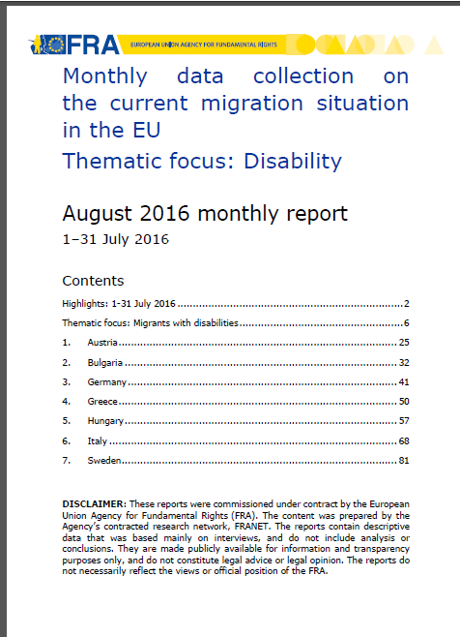 | Monthly data collection on the current migration situation in the EU  Thematic focus: Disability  August 2016 | Persons with disabilities make up around 15% of the global population, and comprise a significant minority of refugees and migrants. In addition to pre-existing physical, sensory, intellectual or psychosocial impairments, people may acquire or develop impairments during the migration process. When identified, these impairments place an obligation on Member States to provide specific support throughout the arrival, registration and asylum process. This thematic focus explores practices in four areas crucial to persons with disabilities and victims of torture in the current migrant situation | en
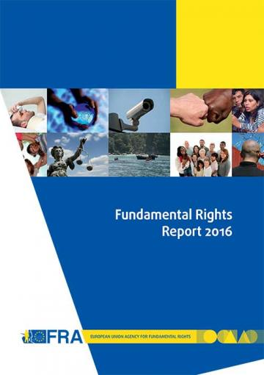 | Fundamental Rights Report 2016  Chapter 8: developments in the implementation of the Convention on the Rights of Persons with Disabilities  May 2016 | Five years on from the EU’s accession to the Convention on the Rights of Persons with Disabilities (CRPD), for the first time in 2015 a United Nations (UN) treaty body, the Committee on the Rights of Persons with Disabilities (CRPD Committee), reviewed the EU’s fulfilment of its human rights obligations. In its concluding observations, the CRPD Committee created a blueprint for the additional steps required for the EU to meet its obligations under the convention. At national level, the CRPD is driving wide-ranging change processes as Member States seek to harmonise their legal frameworks with the convention’s standards. | en  (summary en – fr)
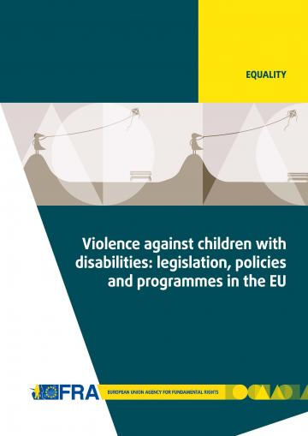 | Violence against children with disabilities: legislation, policies and programmes in the EU  December 2015 | The report outlines relevant international and European standards and reviews national legislation and policies addressing violence against children with disabilities. The report also explores the extent and different causes, settings and forms of such violence, and presents measures and initiatives to prevent it. | en
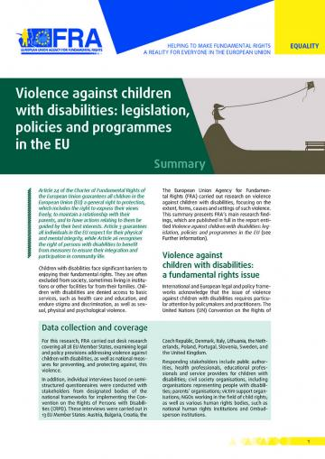 | Summary report:  Violence against children with disabilities: legislation, policies and programmes in the EU  December 2015 | This summary report presents the main research findings identified in the FRA report on Violence against children with disabilities: legislation, policies and programmes in the EU. The report gives a short summary of the key findings and outlines 10 key areas where policymakers and relevant stakeholders should concentrate their efforts to fight violence against children with disabilities, and to effectively protect them from abuse and exclusion across the EU. | bg - cs - da - de - en - fr - hr - it - lt - nl - pl - pt - sl - sv  (et - el - es - lv - hu - ro - sk - fi)
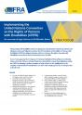 | Implementing the UN CRPD: An overview of legal reforms in EU Member States  May 2015 | The Focus paper outlines how Member States across the EU have reformed their laws and policies to meet their obligations under the CRPD. By bringing together examples of such reforms, it also highlights how the adoption of international commitments can drive wide-ranging processes of change at the national level. | en
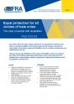 | Equal protection for all victims of hate crime - The case of people with disabilities  March 2015 | The paper discusses the difficulties faced by people with disabilities who become victims of hate crime, and the different legal frameworks in place to protect such victims in the EU’s Member States. It ends by listing a number of suggestions for improving the situation at both the legislative and policy levels. | en
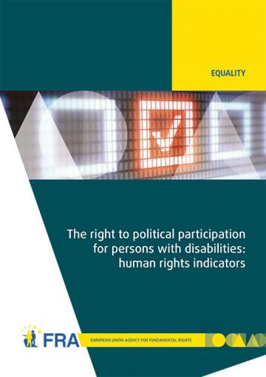 | The right to political participation for persons with disabilities: human rights indicators  May 2014 | The opportunity to be involved in political life, whether by standing for elected office, joining a political party, or following political news stories in the media, is at the heart of what it means to live in a democratic society. The report analyses data on the situation of political participation of persons with disabilities collected from across the 28 EU Member States by the FRA and the European Commission-funded Academic Network of European Disability Experts (ANED).  Data visualisation of the 28 human rights indicators is also available online. | en
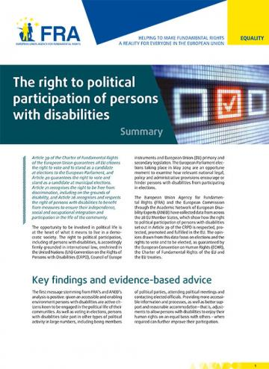 | Summary report:  The right to political participation of persons with disabilities  May 2014 | The human rights indicators presented in the report show that legal and administrative barriers, inaccessible processes and information, and a lack of awareness about political rights can deny persons with disabilities the opportunity to participate in the political lives of their communities. | bg - cs - da - de - en - et - el - es - fr - hr- it - lv - lt - hu - nl - pl - pt - ro - sk - sl - fi - sv
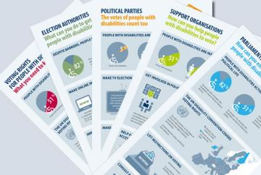 | Infographics on voting rights of people with disabilities  September 2014 | FRA has developed a family of five infographics to help raise awareness of the voting rights of people with disabilities. Each infographic targets a different audience and draws on FRA research into the right to political participation of people with disabilities. | bg - cs - da - de – en - et - el - es - fr - hr- it - lv - lt - hu - nl - pl - pt - ro - sk - sl - fi - sv
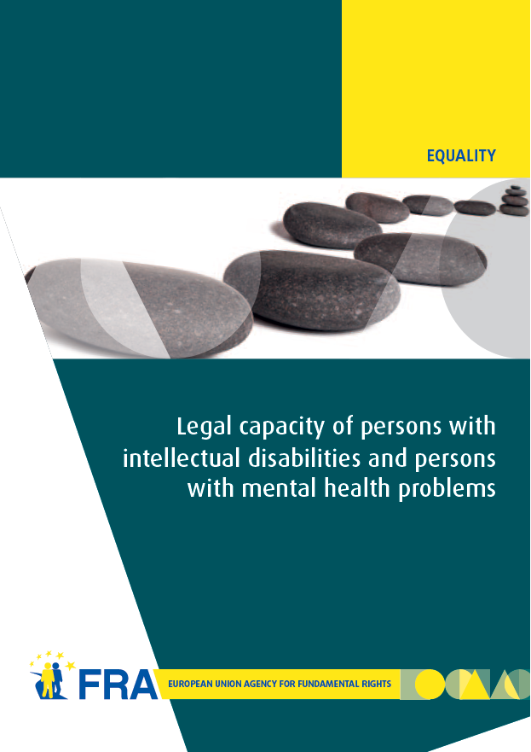 | Legal capacity of persons with intellectual disabilities and persons with mental health problems  July 2013 | Equal recognition of persons before the law is a long-established human rights principle. Nevertheless, legal frameworks in many European Union (EU) Member States allow for the legal capacity of persons with intellectual disabilities and persons with mental health problems to be restricted or removed under certain conditions.  This report analyses the current legal standards on legal capacity across the EU, set against the backdrop of the experiences of interviewees who have had their legal capacity removed or restricted. The FRA report reveals the gap between the promise of the CRPD and the reality those with disabilities face in the EU every day, and, by so doing, hopes to contribute to closing it. | en - de - fr
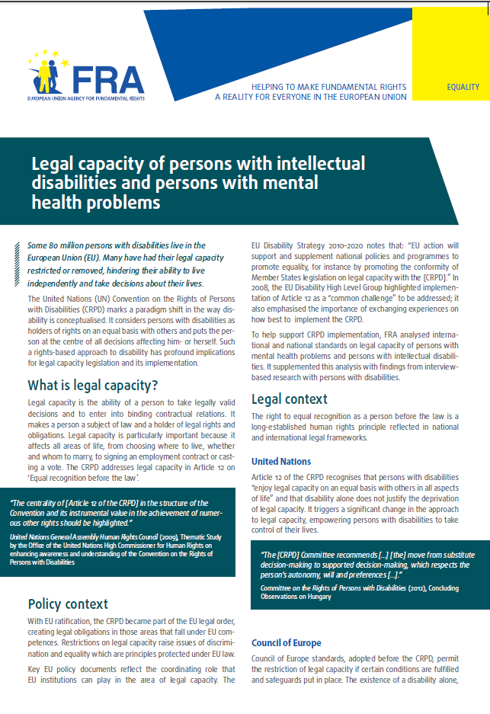 | Factsheet:  Legal capacity of persons with intellectual disabilities and persons with mental health problems  October 2013 | This factsheet presents the key challenges identified by the FRA report on Legal capacity of persons with intellectual disabilities and persons with mental health problems.  The entry into force of the CRPD has prompted discussions about the current legal frameworks governing legal capacity in the EU Member States, aiming at developing models based on supported decision making which promote the independence and autonomy of persons with disabilities. | bg - cs - da - de - en - et - el - es - fr - hr- it - lv - lt - hu - nl - pl - pt - ro - sk - sl - fi - sv
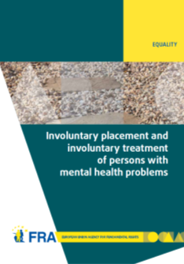 | Involuntary placement and involuntary treatment of persons with mental health problems  June 2012 | Involuntary placement and involuntary treatment of persons with mental health problems affects the most fundamental of rights, including the right to liberty and the right to freedom from torture. Strict safeguards at United Nations and European level attempt to limit undue interference with such rights.  This report analyses the shifting legal panorama and, informed by fieldwork in nine EU Member States on the actual experiences of those involuntarily placed and treated and other stakeholders, points to the need for a renewed discussion of compulsory placement and treatment in the EU. | en - de - fr
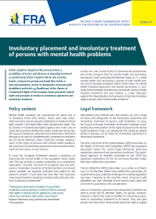 | Factsheet:  Involuntary placement and involuntary treatment of persons with mental health problems  June 2012 | This factsheet presents the key challenges identified by the FRA report on Involuntary placement and involuntary treatment of persons with mental health problems. Mental health problems are experienced by about one in 10 European Union (EU) citizens. Many seek help voluntarily, but some may be placed in institutions or treated without their consent. This might affect their fundamental rights. | en - bg - da - de - el - fr - hu - lv - ro - sv
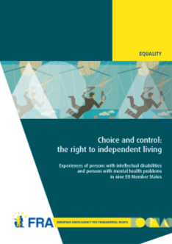 | Choice and control: the right to independent living  June 2012 | Article 19 of the United Nations Convention on the Rights of Persons with Disabilities establishes the right to live independently and be included in the community. Drawing on the findings of interview-based research with persons with mental health problems and persons with intellectual disabilities, this report examines how they experience the principles of autonomy, inclusion and participation in their day-to-day lives. | en - fr - de
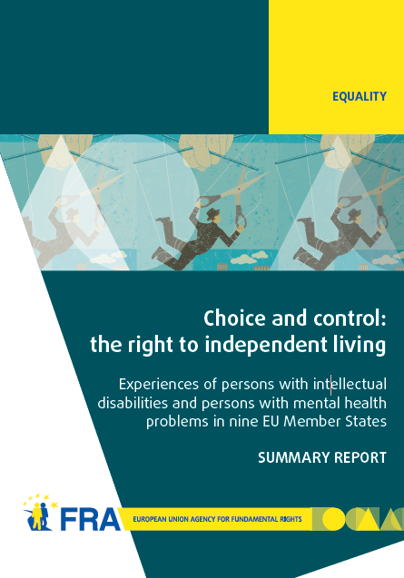 | Summary report: Choice and control: the right to independent living  June 2012 | This summary report presents the key findings identified in the FRA report on Choice and control: the right to independent living. The results show that although much has been done, more efforts are needed to ensure that persons with mental health problems and persons with intellectual disabilities have more choice and control over their lives and are included in the community on an equal basis with others. | en - da - el
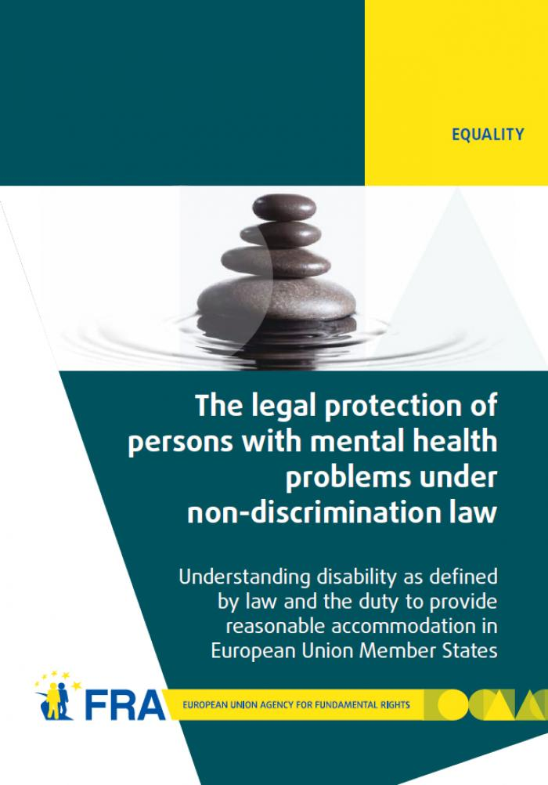 | The legal protection of persons with mental health problems under non-discrimination law  October 2011 | The report examines how disability is defined in international and European law and then explores the obligation to provide reasonable accommodation as contained in international and European standards. The report's findings show that in almost all EU Member States non-discrimination legislation does indeed protect persons with mental health problems. In most cases persons with mental health problems also benefit from reasonable accommodation measures, or other protection measures, in the employment context. | en - de - fr - da
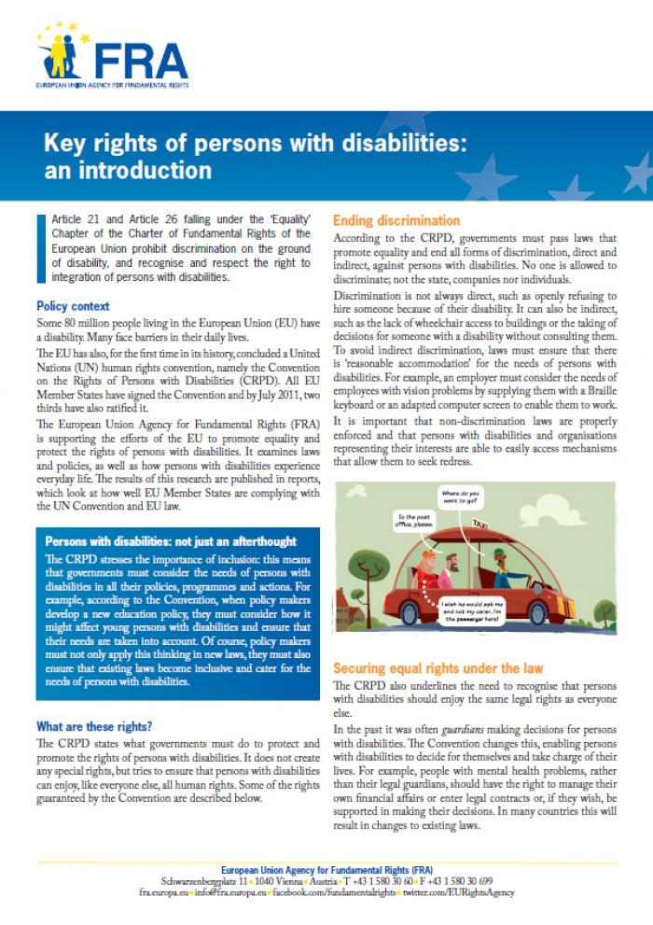 | Factsheet:  Key rights of persons with disabilities: an introduction  August 2011 | This factsheet describes some of the existing rights of people with disabilities, as set out under the UN Convention on the Rights of Persons with Disabilities (CRPD). The factsheet focuses in particular on ending discrimination, equal recognition by law, access to justice, the prevention of inhumane treatment, independent living and the right to political participation. | en - bg - de - el - fr - hu - lv - ro - sv
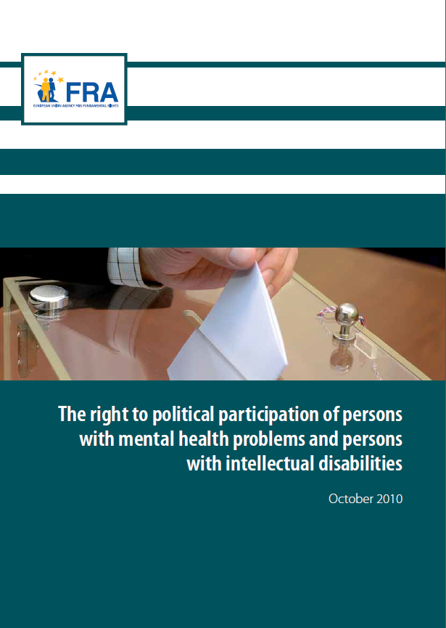 | The right to political participation of persons with mental health problems and persons with intellectual disabilities  November 2010 | This report first recalls the international and European standards favouring the full participation of persons with intellectual disabilities and persons with mental health problems in the electoral process. The comparative law analysis then highlights the diverse approaches adopted in the EU Member States. In a majority of these, persons who have lost their legal capacity are automatically deprived of their right to political participation. | en  de - fr  non-verified language versions:  bg - cs - da - et - el - es - ga - hr- it - lv - lt - hu - mt - nl - pl - pt - ro - sk - sl - fi - sv
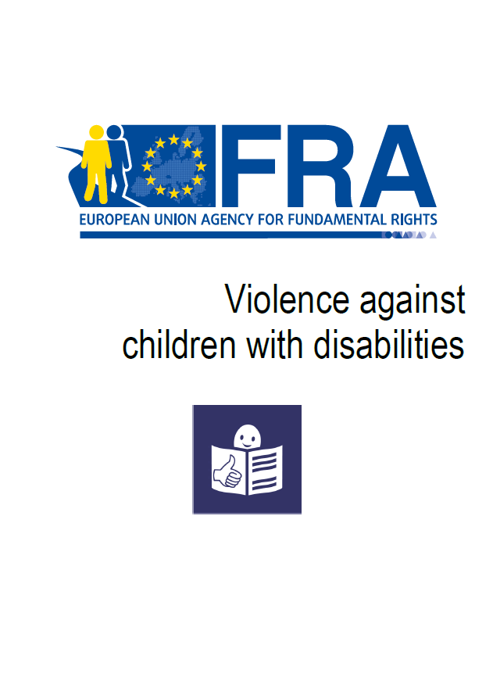 | EASY READ  Violence against children with disabilities  December 2015 | This summary in easy read format looks at violence, where it happens, and why people are violent. It also looks at laws to protect children with disabilities from violence and what countries are doing to prevent this violence. | en
 | EASY READ  Laws about being able to make important decisions for yourself  October 2013 | This summary in easy read format provides information about FRA’s work on the right to equal recognition before the law. | en - de - fr
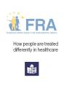 | EASY READ  How people are treated differently in healthcare  March 2013 | This summary in east read format provides information about FRA’s work on how people might be treated differently in healthcare and on multiple discrimination in healthcare. | en
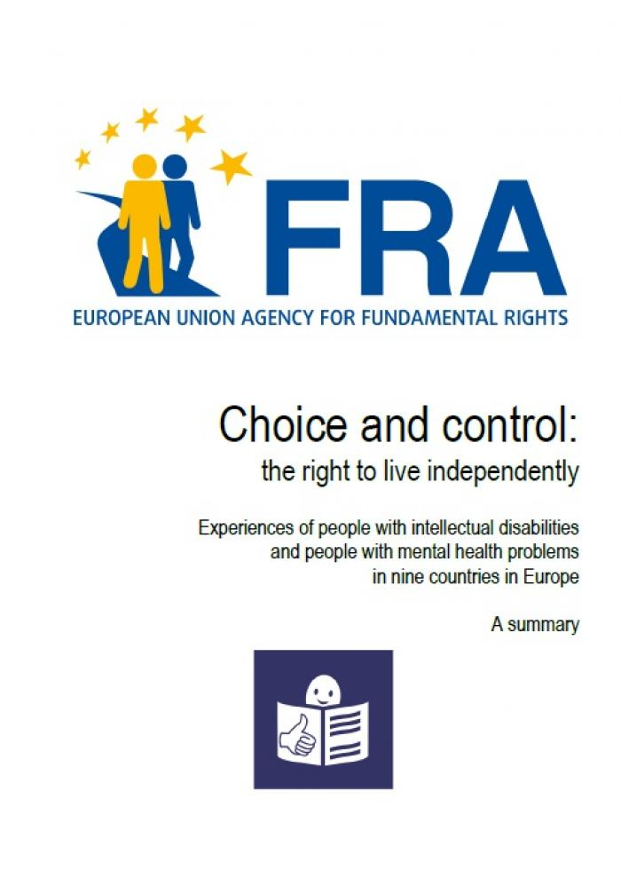 | EASY READ  Choice and control: the right to live independently - Experiences of people with intellectual disabilities  June 2012 | This summary in easy read format provides information about FRA’s work on the right to live independently. | en
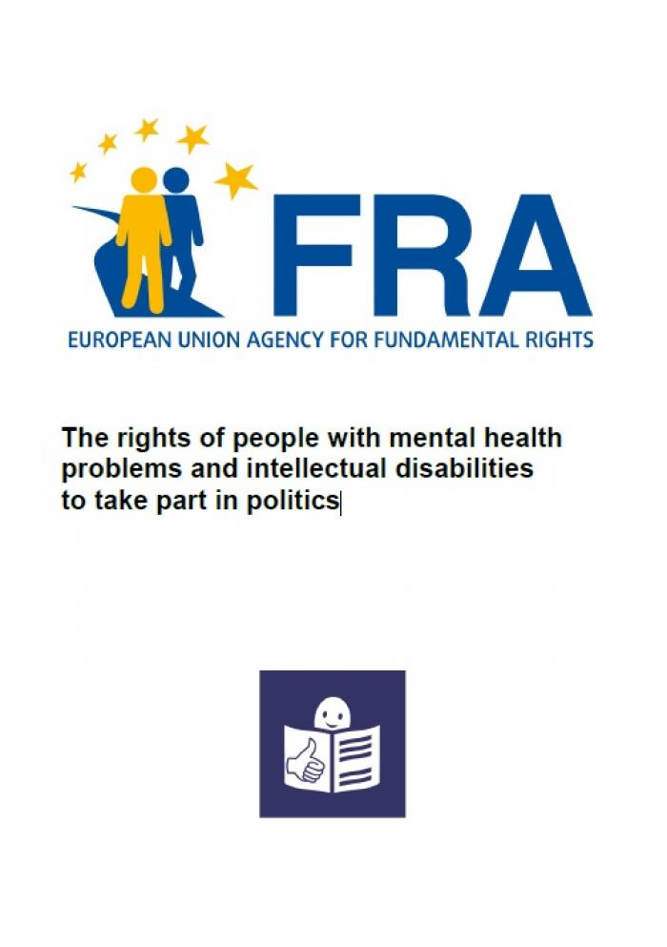 | EASY READ  The rights of people with mental health problems and intellectual disabilities to take part in politics  November 2010 | This summary in easy read format provides information about FRA’s work on the right to vote of persons with intellectual disabilities. | en

ECtHR, Glor v. Switzerland, No. 13444/04, 30 April 2009.
ECtHR, Glor v. Switzerland, No. 13444/04, 30 April 2009; ECtHR, Pretty v. the United Kingdom, No. 2346/02, 29 April 2002.
ECtHR, Artico v. Italy, No. 6694/74, 13 May 1980, para. 33.
ECtHR, Nenov v. Bulgaria, No. 33738/02, 16 July 2009

