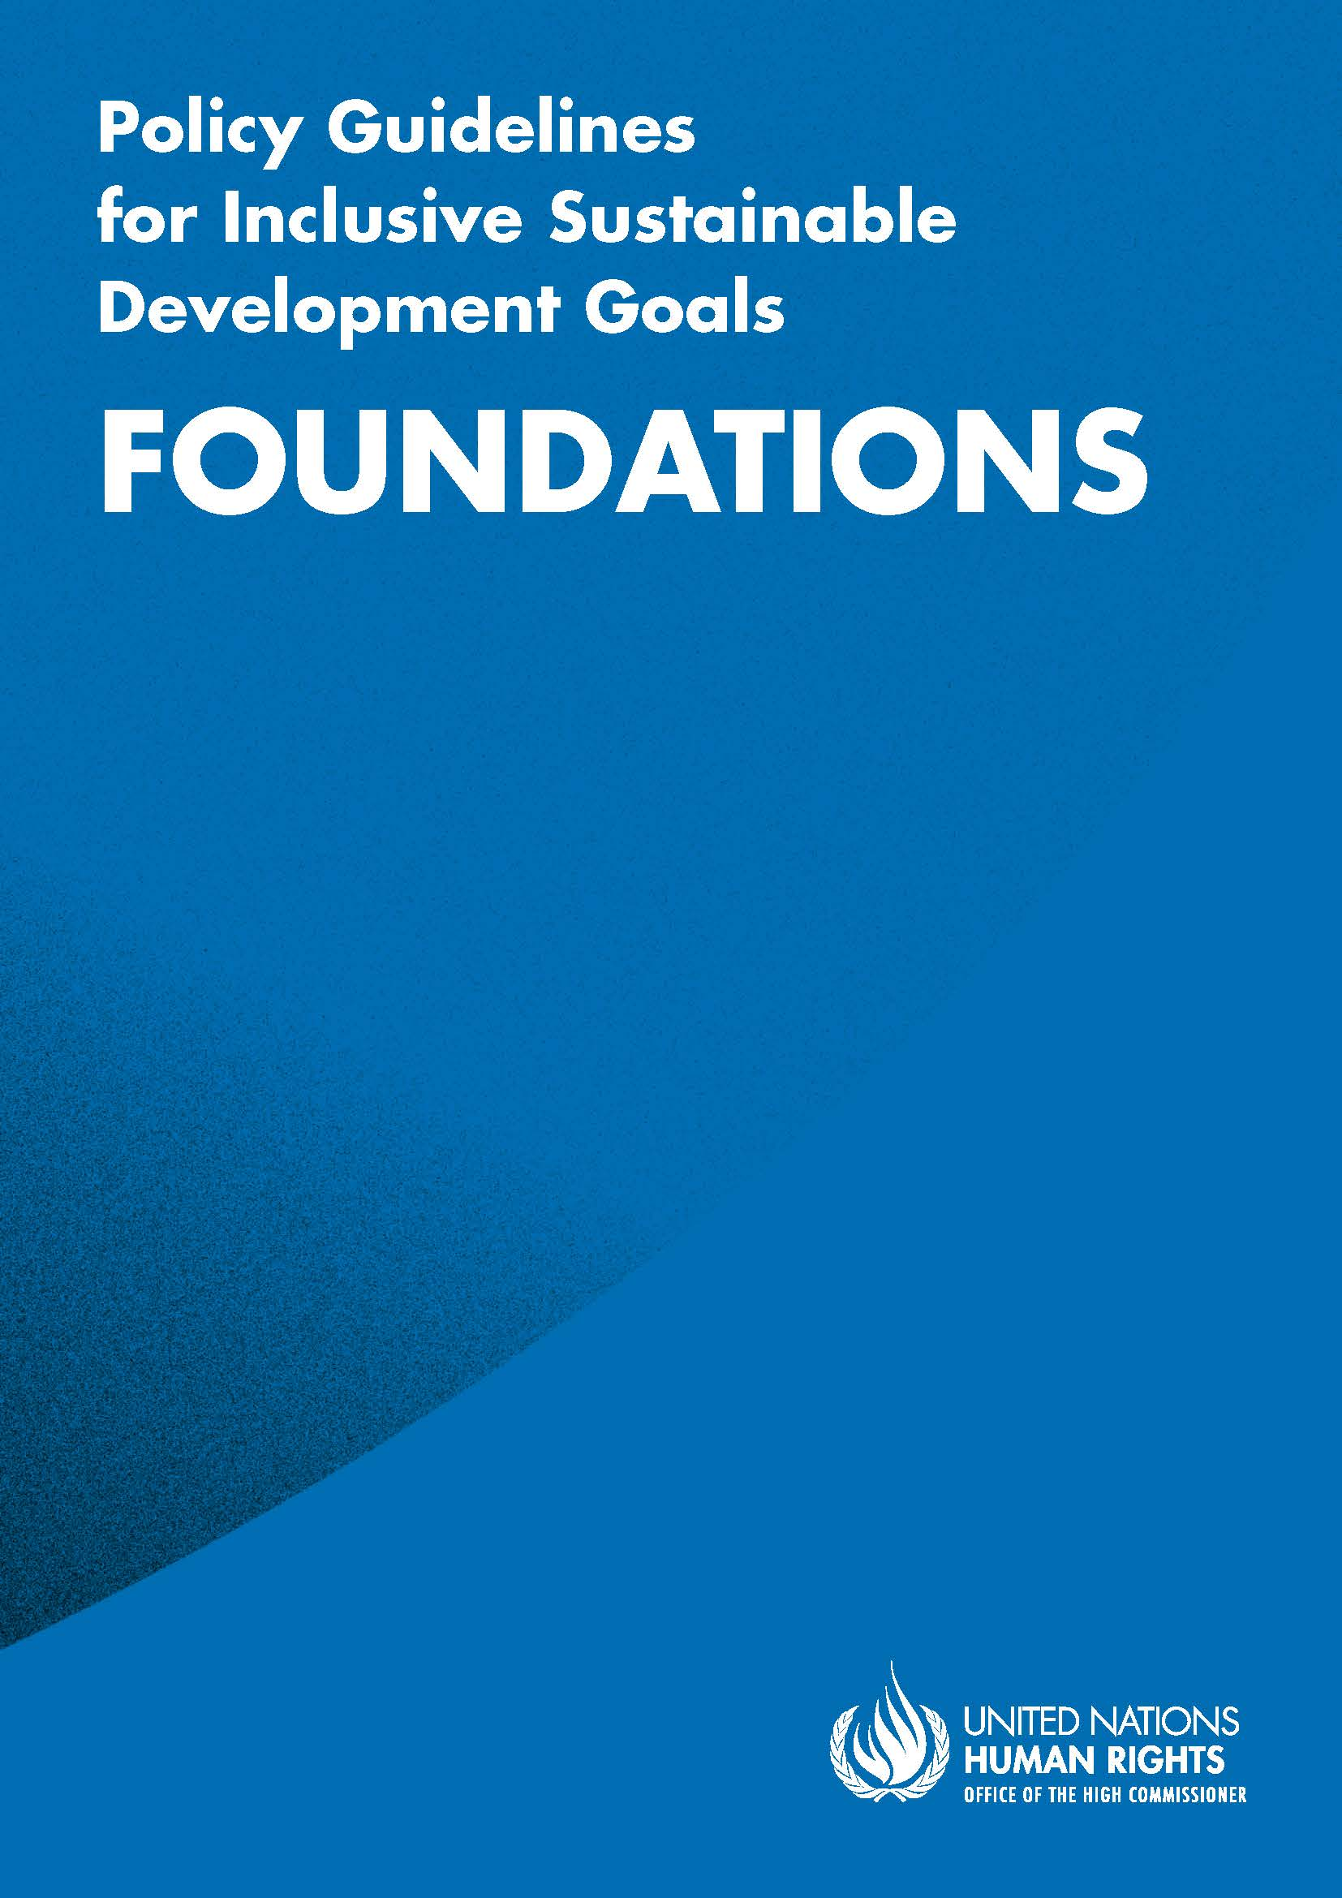

ADVANCE VERSION
© 2020 United Nations
The Policy Guidelines for Inclusive Sustainable Development Goals are a component of the SDG- CRPD Resource Package, developed by the Office of the United Nations High Commissioner for Human Rights (OHCHR). This is an advance version of the SDG-CRPD Resource Package. A final version will be issued upon completion of OHCHR review processes.
The designations employed and the presentation of the material herein do not imply the expression of any opinion whatsoever on the part of the Secretariat of the United Nations concerning the legal status of any country, territory, city or area, or of its authorities, or concerning the delimitation of its frontiers or boundaries.
Symbols of United Nations documents are composed of capital letters combined with figures. Mention of such a figure indicates a reference to a United Nations document.
Photography by Christian Tasso. The photographs featured within the Policy Guidelines were taken as part of the European Union project, Bridging the Gap II – Inclusive Policies and Services for Equal Rights of Persons with Disabilities, and were produced with the financial support of the European Union. They appear courtesy of the International and Ibero-American Foundation for Administration and Public Policies.
The Policy Guidelines for Inclusive Sustainable Development Goals were produced with the financial support of the European Union. Its contents are the sole responsibility of OHCHR and do not necessarily reflect the views of the European Union.

Key concepts and structural requirements to create an enabling legal, policy and programming environment
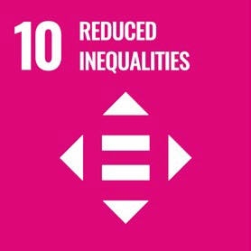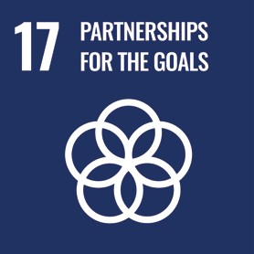

Contents
Introduction 7
Section I: Key concepts from the Convention on the Rights of Persons with Disabilities 7
1. The human rights model of disability 7
1.1 What is disability? 8
1.2 Who is protected by the Convention on the Rights of Persons with Disabilities? 9
1.3 The paradigm shift – what we leave behind 9
1.4 Principles of a rights-based approach to disability inclusion 10
2. Core pillars for all policies 12
2.1 Non-discrimination 12
2.2 Accessibility 15
2.3 Support for persons with disabilities: Assistive technology and support services 16
2.4 Participation 19
2.5 Awareness-raising 20
Section II: Structural requirements to create an enabling legal, policy and programming environment (SDG 10, 16, 17) 21
What is included in this section? 21
3. Governance 22
3.1 Institutional setup for good governance inclusive of persons with disabilities 22
3.2 Results-based strategic planning for policy implementation 23
3.2.1 Twin-track approach 23
3.2.2 Disability assessment and determination as a tool for policymaking 24
3.2.3 Using multi-stakeholder partnerships to achieve strategic objectives 26
3.3 Finance & budget 27
3.3.1 Rights-based budgeting 27
3.3.2 Disability markers 28
3.4 Public procurement 30
3.5 Data collection and disaggregation by disability 31
4. Participation of persons with disabilities in public life 33
4.1 Ensure responsive, inclusive, participatory and representative decision making at all levels 33
4.2 Ensuring the right to vote of persons with disabilities 34
5. Legislation and policy for equality and non-discrimination of persons with disabilities 35
5.1 Inequality and discrimination experienced by persons with disabilities 35
5.2 Putting non-discrimination into practice: Reasonable accommodation 36
5.3 Putting non-discrimination into practice: Addressing diversity and identity 38
5.4 Putting non-discrimination into action: Specific measures 40
5.5 Legal capacity of persons with disabilities 41
6. Accountability and monitoring 44
6.1 Access to information 44
6.2 Accountability and complaints mechanisms 45
6.3 National Human Rights Institutions 46
6.4 Access to justice of persons with disabilities 49
7. Capacity building 51
8. International cooperation 52
9. Additional Resources 54

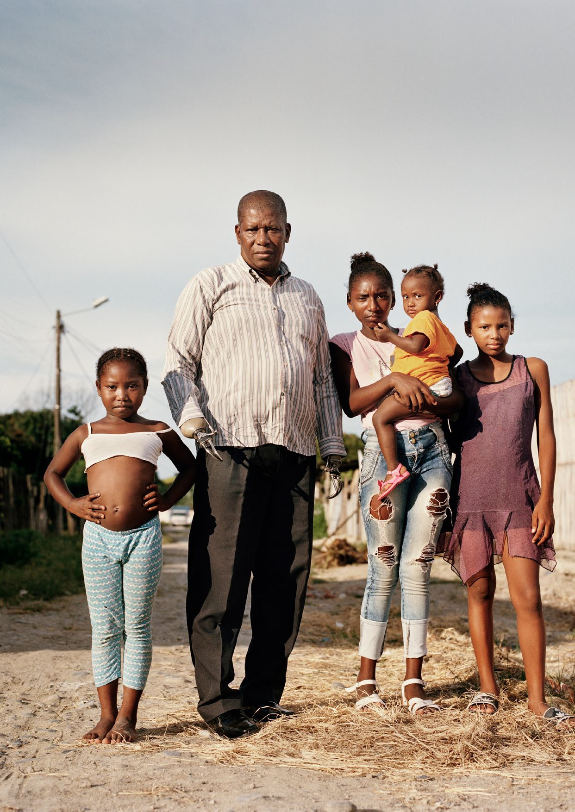

Introduction
To implement a rights-based, disability-inclusive 2030 agenda, key human rights concepts must be applied. The Sustainable Development Goals (SDG) provide us with goals and targets and the Convention on the Rights of Persons with Disabilities (CRPD) provides guidance for how to meet those goals and targets to ensure persons with disabilities are not left behind. This guideline underpins all other sector-specific guidelines by outlining two main areas:
- Section I: explains the human rights model of disability and key concepts that underpin a rights-based approach to disability-inclusive development.
- Section II: explains how to implement general requirements and foundations for the inclusion of persons with disabilities, and considers the structural requirements that enable the implementation of all the Sustainable Development Goals.
It is recommended that this guideline is read prior to the sector-specific guidelines. Concepts explained here are assumed knowledge within the sector-specific guidelines, which build on these concepts and apply them in sector-specific ways.

Section I: Key concepts from the Convention on the Rights of Persons with Disabilities

1. The human rights model of disability
The Convention on the Rights of Persons with Disabilities (2006) enshrines the human rights model of disability. It provides a framework to promote and protect the rights of persons with disabilities and foster inclusion, through respect for difference and recognition of human diversity as a part of humanity.
The Convention had an impact on the negotiations and adoption of the Sustainable Development Goals (SDGs) in 2015 and supported the principle of ‘leaving no-one behind’, which is firmly embedded in the goals. In contrast to the Millennium Development Goals, persons with disabilities are explicitly considered and referenced in the SDGs. The SDGs and the CRPD reinforce each other. The CRPD provides a human rights perspective to the inclusion of persons with disabilities in the implementation of the SDGs. In addition, it outlines the ways in which governments can remove barriers and promote the inclusion and participation of persons with disabilities in development.

1.1 What is disability?
A human rights approach to disability
The CRPD (preamble (e)) says:
…disability is an evolving concept and that disability results from the interaction between persons with impairments and attitudinal and environmental barriers that hinders their full and effective participation in society on an equal basis with others.
This recognises disability as a restriction in participation. The reduction in participation results from persons with impairments experiencing barriers in the environment around them.
This inter-relational way of describing how disability works is known as the “human rights model of disability”.
Barriers can be broadly categorised into the following:
- Environmental barriers: those that are imposed by the context and that can be sub-categorized as:
- Physical barriers: such as the presence of steps, preventing access for someone using a wheelchair or others with mobility difficulties.
- Communication barriers: such as the barriers to participation for a sign language user in a meeting, if sign language interpreters are not provided, or the barrier to accessing information experienced by blind persons when written text is not provided in accessible formats.
- Policy barriers: such as educational systems that prevent the enrolment of children with disabilities in their local school.
- Attitudinal barriers: such as the belief that persons with disabilities cannot learn or work. Attitudinal barriers are particularly pervasive and disabling, as they can lead to apathy towards addressing the other barriers.
In order to allow persons with disabilities to fully participate and access opportunities for development, the barriers that limit the participation of persons with disabilities should be systematically addressed. Persons with disabilities themselves are experts on identifying the factors which prevent full participation and in coming up with solutions to overcome them.
figure i
Understanding of disability under the human rights model
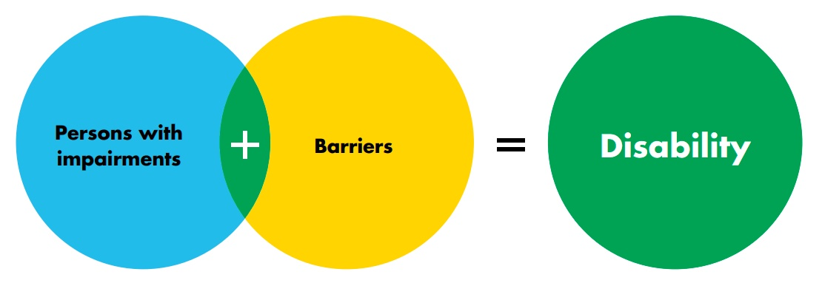

1.2 Who is protected by the Convention on the Rights of Persons with Disabilities?
The Convention primarily protects persons with disabilities against exclusion from participation. It defines persons with disabilities as follows (CRPD, article 1):
Persons with disabilities include those who have long-term physical, mental, intellectual or sensory impairments which in interaction with various barriers may hinder their full and effective participation in society on an equal basis with others.
This group is defined openly, without providing a list of specific impairments, hence giving broad protection to persons with an array of impairments, whether actual (connected to a health condition) or perceived (a characteristic that is considered an impairment).
The impairments referred to in the CRPD are usually well represented in law and policy. Nevertheless, certain parts of the population are commonly overlooked. Policymakers should ensure consideration of underrepresented constituencies, such as persons who are deafblind; persons with impairments arising from rare medical conditions; persons with psychosocial disabilities; persons with autism; persons with developmental disabilities; persons with albinism; among others. Representation of women and girls should also be ensured within all underrepresented constituencies.
The CRPD also protects persons who do not have an impairment but are, nevertheless, affected by disability-based discrimination as a consequence of their association with a person with disability –e.g. a parent who is dismissed from work or treated less favourably because they have a child with disability. To protect persons from discrimination based on disability, governments should adopt a similar approach.

1.3 The paradigm shift – what we leave behind
The CRPD describes disability as an evolving concept. Over the years, the participation of persons with disabilities has been explained in different ways, affecting how disability is understood.
Historically, underlying values and beliefs have mainly been reflected through two perspectives:
    - The medical model of disability. This approach sees persons with impairments as sick or subjects of rehabilitation. It conditions participation to being rehabilitated or “fixed”, to meet societal norms and to fit back into society.
    - The charity model of disability. This approach sees persons with impairments as objects of benevolence who cannot take care of themselves. It conditions participation to receiving “help” or charity.
Both of these models focus on the individual and require changing them to meet societal demands, as opposed to society eliminating barriers for them to participate in recognition of human diversity.
Following the medical and charity approaches, policymakers have limited or no responsibility and those responsible (such as charities or medical experts) have a stronger voice to decide over the lives of persons with disabilities than persons with disabilities themselves.
These perspectives continue to exist in policies and need to be identified and changed to reflect the human rights model of disability.
 Underlying value systems: ableism
The reason the human rights model of disability is such a paradigm shift is that it challenges the discriminatory value systems which underlie medical and charity approaches to disability, such as “ableism”.
What is ableism?
Ableism considers “certain typical characteristics of body and mind as essential for living a life of value”(Special Rapporteur on the rights of persons with disabilities, A/HRC/43/41, para. 9). Having an impairment is different from the desired standards of appearance, behaviour and functioning. This leads to the lives and experiences of persons with disabilities being less valued and results in prejudice, discrimination and exclusion. Ableism is usually behind negative perceptions and stereotypes about persons with disabilities. It causes an unconscious bias, similar to unconscious biases related to gender or race.
This value system, which assumes the lives of persons with disabilities are of less value, leads to stigma and significant discrimination including, for example, segregation, forced sterilization, deprivation of liberty, denial of legal capacity or the failure to consider persons with disabilities as credible experts on their own lives.
In this way, ableism is to persons with disabilities as what racism, sexism and xenophobia are to persons of ethnic minorities, women and foreigners/migrants, respectively. Each of these “-isms” give less value to certain persons when compared to others. While some advances have been made in recognising and calling out racism, sexism and xenophobia in society today, there is little awareness on ableism and its discriminatory consequences.
Racism | Considers persons as inferior on the basis of race, legitimizing discrimination
Sexism | Assigns women stereotypical roles and legitimizes their exclusion from other roles, discrimination, and violence
Xenophobia | Promotes and justifies discrimination of foreigners
Ableism | Assigns less value to the life of persons with disabilities and legitimizes discrimination
See the video on ableism developed by the Special Rapporteur on the rights of persons with disabilities.

1.4 Principles of a rights-based approach to disability inclusion
Applying the human rights model of disability in policy requires a human rights approach to disability.
A human rights approach to policy development requires participation, accountability, non- discrimination and empowerment and is rooted in the legal standards set by the CRPD. These guidelines describe these dimensions, as applied to persons with disabilities.
To support this process, the CRPD outlines eight overarching principles which, in addition to supporting the interpretation of the CRPD, facilitate the implementation of the SDGs. These principles are useful to verify if a policy is rights-based. When these principles are referred to in other parts of the guidelines, hyperlinks are provided.
table 1
General Principles
Principle | Policy application examples
a. Respect for inherent dignity, individual autonomy (including the freedom to make one’s own choices) and independence of persons with disabilities | Laws, policies and programmes should enable persons with disabilities to make their own choices, as their peers do. Policies which limit the choices of persons with disabilities, or promote others making decisions on behalf of persons with disabilities, are not in line with a rights-based approach. For example, skills training programmes which limit persons with disabilities to only three possible vocations, while others can access a wide variety of vocational training, are not rights-based.
b. Non-discrimination | Persons with disabilities should be able to access services and programmes as their peers do. If reasonable accommodation is required to enable this, not providing it would be discriminatory. If specific actions are required to close the gap between persons with disabilities and the broader population, these are not considered to be discrimination.
c. Full and effective participation and inclusion in society | Laws, policies and programmes should promote inclusion and participation, not segregation and exclusion (e.g. segregated housing, education, employment).
d. Respect for difference and acceptance of persons with disabilities as part of human diversity and humanity | Laws, policies and programmes should celebrate human diversity and not promote ableist attitudes. For example, persons with disabilities should be regularly portrayed positively as members of their community, not as victims of tragedy or inspirational figures.
e. Equality of opportunity | Persons with disabilities should get the same opportunities as others; to enable this, non-discrimination measures, including reasonable accommodation, accessibility and support measures, should be in place.
f. Accessibility | To enable participation, persons with disabilities need to be able to access the environment, transportation, information and communications, as well all the facilities and services open to the public. Actions which do not promote accessibility and contribute to the perpetuation of further barriers and inaccessibility (e.g. building of new inaccessible infrastructure, creation of inaccessible ICTs) are not rights-based.
g. Equality between men and women | A rights-based approach also considers gender inequalities and recognises the right to full participation for all genders. Persons with disabilities of all genders have different experiences and may require different policy and programming solutions.
h. Respect for the evolving capacities of children with disabilities and respect for the right of children with disabilities to preserve their identities | Children with disabilities should be respected and given the same rights as other children. Children with disabilities have the right to their own identity and should not be expected to conform to prevailing notions of what is ‘normal’. For example, a deaf child should be supported to identify with Deaf culture and their Deaf identity.

2. Core pillars for all policies
This section describes five core pillars that are necessary to construct an inclusive policy framework. These should also be considered in the design and implementation of any public policy or programme:
- Non-discrimination: a non-discrimination framework which prohibits discrimination across all areas of life and ensures that reasonable accommodation is available to persons with disabilities is essential.
- Accessibility: involves addressing and preventing barriers which restrict the participation of persons with disabilities.
- Support for persons with disabilities (assistive technology and support services) allows them to benefit from policies and programmes alongside their peers and partially remedies limitations in accessibility.
- Participation of persons with disabilities ensures that their valuable expertise and experiences shape policy and programmes, to ensure the most effective solutions.
- Awareness-raising for and about persons with disabilities contributes to combating negative stereotypes and promotes knowledge about, and respect for, their rights and dignity.
Each SDG-specific guideline has a general section with actions applicable across all targets, in which these core pillars are reflected. In addition, certain targets will also have references to these core pillars, when they are of essential importance to the target. The concepts are further explained below.

2.1 Non-discrimination
Discrimination on the basis of disability (CRPD, article 2)
The CRPD (article 2) describes discrimination on the basis of disability as:
Any distinction, exclusion or restriction on the basis of disability which has the purpose or effect of impairing or nullifying the recognition, enjoyment or exercise, on an equal basis with others, of all human rights and fundamental freedoms in the political, economic, social, cultural, civil or any other field. It includes all forms of discrimination, including denial of reasonable accommodation.
This means that persons with disabilities need to be able to access and enjoy the full range of human rights, including legal recognition and protection and access to services and programmes, on an equal basis with others. Due to the range of barriers which prevent full access and participation, reasonable accommodation must be provided to individuals who require it. Denial of reasonable accommodation is considered discrimination.
Reasonable accommodation
“Reasonable accommodation” refers to modifications or adjustments made for a person with disability who requires them in a particular case, to facilitate participation on an equal basis with others.
Reasonable accommodation must be provided on demand, that is, entities responsible for providing it cannot deny it by saying that they are progressively implementing it. If arbitrarily denied, this constitutes discrimination.
“Reasonable accommodation” has legal and technical implications that should be considered in developing legal and regulatory frameworks. In practice, however, most “reasonable accommodations” are simple and practical measures, with low costs, that demand only some flexibility. Furthermore, facilities, procedures and services that are accessible reduce the need for reasonable accommodation. For more information, see the Committee on the Rights of Persons with Disabilities General Comment No. 6 (2018) on equality and non-discrimination.
 Examples of reasonable accommodation in different areas of life:
- A person with disability is granted permission to start the school or working day 1 hour later than others, to have more time in the morning to prepare.
- A blind employee requests screen reader software for their work computer, to perform the core functions of the job. The employer buys the software for the employee.
- A deaf person requires sign language interpretation to participate in some work meetings, as their hearing colleagues do not sign and, whilst they can lip read, this is too difficult in large groups. The employer provides an interpreter for meetings.
- A wheelchair user requires that a removable ramp is provided to enter an otherwise inaccessible public building, e.g. courts or tribunals; staff ensure that the removable ramp is in place.
For more on how to provide reasonable accommodation, including determining what is “reasonable” see “How to determine what is reasonable?” in Section II.
How does reasonable accommodation differ from accessibility?
Table 2 compares and contrasts reasonable accommodation and accessibility.
table 2
 Reasonable accommodation versus accessibility
Reasonable accommodation | Accessibility
Reasonable accommodation is an individual modification or adjustment of existing structures and practices for a person with disability. | Accessibility is a general provision that the built environment, transportation, information and communication should be able to be accessed by all persons, including persons with disabilities. It draws upon universal design principles.
Must be implemented immediately to avoid discrimination. | Can be implemented gradually.
Applies to an individual upon demand (e.g. removable ramp used in a particular situation). | Applies to all people and is part of the structure or system (e.g. designing or reforming the building using universal design principles, such as installing permanent ramps).

Is limited by proportionality - i.e. what is “reasonable” - (e.g. if the accommodation risks bankruptcy of a small business, it is disproportional). | Is unconditional (e.g. if legislation indicates how a building must be designed, it must comply with existing construction rules for accessibility without a proportionality assessment).
Sometimes reasonable accommodation and accessibility are confused because reasonable accommodation can be used as a means of ensuring accessibility for an individual with disability in a particular situation. It may also benefit a collective of persons with disabilities at the same time. For example:
 A wheelchair user approaches a restaurant. As it has 2 steps at the entrance, the restaurant is inaccessible. However, the person calls the waiter who, noticing the barrier, comes carrying a removable ramp and places it to allow the person to enter. Once the person is in, the waiter picks up the ramp and stores it.
The built environment continues to be inaccessible to wheelchair users, as the restaurant still has 2 steps at its entrance. However, the restaurant provided the person with “reasonable accommodation” (by utilising a removable ramp), avoided incurring discrimination, ensured an accommodation that satisfied the individual demand and is prepared to provide such accommodation to other wheelchair users, which permits their access to the restaurant.
Multiple and intersecting discrimination
Persons with disabilities encompass a diverse group of people: people with different impairments; women; children and youth; older persons; living across urban, rural or remote areas; members of ethnic minorities; indigenous peoples; migrants; people coming from different social classes; LGBTIQ (lesbian, gay, bisexual, transgender, queer or intersex) persons; and persons being at one or more of the intersections of these identities.
Intersectional discrimination refers to situations where discrimination is occurring on the basis of multiple and intersecting factors, such as the ones listed above. While the concept sounds complex, in practice it means that people are not homogenous and experience discrimination and marginalisation in different and intersecting ways. A person with disability also has a gender identity, may come from an indigenous group and be young, old, a migrant or live in poverty. For example, a person with disability belonging to an ethnic minority may be overlooked for a job due to stigma about both their disability and ethnicity.
Women and girls with disabilities often face heightened barriers to accessing their basic human rights and are underrepresented in both women’s and disability movements. A woman with disability who experiences gender-based violence has to counter the stigma that most women face when reporting it. In addition, she may face communication and/or physical accessibility barriers, as well as further attitudinal barriers due to misperceptions of asexuality. This combination of factors compounds in a way that means that access to medical, psychological and legal support is severely restricted and that justice is often not reached.
Policymakers should be aware that persons have intersecting identities and may experience multiple forms of discrimination, which compound one another.

2.2 Accessibility
Accessibility is central to being able to live independently and participate fully in life. It is required to make sure persons with disabilities can access:
    - The physical environment
    - Transportation
    - Information and communication
    - Facilities and services open or provided to the public, in both urban and rural areas
Accessibility also applies to systems and procedures, to ensure that they are designed for equal access and participation of persons with disabilities. For example, physical access to schools and accessibility of communications in classrooms will have less impact on increasing the number of students with disabilities if registration procedures and admission tests are not accessible.
Whilst changes cannot be made overnight, governments are obligated to progressively improve accessibility over time. For example, through ensuring that all new buildings, ICT (Information and Communication Technologies) systems, transport systems, etc., are accessible. Procurement processes should reference accessibility requirements and standards. For more information, see Public Procurement in section II.
Increased accessibility will reduce the need for reasonable accommodation and some forms of live support. To improve accessibility over time, governments should develop, promote and monitor minimum standards and guidelines for the accessibility of facilities and services; regulate private facilities and services open to the public; raise awareness; and provide training. For more information see the Guidelines on SDG 11: Sustainable cities and communities, and the Committee on the Right of Persons with Disabilities General Comment No. 2 (2014) on Article 9: Accessibility.
The CRPD requires that accessibility is planned from the onset, using universal design principles. Designing ICT or other goods and services using universal design from the start reduces costs, which improves affordability, and supports the enhanced participation of persons with disabilities.

figure ii
Universal Design Principles
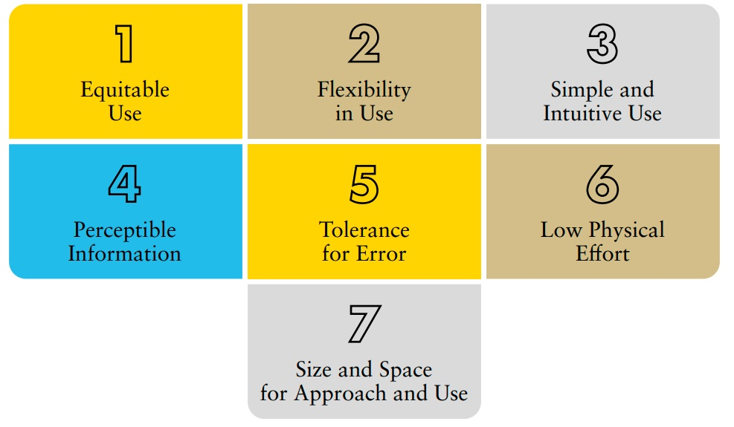

Source: Centre for Excellence in Universal Design, “The 7 Principles”, National Disability Authority, 2020.
These guidelines are complemented by a number of indicators that refer to accessibility under Article 9 of the CRPD (on accessibility), as well as under other articles.

2.3 Support for persons with disabilities: Assistive technology and support services
The Special Rapporteur on the rights of persons with disabilities stated (A/HRC/34/58 of 20 December 2016), on support for persons with disabilities:
Support for persons with disabilities encompasses a wide range of formal and informal interventions, including live assistance and intermediaries, mobility aids and assistive devices and technologies. It also includes personal assistance; support in decision-making; communication support, such as sign language interpreters and alternative and augmentative communication; mobility support, such as assistive technology or service animals; living arrangements services for securing housing and household help; and community services.
Persons with disabilities may also need support in accessing and using general services, such as health, education and justice.
Many persons with disabilities require support services and/or assistive technology to perform daily life activities and participate in society. Alongside non-discrimination and accessibility, support enables persons with disabilities to benefit equally from policies, programmes and services.
Prioritising support and assistive technologies contributes to inclusive implementation across many SDGs.
Assistive technology, products and services
“Assistive technology” is an umbrella term that comprises all systems and services related to the delivery of assistive products and services. More specifically, ‘assistive products’ are those designed to “maintain or improve an individual’s functioning and independence, thereby promoting their well- being” (World Health Organization, “Assistive Technology”, 18 May 2018), e.g. wheelchairs, canes, communication aids. Assistive technology contributes to the prevention of secondary impairments; reduction in the need for formal healthcare; and reduction in the need for live support services.
Related services include fitting, training (including habilitation and rehabilitation services), maintenance and repair services.
At the global level, the World Health Organization has developed the Priority Assistive Product List. In addition, the World Health Assembly has adopted, in 2018, the resolution “WHA 71.8” on “Improving access to assistive technology” and has urged governments to increase access to assistive technology through universal health care coverage and/or social services.
While relevant for most SDGs, policy recommendations in this area (which usually pertains to ministries of social welfare and health) are provided under specific sections on Goal 1 (No poverty) and Goal 3 (Good health and well-being). In addition, given the need for the continuous development and improvement of assistive technology, this will be addressed in a Thematic Brief on research and innovation.
Related CRPD indicators: 20.1, 20.2, 20.3, 20.11, 20.12, 20.19, 20.20, 20.21, 28.1, 28.20, 28.21, 28.27, 1/4.14, 1/4.27, 19.31
Support services for persons with disabilities
Interdependence is an intrinsic aspect of the human experience. Many persons with disabilities require human support to perform daily life activities. At this point, technology is not able to cover all areas of support for persons with disabilities, although accessibility and assistive technologies do reduce the need for human support – e.g. if a person with reduced mobility lives in inaccessible housing, they may require personal support; however, if they live in accessible housing their support needs would be greatly reduced.
Globally, the main sources of support are families and the broader immediate community, such as friends, schoolmates, co-workers and extended family. While solidarity among family members and communities should be encouraged, dependence that leads to negative living environments should not. Hence, persons with disabilities should have support options beyond solidarity networks.
Human support is the most basic form of support and, in certain contexts, the only type of support available - when that is the case, it should be considered a basic- and life-saving service.
Inadequate support increases the risk of neglect, violence and abuse, and may lead to living in segregated settings such as institutions. On the other hand, support services increase independence and the participation of persons with disabilities; and ensure no one is left behind.
Support is key to promote development. It enables the supported person to participate in development, provides employment prospects for people who provide support and frees up family members to pursue education and employment.
Some forms of support, related to civil and political rights, should be immediately provided, e.g. support to exercise legal capacity, to access justice and vote. Other types of support can be progressively implemented over time, using the maximum available resources, including international cooperation.
Categories and types of support
Persons with disabilities are diverse, as well as the barriers that affect them. Support aims at improving their individual autonomy and minimizing environmental barriers. Consequently, there are different types of supports, applicable in different contexts, for different people. Some examples of support, categorized by common barriers, are:
Mobility and physical barriers:
- Assistive products – wheelchairs, crutches
- Animal support – guide dogs
- Human support – personal assistants
Communication and accessibility barriers:
- Assistive products – ICT, smartphones, augmentative communication devices
- Human support – sign language and tactile interpreters, plain language support
Emotional- and self-management barriers:
- Assistive products – software to organize tasks, emergency caller
- Human support – peer-support, administrative support, emergency support
- Emotional support animals
Law and institutional barriers:
- Support for decision-making
- Support to vote
Support can be formal, that is, ruled by a contract or agreement (e.g. service provision), or informal (e.g. through family and friends).
It can be administered by the public sector (e.g. sign language interpreters provided by the Government) or the private sector (e.g. an association that organizes peer-support services).
Provision of support always has a cost, whether it is provided formally (therefore requiring payment) or informally (unpaid care – see disability-extra cost in Policy Guideline on SDG1). Informal support is disproportionately provided by women.
The CRPD acknowledges the requirement of support and provides and entitles persons with disabilities to support measures, throughout the Convention, in connection with specific rights. Several of the accompanying indicators are focused on the adoption of policies to provide support to persons with disabilities.
Governments should adopt policies to promote the development of a diverse array of support services (both public and private) directed to facilitate inclusion and participation in society, which span across all aspects of life. Secondly, the requirement of support should be factored in policymaking and implementation, to ensure its effectiveness towards persons with disabilities - e.g. the attribution, to a person with disability, of a social housing unit to promote their independent living would be incomplete or ineffective without ensuring the availability of the personal assistance services that the person might require.
Community-Based Inclusive Development
Community-based inclusive development is a multi-sector, bottom-up approach, which aims to operationalise the CRPD at the community level. It expanded from a single-sector approach (community-based rehabilitation) and now aims to support the inclusion of persons with disabilities in all aspects of community life. It uses community mobilisation and networks to address the barriers faced by persons with disabilities in accessing mainstream services and programmes within their communities. It also aims to ensure that persons with disabilities have the support networks, services and assistive technology required to support their participation.
Often initiated by non-governmental organizations and, in some cases, adopted as a strategy by the government, this community-based strategy can provide good models and solutions for locally-appropriate forms of disability support services, which fit in with local cultures and contexts and use locally available resources.

2.4 Participation
Consultation with persons with disabilities and their representative organizations
The involvement of targeted populations is key to the effectiveness and success of policies, including at the stages of design, implementation and evaluation. Not only is it practical to know and understand the experiences of those concerned, but it is also a human rights imperative.
Persons with disabilities have historically been excluded from public decision-making, particularly in policy development. Persons with disabilities often had no voice and have been considered as mere “recipients”, not as the rights holders and contributors they are. Charities, religious organisations and professionals have often represented “the best interests” of persons with disabilities in decision- making processes.
The CRPD brings about a change. Under the motto “nothing about us without us”, persons with disabilities are recognized as integral to decision-making processes.
What are representative organisations of persons with disabilities?
Organisations of persons with disabilities are led, directed and governed by persons with disabilities. A clear majority of their membership should be recruited among persons with disabilities themselves. Organizations that do not meet these criteria but work on disability inclusion are considered organizations ‘for’ persons with disabilities and consulting with them is not a requirement under the CRPD, although they are important partners for policy development.
There is a wide range of types of organisations of persons with disabilities: umbrella (global, regional and national); cross-disability (bringing together persons with different impairments); self-advocacy (commonly informal and representing persons with intellectual disabilities); sectoral (representing women and girls, children, youth); and including family members (when groups of persons with disabilities want to be supported by their families as united networks or organizations).
Nothing about us without us
The CRPD ensures the participation of persons with disabilities across its text and, specifically:
- In the development and implementation of legislation and policies to implement the present Convention, and in other decision-making processes concerning issues relating to persons with disabilities, States Parties shall closely consult with and actively involve persons with disabilities, including children with disabilities, through their representative organizations (article 4(3))
- Civil society, in particular persons with disabilities and their representative organizations, shall be involved and participate fully in the monitoring process (article 33(3))
The CRPD Committee has developed standards for the implementation of these obligations in its “General Comment No. 7 (2018) on the participation of persons with disabilities, including children with disabilities, through their representative organizations, in the implementation and monitoring of the Convention”.
Meaningful participation is participation that respects, values and considers the unique role and perspective of OPDs as organisations representing the diversity of persons with disabilities, and enables their regular and effective engagement, by ensuring equal opportunities to contribute to decision-making.
Source: International Disability Alliance, Increasingly Consulted but not yet Participating: IDA Global Survey on Participation of Persons with Disabilities in Development Programmes and Policies (2020)
Persons with disabilities must be recognised as experts on their own lives
This means that their priorities and perspectives should be meaningfully considered and included in policy design, implementation and evaluation.
 Policymakers should
    - promote the involvement of representative organisations in flexible ways, according to capacity, context and priorities
    - systematically elicit and take into account the perspectives of persons with disabilities in all their diversity
    - acknowledge that the responsibility to deliver on the priorities and perspectives of persons with disabilities falls on them, according to the obligations they have as government officials
    - support the engagement of representative organisations in policymaking processes, building their capacity and simplifying the mechanisms to provide input
    - support the formation and functioning of representative organisations, including through easy and free registration processes
    - support the ability of representative organizations to seek and secure funds and resources to support their operations
Related CRPD Indicators 1/4.9, 1/4.10, 1/4.11, 1/4.15, 1/4.16, 1/4.17, 1/4.18, 1/4.28, 1/4.29, 1/4.30, 1/4.31
These guidelines, and the human rights indicators accompanying them, systematically incorporate the obligation to consult with, and actively involve, persons with disabilities and their representative organisations. For further guidance, see International Disability Alliance, Increasingly Consulted but not yet Participating: IDA Global Survey on Participation of Persons with Disabilities in Development Programmes and Policies (2020). For further guidance, see International Disability Alliance, Increasingly Consulted but not yet Participating: IDA Global Survey on Participation of Persons with Disabilities in Development Programmes and Policies (2020), and the video on participation and decision-making developed by the Special Rapporteur on the rights of persons with disabilities.

2.5 Awareness-raising
Attitudinal barriers restrict participation in society and the enjoyment of rights. Lack of knowledge on the rights of persons with disabilities also leads to discrimination. This means awareness-raising both among persons with disabilities and the broader population is critical to achieving inclusive SDG implementation.
Awareness-raising campaigns should assess the underlying attitudes, values and beliefs that lead to discrimination; as well as the level of awareness of rights among the population. General campaigns have proven effective to inform about rights and raise awareness on particular issues, but they do not deliver for changing attitudes.
This requires longer processes, such as training and human rights education. In addition, involving persons with disabilities in awareness-raising is fundamental to change perceptions on persons with disabilities and combat stereotypes.
In recognition of its central importance, the report of the Office of the United Nations High Commissioner for Human Rights on awareness-raising under article 8 of the CRPD addresses this issue. The human rights indicators complementing these guidelines include a set focusing on awareness-raising, corresponding with article 8. Indicators on awareness-raising are also featured across articles on substantive rights, as an essential element to ensure their effective implementation
– through the carrying out of campaigns, communications, training and educational activities related to the right.
Related CRPD Indicators: 8.1, 8.2, 8.5, 8.6

Section II: Structural requirements to create an enabling legal, policy and programming environment (SDG 10, 16, 17)

What is included in this section?
There is a range of foundational issues that underpins progress towards a disability-inclusive implementation across all the SDGs, including governance, coordination, budget, data, legislation, policy, participation, accountability, capacity-building and international cooperation. These are critical for “leaving no one behind”, as per the 2030 agenda. These foundations particularly relate to Goals 10 “Reduced Inequalities”, 16 “Peace, justice and strong institutions” and 17 “Partnerships for the goals”. This section builds upon the previous one by explaining what cross-sectoral actions, systems and frameworks are required to implement a rights-based, disability-inclusive development. Each section includes key recommendations aimed at governments.
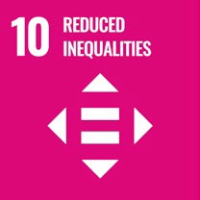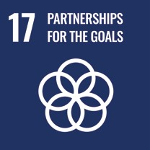

3. Governance
 16.6 Develop effective, accountable and transparent institutions at all levels
Good governance structures are key for the design, implementation and sustainability of the policy measures required for a disability-inclusive implementation of the SDGs.
Figure III shows the institutional set-up outlined within the CRPD to ensure that disability is considered in policy design in all areas and at all levels. Governance which promotes the inclusion of persons with disabilities requires institutional frameworks and clear roles and responsibilities.
Without a good coordination mechanism, disability-related issues can be overlooked, as policies affect persons with disabilities in all aspects.

3.1 Institutional setup for good governance inclusive of persons with disabilities
figure iii
Institutional setup for good governance inclusive of persons with disabilities
Government | Monitoring mechanism | Organizations of persons with disabilities
- Disability focal point at the highest possible level in the administration  - Disability focal points in ministries  - Coordination mechanism among ministries | - National Human Rights Institution  - Other independent monitoring mechanism compliant with the Paris Principles | - Formally granted consultative status vis-à- vis the government focal point and in monitoring mechanism  - Allocation of funds to sustain their independent functioning
The Government disability focal point is the central reference on the issue within the government.
Ministry disability focal points (officials and/or departments with expertise on disability in the area of competence of the ministry) should be appointed.
Federal countries should appoint focal points by State/Province. Local government focal points can also bring value and coordination at the local level.
The coordination mechanism aims at facilitating coordination and coherence of policies among ministries, departments, agencies and federal governments, to ensure that persons with disabilities are included and enjoy the same rights, regardless of the level of government.
Source: United Nations, Human Rights Council, Thematic study by the Office of the United Nations High Commissioner for Human Rights on the structure and role of national mechanisms for the implementation and monitoring of the Convention on the Rights of Persons with Disabilities, 22 December 2009, A/HRC/13/29
Related CRPD indicators: 1/4.1, 1/4.2, 1/4.7, 1/4.8, 1/4.9, 33.1, 33.2, 33.6, 33.8

3.2 Results-based strategic planning for policy implementation
Meeting the Sustainable Development Goals, as well as implementing the CRPD, requires strategic policy development and innovation. Results-based planning is key to ensuring policy coherence and to monitor implementation.
With regard to policies related to persons with disabilities, policy coherence depends on:
    - the adoption of the CRPD as the common framework that guides the development of plans and the implementation process(es)
    - prioritising the lived experiences of persons with disabilities to inform planning
    - appointing responsible entities and allocating budget to meet the outcomes of the country- owned results framework, which includes “agreed objectives and results indicators (i.e. output, outcome, and/or impact)”- see the metadata for SDG indicator 17.15.1
    - monitoring and measuring progress and pitfalls – the accompanying CRPD indicators can support strategic planning by identifying key areas of policy development and providing a measurable results framework on disability policies
Related CRPD indicators: 1/4.4, 1/4.6

3.2.1 Twin-track approach
The twin-track approach is a key concept that supports the strategic planning of inclusive development and the implementation of the CRPD. The twin-track approach includes:
      - systematically mainstreaming the interests and rights of persons with disabilities in policy design and implementation, across all sectors and areas of life
      - adopting targeted policies and programming measures, aimed specifically at persons with disabilities
The balance between mainstreaming strategies and targeted support should be tailored to address the needs of specific communities; however, the overall goal should always be to include persons with disabilities in all aspects of society and development.
figure iv
The twin-track approach
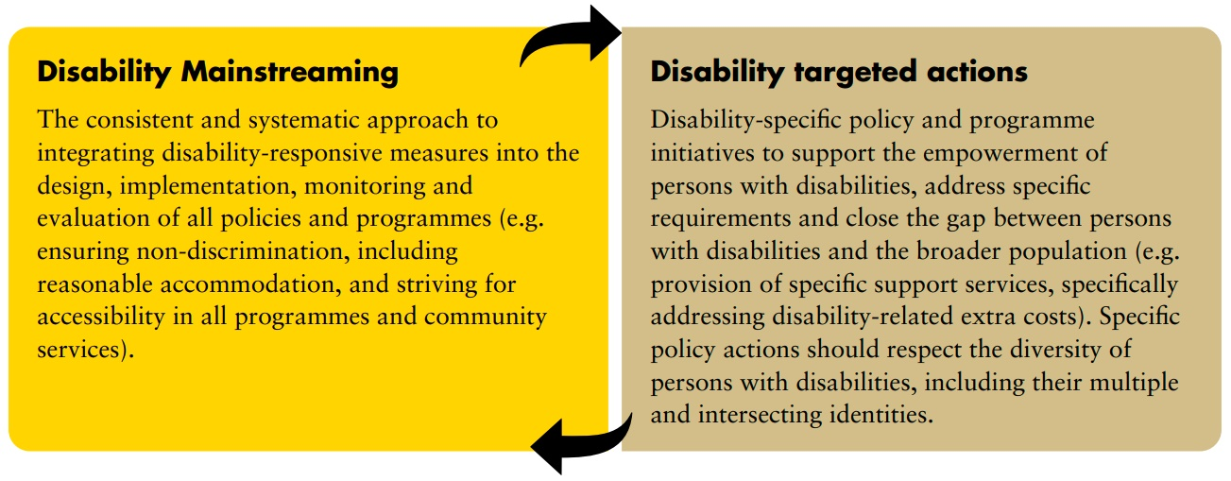
Related CRPD indicators: 5.2, 5.5, 6.3, 7.2

3.2.2 Disability assessment and determination as a tool for policymaking
Disability assessment and determination are processes used to collect information about persons with disabilities for policymaking and planning, budget allocation and to determine eligibility to certain benefits and entitlements. Disability assessment can also be used for the purpose of providing services, such as rehabilitation or education. Data collected through assessment and determination can be compiled into a national database or registry and used to inform policymaking, service planning and budgeting. However, in many countries, a coordinated system has not yet been established.
Disability assessment: the process of collecting disability-related information about an individual.
Disability determination: refers to the official decision (using the assessment findings) about whether someone is identified as a person with disability, often sub-classified according to their functionality. In some countries, this can become an official status, symbolised by a disability card or similar, which can provide access to services and benefits, among others.
There are often additional and different processes to determine eligibility for different types of social protection, insurance, health and support services.
figure v
Assessment, determination and eligibility
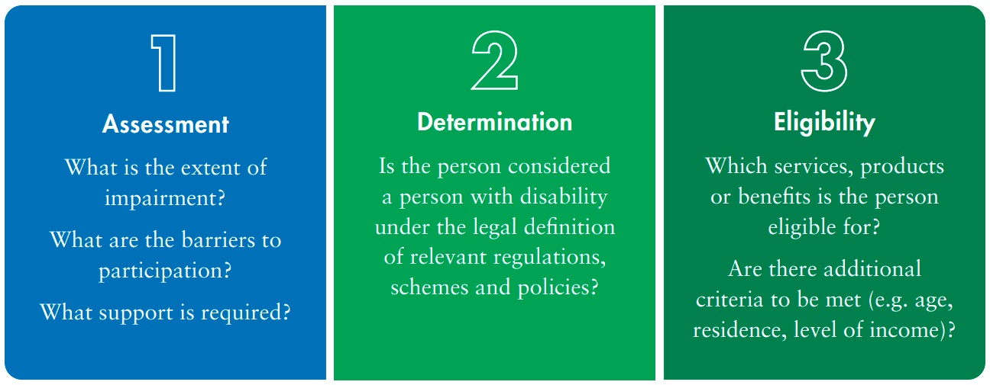
A human rights-based approach to disability assessment seeks to ensure the exercise of rights (purpose) by assessing the individual situation of the person (person-centred) and to provide the necessary support to bridge the barriers (means). Assessing the impairment of a person without meeting these requirements has been contested by the United Nations, leading to reviews in multiple countries.
Figure VI shows how disability assessment fits in the process of ensuring an adequate standard of living.
figure vi
Example of disability assessment in a process of ensuring an adequate standard of living
Policy analysis
- A survey shows that households with a person with disability have 20 per cent less available income to pay for basic services than other households, pushing them under the poverty line
Support
- Households with incomes meeting the poverty line or less require a social protection benefit when they have a member with disability
Assessment purpose
- Define if the household has a member who can be considered a person with disability and their level of income, to ensure equal standard of living in the segment of the population under the poverty line
Assessment
- The assessment aims at collecting relevant data to inform policy makers
- The tool used to make the assessment should match the purpose defined in the policy analysis
- Policy makers must assess the tool based on cost, proportionality of the information collected and implementation functionality, among others
Determination
- The person assessed meets the criteria to be considered a person with disability
Eligibility
- The household meets the requirement of having a member with disability and its income is under the poverty line
Attribution
- The household is granted with a financial benefit that puts them above the poverty line.
Recommendations
When developing assessment and determination processes for eligibility, governments should:
      - follow a human rights-based approach, based on the principles of CRPD Article 3
      - respect the privacy of persons with disabilities, keeping the information confidential
      - ensure that procedures are accessible, to prevent barriers and exclusion
      - include persons with disabilities in the design and monitoring of the process
      - respect the freedom to make one’s own choices
      - ensure that assessments are available for persons everywhere in the country
      - ensure that the assessment method is reliable and proportional to its needs
      - ensure that the outcome of the assessment and determination process is not used to restrict rights (e.g. deny access to employment)
Data gathered and disclosed for disability assessment should comply with the highest standards applicable to personal data protection.
Related CRPD indicators: 1/4.12, 22.4, 31.7

3.2.3 Using multi-stakeholder partnerships to achieve strategic objectives
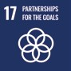 17.16 Enhance the Global Partnership for Sustainable Development, complemented by multi-stakeholder partnerships that mobilize and share knowledge, expertise, technology and financial resources, to support the achievement of the Sustainable Development Goals in all countries, in particular developing countries
17.17 Encourage and promote effective public, public-private and civil society partnerships, building on the experience and resourcing strategies of partnerships
Increasingly, governments partner with other stakeholders to provide goods and services to its population, including companies, universities and civil society organizations. In low- and middle- income countries, international cooperation stakeholders are often also involved. Public-private partnerships have become a common model in funding and implementing development programmes.
Given the impact of these stakeholders on the delivery of products and services for persons with disabilities, it is important that they are all are operating under a rights-based perspective.
Unfortunately, charity and medical approaches to disability often dominate over multi-stakeholder partnership goods and services for persons with disabilities – e.g. public funding directed to finance segregated education, institutionalized services, sheltered employment.
Results-based strategic planning for policy implementation that leads to multi-stakeholder partnerships should follow a human rights-based approach , setting objectives that are aligned with the CRPD and progressively departing from practices and business models that prevent the enjoyment of rights and of the benefits of development. Public procurement and sector-specific regulations can support relation-building processes with the private sector that create better practices.
Related CRPD indicators: 9.1, 9.17, 19.2, 19.6, 19.12, 19.13, 27.1, 27.2, 27.3, 27.4, 32.1
Community of practice example: Business and disability networks
 International Labour Organization’s Global Business and Disability Network
The International Labour Organization’s Global Business and Disability Network (2020) aims to create an inclusive global workforce culture. Its goal is to ensure that employment policies and practices in companies around the world, of all types, are inclusive of persons with disabilities. It promotes business-business and peer-learning through global, regional and national meetings, working groups, joint publications and tools. It supports national-level business initiatives, provides technical assistance and collates national-level information (ILO, 2020) about business and disability.
The Bangladesh Business and Disability Network (BBND, 2020) includes employers, employers’ associations, representative organisations of persons with disabilities, non-governmental organizations and development partners. The network shares learning and experiences to increase the capacity of Bangladeshi businesses to address diversity and inclusion, corporate social responsibility, legal adherence and human resource management.

3.3 Finance & budget
Having the strongest and most inclusive policies will have no impact unless resources are allocated to put commitments into practice. The paradigm shift adopted by the CRPD requires innovative approaches, as well as budgeting and financial management, that deliver for its objectives. Disability- extra costs must be factored in when developing disability reflective budgets. See Policy Guideline on SDG 1, section 5.1.2 on disability extra costs.
Inclusive education, health, employment, social protection and an adequate standard of living, among other social and economic rights, will not be achieved overnight. However, according to international human rights standards, governments must adopt steps as soon as possible (e.g. plan for health policy inclusive of persons with disabilities) and devote the maximum of its available resources to meet the minimum core obligations to satisfy the rights of all persons.
Budgeting in times of financial crises can be difficult. Governments should ensure that cuts that may force restrictions in service delivery do not negatively and disproportionately impact persons with disabilities when compared to others. Governments should refrain from adopting measures that limit or reduce the exercise of existing rights; and should plan for alternatives.
Related CRPD Indicators: 1/4.13, 24.24, 26.7, 28.11

3.3.1 Rights-based budgeting
The importance of rights-based budgeting
Often, budget allocations that target persons with disabilities may be under-executed or spent in ways that contradict the principles and foundations of the CRPD. For example, budget is often allocated to initiatives which further segregation and exclusion (e.g. sheltered workshops, segregated education and training programmes), as opposed to supporting inclusion. This is often due to a historical legacy of spending, that has not been critically reviewed. Resource constraints or reallocation of funds to other areas, particularly due to austerity measures, can undermine policies and restrict the rights of persons with disabilities. On the other hand, rights-based budgeting can largely contribute to the inclusion of persons with disabilities (see United Nations, Realizing human rights through government budgets, New York; Geneva, 2017).
Rights-based budgeting: transitioning over time
Budgeting for inclusion requires a transition plan that allows for the orderly transformation of systems. The level of exclusion that persons with disabilities face is such that, even by creating a battery of services compliant with human rights, a large number of them would not be able to access to them immediately. Consequently, budgeting for inclusion requires an evaluation of the increase in demand for services, by persons with disabilities, over time.
Planning for rights-based budgeting
Budgeting for inclusion does not happen in isolation. Disability-related budgets are impacted by general tax policies, foreign debt and by how resources are prioritized and weighed against each other. Governments aiming for human rights compliance should evaluate their existing economic and financial structures and evaluate possible reforms, following international standards (see United Nations, A/HRC/40/57). Moreover, they should include an international cooperation component, looking at supporting implementation through south-south, triangular and north-south cooperation to complement national resources, particularly on technical cooperation.
Fighting corruption and tax evasion, implementing transparency mechanisms and engaging persons with disabilities themselves, as well as national human rights institutions, in monitoring processes can further support the appropriate investment of the budget, particularly when the proportion of the national budget is small. As disability-related policies are usually underfunded, improving efficiency and efficacy in the administration of funds is fundamental to increase impact.
To ensure optimum use of budget, public expenditure on persons with disabilities, both from mainstream programmes and disability-specific programmes, should be trackable through disability markers (see section 3.3.2 below), to assess whether the use of original budget allocations was appropriate, to detect reallocations (diverting funds to other purposes) and to inform future budget needs and decisions.
 Recommendations
To budget for inclusion, governments should:
      - Do no harm: stop investing in harmful practices that are discriminatory against persons with disabilities
      - Use progressive/non-retrogressive budgeting: ensure that rights-based policies in place are not disrupted by the creation of new policies or by austerity measures
      - Plan ahead: evaluate the actual demand (not only the general statistical base) when planning for services and plan incremental investment to follow increases in demand
      - Enhance monitoring: establish markers that allow tracking of investment in disability-specific and disability-inclusive policies
      - Use rights-based budgeting: focus investment in policies that advance the implementation of the rights of persons with disabilities, following the CRPD
      - Plan for reallocation: reallocate funds from policies that do not meet CRPD standards to disability-inclusive policies
      - Consider proportionality of budget vs population and requirement: when evaluating the budget, ensure that persons with disabilities are properly represented as a significant population group and, if cuts or austerity measures are implemented, ensure that their negative effects do not impact this population disproportionally
Related CRPD Indicators: 1/4.11, 1/4.13, 1/4.14, 1/4.16, 5.4, 31.3, 32.1, 32.2, 32.3, 33.5, 33.7, 33.8

3.3.2 Disability markers
Disability markers are a key budgetary tool to track and monitor public expenditure on persons with disabilities. They should be designed to cover inclusive mainstream policies and disability-specific policies. International cooperation agencies have started to promote and make use of them (see the Organisation for Economic Co-operation and Development - Development Assistance Committee (OECD DAC)’s disability policy marker good practice example, presented below).
Throughout the accompanying CRPD indicators, many call for the development of markers allowing for the tracking of expenditure on persons with disabilities under different areas of policy - e.g.
CRPD indicator: “19.5 Legal requirement to establish a marker on all spending related to the exercise by persons with disabilities of the right to choose their living arrangements and access support services for living independently”.
 OECD DAC Disability Policy Marker (Inclusion and empowerment of persons with disabilities)
Definition
Development co-operation activities are classified as being inclusive of persons with disabilities (scores Principal or Significant) if:
- They have a deliberate objective on ensuring that persons with disabilities are included, and able to share the benefits, on an equal basis to persons without disabilities. or
- If they contribute to promote, protect and ensure the full and equal enjoyment of all human rights and fundamental freedoms by all persons with disabilities, and promote respect for their inherent dignity in line with Art. 1 of the Convention on the Rights of Persons with Disabilities. or
- If they support the ratification, implementation and/or monitoring of the Convention on the Rights of Persons with Disabilities (CRPD).
In accordance with the CRPD, persons with disabilities include those who have long-term physical, mental, intellectual or sensory impairments which in interaction with various barriers may hinder their full and effective participation in society on an equal basis with others.
Classification
2 - Principal objective. A component should be marked as principal (score 2) if disability inclusion, as per the definition above is the main objective of the development co-operation activity and is fundamental in its design and expected results. The activity would not have taken place without this disability inclusion perspective.
Examples of activities that could be marked as principal objective include:
- Support to inclusive education as defined by art 24 of the CRPD.
- Support to job insertion programmes inclusive of persons with disabilities.
- Support to health and social projects specifically designed to reduce the vulnerability of the persons with disabilities.
- Support to reduce architectural barriers in urban areas.
1 - Significant objective
An activity should be marked as significant (score 1) if disability inclusion, as per the above definition, is an important and deliberate objective, but not the principal reason for undertaking the development co-operation activity.
Examples of activities that could be marked as significant objective include: * A new or refurbished infrastructure project that is fully accessible to persons with disabilities. * A local library/school that makes cultural and education material also available in a form accessible to persons with visual or hearing impairments. * A social inclusion project that includes persons with disabilities among the target groups.
0 - Not targeted
An activity should be marked as non-targeted (score 0) if it has been screened against the marker but has not been found to target disability inclusion as defined in section
Examples of activities that could be marked as not-targeted are:
- A programme or activity aimed at improving basic services for the poor that governments that it will also reach persons with disabilities because they tend to be amongst the poorest, but does not contain specific mechanisms or activities to ensure inclusion.
- A programme establishing a segregated school for children with disabilities.
Source. Development Assistance Committee Working Party on Development Statistics, Proposal to introduce a policy marker in the CRS to track development finance that promotes the inclusion and empowerment of persons with disabilities DCD/DAC/STAT(2018)39/REV1 (OECD, 18 June 2018)
Related CRPD Indicators: 1/4.11, 1/4.13, 1/4.14, 1/4.16, 5.4, 31.3, 32.1, 32.2, 32.3, 33.5, 33.7

3.4 Public procurement
Public procurement regulations and practices are key in the improvement of accessibility of facilities, products and services, in terms of the physical environment, information, communication, systems and procedures. Public authorities should include accessibility and universal design within appropriate technical specifications in bid solicitation and procurement plans.
Among other things, accessibility and universal design requirements would ensure that:
    - Products and services purchased by public authorities are usable by, and accessible to, persons with disabilities
    - Any construction/renovation of public facilities enhances accessibility (through construction codes)
    - Private companies that apply for licenses with regulatory authorities ensure accessibility in their bid and service provision
In addition, public procurement of products that contribute to facilitating accessibility for persons with disabilities can have a positive impact on the specific market, lowering prices and thus enhancing their affordability. It also can contribute to promoting the employment of persons with disabilities, when procurement policies include an eligibility criterion that benefits companies that hire persons with disabilities.
Public procurement is also key to prevent multi-stakeholder partnerships, including public-private partnerships, from engaging in practices that support discrimination against persons with disabilities. Sector-specific regulations and public bids should include rights-based standards to counter CRPD violations.
Related CRPD Indicators: 9.17, 9.18, 32.1

3.5 Data collection and disaggregation by disability
17.18 By 2020, enhance capacity-building support to developing countries, including for least developed countries and small island developing States, to increase significantly the availability of high-quality, timely and reliable data disaggregated by income, gender, age, race, ethnicity, migratory status, disability, geographic location and other characteristics relevant in national contexts
Information on persons with disabilities and their situations is critical for the development of effective policies. Internationally, persons with disabilities are estimated to represent 15 per cent of the global population. Countries present variations in the prevalence of disability mainly due to the methodology they use to assess it.
The method used to identify persons with disabilities will vary depending on the intended purpose of the data. To identify persons with disabilities who qualify for a restricted disability allowance, a different threshold of what constitutes disability would be recommended, when compared to the data generated to estimate how many persons with disabilities there are in a country, their health, education, and other outcomes. This latter set of data is preferable for policy and budget planning purposes.
From diagnosis, to self-identification, to functioning
Over time, there have been three main approaches used in relation to disability data. First, disability data was generated from administrative health data. Persons with certain diagnoses were classified as persons with disabilities. This method of collecting disability data was inconsistent, did not allow for reliable and comparable data, and was inefficient.
Disability data was increasingly part of the statistical work of countries. In the second phase, persons with disabilities were identified through self-identification. Respondents were asked questions such as “are you a person with disability?” to identify persons with disabilities for disaggregation purposes. Since “disability” is a social construct, self-identification led to underreporting. Many persons with disabilities did not self-identify in contexts where having a disability had culturally negative connotations, e.g. considering that their impairments did not qualify as such; older persons that did not see themselves as persons with disabilities.
The third and current moment uses functioning as a way of collecting disability data. It is recommended that this approach is used for censuses, large surveys and administrative data, including for the statistical purposes of disaggregation. This approach was designed by the Washington City Group on Disability Statistics and (usually) utilises the Washington Group “Short Set” of questions. This set uses questions that assess universal basic activities or “functions”- seeing, hearing, walking, self-care, cognition and communication. Individuals answer six questions which are used to define whether that person is “with disability” or “without disability”. Respondents who answer “a lot of difficulty” or “cannot do it at all” to at least one of the six functioning questions should be considered a person with disability for the purpose of data disaggregation, particularly for the SDGs. These are persons whose functional limitations place them at risk of being excluded if faced with physical, informational, attitudinal or institutional barriers in their surrounding environment.
The Washington City Group on Disability Statistics: The Washington Group Short Set on Functioning is, currently, the most recognised statistical tool for generating disability data. It includes 6 questions that can be answered on a graded scale, for example: “Do you have difficulty seeing, even if wearing glasses?”
- No – no difficulty
- Yes – some difficulty
- Yes – a lot of difficulty
- Cannot do at all
Policymakers can establish the threshold for disability disaggregation in (c) or (d), though this will affect prevalence figures and analysis of inequalities between persons with and without disabilities.
The Washington Group has developed other tools to better represent different groups, including the Washington Group Extended Set on Functioning, the Short Set Enhanced, and the Washington Group/UNICEF Child Functioning Module. Other organizations are using these same identification questions for employment surveys, humanitarian data collection, disability surveys and household surveys. Having the same identification questions in censuses and surveys allows for comparable data.
For more information on data sources, see the Data Sources Guidance.
The accompanying CRPD indicators approach the issue of data collection from multiple perspectives. The CRPD is the only human rights treaty with a dedicated article that mandates governments to collect data and ensure disaggregation by disability. Consequently, the CRPD indicators on article 31 of the CRPD supports the realization of this obligation. These indicators are closely linked to the data revolution proposed by the 2030 Agenda and reflects the commitments adopted under SDG 17. In addition, all CRPD indicators identify key areas where data should be collected to measure the advancement of human rights. When general surveys are the main data source, disaggregation by disability is included in them. Finally, SDG indicators are incorporated into the CRPD indicators and disaggregation by disability is included in them.
 Recommendations
In accordance with article 31 of the CRPD (on statistics and data collection), governments should:
- Collect disability data within censuses and other large surveys, such as demographic health surveys, labour force surveys and household income and expenditure surveys; disaggregate data by disability status and type of functional difficulty (when technically feasible) by employing tools such as the Washington Group Short, Extended, and Short Set Enhanced set of questions
Related CRPD Indicators 31.7, 31.8, 31.9 and 31.10
- Collect and systematize disaggregated data by disability status, type of impairment (when technically feasible) and age; analyse and use available data to produce insights to guide policy and budgeting decisions
Related CRPD Indicators 31.7, 31.8, 31.9 and 31.10
- Statistical offices should engage and collaborate with the national human rights institutions, whose monitoring role contributes to data collection regarding a diversity of relevant topics for persons with disabilities

4. Participation of persons with disabilities in public life

4.1 Ensure responsive, inclusive, participatory and representative decision making at all levels
 | 16.7 Ensure responsive, inclusive, participatory and representative decision-making at all levels
 | 10.2 By 2030, empower and promote the social, economic and political inclusion of all, irrespective of age, sex, disability, race, ethnicity, origin, religion or economic or other status
Persons with disabilities are extremely underrepresented in public institutions, including in parliament, public sector, judiciary and at all levels of government. This is due to legal and accessibility barriers, among others. Exclusion from public and political life is often compounded for women and young persons with disabilities. For more information on the participation of persons with disabilities, see section I.
161 countries out of 176 include restrictions in accessing public office, based on impairment
Source: United Nations Department of Economic and Social Affairs – Disability, UN Disability and Development Report - Realizing the SDG by, for and with persons with disabilities, 3 April 2019, p. 264
Reform to increase the participation of persons with disabilities in public and political life is recommended, with a particular emphasis on women with disabilities. Some countries have adopted measures in some of these areas, including at the constitutional level, to increase the inclusion of persons with disabilities in aspects of public and political life, for example by reserving seats in parliament for representatives with disabilities. Employment quotas within the public sector are also common and can contribute to increased participation.
Recommendations
To enhance the inclusion of persons with disabilities in national institutions, governments should:
    - Promote reform of legislation and repeal regulatory provisions which prevent persons with disabilities from being part of national or local parliaments, the judiciary or serving as public servants
Related CRPD Indicators 13.1, 13.2, 27.1, 27.2, 29.1, 29.2
    - Adopt specific measures to increase the number of persons with disabilities in positions in parliament, ensuring the provision of support or reasonable accommodation
Related CRPD Indicators 29.7, 29.8, 29.29, 29.30
    - Adopt specific measures to increase the number of persons with disabilities in positions within the public sector
Related CRPD Indicators 27.13, 29.7, 29.8, 29.29, 29.30
    - Ensure the provision of reasonable accommodation in public examinations for judges; the provision of requested support for the exercise of duties as judges or judiciary employees; procedural accommodations for participants in judicial proceedings (e.g. witnesses, jurors)
Related CRPD Indicators: 13.6, 13.9, 13.10, 13.22, 13.23

4.2 Ensuring the right to vote of persons with disabilities
Many electoral systems continue to exclude persons with disabilities; electoral legislation typically includes provisions that restrict the right to vote, be elected and hold office of persons deprived of their legal capacity. This contradicts article 12 of the CRPD and especially impacts persons with intellectual disabilities and persons with psychosocial disabilities. General restrictions on electoral participation and restrictions based on any kind of individual assessment of alleged capacity to vote violate human rights, which has been made explicit in the CRPD and by the CRPD Committee.
During the electoral process, lack of accessibility of voting procedures, voting environment, facilities or information materials can prevent persons with disabilities from voting.
Recommendations
To ensure and facilitate the fulfilment of the rights of persons with disabilities, governments and electoral management bodies should:
    - Repeal legal provisions that restrict, on the basis of disability, the right to vote, be elected and hold office
Related CRPD Indicators 29.1, 29.2
    - Adopt measures to ensure accessibility of voting procedures; pre-election campaigns; voting environment, information, materials and facilities - including developing voting protocols to address barriers faced by persons with disabilities when voting
Related CRPD Indicators 29.3, 29.5, 29.15, 29.19
    - Ensure that, where assistance is required by a person with disability, this is provided by a person of their choice, to ensure autonomy and the secrecy of the ballot
Related CRPD Indicators 29.6, 29.15, 29.20
    - Ensure that persons with disabilities can access complaints and monitoring mechanisms related to electoral processes
Related CRPD indicators: 29.5, 29.26, 29.28
    - Monitor the implementation of these actions - concrete measures should contribute to a higher voter turnout of persons with disabilities in electoral processes
Related CRPD Indicators 29.27, 29.28

5. Legislation and policy for equality and non-discrimination of persons with disabilities
10.3 Ensure equal opportunity and reduce inequalities of outcome, including by eliminating discriminatory laws, policies and practices and promoting appropriate legislation, policies and action in this regard
16.b Promote and enforce non-discriminatory laws and policies for sustainable development

5.1 Inequality and discrimination experienced by persons with disabilities
Persons with disabilities are often subject to inequality and discrimination. Inequality is often present between persons with disabilities and the broader population, concerning education, employment, income, access to goods and services and other key aspects of life.
Given the pervasive nature of disability-based discrimination (that has often been embedded into laws, policies and practices), persons with disabilities experience systemic inequality. To overcome this structural discrimination, it is necessary to adopt specific measures, including affirmative actions to counter systemic discrimination. Individual accommodations and adjustments are a good tool to prevent discrimination and contribute to more inclusive environments.
figure vii
Inclusive equality diagram
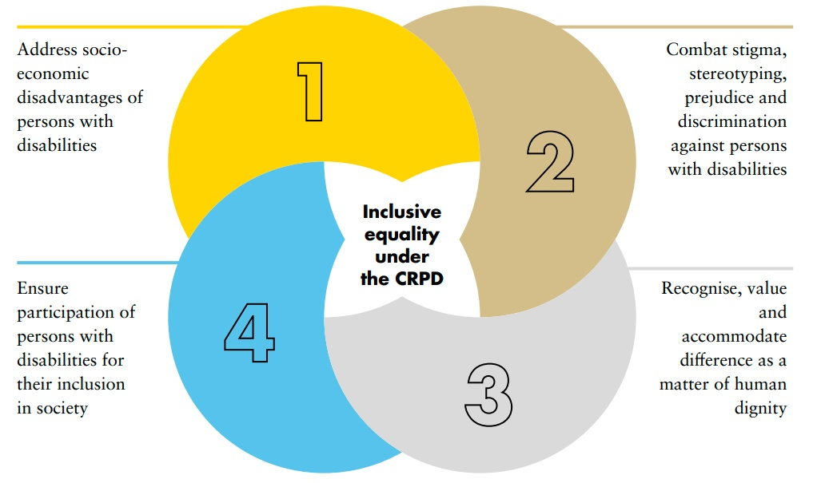
Source: Based on United Nations, Committee on the Rights of Persons with Disabilities, General comment No. 6 (2018) on equality and non-discrimination, 26 April 2018, CRPD/C/GC/6.
 Broad anti-discrimination recommendations
- Propose the enactment or modification of relevant legislation to prohibit discrimination based on disability, including denial of reasonable accommodation, across sectors
Related CRPD Indicators 5.1, 5.5, 13.1
- Repeal legal and regulatory provisions, across sectors, that enable discrimination based on disability
Related CRPD Indicators 1/4.4, 1/4.5, 5.5
- Develop and adopt policies to address and eradicate discriminatory practices, including awareness-raising campaigns and activities
Related CRPD Indicators 5.2, 5.13, 6.11, 8.1, 8.2, 8.4, 8.5, 13.13, 13.14
- Implement awareness-raising programmes to improve perceptions on persons with disabilities, change attitudes and inform about rights
Related CRPD Indicators 5.13, 6.11, 8.2, 8.7, 8.8, 8.9, 13.13, 13.14
- Policymakers should consider religious, ethnic and indigenous backgrounds, gender identity, sexual orientation, sex and age of persons with disabilities in policymaking, and seek diverse participation
Related CRPD Indicators 5.1, 5.2, 5.7, 5.13, 6.11, 13.13, 13.14

5.2 Putting non-discrimination into practice: Reasonable accommodation
Section I introduced reasonable accommodation as a core part of non-discrimination. This section provides more details on its application.
figure viii
Process for providing reasonable accommodation
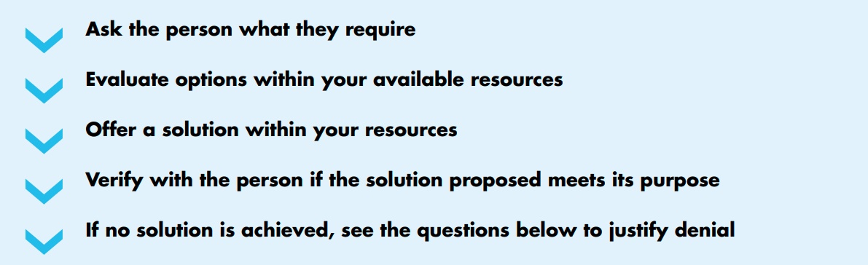
Source: Based on United Nations, Human Rights Council, Equality and non-discrimination under article 5 of the Convention on the Rights of Persons with Disabilities, 9 December 2016, A/HRC/34/26.
How to determine what is reasonable ?
There are several guiding questions to help determine if a request is “reasonable” and does not create a disproportionate or undue burden. These criteria should be established in law.
If the entity in charge of providing accommodation answers YES to all the questions included in table 3, it would be incurring discrimination. If it answers NO to any of them, then the denial would be justified. A flow chart further detailing this process is available in figure IX.

table 3
Criteria for determining whether the accommodation is reasonable
Question | The accommodation required…
Is it legal? | … sits within the bounds of the law (e.g. a screen-reader software is legal in the country)
Is it necessary and appropriate? | … is sufficient to enable participation and access – not more than what is required for the situation  … works for the person and enables access and participation (e.g. a foldable ramp is requested to sort three steps, instead of a lift)
Is it feasible? | … is available in that context (e.g. in a meeting in Germany, Indonesian Sign Language interpretation is required, but Indonesian sign language interpreters are not available)
Is it proportionate (not imposing a disproportionate or undue burden)? | … is financially possible. The duty bearer has the money or access to credit lines to provide for it  … is economically feasible. The implementation of the accommodation doesn’t put the responsible entity at, for example, risk of bankruptcy (e.g. a company is required to adapt a bathroom for an employee. It doesn’t have the money but the government has 0 per cent loans for that purpose, so the company can access funding and provide that the accommodation is paid in time)
figure ix
How to determine what is “reasonable” in the context of reasonable accommodation
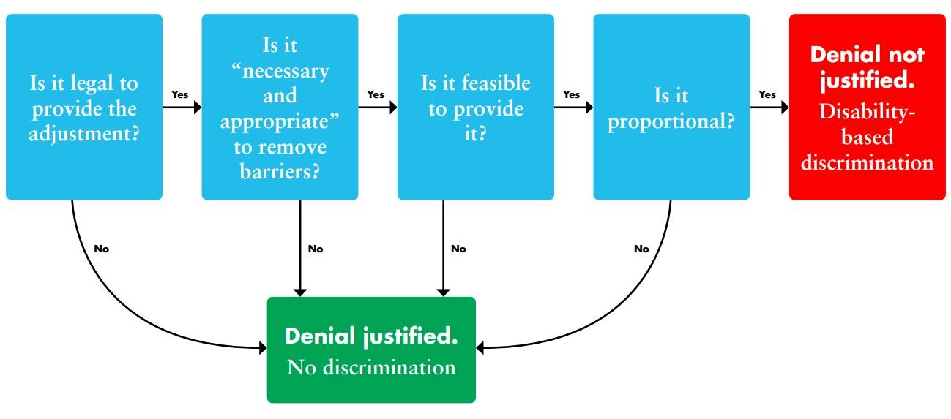
Source: Based on United Nations, Human Rights Council, Equality and non-discrimination under article 5 of the Convention on the Rights of Persons with Disabilities, 9 December 2016, A/HRC/34/26.
Recommendations on reasonable accommodation
Reasonable accommodation is an innovative anti-discrimination measure. Policymakers can promote its respect and uptake by taking the following actions:
- Adopt clear regulations and develop guidance materials and training (such as ILO, Promoting diversity and inclusion through workplace adjustments: A practical guide, 2016) to enable public and private actors to provide reasonable accommodation to persons with disabilities
Related CRPD Indicators 5.1, 5.2, 5.6, 5.10
- Create a centralized reasonable accommodation fund that is flexible and of easy access by different parts of the administration, to react to reasonable accommodation requests
Related CRPD Indicators 5.1, 5.2, 5.6, 5.9 and 5.17
- Adopt clear and restrictive guidelines on disproportionate burden applications, including placing the burden of proof onto the provider of reasonable accommodation

5.3 Putting non-discrimination into practice: Addressing diversity and identity
Policymakers should take into consideration multiple and intersecting identities when developing policy, as persons may face both specific and intersectional discrimination processes. For example, a country may have different policies for health care services for the general population and for indigenous persons, having service governance under the indigenous leadership. Women with disabilities accessing the same service in these two different contexts may experience barriers, if the disability dimension is not considered.
Multiple and intersectional discrimination faced by migrants with disabilities
Migrants with disabilities face compounded legal, policy and accessibility barriers based on their disability and migrant status, leaving them in a highly vulnerable position in the country of transit or destination.
SDG 10 addresses inequalities faced by migrants. It commits governments to “facilitate orderly, safe, regular and responsible migration and mobility of people, including through the implementation of planned and well-managed migration policies” (10.7, A/RES/70/1).
 What steps should be taken for migrants with disabilities?
- Repeal restrictions from immigration laws that discriminate on the basis of disability: Many immigration, naturalization and related procedures still include requirements that discriminate directly or indirectly against persons with disabilities, e.g. meeting health-related requirements to be authorised to immigrate/naturalize.
Related CRPD Indicators 18.5
- Introduce accessible migration procedures and registries: Lack of accessible migration- related information, procedures and registries puts persons with disabilities in a disadvantaged and precarious situation, preventing them from making informed decisions autonomously, complying with formal requirements and eventually being conferred a recognized migrant status
Related CRPD Indicators 18.1, 18.2, 18.6, 18.9 18.14, 18.5
- Repeal restrictions and remove barriers for migrants with disabilities in accessing social protection programmes, health care and other social services: Migrants with disabilities usually face great restrictions in accessing health care, social services and disability benefits based on their migrant status and/or nationality. E.g., eligibility criteria for disability benefits requiring several years of residency in the country - on occasion, even 20 years. Women refugees, migrants and asylum seekers with disabilities may also face an increased risk of violence because they are denied the right to access health and justice systems due to their citizenship status (CRPD art 11).
Related CRPD Indicators 28.10, 28.11, 28.14, 18.5
Sex, gender and age perspectives – not one or the other
Disability affects people with any gender identity, sex or age
Policymakers are required to consider gender identity, sex and age of persons with disabilities to better address their specific requirements to ensure the enjoyment of their rights. Data shows that the larger part of the population of persons with disabilities falls under the youth age-bracket and that there is also a disproportionate representation among older persons due to the increased barriers faced when ageing. Policies usually consider older persons with disabilities from an age perspective only, without cross-analysing the intersection between age and disability, as well as other perspectives.
To address age, sex and gender, the accompanying CRPD indicators reference them from three different perspectives:
  - following articles 6 (women with disabilities) and 7 (children with disabilities) of the CRPD, there are dedicated indicators covering these specific groups and mainstream aspects of policy development and implementation related to them
  - across the indicators, disaggregation by age, sex and disability is promoted, the latter calling for disaggregation by type of impairment (see FAQ 11 of CRPD indicators)
  - following SDG 5 (gender equality) and SDG 10 (reduced inequalities), make specific reference to the marginalized groups, to promote specific actions
Recommendations on multiple and intersectional discrimination
To protect against multiple and intersectional discrimination, governments should:
    - Recognise multiple and intersectional discrimination within legal frameworks on equality and non-discrimination
Related CRPD Indicators 5.1
    - Ensure that complaints mechanisms permit invoking discrimination on multiple and intersecting grounds and that remedies for violations of multiple or intersectional discrimination cases are commensurate
Related CRPD Indicators 13.1, 5.5, 6.1
    - Ensure that data collection and disaggregation systematically disaggregate by disability, and by other characteristics relevant to the national or local context, to enhance detection of situations of systemic discrimination
Related CRPD Indicators 31.1

5.4 Putting non-discrimination into action: Specific measures
Specific measures are often required to “close the gap” between persons with disabilities and the rest of the population, in a pursuit to “leave no one behind”. These measures are also commonly referred to as special measures, temporary measures, positive action, positive discrimination, affirmative action, among others. They aim to address historical or structural inequality of a group, to accelerate progress towards de facto equality.
Specific measures can consist of:
    - Targeted programmes or benefits directed to persons with disabilities, e.g. tax exemption on importation of assistive devices
    - Measures establishing a preference for persons with disabilities over others, e.g. employment quota for persons with disabilities in the public sector
In addition, both kinds of measures might be temporary (until a goal, e.g. de facto equality, is met) or permanent. This depends on the context, issue addressed and targeted group of persons with disabilities. Consistent with their purpose, specific measures do not seek to promote separate systems and standards, but to redress an imbalance toward achieving the de facto equality of a historically disadvantaged group. Importantly, specific measures designed to achieve equal outcomes between persons with disabilities (or for certain sub-groups) and the broader population, are not considered discrimination.
Specific measures are very common and have been used across sectors, for different groups, for many years. However, when it comes to persons with disabilities, some of these measures are based on stereotypes or outdated understandings of disability and may lead to exclusionary practices, which result in reinforcing disadvantage rather than correcting it. For example, there may have been specific measures for blind persons to receive employment in one kind of vocation, due to an assumption that blind persons cannot perform well in other roles. This is discriminatory and contradicts the principles of the CRPD, such as equality of opportunity, respect for autonomy and freedom to make one’s own choices. To prevent unintentional discrimination from specific measures, it is important that they align with the principles and spirit of the CRPD and have been designed in consultation with persons with disabilities and their representative organisations.
Importantly, adopting specific measures does not exempt policymakers from ensuring mainstream services and schemes are accessible and inclusive. Specific measures alone are not enough to achieve equality.
Recommendations on combating structural discrimination
To enhance equality of opportunities and outcomes, governments should:
- Adopt specific measures targeting persons with disabilities, including underrepresented groups of persons with disabilities – e.g., women and girls, youth, indigenous persons or persons with higher support needs
Related CRPD Indicators 5.7, 5.11, 5.12, 6.3
- Design specific measures with the active involvement of persons with disabilities, to ensure they are neither based on, nor result in, reinforcing negative stereotyping and prejudice about persons with disabilities
Related CRPD Indicators 5.7, 5.14, 6.3, 27.13, 29.7

5.5 Legal capacity of persons with disabilities
What is legal capacity?
To have legal capacity is to be recognised as a person who holds rights, as well as someone who can act on those rights and exercise them freely. In most legal systems, all persons hold rights, but there may be restrictions on who can act upon these rights autonomously. For example, children usually have restrictions on how autonomously they can act upon their rights. Having full legal capacity is important for all adults - it entitles them to have legal control over their own decisions and on how to live their life. For example, it gives a person legal authority to manage his/her own financial affairs, including ownership of property, choose where to live and work, and how to manage his/her relationships, health and wellbeing.

Legal capacity and substituted decision-making
Legal capacity is often taken for granted by most adults. However, many persons with disabilities, in most countries of the world, are denied legal capacity. Legal capacity is often restricted, commonly on the assumption that persons with disabilities cannot decide for themselves due to having an impairment or condition; a history of perceived “poor” decision making; or based on an assessment of mental (in)capacity, usually by a health professional.
When persons with disabilities are denied legal capacity, they are legally prevented from making their own choices and decisions and from having them respected. This practice is discriminatory. For example, many persons with psychosocial disabilities are prevented from making their own healthcare decisions and are subjected to involuntary treatment. In other cases, persons with disabilities cannot freely enter into contracts, marry, make their own decisions about their finances, manage their property or vote.
In place of persons with disabilities making their own decisions, others are authorised to take decisions on their behalf. This is called substituted decision-making. Those granted with the authority to engage in “substitute decision-making” include guardians, curators and judges, among others.
Substituted decision-making may also occur, in practice, without any formal appointment, e.g. legal decisions taken on behalf of an individual by family members, doctors or others. Both formal and informal restrictions of legal capacity constitute human rights violations themselves and can lead to further violations.
What is supported decision-making?
The CRPD states that all forms of substituted decision-making, such as guardianship, should be phased out and replaced by rights-based approaches. All adult persons with disabilities have the right to legal capacity and this should not be taken away. Instead, the CRPD obligates governments to provide persons with disabilities with support to exercise their legal capacity, including for making legal decisions. This is called “supported decision-making”. Supported decision-making is voluntary and can include informal or formal support arrangements. For example, a person may choose a trusted person to support them in making certain types of legal decisions. They may also find support through peer support or self-advocacy networks. Some persons with disabilities may access support to help with the communication of their will and preference. Crisis support services are also important to complement supported decision-making, in times of emotional distress.
Persons with disabilities may also undertake “advanced planning”, for example through a power-of- attorney. This means that they communicate their will and preference about possible future events, such as acquiring an impairment, or for situations where they may be facing emotional or psychological distress that may affect their possibilities to make decisions. For example, a person with a psychosocial disability may state the kind of support and service they want in situations of distress, as a way of preventing forced treatment. Public notaries, health systems, civil society organizations and organizations of persons with disabilities are key partners on this issue.
 9 actions to uphold the legal capacity of persons with disabilities
Actions in law
1. Reform legislation, particularly civil law, to ensure it aligns with the CRPD and:
  - Explicitly recognises the legal capacity of persons with disabilities
  - Eliminates plenary or partial guardianship, curatorship, or other substituted decision-making provisions
  - Eliminates provisions which deny or restrict the exercise of other rights on the basis of legal capacity, including the right to vote, marry, access justice, manage property and make decisions about finances, health and family.
Colombia, Costa Rica and Peru reformed their civil law legislation, eliminating guardianship and establishing supported decision-making systems to enable persons with disabilities to make their own decisions (Colombia, Law 1996 of 2019; Costa Rica, Law for the promotion of the autonomy of persons with disabilities, Law no. 9379 (2016); Peru, Legislative decree that recognizes and regulates the legal capacity of persons with disabilities on equal conditions, Legislative decree no. 1384 (2018)).
2. Establish supported decision-making provisions in legislation. Consider how to incorporate other forms of support such as support networks, peer support, crisis support and advanced planning.
According to the Report of the Special Rapporteur on the rights of persons with disabilities (A/HRC/37/56), in 2017, over 20 countries in the world had already established supported decision-making provisions in their legislation to progressively end substituted decision-making and to give legal agency to the largest possible portion of persons with disabilities, as soon as possible.
Actions in policy and practice
3. Eliminate guardianship or other substituted decision-making provisions as a requirement to access to disability-related benefits, pensions, gratuity, tax exemptions, health benefits, social protection, social care, housing, support and other disability-related entitlements and benefits.
In Argentina (Argentina, Resolution 93/2020), while civil law legislation remains to be reformed to eliminate deprivation of legal capacity, the administration has removed guardianship as a requirement to access social protection benefits.
4. Establish supported decision-making systems and services across the country, including in urban, rural and remote areas:
- Promote the establishment and operation of community-based supported decision-making services. Allocate resources to ensure the continuity of these services
- Implement or promote pilot projects and demonstration experiences
- Undertake and promote research on supported decision-making
In Girona, Spain, the organization Support (Support, n.d.) provides supported decision- making services, as well as personalized support to enable social inclusion, to allow persons with intellectual disabilities and persons with psychosocial disabilities to make their own decisions. This includes support to administer their budget; make personal decisions such as getting married or to travel; choose where they live and with whom, including moving from an institution to their own house; rent an apartment; enter an employment contract, and so on.
5. Implement safeguards to monitor the support provided to persons with disabilities, to ensure that their will and preferences are respected and that abuse is prevented.
Abuse against persons with disabilities must be prevented with safeguards, such as time limits, periodic review, requirements for being a supporter, liability, complaint and redress mechanisms and monitoring. In Ireland, anyone can file complaints against a support person, not just the person being supported (National Quality Improvement Team, 2020).
6. Encourage persons, through awareness-raising programmes, to express their will and preferences in the event of acquiring an impairment or experiencing a situation affecting their mental capacity, through advanced decision-making such as power-of-attorney.
7. Ensure access to justice for persons with disabilities and the availability of legal aid services to challenge plenary or partial guardianship, curatorship, or any other form of substituted decision- making.
Including supported decision-making in law can drastically reduce the number of persons under guardianship. Nevertheless, many persons are still deprived of their legal capacity today and they lack the means to challenge it. In Colombia, Article 14 of the Act 1996
of 2019 foresees the role of the personal defendant: “In the cases where the person with disability requires support but does not have persons of trust to appoint, the family law judge shall appoint a personal defendant from the Ombudsman Office (“Defensoria del Pueblo”) to provide the required support for undertaking legal acts that the rights holder requires”.
8. Promote and provide training on the right to legal capacity of persons with disabilities for State authorities, judges, notaries, service providers, financial services, persons with disabilities and their families and other relevant actors.
The paradigm shift on legal capacity adopted by the CRPD challenges almost 2000 years of civil law and may still be considered, by many legal actors, to be counter-intuitive. Training on legal capacity is key to address the consequences of depriving this right and understand why this right cannot be restricted nor denied, giving the appropriate dimension to the issue. Training should include persons with disabilities and partnerships should be built with lawyers, notaries, judges, public prosecutors, judicial schools, law schools and other judicial and legal actors, to successfully address the concerns of the different stakeholders and to ensure respect for the rights holders.
9. Meaningfully involve persons with disabilities and their representative organizations in the development and implementation of supported decision-making systems.
While all persons with disabilities may commonly be excluded from decision-making processes, this is more frequent for those whose legal capacity is challenged. Persons with psychosocial disabilities, persons with intellectual disabilities, persons with developmental disabilities, persons with autism, persons with Down syndrome, among others, are typically disregarded and their voices are consistently ignored or challenged. Like all members of society, their lived experiences matter, and their involvement is fundamental. In Mexico, the Supreme Court, decided, in case 68/2018, that it was unconstitutional to amend the law on persons with disabilities without previously consulting with the concerned population (Mexico, Unconstitutionality Action 68/2018).
See also the video on legal capacity developed by the Special Rapporteur on the rights of persons with disabilities.

6. Accountability and monitoring
16: Promote peaceful and inclusive societies for sustainable development, provide access to justice for all and build effective, accountable and inclusive institutions at all levels.
16.3 Promote the rule of law at the national and international levels and ensure equal access to justice for all
Accountability and monitoring are important aspects of the rights-based approach to disability. The following sections provide specific information about accountability and the monitoring of the rights of persons with disabilities, as part of a “leave no-one behind” approach to development.

6.1 Access to information
16.10 Ensure public access to information and protect fundamental freedoms, in accordance with national legislation and international agreements
Public access to information is key for the transparency of government action and to enable monitoring, by both civil society and the general public. Governments should proactively publish and disseminate public information, as well as provide it on demand. Many countries have found that the enactment of public information laws and the appointment of a public body or agency charged with its implementation are key concrete steps in this direction.
A lack of dissemination of public information in accessible formats (e.g. Braille), accessible digital formats, Easy Read, sign language and others, restricts persons with disabilities’ access to public information, assessment of public action and exercise of their own rights. Information intended for the general public must be made available in accessible formats and technologies.
Recommendations
Governments should:
- Adopt or modify freedom of information laws and regulations, so that accessibility of information for persons with disabilities is ensured in official publications and events
Related CRPD Indicators 21.1, 21.1.1, 21.1.2, 21.2, 21.10
- Ensure accessibility of government websites and reports intended for the general public (see W3C, "Web Content Accessibility Guidelines", 2020)
Related CRPD Indicators 21.15, 21.16
- Ensure that any requests of public information by persons with disabilities are granted in the accessible format they require, including national sign languages, without additional cost
Related CRPD Indicators 21.23

6.2 Accountability and complaints mechanisms
Accountability and complaints mechanisms provide policymakers with valuable information, that helps assess public policies and identify gaps (e.g. absence of a policy to prevent violence against persons with disabilities). In particular, monitoring the number of complaints made by right holders can help to identify trends in the exercise of rights. Policymakers should consider these as a valuable information source to reflect upon, as they consider further actions, e.g. legal or budgetary reform.
Accountability as a way of raising the profile of issues
The work of accountability bodies, such as (monitoring) reports from national human rights institutions or relevant court decisions on a particular issue, including the outcomes of complaints, may raise the visibility of the topic or issue in the public agenda. This can trigger political will at higher levels of government to address the topic. In particular, decisions by the judiciary may also facilitate progress by removing legal obstacles or uncertainties, and allowing further action.
 Recommendations
Improving accountability at the national level
- Make complaints mechanisms in administrative, civil and criminal processes accessible for persons with disabilities and provide for procedural accommodation when needed
- Remove barriers to the participation of persons with disabilities in proceedings, including repealing provisions which restrict legal standing and recognition of legal capacity
- Ensure that information needed to defend rights is accessible, and that free and affordable legal aid is provided to persons with disabilities in all areas of law
- Ensure that the staff involved in the administration of justice are trained on the rights of persons with disabilities, including the barriers they face in accessing justice, the provision of procedural accommodations and overcoming gender- and disability-based stereotypes
- Establish reliable administrative mechanisms to avoid having civil and criminal courts as the only accountability mechanisms
- Ensure due diligence to investigate, prosecute and punish perpetrators and/or provide remedies
to human rights violations against persons with disabilities. Reparation should be provided taking into consideration the specific circumstances of the person with disability, including the exposure of truth as a component of satisfaction and providing guidance for legal and policy reform and capacity-building, as guarantees of non-repetition
For more information, see United Nations, Human Rights Council. Right to access justice under article 13 of the Convention on the Rights of Persons with Disabilities. 27 December 2017.
A/HRC/37/25

6.3 National Human Rights Institutions
Introduction to National Human Rights Institutions
National human rights institutions (NHRIs) in line with the Paris Principles have a broad mandate and functions, covering human rights protection and the promotion of all rights. This includes investigation, monitoring, legislative and policy advice, human rights education and training, and reporting on the human rights situation to national, regional and international levels. Some NHRIs may also handle complaints. Either at the request of public authorities or out of its own initiative, NHRIs may elaborate reports on human rights matters and/or provide advice from a human rights perspective on existing or draft legislation, regulations and policies.
In addition, NHRIs may be mandated to hear and consider complaints and petitions concerning individual situations. Among other things, NHRIs can issue recommendations to public authorities on how to address the complainant(s)’ situation and inform individuals on any available remedies in the justice system. Policymakers can strategically benefit from the work of well-resourced strong NHRIs - they provide an important platform between communities, civil society and rights holders and state institutions, as well as between the international, regional and national human rights protection systems.
Monitoring mechanisms, comprising one or more independent mechanisms, are an integral part of good governance structures (Article 33(2) of the CRPD). Their independence is crucial to the success of their mandate and for them to play a pivotal role between government and civil society. In many cases, NHRIs have been formally appointed as the independent monitoring mechanism for the CRPD.
Since the entry into force of the CRPD in 2008, much improvement took place in the capacity of NHRIs as accountability and complaint mechanisms to address issues related to the rights of persons with disabilities. They built internal capacity (including by creating disability rights teams), enabling them to become relevant interlocutors with governments on disability policy and bringing the human rights perspective to the table. Notwithstanding these important developments, gaps remain and further work is needed to support the development of robust independent monitoring frameworks.
During the CRPD Committee’s 19th session (14 February – 9 March 2018), the Committee and the Global Alliance of National Human Rights Institutions (GANHRI) adopted a joint declaration which sets out areas for collaboration. It recognises the unique and critical role of NHRIs in the promotion and protection of the rights of persons with disabilities to create links with other monitoring mechanisms at the national level (such as national mechanisms for the prevention of torture under the Optional Protocol to the Convention against Torture), and at the international level such as through other human rights treaty bodies, the Universal Periodic Review and the High Level Political Forum on Sustainable Development.
In particular, the declaration commits the CRPD Committee and GANHRI to advocate for strengthening data collection and disaggregation efforts in line with article 31 of the CRPD and Goal 17 of the Sustainable Development Goals, including by incorporating the Washington Group’s Short Set of Questions on Disability for data disaggregation into national statistical instruments.
Recommendations
In connection to national human rights institutions, governments should:
- Ensure adequate provisions in the national budget to the national human rights institution, including for capacity building purposes in the area of the rights of persons with disabilities
Related CRPD Indicators 33.7
- Systematically involve the national human rights institution in legislative and policy development, as well as in reporting on the progress made in the implementation of the CRPD and other relevant obligations, to ensure a human rights-based approach and the alignment with international human rights obligations and standards
Related CRPD Indicators 33.13
- Consider the appointment of the NHRI as part of the independent monitoring framework required by article 33(2) of the CRPD
Related CRPD Indicators 33.6
- Provide for NHRI’s independence and other criteria ensuring compliance with the Paris Principles, relating to the status of national institutions, e.g. by proposing required legislative reforms
Related CRPD Indicators 33.6
How does the United Nations monitor the implementation of the rights of persons with disabilities?
The rights of persons with disabilities are increasingly being mainstreamed across the United Nations system.
Different accountability mechanisms have been created at the international level to monitor the implementation of the development agenda and the rights of persons with disabilities.
Committee on the Rights of Persons with Disabilities
    - It monitors the implementation of the CRPD through periodic country reviews of State Parties
    - Is composed of 18 independent members it can receive complaints and conduct inquiries, as set out in its Optional Protocol
    - It receives information from stakeholders, including States, civil society and national human rights institutions
    - It has reviewed 93 countries to date
    - In reviewing countries, the CRPD Committee also considers actions relating to the SDGs and its targets, and whether they are inclusive of persons with disabilities
    - It provides authoritative interpretation of, and guidance on, the CRPD
Other United Nations committees or treaty bodies also monitor the rights of persons with disabilities when assessing compliance, by States, of other United Nations treaties or conventions.
See the OHCHR website on Treaty Bodies.
Special Rapporteur on the Rights of Persons with Disabilities
    - Mandate created in 2014 and appointed by the Human Rights Council
    - Conducts official visits to countries to monitor the situation of the rights of persons with disabilities and issue recommendations
    - Can receive individual or collective communications and engage with the State concerned
Other United Nations special procedures, either special rapporteurs or independent experts, include the rights of persons with disabilities within their scope of work.
See the OHCHR website on Special Procedures of the Human Rights Council.
Universal Periodic Review
    - Assesses all areas of human rights (not only disability-specific) of all 193 United Nations’ Member States, every 5 years
    - Is the peer-review mechanism of the Human Rights Council: States review States
    - Receives inputs by reports from States, civil society, national human rights institutions, United Nations agencies, etc.
    - Reports a list of recommendations for each State reviewed.
High-level Political Forum on Sustainable Development - Voluntary National Review
    - It reviews implementation of the SDGs (not disability-specific)
    - It is State-led and voluntary
    - It considers a number of selected goals each year

6.4 Access to justice of persons with disabilities
Access to justice is a core element of the rule of law, a fundamental right in itself and a prerequisite for the protection and promotion of all other human rights. The justice system is the key accountability and complaint mechanism that can enforce rights, by mandating public authorities or private actors to cease conduct or to undertake specific concrete actions. Trained staff and judges on the rights of persons with disabilities are fundamental to ensure compliance with international human rights obligations under the CRPD and to provide for effective remedies to persons with disabilities.
Persons with disabilities are among the most excluded in accessing justice. General gaps in the administration of justice are more prominent when it comes to persons with disabilities. Limitations in the administration of justice prevent persons with disabilities from seeking justice and obtaining redress. Common gaps include:
    - the absence of legal aid that is free or affordable
    - lack of independence of mechanisms
    - lack of appropriate sanctions to rights violations
    - lack of accessibility of facilities, information and processes
    - lack of procedural accommodation (adjustment of procedures to allow a person with disability to participate on an equal basis with others)
    - higher rates of poverty
    - lack of qualified agents of justice, including lawyers and judges
Procedural accommodation
Article 13 of the CRPD establishes the right of persons with disabilities to be provided with procedural accommodation to facilitate their participation in the judicial process, as direct or indirect participants (e.g. claimant, respondent, witness, juror). Procedural accommodation allows persons with disabilities to participate in judicial processes on an equal basis with others, by adjusting regular procedures to accommodate specific requirements. Unlike reasonable accommodations, procedural accommodations are not limited by the concept of “disproportionate or undue burden”.
Some examples of procedural accommodations include:
    - adaptation of the venue
    - modifications to the method of questioning, such as allowing leading questions, avoiding compound questions, providing extra time to answer, permitting breaks as needed or using plain language
    - allowing sign language interpreters to participate in confidential jury debates
    - extending or adjusting procedural deadlines, e.g. to file an affidavit prepared by a party or witness to the proceedings for which specific measures were required, such as interpretation, communication support or other forms of support and accessibility
    - adjusting procedural formalities.
Procedural accommodations also include accessibility-related measures that might be required, for example providing assistive listening systems and devices, qualified sign language interpreters or tactile interpreters
International Principles and Guidelines on Access to Justice for Persons with Disabilities
The Special Rapporteur on the rights of persons with disabilities, the Committee on the Rights of Persons with Disabilities and the Special Envoy of the Secretary-General on Disability and Accessibility have recently released the International Principles and Guidelines on Access to Justice for Persons with Disabilities:
    - Principle 1: All persons have legal capacity and, therefore, shall not be denied access to justice on the basis of disability.
    - Principle 2: Facilities and services must be universally accessible to ensure equal access to justice without discrimination of persons with disabilities.
    - Principle 3: Persons with disabilities, including children with disabilities, have the right to appropriate procedural accommodations.
    - Principle 4: Persons with disabilities have the right to access legal notices and information in a timely and accessible manner, on an equal basis with others.
    - Principle 5: Persons with disabilities are entitled to all substantive and procedural safeguards recognized in international law on an equal basis with others, and States must provide the necessary accommodations to guarantee due process.
    - Principle 6: Persons with disabilities have the right to free or affordable legal assistance.
    - Principle 7: Persons with disabilities have the right to participate in the administration of justice on an equal basis with others.
    - Principle 8: Persons with disabilities have the rights to report complaints and initiate legal proceedings concerning human rights violations and crimes, have their complaints investigated and be afforded effective remedies.
    - Principle 9: Effective and robust monitoring mechanisms play a critical role in supporting access to justice for persons with disabilities.
    - Principle 10: All those working in the justice system must be provided with awareness-raising and training programmes addressing the rights of persons with disabilities, in particular in the context of access to justice.
Recommendations
To ensure access to justice for persons with disabilities in line with Article 13 of the CRPD, governments (e.g. ministry of justice), in coordination with the administration of the judiciary, should:
- Develop and implement a plan to facilitate access of persons with disabilities to the justice system, including the development of free or affordable legal aid services
Related CRPD Indicators 13.1 and 13.4, 13.13, 13.16
- Promote reform of laws and regulations to eliminate provisions which impede the access to justice of persons with disabilities - to participate in proceedings as a party, witness or juror -, including those based on restriction or denial of legal capacity and those which restrict or deny admission to the legal and judicial profession on the basis of disability
Related CRPD indicators: 13.2, 13.6, 13.9
- Promote legal and administrative reforms, including training for judicial actors, to ensure the provision of procedural accommodation in judicial procedures
Related CRPD Indicators 13.1, 13.6, 13.14
- Promote legal reform to ensure effective remedies and mechanisms to enforce judicial decisions (particularly for compliance by public bodies)
Related CRPD Indicators 13.1, 13.13 and 13.18

7. Capacity building
17.9 Enhance international support for implementing effective and targeted capacity- building in developing countries to support national plans to implement all the Sustainable Development Goals, including through North-South, South-South and triangular cooperation

The innovative perspectives brought by the CRPD require training and capacity building that should be tailored to the audience and context. Policymakers benefit from engaging in “mind-shifting” capacity building that supports them in understanding the paradigm shift on disability and its implications for practice. Capacity building is critical for changing attitudes towards persons with disabilities. It should not only aim to build technical capacity but also to increase the understanding of persons with disabilities as rights holders and as part of human diversity. One common and specific type of capacity building is training.
Critical characteristics of training on the rights of persons with disabilities are pictured in figure X.
figure x
Critical aspects of training on the rights of persons with disabilities
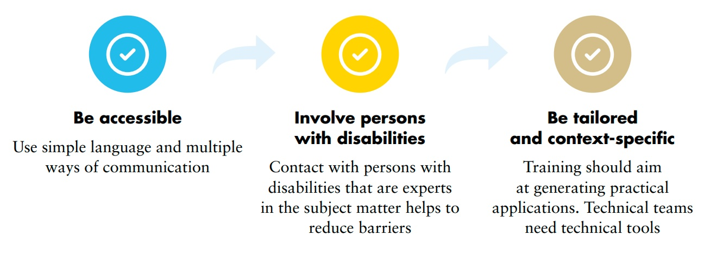
The CRPD indicators consistently include training/capacity building indicators that identify the area of training that is key for advancing specific aspects of a given right and indicators for monitoring progress in training activities.
 Training package on the CRPD
The Office of the United Nations High Commissioner for Human Rights developed training guidelines and modules to ensure a clear understanding of the human rights-based approach to disability. These guidelines aim at providing an overview of the different key aspects of the CRPD and some exercises that can be used and adapted to specific contexts. The guidelines and modules are translated in all United Nations languages.
Source: Office of the United Nations High Commissioner for Human Rights, "OHCHR Training Package on the Convention on the Rights of Persons with Disabilities", 2012-2020

8. International cooperation
17.2 Developed countries to implement fully their official development assistance commitments, including the commitment by many developed countries to achieve the target of 0.7 per cent of gross national income for official development assistance (ODA/ GNI) to developing countries and 0.15 to 0.20 per cent of ODA/GNI to least developed countries; ODA providers are encouraged to consider setting a target to provide at least 0.20 per cent of ODA/GNI to least developed countries
International cooperation is an important source of financial and technical support for the implementation of the SDGs. In this regard, cooperation agencies and international organizations play an important role to foster CRPD implementation. International development banks, such as the Inter-American Development Bank and the Asian Development Bank, offer loans to the public sector for investments (e.g. infrastructure), to support policy reform and development, and to mitigate the effects of macroeconomic crises.
Article 32 of the CRPD calls for all relevant international cooperation programmes to be inclusive of, and accessible to, persons with disabilities. In particular, no funds from international cooperation should be allocated to support measures contrary to the CRPD, e.g. financial support to build new residential institutions for persons with intellectual disabilities which impede their right to live in the community.
National policymakers across different sectors have the opportunity of exploring international cooperation opportunities, together with the department and/or ministry in charge of international cooperation agreements. These can be for funding; to develop or enhance national programmes or projects; to develop capacity-building activities; and/or to seek for technical or economic assistance in a particular area, e.g. training of teachers in inclusive education pedagogy. All initiatives, investments and efforts should be carried out with the participation of organizations of persons with disabilities– both those located in beneficiary countries and those located in donor countries.
Public programmes financed by international cooperation raise the concern of financial sustainability. As many policy initiatives on the rights of persons with disabilities (especially those which are innovative and in line with the CRPD) may initially rely on international cooperation funding, governments may have to foresee, well in advance, regular funding from the national budget, as well as the related source, to ensure the continuation of policies considered positive for the implementation of the SDGs for persons with disabilities.
 The Global Action on Disability (GLAD) Network
The Global Action on Disability (GLAD) Network is a coordination body of bilateral and multilateral donors and agencies, the private sector and foundations committed to the inclusion of persons with disabilities.
Since 2015, the GLAD Network provides a platform for exchange and collaboration between its members, organizations of persons with disabilities and governments, increasing their technical skills and financial commitments to advance the inclusion of persons with disabilities in international cooperation and humanitarian action.
Key issues related to disability and international cooperation
Foreign debt and fiscal consolidation pressure for austerity measures
Following the international financial crisis, many countries’ actions have been conditioned by their decision to adopt fiscal consolidation measures, on occasions required by international financial institutions or by foreign debt services. This has led to the adoption of “austerity measures”, particularly in the area of social protection, reducing the resources available and, thus, negatively and disproportionally impacting persons with disabilities in their income, health and life. This is particularly relevant, once again, in a post-COVID world.
International cooperation actors, including financial institutions, should be attentive to the potential negative effects of their requirements. While pursuing a sound macroeconomic framework is important, measures in that direction should avoid negative effects on persons with disabilities. Societal burdens should continue to be fairly distributed among different sectors and segments of the population, protect marginalized groups of society, and must not increase the exclusion and barriers persons with disabilities face in exercising their rights (See United Nations, Human Rights Council. Report of the Independent Expert on the effects of foreign debt and other related international financial obligations of States on the full enjoyment of all human rights, particularly economic, social and cultural rights, Cephas Lumina. 10 April 2011. A/HRC/20/23).
A twin-track approach is required
International cooperation plays an important role in progressing advances in policies, programming and investment on disability targeted initiatives, such as support to organisations of persons with disabilities; assistive technology; and developing systems for the provision of various types of disability support. It is equally important to mainstream disability into all other existing international cooperation priorities and investments, to avoid that persons with disabilities are left behind.
South-South cooperation
Many areas of CRPD implementation imply a change of approach in legislation and policy, rather than great amounts of additional financial resources. In addition, important developments are taking place in low- and middle-income countries, e.g. legal capacity reforms.
South-South international cooperation is an important tool for many countries, particularly in relation to technical cooperation. Policymakers should explore what their colleagues are doing and resourcing, in countries with similar situations, to reflect on what can be learned and applied, to create positive policy developments in their own countries.
Related CRPD Indicators 32.1, 32.2, 32.3, 32.7 and 33.3

9. Additional Resources
Key Concepts
United Nations, Convention on the Rights of Persons with Disabilities.
United Nations, Report of the Special Rapporteur on the rights of persons with disabilities and disability-inclusive policies, Catalina Devandas-Aguilar. 9 August 2016. A/71/314.
United Nations, Committee on the Rights of Persons with Disabilities. General comment No. 2 (2014), Article 9: Accessibility. 22 May 2014. CRPD/C/GC/2.
United Nations, Committee on the Rights of Persons with Disabilities. General comment No. 3 (2016) on women and girls with disabilities. 25 November 2016. CRPD/C/GC/3.
United Nations, Committee on the Rights of Persons with Disabilities. General comment No. 6 (2018) on equality and non-discrimination. 26 April 2018. CRPD/C/GC/6.
United Nations, Committee on the Rights of Persons with Disabilities. General comment No. 7 (2018) on the participation of persons with disabilities, including children with disabilities, through their representative organizations, in the implementation and monitoring of the Convention.
9 November 2018. CRPD/C/GC/7.
United Nations, Human Rights Council. Awareness-raising under article 8 of the Convention on the Rights of Persons with Disabilities. 17 December 2019. A/HRC/43/27.
United Nations, Report of the Special Rapporteur on the rights of persons with disabilities and the impact of ableism in medical and scientific practice, Catalina Devandas-Aguilar. 17 December 2019. A/HRC/43/41.
United Nations, Report of the Special Rapporteur on the rights of persons with disabilities and participation in decision-making, Catalina Devandas-Aguilar. 12 January 2016. A/HRC/31/62.
United Nations, Report of the Special Rapporteur on the rights of persons with disabilities and rights-based support, Catalina Devandas-Aguilar. 20 December 2016. A/HRC/34/58.
Office of the United Nations High Commissioner for Human Rights. OHCHR Training package on the Convention on the Rights of Persons with Disabilities, 2012.
World Health Organization. Policy brief: access to assistive technology, 2020.
Governance
United Nations, Human Rights Council. Thematic study by the Office of the United Nations High Commissioner for Human Rights on the structure and role of national mechanisms for the implementation and monitoring of the Convention on the Rights of Persons with Disabilities.
22 December 2009. A/HRC/13/29.
Strategic planning for policy implementation
United Nations. Report of the Special Rapporteur on the rights of persons with disabilities and disability-inclusive policies, Catalina Devandas-Aguilar. 9 August 2016. A/71/314.
Participation
United Nations, Committee on the Rights of Persons with Disabilities. General comment No. 7 (2018) on the participation of persons with disabilities, including children with disabilities, through their representative organizations, in the implementation and monitoring of the Convention.
9 November 2018. CRPD/C/GC/7.
United Nations, Human Rights Council. Report of the Special Rapporteur on the rights of persons with disabilities and participation in decision-making, Catalina Devandas-Aguilar. 12 January 2016. A/HRC/31/62.
Cote, Alexandre. The unsteady path: Towards meaningful participation of Organisations of Persons with Disabilities in the implementation of the CRPD and SDGs. A pilot study by Bridging the Gap. Madrid, 2020.
International Disability Alliance. Increasingly Consulted but not yet Participating: IDA Global Survey on Participation of Persons with Disabilities in Development Programmes and Policies (2020).
Disability-based discrimination
United Nations, Committee on the Rights of Persons with Disabilities. General comment No. 6 (2018) on equality and non-discrimination. 26 April 2018. CRPD/C/GC/6.
United Nations, Human Rights Council. Thematic study by the Office of the United Nations High Commissioner for Human Rights on quality and non-discrimination under article 5 of the Convention on the Rights of Persons with Disabilities. 9 December 2016. A/HRC/34/26.
Legal capacity
United Nations, Committee on the Rights of Persons with Disabilities. General comment No.1 (2014) Article 12: Equal recognition before the law. 19 May 2014. CRPD/C/GC/1.
United Nations, Human Rights Council. Report of the Special Rapporteur on the rights of persons with disabilities and legal capacity, Catalina Devandas-Aguilar. 12 December 2017. A/HRC/37/56.
Finance & budget
Beales, Sylvia. Bridging the Gap II: Disability-Inclusive Procurement. Guidance Note. London, March 2020.
Office of the United Nations High Commissioner for Human Rights & International Budget Partnership. Realizing Human Rights through Government Budgets. United Nations Publication, 2017.
Data
The Washington Group. Washington Group on Disability Statistics. 2020.
Access to information
United Nations, Committee on the Rights of Persons with Disabilities. General comment No. 2 (2014), Article 9: Accessibility. 22 May 2014. CRPD/C/GC/2.
W3C Web Accessibility Initiative. Web Content Accessibility Guidelines (WCAG) Overview. W3C, 2020.
CBM. Digital Accessibility Toolkit.
Accountability and access to justice
United Nations, Human Rights Council. Thematic study by the Office of the United Nations High Commissioner for Human Rights on right to access to justice under article 13 of the Convention on the Rights of Persons with Disabilities. 27 December 2017. A/HRC/37/25.
United Nations Human Rights Office of the High Commissioner. International Principles and Guidelines on access to justice for persons with disabilities. 2019.
International cooperation
United Nations. Report of the Special Rapporteur on the rights of persons with disabilities and international cooperation, Catalina Devandas-Aguilar. 20 July 2020.


Office of the United Nations
High Commissioner for Human Rights (OHCHR)
Palais de Nations
CH 1211 Geneva 10 – Switzerland
Email: disability@ohchr.org
Website: www.ohchr.org

