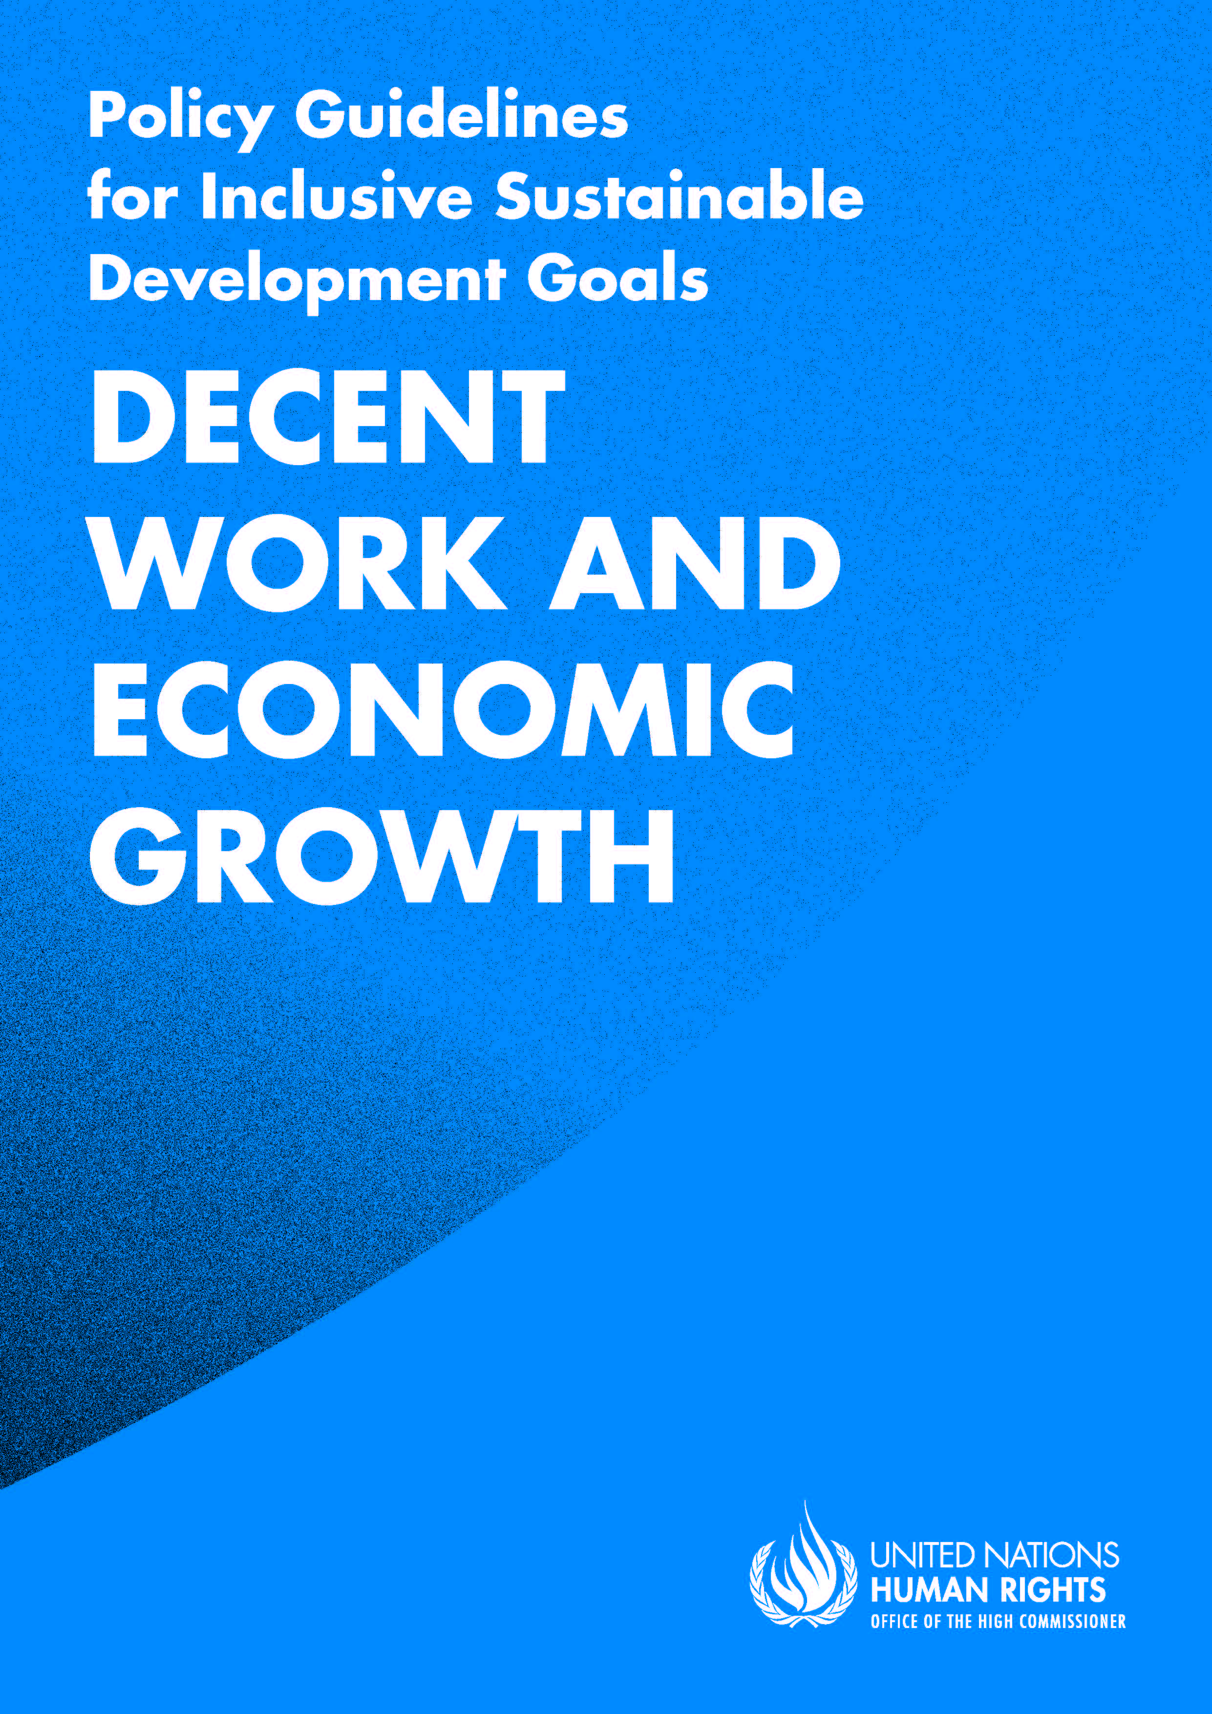


ADVANCE VERSION
© 2020 United Nations
The Policy Guidelines for Inclusive Sustainable Development Goals are a component of the SDG- CRPD Resource Package, developed by the Office of the United Nations High Commissioner for Human Rights (OHCHR). This is an advance version of the SDG-CRPD Resource Package. A final version will be issued upon completion of OHCHR review processes.
The designations employed and the presentation of the material herein do not imply the expression of any opinion whatsoever on the part of the Secretariat of the United Nations concerning the legal status of any country, territory, city or area, or of its authorities, or concerning the delimitation of its frontiers or boundaries.
Symbols of United Nations documents are composed of capital letters combined with figures. Mention of such a figure indicates a reference to a United Nations document.
Photography by Christian Tasso. The photographs featured within the Policy Guidelines were taken as part of the European Union project, Bridging the Gap II – Inclusive Policies and Services for Equal Rights of Persons with Disabilities, and were produced with the financial support of the European Union. They appear courtesy of the International and Ibero-American Foundation for Administration and Public Policies.
The Policy Guidelines for Inclusive Sustainable Development Goals were produced with the financial support of the European Union. Its contents are the sole responsibility of OHCHR and do not necessarily reflect the views of the European Union.

Promote sustained, inclusive and sustainable economic growth, full and productive employment and decent work for all.
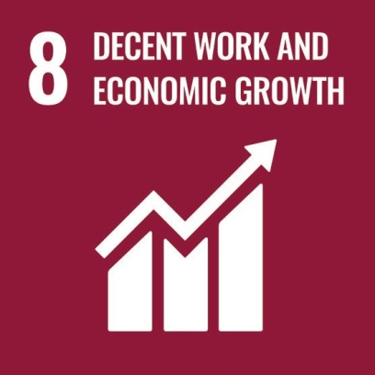
Contents
IN BRIEF 6
1. What is the situation? 7
2. What needs to be done? 11
3. DO’s and DON’Ts 16
IN DEPTH 19
1. Introduction 20
2. Connection to other tools 20
3. Why is Goal 8 important for persons with disabilities? 20
4. Decent work for persons with disabilities: actions applicable across all Goal 8 targets 23
4.1 Governance 23
4.2 Legislation 23
4.3 Close consultation with, and involvement of, persons with disabilities 24
4.4 Awareness-raising 24
4.5 Training on inclusive workplaces 25
4.6 Budget allocation 26
4.7 Data collection and disaggregation 26
4.8 Data protection and privacy 27
4.9 Accountability and complaint mechanisms 27

5. Other key actions by target 28
5.1 Full and productive employment of persons with disabilities – Target 8.5 28
5.1.1 Include the rights of persons with disabilities in labour law, including the prohibition of discrimination, the provision of reasonable accommodation and the right to return to work 28
5.1.2 Adopt an action plan/strategy for the promotion of employment of persons with disabilities in both the private and public sector 29
5.1.3 Carry out awareness-raising campaigns on the labour rights of persons with disabilities 32
5.1.4 Measure and reduce the disability pay gap 33
5.2 Self-Employment of persons with disabilities – Targets 8.3 and 8.10 34
5.2.1 Ensure that mainstream vocational and entrepreneurship training are inclusive of persons with disabilities and that supportive targeted training is available to them 34
5.2.2 Adopt legal and regulatory measures to ensure the equal participation of persons with disabilities in business organizations and equal access to financial services, including micro-finance and credit schemes 35
5.2.3 Make business development services available for persons with disabilities 36
5.3 Protection of labour rights of persons with disabilities – Targets 8.8 and 8.7 37
5.3.1 Ensure freedom of association to persons with disabilities to create and participate in trade unions 37
5.3.2 Ensure that occupational health assessments do not prevent access to employment, based on impairments 38
5.3.3 Incorporate accessibility, in all its dimensions, as a key element of occupational health and safety 40
5.3.4 Adopt disability inclusive strategies against forced labour, including measures to end forced begging and other forms of exploitation 41
6. Additional Resources 42
7. Key Concepts Annex 43

IN BRIEF
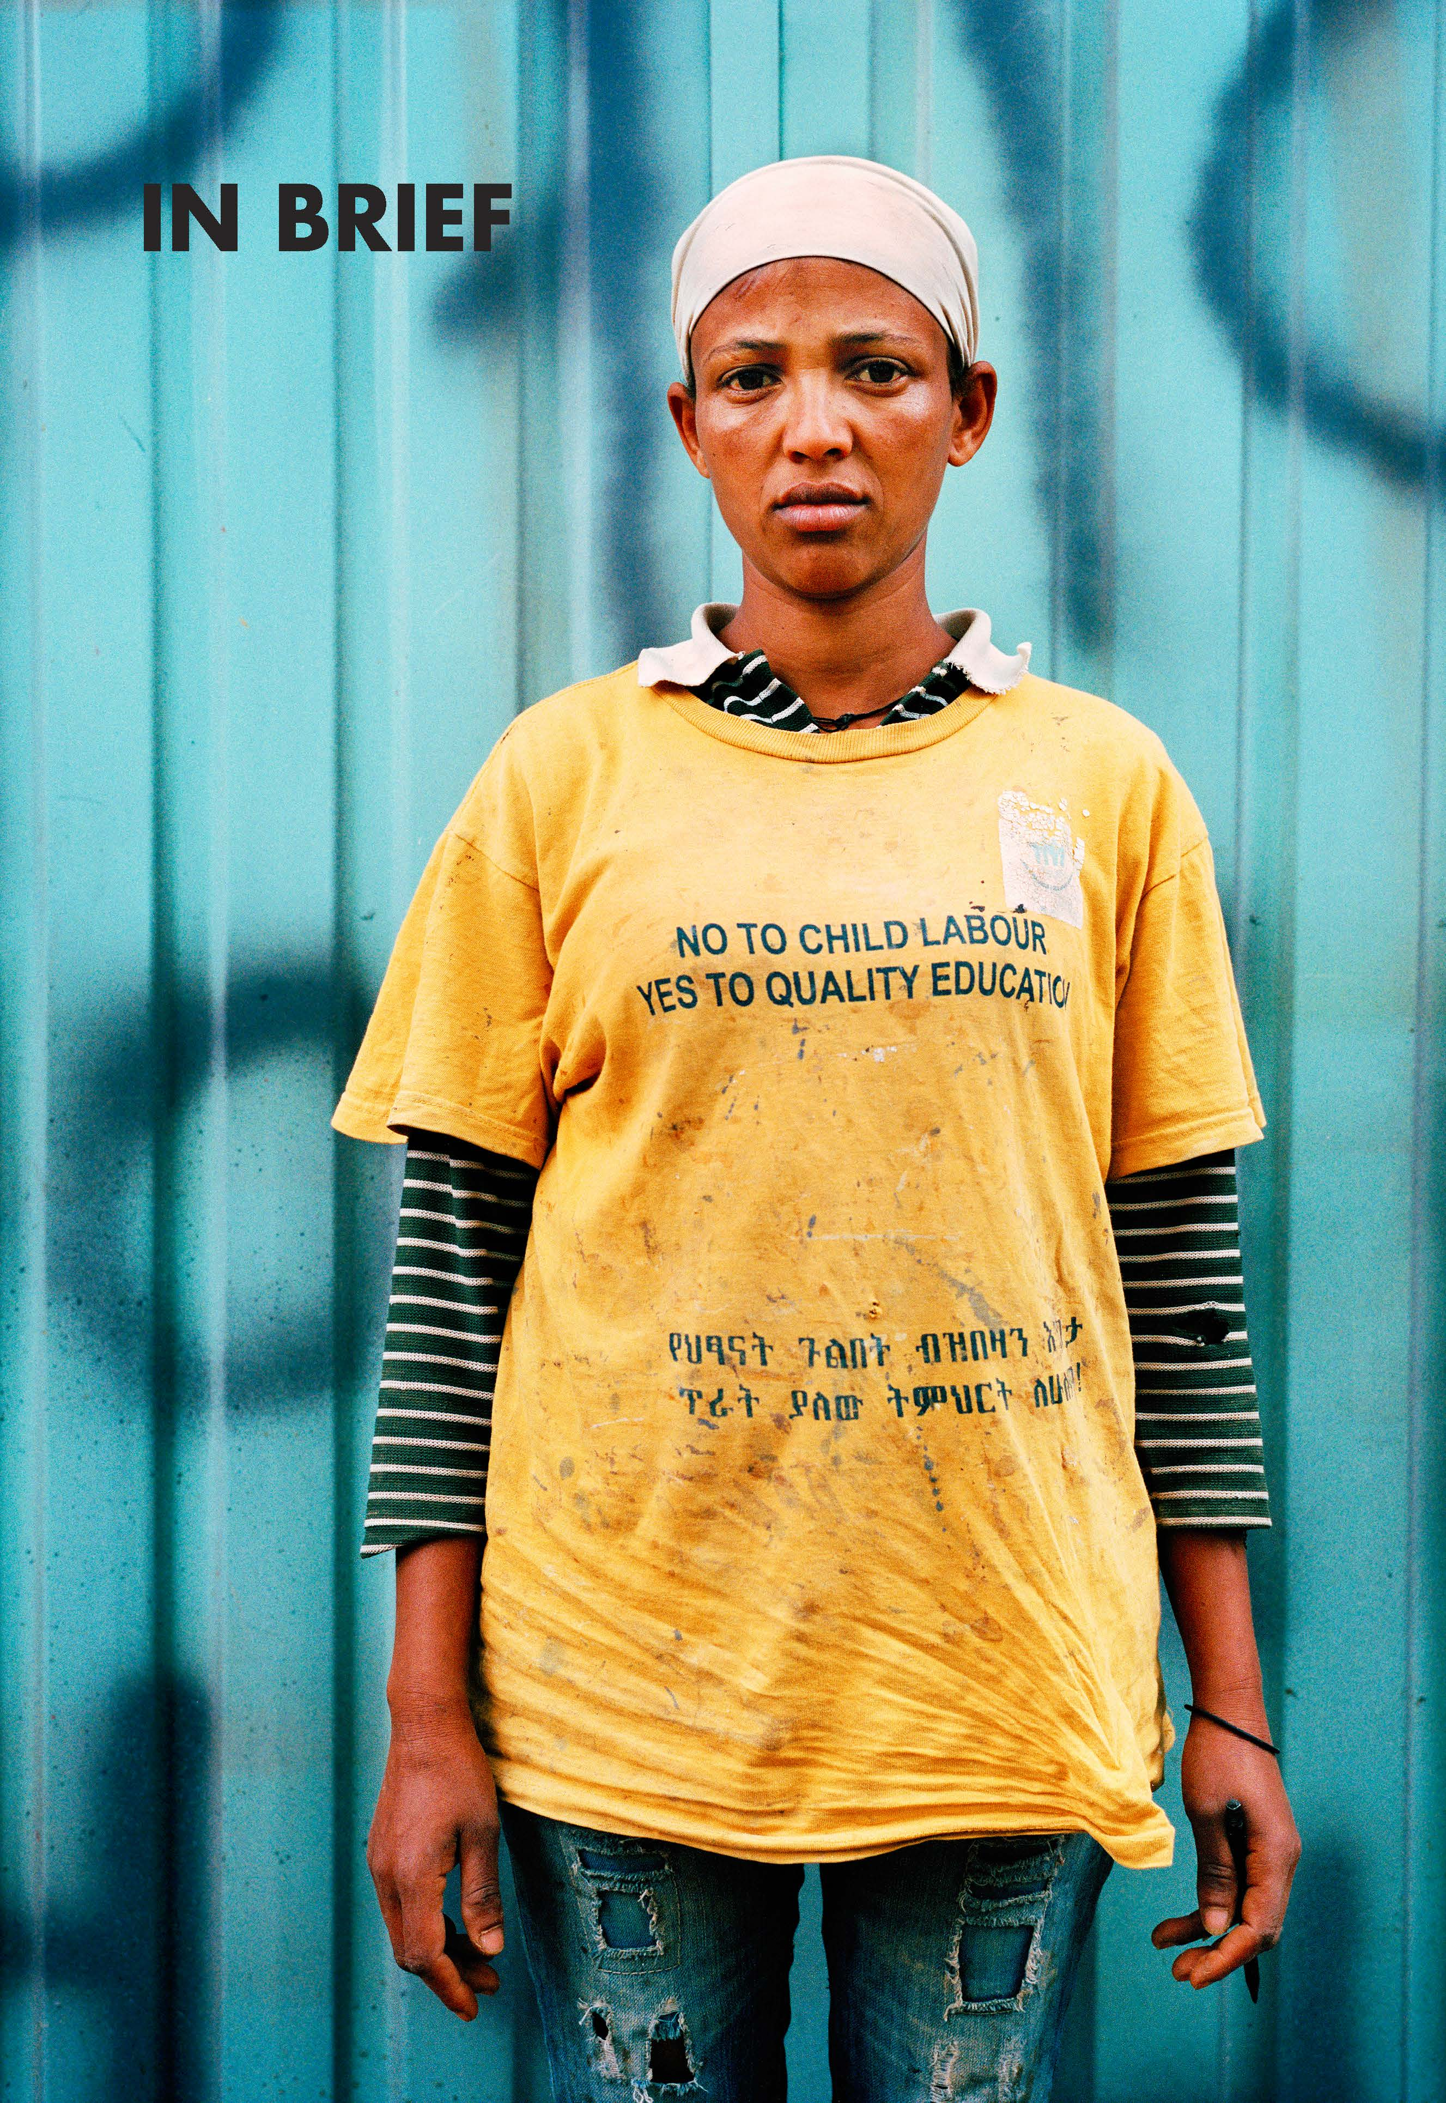

1. What is the situation?
Persons with disabilities have lower rates of employment than other persons. Available data from the United Nations Department of Economic and Social Affairs, Disability and Development Report, 2019) show that, on average, 36 per cent of persons with disabilities are employed compared with 60 per cent of other persons, as shown in figure I.
figure i
Employment to population ratios for persons aged 15 years and over, by disability status, in 8 regions, in 2006-2016
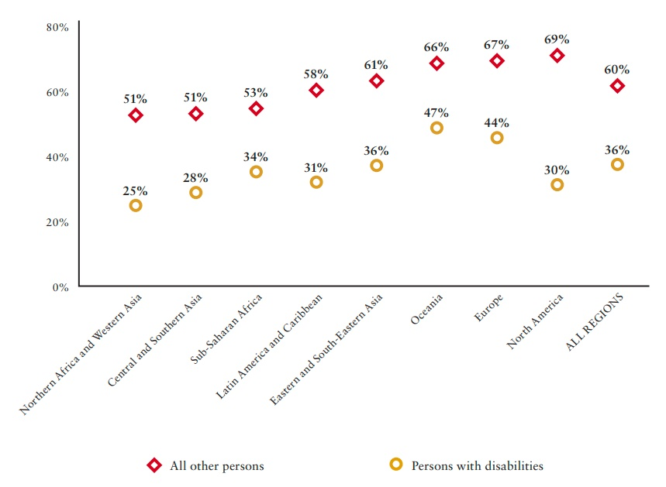
Source: ESCAP, ESCWA, Eurostat, ILO, UNDESA (on the basis of data from IPUMS and SINTEF), as cited in UNDESA, Disability and Development Report, 2019, p. 153.
Data from the Organisation for Economic Co-operation and Development (OECD), also highlight that 49 per cent of persons with disabilities are economically inactive, compared with 20 per cent of other persons, as shown in figure II. Women with disabilities are more excluded from employment than men.
figure ii
Percentage of economically inactive persons with disabilities vs other persons in the OECD (the late 2000s)
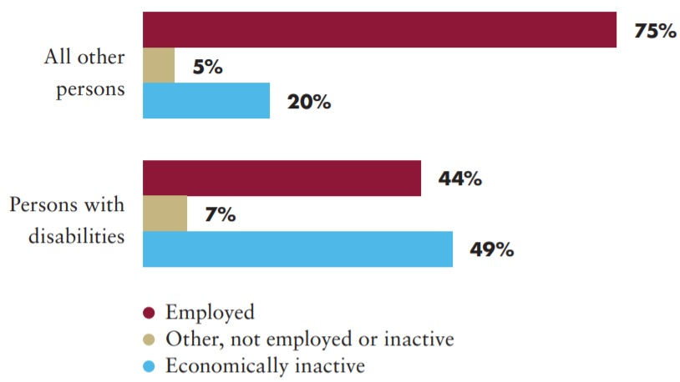
Source: OECD, Sickness, Disability and Work: Breaking the Barriers: A Synthesis of Findings across OECD Countries, 2010.
There is limited data on the “disability pay gap”, but data on three countries indicate of a gap between persons with disabilities and other persons. In one case, for Chile, this gap was of 16 per cent, as shown in figure III
figure iii
Wage Gap for Persons with Disabilities Compared to Others (3 countries)
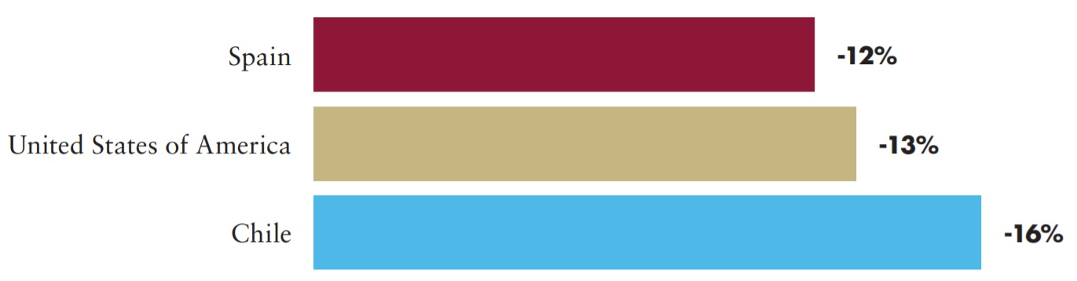
Source: National Statistical Institute of Spain, Erickson et al (2014) and Ministry of Social Development of Chile, as cited in UNDESA, Disability and Development Report, 2019, p. 159.
Given their exclusion from employment, self-employment remains key for persons with disabilities to earn an income. Data on 19 countries indicate that persons with disabilities are 9 per cent more represented than persons without disabilities among the self-employed, on average, with higher rates for a number of low-income countries (UNDESA, Disability and Development Report, 2019).
Persons with disabilities tend to be excluded from education and vocational training, leading to having fewer skills to perform specific tasks or develop businesses. For more information, see Policy Guideline on SDG 4, section 5.4 on SDG Target 4.4.
Many barriers prevent persons with disabilities from accessing financial services required for developing business, including microfinance programmes. Restrictions to legal capacity may also prevent some persons with disabilities from opening bank accounts or accessing credit (e.g. it may be required for persons with intellectual disabilities or others under guardianship to have their guardian sign contracts or authorise their transactions, in contradiction with the recognition of legal capacity).
Legal provisions, including on legal capacity, may also restrict freedom of association and prevent persons with disabilities from creating or from participating in trade unions. These would allow persons with disabilities to defend, advocate for and mainstream their rights and interests.
Persons with disabilities who are unemployed or out of work may need to rely on social protection schemes, where available, or depend entirely on relatives to provide for basic requirements. These sources of protection may not be adequate to provide for disability-related extra costs (see Policy Guideline on SDG 1) and may push persons with disabilities towards begging, or situations of forced labour and exploitation, such as modern slavery and human trafficking. Data on how these practices affect persons with disabilities are scarce.
Persons with disabilities that seek or gain employment experience many barriers throughout the employment cycle. Common examples range from disability discrimination in recruitment to forced early retirement. Table 1 highlights those barriers and provides links to relevant sections of this document that address them.
table 1
 Common barriers relating to the employment cycle and guideline sections that address them
Common barriers | Actions in this guideline
1. Throughout the employment cycle
Lack of reasonable accommodation | 5.1.1 Prohibit discrimination and ensure the provision of reasonable accommodation
2. Recruitment
Lack of accessibility of recruitment processes (e.g. communications, application forms, interviews)
Negative stereotypes and prejudice leading to direct discrimination (e.g.during an interview) | 4.4 Awareness raising  4.5 Ensure training on inclusive workplaces  5.1.1 Include disability rights in labour law
Pre-employment occupational health assessments excluding persons based on their impairment | 5.3.2 Occupational health assessments should not prevent access to employment based on impairment
3. Labour rights in employment
Inaccessibility of workplaces limits inclusion and increases risks to personal safety and limits inclusion | 5.3.3 Incorporate accessibility as a key element of occupational health and safety
Restrictions to create and/or participate in trade unions (e.g. due to deprivation of legal capacity based on impairment) | 5.3.1 Ensure freedom of association of persons with disabilities
4. Training and Promotion
Trainings might not be inclusive, limiting professional development and promotion | 5.2.1 Ensure inclusive vocational and entrepreneurship training  5.1.2 Adopt a strategy to promote employment of persons with disabilities
5. Retention and return to work
Occupational health criteria may restrict return to work of employees with disabilities, including those who recently acquired an impairment | 5.1.1 Include disability rights in labour law  5.3.2 Occupational health assessments should not prevent access to employment based on impairment
6. Retirement
Persons with disabilities, in particular those who recently acquired an impairment, are often forced to early retirement based on their impairment | 4.2 Legislation  5.1.1 Include disability rights in labour law

2. What needs to be done?
Addressing the barriers to inclusion of persons with disabilities in employment is essential for achieving Sustainable Development Goal 8 (SDG 8) and targets such as 8.1 – “sustain per capita economic growth in accordance with national circumstances, and in particular, at least 7 per cent gross domestic product [GDP] growth per annum in the least developed countries”– as demonstrated in figure IV.
figure iv
Process for achieving target 8.1
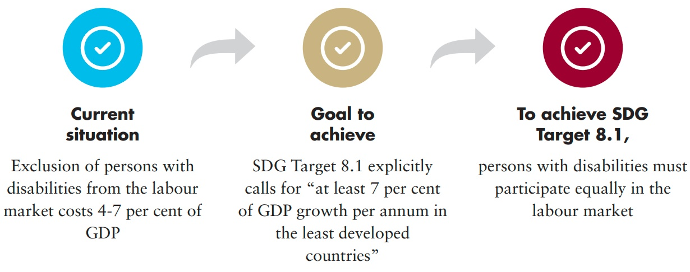
figure v
Steps to achieve inclusion in employment
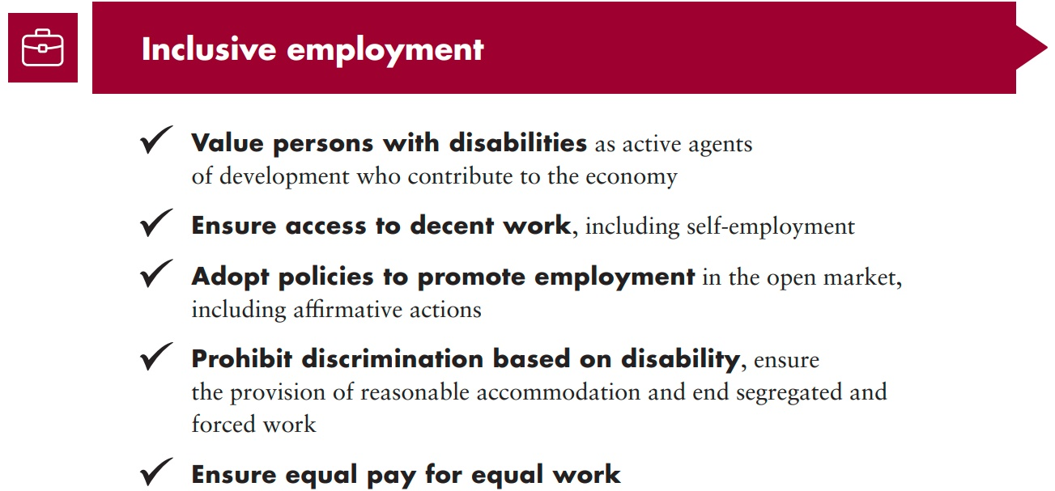
Main areas of intervention to realise Sustainable Development Goal 8
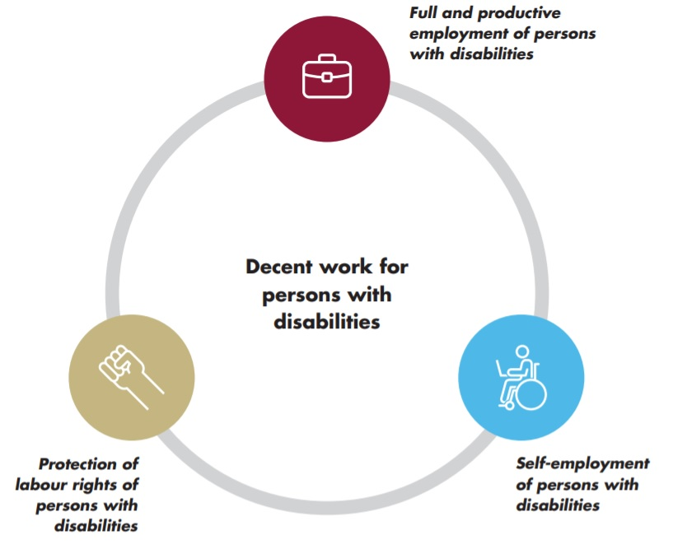
 Decent work for persons with disabilities: Actions applicable across all targets of SDG 8
 Promote sustained, inclusive and sustainable economic growth, full and productive employment and decent work for all
Legislation: The law should provide the basis for removal of barriers and discrimination and regulate the access to employment and labour rights of persons with disabilities on an equal basis with others.
Close consultation and involvement of persons with disabilities: The Ministry of Labour should ensure a systematic and diverse representation of persons with disabilities in the design, implementation and monitoring of policies, to promote their employment.
Awareness-raising: Ministries of Labour and employer federations/ associations should undertake a range of awareness-raising measures targeting senior management, recruitment professionals and agencies among public and private business corporations, as well as among banking and financial services, to tackle stereotypes and prejudice against persons with disabilities in employment.
Training on inclusive workplaces: Ministries of Labour, in collaboration with representative organisations of persons with disabilities, should offer training on concrete strategies towards inclusion in employment. This should be offered to public officials responsible for employment policy, senior managers, employment services and human resources professionals, both from the public and private sectors.
Budget allocation: Ministries should allocate public resources to contribute to the employment of persons with disabilities, using markers to track expenditure.
Data collection and disaggregation: Ministries of Labour should ensure that data on employment are collected and disaggregated by disability.
Data protection and privacy: Government should ensure employment policies and data protection policies refer to privacy, including data management, to protect persons with disabilities.
Accountability and complaint mechanisms: Ministries of Labour should establish internal complaints mechanisms to enable persons with disabilities to bring complaints before the administrative authorities and obtain effective remedies.

Related CRPD indicators: 27.1, 27.2, 27.3, 27.4, 27.11, 27.15, 27.16, 27.17, 27.18, 31.2
 Full and productive employment of persons with disabilities
8.5 By 2030, achieve full and productive employment and decent work for all women and men, including for young people and persons with disabilities, and equal pay for work of equal value
Include the rights of persons with disabilities in labour law, including the prohibition of discrimination, the provision of reasonable accommodation and the right to return to work
Adopt an action plan/ strategy for the promotion of employment of persons with disabilities in both the private and public sector
Carry out awareness- raising campaigns on the labour rights of persons with disabilities
Measure and reduce the disability pay gap
Related CRPD indicators: 5.7, 5.11, 5.12, 13.14, 27.1, 27.4, 27.13, 27.16, 27.25
 Self-employment of persons with disabilities
8.3 Promote development-oriented policies that support productive activities, decent job creation, entrepreneurship, creativity and innovation, and encourage the formalization and growth of micro-, small- and medium-sized enterprises, including through access to financial services
8.10 Strengthen the capacity of domestic financial institutions to encourage and expand access to banking, insurance and financial services for all
Ensure that mainstream vocational and entrepreneurship training are inclusive of persons with disabilities and that supportive targeted training is available to them
Adopt legal and regulatory measures to ensure the equal participation of persons with disabilities in business organizations and equal access to financial services, including micro-finance and credit schemes
Make business development services available for persons with disabilities

Related CRPD indicators: 9.3, 9.4, 12.1, 12.2, 12.15, 19.12, 19.13, 19.26, 24.5, 24.20, 24.27, 27.1, 27.4, 27.12, 27.15, 27.19, 28.3, 28.4, 28.5, 28.14
Protection of labour rights of persons with disabilities
8.8 Protect labour rights and promote safe and secure working environments for all workers, including migrant workers, in particular women migrants, and those in precarious employment
8.7 Take immediate and effective measures to eradicate forced labour, end modern slavery and human trafficking and secure the prohibition and elimination of the worst forms of child labour, including recruitment and use of child soldiers, and by 2025 end child labour in all its forms
Ensure freedom of association to persons with disabilities to create and participate in trade unions
Ensure that occupational health assessments do not prevent access to employment, based on impairments
Incorporate accessibility in all its dimensions as a key element of occupational health and safety
Adopt disability inclusive strategies against forced labour, including measures to end forced begging and other forms of exploitation

Related CRPD indicators: 16.1, 16.3, 16.13, 27.1, 27.2, 27.5, 27.7, 29.9, 29.11, 29.23

3. DO’s and DON’Ts
DO | DON’T
Law, policy and programmes
Include the rights of persons with disabilities in mainstream labour legislation, such as labour codes | Limit the provisions on disability rights to a disability-specific law. This would undermine the visibility of persons with disabilities across sector-specific legislation, including employment law
Develop and share guidance and good practice on reasonable accommodation among employers, trade unions and persons with disabilities | Refer to reasonable accommodation only in general clauses in legislation. Instead, explain it further in detailed regulations and guidance
Ensure that employment laws and policies guarantee the right of workers to remain in their post after acquiring an impairment. This should include provisions for reasonable accommodation if needed, relocation to another post or adjustment of work responsibilities, to remain in employment.  Access to professional and technical re- adaptation programmes should be ensured to support this. | Promote early retirement or pension based on acquiring an impairment, unless all measures for retaining the person in the workforce are exhausted
Adopt specific measures to promote the employment of persons with disabilities in the private and public sectors. This could include employment targets, quotas, fiscal, financial and public procurement incentives, among others. | Establish reserved employment that:  - prevents career advancement  - restricts the number of hours that a person with disability can work  - mandates absolute protection against the dismissal of persons with disabilities  These measures make persons with disabilities less likely to seek employment and employers less likely to hire persons with disabilities
Design protocols, under national legislation, that ensure that recruitment processes consider whether candidates are suitable for the core functions of the job if provided with reasonable accommodation when required | Establish recruitment requirements that go beyond the core functions of the job, nor processes that disregard the provision of reasonable accommodation

DO | DON’T
Adopt measures to prevent discrimination against persons with disabilities accessing affordable, low-rate credit and micro-credit to start their own businesses. Measures should also ensure recognition of the legal capacity of persons with disabilities and include awareness- raising to combat negative stereotypes about persons with disabilities being incapable, unproductive, unable to succeed in economic activities or pay back credits | Limit the access of persons with disabilities to general credit lines, based on stereotypes or legal capacity status
Adopt measures to ensure and monitor that persons with disabilities access equal pay for equal work, in line with legal regulations and market standards applicable to all other workers in the same category | Allow salaries for persons with disabilities to be below minimum wage or market standards, nor allow that persons with disabilities do not receive any salary or remuneration for their work
Ensure a social protection system that enables persons with disabilities to access supports and cover their disability-related costs | Create social protection systems that prevent persons with disabilities from working as many hours as they are capable, for fear of losing their benefits
Practice and implementation
Ensure that information about candidates and employees, that is collected and held to ensure support and reasonable accommodation, is managed confidentially and not used for other purposes | Disclose disability-related information beyond what might be required for the provision of support and reasonable accommodation
Promote employment for all persons with disabilities in the open labour market | Create segregated employment settings for persons with disabilities, regardless of their impairment (e.g. sheltered employment/ workshop, protected employment)
Promote in-job training inclusive of, and accessible to, persons with disabilities | Create capacity-building schemes for persons with disabilities that are disconnected from economic reality and from accessing employment positions

DO | DON’T
Participation
Include persons with all types of disabilities in the national development plan, as agents of change. They are active members of the workforce and contribute to increasing productivity and economic growth | Assume that persons with disabilities cannot contribute to development and are only passive recipients of social aid
Research, data collection and disaggregation
Integrate the “Functional Difficulties and Barriers to Employment” module from the International Labour Organization (ILO) into labour force surveys, to disaggregate data by disability and further data collection on inclusion in the labour force. This ideally includes the Washington Group Short Set, together with optional questions that include psychosocial disabilities and some questions on barriers, accommodations and attitudes | Overlook the importance of collecting data on the employment and economic activities of persons with disabilities through labour force surveys and other instruments, nor limit data collection to disability-specific surveys
Accountability
Monitor the implementation of disability- inclusive labour policies through complaint mechanisms, including those under the Ministry of Labour and the National Human Rights Institution | Limit the possibility of bringing complaints about non-inclusive labour policies and practices to the judiciary, including on disability-based discrimination

IN DEPTH


1. Introduction
This section provides detailed guidance for policymakers on the actions needed for a disability- inclusive implementation of Sustainable Development Goal 8.
Section 2 shows the connection between the Policy Guidelines to achieve SDG 8 with other resources, including the human rights indicators under the Convention on the Rights of Persons with Disabilities (CRPD) and other related tools.
Section 3 provides an overview of the situation of inequality and discrimination faced by persons with disabilities in accessing work and employment, demonstrating why SDG 8 is key to their development.
Sections 4 and 5 provide guidance on policy measures and actions that should be adopted for inclusive implementation of SDG 8. Section 4 addresses the structural measures that are required to ensure equal opportunities for persons with disabilities in accessing decent work. Section 5 provides key considerations and guidance on other actions specific to each SDG 8 target. First, Target 8.5 is addressed under the full and productive employment of persons with disabilities, with a focus on formal employment, while Targets 8.6 and 8.b are considered specifically in relation to youth with disabilities. Second, Targets 8.3 and 8.10 are related to self-employment and the capacity to initiate business and autonomous economic activity, which is sometimes the only option for persons with disabilities to earn a living. Finally, under Targets 8.8 and 8.7, key issues around labour rights for persons with disabilities are addressed, particularly looking at safety and security, freedom of association and exploitation.
Targets 8.1, 8.2, 8.4 and 8.a are not considered in this guideline as they are not population-based and refer to macroeconomic issues, productivity, resource efficiency and aid for trade – thus beyond the scope of the guidelines. Target 8.9 addresses sustainable tourism as a job-creating industry and is addressed in the Thematic Brief on tourism.

2. Connection to other tools
  - CRPD Indicators: Article 27 (work and employment)
  - Other related CRPD articles: 1-4, 5, 6, 8, 9, 12, 13, 19, 24, 26, 28 and 31
  - Data Sources Guidance: Article 27 and other related CRPD articles
  - Training materials: Goal 8
  - Video: Goal 8

3. Why is Goal 8 important for persons with disabilities?
Persons with disabilities experience barriers to participating in employment
Persons with disabilities face a range of barriers to participating in economic life. Exclusion from education and low educational attainment are significant barriers to employment (see Policy Guideline on SDG 4). Attitudinal barriers also prevent persons with disabilities from having equal opportunities and outcomes in economic life.
Barriers to the accessibility of the physical environment, information and communications also limit the access to, and participation in, employment. In addition, the removal of legal capacity prevents some persons with disabilities from signing and engaging in employment contracts.
Persons with disabilities have much lower rates of employment than others
As a result of a number of barriers, persons with disabilities have half the access to employment of others. Data collected across eight regions, indicate that the average employment rate of persons with disabilities is 36 per cent, compared with 60 per cent for others (UNDESA, Disability and Development Report, 2019, p. 153). Similarly, data from the OECD show a higher rate of economic inactivity of persons with disabilities when compared to others: 49 per cent and 20 per cent, respectively (OECD, Sickness, Disability and Work: Breaking the Barriers: A Synthesis of Findings across OECD Countries, 2010, p. 23). Women with disabilities may experience higher levels of exclusion compared to their male and female peers (see Policy Guideline on SDG 5, section 5.3.1).
Persons with disabilities experience wage gaps and segregation
Persons with disabilities who are employed tend to earn less than others. Data are limited, but data collected in three countries show wage gaps of 12 to 16 per cent, and in two of these cases, persons with intellectual disabilities have wage gaps of 29 and 49 per cent (UNDESA, Disability and Development Report, 2019, p. 158).
In many countries, segregated employment settings are still promoted. These include sheltered workshops where labour protections are not provided and salaries are either below minimum wage or non-existent and replaced, in some cases, by stipends. Data from Eurostat (Labour Market Policy Dataset, Category 5.1, 2016) show that countries invest thousands of millions of euros to promote and maintain segregated settings, with one country spending 1,840 million euros.
Persons with disabilities experience barriers to effective self-employment
Because of their exclusion from employment, self-employment remains key for persons with disabilities to earn an income. Data on 19 countries indicate that persons with disabilities are 9 per cent more represented than persons without disabilities among the self-employed, on average, with higher rates for a number of low-income countries (UNDESA, Disability and Development Report, 2019, p. 157).
Access to financial services (e.g. bank accounts and credits) is essential for developing a business. However, many barriers prevent access to financial services by persons with disabilities. Data from five low- and middle-income countries indicate that between 8 and 64 per cent of persons with disabilities consider banks inaccessible (UNDESA, Disability and Development Report, 2019, p. 38). Likewise, data from 2017, mostly from high-income countries, indicate that 28 per cent of banks and 12 per cent of automated teller machines (ATMs) were not accessible. In many countries, the removal of legal capacity of persons with disabilities prevents them from opening bank accounts (e.g. blind persons may be rejected or have to comply with additional requirements, such as having a witness; persons with intellectual disabilities may be requested to have a guardian appointed to authorise transactions). Women with disabilities may face additional difficulties in accessing financial services due to gender-based barriers that restrict their legal capacity, either in law or in practice.
The participation of persons with disabilities in trade unions is often limited
Trade unions have played a key role in promoting the employment and working conditions of persons with disabilities in many contexts, as outlined by ILO, Trade Union action on Disability and Decent Work: A Global Overview (2017). In many contexts though, an outdated approach may still be used and the labour rights of persons with disabilities overlooked. Restrictions to the legal capacity of persons with disabilities may restrict freedom of association and prevent some persons with disabilities from creating or participating in trade unions – thus limiting their opportunities to defend, advocate for and mainstream their rights and interests.
Occupational health assessments do not always look at the ability of the person to fulfil the essential functions of a job
Before and during employment, occupational health assessments may be required to assess whether the applicant or employee can comply with the essential functions of the job or whether any accommodations are required, as well as to provide a healthy work environment. However, occupational health assessments also entail risk. Employers commonly rely on blanket medical assessments which may categorise persons with disabilities as “incapable of working” on the basis of impairment, instead of assessing the capabilities and requirements of each individual to perform the core functions of the job. To avoid this, clear regulations should be developed.
Lack of workplace accessibility can prevent or limit inclusion
Accessibility of the workplace, including of information, communication and transportation to get to work, is key for the inclusion and participation of persons with disabilities in employment, on an equal basis with others, while ensuring the safety of workers with disabilities. Accessible environments prevent accidents and facilitate the evacuation of everyone, including persons with disabilities, in the event of an emergency.
Alternatives to employment often do not provide for the basic requirements of persons with disabilities and can lead to exploitation
Persons with disabilities who are unemployed may need to rely on social protection schemes, where available, or depend entirely on their family to provide for their basic requirements. As those options may not provide for the minimum standard of living outlined under SDG 1 (end poverty in all its forms everywhere), this may lead to persons with disabilities being pushed towards begging, forced labour or exploitation, such as modern slavery and human trafficking. There is limited data on how these practices affect persons with disabilities.
The design of social protection schemes can be a barrier to employment
When social protection programmes link disability benefits to “incapacity to work” they make persons with disabilities less likely to seek work – they are put in the position of deciding between the certainty of minimal benefits versus the risk of trying to find and maintain employment in an environment filled with barriers.
Trying to work can also increase the costs of living with disabilities, due to the need for more supports and/or devices. A better strategy is to separate social protection benefits that address the costs of disability, regardless of work, from benefits aimed at unemployment and poverty alleviation (see Policy Guideline on SDG 1).
Further studies are needed on the barriers to persons with disabilities present in current efforts to achieve SDG 8, as well as on accessibility, protection against discrimination and legal capacity.

4. Decent work for persons with disabilities: actions applicable across all Goal 8 targets
Promote sustained, inclusive and sustainable economic growth, full and productive employment and decent work for all

4.1 Governance
The Ministries or secretariats of Labour are the leading government departments on employment policies. They coordinate and facilitate dialogue with and among representatives of businesses (e.g. chambers), representatives of employees (e.g. trade unions) and other groups with interests in employment policies (including civil society organizations such as organizations of persons with disabilities).
Ministries of Labour have a regulatory and monitoring role towards the private sector of the economy and, usually, a more direct administrative role regarding public employment (e.g. through the public service office). As the ministries fulfil these roles, they also have a role in coordinating with the disability focal point. This is key to promoting and ensuring the inclusion of persons with disabilities in employment (e.g. through monitoring compliance with employment quotas by public agencies – see box on employment quotas in section 5.1.2; providing guidance to private employers on recruitment processes and reasonable accommodation for persons with disabilities; guidance to business development and financial services providers).

4.2 Legislation
Labour law should consider persons with disabilities as active agents of the workforce and should provide the basis for the removal of structural barriers and systemic discrimination. It should regulate non-discrimination in employment, job advertising, recruitment processes, return to work, reasonable accommodation, promotion and retirement conditions, enabling persons with disabilities to enjoy and exercise labour rights on an equal basis with others. Regulations should also address monitoring mechanisms, to ensure that persons with disabilities are treated fairly and that safety and security regulations operate to their benefit (and not against them). In many countries, the rights of persons with disabilities have not been integrated into labour law yet. This limits the visibility and enforcement of the equality of their rights.
Further detail on actions around legislation is also provided under section 5.1.1.

4.3 Close consultation with, and involvement of, persons with disabilities
The Ministry of Labour should ensure the systematic participation of, and active consultation with, persons with disabilities and their representative organizations in the design, implementation and monitoring of policies to promote their employment. This should involve a diverse representation of persons with disabilities, ensuring that the requirements of persons with a broad range of impairments and of different genders are considered.
 Recommendation
Ensure consultation with persons with disabilities and their representative organizations on key areas, including legislation and policies on employment and related training; plans and measures to support entrepreneurship by persons with disabilities (including access to financial services); legislation and regulations on trade unions; measures to prevent forced labour;
cross-ministry consultations on the interaction of social protection and employment.
Related CRPD indicator: 27.17
See also Foundations Guideline, sections 2.4 and 4 on participation of persons with disabilities and the video on participation developed by the Special Rapporteur on the rights of persons with disabilities.

4.4 Awareness-raising
Negative stereotypes and prejudice prevent the access of persons with disabilities to employment. These can include beliefs that persons with disabilities lack skills, are unproductive or less productive than others or have high levels of absenteeism. Such stereotypes and prejudice create attitudinal barriers. These can include attitudes of employers, potential business partners (e.g. in the context of cooperative enterprises and other similar organizations) or co-workers.
Removing these attitudinal barriers requires the promotion of a cultural change in the business world, through strong awareness-raising policies and activities.
 Recommendations
Ministries of Labour and employer federations/ associations can undertake a range of awareness- raising measures targeting senior management, recruitment professionals and agencies, among public and private business corporations, as well as among banking and financial services. These could include:
    - Specific conferences and events that enhance the understanding of the positive impacts, for businesses, of employing persons with disabilities
    - Promoting and supporting the development of inclusive business networks. These can facilitate information sharing and showcasing of good practice to inspire others to take action
    - Specific training programmes that can contribute to assessing and reducing prejudice against persons with disabilities, including women with disabilities, by managers and job recruiters
    - Specific awareness-raising activities addressing other workers, which can contribute to enhancing the inclusion of persons with disabilities. This includes ensuring co-workers are aware of how to interact respectfully with persons with disabilities, to enable participation and to avoid stereotyping and prejudice
Representative organisations of persons with disabilities (OPDs) have an important role to play in raising awareness about the situation and rights of persons with disabilities. They should be engaged in developing and validating messaging about persons with disabilities for any awareness-raising campaigns.
Related CRPD indicators: 27.16, 8.2
See also Foundations Guideline, section 2.5 on “Awareness-raising”.

4.5 Training on inclusive workplaces
Stereotypes about persons with disabilities being “incapable to work” (see Policy Guideline on SDG 1) need to be actively combatted. Public officials responsible for employment policy, senior managers, employment services and human resources professionals, from both the public and private sectors, require specific training to combat this view – including training on concrete strategies towards inclusion and a highlight of the benefits that persons with disabilities bring to the work environment. The involvement of persons with disabilities in delivering such training can be particularly influential. For example, a panel of persons with disabilities being invited to share their experiences (in this case in relation to inclusion in employment) can be the part of a disability-inclusion training that has the most impact on attendants. Developing networks and communities of practice for information sharing, mutual advice and support and coordinated action can also be very useful.
Building the business case for the inclusion of persons with disabilities
Changing organizational culture is not easy. It requires a sound accountability framework that motivates the organization to move in an inclusive direction and a monitoring system that rewards improvement. Not everything can be solved by changing attitudinal barriers if organizational structures and approaches remain the same. Making the business case for the inclusion of persons with disabilities means highlighting the opportunities that companies gain by bringing in persons with disabilities as customers, clients, employees and managers. A broad range of customers benefit from improved inclusion - making a business accessible for workers with disabilities also makes it accessible for others with reduced mobility, such as older persons. For example, providing a ramp as an alternative to steps enables a broader range of persons to enter or move around a building. Providing signage in large print with images enables a broader range of persons to understand the information. A person with disability is more likely to think of how to make products and services more accessible and notice unintentional barriers to using those products and services. By including persons with disabilities, companies, individuals and society all win (ILO, Employment: the win-win of disability inclusion, InfoStories, December 2016).
The United Nations Global Compact and the International Labour Organization developed a guide to help improve business’ understanding of the rights of persons with disabilities. This includes information on how to respect and support the rights of persons with disabilities and allows business to improve their competitiveness and sustainability, in alignment with relevant United Nations conventions and frameworks (United Nations Global Compact and ILO, Guide for business on the rights of persons with disabilities, 2017).
Related CRPD indicators: 27.15, 5.10
 International Labour Organization Global Business and Disability Network
The ILO Global Business and Disability Network is a unique employer-led initiative that works to promote the inclusion of persons with disabilities in workplaces around the world.
Its members include multinational enterprises, national business, disability networks and international not-for-profit and representative organizations of persons with disabilities. Through their work, members demonstrate the clear business benefits of employing persons with disabilities and highlight the valuable contributions they bring to all types of workplaces.
For more information, see http://www.businessanddisability.org.

4.6 Budget allocation
Resources from the public budget should be allocated to contribute to the employment of persons with disabilities, in both public and private sectors, and markers should be established to track expenditure (see Foundations Guideline, section 3.3.2 on “Disability markers”). For example, reasonable accommodation funds for public sector employees with disabilities; subsidies to promote the employment of persons with disabilities in the private sector.
Related CRPD indicators: 1/4.6, 5.6, 5.9, 5.10

4.7 Data collection and disaggregation
Ministries of Labour should ensure that data on employment are collected and disaggregated by disability. Information on the type of disability is important, so it is best to use questions that will identify persons with a broad range of impairments, including persons with psychosocial disabilities. For this, the Washington Group Short Set – Enhanced is highly suggested.
 Recommendations
In order to accurately assess the inclusion of persons with disabilities in employment over time, Ministries of Labour should:
- Ensure that effective systems are in place to collect administrative data on employment in the public and private sector. This can enable the retrieval and analysis of data (e.g. from social protection systems; from establishment surveys; payroll data).
- Coordinate closely with the national statistical office to ensure that all data on employment are compatible and allow for their analysis over time (e.g. census, labour force surveys, disability surveys)
Related CRPD indicator: 31.2
See also Foundations Guideline, section 3.5 on “Data collection and disaggregation”.

 International Labour Organization Labour Force Surveys
The ILO promotes the inclusion of a module on persons with disabilities in labour force surveys that uses the Washington Group Short Set of Questions and enables the collection of data for disaggregation purposes. In addition, this United Nations agency is currently testing a set of questions that go beyond disaggregation, to explore the roots of exclusion in the labour market.
For more information, see https://ilostat.ilo.org/resources/lfs-resources

4.8 Data protection and privacy
Discrimination based on disability operates in multiple forms in the workplace. One of these is connected to disclosing information about impairments, with behaviour thought to be connected to mental health conditions being particularly highly stigmatized.
Persons with disabilities are protected against discrimination, on an equal basis with others, and data protection supports their right to privacy. Persons with disabilities should not be forced to disclose their impairments.
The capacity to do a job is not described by a personal impairment but by the functions required by a specific job. Health and safety regulations must comply with international standards on data protection, particularly on the protection of sensitive data such as health-related data. Employers can only request health-related data, on all persons, including persons with disabilities, if it complies with data protection regulations and if it is also required of all other employees in the same category.
When persons request reasonable accommodations, assessments should aim to define adjustments, support and re-arrangement of functions and should not require medical information. This process should instead be based on a functional assessment and conducted only when the employer has reasonable doubt on the credibility of the request.
Recommendation
Governments should make specific reference to privacy in employment and data protection policies, including on data management, to protect all persons, including persons with disabilities
Related CRPD indicators: 22.1, 22.2, 22.3, 22.4

4.9 Accountability and complaint mechanisms
The right to work is ultimately ineffective if the system does not have in place robust accountability and complaints mechanisms to invoke and enforce rights.
 Recommendations
- The Ministry of Labour should establish simple and transparent internal complaint mechanisms. These should allow persons with disabilities to bring complaints before the administrative authorities (including cases of discrimination, violence, harassment and exploitation in the workplace) and obtain effective remedies. For example, persons with disabilities should be able to challenge decisions which conclude they are “incapable to work” following a work-mandated medical check-up.
- External complaints mechanisms should also be available, particularly to address dissatisfaction with internal complaint mechanisms. These may include complaint mechanisms within national human rights institutions and courts, such as labour courts or employment tribunals.
Related CRPD indicator: 27.18

5. Other key actions by target

5.1 Full and productive employment of persons with disabilities – Target 8.5
By 2030, achieve full and productive employment and decent work for all women and men, including for young persons and persons with disabilities, and equal pay for work of equal value

5.1.1 Include the rights of persons with disabilities in labour law, including the prohibition of discrimination, the provision of reasonable accommodation and the right to return to work
Legislation on gender equality and on persons with disabilities should be explicit in including women with disabilities and responding to their specific requirements, in order to uphold their rights and prevent violations. In addition, specific measures adopted to increase participation, empowerment and enjoyment of the rights of women should address the additional barriers faced by women and girls with disabilities, so that they too benefit from them, e.g. legislation on gender parity in Congress.
Mainstream labour law includes the basic rights and duties of workers and employers in employment relationships. It usually includes the minimum standards required for the majority of workers. These can be raised through a process of agreement between representative organizations of workers (unions) and employers (chambers, associations, etc.). Mainstream labour law also includes standard legal criteria to regulate the different aspects of working relationships.
The rights of persons with disabilities in employment are not usually well reflected in mainstream labour law (e.g. the obligation to provide reasonable accommodation). Instead, these are commonly included in disability-specific legislation. This limits the visibility, understanding, correct implementation and enforcement of the labour rights of persons with disabilities. Labour law judges, lawyers or practitioners may be unaware of the latest legal standards. This is particularly the case for standards recently adopted or amended in line with the CRPD and the human rights-based approach to disability.
For example, amendments to prohibit discrimination on the basis of disability with regard to all matters and concerning all forms of employment – including conditions of recruitment, hiring and employment, the continuance of employment, career advancement and safe and healthy working conditions.
 Recommendations
Ministries of Labour should aim to:
      - Include the rights of persons with disabilities in employment into mainstream labour law and regulations. This should include, among others, provisions on the prohibition of discrimination on the basis of disability, accessibility of working environments in all its dimensions, reasonable accommodation and support measures.
Related CRPD Indicator: 27.1
      - Disseminate information among, and promote training for, labour law judges and legal professionals on the labour rights of persons with disabilities under the CRPD and the human rights-based approach to disability.
Related CRPD Indicators: 27.16, 13.14
See also Foundations Guideline, section 5 on “Legislation and policy for equality and non- discrimination of persons with disabilities” and section 7 on “Capacity building”.

5.1.2 Adopt an action plan/strategy for the promotion of employment of persons with disabilities in both the private and public sector
Developing action plans/strategies to promote employment includes setting priorities, targets and measurable goals with the involvement of the relevant stakeholders, including worker unions, business chambers and organizations of persons with disabilities. Consultation with stakeholders is important to identify the structural barriers and systemic discrimination that may exist in the legislation (e.g. against persons with disabilities in some occupations, towards persons with particular impairments). Legislation, policies and programmes can then be developed to address those barriers. Concrete and time-bound goals should be set for the design of a comprehensive set of measures and programmes, with the required resource allocation. This facilitates:
- Monitoring progress throughout implementation
- The evaluation of programmes when completed
- The making of informed decisions about whether or not to reform and/or renew measures and programmes
A results-oriented strategic plan with monitoring and enforcement mechanisms is essential to increase the participation of persons with disabilities in employment, in both the private and public sectors.
Such a plan should include measures for the promotion of employment of persons with disabilities, such as:
- The dissemination of information and technical guidance on the provision of reasonable accommodation to employees with disabilities
- The development and promotion of schemes to support employees with disabilities
- Measures to promote and enforce accessibility standards for working environments
- Measures to ensure access to assistive technologies and supports required for performing tasks in the workplace
- Fiscal and other administrative incentives, such as subsidies or tax and social contributions exemptions for employers that recruit persons with disabilities
- Employment quotas applicable to the private and public sectors (see box on employment quotas for persons with disabilities)
- Outreach measures targeting the recruitment of individuals or of specific groups of persons with disabilities
- Increasing the availability of vocational training inclusive of persons with disabilities
- Increasing the availability of in-job training for persons with disabilities
- Establishing preference in public procurement to select bidders who employ persons with disabilities
 Recommendations
Ministries of Labour should:
      - Lead the design and development of a national strategy and plan to promote the inclusion of persons with disabilities in employment, in both the private and public sectors. This should include clear timeframes and benchmarks and measurable goals, and should be developed in coordination with the main government disability focal point and with organisations of persons with disabilities.
Related CRPD indicators: 27.4, 1/4.6
      - Develop mechanisms to continuously monitor and periodically evaluate the implementation of the national strategy/plan and its programmes.
Employment quotas for persons with disabilities
Employment quotas for persons with disabilities are an example of “affirmative action” that aim to combat structural discrimination in employment, remedying historical exclusion and inequality. Many countries have passed legislation requiring the employment of a percentage of persons with disabilities in the public and/or private sectors. For private employers, this scheme is commonly correlated to the total number of employees of the enterprise.
Quotas involve preferential treatment in favour of persons with disabilities to fill job positions. This is not considered discrimination against other persons, but rather a necessary measure to fill the gap in the employment of persons with disabilities due to long-standing disability-based discrimination and stigma.
Quota levy systems can also be useful where funds from fines for not meeting quotas go into supporting the training and employment of persons with disabilities.
The ILO has published a report providing a summary of quota schemes for employment of persons with disabilities throughout the world (ILO, Promoting Employment Opportunities for People with Disabilities: Quota Schemes, Vol. 2 (2019)).
The practice of implementing quotas has raised three main issues that need to be addressed:
- “Reserved posts” that can only be filled by persons with disabilities are sometimes used. They are commonly perceived as low-quality and low-skilled jobs and often link specific vocations with specific groups of persons with disabilities (e.g. licenses for blind massage therapists). These reflect low expectations and reinforce stereotypes and prejudice against persons with disabilities, limiting their career choices and development.
- A low level of monitoring and a lack of effective enforcement mechanisms sometimes allow employment quotas to remain unfilled. For example, companies may opt to pay fines for non- compliance rather than making efforts towards the inclusion of employees with disabilities.
- The filling of quotas benefit specific groups of persons with disabilities; those with fewer support requirements tend to be disproportionally benefited over others.
Quotas are also less impactful in low-income countries where a small proportion of persons are formally employed.
Ministries of Labour should promote employment quota measures, strengthen mechanisms to prevent any negative repercussions linked with their use and increase compliance by public and private actors.
Current practice is progressively inclined to replace “quotas” by “targets”. Targets are not required enforceable minimums but aspirational goals. They have proven effective in certain contexts, as they are seen as more positive and employers tend to respond better to them, rather than to the punishment of not complying with quotas.
Ministries of Labour should make context-specific assessments to ensure that the approach adopted is effective in combating systemic discrimination. In some contexts, incentives may be more efficient, while enforcement can be a better choice in others. Neither measure is mutually exclusive.
To ensure equality of outputs from quotas or targets, they should be implemented alongside targeted outreach measures for the recruitment of women with disabilities and of persons with a range of impairments, so persons with fewer support requirements do not benefit disproportionally from these measures. This outreach should include persons with intellectual disabilities, psychosocial disabilities and deafblind persons, who are often the most excluded (or, according to the local context, of groups most excluded). Gender parity should be a goal in all policies, including disability-related policies.
Related indicators: 27.13, 5.7, 5.11, 5.12
 Employment of youth with disabilities
8.5 By 2020, substantially reduce the proportion of youth not in employment, education or training
8.b By 2020, develop and operationalize a global strategy for youth employment and implement the Global Jobs Pact of the International Labour Organization
Worldwide, 68 million youth are unemployed and 136 million are trapped in working poverty. The entry and continuity of youth in economic life is a matter of great concern which is gaining attention at the international level.
The lack of data disaggregation by disability is a barrier to assessing the education and employment situation of youth with disabilities, but it is reasonable to expect higher inequality gaps based on disability. This expectation is based on the general exclusion of persons with disabilities from secondary, tertiary and higher education, as well as from employment.
The ILO-led initiative Decent Jobs for Youth is a clear attempt at concerted and coordinated efforts to address youth unemployment. Information sharing, good practices, stakeholder networks, among others, could also contribute to addressing the specific situation of youth with disabilities.
Focusing on youth with disabilities, the International Labour Organization has developed a guidance document which includes general recommendations of good practices for the inclusion of youth with disabilities in the workplace and features several case studies from around the world (ILO, Bureau of Employer’s Activities, Conditions of Work and Equality Department. Inclusion of youth with disabilities: The business case, 2014).

5.1.3 Carry out awareness-raising campaigns on the labour rights of persons with disabilities
Public awareness-raising campaigns strengthen the capacity of persons with disabilities to identify and claim their rights. Public campaigns need to be carefully designed to effectively reach out to persons with disabilities. Persons with disabilities may not self-identify as campaigns’ target and may not consider the information as relevant to them.
Public campaigns on work and employment should address the specific barriers that different groups of persons with disabilities face. For example, persons with intellectual disabilities and persons with psychosocial disabilities may face higher levels of harassment in the workplace than other persons with disabilities; the extra costs of support in employment is a particular challenge for persons with physical impairments; accessibility of information and communications is a particular challenge for persons who are blind, among others. Consequently, campaigns should be tailored to address each of these barriers separately and require context-specific assessments.
In addition, persons with disabilities may be unsure about claiming their rights, for fear of the consequences. Public campaigns should include references to existing legal aid services and complaint mechanisms and explain that these will ensure the confidentiality of consultations and provide advice on possible courses of action. These advice services could be part of the Ministry of Labour or be complemented by independent entities, such as national human rights institutions.
Recommendations
Ministries of Labour should:
      - Design and develop accessible awareness-raising campaigns on the labour rights of persons with disabilities, tailored to different audiences
      - Design, develop and evaluate awareness-raising campaigns and activities in coordination with the government disability focal point and with organizations of persons with disabilities
Related CRPD indicators: 27.16, 8.2

5.1.4 Measure and reduce the disability pay gap
Persons with disabilities are usually employed in low skilled and low salary job positions, and/or rely on self-employment (see section 5.2). Consequently, persons with disabilities tend to earn, on average, less than others. This is the main cause of the disability pay gap.
While data are scarce, data from some countries show disability-related wage gaps ranging from 12 to 16 per cent. The gap can also differ depending on impairment types. For example, data from two countries show wage gaps of 29 and 49 per cent for persons with intellectual disabilities (UNDESA, Disability and Development Report, 2019, p. 158). This may be related to practices of segregated employment, such as the use of sheltered workshops, where salaries are usually below minimum wage or amount to stipends.
Labour law needs to ensure that there is no exception to labour rights based on a person’s disability. This includes outlining the right to equal pay for equal work and that there should be no exception to this (e.g. for employers of persons with disabilities operating segregated employment such as sheltered workshops).
Recommendations
To promote and ensure equal pay for equal work for persons with disabilities, Ministries of Labour should:
      - Disaggregate data by sex and disability in household and labour force surveys to measure disability pay gaps
      - Include income-related questions in disability surveys
      - Ensure labour law does not include exceptions to labour rights on the employment of persons with disabilities
      - Promote employment practices aimed at reducing the disability pay gap, including in recruitment and salary negotiations
      - Develop systems to monitor the respect for the principle of equal pay for equal work, for persons with disabilities, by public and private employers (e.g. through establishment surveys disaggregated by disability)
Related CRPD indicators: 27.24, 27.25, 27.27

5.2 Self-Employment of persons with disabilities – Targets 8.3 and 8.10
8.3 Promote development-oriented policies that support productive activities, decent job creation, entrepreneurship, creativity and innovation, and encourage the formalization and growth of micro-, small- and medium-sized enterprises, including through access to financial services
8.10 Strengthen the capacity of domestic financial institutions to encourage and expand access to banking, insurance and financial services for all
Given the level of exclusion of persons with disabilities from formal employment, persons with disabilities may opt to seek income and self-sufficiency through self-employment and entrepreneurship, including through cooperative economic organizations. This may be the main or preferred option for the livelihood of persons with disabilities in some countries. However, persons with disabilities also face barriers in self-employment. Due to exclusion from education, vocational training and finance, they may be less equipped and require more support and training to develop an independent business. Women with disabilities may face additional barriers due to attitudes and gender-related restrictions on engagement in business and financial services.

5.2.1 Ensure that mainstream vocational and entrepreneurship training are inclusive of persons with disabilities and that supportive targeted training is available to them
Many persons with disabilities require training to develop the skills that will enable them to work independently in self-employment. In addition to traditional training related to acquiring manual or other skills (e.g. on information and communication technologies), persons with disabilities also require basic business administration and financing skills for self-employment.
Mainstream vocational and entrepreneurship training are usually not inclusive of persons with disabilities. Training commonly available to persons with disabilities tends to be disability-specific, instead of inclusive mainstream training. While targeted training for persons with disabilities might still contribute to developing their skills for specific jobs and work opportunities, it also continues their exclusion from mainstream training environments. These training programmes are not usually directed to build business administration skills and micro-finance capacity.
Training for specific occupations should not be disconnected from the economic reality, nor prevent or restrict persons with disabilities from accessing the open market (e.g. training for very specific employment). Offered training opportunities should be flexible and allow and support persons with disabilities to initiate independent economic activity.
Recommendations
In the area on inclusive mainstream vocational and entrepreneurship training, Ministries of Labour, in coordination with education authorities, should:
      - Ensure that vocational and entrepreneurship training is inclusive of, and accessible to, persons with a broad range of disabilities, by eliminating potential barriers and providing the required support
      - Make targeted training available for persons with disabilities to support and facilitate their inclusion and retention in mainstream training (either before or in parallel to mainstream training)
      - Include capacity building on financial and administration skills within training on entrepreneurship
      - Facilitate access to information and communication technologies and other accessible technologies and provide training on their use for entrepreneurship
      - Evaluate how the training offered has contributed to access to employment or self-employment
      - Consider outreach measures to promote awareness of entrepreneurship and related training among persons with disabilities
Related CRPD indicators: 24.5, 24.20, 24.27, 27.12, 27.15

5.2.2 Adopt legal and regulatory measures to ensure the equal participation of persons with disabilities in business organizations and equal access to financial services, including micro-finance and credit schemes
Legislation and regulations that restrict the legal capacity of persons with disabilities (e.g. guardianship schemes in civil codes; restrictions in banking regulations based on impairment; restrictions to the ability to sign contracts or register a business) are serious barriers to persons with disabilities engaging as partners in business organizations, such as cooperative enterprises.
Restrictions to legal capacity, either in regulations or in practice, prevent the access of persons with disabilities to financial services that are necessary to develop independent activities in self- employment. For example, persons with intellectual disabilities may be required, in practice, to have a guardian appointed to open a bank account, even if this is not required by regulations nor law.
The recognition of legal capacity and access to general financial services, such as bank accounts and credit schemes, are essential to allow individual (or joint) entrepreneurship and self-employment for persons with disabilities. In many contexts, access to personal loans with low or zero interest rates and micro-finance schemes contribute to develop and boost individual businesses and contribute to lifting persons out of poverty. These resources should also be made available to persons with disabilities.
Many additional factors prevent persons with disabilities from accessing basic financial services. Given their low-income level and their disability-related extra costs (See Policy Guideline on SDG 1), persons with disabilities may struggle to qualify for credit and micro-finance schemes, leading to a reduced level of access. For the same reason, they might have low savings capacity, as they are more dependent on credit and more exposed to the financial risks of a failed business venture. The lack of accessibility of banking services, including e-banking services and ATMs, also remains an obstacle (see SDG indicator 8.10.1 – Number of commercial bank branches and automated teller machines (ATMs) per 100,000 adults).
Recommendations
Policymakers regulating the activity of financial institutions or promoting self-employment should take steps to:
      - Reverse any provision in legislation or regulation that restricts the legal capacity of persons with disabilities to engage as partners in businesses organizations (e.g. cooperative enterprises) or to access financial services
Related CRPD Indicators: 12.1, 12.2, 28.3, 28.4, 28.5
      - Promote regulatory frameworks that facilitate access to credit and microfinance schemes by entrepreneurs with disabilities. This may involve making general schemes inclusive and/or developing specific credit lines, including the provision of insurance and safety nets to prevent or mitigate the risk of a failed business venture
Related CRPD Indicators: 27.1, 27.4, 27.19
      - Adopt measures to raise awareness and change attitudes of the staff of banks and financial institutions, both public and private, on the right to legal capacity of persons with disabilities. For example, one approach that has been used is appointing a disability focal person in a peak body for micro-finance and a point person in a national umbrella OPD, to work together towards financial inclusion
Related CRPD Indicators: 12.15, 28.14
      - Establish mandatory accessibility standards for public and private financial institutions and their service provision
Related CRPD Indicators: 9.3, 9.4, 19.12, 19.13, 19.26
See also Foundations Guideline, section 5.5, Box on “9 actions to uphold the legal capacity of persons with disabilities” and section 2.5 on “Awareness-raising”. See also the video on legal capacity developed by the Special Rapporteur on the rights of persons with disabilities.

5.2.3 Make business development services available for persons with disabilities
Business development services aim at developing and improving the performance and competitiveness of a business initiative or established business. These involve the provision of information and advice on the different aspects of a business, such as establishment, registry, operation, access to markets, increased productivity, cost reduction or marketing strategies. They are typically provided by commercial business development agencies, but also by non-profit public agencies or private organisations.
In many contexts, business development services can have a great benefit for entrepreneurs with disabilities, especially given the existing communication and information barriers that hinder access to key administrative and market information.
Recommendations
Ministries of Labour, in coordination with other public agencies involved in self-employment and business development, should:
      - Develop public programmes to provide business development services for entrepreneurs with disabilities
      - Encourage existing private providers of business development services to adopt inclusive practices, to ensure services respond to the diversity of persons with disabilities

5.3 Protection of labour rights of persons with disabilities – Targets 8.8 and 8.7
8.8 Protect labour rights and promote safe and secure working environments for all workers, including migrant workers, in particular women migrants, and those in precarious employment
8.7 Take immediate and effective measures to eradicate forced labour, end modern slavery and human trafficking and secure the prohibition and elimination of the worst forms of child labour, including recruitment and use of child soldiers, and by 2025 end child labour in all its forms

5.3.1 Ensure freedom of association to persons with disabilities to create and participate in trade unions
The freedom of association of workers is a basic labour right that allows for collective representation and bargaining to defend and advance the interests of workers. While, in many contexts, trade unions actively promote working conditions of persons with disabilities (ILO, Trade Union action on Disability and Decent Work: A Global Overview (2017)), disability-related labour rights are mostly unknown and overlooked. Most commonly, these rights are considered from outdated perspectives that tend to exclude persons with disabilities from the workforce, offering early retirement, pensions or other exclusionary alternatives as the only solutions.
Policymakers should promote the inclusion of persons with disabilities in trade unions and collective bargaining mechanisms, to ensure that persons with disabilities and their rights are represented in labour rights discussions. As part of this, OPDs could, for example, provide training for trade unions on the rights and entitlements of persons with disabilities. This should increase their visibility and raise awareness of their working conditions and requirements. Trade unions should then have the opportunity to engage in planning for how barriers will be addressed in the context of their work.
Further, deprivation of legal capacity may prevent some persons with disabilities from creating and/ or participating in trade unions and, thus, from defending, advocating for, and mainstreaming their rights and interests.
Recommendations
Ministries of Labour should:
      - Work with OPDs and trade unions to promote the effective inclusion and participation of persons with disabilities in unions and collective bargaining, to be able to exercise their rights in the workplace
      - Propose the reversing of any legal or regulatory provisions that restrict the right of freedom of association, to form or to participate in trade unions or associations of workers, based on disability (including on the deprivation of legal capacity)
Related CRPD Indicators: 27.1, 29.9, 29.11, 29.23

5.3.2 Ensure that occupational health assessments do not prevent access to employment, based on impairments
As presented by the ILO (Technical and ethical guidelines for workers’ health surveillance, Occupational safety and health series No. 72, 1998), occupational health focuses on 3 objectives:
- the maintenance and promotion of the health and working capacity of workers
- the improvement of the working environment, for work to be safe and healthy
- the development of work organizations and working cultures that support health and safety at work and promote a positive social climate
Occupational health assessments aim at determining the health condition of candidates for employment. Relying on this information, employers can assess whether the employees are fit to comply with the essential – or core – functions of the job (see box below on determining the essential functions of the job), as well as ensure more suitable and safe working conditions (e.g. providing for reasonable accommodation or not assigning non-essential detrimental tasks, to prevent risks to the health of the worker).
In reality, professionals (generally occupational health professionals) are often influenced by outdated concepts of disability or limited by legislation. They tend to focus on the impairment of the person when performing the occupational health assessment. This may result in a blanket assessment of “incapacity to work” (see Policy Guideline on SDG 1, section 4.4). These assessments commonly fail to link the individual capabilities of the person with disability, the core functions of the job and the environment in which that job is operating. This results in exclusion from the labour market. In addition, the understanding of the capability of the person by the assessment professional may be limited by a lack of knowledge on support and assistive technologies and on alternative arrangements in the workplace, including reasonable accommodation.
Professionals in certain countries face a dilemma; either:
- they discriminate against a person with disability, if their assessment unreasonably (e.g. based on stereotype or prejudice) prevents their access to employment
- they fear civil liability claims from employers, if their assessment is not over-comprehensive and detailed (e.g. not pointing out all possible situations employers might have to respond to)
Assessment protocols should support a person-centred approach and provide for a fair fitness assessment that also determines what reasonable accommodations or supports could make the job candidate successful. That is, the assessment should not be to rule someone out, but to determine what is needed to include them. The more the assessment links capabilities, essential functions of the job and needs for accommodation and support, the higher the legal certainty.
 Assessing fitness to work
- Assessments should identify any reasonable accommodations and supports a person may need to perform a job, after the person was offered employment. These can include adjustments in the workplace, flexible hours or rearranging the work among co-workers. The goal of an assessment should not be to rule someone out of a job but to determine what they would need to do the job.
- If a person experiences an injury or illness that leads to functional difficulties while working, the assessment should also include what other jobs are available that might suit them better.
- Only after assessing that the person cannot do the job, even with reasonable accommodation and adjustments in the work of the organization, such as giving them other tasks or a new position, should more permanent solutions like disability-based dismissal or retirement be evaluated.
- Assessments determining refusal of employment or ending of contracts should be available for the person with disability.
- Assessments should not be based on impairments but on a person’s ability to perform the specific job tasks required. Persons with the same impairment can have very different functional capacities. Diagnosis does not describe the capacity of a person to do a job.
- Procedural safeguards should complement the assessment. These should aim to protect the rights of persons with disabilities and ensure that assessments are based on clear criteria (not based solely on impairments).
 Recommendations
Ministries of Labour, in coordination with Ministries of Health, should:
- Develop regulations and protocols on occupational health assessments containing procedural safeguards to prevent discrimination based on impairments
Related CRPD Indicators: 27.1, 27.2
- Disseminate information and guidance to employers, to ensure that occupational health assessments are used to guarantee that someone can perform the essential functions of a job and to plan for providing workplace adjustments, including through reasonable accommodation
Related CRPD Indicator: 27.5
- Develop systems to monitor recruitment processes and occupational health practices regarding persons with disabilities, to remove discrimination based on disability
 Putting it into practice: Determining the “essential functions of the job”
The ILO defines the essential functions of the job as “the fundamental job duties or requirements of a particular job, [which] cannot be eliminated or substantially modified without changing the nature of the job” (p. 67).
Vague or poorly defined job descriptions prevent occupational health professionals and recruiters from objectively assessing the suitability of applicants with disabilities. Defining the essential functions of the job prevents employers from making decisions without clear criteria, as well as discriminatory decision-making.
Determining the essential functions of the job requires considering:
- whether the primary purpose for which the position exists is to perform that particular function
- the number of other workers available to perform the function or among whom the performance of the particular function can be distributed
- the degree of expertise or skill required to perform the function
- the criteria of the employer on which functions are essential, as expressed in the written job description prepared before advertising or interviewing for a job
- the concrete work experience of present or past workers on the job
- the proportion of time required by the worker to perform the function in question
- the consequences of not requiring a worker to perform the specific function
Source: ILO, Promoting diversity and inclusion through workplace adjustments: A practical guide, 2016.

5.3.3 Incorporate accessibility, in all its dimensions, as a key element of occupational health and safety
Accessibility is a principle for the inclusion of persons with disabilities, a precondition to working effectively and a right in itself. Accessibility is an asset for the employing organization – it makes environments friendlier for workers and customers and benefits persons with and without disabilities. In addition, accessibility improves safety by reducing risks and preventing accidents for all persons (e.g. when evacuating in case of emergency). Workplaces that are accessible, in terms of the physical environment, information and communications, enable more autonomy (e.g. to move around, to access and share information) and reduce the need for human support (e.g. personal assistance).
Workplace accessibility contributes to occupational health and safety, not just for persons with disabilities but for everyone. For example, barrier-free exit doors that allow all persons to evacuate, that are well marked, free of obstacles and step-less can also be accessible to persons who have mobility impairments.
Recommendations
Ministries of Labour and other agencies responsible for certifying the safety of workplaces should:
- Establish the accessibility standards applicable to working environments
Related CRPD Indicators: 27.7, 9.7
- Ensure that occupational health and safety standards and emergency protocols of workplaces incorporate accessibility for persons with disabilities and that they are systematically included in monitoring activities, such as workplace inspections

5.3.4 Adopt disability inclusive strategies against forced labour, including measures to end forced begging and other forms of exploitation
Persons with disabilities who are unemployed may need to rely on social protection schemes, where available, or depend entirely on relatives to provide for their basic requirements, such as housing, food, clothing and support. Most countries in the world lack social protection schemes that provide for these basic requirements and low-income households struggle to cope with the extra cost of disability-related expenses of family members.
In such contexts, persons with disabilities may end up in situations of forced labour, including begging. Persons with disabilities are at a higher risk of exploitation from criminal networks, their relatives or others, that force them to beg. They may also be victims of other forms of forced labour, modern slavery and human trafficking, particularly women and girls with disabilities. Generally, there is a lack of data on how these practices affect persons with disabilities and further research and investigation is needed.
 Recommendations
To prevent forced begging and similar practices, Ministries of Labour, in coordination with other agencies (including those working on social protection and with organizations of persons with disabilities), should:
      - Ensure that policies to combat forced labour, modern slavery and human trafficking are inclusive of persons with disabilities
      - Adopt a plan/policy to prevent begging, by providing persons with disabilities with alternative means for an adequate standard of living
      - Combat practices of exploitation against persons with disabilities through forced begging, including by proposing relevant legislation and seeking legal sanctions of perpetrators by the justice system
      - Carry out awareness-raising programmes, including training for the police, the judiciary and other actors monitoring and combating forced labour, and ensure the accessibility and effectiveness of reporting and complaint mechanisms
Related CRPD Indicators: 27.9, 27.10, 16.1, 16.3, 16.13

6. Additional Resources
Fundación ONCE and International Labour Organization Global Business and Disability Network.
Making the Future of Work Inclusive of People with Disabilities. (2019).
International Labour Organization. Achieving equal employment opportunities for persons with disabilities through legislation: guidelines (Geneva, International Labour Organization, 2014).
International Labour Organization, COVID-19 and the World of Work: Ensuring the inclusion of persons with disabilities at all stages of the response Policy Brief. (2020).
International Labour Organization. Employment: The win-win of disability inclusion. InfoStories. December 2016.
International Labour Organization, Promoting diversity and inclusion through workplace adjustments: A practical guide. (Geneva: International Labour Organization, 2016).
International Labour Organization, Technical and ethical guidelines for workers’ health surveillance. Occupational safety and health series No. 72 (Geneva: International Labour Organization, 1998).
International Labour Organization, The Competitive Advantage of Hiring Persons with Disabilities: An employer’s guide to disability inclusion at the workplace. (2016).
International Labour Organization, Bureau for Workers’ Activities. Expert Meeting on Trade Union Actions to Promote Decent Work for Persons with Disabilities. (Geneva: International Labour Organization, 2017).
International Labour Organization, Bureau for Workers’ Activities. Trade Union Action on Decent Work for Persons with Disabilities. (Geneva: International labour Organization, 2017).
International Labour Organization, Bureau of Employer’s Activities, Conditions of Work and Equality Department. Inclusion of youth with disabilities: The business case. (Geneva: International Labour Organization, 2014).
United Nations Department of Economic and Social Affairs. Disability and Development Report: Realizing the sustainable development goals by, for and with persons with disabilities 2018. (New York: United Nations, 2019).
United Nations Global Compact and International Labour Organization, Guide for Business on the Rights of Persons with Disabilities. (2017).

7. Key Concepts Annex
Below are key foundational concepts referred to throughout the Policy Guidelines for Inclusive Sustainable Development Goals (SDG). The guide below is designed as a quick reference and refresher for readers as they use the guidelines. It is recommended that the guideline “Foundations for inclusive Sustainable Development Goal Implementation: Key concepts and structural requirements” is read prior to, or together with, other guidelines, for a deeper understanding of the required foundations for inclusion.

Concepts
Ableism considers certain typical characteristics of body and mind as essential for living a life of value. Ableist perspectives view impairments as undesired, which leads to unconscious bias, prejudice, discrimination and exclusion. Ableism is usually behind negative perceptions and stereotypes about persons with disabilities. See also Foundations Guideline, section 1.3.
Accessibility is the quality that allows persons with disabilities to access and enjoy physical environments, transportation, facilities, services, information and communications, including new technologies and systems. When planning for accessibility, the principles of universal design should be used. See also Foundations Guideline, section 2.2.
Assistive technology, devices and mobility aids are external products (devices, equipment, instruments, software), specially produced or generally available, that maintain or improve an individual’s functioning and independence, participation, or overall well-being. Examples of assistive devices and technologies include wheelchairs, prostheses, hearing aids, visual aids and specialized computer software and hardware that improve mobility, hearing, vision, or the capacity to communicate. See also Foundations Guideline, section 2.3.
Awareness-raising actions are those that aim at informing about rights and changing negative attitudes towards persons with disabilities. They include training, campaigns, mass-media communications and more. Awareness-raising activities should target persons with disabilities and others and should involve persons with disabilities in their design and delivery. See also Foundations Guideline, section 2.5.
Barriers: Disability results from the interaction between persons with impairments and the barriers in the environment around them. Barriers can be broadly categorised into the following:
- Environmental barriers: those that are imposed by the context. They can be sub-categorized as:
- Physical barriers: such as the presence of steps, preventing access for someone using a wheelchair, or others with mobility difficulties.
- Communication barriers: such as the barriers to participation for a sign language user in a meeting if sign language interpreters are not provided, or the barrier to accessing information experienced by blind persons with written text, if accessible formats are not provided.
- Policy barriers: such as educational systems that prevent the enrolment of children with disabilities in their local school.
- Attitudinal barriers: such as the belief that persons with disabilities cannot learn or work. Attitudinal barriers can lead to apathy or inertia towards addressing other barriers. Attitudinal barriers can lead to apathy or inertia towards addressing other barriers.
In order for persons with disabilities to fully participate and access opportunities for development, the barriers that limit their participation should be systematically addressed. Persons with disabilities themselves are experts on identifying barriers and the solutions to overcome them. See also Foundations Guideline, section 1.1.
Disability assessment is the process of collecting information about persons with disabilities, in their context, for the purposes of policymaking and planning, budget allocation and to determine eligibility to certain benefits and entitlements. A disability assessment can also be used solely for the purpose of providing services such as rehabilitation or education. See also Foundations Guideline, section 3.2.2 and Policy Guideline on SDG 1.
Disability determination refers to the official decision (using assessment findings) about whether someone is identified as a person with disability, often also categorized according to their functional ability. In some countries, this can become an official status, symbolised by a disability card, registration, or similar, which can provide access to various services and benefits. There are often additional and/or different processes to determine eligibility for different types of social protection, insurance, health and support services. See also Foundations Guideline, section 3.2.2 and Policy Guideline on SDG 1.
Disability discrimination is described in the Convention on the Rights of Persons with Disabilities (Article 2) as “any distinction, exclusion or restriction on the basis of disability which has the purpose or effect of impairing or nullifying the recognition, enjoyment or exercise, on an equal basis with others, of all human rights and fundamental freedoms in the political, economic, social, cultural, civil or any other field. It includes all forms of discrimination, including denial of reasonable accommodation.” See also Foundations Guideline, section 2.1.
Disability mainstreaming is the process of ensuring that the rights of persons with disabilities are embedded in all policy, assessing policy implications for persons with disabilities, and ensuring their meaningful participation. It is the way of making the concerns and experiences of persons with disabilities an integral dimension of the design, implementation, monitoring and evaluation of policies and programmes in all political, economic and societal spheres so that persons with disabilities have equal benefits, and inequality is not perpetuated. The ultimate goal is to achieve equality of outcomes and foster an inclusive culture. Disability mainstreaming should be combined with disability-specific actions (see Twin-Track Approach). See also Foundations Guideline, section 3.2.1.
Extra-cost of disability refers to the higher expenditure of persons with disabilities and their households, when compared to the rest of the population. Extra-costs commonly stem from specific goods and services (e.g. mobility aids, personal assistance, accessible housing) and/or lack of access to general goods and services (e.g. more expensive health insurance, using taxis where public transport is not accessible). Disability extra-costs affect different policies. For more information, access the Centre for Inclusive Policy’s videos, “Understanding disability extra costs” and “Addressing disability extra costs”. See also Policy Guideline on SDG 1.
International cooperation is the interaction of persons or groups of persons representing various nations and diverse international and regional organisations striving towards the common goal of realizing the rights of persons with disabilities and the Convention on the Rights of Persons with Disabilities. Persons with disabilities, the organisations that represent them, and policymakers, collaborate through their ministries of international affairs, to receive technical and financial support from international organisations and development banks. Financial support designated for international cooperation shall not be used for measures contrary to the Convention on the Rights of Persons with Disabilities and shall be planned to be substituted with national funds, to ensure policy continuation. Technical cooperation among countries with similar realities is important to identify effective solutions. See also Foundations Guideline, section 8.
Intersectional discrimination refers to situations where discrimination is occurring on the basis of multiple and intersecting factors, including sex, gender, ethnicity, age, caste, class, faith, sexual orientation or any other characteristic. Persons with disabilities also have a gender identity, may come from an indigenous group, be young, old, a refugee or living in poverty. See also Foundations Guideline, section 5.3.
Legal capacity is the right to autonomously make legally valid decisions. Some countries restrict the right for adults with disabilities to manage their own financial affairs, including ownership of property, choose where to live and work, and manage their relationships, health and wellbeing.
Restricting or denying this right is against the Convention on the Rights of Persons with Disabilities and has negative effects across all policies. See also Foundations Guideline, section 5.5.
Organisations of persons with disabilities are led, directed, and governed by persons with disabilities. They are established at the local, national, regional or international level to promote and/ or defend the rights of persons with disabilities. A clear majority of the membership of such organisations should be recruited among persons with disabilities themselves. See also Foundations Guideline, section 2.4.
Participation of persons with disabilities refers to the action of allowing and enabling persons with disabilities to take part directly, or through organizations of persons with disabilities, in decision- making processes, including the design, implementation, monitoring and evaluation of policies. To do this, persons with disabilities should be closely consulted and actively involved in all decision-making processes, by being invited to give their opinions and take part in implementation processes.
Participation is an obligation to be met under the Convention on the Rights of Persons with Disabilities for all aspects of policy. “Nothing about us, without us” is the motto that promotes this obligation, and it means that no policy should be developed or implemented without persons with disabilities. See also Foundations Guideline, sections 2.4 and 4.
Persons with disabilities include those who have long-term physical, psychosocial, intellectual or sensory impairments which, in interaction with various barriers, may hinder their full and effective participation in society on an equal basis with others. Hence, persons with disabilities are persons with impairments who experience barriers that restrict their participation. See also Foundations Guideline, section 1.2.
Reasonable accommodation refers to modifications or adjustments made for a person with disability who requires them in a particular case, to facilitate participation on an equal basis with others. Reasonable accommodation must be provided on demand - that is, entities responsible for providing it cannot deny it by saying that they are progressively implementing measures. If arbitrarily denied, this constitutes discrimination.
Some examples include adjustments to the school hours of a student, extended breaks to rest, acquisition of computer software to read screens, a foldable ramp to overcome step(s) or providing a sign language interpreter in a work meeting. See also Foundations Guideline, sections 2.1 and 5.2.
Support for persons with disabilities encompasses a wide range of formal and informal interventions, including live assistance and intermediaries, mobility aids and assistive devices and technologies. It also includes personal assistance; support in decision-making; communication support, such as sign language interpreters and alternative and augmentative communication; mobility support, such as assistive technology or service animals; living arrangements services for securing housing and household help; and community services. Persons with disabilities may require support to perform daily life activities and/or use general services, such as health, education and justice, on an equal basis with others. See also Foundations Guideline, section 2.3.
Supported decision-making is a type of support given to persons with disabilities in relation to legal decisions. This mechanism guarantees that: (i) persons with disabilities exercise their legal capacity (see above) and can make their own decisions in every aspect of life; and (ii) their decisions are not replaced by the decisions of guardians or others. Supported decision-making is voluntary and can include informal and formal support arrangements. For example, a person with disability may choose a trusted person to support them in making certain types of legal decisions. They may also resort to peer support or self-advocacy networks. Some persons with disabilities may access support to help in the communication of their will and preference. See also Foundations Guideline, section 5.5.
Twin track approach is a strategy to develop policies that:
- systematically mainstreams the interests and rights of persons with disabilities in policy design and implementation, across all sectors and areas of life
- adopts targeted policy and programming measures aimed specifically at persons with disabilities
The balance between mainstreaming strategies and targeted support strategies should be tailored to address the needs of specific communities. See also Foundations Guideline, section 3.2.1.
Universal design is the design and composition of products, environments, programmes and services so that they can be accessed, understood and used to the greatest extent possible by all people, regardless of their age, size, ability or disability, and without the need for adaptation or specialized design. The principles of universal design facilitate accessibility, including for persons with disabilities. See also Foundations Guideline, section 2.2.
The Washington Group Short Set is a set of six questions on functioning, designed to be used within national censuses and surveys. The questions are designed to provide comparable data cross- nationally, for populations living in a variety of cultures, with varying economic resources. While not exhaustive, the basic actions represented in this set of six questions are those that are most often found to limit an individual, and result in participation restrictions. The information that results from the use of these questions will (a) represent the majority of, but not all, persons with limitation in basic actions, (b) represent the most commonly occurring limitations in basic actions, and (c) be able to capture persons with similar difficulties across countries. See also Foundations Guideline, section 3.5.


Office of the United Nations
High Commissioner for Human Rights (OHCHR)
Palais de Nations
CH 1211 Geneva 10 – Switzerland
Email: disability@ohchr.org
Website: www.ohchr.org

