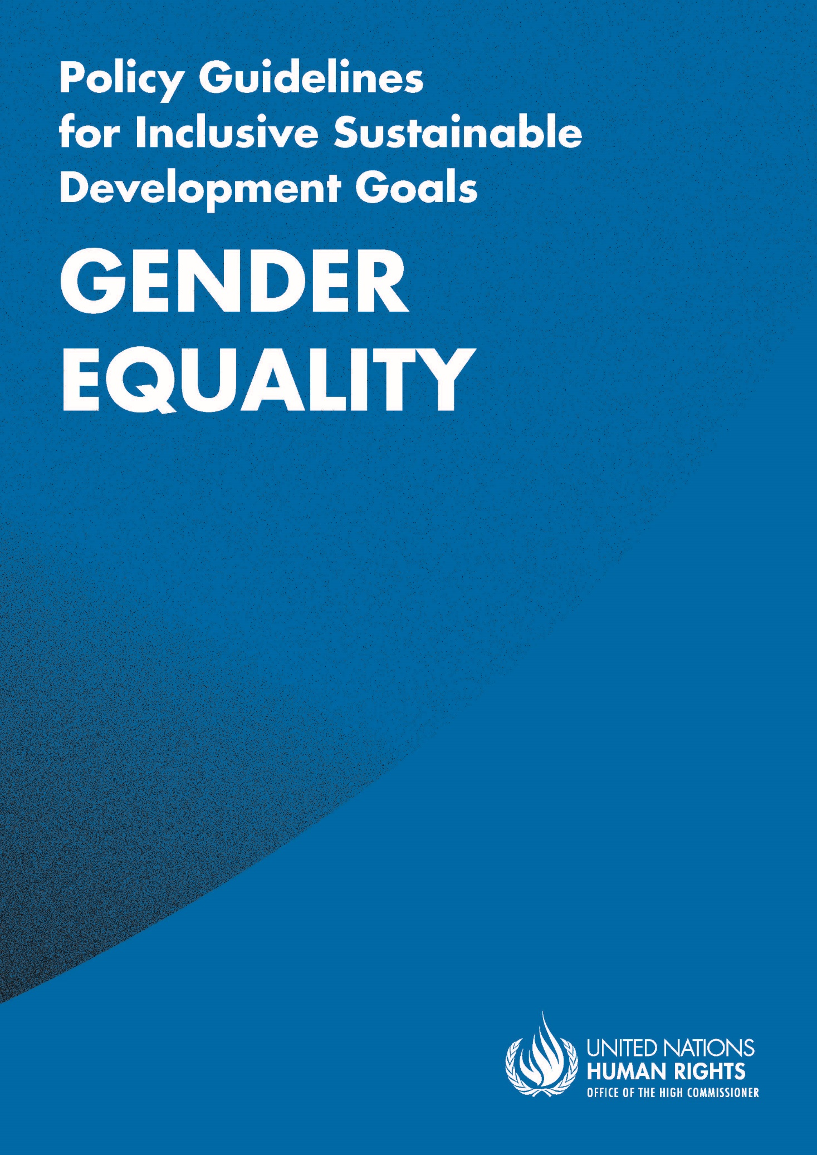

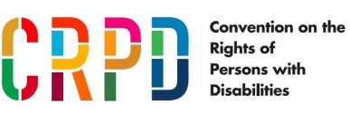
ADVANCE VERSION
© 2020 United Nations
The Policy Guidelines for Inclusive Sustainable Development Goals are a component of the SDG- CRPD Resource Package, developed by the Office of the United Nations High Commissioner for Human Rights (OHCHR). This is an advance version of the SDG-CRPD Resource Package. A final version will be issued upon completion of OHCHR review processes.
The designations employed and the presentation of the material herein do not imply the expression of any opinion whatsoever on the part of the Secretariat of the United Nations concerning the legal status of any country, territory, city or area, or of its authorities, or concerning the delimitation of its frontiers or boundaries.
Symbols of United Nations documents are composed of capital letters combined with figures. Mention of such a figure indicates a reference to a United Nations document.
Photography by Christian Tasso. The photographs featured within the Policy Guidelines were taken as part of the European Union project, Bridging the Gap II – Inclusive Policies and Services for Equal Rights of Persons with Disabilities, and were produced with the financial support of the European Union. They appear courtesy of the International and Ibero-American Foundation for Administration and Public Policies.
The Policy Guidelines for Inclusive Sustainable Development Goals were produced with the financial support of the European Union. Its contents are the sole responsibility of OHCHR and do not necessarily reflect the views of the European Union.
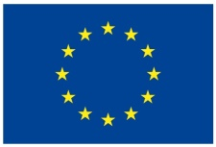
Achieve gender equality and empower all women and girls.
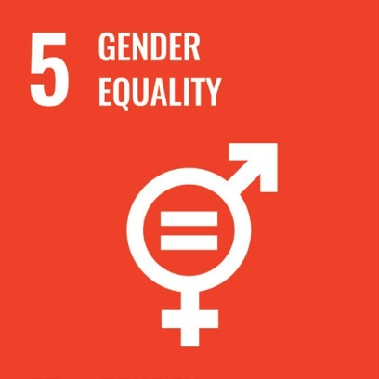

Contents
IN BRIEF 6
1. What is the situation? 7
2. What needs to be done? 9
3. DO’s and DON’Ts 13
IN DEPTH 16
1. Introduction 17
2. Connection to other tools 17
3. Why is Goal 5 important for women and girls with disabilities? 17
4. Equality for women and girls with disabilities: actions applicable across all Goal 5 targets 19
4.1 Gender and disability impact assessments 19
4.2 Twin-track approach 21
4.3 Coordination for inclusive policies 21
4.4 Access to justice for women with disabilities 22
4.5 Active consultation with, and support for, organizations of women with disabilities 23
4.6 Awareness-raising 24
4.7 Budget allocation and expenditure 25
4.8 Data collection and disaggregation by gender and disability 25
4.9 International cooperation 26
5. Other key actions by target 26
5.1 Legislation and policy – Targets 5.1 and 5.c 26
5.1.1 Ensure that legislation on equality and non-discrimination on the basis of sex includes women and girls with disabilities 26
5.1.2 Ensure that legislation on persons with disabilities includes a gender perspective 27
5.1.3 Ensure that legislation on access to justice is inclusive of women and girls with disabilities 27

5.2 Eliminate all forms of violence and harmful practices against women and girls with disabilities – Targets 5.2 and 5.3 28
5.2.1 Promote legislation and adopt policies to prevent violence that are inclusive of women and girls with disabilities 28
5.2.2 Raise awareness and empower women and girls with disabilities to prevent violence and harmful practices against them 29
5.2.3 Ensure that health, protection and rehabilitation services are accessible and available to women and girls with disabilities 30
5.2.4 Ensure that police and justice services are accessible to, and inclusive of, women and girls with disabilities 32
5.3 Economic empowerment of women with disabilities – Targets 5.4, 5.a and 5.b 33
5.3.1 Prevent and mitigate the impact of structural inequalities that push women with disabilities to be economically inactive 33
5.3.2 Ensure the right of women with disabilities to legal capacity and to engage in legal and financial affairs 34
5.3.3 Develop programmes to facilitate access to information and communication technologies inclusive of women with disabilities 35
5.4 Equal participation in political, economic and public life – Target 5.5 35
5.4.1 Ensure the inclusion of women with disabilities in measures to increase the political participation of either women or persons with disabilities 35
5.4.2 Promote the empowerment of women and girls with disabilities to know and claim their rights 36
5.4.3 Adopt specific measures to promote the participation of women with disabilities in public life, including support to organizations of women with disabilities 37
5.5 Sexual and reproductive health and rights – Target 5.6 37
5.5.1 Ensure access to sexual and reproductive health information and services by women and girls with disabilities 37
5.5.2 Respect the right of women and girls with disabilities to free and informed consent 39
6. Additional Resources 42
7. Key Concepts Annex 43

IN BRIEF
I

1. What is the situation?
Women and girls with disabilities are a substantial group; globally, an estimated 19 per cent of women have a disability, compared to 12 per cent of men, as presented in figure I (World Health Organization and World Bank, World Report on Disability, 2011. In low- and middle-income countries, 75 per cent of persons with disabilities are women, as presented in figure II (UN Women, Issue brief: Making the SDGs count for women and girls with disabilities, 2017). Women and girls with disabilities experience complex layers of discrimination on the basis of gender, disability and other characteristics. This manifests in lower rates of literacy (see figure III), employment (see figure IV) and access to health services (including sexual and reproductive health care) than both men with disabilities and women without disabilities. In addition, women with disabilities are less likely to participate in political, economic or public fora and occupy positions of leadership. Out of 18 countries in the Asia-Pacific region, only four included women with disabilities in their parliaments and legislatures (United Nations Department of Economic and Social Affairs, Disability and Development Report, 2019, p. 110).
figure i
Higher prevalence of disability among women
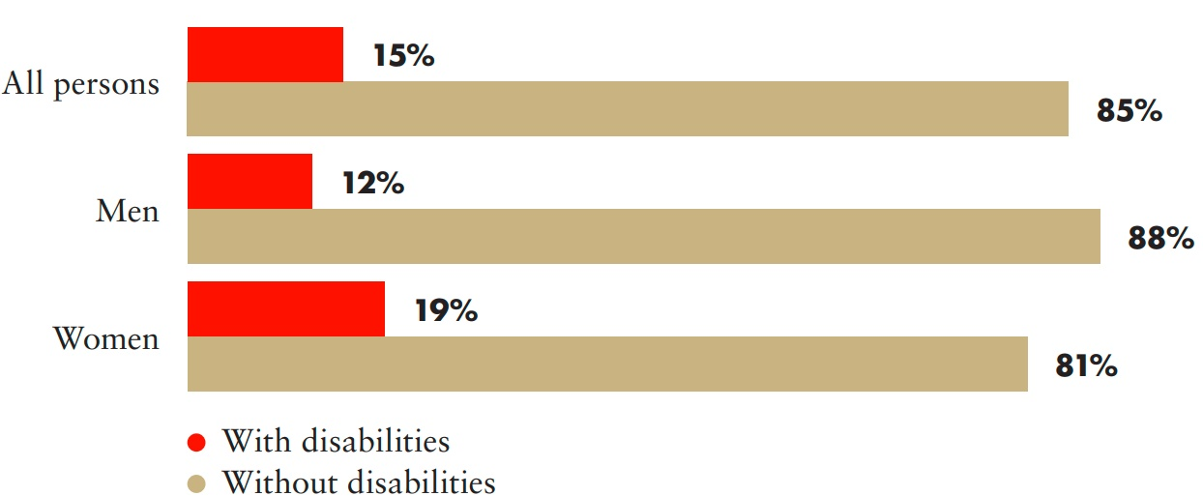
Source: WHO and World Bank, World Report on Disability, 2011.
figure ii
3 out of 4 persons with disabilities are women, in developing countries
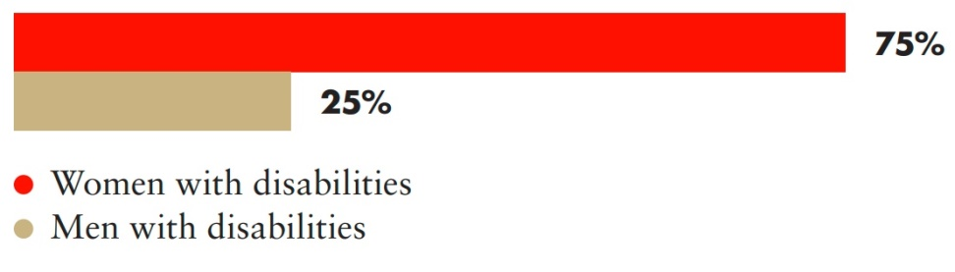
Source: Plan International (2011) as cited in UN Women, Issue brief: Making the SDGs count for women and girls with disabilities, 2017.
figure iii
Literacy rate by sex and disability
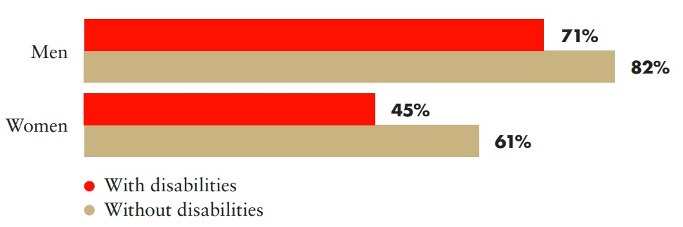
Source: UNDESA, Disability and Development Report, 2019. pp. 107-108.
figure iv
Employment rate by sex and disability
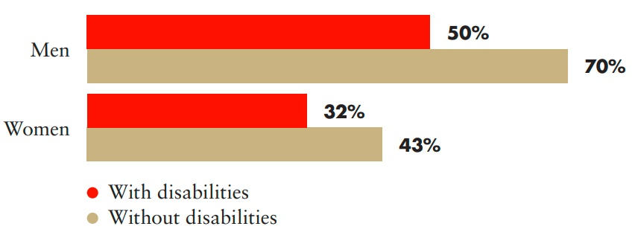
Source: UNDESA, Disability and Development Report, 2019. p. 109.
Women and girls with disabilities are more likely to experience gender-based violence and face significant barriers accessing the justice system. While data continue to be scarce, figure IV shows available data from 28 European countries indicating that 34 per cent of women with disabilities had experienced physical or sexual violence by an intimate partner, compared to 19 per cent for other women (European Union Agency for Fundamental Rights, Violence against women: an EU-wide survey: Main results, 2015). Women with disabilities experience the same forms of violence as women without disabilities, as well as additional forms of violence as a result of disability discrimination; women with disabilities present an up to three times higher rate of being forcibly sterilized than the general population (United Nations, A/72/133, para. 29). See also a video on sexual and reproductive health and rights of women and girls with disabilities developed by the Special Rapporteur on the rights of persons with disabilities.
figure v
Gender-based violence in 28 European countries
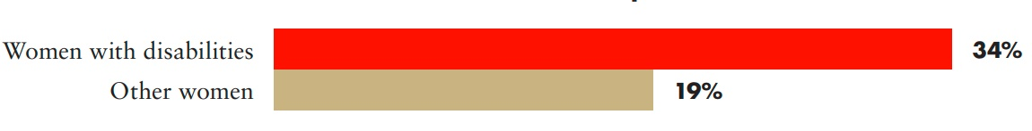
Source: European Union Agency for Fundamental Rights, Violence against women: an EU-wide survey: Main results, 2015. p. 187, table A3.2.

2. What needs to be done?
Main areas of intervention to realise Sustainable Development Goal 5
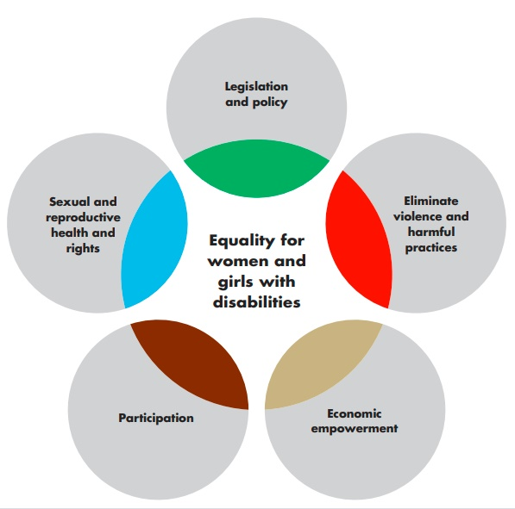

 Equality for women and girls with disabilities: actions applicable across all Goal 5 targets
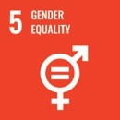 Achieve gender equality and empower all women and girls
Impact assessment: Design and carry out gender and disability impact assessments to evaluate laws, policies, programmes, budget allocation, investments and other government actions, to prevent undermining the equality and inclusion of women and girls with disabilities.

Twin-track approach: Apply a twin-track approach to ensure that women and girls with disabilities are referred to, and reflected in, legislation and policy-making specific to women and gender equality, as well as those targeting persons with disabilities.
Coordination: Ensure coordination across ministries and from national to sub-national levels, to strengthen policy coherence and implementation for women and girls with disabilities, in consultation with them and their representative organizations.

Access to justice: Ensure that complaint mechanisms and investigations are accessible, gender- responsive and disability-inclusive and enable the possibility to file complaints on the basis of multiple and intersecting forms of discrimination.
Active Consultation: Promote the development and strengthening of organizations of women and girls with disabilities.

Awareness-raising: Carry out awareness-raising campaigns to inform, educate and train about the rights of women and girls with disabilities, promoting their empowerment and combating stigma and stereotypes against them.
Budget: Ensure an adequate budget for disability inclusion and gender equality and allocate and monitor budgets directed to women and girls with disabilities, through the adoption of gender and disability markers.

Data: Collect disaggregated data to monitor and enhance the inclusion of women and girls with disabilities across all sectors.
International cooperation: Develop international cooperation strategies, policies and agreements to promote the rights of women and girls with disabilities, by applying a twin-track approach, engaging in gender and disability impact assessments and tracking investment and expenditure on the basis of gender and disability.

CRPD indicators: 1-4.7, 1-4.9, 1-4.11, 1-4.21, 1-4.16, 6.1, 6.3, 6.5, 6.6, 6.11, 6.12, 6.13, 8.1, 8.2, 31.2, 31.3, 32.1, 32.7
 Legislation and policy
5.1 End all forms of discrimination against all women and girls everywhere
5.c Adopt and strengthen sound policies and enforceable legislation for the promotion of gender equality and the empowerment of all women and girls at all levels
Ensure that legislation on equality and non- discrimination on the basis of sex includes women and girls with disabilities
Ensure that legislation on persons with disabilities includes a gender perspective
Ensure that legislation on access to justice is inclusive of women and girls with disabilities

CRPD indicators: 5.1,5.2, 5.7, 6.1, 6.3, 6.5, 13.1, 13.3, 13.6
 Eliminate all forms of violence and harmful practices against women and girls with disabilities
5.2 Eliminate all forms of violence against all women and girls in the public and private spheres, including trafficking and sexual and other types of exploitation
5.3 Eliminate all harmful practices, such as child, early and forced marriage and female genital mutilation
Promote legislation and adopt policies to prevent violence that are inclusive of women and girls with disabilities
Raise awareness and empower women and girls with disabilities to prevent violence and harmful practices against them
Ensure that health, protection and rehabilitation services are accessible and available for women and girls with disabilities
Ensure that police and justice services are accessible to, and inclusive of, women and girls with disabilities

CRPD indicators: 13.12, 13.14, 16.1, 16.3, 16.4, 16.5, 16.6, 16.14, 16.15, 16.16, 16.17, 16.19
 Economic empowerment of women with disabilities
5.4 Recognize and value unpaid care and domestic work through the provision of public services, infrastructure and social protection policies and the promotion of shared responsibility within the household and the family as nationally appropriate
5.a Undertake reforms to give women equal rights to economic resources, as well as access to ownership and control over land and other forms of property, financial services, inheritance and natural resources, in accordance with national laws
5.b Enhance the use of enabling technology, in particular information and communications technology, to promote the empowerment of women
Prevent and mitigate the impact of structural inequalities that push women with disabilities to be economically inactive
Ensure the right of women with disabilities to legal capacity and to engage in financial and legal affairs
Develop programmes to facilitate access to information and communication technologies inclusive of women with disabilities

CRPD indicators: 12.1, 12.2, 21.4, 21.5, 27.8, 28.4, 28.5
 Equal participation in political, economic and public life
5.5 Ensure women’s full and effective participation and equal opportunities for leadership at all levels of decision-making in political, economic and public life
Ensure the inclusion of women with disabilities in measures to increase the political participation of either women or persons with disabilities
Promote the empowerment of women and girls with disabilities to know and claim their rights
Adopt specific measures to promote the participation of women with disabilities in public life, including support to organizations of women with disabilities
CRPD indicators:1-4.17, 6.2, 6.7, 6.8, 6.9, 6.14, 6.15, 6.17, 29.1, 29.2, 29.7, 29.25
 Sexual and reproductive health and rights for women and girls with disabilities
5.6 Ensure universal access to sexual and reproductive health and reproductive rights as agreed in accordance with the Programme of Action of the International Conference on Population and Development and the Beijing Platform for Action and the outcome documents of their review conferences
Ensure access to sexual and reproductive health information and services by women and girls with disabilities
Respect the right of women and girls with disabilities to free and informed consent
CRPD indicators: 16.2, 23.5, 23.12, 23.16, 25.6, 25.7, 25.8, 25.15, 25.18

3. DO’s and DON’Ts
DO | DON’T
Law, policy and programmes
Include explicit references to women and girls with disabilities and address their specific requirements in legislation that recognizes, promotes and protects the rights of all women in general. | Refer to the rights of women and girls with disabilities only in disability-specific legislation.
Include explicit references to women and girls with disabilities and address their specific requirements in legislation and policies relating to persons with disabilities. | Assume gender-neutral disability legislation and policy sufficiently protect the rights of women and girls with disabilities.
Adopt specific measures to address equality and non-discrimination and promote the participation and empowerment of women and girls with disabilities. | Assume that measures for participation and empowerment targeting persons with disabilities in general address the specific situation of women and girls with disabilities.
Governance, inter-institutional coordination
Coordinate across and within ministries, assigning focal points on gender and disability within each ministry/department and actively engaging with women with disabilities and their representative organizations. | Assume that assigning a disability focal point under one ministry/department is sufficient for securing disability-specific expertise for the entire government.
Actively engage and consult with women with disabilities and their representative organizations. | Assume that women with disabilities are being consulted because either organizations of persons with disabilities or women’s rights organizations are being consulted.

DO | DON’T
Practice and implementation
Actively engage diverse women and girls with disabilities in designing and implementing gender and disability impact assessments. | Make assumptions without consulting women and girls with disabilities about the impact on them of laws, policies and other government action.
Identify underrepresented groups in each specific context and assess attitudes, norms, relations and inequalities that impact women and girls with disabilities. | Assume that risks and concerns affecting women and girls in general, or people with disabilities in general, fully encompass those affecting women and girls with disabilities.
Develop a plan to address discrimination against women with disabilities, considering their diversity (girls, older women, women with different impairments, migrants, indigenous women and girls with disabilities etc.). | Consider women with disabilities as a homogenous group, nor overlook the barriers specific populations of women and girls with disabilities face (e.g. deaf women and girls, women with psychosocial disabilities).
Awareness-raising
Promote social change that challenges attitudes, stigma, stereotypes and discrimination faced by women and girls with disabilities, ensuring a rights-based approach informed by women and girls with disabilities themselves. | Reinforce negative stereotypes of women and girls with disabilities in public campaigns and capacity-building activities on gender and/or disability.
Training
Train service providers, including first responders, to work with women and girls with disabilities and provide services that are based on equality, non-discrimination and respect for personal autonomy. This includes the understanding of appropriate referral mechanisms. | Overlook staff, including emergency support staff, in capacity-building activities, resulting in either inadequate or inappropriate referrals for women with disabilities (e.g. a health worker referring a woman experiencing violence to an institution on the basis of psychosocial disability and/or homelessness).
Provide capacity-building opportunities directed at women and girls with disabilities, the government and service providers. | Focus all capacity-building initiatives on women and girls with disabilities and neglect strengthening the “supply” side (e.g., government, service providers).

DO | DON’T
Adopt specific measures to address discrimination and ensure that women’s empowerment initiatives are inclusive of women and girls with disabilities, while also engaging in targeted capacity-building activities for women and girls with disabilities. | Address the empowerment of women with disabilities only through disability-specific actions, nor overlook their inclusion in gender equality initiatives.
Participation
Provide both financial and capacity-building support to organizations of women with disabilities. | Assume that women rights’ organizations and/ or organizations of persons with disabilities are representative of women with disabilities.
Data collection and disaggregation
Disaggregate data consistently by gender and impairment in all population-based data collection efforts (e.g. census, surveys), ensuring participation , self-identification, transparency, privacy and accountability. Further, ensure that adopted indicators call for disaggregation by gender and impairment. | Limit data collection of, and disaggregation by, disability to disability-specific surveys.
Collect context-specific data on women and girls with disabilities and on the attitudinal and environmental barriers that prevent the enjoyment of their human rights, with their participation. | Assume that data on persons with disabilities and the barriers they face appropriately capture the situation of women and girls with disabilities.

IN DEPTH
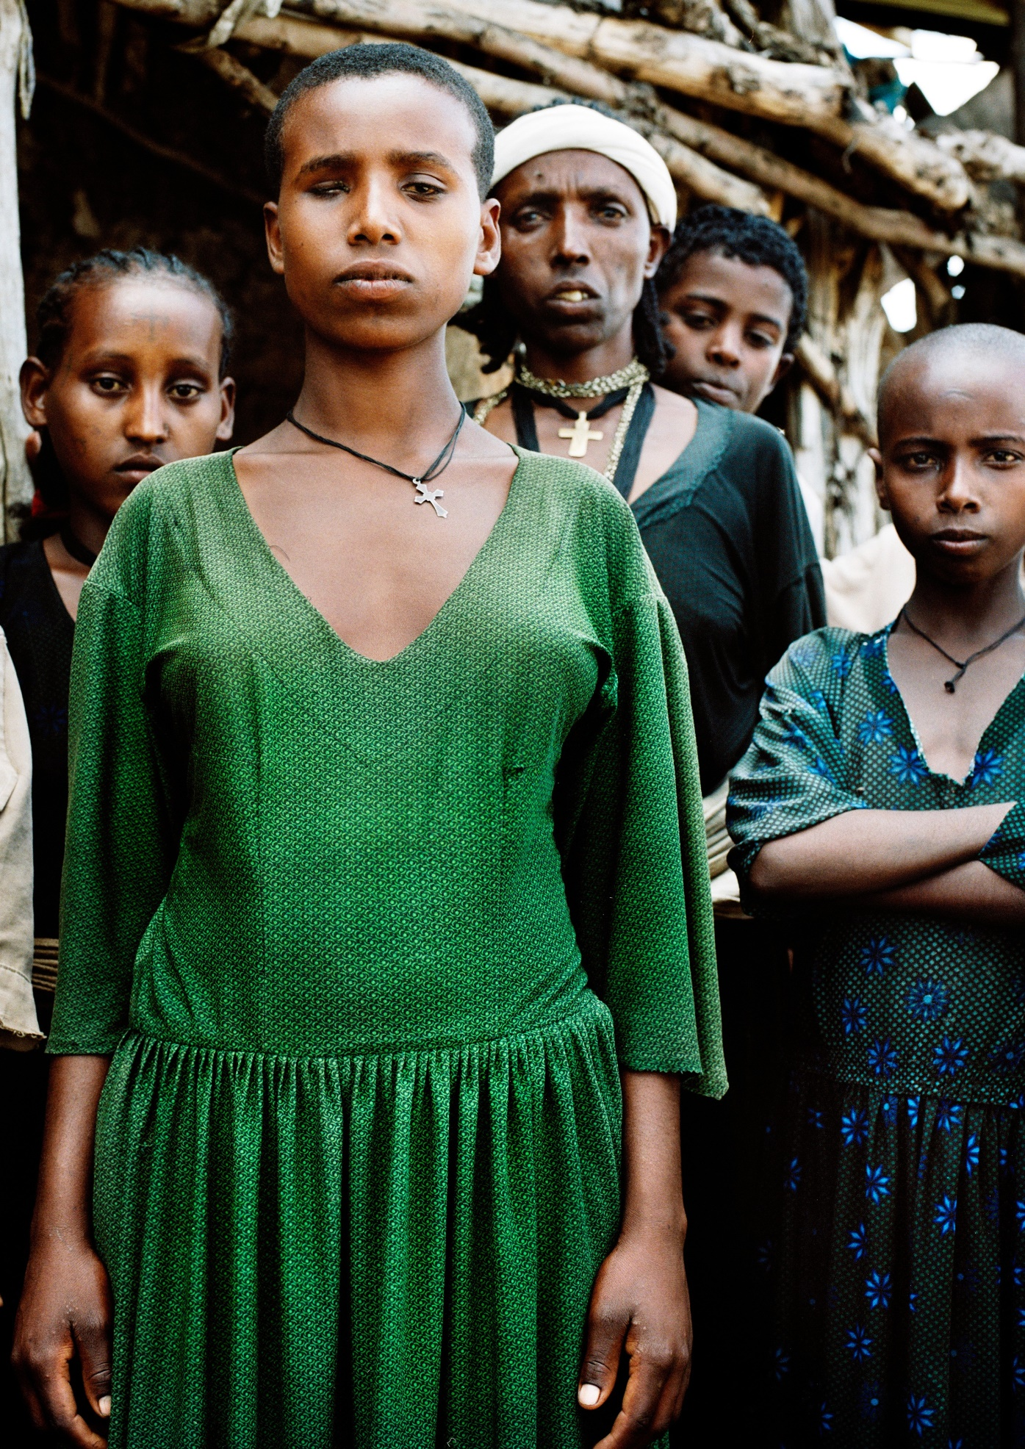

1. Introduction
This section provides detailed guidance for policymakers on the measures that are required to implement Sustainable Development Goal 5 (SDG 5) on Gender Equality in a way that is inclusive of women and girls with disabilities.
Section 2 shows the connection between the Policy Guidelines to achieve SDG 5 with other resources, including the human rights indicators under the Convention on the Rights of Persons with Disabilities (CRPD) and other related tools.
Section 3 provides an overview of the situation of inequality and discrimination faced by women and girls with disabilities, demonstrating why SDG 5 is key for their development. Sections 4 and 5 provide guidance on policy measures and actions that should be adopted for inclusive implementation of SDG 5: section 4 addresses the measures for the inclusion of women and girls with disabilities that are applicable across all targets, while section 5 provides considerations and guidance on key actions specific to each SDG 5 target. Targets 5.1 and 5.c are considered together, as they call for legislative and policy measures; Targets 5.2 and 5.3 are considered together, as they focus on violence and harmful practices; Targets 5.4, 5.a and 5.b are grouped because they are connected to economic life and empowerment. Targets 5.5, on political participation, and 5.6, on sexual and reproductive health and rights, are considered independently.
It is important to note that gender equality and the rights of women and girls with disabilities should be integrated throughout all Sustainable Development Goals (see Foundations Guideline, section 5.3 “Putting non-discrimination into practice: Addressing diversity and identity”).

2. Connection to other tools
  - CRPD Indicators: Article 6 (women with disabilities)
  - Other related CRPD articles and indicators: Articles 1-4, 5, 7, 8, 9, 12, 13, 15/17, 16, 19, 21, 23, 24, 25, 27, 28, 29, 31, 32, 33.
  - Data Sources Guidance: Article 6 and other related CRPD provisions
  - Training materials: Goal 5
  - Video: Goal 5

3. Why is Goal 5 important for women and girls with disabilities?
Global estimates suggest that the disability prevalence is 19 per cent for women, compared to 12 per cent for men (WHO and World Bank, World Report on Disability, 2011. In addition, women with disabilities represent 75 per cent of persons with disabilities living in low- and middle-income countries (Plan International (2011) as cited in UN Women, Issue brief: Making the SDGs count for women and girls with disabilities, 2017)).
Despite this data, women and girls with disabilities remain among the most marginalized groups in society and face intersecting forms of discrimination based on gender, age and disability, among others. This makes them more likely to be excluded from education, employment, political and public life and access to justice, as well as from exercising their autonomy in relation to their health, including sexual and reproductive health. This discrimination leads to worse rates in literacy (45 per cent) and employment (32 per cent), when compared to men with disabilities (at 61 per cent and 43 per cent, respectively) (UNDESA, Disability and Development Report, 2019). Relevant laws for women with disabilities (e.g. disability law, gender equality law) do not usually take into account the intersectionality of disability and gender and thus fail to acknowledge and protect their rights. By 2016, in Latin America, 12 out of 20 countries had measures targeted at women with disabilities in their gender equality plans and only 6 countries, out of 19 in the region, addressed women in their disability laws (UNDESA and United Nations Economic Commission for Latin America and the Caribbean, United Nations Expert Group Meeting on Advancing the Rights and Perspectives of Women and Girls with Disabilities in Development and Society, 2016, pp. 34-35).
Women and girls with disabilities face higher risks of being subjected to various forms of physical and sexual violence. A survey from 2012 indicated that, in 28 European countries, 34 per cent of women with disabilities had experienced physical or sexual violence by an intimate partner, compared to 19 per cent of other women. Furthermore, women with disabilities present an up to three times higher rate of being forcibly sterilized than the rate for the general population (European Union Agency for Fundamental Rights, Violence against women: an EU-wide survey: Main results, 2015).
Women with disabilities face several barriers to their participation in economic life and access to economic resources. Lower employment rates coupled with restricted participation in social life and existing stereotypes on gender roles lead to a higher risk of unpaid care and domestic work.
Limitations on women’s property rights may be exacerbated for women with disabilities, due to restrictions on the exercise of legal capacity – which prevents them from administering their assets. Finally, access to, and use of, enabling technology that could empower women with disabilities, including for economic life, is also lower. For example, in 13 low- and middle-income countries, only 21 per cent of women with disabilities use the internet, compared with 33 per cent of other women (UNDESA, Disability and Development Report, 2019, p. 133).
Women with disabilities are less likely to participate in political, economic or public leadership. In 2017, 14 out of 18 countries in the Asia-Pacific region had no women with disabilities in their parliaments and legislatures (UNDESA, Disability and Development Report, 2019, p. 110).
Women with disabilities face specific barriers in accessing sexual and reproductive health information, education and services. Available literature consistently affirms that women and girls with disabilities access less education and have less knowledge in this area. Lesser access of persons with disabilities to sexual education expose them to a higher risk of exposure to sexually transmitted infections (UNDESA, Disability and Development Report, 2019, pp. 65-72). For instance, a meta- analysis of the literature on sub-Saharan Africa observed an increasing gradient in the risk of contraction of HIV according to gender and disability (De Beaudrap, Mac-Seing and Pasquier, Disability and HIV: a systematic review and a meta-analysis of the risk of HIV infection among adults with disabilities in Sub-Saharan Africa, AIDS Care, vol.26, No. 12 (17 July 2014), pp. 1467- 1476).
Women with disabilities, in particular those with intellectual disabilities, have been disproportionately subjected to forced, coerced and otherwise involuntary sterilization based on negative stereotypes related to their sexuality and capability for motherhood, as well as on eugenics and other discriminatory discourse. Authorities of institutions might allow for, and decide on, forced sterilization to prevent pregnancies and manage menstruation, against the will and preferences of the concerned person. In addition, treatment and surgeries for menstrual management purposes imposed on women with disabilities are invasive and can lead to irreversible consequences, such as the loss of fertility.

4. Equality for women and girls with disabilities: actions applicable across all Goal 5 targets
Achieve gender equality and empower all women and girls

4.1 Gender and disability impact assessments
Women and girls with disabilities face significant barriers due to multiple and intersecting forms of discrimination (both on the basis of gender and disability) and are disproportionately excluded when compared to either men with disabilities or women without disabilities. Recognizing the unique and diverse experiences of women and girls with disabilities is key to ensuring that policy solutions aimed at the advancement of women, as well as those targeting persons with disabilities, also embrace women with disabilities and do not undermine their inclusion.
0Impact assessments are critical to gauge the intended and unintended impacts of actions and to better design and plan them. They are also important to ensure that relevant and context-specific concerns of all populations are taken into account. For example, gender impact assessments are centred on detecting whether a law, policy or programme reduces, maintains or increases the inequalities between women and men. To address the situation of women and girls with disabilities, it is imperative that impact assessments consider both gender and disability, throughout different action stages (see Table 1). For example, a campaign to prevent gender-based violence may aim to protect all women but, if the information and communications are not accessible, women with disabilities would be excluded from the campaign benefits. Table 1 sets out the necessary steps to carry out a gender and disability impact assessment.
table 1
 Steps to carry out a gender and disability impact assessment

Step 1  Defining the policy purpose | Will the policy purpose/objectives contribute to equality in relation to both gender and disability?  Will the policy purpose/objectives contribute to the equality of women with disabilities specifically?
Step 2  Checking gender and disability relevance | Are women and girls with disabilities, including the diverse constituents of this group, explicitly identified as a target group?  Will the policy have an impact on the situation of women and girls with disabilities? What are the direct and indirect impacts?

Step 3  Gender and disability analysis | Are the compounded and intersecting forms of discrimination experienced by those marginalized by gender, disability and other characteristics explored when:  - assessing the current and future situation without interventions in the target group?  - assessing the expected impact after such interventions?  Do this by:  - Collecting and analysing gender and disability disaggregated data, as well as data  on other identities marginalised in the target area  - Consulting with diverse target groups, including women and girls with disabilities, who experience intersecting inequalities  - Identifying and addressing specific inequalities experienced by women and girls with disabilities  Assessments should consider impact in terms of the diversity of women and girls with disabilities and their multiple layers of identity (deaf women, women with psychosocial disabilities, women with multiple disabilities, migrant women with disabilities, older women with disabilities, etc.) and address issues and their impact accordingly, e.g. forced treatment, including forced sterilization and institutionalization.
Step 4  Measuring gender and disability impact | Do the policy purposes/objectives lead to positive, negative or neutral impacts on women with disabilities? This should be weighed in terms of participation, access to services and resources and transformation of social norms and attitudes towards women with and without disabilities.  Policy gaps between women with disabilities and other women arise when there are:  - positive impacts on women and neutral or negative impacts on women with disabilities  - positive impacts on women but less positive impacts on women with disabilities  For example, a gender quota measure for women for accessing higher education may not consider the requirements or accommodations needed by women with disabilities. The measure will likely increase the number of women in higher education but, at the same time, contribute to widening the gap in enrolment rates between women with disabilities and other women.
Step 5  Findings and proposals | What are the policy gaps that directly or indirectly undermine the inclusion of women with disabilities?  What measures can be recommended to improve policy design? Participation of women and girls with disabilities and their representative organizations in designing these assessments and measures is crucial to the success of policy design and implementation.
Source: Adapted from the European Institute for Gender Equality, Gender Impact Assessment: Gender mainstreaming toolkit, 2016.
Recommendation
    - Design and carry out gender and disability impact assessments to evaluate laws, policies, programmes, budget allocation, investments and other government actions, to prevent undermining the equality and inclusion of women and girls with disabilities.
Related CRPD Indicators: 6.3, 6.10

4.2 Twin-track approach
National legislation and policies often overlook women and girls with disabilities and leave them unprotected from the inequalities and rights violations they experience, on the basis of both gender and disability. On the one hand, domestic violence legislation and policies which target women may not reflect the specific forms of violence experienced by women and girls with disabilities and leave unaddressed the specific barriers which they face in seeking assistance and accessing justice. On the other hand, legislation specific to the rights of persons with disabilities may fail to recognize the experiences of women with disabilities in enjoying and effectively exercising their rights, e.g. the right to pregnancy and motherhood. Such neglect leads to gaps in protection for women and girls with disabilities, both in law and in its practical application.
Recommendations
For the full protection of the rights of women and girls with disabilities, apply a twin-track approach to legislation and policymaking by ensuring that:
    - Legislation on gender equality and women’s rights, e.g. gender-based violence, include a disability perspective and explicitly refer women and girls with disabilities
    - Legislation on persons with disabilities includes a gender perspective
Related CRPD Indicators: 6.1, 6.3, 6.5
See also Foundations Guideline, section 3.2.1 on “Twin-track approach”.

4.3 Coordination for inclusive policies
While an increasing number of countries are establishing gender focal points and ministries responsible for gender equality and women, on the most part policies on gender continue to be distributed among multiple ministries and departments. Among SDG 5 targets, for example, discrimination, violence and harmful practices and equal participation in political life tend to fall within the mandate of the ministry of justice; economic empowerment under the ministry of social development and employment; sexual and reproductive health and rights under the ministry of health. By contrast, disability-related policies tend to be concentrated under the mandates of the ministries of welfare and health or centralized within a disability focal point. Coordination among public agencies with relevant expertise is key to ensure the inclusion of gender and disability perspectives across policies emerging from different ministries. Similarly, vertical coordination from central government policymakers at the national level down to local government implementers is key for successful delivery on results. Decision-making processes through this coordination must involve women and girls with disabilities.
Recommendations
To ensure coordination for inclusive policies, governments should:
    - Appoint focal points on gender and disability issues within different ministries/departments
Related CRPD Indicators: 33.1
    - Establish procedures for coordination, including through an inter-ministerial coordination mechanism and internal vertical coordination – from national to sub-national levels – for successful policy implementation
Related CRPD Indicators: 33.2
    - Ensure close consultation with, and the active involvement of, women with disabilities and their representative organizations with both gender and disability focal points and the coordination mechanism(s)
Related CRPD Indicators: 6.9, 6.12, 1/4.9, 33.4
See also Foundations Guideline, section 3.1 on “Institutional set-up for good governance inclusive of persons with disabilities”.

4.4 Access to justice for women with disabilities
Women with disabilities face significant barriers in accessing justice and participating in legal proceedings, due to both gender and disability discrimination. First, they may not have access to information about their rights, including on the opportunities available to access justice and seek redress. Second, legal assistance and legal aid may be both inaccessible and unaffordable to women with disabilities.
Further, women and girls with disabilities are less likely to have their complaints taken seriously, on account of stereotypes concerning both gender and disability. For example, women and girls with disabilities who are survivors of violence may have their complaints dismissed by the police or authorities due to a perceived lack of credibility.
On account of inaccessible information and services, they are also less likely to access support services available for other women, such as hotlines and shelters. In addition, women and girls with intellectual disabilities and those with psychosocial disabilities are more likely to be denied their right to legal capacity, thus being either prevented from lodging complaints and testifying or having their testimony discredited as unreliable.
In some countries, women and girls with disabilities cannot bring claims on the basis of intersecting or multiple discrimination, as this is not reflected in law and procedures.
 Recommendation
    - Governments should ensure that complaint mechanisms and investigations are accessible, gender-responsive and disability-inclusive, and enable the possibility to file complaints on the basis of multiple and intersecting forms of discrimination.
Related CRPD Indicators: 13.1, 13.4, 13.6, 13.11, 13.12, 13.13
See also Foundations Guideline, section 6.4 on “Access to justice” and the International Principles and Guidelines on access to justice for persons with disabilities.

4.5 Active consultation with, and support for, organizations of women with disabilities
In many countries, women and girls with disabilities have limited participation or voice within both organizations of persons with disabilities and women’s rights organizations. As a consequence, they are excluded from consultation and participatory processes and their specific concerns and views remain neglected in public decision-making.
 Recommendations
Governments should promote the development and strengthening of organizations of women and girls with disabilities, by:
    - Providing targeted capacity-building to women and girls with disabilities on their rights, empowerment and management and development of their representative organizations
Related CRPD Indicators: 1/4.17, 6.3, 6.7, 6.8, 6.9, 6.12
    - Providing financial support for the development of organizations of women and girls with disabilities
Related CRPD Indicators: 1/4.11, 1/4.16, 6.3, 6.9, 33.9
    - Ensuring close consultation with, and the active involvement of, women and girls with disabilities in the design and development of legislation and policies that concern them, whether they relate directly to persons with disabilities, women, gender equality or any other subject which impacts them
Related CRPD Indicators: 6.9, 6.12, 7.14
See also Foundations Guideline, sections 2.4 and 4 on participation of persons with disabilities. See also the video on participation developed by the Special Rapporteur on the rights of persons with disabilities.
 Consultation of women with disabilities
Given the long-standing marginalization of women and girls with disabilities, they have had fewer opportunities to establish organizations representing their concerns as women and as persons with disabilities. As a result, few countries currently have organizations of women with disabilities.
However, this should not prevent governments from consulting directly with women with disabilities. Choosing channels of consultation may be challenging, and it is thus advisable to:
- Ask organizations of persons with disabilities whether there are women with disabilities who can represent the organization in consultations
- Consult with mainstream women’s organizations that have proven experience defending the rights of women with disabilities in accordance with the human rights-based approach to disability (CRPD perspective) and ask whether there are women with disabilities who can represent the organization in consultations
- Ensure that consultations are open and accessible to individual women with disabilities and ask women with disabilities to look within their own formal and informal networks to reach out to groups which are underrepresented (such as women with psychosocial disabilities, women with intellectual disabilities), including women who face compounded barriers based on how their impairment intersects with their other identities and characteristics, such as race, age, ethnicity or sexual orientation.

4.6 Awareness-raising
Women and girls with disabilities experience unique attitudinal barriers, stereotypes, prejudices and stigma based on both gender and disability. For instance, their role as a mother may be contested and, thus, create barriers in accessing family planning and sexual and reproductive health information and services. Awareness-raising plays a key role in educating and informing both government and society at large about the rights of women and girls with disabilities, preventing violence against them and promoting their empowerment.
 Recommendations
To raise awareness, governments should:
    - Disseminate information about the rights of women with disabilities and enhance their portrayal and visibility as active members of society, through awareness-raising campaigns
Related CRPD Indicators: 6.11, 6.12, 8.7, 8.2
    - Promote social change and combat stigma and stereotypes through targeted training, including with the direct participation of women and girls with disabilities
Related CRPD Indicators: 6.11, 6.12, 8.2, 8.20
    - Build the capacity of women with disabilities themselves, as well as the capacity of public officials, professionals and service providers (e.g. first responders, health workers, social workers, police officials), particularly those working on policies or services combating discrimination, hate crime and femicide, including gender-based or disability-based violence against women.
Related CRPD Indicators: 6.10, 8.9, 1/4.20
See also Foundations Guideline, section 2.5 on “Awareness-raising”.
 Raising awareness about gender-based violence among women with disabilities in the refugee community
The Women’s Refugee Commission and the International Rescue Committee piloted and evaluated actions to promote disability inclusion in gender-based violence programming. In Ethiopia, traditional “coffee discussions” were being used, in 2018, as a vehicle for conversations about gender-based violence and the available services in the refugee community. Women with disabilities volunteered to host coffee discussions in their homes, inviting other women who lived near them to join the activity. Thus, women with disabilities who were isolated in their homes had the opportunity to learn more about gender-based violence and to strengthen protective peer networks within their neighbourhoods. (United Nations Population Fund and Women Enabled International, Women and young persons with disabilities: Guidelines for Providing Rights-Based and Gender- Responsive Services to Address Gender-Based Violence and Sexual and Reproductive Health and Rights, 2018, p. 33)

4.7 Budget allocation and expenditure
The success of policies and programmes is highly dependent on both the resources allocated to implement them and actual expenditure. Increasing investment, and/or allocating specific budget lines to women or persons with disabilities, may not necessarily have an impact on women and girls with disabilities, and may, in fact, contribute to widening the gap between women and girls with disabilities and both the wider groups of women and persons with disabilities.
Recommendation
    - Specific budget allocations should be directed to actions supporting women and girls with disabilities and expenditure should be trackable through the adoption of gender and disability markers, to assess the commitment behind legislation and policies.
Related CRPD Indicators: 6.4, 6.6
See also Foundations Guideline, section 3.3 on “Finance and budget”.

4.8 Data collection and disaggregation by gender and disability
Data collection and disaggregation by gender and disability allows for the identification and tackling of the barriers and cases of structural discrimination against women and girls with disabilities.
 Improving programming on the rights of persons with disabilities through disability-inclusive data collection
With the support of the UN Partnership on the Rights of Persons with Disabilities, Bolivia strengthened its disability reporting by integrating disability information in the statistics collected in three key sectors – education, health, and justice. The Ministry of Justice sought to improve justice for persons with disabilities by introducing disability variables into the Integral System of Prevention, Care, Punishment, and Eradication of Gender-Based Violence [GBV]. This also led to a guide for users of the system addressing disability-rights and GBV- and disability-inclusive data collection.
UNFPA and Women Enabled International, Women and young persons with disabilities: Guidelines for Providing Rights-Based and Gender-Responsive Services to Address Gender-Based Violence and Sexual and Reproductive Health and Rights, 2018, p. 27)
Recommendations
In regard to data collection and disaggregation by gender and disability, governments should:
    - Collect and analyse qualitative and quantitative data on women and girls with disabilities and the attitudinal and environmental barriers that prevent the enjoyment of their human rights
    - Disaggregate data by gender and disability, as well as by other characteristics which may be more commonly subjected to discrimination in the country/local context (such as race, ethnicity, sexual orientation, age, migrant status, indigenous background)
Related CRPD Indicators 31.1, 31.2
See also Foundations Guideline, section 3.5 on “Data collection and disaggregation”.

4.9 International cooperation
For many countries, international cooperation policies provide an opportunity to implement SDG targets for women and girls with disabilities in line with the CRPD, both as donors or recipient countries.
Recommendation
    - Governments should consider all of the elements mentioned in previous sections when developing international cooperation strategies, policies and agreements, particularly by engaging in gender and disability impact assessments, having a twin-track approach to programming and creating separated gender and disability markers to capture investment and expenditure information.
Related CRPD Indicators: 6.3, 6.4, 32.1, 32.3
See also Foundations Guideline, section 8 on “International cooperation”.

5. Other key actions by target

Legislation and policy – Targets 5.1 and 5.c
5.1 End all forms of discrimination against all women and girls everywhere
5.c Adopt and strengthen sound policies and enforceable legislation for the promotion of gender equality and the empowerment of all women and girls at all levels

5.1.1 Ensure that legislation on equality and non-discrimination on the basis of sex includes women and girls with disabilities
Legislation on gender equality and on persons with disabilities should be explicit in including women with disabilities and responding to their specific requirements, in order to uphold their rights and prevent violations. In addition, specific measures adopted to increase participation, empowerment and enjoyment of the rights of women should address the additional barriers faced by women and girls with disabilities, so that they too benefit from them, e.g. legislation on gender parity in Congress.
Recommendations
In particular, governments should:
      - Ensure that the legal framework on gender equality explicitly refers to discrimination based on disability and recognizes that the denial of reasonable accommodation, applicable to all rights and areas of life, constitutes discrimination.
Related CRPD Indicators: 6.1, 5.1, 5.6, 5.9, 5.10
      - Prohibit multiple and intersecting forms of discrimination, including those based on gender and disability, in equality and non-discrimination legal frameworks.
Related CRPD Indicators: 6.1, 5.1, 7.1
      - Integrate the prohibition of multiple and intersecting forms of discrimination, including those based on disability and gender, in sector-specific legislation (education, employment, health, protection from violence, among others).
Related CRPD Indicators: 5.5
      - Promote that any legislation providing measures to increase the participation and empowerment of women and girls is explicitly inclusive of women and girls with disabilities and contemplates their specific requirements.
Related CRPD Indicators: 6.3, 5.11, 7.2
See also Foundations Guideline, section 2.1 and 5 on non-discrimination and equality.

5.1.2 Ensure that legislation on persons with disabilities includes a gender perspective
Legislation on persons with disabilities often does not explicitly consider the situation of women with disabilities, nor the potential impacts legislation may have on them. For example, if not explicitly addressed when adopting the measure, employment quotas tend to disproportionally benefit men with disabilities over women with disabilities, due to gender stereotypes that exclude women from employment.
Recommendation
      - Governments should design legislation on persons with disabilities keeping in mind that neither provisions nor implementation reinforces or deepens inequalities against women with disabilities.
Related CRPD Indicators: 6.1, 6.5

5.1.3 Ensure that legislation on access to justice is inclusive of women and girls with disabilities
Rights-based legislation requires both recognition and mechanisms for enforcement. Thus, legislation should provide for effective remedies for the violations of the rights of women and girls with disabilities. In addition, it should consider their requirements in accessing complaints mechanisms and the justice system, as well as in effectively participating in proceedings. This applies across a range of settings, e.g. in relation to housing, employment, parental rights, political participation, gender-based and disability-based violence and other human rights violations.
 Support for accessing justice
The National Union of Women with Disabilities of Uganda trained 32 women with disabilities as paralegals with knowledge about the rights of women and girls with disabilities related to sexual and reproductive health and rights and gender-based violence. The paralegals offer peer-to-peer support with regard to reporting violations and conducting the necessary follow-up to ensure justice is achieved. (United Nations, A/72/133, para. 49).
 Recommendations
Governments should ensure that legislation, including procedural legislation and regulations (e.g. criminal procedural law):
      - Allows for the effective and direct access and participation of women with disabilities in proceedings, including by recognising their legal standing, legal capacity (as a party, as a witness, etc.) and right to age- and gender-appropriate procedural accommodations
      - Provides mechanisms to ensure access to free legal aid for women with disabilities
      - Provides effective remedies to women and girls with disabilities who have experienced violations and sanctions to the perpetrators of those violations
Related CRPD Indicators: 5.5, 6.1, 6.13, 7.7, 7.19, 13.1, 13.4, 13.5, 13.18
See also Foundations Guideline, section 6.4 on “Access to justice” and the International Principles and Guidelines on access to justice for persons with disabilities.

5.2 Eliminate all forms of violence and harmful practices against women and girls with disabilities – Targets 5.2 and 5.3
5.2 Eliminate all forms of violence against all women and girls in the public and private spheres, including trafficking and sexual and other types of exploitation
5.3 Eliminate all harmful practices, such as child, early and forced marriage and female genital mutilation

5.2.1 Promote legislation and adopt policies to prevent violence that are inclusive of women and girls with disabilities
Compared to both other women and men with disabilities, women and girls with disabilities are disproportionately at a higher risk of violence due to discrimination, stigma, traditional superstitious beliefs and stereotypes of vulnerability or helplessness. They are also rendered more vulnerable to being subjected to child marriage and experiencing female genital mutilation.
 Recommendations
To promote legislation and adopt policies to prevent violence that are inclusive of women and girls with disabilities, and in addition to the legislation considered under sections 4.2 and 5.1, governments should:
      - Promote the adoption and review of disability-inclusive legislation and policies to prevent and combat gender-based violence; trafficking; sexual, economic or other types of exploitation; child, early and forced marriage; female genital mutilation; harmful practices against women and girls with disabilities such as forced sterilization and forced abortions. Legislation and policy frameworks should:
        - Adopt and implement a national policy and action plan to prevent and eradicate these practices
        - Ensure that prevention measures address women and girls with disabilities by engaging in consultation with their representative organizations
        - Ensure access to services and support for survivors of violence, such as housing, health, social or rehabilitation services, and address existing barriers to accessing services, including through the provision of reasonable accommodation
        - Adopt and implement accessibility standards for facilities, information and communications related to those services
        - Ensure the confidentiality of information and communications, including disability- related information
        - Create or appoint monitoring mechanisms, in particular of all public and private facilities and programmes designed to serve persons with disabilities
        - Provide remedies and redress for all women and girls with disabilities who experience any form of violence, exploitation, abuse or harmful practices, and apply sanctions and penalties to perpetrators
Related CRPD Indicators: 6.1, 16.1, 16.2, 16.6, 16.7, 16.8, 16.9, 16.10, 16.11, 16.12, 15/17.3, 15/17.4, 15/17.5, 15/17.6
Right to legal capacity
Discriminatory laws often deny women and girls with disabilities their right to legal capacity and to decision-making over their own bodies. Formal and informal forms of substituted decision-making by professionals, parents or guardians give rise to numerous violations of fundamental rights, including the right to motherhood and the right to make autonomous and voluntary decisions over their health, including their sexual and reproductive health.
In addition, women and girls with disabilities face multiple barriers in accessing justice against violence and abuse, due to beliefs that they are unreliable or incompetent; this can affect their ability to report abuse, make complaints and testify in proceedings.
The exercise of legal capacity is a fundamental human right. A legislative and policy environment that is inclusive of women and girls with disabilities should respect and safeguard their right to legal capacity. It should also take all necessary measures to ensure that women with disabilities can exercise this right and have access to supported decision-making.
See also Foundations Guideline, section 5.5 on “Legal capacity”, and the video on legal capacity developed by the Special Rapporteur on the rights of persons with disabilities.

5.2.2 Raise awareness and empower women and girls with disabilities to prevent violence and harmful practices against them
Women and girls with disabilities are more prone to be victims of violence, abuse, exploitation and harmful practices. Due to isolation, stereotypes, unconscious bias and lack of support services (that make them dependent on relatives or others), women and girls with disabilities may be prevented from reporting these situations. In addition, economic dependence may exacerbate the risk of violence against them.
In order to address these issues, primary prevention of violence through measures of awareness- raising and empowerment must address the specific situations of women and girls with disabilities. These efforts should be complemented by measures to combat violence, as well as to address the consequences of violence, that are inclusive and take into consideration women and girls with disabilities (see section 5.2.3).
 Recommendations
In regard to awareness-raising and empowerment for the prevention of violence against women and girls with disabilities, governments should:
      - Develop awareness-raising campaigns, directed to women and girls with disabilities and the public, to inform about:
        - the rights of women and girls with disabilities to be free from violence
        - the available complaint mechanisms to report violations
        - the available services providing assistance Related CRPD Indicators: 6.11, 16.20
      - Develop training and other activities based on previous context assessments, to empower women and girls with disabilities and to build the capacity of relevant staff, such as:
        - inclusive educational programmes on building healthy relationships, to enable women and girls with disabilities to identify situations of violence, exploitation and abuse
        - inclusive and comprehensive sexuality education that is made accessible and available to women and girls with disabilities
        - community-based support directed to reducing the isolation of women and girls with disabilities
        - training for service providers, professionals and community workers, so they can better detect violence and provide assistance to women and girls with disabilities who experience violence
Related CRPD Indicators: 6.7, 6.8, 16.15, 16.20, 24.12
      - Develop counselling and psychosocial support services inclusive of women and girls with disabilities, in order to provide for primary and secondary prevention of violence
Related CRPD Indicators: 16.15, 16.18
      - Adopt measures for the economic empowerment of women and girls with disabilities
Related CRPD Indicators: 6.2, 6.3, 6.20, 6.21, 27.19, 27.20, 27.21, 27.24

5.2.3 Ensure that health, protection and rehabilitation services are accessible and available to women and girls with disabilities
Women and girls with disabilities face great barriers in accessing health, protection and rehabilitation services. Lack of availability, affordability and accessibility of health care services is a common problem for persons with disabilities. In the same vein, protection and rehabilitation services for women who have experienced violence, such as helplines, emergency housing and psychosocial
support, tend to be inaccessible to women with disabilities and not responsive to their requirements.
In all cases, service providers might lack training opportunities to better address the requirements of women with disabilities.
Persons that face violence usually begin by seeking general health services to treat the physical, social and psychological consequences of violence. At this point, health workers are in a unique position to identify disability- and/or gender-based violence. Quality health services should be able, in the first contact, to support and refer the person to the appropriate protection, rehabilitation and justice and policing services (see section 5.2.4). Furthermore, quality health services should be inclusive and avoid providing referrals towards long-term institutionalised care services for persons with disabilities.
Recommendations
In regard to ensuring that health, protection and rehabilitation services are accessible and available to women and girls with disabilities, governments should:
      - Ensure that health service providers are equipped to provide secondary and tertiary prevention of violence and harmful practices against women and girls with disabilities, including by:
        - Training staff on the identification of gender- and disability-based violence, abuse, exploitation and harmful practices
        - Enabling health and social services, especially first-line services, to provide disability- and gender-sensitive care
        - Establishing referrals mechanisms to other services, including protection and rehabilitation services
      - Ensure that protection services are accessible to, and inclusive of, all women and girls with disabilities, including:
        - Crisis hotlines that allow for alternative modes of communication
        - Crisis information and counselling
        - Crisis centres
        - Emergency shelters accessible to, and inclusive of, women with disabilities
        - Financial and material assistance provided directly to women with disabilities
      - Ensure the availability of community-based rehabilitation services to women and girls with disabilities survivors of violence and harmful practices, including:
        - Psychosocial support to address the long-term consequences of violence, including peer-support groups
        - Social reintegration services, such as assistance with recovering or replacing identity documents
        - Assistance towards economic independence, recovery and autonomy
Related CRPD Indicators: 16.3, 16.14, 16.15, 16.16, 16.18, 16.19, 15/7.3
See also Policy Guideline on SDG 3.

5.2.4 Ensure that police and justice services are accessible to, and inclusive of, women and girls with disabilities
Women and girls with disabilities face great barriers in accessing police and justice services. Accessible information on their rights and on services and mechanisms available is usually lacking,
e.g. on programmes to facilitate access to justice. Even when women and girls with disabilities have access to some information, facilities and procedures tend to be inaccessible and unresponsive to their requirements. Finally, stereotypes and prejudice against women with disabilities may lead to their complaints not being taken seriously, nor effectively investigated, prosecuted or sanctioned by law-enforcement agents.
In this policy area, there are an array of actors with different functions and responsibilities, who should coordinate to ensure the inclusion of women and girls with disabilities throughout their activities:
  - Agencies within the public administration, e.g. police, legal aid services for women and girls who have experienced violence, public health system, protection services
  - National human rights institutions, which may have complaint mechanisms
  - Public attorney’s office
  - The judiciary, notably civil and criminal jurisdictions, and/or traditional justice systems, including customary courts
  - Civil society organizations working on the rights of persons with disabilities, women rights’ organizations and civil society organizations providing services regarding gender-based violence
Recommendations
To ensure access to justice and policing services for women and girls with disabilities, governments and justice systems should:
- Ensure that women and girls with disabilities are able to report violence and seek assistance, including by:
  - Providing training to police officials and other staff, including on accessible communication methods, and combating stereotypes and prejudices to ensure that the complaints and testimonies of women and girls with disabilities are appropriately registered
  - Establishing protocols to facilitate the process to report and submit claims by women and girls with disabilities
Related CRPD indicators: 13.1, 13.2, 13.6, 13.14, 13.16
  - Providing legal aid services accessible to, and inclusive of, women and girls with disabilities (in collaboration with other agencies, e.g. Public Attorney Offices)
Related CRPD indicators: 13.4, 13.16
  - Ensuring the safety and protection from retaliation of the persons concerned
- Ensure the participation of women with disabilities in all procedures, on an equal basis with others, including by:
  - Ensuring the provision of procedural and age-appropriate accommodations, when required
Related CRPD indicators: 13.6, 13.16
  - Ensuring the accessibility of all facilities (courts, legal aid centres, police stations, etc.), information and communication throughout procedures
Related CRPD indicators: 13.8, 13.11, 13.17
  - Ensuring the direct participation of women and girls with disabilities in legal proceedings Related CRPD indicators: 13.1, 13.5
- Provide effective remedies for women and girls with disabilities who have experienced violence, including by:
  - Ensuring efficient proceedings and timely decisions, be it administrative or judicial, including protection orders to prevent further violence
  - Ensuring effective sanctions to perpetrators of violence, abuse, exploitation or harmful practices against women and girls with disabilities
  - Ensuring full reparation to women with disabilities, including through compensation funds and other services
Related CRPD indicators: 5.5, 6.1, 6.13, 7.7, 7.19, 13.1, 13.4, 13.5, 13.8
See also Foundations Guideline, section 6.4 on “Access to justice”.

5.3 Economic empowerment of women with disabilities – Targets 5.4, 5.a and 5.b
5.4 Recognise and value unpaid care and domestic work through the provision of public services, infrastructure and social protection policies and the promotion of shared responsibility within the household and the family as nationally appropriate
5.a Undertake reforms to give women [with disabilities] equal rights to economic resources, as well as access to ownership and control over land and other forms of property, financial services, inheritance and natural resources, in accordance with national laws
5.b Enhance the use of enabling technology, in particular information and communications technology, to promote the empowerment of women

5.3.1 Prevent and mitigate the impact of structural inequalities that push women with disabilities to be economically inactive
Exclusion from education and employment, as well as lack of support, are some of the problems that restrict the participation of women and girls with disabilities in society and push them to remain in their homes. Families may lack the means to support women and girls with disabilities and resort to institutions, which especially affects women and girls with intellectual disabilities.
Women with disabilities are less likely than other women to be employed and have an income – the employment rate of women with disabilities is estimated at 32 per cent, compared to 50 per cent for other women (UNDESA, Disability and Development Report, 2019, p. 109). In addition, many women with disabilities face barriers in accessing financial services to aid the development of their own economic activity. In many countries, gender stereotypes based on conservative views on the role of women in society contribute to perpetuating these inequalities, preventing women from seeking or accessing employment. For women with disabilities, this is compounded with the prejudice of them being unproductive, which leads to low expectations and low attainments. Lack of specific research on this and other related areas does not facilitate the addressing of this issue.
Recommendations
To address this situation and bring women with disabilities out of their homes and into economic life, governments should:
      - Develop policies for independent living targeting women with disabilities, including by strengthening support services and social protection schemes
Related CRPD Indicators: 19.1, 19.2, 19.8, 19.9, 19.10, 19.14, 19.27, 19.30, 28.16, 28.17
      - Develop policies for the promotion of employment and self-employment specifically directed to women with disabilities, including through the adoption of specific measures favouring them over others
Related CRPD Indicators: 6.3, 6.5, 27.3, 27.4, 27.12, 27.19, 27.20, 27.21
      - Research and address structural barriers to the participation of women with disabilities, including barriers that relate to domestic and unpaid care work
Related CRPD Indicators: 27.13 See also Policy Guideline on SDG 8.

5.3.2 Ensure the right of women with disabilities to legal capacity and to engage in legal and financial affairs
Article 12(5) of the CRPD upholds the right to “own or inherit property, to control their own financial affairs and to have equal access to bank loans, mortgages and other forms of financial credit”. However, many women with disabilities are deprived of their right to exercise legal capacity
– it is substituted by third parties, such as guardians. Consequently, women with disabilities have no administration of their own assets, by law or in practice.
Women with disabilities face additional barriers in controlling their assets and accessing economic resources and financial services than men with disabilities, on account of their gender. In many countries, access to, and control of, assets and land are limited for women – and even more so for women with disabilities. All measures to promote women’s rights to land, assets and their economic independence should also apply to, and be inclusive of, women with disabilities.
Recommendation
To ensure the right of women with disabilities to legal capacity and to engage in legal and financial affairs, governments should:
      - Promote the review of legal frameworks to explicitly ensure women with disabilities, among all women, have equal rights to own and inherit land and properties and to sign contracts, including the right to exercise legal capacity
CRPD indicators: 6.1, 6.2, 5.5, 12.1, 12.2, 12.3, 27.8, 28.5

5.3.3 Develop programmes to facilitate access to information and communication technologies inclusive of women with disabilities
Digital literacy and access to information and communication technologies (ICTs) are nowadays key for the access to information and empowerment of women with disabilities.
Recommendations
In order to increase and improve access to ICTs, governments should:
      - Ensure that programmes to facilitate access to ICTs are inclusive of women with disabilities and provide for accessible goods and services, that are respectful of the diversity of their impairments
Related CRPD indicators: 21.25, 21.26, 9.25
      - Ensure that digital literacy programmes are inclusive of women with disabilities, whether within or outside formal education
Related CRPD indicators: 24.30
      - Promote a legal and/or regulatory framework for public procurement that includes accessibility standards and requirements for goods and services (computers, phones, software, applications, etc.)
Related CRPD indicators: 9.1, 9.4, 9.25, 21.1.2, 21.2, 21.23, 21.25, 21.26

5.4 Equal participation in political, economic and public life – Target 5.5
5.5 Ensure women’s full and effective participation and equal opportunities for leadership at all levels of decision-making in political, economic and public life

5.4.1 Ensure the inclusion of women with disabilities in measures to increase the political participation of either women or persons with disabilities
Women with disabilities face legal and practical barriers to their political participation. They experience the same restrictions in participation in political life as other persons with disabilities, such as being denied the right to vote or stand for election. Further, in some countries, all women are restricted in law or in practice from exercising the right to vote, to be elected and to hold office.
Women with disabilities tend to be more excluded than both women without disabilities and men with disabilities, in all areas of political participation.
Recommendations
In order to ensure women with disabilities benefit equally from specific measures to increase political participation of either women in general or persons with disabilities, governments should:
      - Repeal legal provisions allowing for restriction on the right to vote on the basis of disability and/or gender
Related CRPD Indicators: 29.1, 29
      - Include explicit measures to increase the political participation of women with disabilities within existing gender parity schemes or other specific measures
Related CRPD indicators: 6.3
      - Include explicit measures to increase political participation of women with disabilities, e.g. equal distribution of reserved seats for men and women with disabilities in parliament
Related CRPD indicators: 29.7, 29.21
See also Foundations Guideline, section 4 on “Participation of persons with disabilities in public life”.

5.4.2 Promote the empowerment of women and girls with disabilities to know and claim their rights
Effective participation and inclusion as an active member of the community require empowerment – taking hold of one’s inherent power to shape one’s own life and the life of the community. Many women and girls with disabilities have been denied opportunities to take charge and make decisions about their body, aspirations and life trajectory. As both women and individuals with disabilities, women and girls with disabilities experience compounded barriers, within their family, school, workplace and community, to assert their rights and interests; they may be unaware of their rights and/or how to claim them and be at a loss of accessible information or opportunities to do so.
Recommendations
To promote the empowerment of women and girls with disabilities, governments should:
      - Conduct training and empowerment activities targeting women and girls with disabilities and ensure their inclusion in activities targeting women, persons with disabilities and other groups, to support and foster their agency and equip them with the competences, knowledge and environments to enable them to know and exercise their rights.
      - Disseminate accessible information and engage in accessible communications to raise awareness and educate women and girls with disabilities about their rights and about access to justice to invoke them
      - Take measures to eliminate measures and practices that have the effect of diminishing the empowerment of women and girls with disabilities
      - Increase the ability and accountability of individuals and institutions who are responsible for respecting, promoting and fulfilling the rights of women and girls with disabilities
Related CRPD indicators: 6.1, 6.3, 6.4, 6.7, 6.8, 6.9, 6.12

5.4.3 Adopt specific measures to promote the participation of women with disabilities in public life, including support to organizations of women with disabilities
Women with disabilities are underrepresented in all aspects of public life and civil society, including in organizations of persons with disabilities and women’s rights organisations. There are also very few organizations specifically of women with disabilities. This prevents them from expressing their opinions and participating in public decision-making processes.
Recommendations
To complement the actions recommended in section 4.5 and promote the participation of women with disabilities in public life (including support to organizations of women with disabilities), governments should:
      - Adopt specific measures to promote the inclusion of women with disabilities in leadership positions within civil society, notably in organizations of persons with disabilities and women’s rights organizations. For example, this could include requiring a percentage of women with disabilities to occupy leadership positions or to participate in consultations
Related CRPD indicators: 6.9, 6.17, 29.24
      - Ensure that programmes and training on human rights, leadership, civic participation and advocacy are inclusive of women and girls with disabilities and engage in outreach to ensure their inclusion
CRPD indicator: 6.7, 6.8, 8.6
See also Foundations Guideline, sections 2.4 and 4 on participation of persons with disabilities.

5.5 Sexual and reproductive health and rights – Target 5.6
5.6 Ensure universal access to sexual and reproductive health and reproductive rights as agreed in accordance with the Programme of Action of the International Conference on Population and Development and the Beijing Platform for Action and the outcome documents of their review conferences

5.5.1 Ensure access to sexual and reproductive health information and services by women and girls with disabilities
Women and girls with disabilities face challenges in accessing, and are commonly denied access to, sexual and reproductive health services, based on stereotypes, prejudice and on the lack of accessibility of facilities, information and communication. For instance, they may have less access to family planning and maternal health care than other women. However, women with disabilities have the right to sexuality education and to access sexual and reproductive health information and services, including family planning, on an equal basis with others.
Sexual and reproductive health programmes tend to overlook the specific requirements that women with disabilities with different impairments may have. In addition, stereotypes lead to their exclusion, in practice, from mainstream services. Some women with disabilities may require specific services, which should be factored in the programming of sexual and reproductive health initiatives, at all levels.
Recommendations
To ensure access to sexual and reproductive health information and services by women and girls with disabilities, governments should:
      - Promote and ensure that legislation and policies explicitly recognize the sexual and reproductive health and rights of women and girls with disabilities, on an equal basis with others
Related CRPD indicators: 25.1, 25.2, 25.3, 23.2, 23.5
      - Ensure that comprehensive sexuality education and information is accessible to, and inclusive of, women and girls with disabilities
Related CRPD indicators: 24.12, 25.2, 25.4, 25.9, 25.10
      - Develop inclusive regulations and programmes to ensure that women and girls with disabilities have access to family planning information and services, including prevention and testing for sexually transmitted infections, access to contraceptives, safe abortion, post-abortion care and voluntary and confidential counselling that respects and supports their autonomy in decision- making (see also sections 5.2.1 and 5.5.2)
Related CRPD indicators: 23.2, 23.5, 25.2, 25.3, 25.28
      - Ensure access of women and girls with disabilities to maternal and newborn health services, to ensure antenatal care, skilled birth attendance, emergency obstetric care, post-partum care and newborn care
Related CRPD indicators: 25.2, 25.3, 25.4, 25.9, 25.10, 25.15, 25.20
      - Ensure that information and awareness-raising campaigns for prevention, testing, and treatment services for sexually transmitted infections, including HIV, are available and accessible to women and girls with disabilities
Related CRPD indicators: 25.3, 25.4, 25.9, 25.10, 25.19, 25.23
      - Ensure that women with disabilities have access to women’s health information and services, including on termination of pregnancy (according to national laws), pelvic exams, pap smear tests, mammograms and cancer screenings.
Related CRPD indicators: 25.4, 25.9, 25.10
      - Develop programmes for the dissemination of age-, development- and disability-appropriate information on adolescent- and youth-friendly health information and services, tailored to girls and young women with disabilities.
Related CRPD indicators 25.4, 25.9, 25.10
See also the video on sexual and reproductive health and rights of women and girls with disabilities developed by the Special Rapporteur on the rights of persons with disabilities.
 Training healthcare and community workers, teachers and other public officials on the sexual and reproductive health and rights of girls and young women with disabilities
In Guwahati, India, a team of service providers was trained to provide support to young persons with disabilities, with regard to accessing sexual and reproductive health and rights, information and services, and identifying sexually abusive behaviours.
In Uruguay, the government developed a guide on the sexual and reproductive health and rights of persons with disabilities, that has been distributed to all health centres across the country.
(United Nations, A/72/133, para. 45)

5.5.2 Respect the right of women and girls with disabilities to free and informed consent
Women with disabilities, especially those with intellectual disabilities and with psychosocial disabilities, are often restricted in their autonomy in decision-making, in the areas of sexual relations, contraceptives and reproductive health. This includes rights violations such as forced contraception and forced abortion.
In particular, the forced sterilization of women and girls with disabilities represents a widespread rights violation and research indicates that sterilization of women and girls with disabilities is up to three times higher than the rate for the general population (United Nations, A/72/133, para. 29).
End forced treatment
Women with disabilities are more likely than other women to be subjected to forced interventions which infringe their sexual and reproductive rights, such as forced sterilisation, forced contraception and forced abortions.
Where laws against forced sterilisation exist, they commonly prohibit sterilisation without the free and informed consent of the individual concerned and some also carry a blanket prohibition on the sterilisation of children. However, these same laws often provide an exception when it comes to women and girls with disabilities, that permits sterilisation to be performed without the consent of the individual concerned.
These exceptions are widely accepted, in both law and practice, based on:
- prejudices that women with disabilities are incapable of giving consent and/or are unfit to raise children
- restriction or denial of the legal capacity of the woman concerned, with substituted decision- making being exercised by a third party (guardian, family member)
iii) the intervention being deemed to be in the “best interest” of the woman; the intervention being deemed to be required by “medical or therapeutic necessity” to avoid a threat to the life or health of the woman; the pregnancy posing a “danger for the psychological state” of the woman
All of these exceptions constitute discrimination against women and girls with disabilities on the basis of gender and disability.
Menstrual management may also be used as a pretext, based on medical grounds, for forced treatment that result in the sterilization of women and girls with disabilities. This disproportionally affects women and girls with psychosocial disabilities and those with intellectual disabilities. Forced contraception and forced abortions are carried out on the basis of the same rationale.
Other surgical procedures and hormonal treatments, such as oestrogen treatment, have been administered to girls and young women with higher support requirements. The treatment limits their growth (in terms of height and weight) and their entry into puberty, which prevents the onset of menstruation. The ultimate purpose of these kinds of treatment cannot be justified on medical grounds – their principal objective is to facilitate care.
Legal and policy frameworks should remove exceptions permitting forced treatment and practices without the informed consent of women and girls with disabilities and ensure their protection against them, as a key component to the realisation of SDG 5.
Related CRPD Indicators 15/17.3, 15/17.4, 15/17.5, 15/17.12, 15/17.13, 23.2, 23.20
See also the video on sexual and reproductive health and rights of women and girls with disabilities and video on legal capacity developed by the Special Rapporteur on the rights of persons with disabilities.
 Recommendations
To respect the right of women and girls with disabilities to free and informed consent, governments should:
      - Promote, in legislation, the prohibition of non-consensual and harmful practices, such as forced sterilization, forced abortion or forced contraception, regardless of the age and legal capacity status of the individual concerned
CRPD indicators: 25.6, 25.7, 15/17.3, 15/17.5, 12.1, 12.2, 16.2
      - Develop protocols to ensure that sexual and reproductive health programmes, services and education are founded on the respect for the sexual and reproductive autonomy of all women, including women and girls with disabilities. Protocols should include the provision of specific measures for accessibility and reasonable accommodation so that women and girls with disabilities can access information and exercise their sexual and reproductive health rights on an equal basis with others
CRPD indicators: 25.6, 23.5
      - Train healthcare workers on the right to free, prior and informed consent of women and girls with disabilities
CRPD indicators: 23.12, 25.18, 16.19
 Key points for free, prior and informed consent
The following steps can be practiced to uphold the free, prior and informed consent of women and girls with disabilities:
- Ensure that all information and services communicate the availability of alternative modes of communication and supported decision-making for the exercise of free, prior and informed consent.
- Ensure that all relevant staff are trained on the right to free, prior and informed consent of women and girls with disabilities, including by ensuring accessible communications and services, alternative modes of communication and supported decision-making . Keep records of all training completed by staff members.
- Assess and determine whether the individual concerned may benefit from alternative modes of communication or the provision of supported decision-making in order to communicate their consent or refusal to medical treatment.
- Document the process to ensure voluntary, prior and informed consent to a specific treatment or service (including communication of medical procedures, side effects and any alternative treatments offered) and the type of alternative modes of communication and/or support measures offered and implemented.
- Keep records of signed informed consent forms together with the documentation of the process utilized to obtain consent.

6. Additional Resources
Browne, Sophie. Issue Brief: Making the SDGs count for women and girls with disabilities (UN Women, 2017).
United Nations, Report of the Special Rapporteur on the rights of persons with disabilities on sexual and reproductive health and rights of girls and young women with disabilities, Catalina Devandas- Aguilar. 14 July 2017. A/72/133.
United Nations, Committee on the Rights of Persons with Disabilities. General comment No. 3 (2016) Article 6: Women and girls with disabilities. 2 September 2016. CRPD/C/GC/3.
United Nations Department of Economic and Social Affairs – Disability, UN Disability and Development Report - Realizing the SDG by, for and with persons with disabilities, 3 April 2019.
United Nations Population Fund and Women Enabled International (2018). Women and young persons with disabilities: Guidelines for Providing Rights-Based and Gender-Responsive Services to Address Gender-Based Violence and Sexual and Reproductive Health and Rights. (New York, 2018).
United Nations Special Rapporteur on the Rights of Persons with Disabilities, United Nations Committee on the Rights of Persons with Disabilities and Special Envoy of the United Nations on Disability and Accessibility. International Principles and Guidelines on Access to Justice for Persons with Disabilities (Geneva, 2020).
World Health Organization, Eliminating forced, coercive and otherwise involuntary sterilization: an interagency statement, OHCHR, UN Women, UNAIDS, UNDP; UNFPA, UNICEF and WHO (Geneva, 2014).
World Health Organization and World Bank. World Report on Disability, 2011 (Geneva, 2011).

7. Key Concepts Annex
Below are key foundational concepts referred to throughout the Policy Guidelines for Inclusive Sustainable Development Goals (SDG). The guide below is designed as a quick reference and refresher for readers as they use the guidelines. It is recommended that the guideline “Foundations for inclusive Sustainable Development Goal Implementation: Key concepts and structural requirements” is read prior to, or together with, other guidelines, for a deeper understanding of the required foundations for inclusion.
Concepts
Ableism considers certain typical characteristics of body and mind as essential for living a life of value. Ableist perspectives view impairments as undesired, which leads to unconscious bias, prejudice, discrimination and exclusion. Ableism is usually behind negative perceptions and stereotypes about persons with disabilities. See also Foundations Guideline, section 1.3.
Accessibility is the quality that allows persons with disabilities to access and enjoy physical environments, transportation, facilities, services, information and communications, including new technologies and systems. When planning for accessibility, the principles of universal design should be used. See also Foundations Guideline, section 2.2.
Assistive technology, devices and mobility aids are external products (devices, equipment, instruments, software), specially produced or generally available, that maintain or improve an individual’s functioning and independence, participation, or overall well-being. Examples of assistive devices and technologies include wheelchairs, prostheses, hearing aids, visual aids and specialized computer software and hardware that improve mobility, hearing, vision, or the capacity to communicate. See also Foundations Guideline, section 2.3.
Awareness-raising actions are those that aim at informing about rights and changing negative attitudes towards persons with disabilities. They include training, campaigns, mass-media communications and more. Awareness-raising activities should target persons with disabilities and others and should involve persons with disabilities in their design and delivery. See also Foundations Guideline, section 2.5.
Barriers: Disability results from the interaction between persons with impairments and the barriers in the environment around them. Barriers can be broadly categorised into the following:
- Environmental barriers: those that are imposed by the context. They can be sub-categorized as:
- Physical barriers: such as the presence of steps, preventing access for someone using a wheelchair, or others with mobility difficulties.
- Communication barriers: such as the barriers to participation for a sign language user in a meeting if sign language interpreters are not provided, or the barrier to accessing information experienced by blind persons with written text, if accessible formats are not provided.
- Policy barriers: such as educational systems that prevent the enrolment of children with disabilities in their local school.
- Attitudinal barriers: such as the belief that persons with disabilities cannot learn or work. Attitudinal barriers can lead to apathy or inertia towards addressing other barriers. Attitudinal barriers can lead to apathy or inertia towards addressing other barriers.
In order for persons with disabilities to fully participate and access opportunities for development, the barriers that limit their participation should be systematically addressed. Persons with disabilities themselves are experts on identifying barriers and the solutions to overcome them. See also Foundations Guideline, section 1.1.
Disability assessment is the process of collecting information about persons with disabilities, in their context, for the purposes of policymaking and planning, budget allocation and to determine eligibility to certain benefits and entitlements. A disability assessment can also be used solely for the purpose of providing services such as rehabilitation or education. See also Foundations Guideline, section 3.2.2 and Policy Guideline on SDG 1.
Disability determination refers to the official decision (using assessment findings) about whether someone is identified as a person with disability, often also categorized according to their functional ability. In some countries, this can become an official status, symbolised by a disability card, registration, or similar, which can provide access to various services and benefits. There are often additional and/or different processes to determine eligibility for different types of social protection, insurance, health and support services. See also Foundations Guideline, section 3.2.2 and Policy Guideline on SDG 1.
Disability discrimination is described in the Convention on the Rights of Persons with Disabilities (Article 2) as “any distinction, exclusion or restriction on the basis of disability which has the purpose or effect of impairing or nullifying the recognition, enjoyment or exercise, on an equal basis with others, of all human rights and fundamental freedoms in the political, economic, social, cultural, civil or any other field. It includes all forms of discrimination, including denial of reasonable accommodation.” See also Foundations Guideline, section 2.1.
Disability mainstreaming is the process of ensuring that the rights of persons with disabilities are embedded in all policy, assessing policy implications for persons with disabilities, and ensuring their meaningful participation. It is the way of making the concerns and experiences of persons with disabilities an integral dimension of the design, implementation, monitoring and evaluation of policies and programmes in all political, economic and societal spheres so that persons with disabilities have equal benefits, and inequality is not perpetuated. The ultimate goal is to achieve equality of outcomes and foster an inclusive culture. Disability mainstreaming should be combined with disability-specific actions (see Twin-Track Approach). See also Foundations Guideline, section 3.2.1.
Extra-cost of disability refers to the higher expenditure of persons with disabilities and their households, when compared to the rest of the population. Extra-costs commonly stem from specific goods and services (e.g. mobility aids, personal assistance, accessible housing) and/or lack of access to general goods and services (e.g. more expensive health insurance, using taxis where public transport is not accessible). Disability extra-costs affect different policies. For more information, access the Centre for Inclusive Policy’s videos, “Understanding disability extra costs” and “Addressing disability extra costs”. See also Policy Guideline on SDG 1.
International cooperation is the interaction of persons or groups of persons representing various nations and diverse international and regional organisations striving towards the common goal of realizing the rights of persons with disabilities and the Convention on the Rights of Persons with Disabilities. Persons with disabilities, the organisations that represent them, and policymakers, collaborate through their ministries of international affairs, to receive technical and financial support from international organisations and development banks. Financial support designated for international cooperation shall not be used for measures contrary to the Convention on the Rights of Persons with Disabilities and shall be planned to be substituted with national funds, to ensure policy continuation. Technical cooperation among countries with similar realities is important to identify effective solutions. See also Foundations Guideline, section 8.
Intersectional discrimination refers to situations where discrimination is occurring on the basis of multiple and intersecting factors, including sex, gender, ethnicity, age, caste, class, faith, sexual orientation or any other characteristic. Persons with disabilities also have a gender identity, may come from an indigenous group, be young, old, a refugee or living in poverty. See also Foundations Guideline, section 5.3.
Legal capacity is the right to autonomously make legally valid decisions. Some countries restrict the right for adults with disabilities to manage their own financial affairs, including ownership of property, choose where to live and work, and manage their relationships, health and wellbeing.
Restricting or denying this right is against the Convention on the Rights of Persons with Disabilities and has negative effects across all policies. See also Foundations Guideline, section 5.5.
Organisations of persons with disabilities are led, directed, and governed by persons with disabilities. They are established at the local, national, regional or international level to promote and/ or defend the rights of persons with disabilities. A clear majority of the membership of such organisations should be recruited among persons with disabilities themselves. See also Foundations Guideline, section 2.4.
Participation of persons with disabilities refers to the action of allowing and enabling persons with disabilities to take part directly, or through organizations of persons with disabilities, in decision- making processes, including the design, implementation, monitoring and evaluation of policies. To do this, persons with disabilities should be closely consulted and actively involved in all decision-making processes, by being invited to give their opinions and take part in implementation processes.
Participation is an obligation to be met under the Convention on the Rights of Persons with Disabilities for all aspects of policy. “Nothing about us, without us” is the motto that promotes this obligation, and it means that no policy should be developed or implemented without persons with disabilities. See also Foundations Guideline, sections 2.4 and 4.
Persons with disabilities include those who have long-term physical, psychosocial, intellectual or sensory impairments which, in interaction with various barriers, may hinder their full and effective participation in society on an equal basis with others. Hence, persons with disabilities are persons with impairments who experience barriers that restrict their participation. See also Foundations Guideline, section 1.2.
Reasonable accommodation refers to modifications or adjustments made for a person with disability who requires them in a particular case, to facilitate participation on an equal basis with others. Reasonable accommodation must be provided on demand - that is, entities responsible for providing it cannot deny it by saying that they are progressively implementing measures. If arbitrarily denied, this constitutes discrimination.
Some examples include adjustments to the school hours of a student, extended breaks to rest, acquisition of computer software to read screens, a foldable ramp to overcome step(s) or providing a sign language interpreter in a work meeting. See also Foundations Guideline, sections 2.1 and 5.2.
Support for persons with disabilities encompasses a wide range of formal and informal interventions, including live assistance and intermediaries, mobility aids and assistive devices and technologies. It also includes personal assistance; support in decision-making; communication support, such as sign language interpreters and alternative and augmentative communication; mobility support, such as assistive technology or service animals; living arrangements services for securing housing and household help; and community services. Persons with disabilities may require support to perform daily life activities and/or use general services, such as health, education and justice, on an equal basis with others. See also Foundations Guideline, section 2.3.
Supported decision-making is a type of support given to persons with disabilities in relation to legal decisions. This mechanism guarantees that: (i) persons with disabilities exercise their legal capacity (see above) and can make their own decisions in every aspect of life; and (ii) their decisions are not replaced by the decisions of guardians or others. Supported decision-making is voluntary and can include informal and formal support arrangements. For example, a person with disability may choose a trusted person to support them in making certain types of legal decisions. They may also resort to peer support or self-advocacy networks. Some persons with disabilities may access support to help in the communication of their will and preference. See also Foundations Guideline, section 5.5.
Twin track approach is a strategy to develop policies that:
- systematically mainstreams the interests and rights of persons with disabilities in policy design and implementation, across all sectors and areas of life
- adopts targeted policy and programming measures aimed specifically at persons with disabilities
The balance between mainstreaming strategies and targeted support strategies should be tailored to address the needs of specific communities. See also Foundations Guideline, section 3.2.1.
Universal design is the design and composition of products, environments, programmes and services so that they can be accessed, understood and used to the greatest extent possible by all people, regardless of their age, size, ability or disability, and without the need for adaptation or specialized design. The principles of universal design facilitate accessibility, including for persons with disabilities. See also Foundations Guideline, section 2.2.
The Washington Group Short Set is a set of six questions on functioning, designed to be used within national censuses and surveys. The questions are designed to provide comparable data cross- nationally, for populations living in a variety of cultures, with varying economic resources. While not exhaustive, the basic actions represented in this set of six questions are those that are most often found to limit an individual, and result in participation restrictions. The information that results from the use of these questions will (a) represent the majority of, but not all, persons with limitation in basic actions, (b) represent the most commonly occurring limitations in basic actions, and (c) be able to capture persons with similar difficulties across countries. See also Foundations Guideline, section 3.5.


Office of the United Nations
High Commissioner for Human Rights (OHCHR)
Palais de Nations
CH 1211 Geneva 10 – Switzerland
Email: disability@ohchr.org
Website: www.ohchr.org

