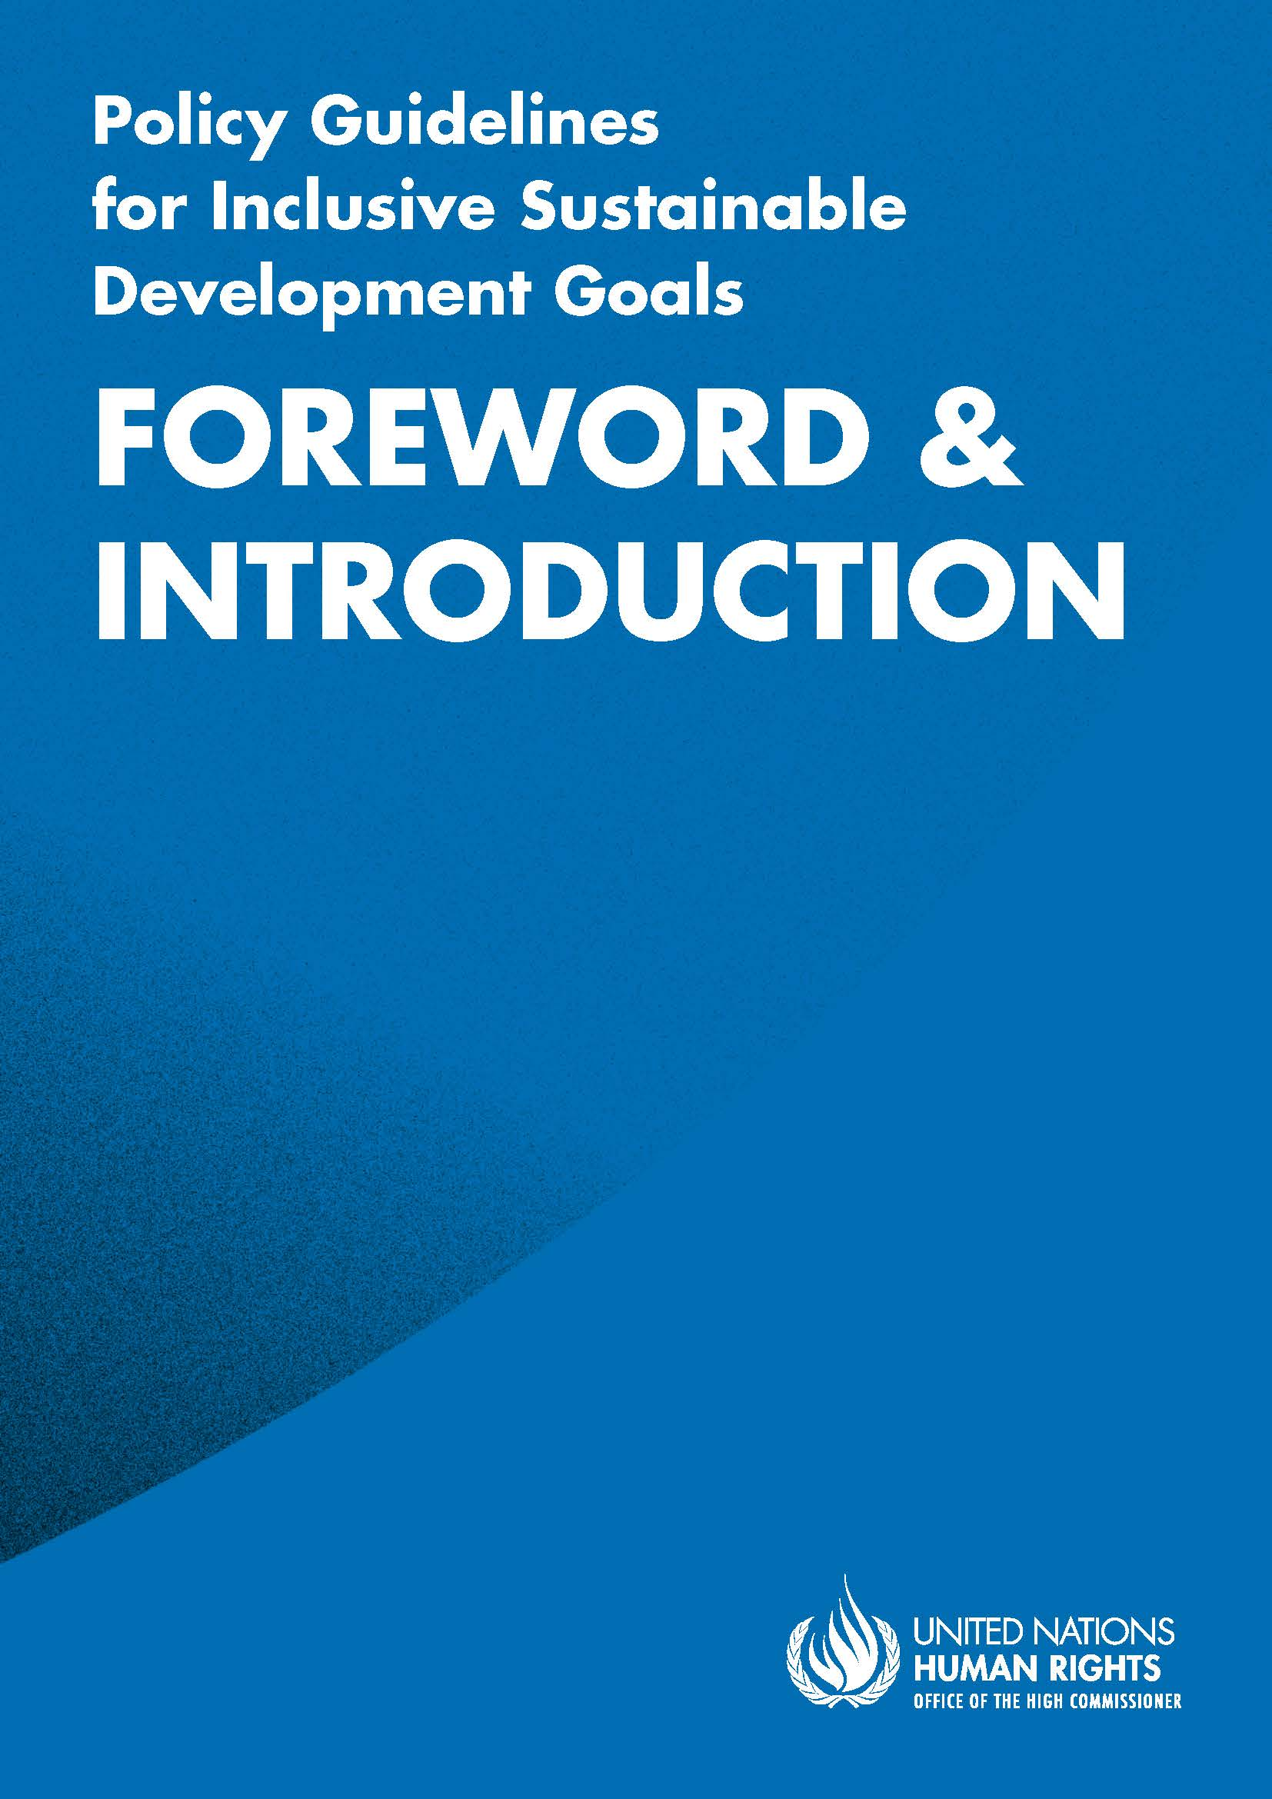
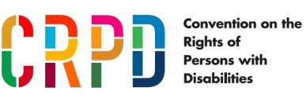
Acknowledgements
The Office of the United Nations High Commissioner for Human Rights (OHCHR) wishes to acknowledge the invaluable contributions made by organizations and individuals to the development of the Policy Guidelines for Inclusive Sustainable Development Goals, namely: representatives from national government disability focal points, National Statistics Offices, National Human Rights Institutions, United Nations entities and experts, organizations of persons with disabilities and other civil society organizations. In particular, a special thanks to the first Special Rapporteur on the Rights of Persons with Disabilities, Catalina Devandas Aguilar; the Special Envoy of the Secretary-General on Disability and Accessibility, Maria Soledad Cisternas Reyes; and the Committee on the Rights of Persons with Disabilities.
ADVANCE VERSION
© 2020 United Nations
The Policy Guidelines for Inclusive Sustainable Development Goals are a component of the SDG- CRPD Resource Package, developed by the Office of the United Nations High Commissioner for Human Rights (OHCHR). This is an advance version of the SDG-CRPD Resource Package. A final version will be issued upon completion of OHCHR review processes.
The designations employed and the presentation of the material herein do not imply the expression of any opinion whatsoever on the part of the Secretariat of the United Nations concerning the legal status of any country, territory, city or area, or of its authorities, or concerning the delimitation of its frontiers or boundaries.
Symbols of United Nations documents are composed of capital letters combined with figures. Mention of such a figure indicates a reference to a United Nations document.
Photography by Christian Tasso. The photographs featured within the Policy Guidelines were taken as part of the European Union project, Bridging the Gap II – Inclusive Policies and Services for Equal Rights of Persons with Disabilities, and were produced with the financial support of the European Union. They appear courtesy of the International and Ibero-American Foundation for Administration and Public Policies.
The Policy Guidelines for Inclusive Sustainable Development Goals were produced with the financial support of the European Union. Its contents are the sole responsibility of OHCHR and do not necessarily reflect the views of the European Union.
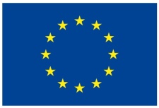
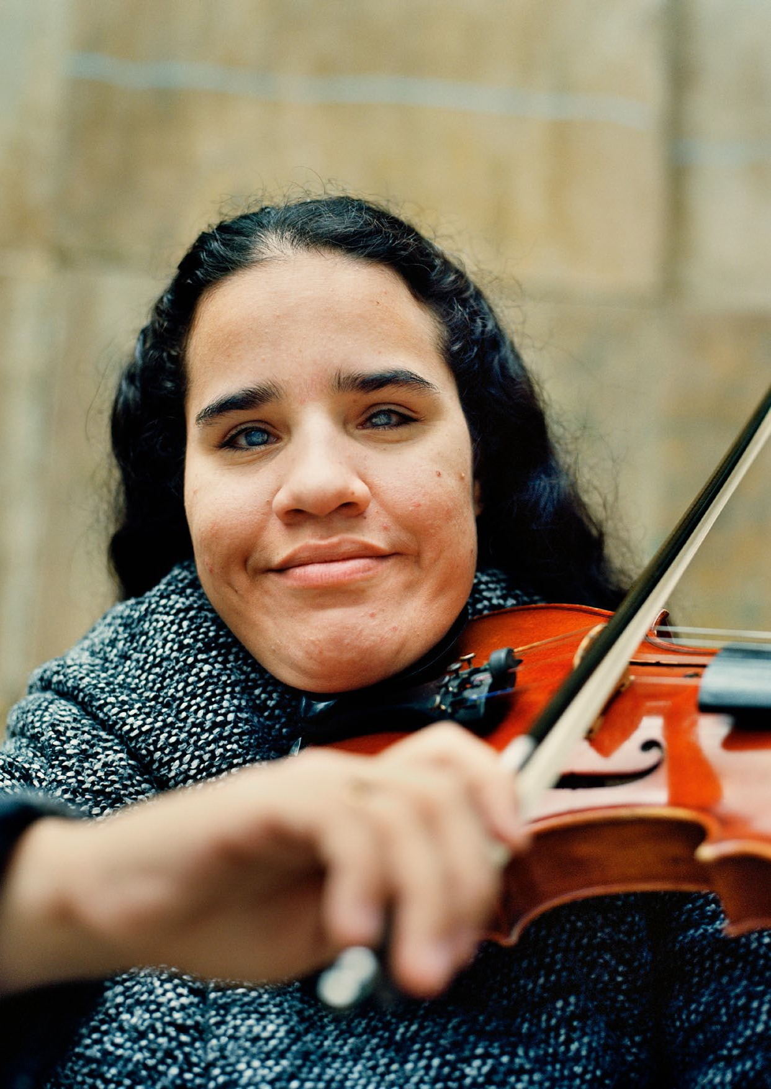

Foreword by the United Nations High Commissioner for Human Rights
The 2030 Agenda for Sustainable Development pledges commitments towards shared prosperity, lasting protection of our planet and its resources, and building peaceful, just and inclusive societies based on respect for human rights. This brings new opportunities for persons with disabilities and their recognition as key actors in the collective journey of transforming our world. However, without a rights based approach, these efforts are doomed to failure; never before has it been so clear that we cannot achieve full inclusion and participation of persons with disabilities without progressing the human rights agenda.
Advancing the rights of persons with disabilities has been a primary focus of my Office for many years now. Since the adoption of the Convention on the Rights of Persons with Disabilities (CRPD), its principles and provisions have formed the basis of all our work to ensure the inclusion of the diverse population of persons with disabilities, including women and girls, older persons, migrants and indigenous peoples, as well as underrepresented groups, such as persons with intellectual disabilities and persons with psychosocial disabilities. My Office was an active agent in the promotion of a disability-inclusive development agenda and foresaw in 2015 an implementation gap that needed to be addressed for persons with disabilities to no longer be left behind.
With a view to ensuring mutual reinforcement of the Sustainable Development Goals (SDGs) and the CRPD, my Office has developed the SDG-CRPD resource package, to ensure that all actions for the SDGs are inclusive of persons with disabilities and guided by the CRPD. I would like to acknowledge the support of the European Union and all those that contributed to this work, in particular, organisations of persons with disabilities. While the resource package is primarily targeted at States which are responsible for both SDG and CRPD implementation, it acknowledges that we all have a role to play in creating more inclusive and sustainable communities. Whether it be through investment, research, training, monitoring or sharing experiences, the SDG-CRPD resource package can serve as an indispensable guide for all stakeholders.
I encourage wide dissemination and use of the resource package for the benefit of the entirety of the human family; by strengthening our responses against all forms of exclusion, it contributes to making the journey to 2030 and beyond, indeed a collective one. My Office stands ready to support States, organizations of persons with disabilities and the UN family to get the most out of these tools. Let’s build disability-inclusive societies!

Michelle Bachelet
United Nations High Commissioner for Human Rights

Policy Guidelines for Inclusive Sustainable Development Goals

1. Introduction
In 2015, the United Nations adopted the 2030 Agenda for Sustainable Development (2030 Agenda) which puts forward 17 Sustainable Development Goals (SDG) with 169 targets. The negotiations of the 2030 Agenda were carried out with the active involvement of organizations of persons with disabilities (OPD) and, as a result, the 2030 agenda reflects the rights of persons with disabilities across different goals. This demonstrates a significant advancement compared to the previous Millennium Development Goals, which did not consider the situation of persons with disabilities and, hence, widened the gap between persons with disabilities and others, leaving them behind.
Learning from this lesson, the SDGs call on the international community to commit to leaving no one behind and reaching the furthest behind first, to address the situation of those most excluded from development and to implement policies to combat the discrimination entrenched in existing structures and systems.
The Convention on the Rights of Persons with Disabilities (CRPD), which entered into force in 2008, provides a blueprint for actions to include and uphold the rights of persons with disabilities. This human rights treaty calls for a paradigm shift from previous understandings of disability to a human rights model of disability. This new generation human rights treaty not only enumerates the human rights of persons with disabilities, it also serves as a development tool for their implementation into policies and practices. The CRPD serves as a guide for the implementation of the SDGs by providing a human-rights perspective to the inclusion of persons with disabilities, in the pursuit to ‘leave no one behind’.

2. Purpose
These guidelines aim to support policymakers in the development of laws, policies and programmes following the SDGs and under the guidance of the CRPD. The purpose of the guidelines is to:
  - provide guidance to policymakers regarding the development of national policies, following the commitments adopted by the government with regard to the SDGs, in a way that is respectful of the rights of persons with disabilities
  - inform government stakeholders, national statistical offices, national human rights institutions, United Nations field presences and civil society, particularly organizations of persons with disabilities, on the findings made at the international level through human rights monitoring systems, for them to identify opportunities for advancing the rights of persons with disabilities in their country and contribute to their monitoring.
These guidelines do not seek to:
- give an exhaustive description of all rights
- give detailed instruction on the implementation of the CRPD.
The guidelines list additional resources to further explore the recommendations issued by the United Nations system.

3. The development of the guidelines
The development of these guidelines was informed by consultations held with governments, national human rights institutions, national statistical offices, civil society organizations, organizations of persons with disabilities, international cooperation agencies, United Nations agencies and technical experts, as well as other stakeholders.

4. The structure of these guidelines
These guidelines are divided into four parts:
- Introduction (present document): presents the purpose and structure of the guidelines, how to use them and how they link with other tools in the SDG-CRPD resource package (human rights indicators and data sources guidelines, videos and training materials).
- Foundations for inclusive Sustainable Development Goals: key concepts and structural requirements:
Section I provides an introduction to key concepts from the CRPD, addressing cross-cutting components of a disability-inclusive implementation of the SDGs.
Section II focuses on the structural requirements of governments to create an enabling legal, policy and programming environment, which build the foundation for a more inclusive society.
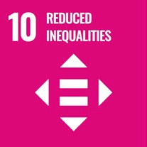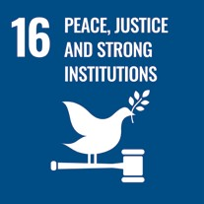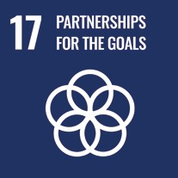
This content specifically addresses the Sustainable Development Goals (SDGs) which relate to key aspects of governmental institutional policy and accountability frameworks, covering:
  - Governance
  - Participation
  - Legislation and policy
  - Accountability and monitoring
  - Capacity building
  - International cooperation
This includes reference to:
- SDG 10: Reduce inequality within and among countries
- SDG 16: Promote peaceful and inclusive societies for sustainable development, provide access to justice for all and build effective, accountable and inclusive institutions at all levels
- SDG 17: Strengthen the means of implementation and revitalise the Global Partnership for Sustainable Development.
- SDG-specific sectoral guidelines: provide more in-depth guidance related to specific SDGs/ sectoral areas.
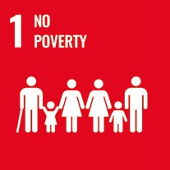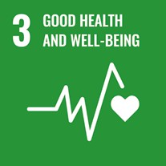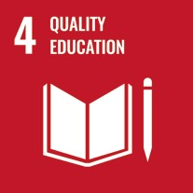
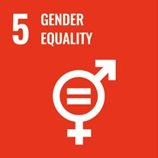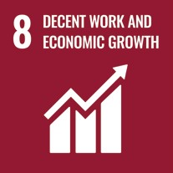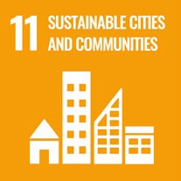
- The SDG-specific sectoral guidelines include the following topics:
- SDG 1: No poverty
- SDG 3: Good health and well-being
- SDG 4: Quality education
- SDG 5: Gender equality
- SDG 8: Decent work and economic growth
- SDG 11: Sustainable cities and communities
- These include an initial ‘In Brief’ section designed to provide a quick overview of the topic in relation to persons with disabilities and to give policymakers a snapshot of what needs to be done with respect to that specific goal. The ‘In Brief’ section includes the following content:
- What is the situation?
- What needs to be done?
- DO’s and DON’Ts
- This is followed by an ‘In Depth’ section which addresses in more detail the specific issues and key actions called for by the SDGs, connecting these actions to the complementary Human Rights Indicators on the Convention on the Rights of Persons with Disabilities, Data Sources Guidance, SDG-CRPD videos and Training materials on disability-inclusive Sustainable Development. The ‘In Depth’ sections cover the following:
- Introduction to the goal
- Connection to other tools
- Why is this Goal important for persons with disabilities?
- Actions applicable across all targets
- Other key actions by target
- Additional Resources
- Thematic briefs: These provide information and recommended actions in relation to the inclusion of persons with disabilities for the following issues:
- Food and nutrition
- Clean water and sanitation
- Climate change and disaster risk reduction
- Rural areas
- Tourism
- Research and innovation
The thematic briefs cover a range of SDG goals and targets which are identified in each brief. These are structured similar to the “In Brief” sections of the SDG-specific sectoral guidelines and include the following content:
- What is the situation?
- What needs to be done?
- DO’s and DON’Ts
- Additional Resources

5. How to use these guidelines

The importance of the Foundations Guideline
The guidelines have been designed to be used as standalone documents, as well as a set of cohesive guidelines. It is strongly recommended that the Foundations guideline: Foundations for inclusive Sustainable Development Goals: key concepts and structural requirements is read first. The Foundations guideline explains key concepts and terminology that are referenced and built upon in the SDG-specific guidelines and thematic briefs and should accompany each SDG-specific sectoral guideline and thematic brief. If the SDG-specific guidelines and briefs are read in isolation, cross- cutting requirements may be missed.

Navigating the guidelines
Each document (with the exception of the Foundations guideline) follows a similar structure for ease of navigation and use. Furthermore, key areas of content are marked by common headings and icons. Markers or icons are used to quickly indicate to the reader when the content includes:
  - Recommendations 
  - Good practice examples 
  - Key concepts
  - Further information 

Key Concepts Annex
Each guideline (except the Foundations guideline) and thematic brief has an annex which includes short descriptions of key concepts, to aid with comprehension. When these concepts are used in the guideline/brief, hyperlinks are provided to the description in the “Key concepts annex”. These key concepts are explained in more detail in the Foundations guideline: Foundations for inclusive Sustainable Development Goals: key concepts and structural requirements. The key concepts annex provides a short reminder of the content in the Foundations guideline, which should be read first.

Using the guidelines alongside complementary resources
These guidelines are complemented by other resources developed by the Office of the United Nations High Commissioner for Human Rights: the Human Rights Indicators to the Convention on the Rights of Persons with Disabilities, the Data Sources Guidance, the Training materials on disability- inclusive Sustainable Development Goals and a series of SDG-CRPD videos. These resources mutually reinforce each other in their objective to provide concrete guidance on the promotion of the rights of persons with disabilities and the tracking of progress for this objective. The Human Rights Indicators on the CRPD and the Data Sources Guidance can also be used independently to monitor CRPD and SDG implementation. More information on these complementary resources is provided below.

6. Complementary Resources

6.1 Human Rights Indicators on the CRPD
Human rights indicators enhance human rights implementation and measurement by:
    - highlighting the practical content of norms
    - measuring progress
    - bringing transparency and accountability
    - strengthening the follow-up on recommendations
The Human Rights Indicators on the CRPD are key to facilitating the understanding and implementation of the provisions of the Convention. They serve to give guidance on actions and measures that need to be taken in implementing the CRPD and in facilitating the assessment of its progress.
Law-, policy- and other decision-makers across all levels of government can benefit from these indicators, to know what kind of steps are needed to transform the legal, policy and budgetary framework and to measure progress in doing so. In addition, the indicators serve as a tool for any organisation or body to assess implementation and to hold the government accountable, e.g.
National Human Rights Institutions, civil society (including organizations of persons with disabilities), international cooperation agencies, United Nations agencies, donors.
The human rights indicators on the CRPD were developed based on the CRPD and the CRPD Committee’s jurisprudence, as well as other human rights standards. Following the methodology developed by the Office of the United Nations High Commissioner for Human Rights on human rights indicators, the CRPD indicators can be applied and contextualised at the national level, for all rights.
The CRPD indicators incorporate SDG indicators, showing the link between the two instruments and demonstrating how efforts and actions to uphold the rights of persons with disabilities mutually reinforce both. For more information, please consult the Frequently Asked Questions which accompany the human rights indicators on the CRPD.

6.2 Data Sources Guidance
The absence of data related to persons with disabilities has been a longstanding barrier to shaping laws and policies that improve the development, access and exercise of their rights on an equal basis with the rest of society. Identifying data sources and their gaps is key to ensuring that government action is informed to better reach out to those who are left behind, including persons with disabilities.
The Data Sources Guidance gives information on how different sources of data can be used to respond to, and provide a measure for, the outcome indicators of the human rights indicators on the CRPD. For each article, the outcome indicators are listed, accompanied by examples of data sources for constructing each indicator. Examples of countries already producing relevant data are given or, when no country was found reporting on the indicator, the guidance seeks to provide examples of where modifications to existing data collection could be applied to produce it.
The goal of this document is to highlight existing data sources and identify areas where further efforts are needed to build on existing data collection to fulfil the reporting on these indicators as efficiently as possible.
For some indicators, this is straightforward and requires few, if any, modifications to data collection. Other indicators are more challenging. For more information, please read the introduction to the Data Sources Guidance.

6.3. Training materials on disability-inclusive Sustainable Development Goals
The Training materials on disability-inclusive Sustainable Development Goals provide guidance on organizing both in-person and online training on disability-inclusive SDGs implementation.
Mirroring the sector-specific SDG Policy Guidelines, the training materials include the following modules:
- Foundations for inclusive Sustainable Development Goals
- SDG 1: No poverty
- SDG 3: Good health and well-being
- SDG 4: Quality education
- SDG 5: Gender equality
- SDG 8: Decent work and economic growth
- SDG 11: Sustainable cities and communities
Each training module is composed of a:
- Facilitator’s guide – complete with facilitator’s notes, activities and supporting materials, as well as indications for the preparation of in-person or online training
- Set of presentation slides for in-person and for online training

6.4 Videos
The SDG-CRPD videos mirror the guidelines and can be used for training and awareness-raising activities. The following videos are available with multiple accessibility features including captioning, International Sign interpretation and audio description:
    - Overview of the SDG-CRPD resource package
    - Foundations for inclusive SDGs
    - SDG 1: No poverty
    - SDG 3: Good health and well-being
    - SDG 4: Inclusive quality education
    - SDG 5: Gender equality
    - SDG 8: Decent work and economic growth
    - SDG 11: Sustainable cities and communities

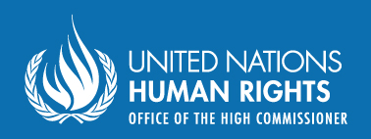
Office of the United Nations
High Commissioner for Human Rights (OHCHR)
Palais de Nations
CH 1211 Geneva 10 – Switzerland
Email: disability@ohchr.org
Website: www.ohchr.org

