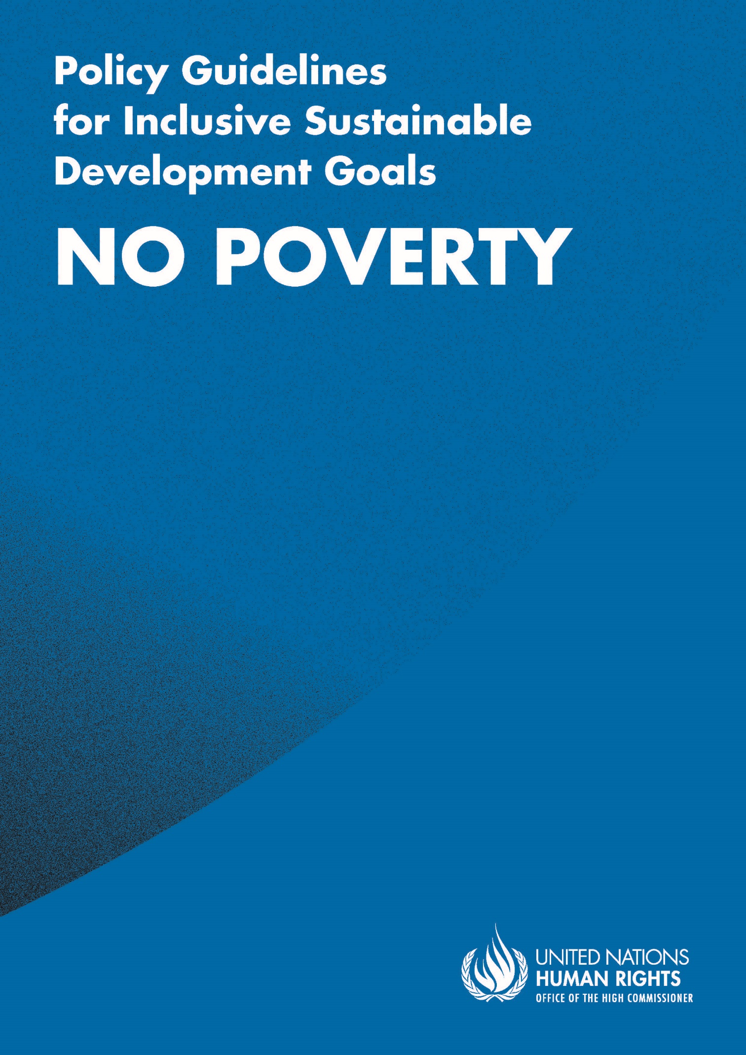

ADVANCE VERSION
© 2020 United Nations
The Policy Guidelines for Inclusive Sustainable Development Goals are a component of the SDG- CRPD Resource Package, developed by the Office of the United Nations High Commissioner for Human Rights (OHCHR). This is an advance version of the SDG-CRPD Resource Package. A final version will be issued upon completion of OHCHR review processes.
The designations employed and the presentation of the material herein do not imply the expression of any opinion whatsoever on the part of the Secretariat of the United Nations concerning the legal status of any country, territory, city or area, or of its authorities, or concerning the delimitation of its frontiers or boundaries.
Symbols of United Nations documents are composed of capital letters combined with figures. Mention of such a figure indicates a reference to a United Nations document.
Photography by Christian Tasso. The photographs featured within the Policy Guidelines were taken as part of the European Union project, Bridging the Gap II – Inclusive Policies and Services for Equal Rights of Persons with Disabilities, and were produced with the financial support of the European Union. They appear courtesy of the International and Ibero-American Foundation for Administration and Public Policies.
The Policy Guidelines for Inclusive Sustainable Development Goals were produced with the financial support of the European Union. Its contents are the sole responsibility of OHCHR and do not necessarily reflect the views of the European Union.

End poverty in all its forms everywhere.
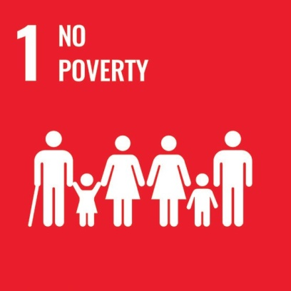

CONTENTS
IN BRIEF 6
1. What is the situation? 7
2. What needs to be done? 9
3. DO’s and DON’Ts 12
IN DEPTH 15
1. Introduction 16
2. Connection to other tools 16
3. Why is Goal 1 important for persons with disabilities? 17
4. Inclusive social protection systems: actions applicable to Target 1.3 and across all Goal 1 Targets 20
4.1 Twin-track approach for inclusive social protection 20
4.2 A human rights-based approach to social protection, focused on support for inclusion 23
4.3 Disability assessment and determination should focus on support requirements, rather than impairment 25
4.4 Moving away from a focus on “incapacity to work” 26
4.5 Tailoring benefits to the diversity of persons with disabilities 27
4.6 Access to basic general services and disability-specific services to ensure full and effective participation in the community 30
4.7 Consultation with organizations of persons with disabilities 33
4.8 Awareness-raising 34
4.9 Finance and budget 34

5. Other key actions by target 36
5.1 End poverty for persons with disabilities –Targets 1.1, 1.2, 1.a and 1.b 36
5.1.1 Disaggregate data by disability when measuring poverty 36
5.1.2 Factor in disability-related extra costs when measuring poverty 37
5.1.3 Increase budget to finance universal coverage of persons with disabilities 39
5.2 Access to basic general services, disability-specific services (including assistive technology) and financial services to ensure full and effective participation in the community – Target 1.4 40
5.2.1 Access to basic services 40
5.2.2 Access to assistive technology for persons with disabilities 41
5.2.3 Access to financial services 44
6. Additional Resources 45
7. Key Concepts Annex 46

IN BRIEF
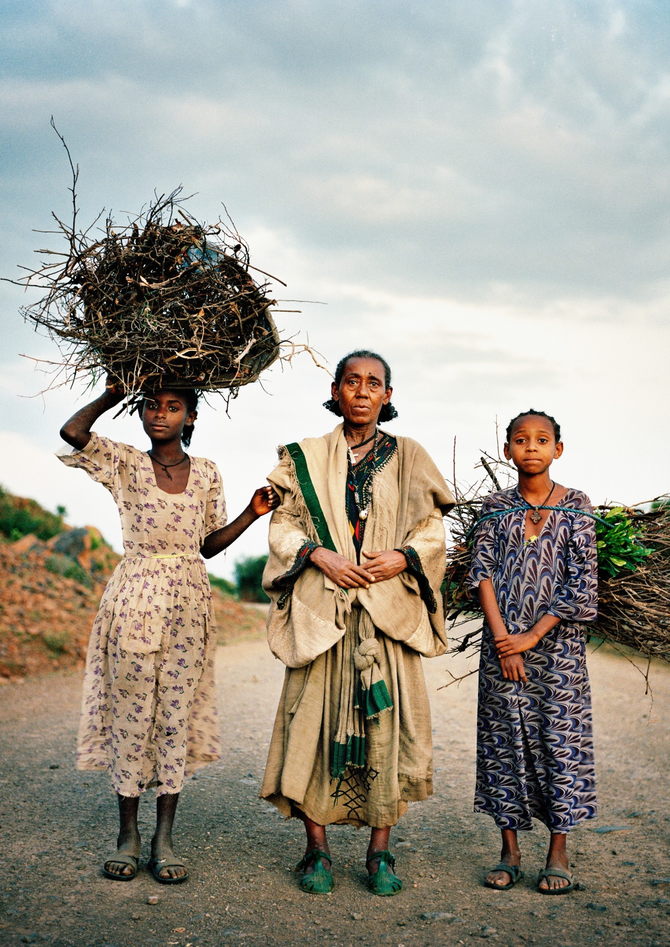

1. What is the situation?
Persons with disabilities are more likely to be poor than persons without disabilities. Data from some middle- and low-income countries show that a higher proportion of households with persons with disabilities is under the international poverty line when compared to households without persons with disabilities. Further, data from six countries - presented in figure I - show that the proportion of persons with disabilities under the national poverty line is systematically greater than other persons.
figure i
2011-2016 percentage of persons with disabilities below the national poverty line, versus percentage of other persons below the national poverty line
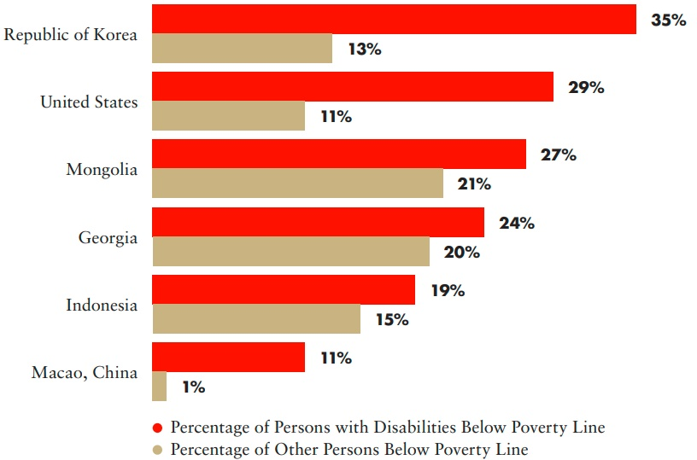
Source: United Nations Department of Economic and Social Affairs, Disability and Development Report, 2019. Figure II.2, p. 34.
Extra costs associated to disability-specific goods and services (e.g. mobility aids, personal assistance, sign language interpreting) and increased consumption of general good and services (e.g. transport, health care) are estimated at 30-40 per cent of the average income as seen in figure II. The extra cost of disability tips households into poverty and prevents their sustainable escape from poverty. When taking into consideration disability-related extra costs, the poverty rate of households with persons with disabilities significantly increases (International Labour Organization, World Social Protection Report 2017-19: Universal protection to achieve the Sustainable Development Goals, 2017).
figure ii
Extra-costs associated with disability as a percentage of average income
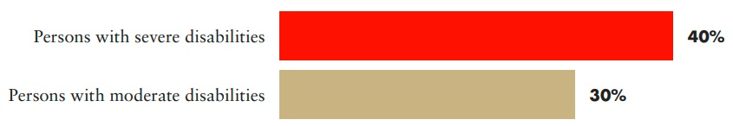
Source: UNDESA, Disability and Development Report, 2019. pp. 37-38.
Ensuring that persons with disabilities can access social protection schemes is vital to prevent the widening of inequalities and to promote an inclusive economic recovery. However, persons with disabilities face a broad range of challenges in accessing social protection schemes due to eligibility criteria, conditionalities and failure to account for disability-related extra costs, among others.
figure iii
Proportion of persons with “severe” disabilities accessing disability cash benefits, by region, 2015
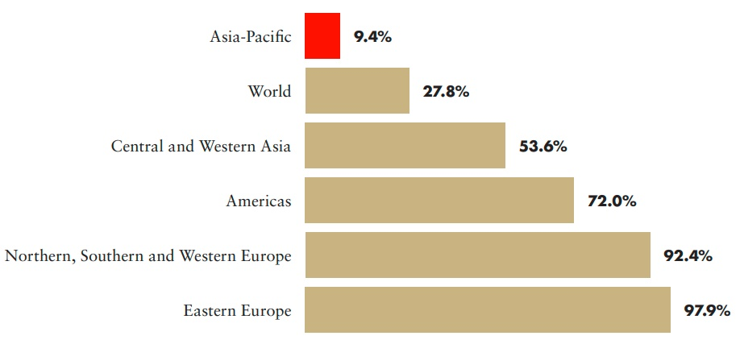
Source: ILO, World Social Protection Report 2017-19: Universal protection to achieve the Sustainable Development Goals, 2017, p. 69.
Accessibility, legal and attitudinal barriers deny persons with disabilities access to financial services such as opening a bank account to receive and manage benefits. Across five low- and middle- income countries, 8 to 64 per cent of persons with disabilities consider banks inaccessible (United Nations Department of Economic and Social Affairs, Disability and Development Report, 2019. p. 38).
A legal barrier may be the restriction of legal capacity of persons with disabilities, which can deny them from opening a bank account (e.g. a person who is blind may be rejected or be asked for additional requirements, such as a witness; persons with intellectual disabilities may be required to have a guardian appointed, even if not required by regulations).
Due to these multiple barriers, persons with disabilities continue to be excluded from workplaces and from engaging in entrepreneurial activities. The cost is not only borne by persons with disabilities whose broader participation is impeded, but the exclusion of persons with disabilities bears economic losses for society as a whole, ranging from 3 to 7 per cent of the Gross Domestic Product (GDP).
figure iv
The cost of exclusion of persons with disabilities from the labour force
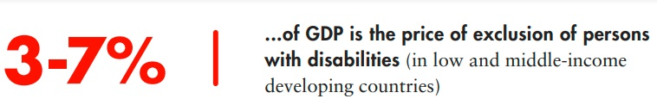
Source: ILO, World Social Protection Report 2017-19: Universal protection to achieve the Sustainable Development Goals, 2017, p.72.

2. What needs to be done?
To end poverty for all and to ensure all persons with disabilities experience a sustainable escape from poverty, governments must:
  - make structural changes to social protection systems, to ensure they are disability-inclusive
  - ensure disability-related extra costs are considered when measuring and monitoring poverty reduction
  - ensure social protection programmes facilitate the access to basic general services, assistive technologies and financial services
Main areas of intervention to realise Sustainable Development Goal 1
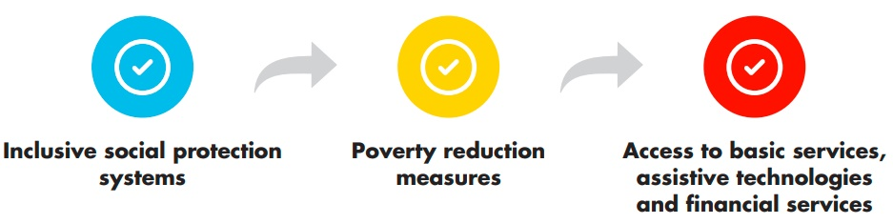
 Inclusive social protection systems – actions applicable to Target 1.3 and across all SDG 1 targets
End poverty in all its forms everywhere
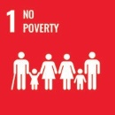 1.3 Implement nationally appropriate social protection systems and measures for all, including floors, and by 2030 achieve substantial coverage of the poor and the vulnerable
Adopt a twin-track approach to implement a cohesive social protection system, through accessible and inclusive mainstream benefits and disability-specific schemes, to ensure both basic income security and coverage of disability-related extra costs for all persons with disabilities.

Adopt a human rights-based approach to social protection, by shifting from a medical- or charity- focused approach to focusing on providing support for inclusion and participation.
Ensure that disability assessment and determination focus on support requirements to achieve participation rather than impairment

Move away from an “incapacity to work” approach by developing a flexible combination of benefits, ensuring basic income security and coverage of disability-related extra costs, including for those who seek and gain employment.
Tailor benefits to the diversity of persons with disabilities, to ensure that disability-related extra costs are considered in poverty reduction and social protection programmes, as well as in their eligibility criteria.

Facilitate access to basic general services and disability-specific services, to ensure full and effective participation in the community, including by investing in the development of community services (such as housing and support services), implementing a deinstitutionalization plan and creating social protection schemes that expand choice in support, to uphold independent living in the community.
Ensure consultation and meaningful participation of persons with disabilities in the design, implementation and delivery of both disability-specific and mainstream social protection programmes, particularly of those who experience a heightened risk of exclusion (women with disabilities, persons with psychosocial disabilities, persons with intellectual disabilities, persons who are deafblind, persons with disabilities from rural areas, etc.).

Carry out awareness-raising campaigns and activities, including the dissemination of accessible information on social protection programmes, procedures and eligibility, to reach out to all persons with disabilities (and their families) as potential beneficiaries.
Ensure budget allocation and financing schemes are well established and institutionalized, to strengthen the sustainability of the social protection system (in particular for programmes benefitting persons with disabilities); engage in the collection of disaggregated data, to monitor their impacts.

CRPD indicators: 28.3, 28.4, 28.5, 27.6, 28.12, 28.9, 28.11, 28.14, 28.16, 28.17, 28.10, 28.1, 28.2, 28.6, 28.7, 28.8, 28.18, 28.19, 28.27, 19.2.1, 19.2.2, 19.2.3, 19.3, 19.4, 19.5, 19.7, 19.8, 19.14, 19.26, 19.27, 19.28, 19.29, 19.9, 19.10, 19.11, 19.16, 19.17, 19.19, 19.20, 19.30, 23.1, 23.10, 23.15, 23.25, 19.32, 19.33, 19.34, 20.10, 1/4.19
End poverty in all its forms for persons with disabilities
1.1 By 2030, eradicate extreme poverty for all people everywhere, currently measured as people living on less than $1.25 a day
1.2 By 2030, reduce at least by half the proportion of men, women and children of all ages living in poverty in all its dimensions according to national definitions
1.a Ensure significant mobilization of resources from a variety of sources, including through enhanced development cooperation, in order to provide adequate and predictable means for developing countries, in particular least developed countries, to implement programmes and policies to end poverty in all its dimensions
1.b Create sound policy frameworks at the national, regional and international levels, based on pro-poor and gender-sensitive development strategies, to support accelerated investment in poverty eradication actions
Disaggregate data by disability when measuring poverty
Factor in disability-related costs when measuring poverty
Increase budget to finance universal coverage of persons with disabilities

CRPD indicators: 28.22, 28.23, 28.24, 28.25, 31.7, 31.8, 31.9, 31.10, 28.3, 28.9, 28.17, 28.11, 28.16.
 Access to basic general services, disability-specific services (including assistive technology) and financial services, to ensure full and effective participation in the community
1.4 By 2030, ensure that all men and women, in particular the poor and the vulnerable, have equal rights to economic resources, as well as access to basic services, ownership and control over land and other forms of property, inheritance, natural resources, appropriate new technology and financial services, including microfinance
Ensure access to basic services
Ensure access to assistive technology and products of good quality for persons with disabilities
Ensure access to financial services

CRPD indicators: 9.4, 19.12, 19.13, 19.26, 12.1, 12.2, 28.1, 28.2, 28.3, 12.15, 28.14, 20.1, 20.2, 20.3, 20.11, 20.12, 20.19, 20.20, 20.21, 28.21, 28.27, 1/4.14, 1/4.27, 19.31

3. DO’s and DON’Ts
DO | DON’T
Law, policy and programmes
Ensure that legislation and policies on social protection are compatible with the right to work and to employment. | Establish disincentives such as incompatibility between cash transfers or services and work or employment, forcing persons with disabilities to choose between a stable poverty reduction scheme or unstable employment.
Adopt a twin-track approach by ensuring that mainstream social protection schemes are inclusive of, and accessible to, persons with disabilities, as well as developing disability- specific programmes to ensure that disability- specific considerations are not left unattended,  e.g. disability-related extra-costs. | Assume that mainstream social protection programmes cover all the requirements of persons with disabilities.
Governance, inter-institutional coordination
Ensure that social protection systems facilitate access to basic services (health care, education, nutrition, housing, etc.) and disability-specific services (assistive technology, rehabilitation, personal assistants, etc.) by covering the costs either directly (e.g. in-kind assistance such as concessions, universal health coverage) or indirectly (e.g. cash assistance such as universal cash benefits for persons with disabilities that are sufficient to cover disability-related costs). | Focus only on monetary measures of poverty nor implement social protection programmes solely focused on poverty-targeted cash transfers.
Practice and implementation
Ensure that poverty reduction schemes include persons with disabilities on an equal basis with others. | Impose conditionalities within poverty reduction schemes without providing the necessary support for persons with disabilities to fulfil them (e.g. requiring children with disabilities to be attending school without providing the support needed to overcome any barriers they may face in enrolling and attending school).

DO | DON’T
Ensure that social protection floors include the extra-cost of disability and appropriately provide for them, in addition to providing for basic income security and access to health care. | Implement “one-size-fit-all” means-tested or proxy means-tested eligibility thresholds that do not take into account the extra costs of disability.
Ensure that disability assessment for accessing disability benefits is easy to implement and available across the country’s territory. | Use complex disability assessment mechanisms that cannot be rolled out throughout the territory and which become barriers, rather than entry points, to access support.
Develop flexible combinations of benefits to ensure basic income security and coverage of disability-related extra costs, including for persons with disabilities who seek and obtain work. | Establish conditions for access to social protection based on the “incapacity to work” of persons with disabilities.
Create community-based support services, such as personal assistance and peer support, and allocate funds to progressively increase the number of persons with disabilities accessing them. | Perpetuate nor develop institutionalization by continuing to invest in institutions (large, small, group-homes, day care, etc.) and other segregated housing, such as psychiatric institutions.
Create social protection schemes that recognize and compensate parents, caregivers and other family members, particularly women, who provide support to persons with disabilities; develop personal assistance services and third- person support allowances, enabling persons with disabilities to choose their support services. | Rely on family members to provide support to persons with disabilities without simultaneously creating community-based inclusive development programmes and disability-support services, such as personal assistants.
Information, communication and awareness-raising
Ensure that the implementation of programmes includes robust awareness-raising campaigns and activities - including the dissemination of accessible information to all persons with disabilities and their families -, notably on entitlements and benefits, eligibility criteria, conditionalities and all procedures. | Fail to accompany programmes with awareness-raising activities and dissemination of accessible information, thus failing to reach out to potential beneficiaries, including persons with disabilities and their families.

DO | DON’T
Participation
Facilitate the meaningful involvement of organizations of persons with disabilities (OPDs), in all their diversity, in legislation, policy design and development, and outreach mechanisms. | Overlook the key inputs and support that OPDs can provide to ensure the effectiveness of policies and of outreach which meets the requirements of all persons with disabilities.
Data collection and disaggregation
Ensure that the social protection monitoring framework allows for the disaggregation by disability, alongside disaggregation by gender, economic status and location (e.g. urban/rural), and the assessment of the extent to which programmes promote the participation and inclusion of persons with disabilities. | Rely only on census data to monitor the impact of social protection systems.

IN DEPTH
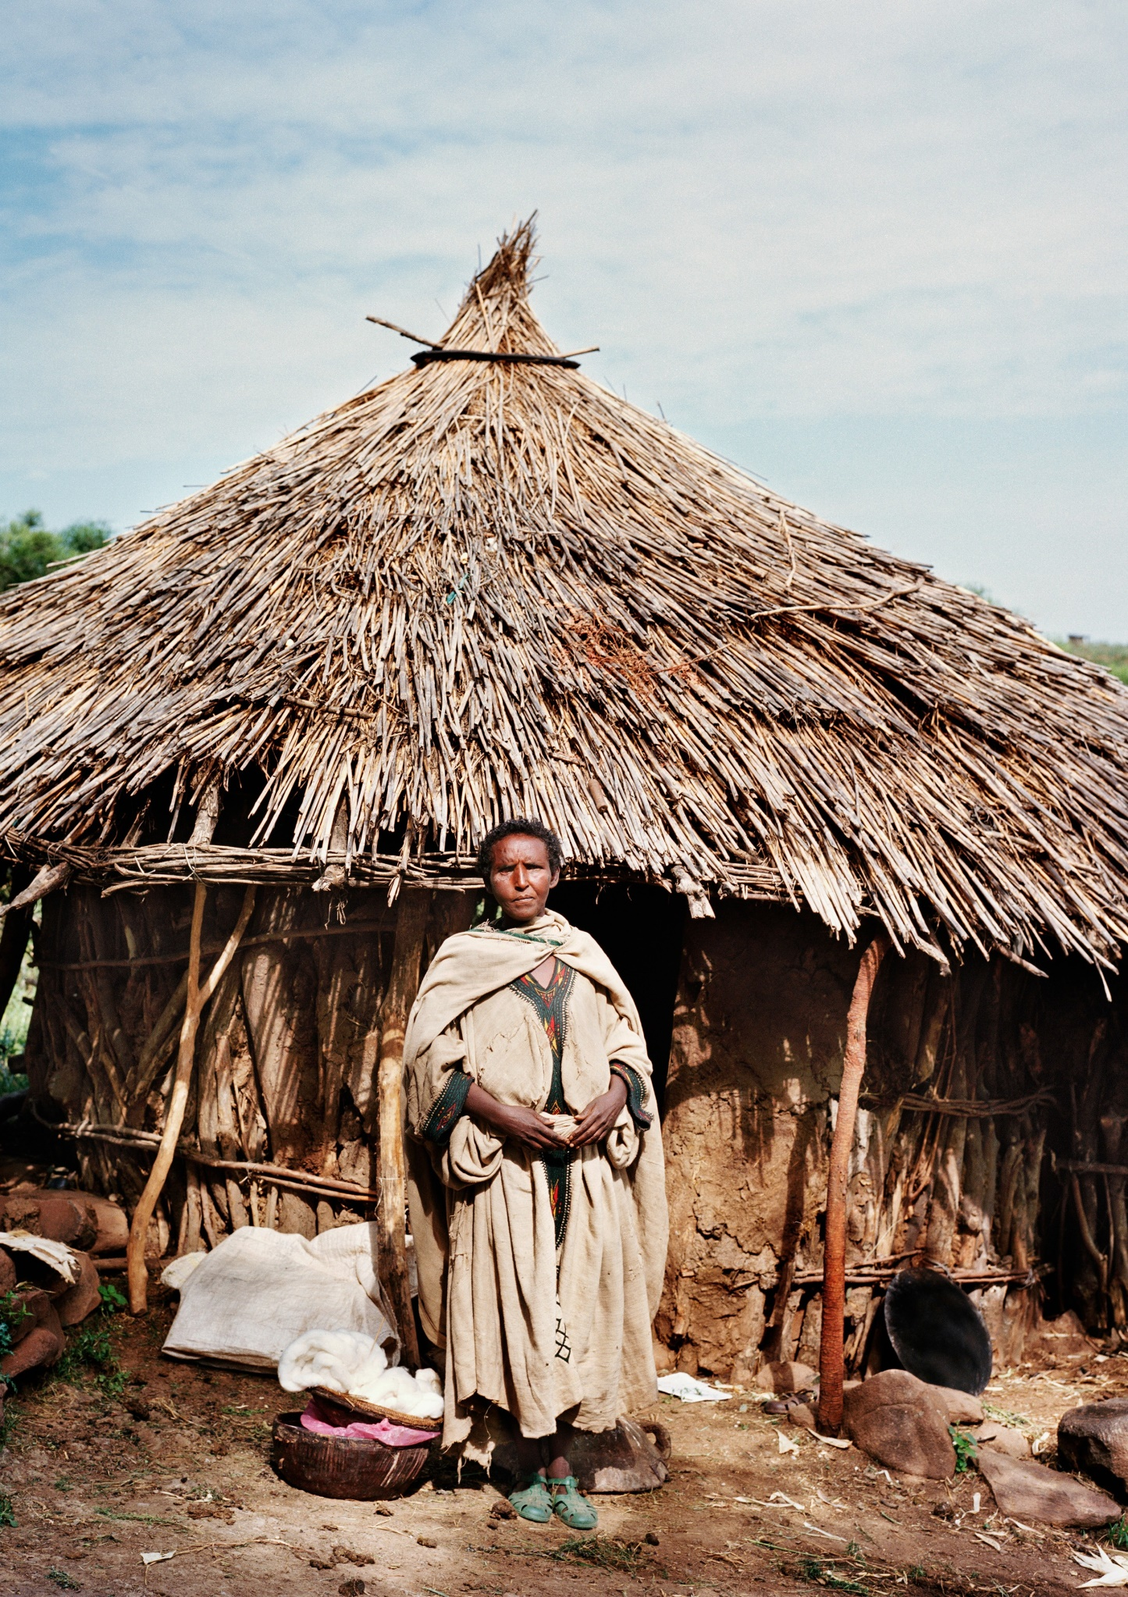

1. Introduction
This section provides detailed guidance for policymakers, on measures that are required to implement the Sustainable Development Goal 1 (SDG 1) on Ending Poverty in a way that is inclusive of persons with disabilities.
Section 2 shows the connection between the Policy Guidelines to achieve SDG 1 with other resources, including the human rights indicators under the Convention on the Rights of Persons with Disabilities (CRPD) and other related tools.
Section 3 provides an overview of the disadvantaged situation of persons with disabilities, including in accessing social protection.
Sections 4 and 5 provide guidance on policy measures and actions that should be adopted for an inclusive implementation of the SDG 1. In particular, Section 4 addresses structural measures that are needed to develop a social protection system that is inclusive of persons with disabilities (Target 1.3) and section 5 provides guidance on actions related to specific SDG 1 targets.
Given its broad scope, Target 1.3 is referred to within Section 4, which addresses the structural elements of inclusive social protection systems. An inclusive social protection system serves as the main platform to lead and support persons with disabilities out of poverty and exclusion, and to facilitate their participation in the national development system. Along the same lines, Section 5 groups targets 1.1 and 1.2, aimed at ensuring poverty reduction, with targets 1.a and 1.b, aimed at improving resource mobilization for such programmes.
Preventing poverty and supporting a sustainable escape from poverty requires a multi-sectoral approach. It is essential to develop inclusive social protection systems that will progressively ensure access to basic services such as education (SDG 4), health (SDG 3), water and sanitation (see Thematic Brief on WASH), transportation (SDG 11), resilience to climate change and disasters (see Thematic Brief on climate change and disaster risk reduction) and promotion of economic empowerment through the promotion of decent work (SDG8). These topics are covered in their respective guidelines and Thematic Briefs. The present guideline will focus on social protection, as well as facilitating access to basic services, assistive technology and financial services for persons with disabilities, which are key elements of effective social protection.

2. Connection to other tools
  - CRPD Indicators: Article 28 (Adequate standard of living and social protection)
  - Other related CRPD articles: Articles 1-4, 5, 6, 7, 9, 11, 12, 13, 19, 25, 26, 27, 31, 32
  - Data Sources Guidance: Article 28 and other related CRPD articles.
  - Training materials: Goal 1
  - Video: Goal 1

3. Why is Goal 1 important for persons with disabilities?
Recent evidence identifies that persons with disabilities are disproportionally affected by multidimensional poverty and are more economically insecure and exposed to shocks. Disability can lead to poverty because persons with disabilities experience barriers to participating fully in economic and social life and face extra costs such as assistive devices, more frequent healthcare, and inaccessible transport. In addition, people living in poverty are at risk of acquiring disability due to factors such as malnutrition, unsafe living and working conditions and lack of access to immunizations, healthcare and safe water and sanitation.
However, many poverty reduction policies underestimate the challenges faced by persons with disabilities. For instance, income and consumption poverty data for statistical or targeting purposes, which are often collected and analysed at the household level, rarely consider intra-household dynamics which may impact persons with disabilities. Nor do these data consider the fact that some groups are more exposed to deprivation and vulnerabilities, such as women and girls, people living in rural or remote areas, persons with high support needs or persons with intellectual disabilities or persons with psychosocial disabilities.
More critically, they often fail to identify the diversity of disability-related extra costs, which are a critical driver leading to, and impeding escape from, poverty, for persons with disabilities and their families. Those costs vary depending on the level of support requirements, barriers and healthcare needs. They may tip persons with disabilities and their families into poverty and prevent them from seizing economic opportunities. For more on disability-related extra costs, access the Centre for Inclusive Policy’s videos: “Understanding disability extra costs”, and “Addressing disability extra costs”.
For example, persons with disabilities are more likely to face catastrophic health expenditures. A rough estimation based on data from seven countries suggests that the disability-related extra costs incurred by persons with disabilities and their families vary between 30 per cent and 40 per cent of the average income (see Figure II), depending on the support requirements of the person concerned. Hence, persons with disabilities may require more resources to achieve the same standard of living as others. It is important to note that those data consider the expenses that persons can afford and not necessarily the ones that they would require but cannot afford (World Health Organization and World Bank, World Report on Disability, 2011, p.69). Actual costs of goods and services required to achieve basic participation can represent several times the poverty line, especially due to assistive devices and human assistance and support (United Nations Partnership to Promote the Rights of Persons with Disabilities and Leonard Cheshire. Inclusive Social Protection for Empowerment of Persons with Disabilities: Considering the disability related extra costs in social protection. 2020).
All of these elements also explain why the poverty gap between persons with disabilities and others tends to increase with the level of economic development of countries, given that persons with disabilities are not in the same position to seize economic opportunities.
Social protection can reduce inequality, ensure participation, and provide a sustainable escape from poverty, but current coverage is low
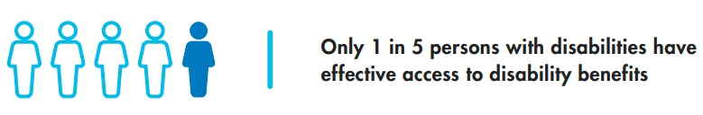
Source: ILO, World Social Protection Report 2017–19: Universal social protection to achieve the Sustainable Development Goals, 2017 p. 70
Persons with disabilities face significant barriers in accessing social protection programmes - they are not designed in an inclusive manner and are based on outdated approaches, which undermine autonomy and inclusion. Current social protection coverage for persons with disabilities is not sufficient. While coverage in many high-income countries is quasi-universal, recent estimations indicate that, worldwide, only 27.8 per cent of persons with disabilities with high support requirements access disability cash-benefits, falling to only 9.4 per cent for Asia and the Pacific (ILO, World Social Protection Report 2017-19: Universal protection to achieve the Sustainable Development Goals, 2017, p. 70). This coverage is even lower when only considering low- and middle-income countries, with 18.5 per cent global coverage and only 1 per cent coverage in low- income countries (Durán-Valverde and others, Measuring financing gaps in social protection for achieving SDG target 1.3: Global estimates and strategies for developing countries (Geneva: ILO, 2019)).
Coverage of persons with disabilities within social protection systems is low due to several factors, including:
- The combination, in many low- and middle-income countries, of contributory schemes (social insurance) which cover a small part of the population in the formal economy and poverty- targeting schemes, leaving most persons with disabilities without any support.
- Eligibility criteria and disability identification challenges, leading to a combination of exclusion errors related to both means-testing and disability determination.
- Failure to account for extra costs of disability in means-testing.
- Conditionalities of mainstream social protection schemes, that may exclude persons with disabilities.
- The inaccessibility of social protection delivery mechanisms (see UNPRPD, ILO and UNICEF. Building Inclusive Social Protection Systems Supporting Empowerment of Persons with Disabilities: Inclusive social protection delivery mechanisms delivery, forthcoming).
Focus on incapacity to work and limited consideration of disability-related extra costs
Eligibility for disability benefits is often based on the criteria of incapacity to work. As a result, in many countries, persons with disabilities who seek socio-economic participation do not get much or any support, despite all the barriers they face in finding work. These schemes ignore the costs faced by persons with disabilities in overcoming barriers to seek and retain work, especially in the context of high rates of informal work, in which tax incentives for employers will have little impact on the vast majority of persons with disabilities.
Some low- and middle-income countries, such as Fiji, Mauritius, Namibia, Nepal, Viet Nam, Thailand or Georgia, have adopted universal disability allowances compatible with work and with other income support schemes, such as old-age pension or family poverty assistance (UNPRPD and Leonard Cheshire. Inclusive Social Protection for Empowerment of Persons with Disabilities: Considering the disability related extra costs in social protection, 2020). Most countries’ mainstream social protection schemes do not account for disability-related extra costs A few countries, such as Indonesia and the Republic of Moldova, have made some adaptations in terms of eligibility thresholds, disability top-up or higher benefit amounts to compensate for extra costs. However, these mainstream schemes are household schemes, with little choice and control given to persons with disabilities over how to use this extra support, which is often low.
A critical measure is to ensure that persons with disabilities benefit, as a priority, in the expansion of universal health coverage and basic packages to include rehabilitation and assistive devices.
Social protection delivery mechanisms and financial services are often not accessible
Even when the design and eligibility criteria of schemes seek to be inclusive, there are usually significant issues related to the accessibility of delivery mechanisms. The complexity of procedures, lack of accessible information, additional transport-related barriers and lack of awareness of staff and payment providers make it difficult for persons with disabilities to access and make use of the benefits to which they may be entitled. For more information, access the Centre for Inclusive Policy’s video: “Making social protection delivery mechanisms accessible”.
Lack of access to financial services may impede benefits from cash-transfer programmes
Social protection beneficiaries generally require a bank account to receive and manage disability cash benefits. However, physical, legal and attitudinal barriers prevent persons with disabilities from having equal access to financial services. Data from five developing countries found that the percentage of persons with disabilities who consider banks to be inaccessible ranged between 8 and 64 per cent (UNDESA, Disability and Development Report, 2019, p. 39). Even in developed countries, 28 per cent of banks and 12 per cent of automatic teller machines (ATM) were not accessible. In many countries, laws prevent persons with disabilities from opening and managing bank accounts on their own. In some cases, blind persons may have to comply with additional requirements to undertake bank transactions, such as having a guardian or witness present. Even when regulations do not formally require a guardian, in practice, persons with intellectual disabilities may be obligated to have a guardian appointed to open an account, as they are perceived to be “incapable” and denied legal capacity.

4. Inclusive social protection systems: actions applicable to Target 1.3 and across all Goal 1 Targets
End poverty in all its forms everywhere
1.3 Implement nationally appropriate social protection systems and measures for all, including floors, and by 2030 achieve substantial coverage of the poor and the vulnerable

4.1 Twin-track approach for inclusive social protection
The low coverage of persons with disabilities by social protection systems is largely due to the fact that, in most low- and middle-income countries, social protection systems combine contributory schemes for formal workers and poverty-targeted schemes, leaving most persons with disabilities in the middle, without support.
More than half of all countries providing disability benefits do so only through contributory schemes. Given that persons with disabilities are more unlikely to work and have participated in contributory schemes in the formal economy, they are not eligible for such disability benefits. Children with disabilities are also ineligible.
While around 40 countries utilize non-contributory schemes, these are largely means-tested schemes which do not take into account disability-related extra costs. This means that the full extent of expenditures faced by persons with disabilities and their families is not taken into consideration in calculating the means of a household, compared to their income. Further, non-contributory schemes may discourage seeking employment, in order to continue receiving the benefit. As of 2015, only 23 countries were combining contributory and universal non-contributory schemes. Positively, some developing countries are progressing towards universal social protection for persons with disabilities. However, as part of fiscal consolidation policies and “austerity” measures, other countries are cutting benefits and leaving some persons with disabilities without support, including by narrowing benefits to only the poorest, or by replacing universal schemes with means-tested schemes (ILO, World Social Protection Report 2017-19: Universal protection to achieve the Sustainable Development Goals, 2017).
figure v
Overview of disability cash benefit schemes, by type of scheme and benefit, 2015
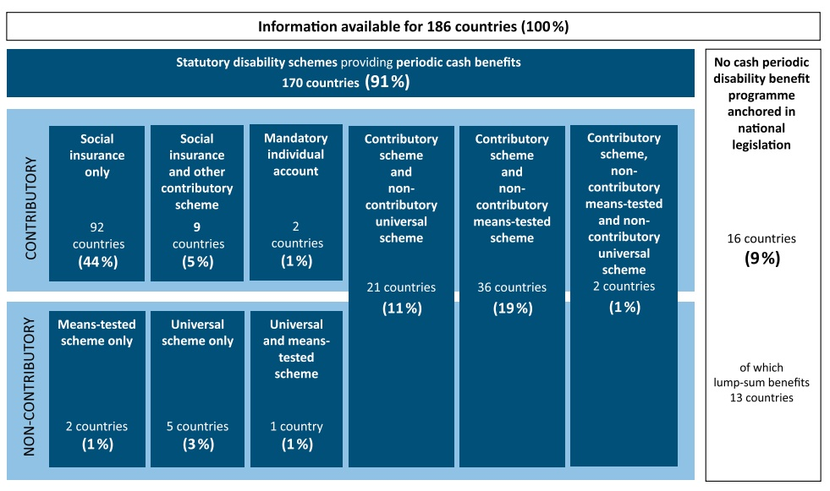
Source: ILO, World Social Protection Report 2017-19: Universal protection to achieve the Sustainable Development Goals, 2017, p. 68.

Social protection systems aim at ensuring a minimum standard of living that provides for common ground and enables the participation of all members in a society. To contribute to the sustainable escape of persons with disabilities from poverty, social protection systems need to provide across the life cycle, including:
- Basic income security that enables access to common necessary goods and services
- Access to needed healthcare, including rehabilitation and assistive devices, without facing financial hardship
- Coverage of disability-related costs, including access to the required support
- Improved access to services, such as childcare and education, transport, vocational training, support to employment and livelihood generation, among others.
To achieve this, social protection systems need to utilise a twin track approach, combining a diversity of mainstream and disability-specific schemes, as seen in table 1.
table 1
Example of mainstream and disability-specific social protection schemes applicable to persons with disabilities
 | Childhood | Working-age | Old age
Income security | Family assistance benefits | Poverty assistance; unemployment benefit; disability pension | Old-age pension
Coverage of disability-related costs, including support services | Child with disability benefit; Concessions; Caregivers benefit | Disability support allowance, covering disability- related costs and compatible with paid work and other benefits; Concessions
 | Early identification and intervention; counselling; respite care | Personal assistance schemes; third person support benefit; caregivers benefit; interpreters
Healthcare | Universal healthcare coverage, including rehabilitation and assistive technology; health insurance subsidies
Access to basic services and employment | Connection with early childhood development programmes; education | Economic empowerment programmes; return to work programmes; public works; women empowerment
For more information and guidance on combining social protection schemes tailored to the individual, consult the Centre for Inclusive Policy’s video “Addressing disability extra costs”.
 Recommendations
Regarding the twin-track approach for inclusive social protection, governments should:
    - Develop a cohesive social protection system that provides support across the life cycle, through a combination of in cash and in-kind benefits, including through accessible and inclusive mainstream benefits and disability-specific schemes, to ensure both basic income security and coverage of disability-related extra costs for all persons with disabilities
Related CRPD Indicators: 28.3, 28.4, 28.5 27.6
See also Foundations Guideline, section 3.2.1 on “Twin-track approach”.

4.2 A human rights-based approach to social protection, focused on support for inclusion
In the domain of social protection, persons with disabilities have been historically considered as a part of the population in need of care and assistance. This responds to the medical and charity models of disability, whereby persons with disabilities are not seen as agents of development but as objects of protection. In this perspective, persons with disabilities are seen as incapable of working, and social protection systems have accordingly focused on income replacement related to incapacity to work.
To adequately end poverty for persons with disabilities, social protection systems must adopt a human rights-based approach anchored in the CRPD, which implies a shift - from focusing on minimal income replacement, related to incapacity to work, to focusing on ensuring support for inclusion and participation. While acknowledging the fact that many persons with disabilities face tremendous barriers in the labour market, a rights-based approach combines basic income security with coverage of disability-related extra costs across the life cycle.
As a first step in transforming social protection systems to eliminate deeply entrenched medical and charity approaches, and to embrace a rights-based approach, it is necessary to assess the extent to which a social protection programme, and the system as a whole, is inclusive. This assessment can be done by asking the questions on figure VI, which are based on the principles of the CRPD.
figure vi
Human rights assessment of social protection programmes
Programme level
- Do the programme objectives, design and delivery promote the socio-economic inclusion and participation of persons with disabilities or do they, perhaps inadvertently, contribute to their segregation and/or isolation?
- Is the programme designed, publicized and delivered in a way that promotes the dignity, rights and potential of persons with disabilities, with full respect to their diversity?
- Is the programme designed and delivered in a way that fosters the choice, control and autonomy of persons with disabilities, and sub-categories within this group which face multiple barriers (e.g. women, ethnic minorities and indigenous people)?
- Are OPDs included in the design and implementation of the programme?
- Is the information on the programme (including eligibility conditions, admission procedures, and complaint and appeal procedures) accessible to all persons with disabilities?
- Are there physical barriers that limit the access of some persons with disabilities to the programme?
- Is the programme staff prepared to welcome and support beneficiaries with disabilities?
- Does the programme contain requirements or conditions for which compliance will be more difficult for persons with disabilities, or categories of persons with disabilities (e.g. women, ethnic minorities and indigenous peoples), due to existing barriers in the environment?
- With regard to child benefits, are these benefits designed to ensure that the child lives with their family?
- Does the monitoring framework for the scheme/programme allow for disaggregation by disability and assessment of the extent to which the programme promotes the participation and inclusion of persons with disabilities and sub-groups within this category? This may require the data collection of additional factors such as gender, economic status and location (e.g. urban/ rural) of the individual.
- Are OPDs included in the monitoring of the programme?
System level
- Do national dialogue processes for formulating or revising national social protection strategies foresee consultations with OPDs, including those of women with disabilities?
- Do national monitoring processes of social protection systems include OPDs?
- Do (es) the disability and determination mechanism(s) take into insertion support requirements of the persons?
- Does the legal framework governing the social protection system include non-discrimination on the grounds of disability, including an obligation to provide for reasonable accommodations and respond to disability related requirements?
- Do the resources allocated to the social protection system allow for adequate coverage of all persons with disabilities, including coverage of disability related costs, through a combination of schemes and programmes providing support in cash and in kind?
- Do the monitoring mechanisms of the social protection system allow for the consolidation of disability-related data from different programmes and schemes, in order to evaluate the relevance and effectiveness of the support provided to persons with disabilities?
Source: ILO and IDA, Joint Statement: Towards inclusive social protection systems supporting the full and effective participation of persons with disabilities, 2019.
 Recommendations
To ensure a human-rights approach to social protection, focused on support for inclusion, governments should:
    - Adopt a human rights-based approach to social protection, by shifting from focusing on medical- or charity-focused approaches to focusing on providing support for inclusion and participation
    - Assess the extent to which a social protection programme, and the system as a whole, is inclusive, by undertaking a human-rights based assessment
Related CRPD Indicators: 28.3, 28.5, 28.9
See also Foundations Guideline, section 1.4 on “Principles of a rights-based approach to disability inclusion”.

4.3 Disability assessment and determination should focus on support requirements, rather than impairment
The Committee on the Rights of Persons with Disabilities (CRPD Committee) has consistently recommended that countries reform their disability assessment, moving them away from a focus solely on a medical assessment of impairment and towards a more holistic assessment which considers the situation of the individual and their support requirements to achieve participation. A recent review of CRPD Committee jurisprudence and practices in 34 countries (Waddington and Priestley, A human rights approach to disability assessment, Journal of International and Comparative Social Policy, 2020, p.10) concludes that countries should:
 Base the design of disability assessments on a social and human rights model of disability, and incorporate this approach into the practical implementation of such assessments.
Support the active participation of persons with disabilities in generating the evidence on which their individual disability assessments are made, for example, through the availability of peer- supported self-assessment.
Involve multidisciplinary expertise within the disability assessment system, including human rights expertise.
Provide accessible and user-friendly information for applicants and claimants with disabilities, using adaptable media, and covering application processes, eligibility criteria, appeal and support options, as well as information on the entitlements to which the assessment leads.
Reduce the administrative burden on applicants (and systems) by eliminating duplicative or multiple (methods of) assessments, thereby increasing consistency and transparency in the process.
Consult with and involve organizations of persons with disabilities and human rights bodies in the design and regular review of disability assessments.
Considering the limited human resources and institutional capacities in many low- and middle- income countries, it is recommended to adopt assessment tools and processes tailored to local capacities, to ensure that persons with disabilities have easy access to the process, wherever they are.
Accessing resources, losing rights
In many countries, seeking access to social protection measures can lead to deprivation of fundamental rights. Disability assessment and determination mechanisms can contribute to restriction of legal capacity by obliging individuals to be represented or to access funds through a third person, often a family member. Conditionalities can bundle benefits with unwanted or even coercive measures, such as mental health treatments as a condition for social housing. They may also orient children with disabilities towards special education.
Individual disability assessment should never contribute to the restriction of rights, and rather serve to assess the support an individual requires to overcome barriers. Requiring an individual to be deprived of their legal capacity in order to have access to a benefit solely via their guardian not only results in restricting a series of human rights but also contradicts the enabling function and purpose of social protection. Those who require support in decision-making should be granted with such support, and any support requirements should not preclude access to social protection.

4.4 Moving away from a focus on “incapacity to work”
Historically, impairment and disability have forced persons with disabilities to leave the workforce and be labelled as ‘incapable to work’, followed by the mobilization of contributory insurance schemes. This perspective has transferred across to non-contributory disability benefits and resulted in social protection systems based on ‘incapacity to work,’ shaped by a medical approach to disability.
Where services cannot ‘rehabilitate’ or ‘fix’ persons with disabilities to (re)join the workforce, social protection systems provide financial benefits for subsistence, depriving them of any opportunity to seek employment – which would be incompatible with the benefit.
Hence, the person with disability is forced to opt between:
- being labelled with ‘incapacity to work’, accompanied by a benefit (minimum income secured)
- seeking employment in a hostile labour market, without any benefit (no stable income secured nor support for disability-related extra costs)
Other social protection policies also reinforce exclusion – for example, when services and supports are only available within social care institutions, instead of making available community-based supports and services, or when special education is the only form of education on offer for children with disabilities, instead of inclusive quality education.
Considering the multiple barriers in the labour market, social protection systems should prioritize persons with disabilities, along with older persons and children, for provision of basic income security. However, ‘incapacity to work’ cannot be the solution. Social protection systems should develop flexible approaches which acknowledge the tremendous challenges faced by persons with disabilities in the labour market and provide them with a supportive (not coercive) combination of basic income security and coverage of disability-related extra costs, including for those who seek or obtain work.
 Flexible approaches to ensure basic income security compatible with seeking and obtaining work
Basic income security could be means-tested with flexible exit and re-entry, while support to cover disability-related costs should be compatible with work and universal. For example, a person with disability with a financial benefit who gets a job is partially or completely suspended from getting that benefit while employed but automatically gets the benefit if they lose the job, without having to reapply for it. By implementing this, the person would be safe to seek employment, as they would not have to carry the burden of losing the benefit or of falling under the basic income that they were receiving. Basic income security can be achieved through both mainstream approaches that may need to be adapted (basic income, poverty assistance schemes, unemployment insurance, long term sickness, etc.) and disability-specific schemes (see Policy Guideline on SDG 8).
In many low- and middle-income countries, however, there is no working-age basic income security and, often, only one disability benefit. In this case, a “hybrid” universal disability allowance, compatible with work, can play a dual role, depending on the person’s circumstance: basic income security for those who do not work and coverage of disability costs for those who earn an income (A. Cote, “Disability, inclusion and social protection”, in Handbook of Social Protection Systems, Bonn Rhein Sieg University, forthcoming; UNPRPD, ILO and UNICEF. Building Inclusive Social
Protection Systems Supporting Empowerment of Persons with Disabilities, Introduction to the background papers series, forthcoming.)
Social protection systems must be grounded on the human rights-based approach to disability and, thus, oriented to remove barriers to participation and to facilitate the exercise of rights by persons with disabilities. In particular, they should not prevent the enjoyment of the right to employment, rather facilitate it.
 Recommendation
In this regard, governments should:
    - Develop flexible combinations of benefits ensuring basic income security and coverage of disability-related extra costs, including for those who seek and obtain employment
Related CRPD Indicators: 28.5, 27.6

4.5 Tailoring benefits to the diversity of persons with disabilities
As highlighted in Section 3, persons with disabilities and their households often incur higher expenditures than others, on both goods and services related to disability (e.g. mobility aids, personal assistance, accessible housing) and on general goods and services (e.g. healthcare, transportation).
This is commonly referred to as “disability-related extra costs” Currently, very few social protection systems measure disability-related extra costs or factor these costs into social protection schemes.
Not accounting for these extra costs undermines the effectiveness of social protection policies in a number of key ways. First, social protection schemes with eligibility based on particular well-being or income thresholds (e.g. poverty-targeted schemes) will inappropriately leave out households with members with disabilities if their disability-related costs are not factored in. As poverty measurements rarely account for disability-related extra costs, there is an underestimation of the socio-economic vulnerabilities of persons with disabilities. Poverty-targeted and means-tested programmes which do not factor disability-related extra costs in their eligibility thresholds exclude many persons with disabilities and their families who, despite their higher income, have lower standards of living and participation, due to disability-related extra costs. This is shown in Figure VII.
figure vii
Means-tested programmes which do not factor in disability-related extra costs in their eligibility thresholds inappropriately exclude many persons with disabilities and their families
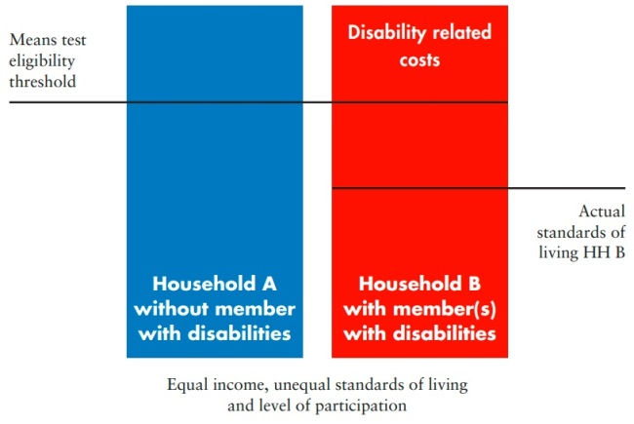
Source: Adapted from UNPRPD and Leonard Cheshire. Inclusive Social Protection for Empowerment of Persons with Disabilities: Considering the disability related extra costs in social protection, 2020.
Second, social protection schemes with benefit levels aimed at helping households to achieve a minimum standard of living will not be sufficient for households with members with disabilities to achieve that standard of living, if their disability-related costs are not factored in. Benefits designed to bring persons or households to a certain standard of living have to be increased, or complemented by other benefits, to cover disability-related costs. When the level of benefits does not cover disability- related extra costs, eligible persons with disabilities will still be worse off when compared to others. This is shown in Figure VIII.
figure viii
Social protection benefit levels which do not factor in disability-related extra costs will not achieve the anticipated standard of living for households with member(s) with disabilities
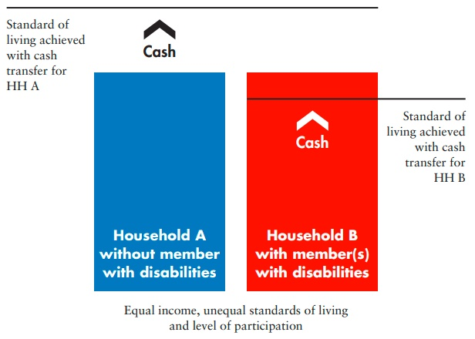
Source: Adapted from UNPRPD and Leonard Cheshire. Inclusive Social Protection for Empowerment of Persons with Disabilities: Considering the disability related extra costs in social protection, 2020.
Therefore, to be effective in supporting a sustainable escape from poverty for persons with disabilities, social protection systems must assess the disability-related extra costs experienced in a particular country and incorporate those disability-related extra costs in the design and implementation of social protection schemes.
This will require changes in three key areas (UNPRPD and Leonard Cheshire. Inclusive Social Protection for Empowerment of Persons with Disabilities: Considering the disability related extra costs in social protection. 2020):
- Adapting the income or consumption threshold for qualifying for programmes in means-tested and poverty-targeted programmes
- Defining adequate levels of benefits to compensate for disability-related extra costs
- Defining the most cost-effective and context-relevant combination of different instruments to cover disability-related extra costs (e.g. cash transfers and in-kind benefits)
To tackle these issues, different countries have adopted different approaches, which ultimately tend to evolve towards a combination of mainstream schemes, disability allowance, healthcare coverage, concessions and services. The steps taken will depend upon the social protection programmes already existing in the country.
For example, a few low- and middle-income countries have disability allowance schemes that are compatible with other basic income security/poverty assistance schemes, such as cash transfers, concession and direct services (these include Nepal, North Macedonia, Georgia, Fiji, Thailand and Viet Nam). For these countries, there is no need to adapt the mainstream disability scheme; however, it is important that any means-testing used for other schemes does not take into consideration the disability allowance when calculating the income or resources of the household, as this would defeat the purpose of it being able to address disability-related extra costs.
Some countries which have not yet adopted a universal disability allowance have taken steps to factor disability-related extra costs into their mainstream social assistance schemes, rather than create a new disability allowance. This can take the form of a disability “top-up” or higher benefit amount for beneficiaries with disabilities (e.g. Indonesia’s Programme Keluarga Harapan (PKH); the social cash transfer programme in Zambia which provides higher amounts of social assistance to households of persons with disabilities; or the higher eligibility threshold for persons with disabilities in the Republic of Moldova). Those adaptations, however, are not sufficient, as they usually apply to schemes with limited coverage and only compensate for very basic disability-related costs, not considering the full costs of goods and services required to ensure equal basic participation. Adapting mainstream schemes for disability-related extra costs can, however, be a starting point to progressively develop an inclusive and life cycle approach to social protection systems.
It is to be noted that cash transfers cannot be the only solution to address disability-related extra costs. In most low- and middle-income countries, existing cash transfers cannot cover human
support-related costs, such as personal assistance or guide interpreters, which may require investment in developing and providing the service directly.
Whose income and whose benefits?
A person with disability without an income of their own may be part of a household with middle- or high-income members, who may or may not be in a position, or be willing, to support them. Social protection support should not be based on the assumption that families must be the ones supporting persons with disabilities. It deprives persons with disabilities, and their families, from equal opportunities and choices and can foster neglect and abuse due to burnout, among other issues.
Social protection must address the individual requirements of the person with disability. Establishing thresholds based on the means or income of the household could impede access by the individual to the services and supports required to sustain autonomy and independence, on an equal basis with others. While support for children with disabilities may pass through their parents, support for adults with disabilities should be individual and, if means-tested, consider only the income of the person with disability.
 Recommendations
In regard to tailoring benefits to the diversity of persons with disabilities, governments should:
    - Ensure that disability-related extra costs are considered in poverty reduction and social protection programmes, as well as in their eligibility criteria
Related CRPD Indicators: 28.3, 28.9, 28.17
    - Provide a combination of in-kind and cash benefits to facilitate coverage of disability-related extra costs
Related CRPD Indicators: 28.3, 28.9, 28.10, 28.11, 28.17
Non-contributory schemes and conditionalities excluding persons with disabilities
Many non-contributory social protection schemes include conditionalities that beneficiaries have to comply with, in order to obtain and/or maintain the benefit. In this way, social protection contributes to foster other policy objectives. A very clear example is the income support benefit that requires parents to ensure their children attend school and are vaccinated.
On many occasions and in many contexts, such kind of schemes may create obstacles and exclude persons with disabilities, due to existing barriers. This is the case, for instance, when the conditionality is the requirement to attend school but there is no school available that includes children with disabilities; or when the social protection benefit is conditioned to have a guardian appointed (see box “accessing resources, losing rights” above), which compromises the autonomy and exercise of legal capacity of the individual.
 Policymakers need to ensure that requirements related to these schemes do not infringe other rights and that adequate support is provided to ensure that families or persons with disabilities can comply with conditionalities, especially those related to education and health. If, despite efforts, such support is not effective, conditionalities should be waived to prevent the denial of rights recognized under the Convention.
Related CRPD Indicators: 28.3, 28.4 and 28.5

4.6 Access to basic general services and disability-specific services to ensure full and effective participation in the community
Implementing SDG 1 requires taking action both to alleviate the impact of poverty and to provide for conditions that allow persons with disabilities to participate actively in economic life, as well as creating a sustainable escape from poverty. This requires, at a minimum, the development of accessible and inclusive policies and environments and the provision of support measures, in order to promote and enhance the autonomy and economic independence of persons with disabilities, while living within the community.
In most low- and middle-income countries, support has been understood as a responsibility of the family, with little intervention and support from the state. In industrialized countries, including former socialist countries, social protection systems developed an over-reliance on institutional care, especially residential institutions for children and adults with high support requirements, where services and staff are centralized to “care for” persons with disabilities. These structures followed the assumption that persons with disabilities are “unable to work” and considered them as “objects of care”.
Decades of institutionalization of persons with disabilities have shown harmful results. Those living in institutionalized settings are at higher risk of violence, abuse, neglect and abandonment, with long-term and profound impacts on their physical and mental health and well-being. They experience isolation and exclusion from society and are, consequently, disengaged from development. What was originally conceived as a “benevolent” system to “treat” and “care for” persons with disabilities in a cost-efficient manner, ended up revealing itself as an inherently harmful, exclusionary, costly and difficult to dismantle structure. The CRPD Committee has consistently recommended that governments develop and implement time-bound reforms for deinstitutionalization and develop community-support services. Furthermore, the current global COVID-19 pandemic has shown how institutionalization also creates a health hazard in the case of a pandemic, with a disproportionate death toll of persons with disabilities in institutions, particularly older persons with disabilities.
In many countries, poverty is a key driver for institutionalization when families can no longer afford to provide the care and support required by their family member(s) in their own home. This is why a combination of benefits and services to address disability-related extra costs is essential. In countries where no such system is yet in place, it is critical for social protection systems to support the development of community services and avoid investment in residential institutions.
It is important to note that community-support services do not exclude residential services such as respite care, assisted living services or peer-run resource centres, as long as the principles of autonomy, choice and inclusion are firmly at the core of the services.
Social protection systems, when designed to achieve active participation in economic and social life, can play a fundamental role in preventing institutionalization by tackling poverty, covering disability- related costs and facilitating or incentivizing the development of community-support services. To achieve this, social protection schemes need to be coordinated with other areas of policy and oriented to the goals of independent living and inclusion of persons with disabilities within the community.
Comprehensive enabling systems are key for persons with disabilities to contribute to national development as agents of change.
Recommendations
In regard to facilitating access to basic general services and disability-specific services to ensure full and effective participation in the community, governments should:
    - Invest in the development of community-support services, case management and a combination of cash-transfer and services
Related CRPD Indicators: 19.5, 19.9, 19.10, 19.21, 28.9
    - Adopt and implement a deinstitutionalization plan with benchmarks, indicators and measurable goals, which ensures the provision of economic assistance and support services for adults to transition from institutional care to independent living in the community, and for children with disabilities (and their families) to live with their family or in a family setting
Related CRPD Indicators: 19.2.1, 19.2.2, 19.2.3, 19.4, 19.5, 19.17, 19.32, 19.33, 19.34, 23.9, 23.10
    - Ensure that policies and programmes on housing, both private and public, are inclusive of persons with disabilities by, for example, respecting and requiring accessibility standards or ensuring provision of reasonable accommodation
Related CRPD Indicators: 28.1, 28.2, 28.6, 28.7, 28.8, 28.18, 28.19, 28.27, 19.2, 19.3, 19.7, 19.8, 19.14, 19.26, 19.27, 19.28, 19.29
See also Policy Guideline on SDG 11, section 5.1.
    - Adopt policies and programmes and allocate funding to promote the development and progressive increase of support services for adult persons with disabilities, notably “person- directed/user-led” personal assistance services and peer-support, so that they can live independently and be included in the community
Related CRPD Indicators: 19.1, 19.2, 19.3, 19.4, 19.5, 19.9, 19.10, 19.11, 19.16, 19.17, 19.20, 19.30
    - Create social protection schemes that recognize and compensate parents, caregivers and other family members, particularly women, who provide support to children with disabilities and develop personal assistance services and third-person support allowances to enable persons with disabilities to choose their support services
Related CRPD Indicators: 23.1, 23.10, 23.15, 23.25
From medically- and charity-based institutions to human rights-based services
Many persons with disabilities require services and supports for daily living. Historically, in many industrialised countries, these services were designed in law and practice with the purpose of rehabilitating and housing persons with disabilities or providing respite for their families. Residential institutions became convenient “all-in-one” service facilities which were supposed to provide for all the requirements of persons with disabilities. In practice, however, this has resulted in the institutionalization and segregation of persons with disabilities, fuelling exclusion and denying them their right to live in the community. Most persons with disabilities continue to rely on residential services, not by choice but because of the absence of alternatives in the community.
Deinstitutionalization reform has proven difficult. On the supply side, the apparent cost-effectiveness of institutions when compared to the complexity of developing a network of community-based support services, the lack of a clear plan for the retraining and conversion of staff, and compensating for the gap left in the local economy following the closure of institutions have been key factors undermining reform efforts. On the demand side, especially from families, the lack of adequate social protection and progress in making communities and basic services inclusive has weakened confidence in transitioning away from institutionalization.
By providing support across the life cycle, through a combination of universal disability allowance(s), in kind support and promotion of the development of community-support services, social protection systems can serve as a critical pillar in the transition towards the inclusion of persons with disabilities in their communities.
While no social protection system can be modified overnight, the following set of concrete actions is recommended, as a starting point for the process:
Ending institutional care
- Adopt legislation that allows for the development and funding of independent living services and that requests the adoption and implementation of a transitioning plan, with a timeframe and interim goals
- Make a budget assessment of the current expenditure in institutionalization services
- Make an assessment of the population receiving institutionalization services and of others interested in benefitting from independent living services, in the short-, medium- and long- terms
- Assess community-based resources, including the immediate community, to facilitate the inclusion of persons with disabilities
- Develop a plan to ensure that public funding is progressively mobilized towards supporting independent living services only, abandoning the support of institutionalization services
- Initiate pilot projects to provide independent living services to persons with disabilities that request them
- Ensure access to quality assistive products
- Periodically evaluate progress against the indicators in the action plan
Source: United Nations, Committee on the Rights of Persons with Disabilities. General Comment No. 5 (2017) on living independently and being included in the community. 27 October 2017. CRPD/C/GC/5.; United Nations, Human Rights Council, Report of the Special Rapporteur on the rights of persons with disabilities, Catalina Devandas-Aguilar. 20 December 2016. A/HRC/34/58.

4.7 Consultation with organizations of persons with disabilities
Consultation with, and active involvement of, persons with disabilities, including through their representative organizations, contributes to design effective and legitimised social protection policies. Participation should not be limited to discussing and assessing the effectiveness of disability-specific schemes but be extended to mainstream schemes and benefits and to the overall social protection system, including the definition of strategies and priorities for social protection.
Recommendation
In regard to consultation with organizations of persons with disabilities, governments should:
    - Consult with, and ensure meaningful participation of, persons with disabilities in the design, implementation and delivery of both disability-specific and mainstream social protection programmes, particularly those persons who may experience a heightened risk of exclusion, including women with disabilities, persons with psychosocial disabilities, persons with intellectual disabilities, persons who are deaf-blind and persons with disabilities from rural areas.
Related CRPD Indicators: 28.12
See also Foundations Guideline, section 2.4 on “Participation” and the video on participation developed by the Special Rapporteur on the rights of persons with disabilities”.

4.8 Awareness-raising
A lack of awareness-raising strategies and of dissemination of information in accessible formats on the available social protection programmes, their different benefits, their eligibility criteria and their administrative procedures prevents the access to benefits and services by persons with disabilities.
Recommendation
In regard to awareness-raising, governments should:
    - Always accompany the implementation of programmes with strong awareness-raising campaigns, activities and dissemination of accessible information for all persons with disabilities and their families, notably on:
      - the entitlements and benefits
      - their eligibility criteria
      - if needed, their conditionalities
      - all procedures
Related CRPD Indicators: 28.14, 19.19, 20.10, 1/4.19
See also Foundations Guideline, section 2.5 on “Awareness-raising”.

4.9 Finance and budget
Transparent budget allocation and financing schemes, as well as related accountability mechanisms, are key to ensure the financial, fiscal and economic sustainability of the social protection system – both overall and for those programmes benefitting persons with disabilities in particular – and to periodically assess its performance and efficiency.
Recommendations
In regard to finance and budget, governments should:
    - Ensure budget allocation and public spending processes are well established, institutionalized and predictable and that budget-related information is produced
    - Ensure that the financial sources of different schemes and programmes are clearly established and, when necessary, in the law (e.g. general revenues, earmarked taxation, social insurance contributions, income from capital and co-payments for services)
    - Ensure the collection of data on persons with disabilities, and its disaggregation, on:
      - Budget allocated and spent by social protection functions and programmes (mainstream or disability-specific)
      - Budget spent by transferences to beneficiaries (benefits in cash or in-kind to persons with disabilities)
      - Beneficiaries of programmes (both mainstream or disability-specific), disaggregated by age, sex and disability
Related CRPD Indicators: 28.11, 28.16, 28.17
Progressive realization of universal access to social protection
Social protection systems should ultimately ensure universal coverage of all persons with disabilities with any support requirements, all over the country and in all social circumstances. Balancing these requirements with development objectives and fiscal sustainability will require progressive realization.
To meet development objectives, governments may be tempted to allocate budget to groups of persons with disabilities who are at the verge of inclusion in the labour market, such as those well qualified or with low support requirements. However, such an approach will inevitably lead to increased and entrenched inequalities, leaving some groups of persons with disabilities further behind.
Social protection systems should combine instruments such as concessions (health insurance subsidies, free public transports, assistive devices) for all persons with disabilities with cash transfers, initially only for children with disabilities and for persons with higher support requirements – thus, most likely to face high disability-related costs .
Related resource allocation should be guided by the principle of equity, as well as the “no one left behind” principle. This would provide a good balance between populations with lower investment requirements, which may deliver faster on the development objectives, and populations that might be exposed to structural limitations, such as persons with higher support requirements.
Transparency and support to organizations of persons with disabilities, allowing them to perform budget monitoring, is key to ensure a robust dialogue between persons with disabilities and the government, to advance into sound policy implementation.

5. Other key actions by target

5.1 End poverty for persons with disabilities –Targets 1.1, 1.2, 1.a and 1.b
1.1 By 2030, eradicate extreme poverty for all people everywhere, currently measured as people living on less than $1.25 a day
1.2 By 2030, reduce at least by half the proportion of men, women and children of all ages living in poverty in all its dimensions according to national definitions
1.a Ensure significant mobilization of resources from a variety of sources, including through enhanced development cooperation, in order to provide adequate and predictable means for developing countries, in particular least developed countries, to implement programmes and policies to end poverty in all its dimensions
1.b Create sound policy frameworks at the national, regional and international levels, based on pro-poor and gender-sensitive development strategies, to support accelerated investment in poverty eradication actions

5.1.1 Disaggregate data by disability when measuring poverty
Poverty rates are measured through statistical data according to different methods and thresholds, some of which are dependent on the evolution and update of the cost of living throughout the years:
      - Extreme poverty (SDG target 1.1): less than 1.25 USD a day.
      - International poverty line (SDG indicator 1.1.1): less than 1.90 USD a day (as of 2019).
      - National poverty line (SDG indicator 1.2.1): nationally defined, commonly based on household surveys.
      - Poverty in all its dimensions, according to national definitions.
Regardless of the method or threshold, data disaggregation by disability status is still not systematic in statistical data collection efforts to measure poverty, e.g. household income and expenditure surveys, living standard surveys. This explains why data on this matter are scarce, especially on
low-and middle-income countries (see Section 3), and prevents governments from adopting fully- informed and effective poverty reduction strategies for the benefit of persons with disabilities.
Article 31 of the CRPD (on statistics and data collection), mandates governments to collect data and ensure disaggregation by disability, to enable them to adopt and implement the measures required by the treaty. Similarly, the accompanying CRPD indicators have incorporated those SDGs indicators related to poverty (1.1.1, 1.2.1, and 1.2.2) calling for disaggregation by disability.
Nowadays, the tools developed by the Washington City Group on Disability Statistics (e.g. the Short Set of Questions on Disability), which combines an objective component -the functioning- and a self-perceptive component, are considered the more accurate and reliable tools for disability disaggregation.
Recommendations
In line with Article 31 of the CRPD, governments should ensure that:
- Data collection efforts to measure extreme poverty and poverty (under any method or threshold), disaggregate by disability status, and type of disability when technically feasible, by employing tools such as the Washington Group Short and Extended set of questions
Related CRPD Indicators: 28.22, 28.23, 28.24, 28.25, 31.7, 31.8, 31.9, 31.10
- Data collection efforts to measure extreme poverty and poverty (under any method or threshold) contemplate and allow for the presentation of rates accounting for disability-related extra costs (see section 5.1.2)

5.1.2 Factor in disability-related extra costs when measuring poverty
As highlighted in Section 3 and Section 4.4, persons with disabilities and households with persons with disabilities often incur higher expenditures than the rest of the population, due to the need for goods and services that are entirely related to disability (e.g. mobility aids, personal assistance, accessible housing) and/or for paying more to access general goods and services (e.g. health insurance).
As previously mentioned, failure to factor disability-related costs in poverty measurement will underestimate the poverty rates of persons with disabilities and their families. Also, to provide effective support, the design of social protection schemes, both mainstream (e.g. universal income support) and disability-specific (e.g. disability allowance), should take into consideration disability- related extra costs.
Social protection systems should level the field, eliminating the extra-cost or compensating it to the point that covering it is affordable, through a combination of in-kind and financial benefits.
The first step in levelling the field is to calculate the context-specific disability-related extra costs experienced by the full diversity of persons with disabilities. At the population level, there are a variety of approaches for measuring these extra costs, as set out in the case study box below. At the individual level, disability assessment procedures that focus on support requirements and barriers to participation can provide a wealth of information on the costs persons with disabilities face in carrying out daily activities and seeking socio-economic participation.
Recommendations
In regard to factoring in disability-related extra costs when measuring poverty, governments should:
- Estimate the context-specific disability-related extra costs in order to inform efforts to measure extreme poverty and poverty (see section 5.1.1), as well as the design of social protection programmes and benefits, and related budgetary proposals and allocations
- Develop procedures and information systems that determine the disability-related extra costs required to facilitate inclusion and participation of applicants and beneficiaries, at the individual level, in order to cover them and more accurately inform future budgetary processes
Related CRPD Indicators: 28.3, 28.9, 28.17
 Measuring disability-related extra costs
There are different approaches to measure disability-related extra costs , depending on whether one seeks to assess:
      - the current additional expenses and opportunity costs of persons with disabilities and their families, when compared to others
      - all the costs of goods and services that would be required by persons with disabilities to achieve equal participation
To estimate the current impact of disability costs (what people can afford today), two methods can be used:
      - The good and service (GS) method, which assesses, through a survey, current expenses outlaid on disability-specific items and additional general consumption expenses
      - The standard of living (SOL) method, which uses existing datasets, such as household income and expenditure surveys, to estimate the disability costs by comparing the standard of living (often based on an asset index) of otherwise similar households with and without a member with disability.
The GS method is more costly to conduct but gives more specific information on the diversity, type and level of expenses face by persons with disabilities, while the SOL method is very suited to get an initial overall estimate. The SOL method is useful to factor current disability-related costs in statistical poverty measurements or, possibly, to adapt eligibility thresholds or benefits for mainstream means-tested schemes.
However, neither GS nor SOL capture the costs required to achieve basic participation. To know that, a survey on good and services required (GSR) would be needed. A GSR survey asks a diversity of persons with disabilities (different types of disability, urban/ rural, age groups, gender) what are the goods and services they would require to achieve basic participation, then estimates the costs of those good and services, for each group. This provides critical information for the design of social protection schemes and to define the best combination of in-cash and in-kind support.
Source: UNPRPD and Leonard Cheshire. Inclusive Social Protection for Empowerment of Persons with Disabilities: Considering the disability related extra costs in social protection, 2020
KEY QUESTIONS | WHICH METHOD? | RELEVANCE FOR SOCIAL PROTECTION
What is the current economic impact of disability related barriers and lack of support for persons with disabilities and their families? | SOL method and measure of differences in income earned; GS method | Assess more accurately standards of living and exposure to poverty and vulnerability
What are the different expenditures facing persons with disabilities and their families in addition to or instead of other common goods and services compared to persons without disabilities? | GS method | Assess relevance and adequacy of current interventions for the diversity of persons with disability
What are the cost and expenses that persons with disabilities and their families would require to achieve equal participation? | GSR method | Define the best combination of support in cash, services as well as concessions; prioritize investment in service delivery and barrier removals
Source: UNPRPD and Leonard Cheshire. Inclusive Social Protection for Empowerment of Persons with Disabilities: Considering the disability related extra costs in social protection, 2020

5.1.3 Increase budget to finance universal coverage of persons with disabilities
As noted above, available data show that social protection and poverty reduction programmes do not reach all the persons with disabilities under the national or international lines of poverty. In addition, they may not ensure an adequate standard of living to the beneficiaries. Finally, they typically do not consider the extra costs associated with disability (see Section 4.4 and 5.1.2). In this sense, social protection policies remain largely under-resourced.
Moving from charity- and medically-based to rights-based social protection systems may require an initial investment, in transitioning from one system to the other, and a progressive reallocation of funds, from the previous structure to the new one.
Increased budget is required in order to expand coverage of social protection policies and reach all persons with disabilities who are under the poverty line. To do so, a variety of sources can be considered, on order to provide resources for social protection policies, e.g. general revenues, earmarked taxation, social insurance contributions; even development cooperation can be considered as a resource, within each country’s macro economical system, provided that sustainability is sought and, when possible, ensured.
Recommendations
In regard to increasing budget to finance universal coverage, by social protection, of persons with disabilities, governments should:
- Evaluate funding schemes of social protection policies that benefit persons with disabilities, to assess their relevance, sufficiency and sustainability under a rights-based perspective
- Establish disability markers to track social protection expenditure that benefits persons with disabilities (see Foundations Guideline, section 3.3.2 on “Disability markers”)
- Increase resource mobilization for social protection policies that benefit persons with disabilities, in order to reach all the persons with disabilities who are under the poverty line and to cover their disability-related extra costs
Related CRPD Indicators: 28.3, 28.9, 28.11, 28.16, 28.17, 28.22, 28.23, 28.24, 28.25

5.2 Access to basic general services, disability-specific services (including assistive technology) and financial services to ensure full and effective participation in the community – Target 1.4
1.4 By 2030, ensure that all men and women, in particular the poor and the vulnerable, have equal rights to economic resources, as well as access to basic services, ownership and control over land and other forms of property, inheritance, natural resources, appropriate new technology and financial services, including microfinance

5.2.1 Access to basic services
Social protection systems can play a role in facilitating access to the general basic services that persons with disabilities are entitled to, including healthcare, education and skills development, nutrition, housing, transport, etc. Social protection programmes can help cover the costs of accessing these services, either directly (e.g. programmes such as concessions or non-contributory universal health coverage) or indirectly (e.g. universal cash benefits for persons with disabilities that are sufficient to cover schooling).
Recommendation
In regard to access to basic services, governments should:
      - Invest in making basic services (education, health, water and sanitation, transport, etc.) available, accessible and affordable for persons with disabilities
Related CRPD Indicators: 9.4, 19.12, 19.13, 19.5, 19.26, 20.7, 20.8, 20.9, 28.1, 28.2, 28.3, 28.14, 28.21, 28.27

5.2.2 Access to assistive technology for persons with disabilities
Assistive technology, products and services are key enablers for persons with disabilities to access basic services, such as health, education and transportation, and to participate in society. For example, for some persons with physical impairments, accessing a wheelchair is the first and essential enabling step to avoid isolation. Similarly, blind persons may require canes, hard-of-hearing persons may require hearing-aids and persons with intellectual impairments may require assistive technology for communication. Table 2 provides examples of assistive technology. See also Priority Assistive Products List of the WHO.
table 2
Examples of assistive technology
Category | Product examples
Mobility | Walking stick, crutch, walking frame, manual and powered wheelchair, tricycle Artificial leg or hand, leg or hand splint, clubfoot brace  Corner chair, supportive seat, standing frame  Adapted cutlery and cooking utensils, dressing stick, shower seat, toilet seat, toilet frame, feeding robot
Vision | Eyeglasses, magnifier, magnifying software for computer White cane, GPS-based navigation device  Braille systems for reading and writing, screen reader for computer, talking book player, audio recorder and player  Braille chess, balls that emit sound
Hearing | Headphone, hearing aid  Amplified telephone, hearing loop
Communication | Communication cards with texts, communication board with letters, symbols or pictures  Electronic communication device with recorded or synthetic speech
Cognition | Task lists, picture schedule and calendar, picture based instructions  Timer, manual or automatic reminder, smartphone with adapted task lists, schedules, calendars and audio recorder  Adapted toys and games
Source: WHO and UNICEF, Assistive Technology for Children with Disabilities: Creating Opportunities for Education, Inclusion and Participation. A discussion paper (2015).
Access to assistive technology and products for persons with disabilities remains very limited, world- wide. In low- and middle-income countries, only 5 to 15 per cent of persons who require assistive products have access to them. In addition, globally, only 5 to 15 per cent of the 75 million persons with disabilities who require a wheelchair have access to it (WHO, Assistive Technology, 18 May 2018). Many persons with disabilities require assistive products which are not provided by governments and are not affordable in the open market, e.g. a person may require an electronic wheelchair, not included in the government-provided aid list, and quite expensive for individual purchase.
Furthermore, a lack of availability at the local level of skilled personnel that ensures proper prescription, fitting, user training, maintenance, repair services and replacement parts (e.g. batteries), prevents appropriate and sustainable use of assistive products. In this regard, available data show that 25 per cent of respondents to a global survey in low- and middle-income countries reported that repair services were available, compared to 62 per cent of respondents in high-income countries (UNICEF and WHO. Assistive Technology for Children with Disabilities: Creating Opportunities for Education, Inclusion and Participation. A discussion paper. 2015).
One of the major challenges to the development of policies in this area is the lack of systematised and disability-disaggregated data. These data would allow governments to determine and assess the current and potential demand for assistive technology and products, how that demand is currently being met and what are the barriers leading to insufficient supply. Without it, it is difficult to allocate sufficient resources and to assess the system’s capacity to provide assistive technology.
Thus, data on the demand of assistive technology should be taken into account within efforts to obtain and systematise both statistical and administrative data, since they can provide valuable input to policy design and allocation of resources. WHO has supported several national data-gathering efforts, to assess the demand for assistive technology, for example through the development of the rapid Assistive Technology Assessment (rATA) questionnaire.
Social protection programmes can facilitate increased access of persons with disabilities to assistive technology and products.
Recommendations
In regard to access to assistive technology for persons with disabilities, governments should:
      - Develop and promote legislation and develop programmes to facilitate the access of persons with disabilities to assistive technology and products, including mobility devices - in particular, those in the Priority Assistive Products List of the WHO, tailored to the requirements of each person; to carry out training in their use, maintenance, repair services and replacement of parts, as required.
      - Provide training to social and health services involved in the provision of assistive products, prioritizing community-level and primary healthcare, to ensure quality standards in service delivery throughout different stages:
        - Assessment of the requirements of the person with disability, to select the best product
        - Fitting the product, to ensure comfort in its use
        - Training of the person with disability, to enable safe and effective use of the product
        - Follow-up, to ensure that the product keeps meeting the requirements of the person
      - Adopt measures, including through procurement policy, financing mechanisms and market- shaping, to ensure affordability and quality of assistive technologies and devices in the open market
      - Adopt data collection systems to measure and assess the requirement of assistive technology by persons with disabilities
Related CRPD indicators: 20.1, 20.2, 20.3, 20.11, 20.12, 20.19, 20.20, 20.21, 28.1, 28.20, 28.21, 28.27, 1/4.14, 1/4.27, 19.31
 Adapted vehicles and their use to enhance the mobility of persons with disabilities
Availability and facilitation of access to adapted cars, tricycles, other vehicles and adaptive equipment are key to enhance the mobility of persons with disabilities, especially when public transportation services (buses, trams, etc.) remain inaccessible. Importantly, in rural and remote areas where public transportation services are inexistent, or very limited, and assistive technology faces performance issues, adapted vehicles may be the sole alternative a person with disability can rely on. Point-to-point transport is a fundamental link in the transportation chain and should be integrated into the mobility strategy.
Facilitating access to adapted vehicles and adaptive equipment, which might be imported, will benefit those persons with disabilities who require and are able to afford them. Tax exemptions in import taxes; waiver or reduction of insurance, vehicle registration and related costs; subsidised purchases; or public procurement strategies to impact market prices, are some of the measures that governments could adopt to promote access to these vehicles. In addition, private (e.g. transportation company, non-governmental organization) and public actors (e.g. local government in a remote area) may also benefit from these measures and offer transportation services to persons with disabilities.
Accordingly, regulations on driver’s licenses should be inclusive of persons with disabilities and consider adapted vehicles and adaptive equipment.
Related CRPD indicators: 20.4, 20.5, 20.6, 20.22, 20.23, 20.24

5.2.3 Access to financial services
Access to common financial services, such as bank accounts, debit cards and ATMs, is instrumental to enable individuals to access and benefit from social protection programmes, e.g. cash transfers. However, accessibility, legal and attitudinal barriers deny persons with disabilities access to these basic financial services. Furthermore, restrictions to legal capacity, in law and practice, prevent persons with disabilities from opening bank accounts. For example, in some countries, persons with intellectual disabilities may be required to have a guardian appointed to open a bank account, even if not required by regulations; blind persons may be rejected or asked for additional requirements (e.g. witnesses). Consequently, persons with disabilities have less access to social benefits and less control over the administration of their own resources.
 Recommendations
In regard to access to financial services, governments should:
      - Establish mandatory accessibility standards for public and private financial institutions and their service provision
Related CRPD Indicators: 9.4, 19.12, 19.13, 19.26
      - Repeal any legislation or regulation that may restrict the legal capacity of persons with disabilities to access financial services, necessary for social protection policies (see Foundations Guideline, section 5.5, Box on “9 actions to uphold the legal capacity of persons with disabilities”, the video on legal capacity developed by the Special Rapporteur on the rights of persons with disabilities)
Related CRPD Indicators: 12.1, 12.2, 28.1, 28.2, 28.3
      - Adopt measures to raise awareness and change attitudes of staff of banks and financial institutions, both public and private, on the right to legal capacity of persons with disabilities (see also Foundations Guideline, section 2.5 on “Awareness raising”)
Related CRPD Indicators: 12.15, 28.14 (awareness-raising on social protection schemes)

6. Additional Resources
Cote, A. Disability, inclusion and social protection. In Handbook of Social Protection Systems. Bonn Rhein Sieg University, forthcoming.
Inter-Agency Social Protection Assessments. CODI (Core Diagnostic Instrument) “What Matters” Guidance Note.
International Labour Organization and International Disability Alliance, Joint Statement: Towards inclusive social protection systems supporting the full and effective participation of persons with disabilities. 2019.
International Labour Organization, World Social Protection Report 2017–19: Universal social protection to achieve the Sustainable Development Goals. Geneva: ILO, 2017.
United Nations. Report of the Special Rapporteur on the rights of persons with disabilities, Catalina Devandas-Aguilar. 7 August 2015. A/70/297.
United Nations Department of Economic and Social Affairs – Disability, UN Disability and Development Report - Realizing the SDG by, for and with persons with disabilities, 3 April 2019.
United Nations Partnership to Promote the Rights of Persons with Disabilities and Leonard Cheshire. Inclusive Social Protection for Empowerment of Persons with Disabilities: Considering the disability related extra costs in social protection. 2020. Working paper.
United Nations Partnership to Promote the Rights of Persons with Disabilities, International Labour Organization and United Nations Children’s Fund. Building Inclusive Social Protection Systems Supporting Empowerment of Persons with Disabilities: Disability identification and eligibility determination. Background paper. Forthcoming.
United Nations Partnership to Promote the Rights of Persons with Disabilities, International Labour Organization and United Nations Children’s Fund. Building Inclusive Social Protection Systems Supporting Empowerment of Persons with Disabilities: Inclusive social protection delivery mechanisms delivery. Background paper. Forthcoming.
United Nations Partnership to Promote the Rights of Persons with Disabilities, International Labour Organization and United Nations Children’s Fund. Building Inclusive Social Protection Systems Supporting Empowerment of Persons with Disabilities: Introduction to the background papers series. Forthcoming.
Waddington, Lisa and Mark Priestley. A human rights approach to disability assessment, Journal of International and Comparative Social Policy (12 October 2020).
World Health Organization. Assistive Technology. 18 May 2018. World Health Organization. Priority Assistive Products List (APL).
World Health Organization and United Nations Children’s Fund. Assistive Technology for Children with Disabilities: Creating Opportunities for Education, Inclusion and Participation. A discussion paper. Geneva: WHO; New York: UNICEF, 2015.

7. Key Concepts Annex
Below are key foundational concepts referred to throughout the Policy Guidelines for Inclusive Sustainable Development Goals (SDG). The guide below is designed as a quick reference and refresher for readers as they use the guidelines. It is recommended that the guideline “Foundations for inclusive Sustainable Development Goal Implementation: Key concepts and structural requirements” is read prior to, or together with, other guidelines, for a deeper understanding of the required foundations for inclusion.
Concepts
Ableism considers certain typical characteristics of body and mind as essential for living a life of value. Ableist perspectives view impairments as undesired, which leads to unconscious bias, prejudice, discrimination and exclusion. Ableism is usually behind negative perceptions and stereotypes about persons with disabilities. See also Foundations Guideline, section 1.3.
Accessibility is the quality that allows persons with disabilities to access and enjoy physical environments, transportation, facilities, services, information and communications, including new technologies and systems. When planning for accessibility, the principles of universal design should be used. See also Foundations Guideline, section 2.2.
Assistive technology, devices and mobility aids are external products (devices, equipment, instruments, software), specially produced or generally available, that maintain or improve an individual’s functioning and independence, participation, or overall well-being. Examples of assistive devices and technologies include wheelchairs, prostheses, hearing aids, visual aids and specialized computer software and hardware that improve mobility, hearing, vision, or the capacity to communicate. See also Foundations Guideline, section 2.3.
Awareness-raising actions are those that aim at informing about rights and changing negative attitudes towards persons with disabilities. They include training, campaigns, mass-media communications and more. Awareness-raising activities should target persons with disabilities and others and should involve persons with disabilities in their design and delivery. See also Foundations Guideline, section 2.5.
Barriers: Disability results from the interaction between persons with impairments and the barriers in the environment around them. Barriers can be broadly categorised into the following:
- Environmental barriers: those that are imposed by the context. They can be sub-categorized as:
- Physical barriers: such as the presence of steps, preventing access for someone using a wheelchair, or others with mobility difficulties.
- Communication barriers: such as the barriers to participation for a sign language user in a meeting if sign language interpreters are not provided, or the barrier to accessing information experienced by blind persons with written text, if accessible formats are not provided.
- Policy barriers: such as educational systems that prevent the enrolment of children with disabilities in their local school.
- Attitudinal barriers: such as the belief that persons with disabilities cannot learn or work. Attitudinal barriers can lead to apathy or inertia towards addressing other barriers. Attitudinal barriers can lead to apathy or inertia towards addressing other barriers.
In order for persons with disabilities to fully participate and access opportunities for development, the barriers that limit their participation should be systematically addressed. Persons with disabilities themselves are experts on identifying barriers and the solutions to overcome them. See also Foundations Guideline, section 1.1.
Conditionality: “In the context of social welfare, the term conditionality refers to (…) households or individuals who receive government transfers conditional on some form of behavioral compliance.
This means that in order to continue receiving support qualifying households have to meet specific conditions that are spelled out by the programme. (…) [C]onditionality is supposed to tackle behavioral barriers that prevent households to improve their situation and escape poverty.” (Ester Schüring, Conditions, conditionality, conditionalities, responsibilities – finding common ground. Working paper. 2010WP014. (Maastricht: Maastricht Graduate School of Governance, 2010). pp. 4-5)).
Contributory schemes are social protection programmes for which financial contributions by beneficiaries and their employees determine entitlement to benefits. These schemes are also often referred to as social insurance. An example of a contributory scheme is contributory health insurance, which comprises employment-related schemes which provide health insurance to employees, based on contributions (from employers and/or employees).
Disability assessment is the process of collecting information about persons with disabilities, in their context, for the purposes of policymaking and planning, budget allocation and to determine eligibility to certain benefits and entitlements. A disability assessment can also be used solely for the purpose of providing services such as rehabilitation or education. See also Foundations Guideline, section 3.2.2 and Policy Guideline on SDG 1.
Disability determination refers to the official decision (using assessment findings) about whether someone is identified as a person with disability, often also categorized according to their functional ability. In some countries, this can become an official status, symbolised by a disability card, registration, or similar, which can provide access to various services and benefits. There are often additional and/or different processes to determine eligibility for different types of social protection, insurance, health and support services. See also Foundations Guideline, section 3.2.2 and Policy Guideline on SDG 1.
Disability discrimination is described in the Convention on the Rights of Persons with Disabilities (Article 2) as “any distinction, exclusion or restriction on the basis of disability which has the purpose or effect of impairing or nullifying the recognition, enjoyment or exercise, on an equal basis with others, of all human rights and fundamental freedoms in the political, economic, social, cultural, civil or any other field. It includes all forms of discrimination, including denial of reasonable accommodation.” See also Foundations Guideline, section 2.1.
Disability mainstreaming is the process of ensuring that the rights of persons with disabilities are embedded in all policy, assessing policy implications for persons with disabilities, and ensuring their meaningful participation. It is the way of making the concerns and experiences of persons with disabilities an integral dimension of the design, implementation, monitoring and evaluation of policies and programmes in all political, economic and societal spheres so that persons with disabilities have equal benefits, and inequality is not perpetuated. The ultimate goal is to achieve equality of outcomes and foster an inclusive culture. Disability mainstreaming should be combined with disability-specific actions (see Twin-Track Approach). See also Foundations Guideline, section 3.2.1.
Extra-cost of disability refers to the higher expenditure of persons with disabilities and their households, when compared to the rest of the population. Extra-costs commonly stem from specific goods and services (e.g. mobility aids, personal assistance, accessible housing) and/or lack of access to general goods and services (e.g. more expensive health insurance, using taxis where public transport is not accessible). Disability extra-costs affect different policies. For more information, access the Centre for Inclusive Policy’s videos, “Understanding disability extra costs” and “Addressing disability extra costs”. See also Policy Guideline on SDG 1.
International cooperation is the interaction of persons or groups of persons representing various nations and diverse international and regional organisations striving towards the common goal of realizing the rights of persons with disabilities and the Convention on the Rights of Persons with Disabilities. Persons with disabilities, the organisations that represent them, and policymakers, collaborate through their ministries of international affairs, to receive technical and financial support from international organisations and development banks. Financial support designated for international cooperation shall not be used for measures contrary to the Convention on the Rights of Persons with Disabilities and shall be planned to be substituted with national funds, to ensure policy continuation. Technical cooperation among countries with similar realities is important to identify effective solutions. See also Foundations Guideline, section 8.
Intersectional discrimination refers to situations where discrimination is occurring on the basis of multiple and intersecting factors, including sex, gender, ethnicity, age, caste, class, faith, sexual orientation or any other characteristic. Persons with disabilities also have a gender identity, may come from an indigenous group, be young, old, a refugee or living in poverty. See also Foundations Guideline, section 5.3.
Legal capacity is the right to autonomously make legally valid decisions. Some countries restrict the right for adults with disabilities to manage their own financial affairs, including ownership of property, choose where to live and work, and manage their relationships, health and wellbeing.
Restricting or denying this right is against the Convention on the Rights of Persons with Disabilities and has negative effects across all policies. See also Foundations Guideline, section 5.5.
Non-contributory schemes are those that “normally require no direct (financial) contribution from beneficiaries or their employers as a condition of entitlement to receive benefits” (Christina Behrendt and Krzysztof Hagemejer, “Introduction: Social Transfers”, International Labour Organization Social Protection, 24 October 2018). They are usually financed through tax. Non-contributory schemes are generally divided into ‘non-means tested’ schemes that apply to all and ‘means-tested’ schemes that apply only to people whose income falls beyond a certain threshold.
Organisations of persons with disabilities are led, directed, and governed by persons with disabilities. They are established at the local, national, regional or international level to promote and/ or defend the rights of persons with disabilities. A clear majority of the membership of such organisations should be recruited among persons with disabilities themselves. See also Foundations Guideline, section 2.4.
Participation of persons with disabilities refers to the action of allowing and enabling persons with disabilities to take part directly, or through organizations of persons with disabilities, in decision- making processes, including the design, implementation, monitoring and evaluation of policies. To do this, persons with disabilities should be closely consulted and actively involved in all decision-making processes, by being invited to give their opinions and take part in implementation processes.
Participation is an obligation to be met under the Convention on the Rights of Persons with Disabilities for all aspects of policy. “Nothing about us, without us” is the motto that promotes this obligation, and it means that no policy should be developed or implemented without persons with disabilities. See also Foundations Guideline, sections 2.4 and 4.
Persons with disabilities include those who have long-term physical, psychosocial, intellectual or sensory impairments which, in interaction with various barriers, may hinder their full and effective participation in society on an equal basis with others. Hence, persons with disabilities are persons with impairments who experience barriers that restrict their participation. See also Foundations Guideline, section 1.2.
Reasonable accommodation refers to modifications or adjustments made for a person with disability who requires them in a particular case, to facilitate participation on an equal basis with others. Reasonable accommodation must be provided on demand - that is, entities responsible for providing it cannot deny it by saying that they are progressively implementing measures. If arbitrarily denied, this constitutes discrimination.
Some examples include adjustments to the school hours of a student, extended breaks to rest, acquisition of computer software to read screens, a foldable ramp to overcome step(s) or providing a sign language interpreter in a work meeting. See also Foundations Guideline, sections 2.1 and 5.2.
Support for persons with disabilities encompasses a wide range of formal and informal interventions, including live assistance and intermediaries, mobility aids and assistive devices and technologies. It also includes personal assistance; support in decision-making; communication support, such as sign language interpreters and alternative and augmentative communication; mobility support, such as assistive technology or service animals; living arrangements services for securing housing and household help; and community services. Persons with disabilities may require support to perform daily life activities and/or use general services, such as health, education and justice, on an equal basis with others. See also Foundations Guideline, section 2.3.
Supported decision-making is a type of support given to persons with disabilities in relation to legal decisions. This mechanism guarantees that: (i) persons with disabilities exercise their legal capacity (see above) and can make their own decisions in every aspect of life; and (ii) their decisions are not replaced by the decisions of guardians or others. Supported decision-making is voluntary and can include informal and formal support arrangements. For example, a person with disability may choose a trusted person to support them in making certain types of legal decisions. They may also resort to peer support or self-advocacy networks. Some persons with disabilities may access support to help in the communication of their will and preference. See also Foundations Guideline, section 5.5.
Twin track approach is a strategy to develop policies that:
- systematically mainstreams the interests and rights of persons with disabilities in policy design and implementation, across all sectors and areas of life
- adopts targeted policy and programming measures aimed specifically at persons with disabilities
The balance between mainstreaming strategies and targeted support strategies should be tailored to address the needs of specific communities. See also Foundations Guideline, section 3.2.1.
Universal design is the design and composition of products, environments, programmes and services so that they can be accessed, understood and used to the greatest extent possible by all people, regardless of their age, size, ability or disability, and without the need for adaptation or specialized design. The principles of universal design facilitate accessibility, including for persons with disabilities. See also Foundations Guideline, section 2.2.
The Washington Group Short Set is a set of six questions on functioning, designed to be used within national censuses and surveys. The questions are designed to provide comparable data cross- nationally, for populations living in a variety of cultures, with varying economic resources. While not exhaustive, the basic actions represented in this set of six questions are those that are most often found to limit an individual, and result in participation restrictions. The information that results from the use of these questions will (a) represent the majority of, but not all, persons with limitation in basic actions, (b) represent the most commonly occurring limitations in basic actions, and (c) be able to capture persons with similar difficulties across countries. See also Foundations Guideline, section 3.5.


Office of the United Nations
High Commissioner for Human Rights (OHCHR)
Palais de Nations
CH 1211 Geneva 10 – Switzerland
Email: disability@ohchr.org
Website: www.ohchr.org

