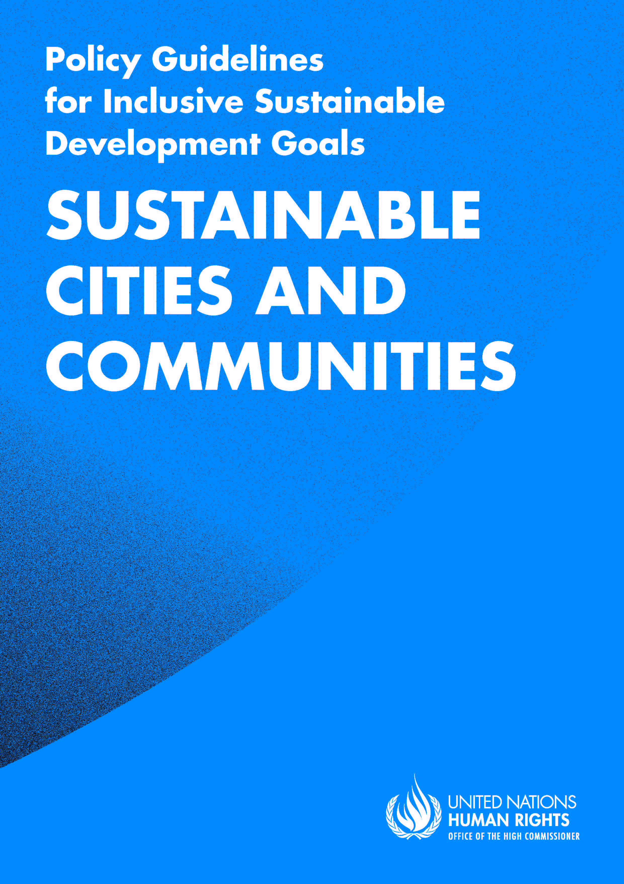

ADVANCE VERSION
© 2020 United Nations
The Policy Guidelines for Inclusive Sustainable Development Goals are a component of the SDG- CRPD Resource Package, developed by the Office of the United Nations High Commissioner for Human Rights (OHCHR). This is an advance version of the SDG-CRPD Resource Package. A final version will be issued upon completion of OHCHR review processes.
The designations employed and the presentation of the material herein do not imply the expression of any opinion whatsoever on the part of the Secretariat of the United Nations concerning the legal status of any country, territory, city or area, or of its authorities, or concerning the delimitation of its frontiers or boundaries.
Symbols of United Nations documents are composed of capital letters combined with figures. Mention of such a figure indicates a reference to a United Nations document.
Photography by Christian Tasso. The photographs featured within the Policy Guidelines were taken as part of the European Union project, Bridging the Gap II – Inclusive Policies and Services for Equal Rights of Persons with Disabilities, and were produced with the financial support of the European Union. They appear courtesy of the International and Ibero-American Foundation for Administration and Public Policies.
The Policy Guidelines for Inclusive Sustainable Development Goals were produced with the financial support of the European Union. Its contents are the sole responsibility of OHCHR and do not necessarily reflect the views of the European Union.

Make cities and human settlements inclusive, safe, resilient and sustainable.
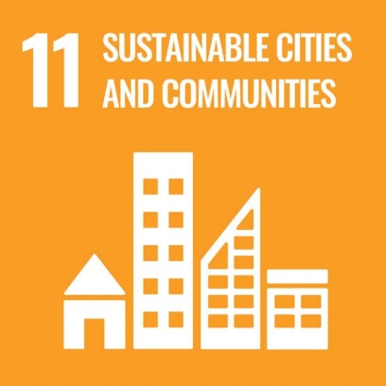

Contents
IN BRIEF 6
1. What is the situation? 7
2. What needs to be done? 9
3. DO’s and DON’Ts 12
IN DEPTH 15
1. Introduction 16
2. Connection to other tools 16
3. Why is Goal 11 important for persons with disabilities? 16
4. Inclusive cities and communities: actions applicable across all targets 18
4.1 Incorporate accessibility standards into legislation and regulatory frameworks 18
4.2 Ensure coordination across the government to support inclusive urban environments 18
4.3 Appoint and support disability focal points 19
4.4 Ensure consultation and participation of persons with disabilities in urban planning and management 19
5. Other key actions by target 20
5.1 Accessible housing, slums and homelessness – Target 11.1 20
5.1.1 Ensure that planning and construction legislation incorporates accessibility standards that apply to housing 20
5.1.2 Ensure that persons with disabilities have access to public housing, on an equal basis with others 23
5.1.3 Adopt a strategy to upgrade slums while providing low-cost practical interventions to meet the minimum standards of accessibility 24
5.1.4 Address the homelessness of persons with disabilities, particularly by ensuring the accessibility of homeless shelters and emergency support services 25

5.2 Transportation systems inclusive of persons with disabilities – Target 11.2 26
5.2.1 Ensure access to appropriate assistive products and technologies to facilitate individual mobility and access to transportation 27
5.2.2 Increase the access to public transportation for persons with disabilities, through the application of accessibility standards and measures that cover the additional disability-related costs of travel 28
5.2.3 Ensure the availability of accessible point-to-point transportation and implement accessible flexible transportation lines 29
5.3 Inclusive public spaces – Target 11.7 30
5.3.1 Promote the accessibility of public spaces by establishing, monitoring and enforcing relevant accessibility standards 30
5.3.2 Develop a strategy to improve the accessibility of public spaces that involves the participation of persons with disabilities and their representative organizations 31
5.3.3 Increase the accessibility of buildings and facilities open to the public through the application of accessibility standards and the development of incentives to encourage accessibility improvements of small businesses, during renovation processes 32
5.3.4 Collect and analyse data on the accessibility of public spaces and of facilities open to the public, to measure progress 33
6. Additional Resources 34
7. Key Concepts Annex 35

IN BRIEF
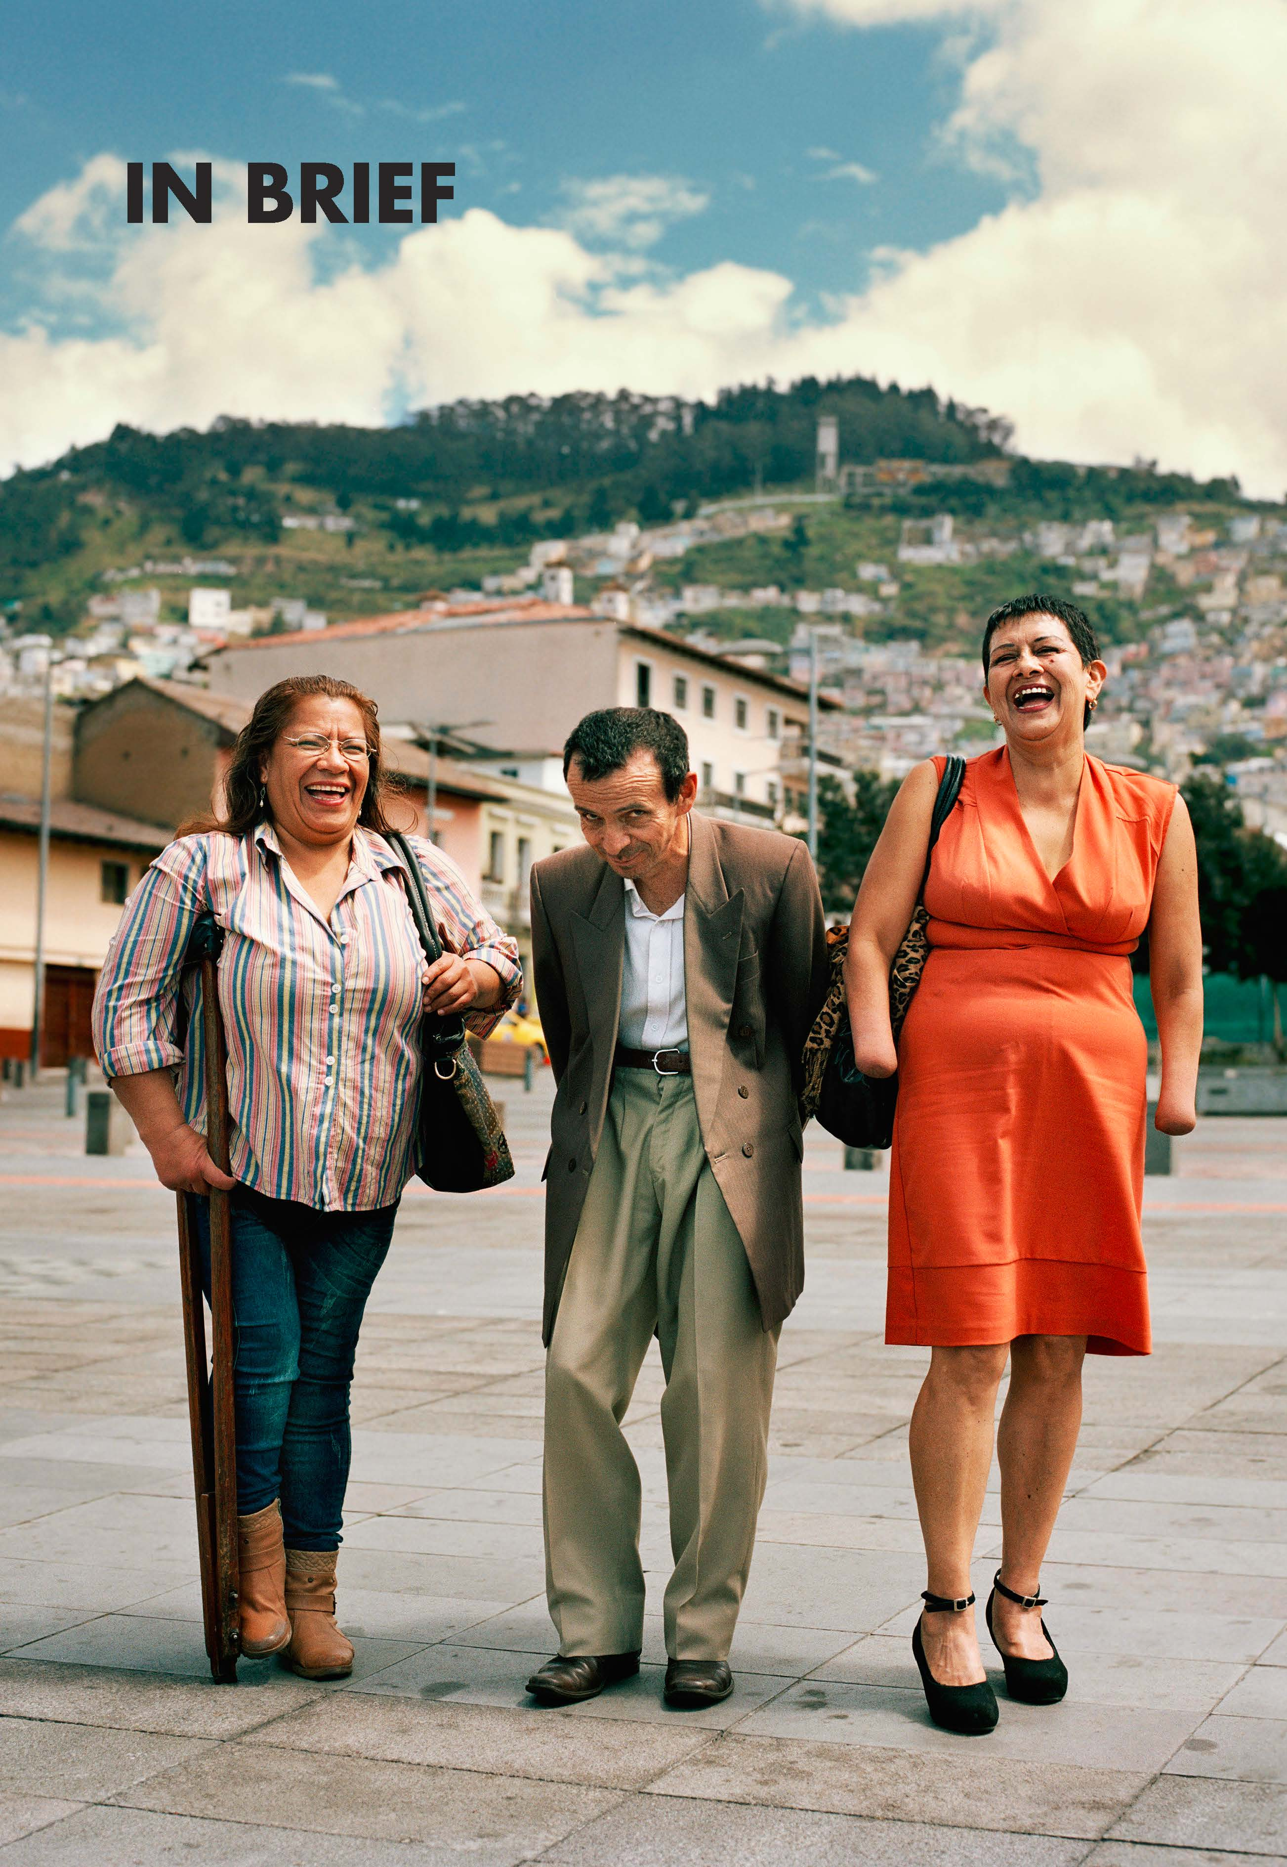

1. What is the situation?
Of the 6.25 billion people predicted to be living in urban areas by 2050, an estimated 15 per cent, or 937 million, will be persons with disabilities (Secretariat for the Convention on the Rights of Persons with Disabilities, Accessibility and Disability Inclusion in Urban Development). Cities and human settlements can impede or enable the inclusion of persons with disabilities, depending on how they are planned and built. Many persons with disabilities face a widespread lack of accessibility to built environments, such as housing, public buildings and spaces, transportation, urban services, information and communications. This lack of accessibility contributes greatly to the marginalisation of persons with disabilities and results in disproportionate rates of poverty and exclusion. Women and girls with disabilities often experience a lack of participation in urban planning processes and additional barriers in accessing the urban environment and services, such as safety concerns in the use of public spaces or transport.
Persons with disabilities face exclusion from housing, both private and public, at a higher rate than others. While statistical data disaggregated by disability are scarce, data from Europe show that persons with disabilities experience poorer quality housing conditions and spend more on housing costs, compared to other people (Eurostat, “Severe housing deprivation rate by level of activity limitation, sex and age”, 2 December 2020).
Persons with disabilities face serious limitations in accessing, or are completely excluded from, transport, both in cities and rural areas. Data from 8 low- and middle-income countries show that 36 per cent of persons with disabilities consider transportation services not accessible or hindering (United Nations Department of Economic and Social Affairs, Disability and Development Report, 2019, p. 226). According to a survey conducted in Australia, the major obstacles for persons with disabilities in using public transportation were steps to get in or out of vehicles, barriers in getting to stops or stations, lack of seating or difficulty standing, pain or discomfort when sitting, fear or anxiety, inaccessible doors to get in and out of vehicles and inadequate access to toilets, as seen in Figure I.
figure i
Percentage of persons with disabilities by reasons for being unable to use public transportation, in Australia, 2015
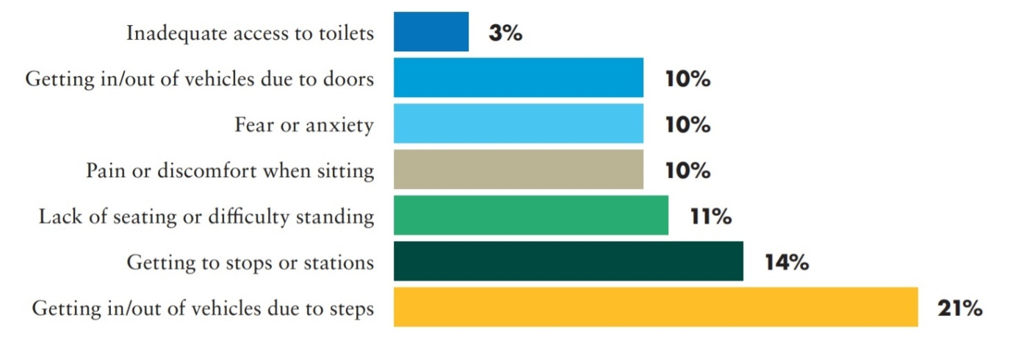
Source: UNDESA, Disability and Development Report, 2019, p. 227.
The exclusion of persons with disabilities from urban planning processes has long-lasting negative effects. Once buildings, facilities and public spaces are constructed, retrofitting them for accessibility can be inefficient or not feasible, leaving barriers in place that are difficult to remove. The inaccessibility of public spaces in cities restricts the autonomy and mobility of persons with disabilities, resulting in multiple impacts on their life, including on their social and economic participation. Available data from 8 low- and middle-income countries show that, on average, almost 40 per cent of persons with disabilities consider recreational facilities inaccessible, as seen in figure II.
figure ii
Persons with disabilities who report that recreational facilities (e.g. cinema, pubs) are not accessible to them (8 countries, 2011)
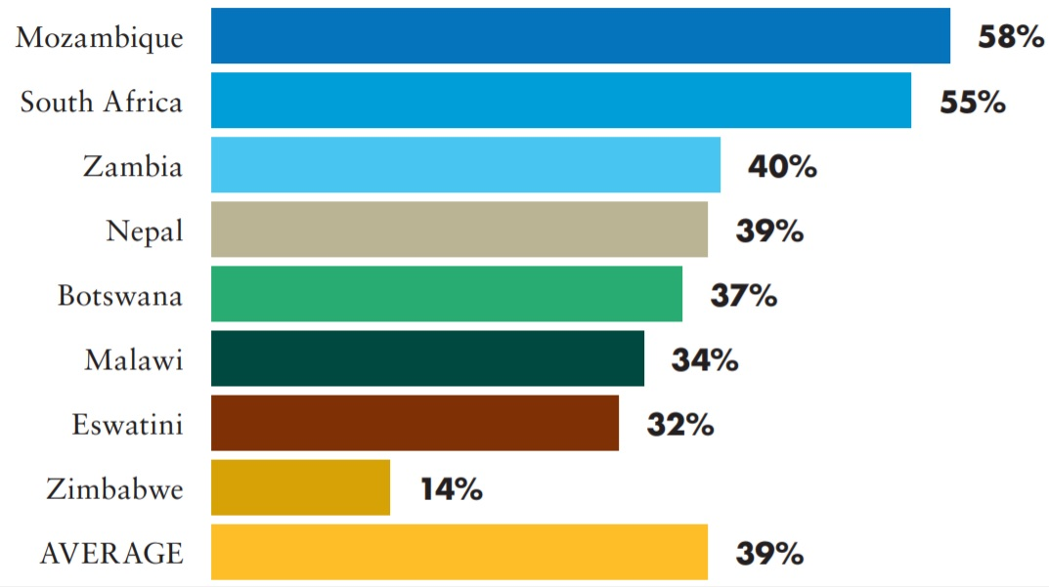
Source: UNDESA, Disability and Development Report, 2019, p. 228.

2. What needs to be done?
Main areas of intervention to realise Sustainable Development Goal 11
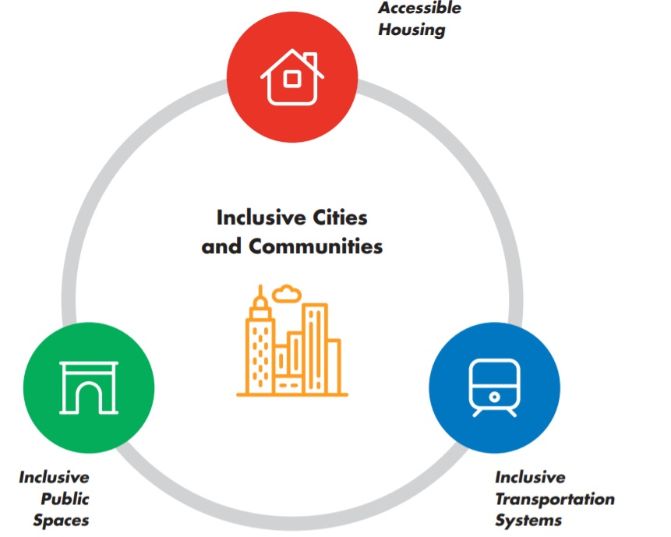
 Inclusive cities and communities: actions applicable across all Goal 11 targets
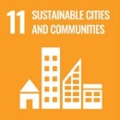 Make cities and human settlements inclusive, safe, resilient and sustainable
Incorporate accessibility standards into legislation and regulatory frameworks
Ensure coordination across the government to support inclusive urban environments
Appoint and support disability focal points
Ensure consultation and participation of persons with disabilities in urban planning and management

CRPD indicators: 9.1, 9.2, 9.3, 9.4, 20.1, 20.7, 20.8, 20.9, 28.2, 30.2, 30.3, 33.2, 33.3, 33.4, 33.5, 1/4.9, 1/4.10, 1/4.28
 Accessible housing, slums and homelessness
11.1 By 2030, ensure access for all to adequate, safe and affordable housing and basic services and upgrade slums
Ensure that planning and construction legislation incorporates accessibility standards that apply to housing
Ensure persons with disabilities have access to public housing, on an equal basis with others
Adopt a strategy to upgrade slums, while providing low-cost practical interventions to meet minimum standards of accessibility
Address homelessness of persons with disabilities, particularly by ensuring the accessibility of homeless shelters and emergency support services

CRPD indicators: 9.1, 9.3, 9.10, 9.11, 28.1, 28.2, 28.6, 28.7, 28.9, 28.12, 28.14, 28.17, 28.19, 13.1, 13.2, 13.4, 13.6, 13.14, 13.16, 16.15, 16.18
Transportation systems inclusive of persons with disabilities
11.2 By 2030, provide access to safe, affordable, accessible and sustainable transport systems for all, improving road safety, notably by expanding public transport, with special attention to the needs of those in vulnerable situations, women, children, persons with disabilities and older persons
Ensure access to appropriate assistive products and technologies to facilitate individual mobility and access to transportation
Increase the access to public transportation for persons with disabilities, through the application of accessibility standards and measures that cover the additional disability- related costs of travel
Ensure the availability of accessible point-to-point transportation and implement accessible flexible transportation lines
CRPD indicators: 20.1, 20.2, 20.3, 20.11, 20.12, 20.19, 20.20, 20.21, 28.1, 28.20, 28.21, 28.27, 1/4.14, 1/4.27, 19.31, 9.1, 9.2, 9.7, 9.8, 9.9, 9.18, 9.22
 Inclusive public spaces
11.7 By 2030, provide universal access to safe, inclusive and accessible, green and public spaces, in particular for women and children, older persons and persons with disabilities
Promote the accessibility of public spaces by establishing, monitoring and enforcing relevant accessibility standards
Develop a strategy to improve the accessibility of public spaces, that involves the participation of persons with disabilities and their representative organizations
Increase the accessibility of buildings and facilities open to the public through the application of accessibility standards and the development of incentives to encourage accessibility improvements of small businesses during renovation processes
Collect and analyse data on the accessibility of spaces and facilities open to the public, to measure progress
CRPD indicators: 9.1, 9.3, 9.17, 9.7, 9.20, 9.23

3. DO’s and DON’Ts
DO | DON’T
Governance, inter-institutional coordination
Appoint disability focal points in government areas related to urban planning and management, housing and transportation and establish mechanisms to ensure their coordination | Overlook the need for disability-related expertise and permanent input within government areas for urban planning, social housing and transportation
Ensure the inclusion of persons with disabilities in consultations and participatory processes of urban planning and management | Adopt and impose policies on urban development without the participation of persons with disabilities and their representative organizations
Establish well-resourced monitoring bodies to proactively enforce accessibility standards | Rely solely on regulatory standards to achieve accessibility in practice
Practice and Implementation - urban development and housing
Ensure that urban planning and construction legislation includes accessibility standards to regulate and provide clear guidance on accessibility in the built environment and the public realm. Ensure that this legislation is regularly reviewed and updated, to reflect best practices | Adopt general urban planning and construction legislation with little or vague references to accessibility in its provisions
Ensure that planning and construction permit processes incorporate compliance with accessibility standards | Allow the construction of buildings that do not meet accessibility criteria
Evaluate each urban project according to existing standards and practicality of the accessibility solutions included, engaging persons with disabilities in community-based urban development | Allow construction projects to proceed without having first assessed the requirements of persons with disabilities or factored universal design principles into their design

DO | DON’T
Ensure that urban development processes engage with and include the diversity of persons with disabilities, including women and girls with disabilities | Limit urban development to persons with disabilities who are wheelchair users or have difficulty in mobility. Inaccessible environments pose different barriers to different groups of persons with disabilities
Ensure that public housing programmes are inclusive of persons with disabilities, including women and girls with disabilities. Include accessible housing units which are responsive to diverse requirements | Assume social housing programmes are accessible or respond to the requirements of persons with disabilities
Practice and Implementation – transportation
Integrate accessibility considerations into various modes of transportation, to promote individual mobility (including access to assistive technologies), as well as mass transportation | Limit the focus on accessibility to certain modes of transportation (e.g. mass transportation or point-to-point transportation), as this will result in disconnected travel routes for persons with disabilities
Ensure that public procurement contracts include accessibility requirements for providing transportation services and infrastructure | Limit accessibility requirements to physical and communicational accessibility, without addressing attitudinal barriers posed by service providers and the wider public
Establish accountability mechanisms to monitor the transportation experiences of persons with disabilities, particularly relating to the performance of accessibility features (e.g. ramps, elevators, signals, information on traffic and outages) and encountered attitudes (e.g. satisfaction with service provision, compliance with training requirements, cases of discrimination) | Assume that existing accountability mechanisms are sufficient to address discrimination against persons with disabilities in their access to, and use of, transportation services
Include compliance with accessibility features as a pre-requisite for the commercial delivery of transport services and as a condition of periodic technical and safety verifications | Leave technical and safety verifications on accessibility as a one-off assessment

DO | DON’T
Research, data collection and disaggregation
Ensure that data collection related to housing aims at measuring impact on the right of each individual with disability to live independently and be included in the community | Count persons with disabilities living in institutions (e.g. mental health and/or social care institutions) as persons who have access to adequate housing
Collect and analyse data on the accessibility of public spaces, facilities and places open to the public (e.g. restaurants, shops). Consider the diverse perspectives of persons with disabilities | Assume that public spaces, places and facilities intended for public use are accessible to everyone

IN DEPTH
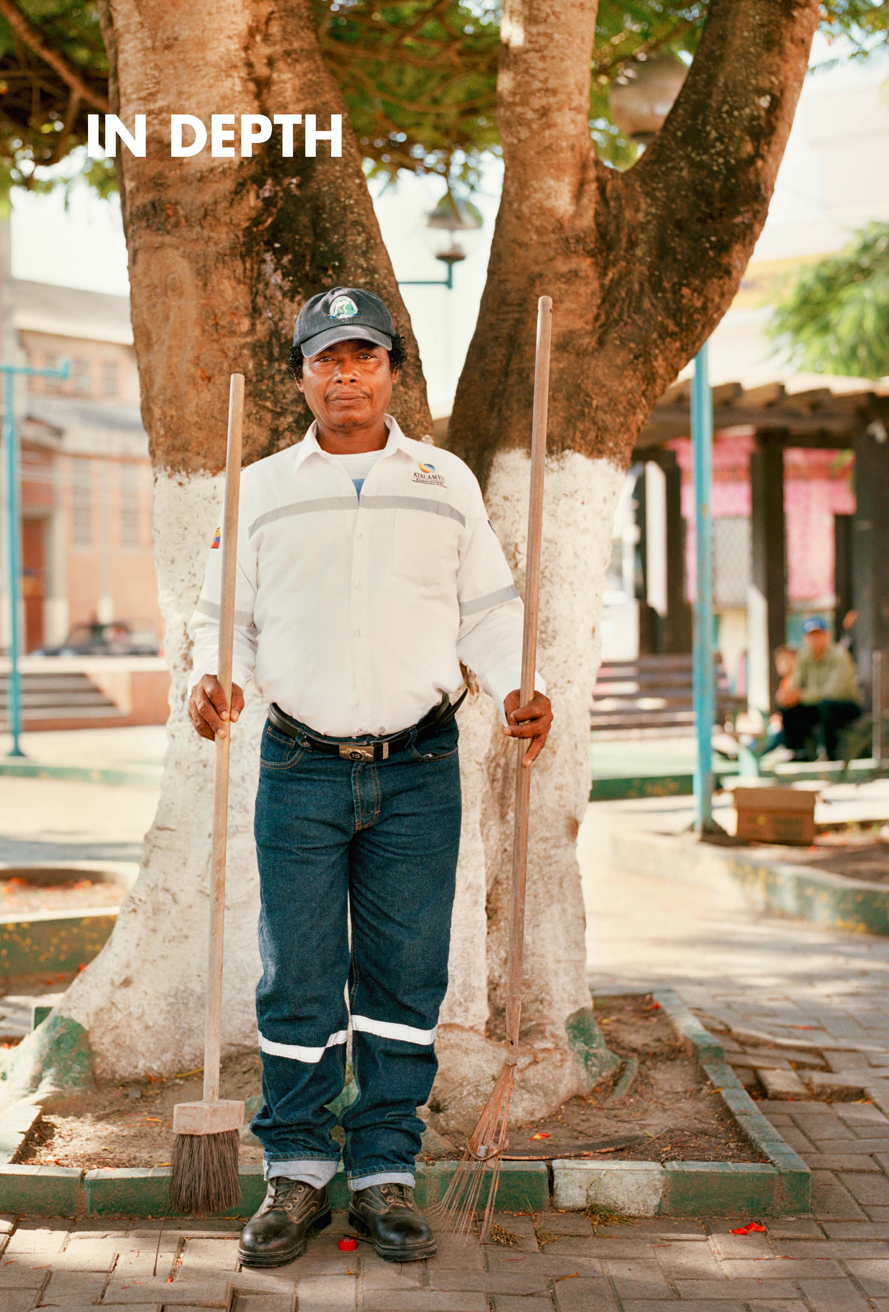

1. Introduction
This section provides detailed guidance for policymakers on the relevant measures to implement Sustainable Development Goal 11 (SDG 11) on making cities inclusive, safe, resilient and sustainable in ways that equally benefit persons with disabilities. Section 2 shows the connection between the Policy Guidelines to achieve SDG 11 with other resources, including the human rights indicators under the Convention on the Rights of Persons with Disabilities (CRPD) and other related tools.
Section 3 provides an overview of the situation of persons with disabilities in urban areas and describes the exclusion experienced in access to housing, transportation and public spaces (or places open to the public), demonstrating why SDG 11 is key for their inclusion and development. Sections 4 and 5 provide guidance on policy measures and actions that should be adopted for an inclusive implementation of SDG 11. In particular, section 4 addresses measures that are structural to develop cities that are inclusive of persons with disabilities and section 5 provides considerations and guidance on key actions specific to SDG 11 targets.
Guidance on some targets under SDG 11 is covered in thematic briefs. Targets 11.5 and 11.b are addressed in the Thematic Brief on climate change and disaster risk reduction. Considerations related to Target 11.a are included in the Thematic Brief on rural areas and persons with disabilities. Other targets do not present disability-related considerations and, therefore, are not addressed within these guidelines (Targets 11.4 on the preservation of the world’s cultural and natural heritage and 11.c on support to least developed countries in building sustainable and resilient buildings utilizing local materials).

2. Connection to other tools
  - CRPD Indicators: Article 9 (accessibility), Article 28 (adequate standard of living and social protection), and Article 30 (participation in cultural life, recreation, leisure and sport)
  - Other related CRPD articles: Articles 1-4, 5, 6, 13, 19, 20, 31
  - Data Sources Guidance: Articles 9, 28, 30 and other related CRPD articles
  - Training materials: Goal 11
  - Video: Goal 11

3. Why is Goal 11 important for persons with disabilities?
Of the 6.25 billion people predicted to be living in urban areas by 2050, an estimated 15 per cent, or 937 million, will be persons with disabilities (Secretariat for the Convention on the Rights of Persons with Disabilities, Accessibility and Disability Inclusion in Urban Development). Cities and human settlements can impede or enable the inclusion of persons with disabilities, depending on how they are planned and built. Many persons with disabilities face a widespread lack of accessibility to built environments, such as housing, public buildings and spaces, transportation, urban services, information and communications.
This lack of accessibility contributes greatly to the marginalisation of persons with disabilities and results in disproportionate rates of poverty and exclusion. Women and girls with disabilities often experience a lack of participation in urban planning processes and additional barriers in accessing the urban environment and services, such as safety concerns in the use of public spaces or transport.
Persons with disabilities face higher exclusion from housing, both public and private, than others. Data from 32 countries in Europe show that 4.7 per cent of persons with disabilities experience severe housing deprivation, compared to 4.1 per cent of other people surveyed (Eurostat, “Severe housing deprivation rate by level of activity limitation, sex and age”, 2 December 2020). Legislation on urban planning and construction does not always incorporate accessibility standards. Mechanisms for monitoring accessibility are also weak or non-existent in many places, resulting in gaps in the implementation of accessibility standards. This leads to a lack of availability of adequate housing for persons with disabilities. Based on data from 3 countries, an average of 1 out of 3 persons with disabilities indicated that their housing was not sufficiently accommodative of their requirements (UNDESA, Disability and Development Report, 2019, p. 224). Many may also be unable to afford modifications to their home to make it more accessible. Increasing costs in housing push persons with disabilities, who usually have lower incomes, into poorer areas, slums and homelessness. Data from Europe show that 12.4 per cent of households with persons with disabilities suffer housing overburden costs, compared to 9.5 per cent of others (Eurostat, “Severe housing deprivation rate by level of activity limitation, sex and age”, 2 December 2020).
Persons with disabilities face restrictions or are completely excluded from transportation services. Data from 8 low- and middle-income countries show that 36 per cent of persons with disabilities consider transportation services not accessible or hindering. According to a survey conducted in Australia, major obstacles for persons with disabilities in using public transportation were steps to get in or out of vehicles, barriers in getting to stops or stations, lack of seating or difficulty standing, pain or discomfort when sitting, fear or anxiety, inaccessible doors to get in and out of vehicles and inadequate access to toilets (UNDESA, Disability and Development Report, 2019, p. 226).
Whenever accessibility is considered in transportation, the focus has often only been on wheelchair- users. However, other persons with disabilities also require accessibility features, e.g. audio or visual signalling. In addition, public policies tend to focus on mass transportation, which many persons with disabilities cannot access even when accessibility requirements are met. Multi-modal transportation and individual assistive products and technologies are usually disregarded.
The exclusion of persons with disabilities from urban planning processes has long-lasting negative effects. Once buildings, facilities and public spaces are constructed, retrofitting them for accessibility can be inefficient or not feasible, leaving in place barriers for persons with disabilities that are difficult to remove. The inaccessibility of public spaces in cities restricts the autonomy and mobility of persons with disabilities, resulting in multiple impacts on their life, including in their social and economic participation. Available data from 8 low- and middle-income countries show that, on average, almost 40 per cent of persons with disabilities consider recreational facilities inaccessible (UNDESA, Disability and Development Report, 2019, p. 228).

4. Inclusive cities and communities: actions applicable across all targets
Make cities and human settlements inclusive, safe, resilient and sustainable

4.1 Incorporate accessibility standards into legislation and regulatory frameworks
Legislation should ensure the right of access of persons with disabilities, on an equal basis with others, to the built environment, housing, transportation, information and communications, and services and facilities open or provided to the public. Accessibility standards should also be incorporated into legislation on construction, urban planning and transportation, to support the systematic implementation of accessibility. Incorporating accessibility standards into these various areas of legislation is important in ensuring that the relevant public officials, professionals and stakeholders are involved in their implementation and monitoring.
Recommendations
    - Accessibility standards need to be clear and enforceable. Legislative and regulatory frameworks should include mechanisms that allow public agencies to enforce accessibility standards. This should include penalties or refusal of permit approvals for non-compliance, as well as effective monitoring and complaint mechanisms which allow for the input of the public and are inclusive of, and accessible to, persons with disabilities.
    - Accessibility should also be incorporated into public procurement policies as a requirement and as a clause for all new construction and transportation contracts.
    - Improving the awareness and understanding of government staff, providers of public services and professionals (particularly engineers, architects, transport operators) of universal design and accessibility standards is critical to supporting the implementation of accessibility.
Related CRPD indicators: 9.1, 9.2, 9.3, 9.4, 9.17, 20.1, 20.7, 20.8, 20.9, 28.2, 30.2, 30.3

4.2 Ensure coordination across the government to support inclusive urban environments
Inclusive cities require effective coordination among different areas within the government, including between levels of government (e.g. the local with the national government). Efficient coordination mechanisms across different areas of government are pivotal to an integrated and effective implementation of inclusive urban environments and services.
Recommendations
As a minimum, government ministries responsible for urban development, social welfare and disability should coordinate closely when developing inclusive and accessible public housing projects or when undertaking slum upgrading processes.
See also Foundations Guideline, section 2 on “Governance”
Related CRPD indicators: 33.2, 33.3, 33.4, 33.5
Addressing complexity in urban design
Intervening in an urban space for accessibility purposes requires an approach that addresses the complexity of systems that coincide in a given space. Building an inclusive space should meet the requirements of structure, connectedness, accessibility, stability, resilience and robustness while being conducive to an improvement of equity, safety, spatial justice, adaptiveness and social contact and exchange.
For example, a ramp is needed at the corner of a street. The ramp should have its equivalent on the other side of the street to complete an itinerary. It should be safe for wheelchair-users, blind persons, older persons, children and others. It should not disrupt pathways of cars or cyclists and may be required in a place where there are rain drainage systems, sewage, electricity or street signalling.
Building this ramp will require the intervention of multiple areas of government and different skills. Sometimes, service providers (like private companies managing electricity services) should also be involved, to prevent situations where a lack of coordination results in inefficient design.

4.3 Appoint and support disability focal points
Governments, including local governments, require dedicated time and expertise to design, implement and improve policies that are inclusive of persons with disabilities. Disability focal points working within the various ministries, as well as cross-departmental disability focal points, have a significant role to play, as they are critical in supporting the development of inclusive policies and ensuring that these are informed by both the lived experience of persons with disabilities and accessibility expertise.
See also Foundations Guideline, section 2 on “Governance”

4.4 Ensure consultation and participation of persons with disabilities in urban planning and management
11.3 By 2030, enhance inclusive and sustainable urbanization and capacity for participatory, integrated and sustainable human settlement planning and management in all countries
SDG Target 11.3 stresses the need to enhance inclusive and sustainable urbanization and participatory planning and management. SDG indicator 11.3.2 requires that city governments have a direct participation structure that ensures regular and democratic participation of civil society in urban planning and management. Participatory processes that involve civil society will contribute to enhancing the legitimacy and effectiveness of policies.
Persons with disabilities and their representative organizations are the main experts on their situation, the barriers they face and their requirements. Their participation in the matters that concern them is key to ensuring that their views are reflected in policy design and implementation (Article 4 (3), CRPD). Any participatory decision-making structure or process within urban planning (such as community consultation workshops) needs to include persons with disabilities, through their representative organizations.
Related CRPD indicators: 1/4.9, 1/4.10, 1/4.28
See also Foundations Guideline, section 2.4 on “Participation”
 The Cities for All initiative – Global Compact on Inclusive and Accessible cities
The Global Compact on Inclusive and Accessible Cities is an initiative led by World Enabled involving many partners, such as city governments, the private sector and civil society organizations, including representative organizations of persons with disabilities, e.g. the International Disability Alliance, the World Blind Union.
This Global Compact promotes the implementation of the SDGs and of the New Urban Agenda. It mobilizes partners to improve the inclusion of persons with disabilities in urban areas. In particular, it highlights the need to address the barriers faced by children and youth with disabilities and the obstacles to equal participation faced by women with disabilities, by facilitating the active participation of persons with disabilities and their representative organizations in planning processes.

5. Other key actions by target

5.1 Accessible housing, slums and homelessness – Target 11.1
11.1 By 2030, ensure access for all to adequate, safe and affordable housing and basic services and upgrade slums

5.1.1 Ensure that planning and construction legislation incorporates accessibility standards that apply to housing
Accessibility is best implemented from the outset. New buildings and construction should be designed and developed in line with accessibility standards and universal design principles. As this has not always been the case, persons with disabilities currently have very limited opportunities to access housing that is suitable for their requirements.
Modifications to existing housing in urban areas poses challenges, and it is usually more expensive to retrofit for accessibility. In some cases, technical solutions may not be possible (e.g. lack of sufficient space) and, in other cases, modifications are not easily undertaken due to the ownership of the property (e.g. co-ownership of the apartment building). In addition to feasibility and costs, there are also attitudinal barriers related to the undertaking of accessibility renovations, as people may consider them as a disproportionate and unnecessary expense – this reflects the lack of understanding and value given to the inclusion of persons with disabilities in daily life. In some cases, paying penalties for the lack of compliance to accessibility standards is preferred over actually making spaces accessible. A lack of understanding about the importance of accessibility and long-term benefits for the community as a whole results in the continued exclusion of persons with disabilities from accessing appropriate housing.
Accessibility standards need to be integrated across construction codes and urban planning legislation, in order to influence construction and renovation of buildings and of the surrounding physical environment. Planning legislation and construction codes should outline clear responsibilities for implementing, monitoring and enforcing the implementation of accessibility standards.
Inclusive cities call for the provision of accessible housing for persons with disabilities. Governments need to support the supply of currently accessible housing, as well as influence house designs that can be adapted, in the future, to accommodate occupants who may acquire an impairment. Adaptable buildings (see box below) may be a useful approach to increasing the accessibility of housing, compatible with the financial and evolving requirements of the current population.
 Criteria for improving the accessibility of existing buildings: visitability, adaptability and feasibility
There are three main accessibility criteria that can guide the regulation and implementation of accessibility solutions for existing buildings, including housing. These are:
Visitability: refers to a building that meets three requirements: at least one entrance with no steps into the main floor, wide enough doors and hallways that allow for wheelchair users to access common areas and one wheelchair accessible bathroom on the main floor. Visitability enables all people to visit the house or building but does not require the entire building to be accessible.
Adaptability: while not all private and public housing units are initially constructed to accommodate persons with disabilities, the design of the housing unit should allow for future adaptations, if required. For example, a bathroom may originally include a bathtub – the adaptability of the bathroom design would allow for the bathtub to be removed at a low cost and provide space to add in a “roll-in shower”.
Feasibility: standards in buildings allow for exceptional accessibility measures to be implemented where technical restrictions preclude general accessibility standards. Feasibility standards should be applied on an exceptional basis and constructors should be held to strict scrutiny (e.g. by presenting documentation that proves that no safe technical solutions can be implemented due to characteristics of the building). In those cases, urban planning law enforcement agencies can authorize the use of alternative standards, such as “assisted ramps” (those that require support from a third person to be used safely), “removable ramps” (ramps that can be removed to avoid blocking circulation), “stair lifts” (electronic devices that allow for wheelchairs to climb stairs), among others.
Examples of challenges and possible solutions to ensure accessible housing
 | Examples | Challenges | Possible solutions
New buildings | Private access buildings | Constructing accessible buildings can still be perceived as costly, despite the fact that studies show that accessible buildings can be constructed at no or marginal extra-cost | Implement accessibility standards that create different levels of accessible units, such as “visitable and adaptable” or “accessible and adaptable”.  Extra-cost estimations to move from one category to the next are required, as well as awareness-raising
Public housing | Temporary housing (displacement, urbanization, other), permanent housing | Government and public-private partnerships tend to cut space to the minimum to reduce costs | Standards and public procurement rules should include adaptability standards, to prevent forced eviction due to inaccessibility
Existing buildings with technical restrictions to safe renovations | Ancient buildings, small properties | Certain buildings may present a structural design that impedes the implementation of accessibility measures that meet safety standards | After exhausting technical solutions (e.g. compensated ramps), use “feasibility” standards as an exception to general standards. Ensure strict legal and accountability mechanisms, as well as safeguards, to avoid the abuse of these standards against general urban planning law standards
Existing buildings with a legal prohibition to renovate | Historic buildings, rented buildings, co-owned buildings, among others | Provisions in law or contracts may restrict changes in the building | After exhausting technical solutions, such as external ramps or elevators that do not change the building, seek to present accessibility as a matter of “public interest” or “public order”, to overcome private law provisions

Funding accessibility
Accessibility-compliance costs
Ensuring accessible constructions is an obligation under urban planning legislation. Businesses should not impose additional charges to recover accessibility costs. Accessibility costs are part of business expenses and should be factored in the operational cost of businesses.
Financial support, tax credit and deductions
Funding accessibility is fundamental to increase the availability of accessible buildings for persons with disabilities. Individual financial support directed to persons with disabilities to adapt existing buildings is an efficient way of supporting accessibility. Financial support can be arranged through zero- or low-interest credit lines.
Small businesses may also benefit from credit lines. Tax incentives, through tax credit and deductions, can contribute to increasing the availability of accessible housing and the accessibility of commercial facilities.
Recommendations
To support the development and availability of accessible housing, governments must:
      - Develop comprehensive accessibility standards that apply to public and private housing. This should include standards that address the housing requirements of persons with disabilities
      - Monitor and enforce accessibility standards at the design and final stages of construction or modification of the building. Develop indicators for verifying accessibility, to improve the efficiency and effectiveness of monitoring processes
Related CRPD indicators: 9.1, 9.3, 9.10, 9.11

5.1.2 Ensure that persons with disabilities have access to public housing, on an equal basis with others
Persons with disabilities are more vulnerable to exclusion from work and, thus, are disproportionally represented among the poor. Difficulties in accessing employment present barriers for persons with disabilities in securing the financial conditions required to rent or finance adequate housing. In addition, urban planning and construction legislation often do not include accessibility requirements that apply to private housing. Consequently, persons with disabilities are commonly excluded from accessing appropriate housing through the housing market.
While public housing is significantly more affordable, it can also be beyond the reach of persons with disabilities or households with members with disabilities. This may be due to the criteria for public housing eligibility or related financial assistance, which ordinarily do not take into consideration the impact of disability-related extra costs (such as regular medication, assistive products and technologies, additional healthcare) on household income. Persons with disabilities might also be considered ineligible for public housing based on deprivation of legal capacity, where the law does not recognize their right to administer property. Furthermore, there is scarcity of other measures to support or prioritize persons with disabilities and their families in accessing public housing. There is also often a lack of accessibility requirements that apply to public housing, either for new buildings or for existing public housing that could be made accessible at a low cost.
 Recommendations
In order to address these gaps in accessible public housing, governments should:
      - Ensure that public housing programmes respect the legal capacity of persons with disabilities to own property
      - Ensure that the development of public housing utilizes universal design principles that promote accessibility (such as wide doorways, avoiding the unnecessary use of steps) and enable future renovations to enhance it
Related CRPD indicators: 28.1, 28.2, 28.6, 28.7
      - Prioritize the access of persons with disabilities to public housing programs. Eligibility criteria of public housing programmes should take into consideration the impact of additional disability-related costs for persons with disabilities, including costs associated with accessibility modifications for their home
Related CRPD indicators: 28.9, 28.17
      - Provide grants and credit at no- or low-interest rates, to persons with disabilities and their households, to make required accessibility modifications to housing
 Accessible housing schemes

5.1.3 Adopt a strategy to upgrade slums while providing low-cost practical interventions to meet the minimum standards of accessibility
Persons with disabilities are overrepresented among the poor. For them, inclusive and accessible social housing remains the lowest-cost sustainable solution. Nevertheless, the lack of availability of affordable and accessible housing alternatives may push persons with disabilities into urban slums. In these contexts, persons with disabilities experience reduced hygienic conditions, the negative effects of water and air pollution, reduced safety and security and lack of services, particularly primary health care, emergency services and early intervention services. Implementing and maintaining accessibility in slums is challenging but essential for the persons with disabilities who reside there.
Accessibility provides an enabling environment for persons with disabilities to develop to the maximum of their potential and to move around autonomously and safely, without compromising their health or putting themselves at risk of accidents and injuries. However, the reality is that slums develop and grow with little or no planning, outside legal and regulatory frameworks and following power dynamics within the community, ultimately without regard for persons with disabilities.
Given these factors, upgrading slums requires decisive action to design practical accessibility solutions and features under the criterion of “feasibility” and increased efforts to ensure the sustainability of upgrading interventions. This requires local governments to propose a community approach that ensures the inclusive participation of slum dwellers (United Nations Human Settlements Programme, Human rights in cities handbook series: The human rights-based approach to housing and slum upgrading, vol. 1 (Nairobi: UN-Habitat, 2017)).
Such an approach calls for the community to participate in decision-making and design, including in identifying accessibility requirements (among other issues), thereby enhancing the legitimacy, acceptance and ownership of the process. Community ownership of accessibility improvements is likely to lead to better maintenance and sustainability of the interventions.
 Recommendations
Governments should adopt strategies to increase accessibility in slums. This should include the following actions:
      - Consult persons with disabilities and their households about the accessibility barriers experienced in safely entering and circulating within slums. Ensure that consultation includes a diversity of representation across gender and impairment
      - Develop accessibility plans in collaboration with persons with disabilities and the community, to promote ownership
      - Develop accessibility guidelines that are suitable to the local context
      - Allocate funds to support accessibility improvements as part of slum upgrade initiatives Related
CRPD indicators: 28.1, 28.2, 28.6, 28.7, 28.12, 28.14, 28.19

5.1.4 Address the homelessness of persons with disabilities, particularly by ensuring the accessibility of homeless shelters and emergency support services
Available evidence suggests that there is a disproportionate number of persons with disabilities who are homeless (UNDESA, Disability and Development Report, 2019). Persons with disabilities are particularly at risk of homelessness due to entrenched stigma and discrimination, which causes greater challenges in accessing employment, assets, housing services or community support.
Deinstitutionalization of persons with disabilities without appropriate planning and coordination, in the context of the lack of affordable housing and support services, also leaves many persons with disabilities homeless. Given the lack of disability-disaggregated data, homelessness affecting persons with disabilities is still largely unacknowledged and unaddressed.
As a consequence, policy responses to homelessness are not usually inclusive of persons with disabilities, nor responsive to their requirements. For instance, emergency shelters are not made accessible, support services are inaccessible or insufficient and financial assistance does not consider nor cover disability-related extra costs.
Homeless persons with disabilities, like all homeless populations, are exposed to violence, abuse and exploitation. This is particularly the case for women with disabilities, who may experience a higher risk of violence and exclusion on account of their gender and impairment. Shelters and other services targeting homeless populations may not be accessible or inclusive of persons with disabilities.
Persons with disabilities may also be targeted or exploited due to their impairment (e.g. a child with a physical disability may be forced to engage in begging, see Policy Guideline on SDG 8, section 5.3.4). Complaint mechanisms and survivor support services need to be accessible to persons with disabilities and responsive to their requirements.
Recommendations
To respond to the homelessness of persons with disabilities, governments must:
      - Ensure the accessibility of emergency shelters and other transitional or permanent accommodations provided to persons with disabilities
      - Ensure the provision of emergency support services that are responsive to the requirements of persons with disabilities
      - Ensure that any financial assistance programme for homeless persons has the capacity to cover the extra costs related to disability
      - Ensure that complaint mechanisms, legal aid services and survivor support services are accessible and responsive to the requirements of persons with disabilities
Related CRPD indicators: 13.1, 13.2, 13.4, 13.6, 13.14, 13.16, 16.15, 16.18
See also Policy Guidelines on SDG 1.
The Housing First model: addressing homelessness of persons with disabilities
Since the 1990s, many governments, including in Australia, Canada, Denmark, Finland, France, Japan, the United Kingdom of Great Britain and Northern Ireland and the United States of America have adopted the Housing First approach to address long-term homelessness, especially of persons with psychosocial disabilities. This approach has been used as an alternative to programs based on emergency shelter and transitional housing.
As the name suggests, the Housing First approach focuses first and foremost on providing long-term, permanent and affordable housing, as quickly as possible, to persons experiencing homelessness, while providing other support services – instead of providing emergency and transitional accommodations until “housing readiness”. For this model, stable housing is the first issue to resolve and an important factor for the success of other social services provided to the person or family experiencing homelessness.
European Observatory on Homelessness, Housing First, 2012.

5.2 Transportation systems inclusive of persons with disabilities – Target 11.2
11.2 By 2030, provide access to safe, affordable, accessible and sustainable transport systems for all, improving road safety, notably by expanding public transport, with special attention to the needs of those in vulnerable situations, women, children, persons with disabilities and older persons

5.2.1 Ensure access to appropriate assistive products and technologies to facilitate individual mobility and access to transportation
For many persons with disabilities, mobility within and outside of their homes begins with having access to assistive products and technologies (e.g. wheelchairs, white canes, spectacles, prosthetics). However, many persons with disabilities do not have access to assistive products that meet their requirements. It is estimated that, globally, only 1 in 10 people in need have access to assistive products (WHO, “Assistive Technology”, 2018).
Strong coordination between the government sectors responsible for providing assistive products and technologies and those in charge of urban development and transportation is key to enhancing the mobility of persons with disabilities. The coordination between government sectors helps to reinforce their respective policy intervention. For example, a person with disability living in an urban slum will benefit from accessing a wheelchair but will benefit significantly more if the slum upgrading establishes accessible paths from that person’s house to the transit point of an accessible transportation system (see section 5.1.3).
Data generated on assistive products (e.g. number of persons with disabilities in a neighbourhood who require and use assistive products for mobility) can be important for informing the development of accessible transportation services that are driven by specific requirements (e.g. for paratransit, flexi-lines and point-to-point transportation) (see section 5.2.2).
 Recommendations
To promote mobility and access to transportation of persons with disabilities, governments should:
      - Develop legislation and programs to facilitate the access of persons with disabilities to assistive products and technologies, in particular those in the WHO, Priority Assistive Products List (2016)
      - Establish mechanisms to ensure coordination among the government sectors responsible for facilitating access to assistive products and technologies, urban development and transportation
      - Ensure mechanisms for sharing relevant aggregate data on persons with disabilities (on those who require and who use assistive products and technologies for mobility) with the government sectors responsible for urban development and transportation
Related CRPD indicators: 20.1, 20.2, 20.3, 20.11, 20.12, 20.19, 20.20, 20.21, 28.1,
28.20, 28.21, 28.27, 1/4.14, 1/4.27, 19.31
See also Policy Guideline on SDG 1, section 5.2.2 on “Access to assistive technology for persons with disabilities”.
Figure III shows how individual mobility can be ensured at different levels. Human support is the most basic mobility resource and operates when no assistive technology exists. Assistive technology increases individual functioning to a point where larger point-to-point transportation is needed.
Beyond accessible point-to-point transport, flexilines / paratransit services can transport both persons with disabilities and others, in an itinerary that is flexible to the requirements of the passengers. Mass transport should be accessible in all its dimensions. The correct integration of these systems will yield optimum cost-effectiveness. The first three levels are mandatory to ensure the mobility of persons with disabilities.
figure iii
Integrating individual mobility at different levels
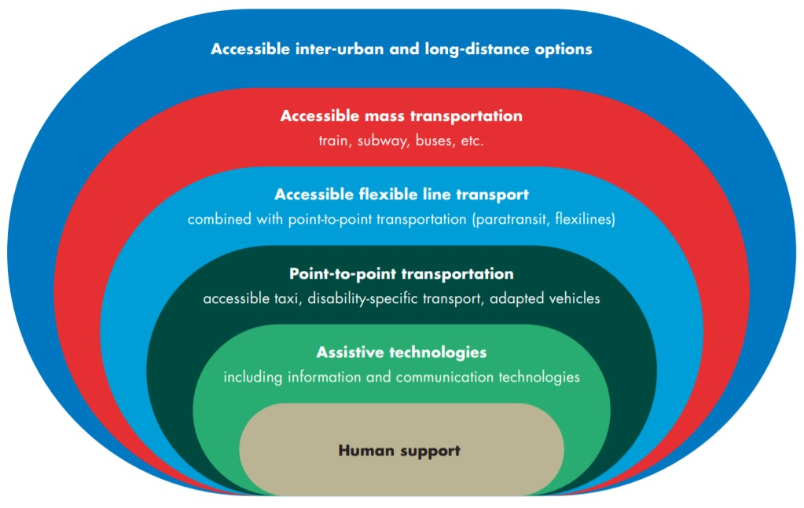

5.2.2 Increase the access to public transportation for persons with disabilities, through the application of accessibility standards and measures that cover the additional disability-related costs of travel
Public transportation services remain inaccessible for many persons with disabilities. Data from 8 low- and middle-income countries show that, on average, 36 per cent of persons with disabilities consider transportation services inaccessible or hindering (UNDESA, Disability and Development Report, 2019, p. 226). Inaccessible public transport restricts the mobility of persons with disabilities and forces them to use alternative transportation, that is usually more expensive, e.g. accessible taxis (see section 5.2.3). Even in countries where accessibility standards have been adopted in relation to transportation, there are challenges with compliance, monitoring and enforcement.
Persons with disabilities experience a range of barriers in accessing public transport. They may face:
- Regulatory barriers (e.g. a general prohibition of travelling with animals prevents blind persons who use guide dogs from travelling on public transportation)
- Attitudinal barriers, such as prejudice by transportation service providers, which can prevent access to the service altogether (e.g. bus driver that avoids stopping to pick up a person with disability) or lead to mistreatment and discrimination when accessing the service
- Financial barriers, in cases when transportation is not affordable (e.g. persons with disabilities who need to travel with their personal assistants, increasing costs)
- Lack of accessibility or complete unavailability of transport
Recommendations
To improve access to public transportation for persons with disabilities, governments should:
      - Ensure that accessibility standards are incorporated into transportation legislation. Accessibility standards should apply to aerial, road, railway and water passenger transportation services, including urban, inter-urban and long-distance services
      - Establish or strengthen mechanisms to monitor and enforce accessibility standards for transportation
      - Require transport operators to undertake training on accessibility standards, eliminating discrimination based on disability and providing accessible and inclusive customer service
      - Provide assistance for persons with disabilities to cover the disability-related extra costs associated with travel, e.g. travelling with a personal assistant
Related indicators: 9.1, 9.2, 9.7, 9.8, 9.9, 9.18, 9.22

5.2.3 Ensure the availability of accessible point-to-point transportation and implement accessible flexible transportation lines
Many persons with disabilities who can afford it, or who are supported by social protection, may rely on point-to-point transportation services (e.g. accessible taxi services or disability-specific services). This is particularly the case where accessibility of public transportation is limited or where mass transportation does not exist or is limited due to the size of the city. However, the availability of point-to-point services is usually low or non-existent in rural areas and the price of these services is much higher than other forms of non-accessible transportation.
Flexible transport or paratransit lines, to facilitate the access by persons with disabilities who face difficulties in reaching public transportation stops, are an affordable complementary solution to point-to-point transportation and should be made fully accessible and promoted. These services should cover urban and interurban transportation.
Recommendations
Governments must seek to:
      - Assess the current and potential demand for point-to-point transportation services and for flexible public transportation lines
      - Adopt policies that create incentives for increasing the supply of accessible point-to-point transportation and flexible public transportation lines that can respond to the demand assessed. Incentives might include tax reductions or exemptions, subsidies, or others
      - Adopt measures to increase the affordability of point-to-point transportation for persons with disabilities, including through social protection benefits for disability-related extra-costs, especially where public transportation services are not accessible
      - Work with persons with disabilities to identify alternative local and accessible transport solutions
      - Ensure the accessibility of mass transportation
Related indicators: 9.1, 9.2, 9.8, 9.9, 9.22

5.3 Inclusive public spaces – Target 11.7
11.7 By 2030, provide universal access to safe, inclusive and accessible, green and public spaces, in particular for women and children, older persons and persons with disabilities

5.3.1 Promote the accessibility of public spaces by establishing, monitoring and enforcing relevant accessibility standards
The inaccessibility of public spaces in cities restricts the autonomy and mobility of persons with disabilities. This results in multiple impacts on their life, including on their social, economic and political participation. Some of the barriers persons with disabilities face when accessing and enjoying public spaces include steps to entering or within the public space, shared pedestrian space with vehicles or bikes, obstructions along pathways and noise and pollution levels. Typically, accessibility features such as ramps, accessible orientation signage and traffic signals are missing in public spaces.
Whilst legislated accessibility standards may exist in many countries, compliance is low. The mechanisms for monitoring and enforcing accessibility standards are also often weak and under- resourced. An example of this situation may be the development of an inaccessible open space, regardless of existing standards, together with a lack of effectiveness of the complaint mechanism, to mandate the required modifications to achieve accessibility. Establishing an effective system for monitoring and enforcing accessibility upfront, during the design and construction process, is critical and can be done through public procurement and permit processes for urban planning and construction.
Even when accessible public spaces exist, there can be obstacles that affect the entry to, or movement around, the public space, such as parked vehicles (including bicycles and scooters), overgrown plants, street vendors or shops with unregulated use of public space. Regulations and implementation monitoring of the use of public spaces is key to ensuring and maintaining accessibility.
 Recommendations
To improve the access to public spaces by persons with disabilities, governments should:
      - Ensure that urban planning and construction legislation incorporate accessibility standards that apply to both the physical environment and services open to the public. This should include open spaces (e.g. parks, recreational areas, public squares, plazas) and built environments (e.g. streets, avenues and boulevards, pavements, sidewalks, traffic lights)
      - Include accessibility standards as a requirement in public procurement (e.g. requirement for those bidding for construction projects in public or open spaces)
      - Ensure that planning and construction permit processes incorporate the compliance with accessibility standards. The granting of permits for the development or construction of open and public spaces should be dependent upon compliance with accessibility standards
      - Establish simple, innovative and accessible complaint mechanisms that facilitate public monitoring of the accessibility of public spaces (e.g. individuals can take photos of inaccessible locations and submit them to local authorities through an online platform). The complaint process should also include effective mechanisms that investigate and address the issues identified, as well as provide a response to the person who made the complaint
Related CRPD indicators: 9.1, 9.3, 9.17
See also Foundations Guideline, sections 2.2 on “Accessibility” and 3.4 on “Public procurement”.

5.3.2 Develop a strategy to improve the accessibility of public spaces that involves the participation of persons with disabilities and their representative organizations
Currently, many public spaces remain inaccessible to persons with disabilities. Improvements that are made to public spaces, such as greening or beautification of open space, may not always have accessibility as a key objective. Therefore, in addition to the use of accessibility standards, city or municipal governments should develop strategies to improve the accessibility of existing and new public spaces.
Recommendations
In developing a strategy that addresses the accessibility of public spaces, governments should:
      - Undertake consultations with persons with disabilities and their representative organizations to understand their perspectives in accessing public spaces (including any barriers), particularly in areas highly transited by the general public
      - Ensure that the development of new public spaces is equally distributed across the city and located in areas easily reached by different transport modes
      - Ensure sufficient allocation of resources for improving the accessibility of public spaces
      - Involve persons with disabilities and their representative organizations in monitoring the implementation of the accessibility strategy
Related CRPD indicators: 9.7, 9.20, 9.23
 Safe cities for persons with disabilities
Persons with disabilities are exposed to different risks in public spaces, including the risk of accidents due to a lack of accessibility but also a high exposure to different kinds of harassment and crime. In these matters, statistical data disaggregated by disability is either unavailable or scarce.
All measures directed to ensure the accessibility of public spaces, housing and transportation contribute to enhancing the autonomy and safety of persons with disabilities when moving around.
They may also reduce the occasional reliance on strangers for support (e.g. blind persons having to request support to cross a street without accessible traffic light), which decreases the risk of inappropriate physical contact, theft and other crimes.
SDG indicator 11.7.2 focuses on “physical or sexual harassment”. Persons with disabilities, notably women and girls with disabilities, will benefit from general measures to reduce the incidence of violence and harassment, as well as to improve safety (e.g. improved lighting).
However, persons with disabilities may also experience other forms of harassment, which may provoke feelings of exclusion. For example, it is a common experience for persons with disabilities, particularly those with visible disabilities, to be approached on the street or in public spaces by “well-intentioned” strangers who offer alms or assistance, which may also involve inappropriate physical contact. Such unsolicited acts invade the personal space of the individual and may arouse feelings of insecurity. They are also offensive, as they perpetuate charity discourses and stereotypes relating to persons with disabilities.
In another example, street patrolling police officers may target and harass persons with psychosocial disabilities who are homeless to leave an area or to refrain from certain behaviour, considered irregular but harmless.
Overall, local governments should include disability perspectives, including through the involvement of organizations of persons with disabilities, throughout urban development and management, community involvement and development, usage of space and policing practices (e.g. training on disability awareness and effective communication for street-level law enforcement officers).
Related indicators: 16.3, 16.5, 16.31

5.3.3 Increase the accessibility of buildings and facilities open to the public through the application of accessibility standards and the development of incentives to encourage accessibility improvements of small businesses, during renovation processes
The inaccessibility of buildings and facilities designed for public use has inequitable impacts on persons with disabilities. It prevents persons with disabilities from accessing buildings, facilities and services within buildings, which results in restrictions to their autonomy and participation in society. The exclusion of persons with disabilities from public life also means that there is less opportunity for interactions and connections in the community that can help in breaking down negative attitudes about disability.
All buildings and facilities open to the public should be made accessible. This includes both public and privately-owned buildings and facilities that are intended for public use. All new buildings and facilities should comply with accessibility standards. Compliance with accessibility standards should be a requirement for granting any planning and construction permit. Lack of compliance with accessibility standards should prevent the granting of any permits to operate.
For existing facilities, both public and private, especially in contexts where high-level accessibility standards and enforcement mechanisms tend to be ineffective, two of the accessibility criteria presented in section 5.1.1 should be applied: visitability and feasibility.
Regarding existing public buildings, administrative procedures (including funding processes) should be used to serve as incentives to the public authorities in charge of their administration, for them to undertake renovations to ensure accessibility for persons with disabilities.
For existing private facilities open to the public, administrative procedures for granting permits for new or increased commercial operation present an opportunity to facilitate compliance with accessibility standards. This can occur when:
- A new business renovates facilities prior to the start of its operation
- An existing business renovates its facilities to increase the capacity of its operation (e.g. a restaurant renovates the facility to increase seating capacity) or modifies the use of its facilities to increase commercial operations (e.g. bookshop and café within same premises)
In these cases, businesses may be resistant to the extra expenditure required to comply with accessibility standards, particularly small businesses and those seeking to undertake renovations at a minimal cost. Financial schemes, including low- or no-cost loans, tax exemptions or others, can help businesses comply with accessibility standards.
Recommendations
To improve the accessibility of buildings and facilities open to the public, governments should:
- Ensure that urban planning and construction legislation incorporates accessibility standards that apply to all buildings and facilities open to the public
- Develop incentives that support small businesses in undertaking accessibility improvements, particularly when renovating existing premises. This could include developing financial schemes to support building modifications.

5.3.4 Collect and analyse data on the accessibility of public spaces and of facilities open to the public, to measure progress
Data on the accessibility of public spaces and places open to the public is usually scarce and not systematized. This makes it difficult to assess the current situation, hinders monitoring efforts to measure progress and compliance and the identification of remaining gaps.
Recommendations
In this area, governments should:
      - Develop information systems to collect and systematize data on the accessibility of public spaces and places open to the public, with the involvement of the relevant areas of government and of organizations of persons with disabilities
      - Ensure the availability and publicity of information for the purposes of monitoring and enforcing accessibility standards
Related CRPD indicators: 9.20, 9.23
See also Foundations Guideline, section 3.5 on “Data collection and disaggregation”.

6. Additional Resources
Disability Inclusive and Accessible Urban Development Network. The Inclusion Imperative: Towards Disability-inclusive and Accessible Urban Development. Key Recommendations for an Inclusive Urban Agenda.
United Nations. Adequate housing as a component of the right to an adequate standard of living, and the right to non-discrimination in this context. Report of the Special Rapporteur on adequate housing as a component of the right to an adequate standard of living, and on the right to non- discrimination in this context. 12 July 2017. A/72/128.
United Nations Department of Economic and Social Affairs. Disability and Development Report: Realizing the Sustainable Development Goals by, for and with persons with disabilities 2018. (New York: United Nations, 2019).
United Nations Department of Economic and Social Affairs. Good Practices of Accessible Urban Development: Making urban environments inclusive and fully accessible to ALL. (United Nations).
United Nations Economic and Social Commission for Asia and the Pacific. Disability at a Glance 2019: Investing in Accessibility in Asia and the Pacific — Strategic Approaches to Achieving Disability-inclusive Sustainable Development (United Nations, 2019).
United Nations Human Settlements Programme. Accessibility of Housing: A Handbook of Inclusive Affordable Housing: Solutions for Persons with Disabilities and Older Persons. (Nairobi: UN- Habitat, 2014).
United Nations Human Settlements Programme. Human rights in cities handbook series: The Human Rights-Based Approach to Housing and Slum Upgrading. Vol. 1 (Nairobi: UN-Habitat, 2017).
World Health Organization. Assistive technology. 18 May 2018.

7. Key Concepts Annex
Below are key foundational concepts referred to throughout the Policy Guidelines for Inclusive Sustainable Development Goals (SDG). The guide below is designed as a quick reference and refresher for readers as they use the guidelines. It is recommended that the guideline “Foundations for inclusive Sustainable Development Goal Implementation: Key concepts and structural requirements” is read prior to, or together with, other guidelines, for a deeper understanding of the required foundations for inclusion.

Concepts
Ableism considers certain typical characteristics of body and mind as essential for living a life of value. Ableist perspectives view impairments as undesired, which leads to unconscious bias, prejudice, discrimination and exclusion. Ableism is usually behind negative perceptions and stereotypes about persons with disabilities. See also Foundations Guideline, section 1.3.
Accessibility is the quality that allows persons with disabilities to access and enjoy physical environments, transportation, facilities, services, information and communications, including new technologies and systems. When planning for accessibility, the principles of universal design should be used. See also Foundations Guideline, section 2.2.
Assistive technology, devices and mobility aids are external products (devices, equipment, instruments, software), specially produced or generally available, that maintain or improve an individual’s functioning and independence, participation, or overall well-being. Examples of assistive devices and technologies include wheelchairs, prostheses, hearing aids, visual aids and specialized computer software and hardware that improve mobility, hearing, vision, or the capacity to communicate. See also Foundations Guideline, section 2.3.
Awareness-raising actions are those that aim at informing about rights and changing negative attitudes towards persons with disabilities. They include training, campaigns, mass-media communications and more. Awareness-raising activities should target persons with disabilities and others and should involve persons with disabilities in their design and delivery. See also Foundations Guideline, section 2.5.
Barriers: Disability results from the interaction between persons with impairments and the barriers in the environment around them. Barriers can be broadly categorised into the following:
- Environmental barriers: those that are imposed by the context. They can be sub-categorized as:
- Physical barriers: such as the presence of steps, preventing access for someone using a wheelchair, or others with mobility difficulties.
- Communication barriers: such as the barriers to participation for a sign language user in a meeting if sign language interpreters are not provided, or the barrier to accessing information experienced by blind persons with written text, if accessible formats are not provided.
- Policy barriers: such as educational systems that prevent the enrolment of children with disabilities in their local school.
- Attitudinal barriers: such as the belief that persons with disabilities cannot learn or work. Attitudinal barriers can lead to apathy or inertia towards addressing other barriers. Attitudinal barriers can lead to apathy or inertia towards addressing other barriers.
In order for persons with disabilities to fully participate and access opportunities for development, the barriers that limit their participation should be systematically addressed. Persons with disabilities themselves are experts on identifying barriers and the solutions to overcome them. See also Foundations Guideline, section 1.1.
Disability assessment is the process of collecting information about persons with disabilities, in their context, for the purposes of policymaking and planning, budget allocation and to determine eligibility to certain benefits and entitlements. A disability assessment can also be used solely for the purpose of providing services such as rehabilitation or education. See also Foundations Guideline, section 3.2.2 and Policy Guideline on SDG 1.
Disability determination refers to the official decision (using assessment findings) about whether someone is identified as a person with disability, often also categorized according to their functional ability. In some countries, this can become an official status, symbolised by a disability card, registration, or similar, which can provide access to various services and benefits. There are often additional and/or different processes to determine eligibility for different types of social protection, insurance, health and support services. See also Foundations Guideline, section 3.2.2 and Policy Guideline on SDG 1.
Disability discrimination is described in the Convention on the Rights of Persons with Disabilities (Article 2) as “any distinction, exclusion or restriction on the basis of disability which has the purpose or effect of impairing or nullifying the recognition, enjoyment or exercise, on an equal basis with others, of all human rights and fundamental freedoms in the political, economic, social, cultural, civil or any other field. It includes all forms of discrimination, including denial of reasonable accommodation.” See also Foundations Guideline, section 2.1.
Disability mainstreaming is the process of ensuring that the rights of persons with disabilities are embedded in all policy, assessing policy implications for persons with disabilities, and ensuring their meaningful participation. It is the way of making the concerns and experiences of persons with disabilities an integral dimension of the design, implementation, monitoring and evaluation of policies and programmes in all political, economic and societal spheres so that persons with disabilities have equal benefits, and inequality is not perpetuated. The ultimate goal is to achieve equality of outcomes and foster an inclusive culture. Disability mainstreaming should be combined with disability-specific actions (see Twin-Track Approach). See also Foundations Guideline, section 3.2.1.
Extra-cost of disability refers to the higher expenditure of persons with disabilities and their households, when compared to the rest of the population. Extra-costs commonly stem from specific goods and services (e.g. mobility aids, personal assistance, accessible housing) and/or lack of access to general goods and services (e.g. more expensive health insurance, using taxis where public transport is not accessible). Disability extra-costs affect different policies. For more information, access the Centre for Inclusive Policy’s videos, “Understanding disability extra costs” and “Addressing disability extra costs”. See also Policy Guideline on SDG 1.
International cooperation is the interaction of persons or groups of persons representing various nations and diverse international and regional organisations striving towards the common goal of realizing the rights of persons with disabilities and the Convention on the Rights of Persons with Disabilities. Persons with disabilities, the organisations that represent them, and policymakers, collaborate through their ministries of international affairs, to receive technical and financial support from international organisations and development banks. Financial support designated for international cooperation shall not be used for measures contrary to the Convention on the Rights of Persons with Disabilities and shall be planned to be substituted with national funds, to ensure policy continuation. Technical cooperation among countries with similar realities is important to identify effective solutions. See also Foundations Guideline, section 8.
Intersectional discrimination refers to situations where discrimination is occurring on the basis of multiple and intersecting factors, including sex, gender, ethnicity, age, caste, class, faith, sexual orientation or any other characteristic. Persons with disabilities also have a gender identity, may come from an indigenous group, be young, old, a refugee or living in poverty. See also Foundations Guideline, section 5.3.
Legal capacity is the right to autonomously make legally valid decisions. Some countries restrict the right for adults with disabilities to manage their own financial affairs, including ownership of property, choose where to live and work, and manage their relationships, health and wellbeing.
Restricting or denying this right is against the Convention on the Rights of Persons with Disabilities and has negative effects across all policies. See also Foundations Guideline, section 5.5.
Organisations of persons with disabilities are led, directed, and governed by persons with disabilities. They are established at the local, national, regional or international level to promote and/ or defend the rights of persons with disabilities. A clear majority of the membership of such organisations should be recruited among persons with disabilities themselves. See also Foundations Guideline, section 2.4.
Participation of persons with disabilities refers to the action of allowing and enabling persons with disabilities to take part directly, or through organizations of persons with disabilities, in decision- making processes, including the design, implementation, monitoring and evaluation of policies. To do this, persons with disabilities should be closely consulted and actively involved in all decision-making processes, by being invited to give their opinions and take part in implementation processes.
Participation is an obligation to be met under the Convention on the Rights of Persons with Disabilities for all aspects of policy. “Nothing about us, without us” is the motto that promotes this obligation, and it means that no policy should be developed or implemented without persons with disabilities. See also Foundations Guideline, sections 2.4 and 4.
Persons with disabilities include those who have long-term physical, psychosocial, intellectual or sensory impairments which, in interaction with various barriers, may hinder their full and effective participation in society on an equal basis with others. Hence, persons with disabilities are persons with impairments who experience barriers that restrict their participation. See also Foundations Guideline, section 1.2.
Reasonable accommodation refers to modifications or adjustments made for a person with disability who requires them in a particular case, to facilitate participation on an equal basis with others. Reasonable accommodation must be provided on demand - that is, entities responsible for providing it cannot deny it by saying that they are progressively implementing measures. If arbitrarily denied, this constitutes discrimination.
Some examples include adjustments to the school hours of a student, extended breaks to rest, acquisition of computer software to read screens, a foldable ramp to overcome step(s) or providing a sign language interpreter in a work meeting. See also Foundations Guideline, sections 2.1 and 5.2.
Support for persons with disabilities encompasses a wide range of formal and informal interventions, including live assistance and intermediaries, mobility aids and assistive devices and technologies. It also includes personal assistance; support in decision-making; communication support, such as sign language interpreters and alternative and augmentative communication; mobility support, such as assistive technology or service animals; living arrangements services for securing housing and household help; and community services. Persons with disabilities may require support to perform daily life activities and/or use general services, such as health, education and justice, on an equal basis with others. See also Foundations Guideline, section 2.3.
Supported decision-making is a type of support given to persons with disabilities in relation to legal decisions. This mechanism guarantees that: (i) persons with disabilities exercise their legal capacity (see above) and can make their own decisions in every aspect of life; and (ii) their decisions are not replaced by the decisions of guardians or others. Supported decision-making is voluntary and can include informal and formal support arrangements. For example, a person with disability may choose a trusted person to support them in making certain types of legal decisions. They may also resort to peer support or self-advocacy networks. Some persons with disabilities may access support to help in the communication of their will and preference. See also Foundations Guideline, section 5.5.
Twin track approach is a strategy to develop policies that:
- systematically mainstreams the interests and rights of persons with disabilities in policy design and implementation, across all sectors and areas of life
- adopts targeted policy and programming measures aimed specifically at persons with disabilities
The balance between mainstreaming strategies and targeted support strategies should be tailored to address the needs of specific communities. See also Foundations Guideline, section 3.2.1.
Universal design is the design and composition of products, environments, programmes and services so that they can be accessed, understood and used to the greatest extent possible by all people, regardless of their age, size, ability or disability, and without the need for adaptation or specialized design. The principles of universal design facilitate accessibility, including for persons with disabilities. See also Foundations Guideline, section 2.2.
The Washington Group Short Set is a set of six questions on functioning, designed to be used within national censuses and surveys. The questions are designed to provide comparable data cross- nationally, for populations living in a variety of cultures, with varying economic resources. While not exhaustive, the basic actions represented in this set of six questions are those that are most often found to limit an individual, and result in participation restrictions. The information that results from the use of these questions will (a) represent the majority of, but not all, persons with limitation in basic actions, (b) represent the most commonly occurring limitations in basic actions, and (c) be able to capture persons with similar difficulties across countries. See also Foundations Guideline, section 3.5.

Office of the United Nations
High Commissioner for Human Rights (OHCHR)
Palais de Nations
CH 1211 Geneva 10 – Switzerland
Email: disability@ohchr.org
Website: www.ohchr.org

