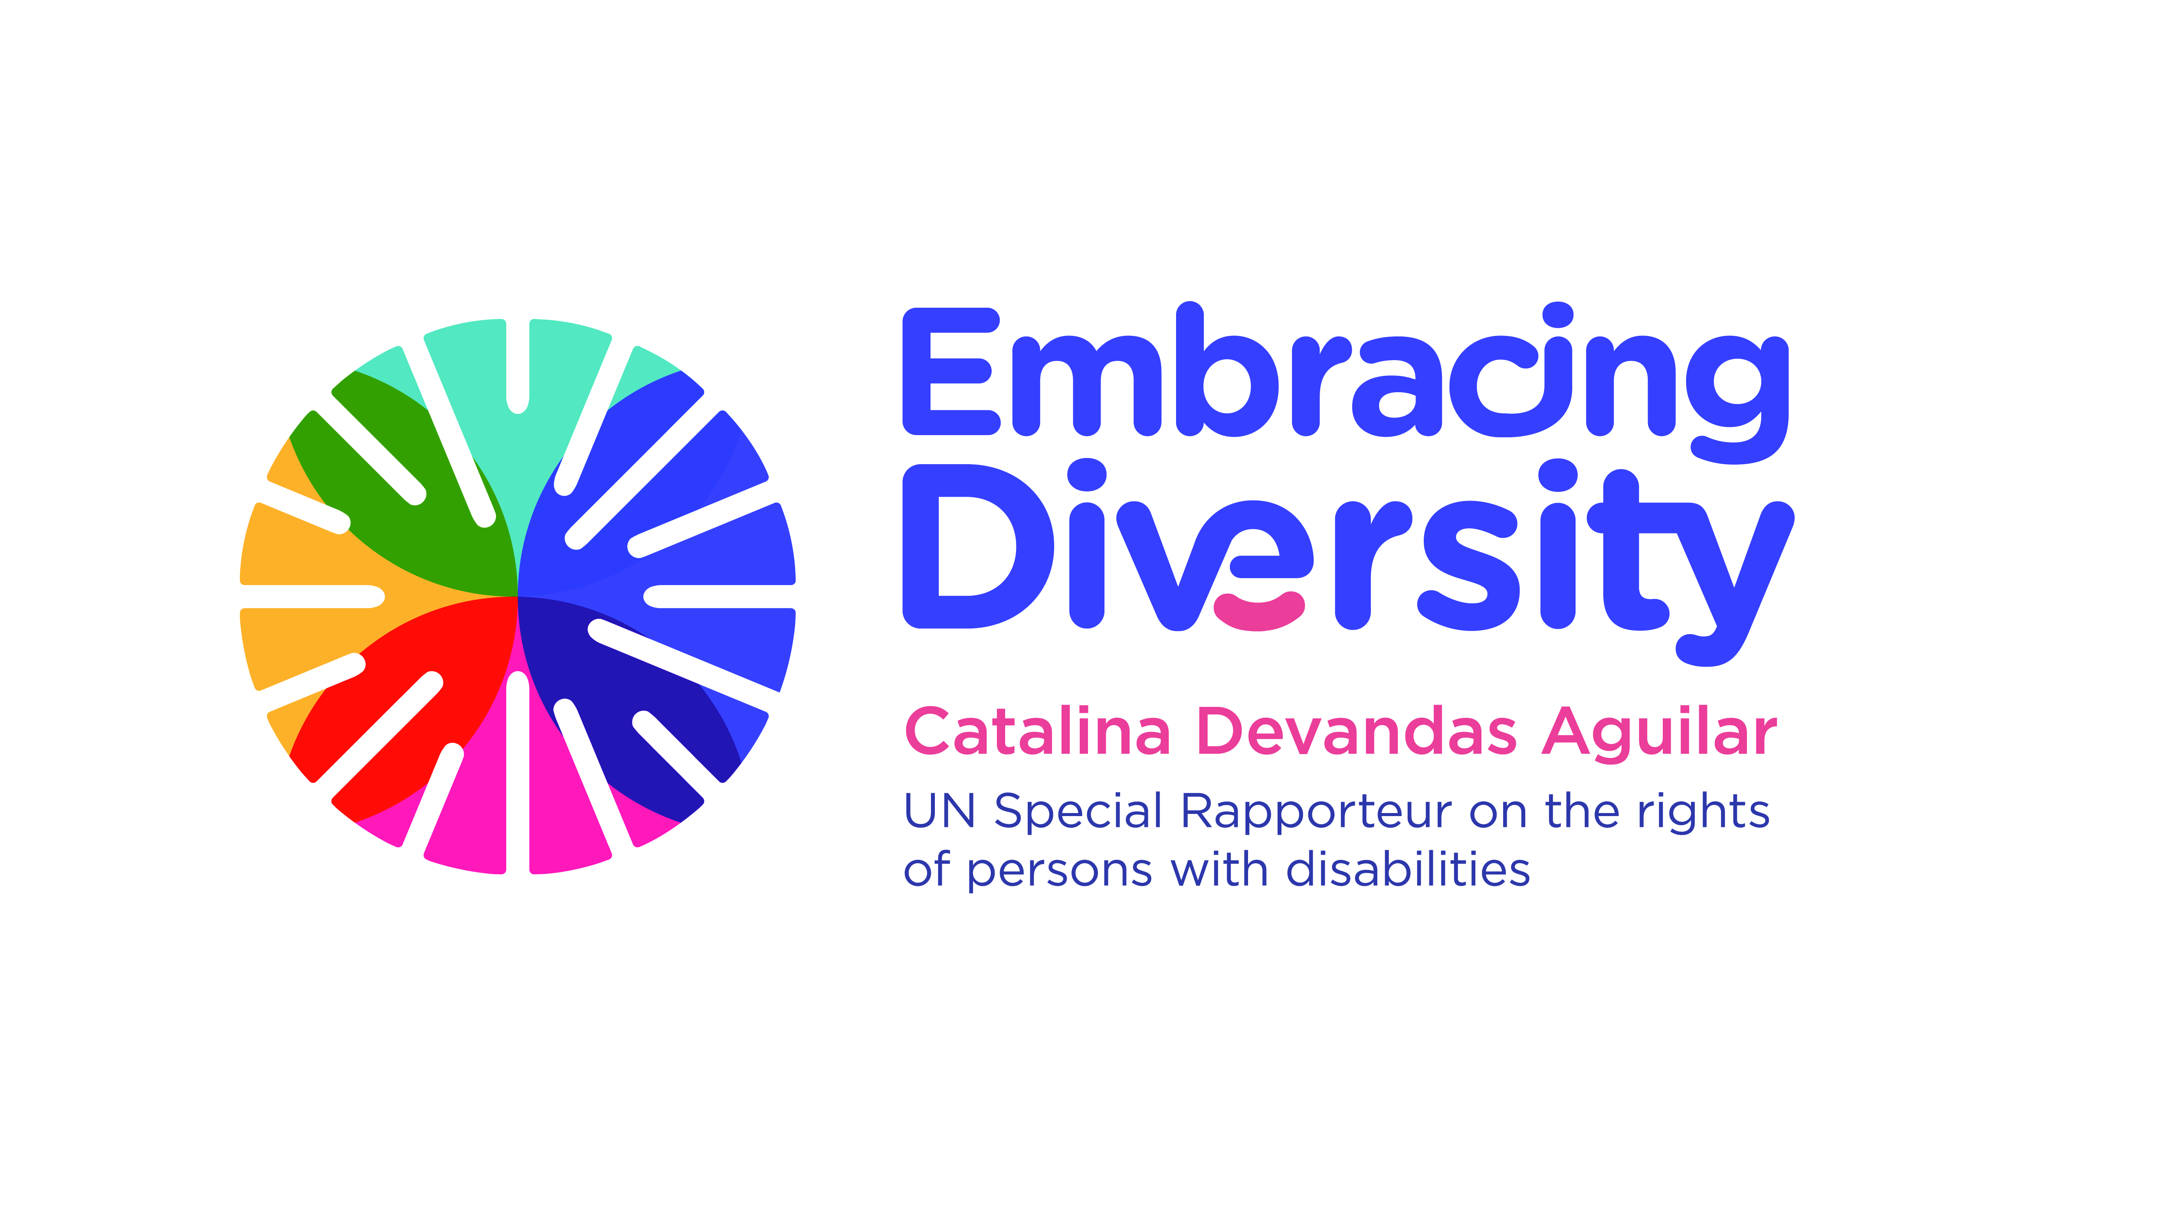

Expert Group Meeting on Bioethics and disability

16 and 17 September 2019
Room 1-016, 1st floor
Palais Wilson, OHCHR
Geneva, Switzerland

AGENDA

16 September 2019

Time | Session | Moderator/ Panelists
09.45-10.00 | Arrival of participants and registration
10.00-10.15 | Opening and welcome remarks  - Ms. Catalina Devandas Aguilar, Special Rapporteur on the Rights of Persons with Disabilities
10.15-10.30 | Introduction of participants and objectives of the meeting | Catalina Devandas
10.30-11.15 | Session 1: Presentation and discussion of background paper on bioethics and disability, written by Jackie Leach Scully and Tom Shakespeare | Tom Shakespeare  Jackie Leach Scully (through Skype)
11.15-11.30 | Break
11.30-13.00 | Session 2: Bioethics and disability  - Why is bioethics important for the life of persons with disabilities? Why is the disability perspective relevant for bioethics?  - What are the tensions between bioethics and disability rights?  - What are the main contributions of the CRPD to the discussion about bioethics and disability?  - How can we address the differences between the Global North and the Global South with regard to disability bioethics? | Moderator:  Alberto Vásquez  Panellists:  Laszlo Lovaszy  Alicia Ouellette
13.00 - 14.30 | Lunch break
14.30-16:00 | Session 3: Notions of normality and quality of life  - How to challenge the dominant assumption in bioethics that affectations to the “normal” functioning devalue human life?  - How to evaluate the quality of life of persons with disabilities in the discussion about bioethics and disability?  - How do persons with severe impairments evaluate the quality of their own lives?  - How to combat stereotypes, prejudices and harmful practices relating to persons with disabilities, in the context of bioethics? | Moderator:  Tom Shakespeare  Panellists:  Rosemarie Garland-Thomson  Henriette Raventos Vorst
16.00-16.15 | Break
16:15-17:45 | Session 4: Beginning of life: Prenatal diagnosis and disability-selective abortion  - How to address the main challenges, gaps and potential areas of tension related to prenatal testing and disability-selective abortion?  - How to promote the access of persons with disabilities to reproductive technologies on an equal basis to others?  - How to ensure the informed consent of persons with disabilities in the context of prenatal diagnosis and disability-selective abortion?  - How to promote the highest recognition of the rights of persons with disabilities in discussions related to prenatal diagnosis and disability-selective abortion? | Moderator:  Cristina Michels  Panellists:  Rupsa Malik  Anita Ghai  Paula Siverino Bavio

17 September 2019

Time | Session | Moderator
10.00-10.15 | Recap of the first day | Catalina Devandas
10.15-11.30 | Session 5: Controversial and/or irreversible treatments  - How to address the informed consent of persons with disabilities in the context of controversial and/or irreversible treatments?  - How to evaluate cases involving children with disabilities in the context of controversial and/or irreversible treatments?  - How to address the main challenges, gaps and potential areas of tension related to controversial and/or irreversible treatments of persons with disabilities?  - How to promote the highest recognition of the rights of persons with disabilities in discussions related to controversial and/or irreversible treatments? | Moderator: Victoria Lee  Panellists:  Tina Minkowitz  Teresa Blankmeyer
11.30-11.45 | Break
11.45-13.15 | Session 6: Euthanasia and assisted suicide  - How to address the main challenges, gaps and potential areas of tension related to euthanasia and assisted suicide of persons with disabilities?  - How has legislation allowing euthanasia and assisted suicide impacted on persons with disabilities?  - How to ensure palliative care available for everyone, including persons with disabilities?  - How to promote the highest recognition of the rights of persons with disabilities in discussions related to euthanasia and assisted suicide? | Moderator:  Facundo Chávez  Panellists:  Trudo Lemmens  Scott Kim
13.15-14.30 | Lunch break
14.30-16.00 | Session 7: Including ‘disability-rights perspective’ in bioethics agenda  - How are persons with disabilities included in decision-making and public debate related to bioethics?  - What should be the role of Ethical National Committees?  - Could you share good practices for the implementation of disability inclusive bioethical work?  - What collaborative strategies can we employ to promote the inclusion of disability rights perspective in bioethics agenda? | Moderator: Alicia Ouellette  Panellists:  Augustina Naami  Derrick Aarons
16.00-16.15 | Break
16.15-17.30 | Session 8: Recommendations | Moderator:  Alberto Vásquez
17:30- 17:45 | Closing remarks  - Ms. Catalina Devandas Aguilar, Special Rapporteur on the Rights of Persons with Disabilities

