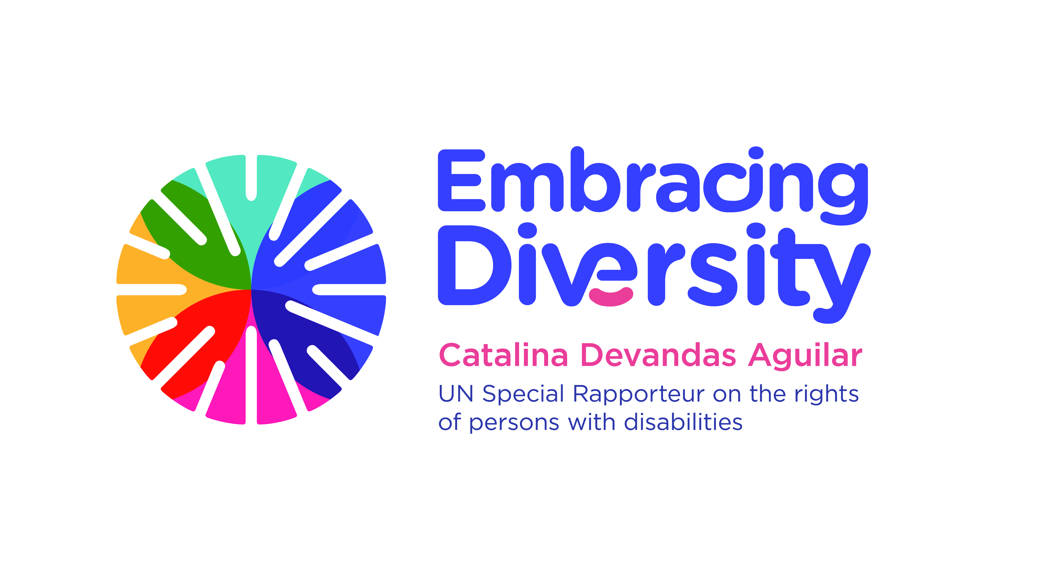

Expert Group Meeting on Bioethics and Disability

16 and 17 September 2019
1st floor Conference Room
OHCHR-Palais Wilson, Geneva, Switzerland

List of Participants

- Mr. Derrick Aarons, Bioethicist and physician, Member of the International Bioethics Committee, aaronsderrick27@gmail.com
- Ms. Teresa Blankmeyer Burke, Assistant Professor of Philosophy, Gallaudet University, teresa.burke@gallaudet.edu
- Ms. Lydia Brown, lydia@autistichoya.com
- Mr. Facundo Chávez Penillas, Human Rights and Disability Advisor, Office of the High Commissioner for Human Rights, fchavezpenillas@ohchr.org
- Ms. Catalina Devandas, Special Rapporteur on the rights of persons with disabilities, cdevandas@sr-disability.org
- Ms. Rosemarie Garland-Thomson, Professor of English and Bioethics, Emory University, rgarlan@emory.edu
- Ms. Anita Ghai, Professor in the School of Human Studies, Ambedkar University, anita.satypal@gmail.com
- Ms. Jackie Leach Scully, Professor of Bioethics, Director, Disability Innovation Institute, Faculty of Arts & Social Sciences, University of New South Wales (participation through Skype), jackie.scully@newcastle.ac.uk
- Ms. Lindsay Lee, World Health Organization, lindsayevanslee@gmail.com
- Ms. Victoria Lee, Human Rights Officer, Office of the High Commissioner for Human Rights, vlee@ohchr.org
- Mr. Lászlo Lovászy Gabor, Member of the CRPD Committee; Lecturer at the National University of Public Service, Faculty of Public Administration; Lecturer at University of Pécs, Faculty of Law, lovaszy.laszlo.gabor@uni-nke.hu
- Ms. Cristina Michels, Human Rights Officer, Office of the High Commissioner for Human Rights, cmichels@ohchr.org
- Mr. Trudo Lemmens, Professor and Scholl Chair in Health Law and Policy, University of Toronto, trudo.lemmens@utoronto.ca
- Ms. Augustina Naami, Lecturer at the Department of Social Work, University of Ghana, anaami@ug.edu.gh
- Ms. Rupsa Mallik, Director of Programs and Creation, CREA, rmallik@creaworld.org
- Ms. Tina Minkowitz, Esq., Center for the Human Rights of Users and Survivors of Psychiatry, tminkowitz@earthlink.net
- Ms. Alicia Ouellette, President and Dean, Albany Law School and Professor of Bioethics at Union Graduate College and the Mount Sinai School of Medicine, aouel@albanylaw.edu
- Ms. Henriette Raventos Vorst, Professor of genetics and at the School of Biology, Universidad de Costa Rica, henriette.raventos@ucr.ac.cr, hraventos@gmail.com
- Ms. Paula Siverino Bavio, Bioethicist and Member of the International Bioethics Committee, Buenos Aires, paulasiverino@gmail.com
- Mr. Tom Shakespeare, Professor of Disability Research, London School of Hygiene and Tropical Medicine, Tom.Shakespeare@lshtm.ac.uk
- Ms. Azin Tadjdini, Associate Human Rights Officer, Office of the High Commissioner for Human Rights, atadjdini@ohchr.org
- Mr. Alberto Vásquez Encalada, Research coordinator, Office of the Special Rapporteur, research@sr-disability.org

