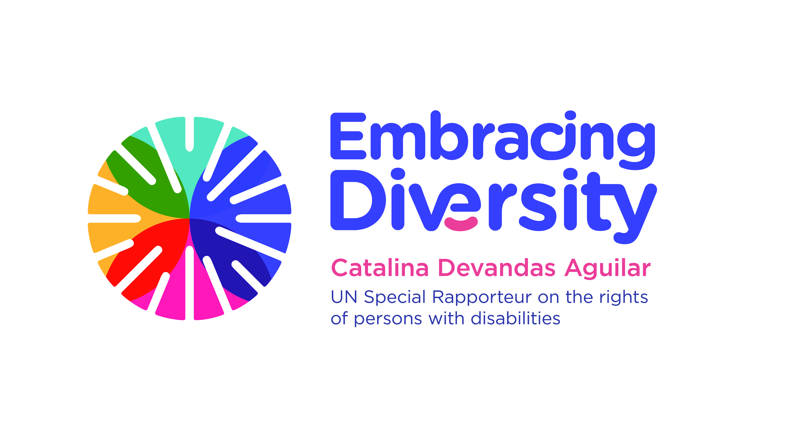

Expert Consultation on
Access to justice of persons with disabilities

21 February 2020
OHCHR-Motta, Room RI-14
Geneva, Switzerland

AGENDA

Time | Session
10.00-10.30 | Welcome, introduction of participants and objectives of the expert consultation  - Ms. Catalina Devandas Aguilar, Special Rapporteur on the rights of persons with disabilities
10.30-10.50 | Presentation of the report and the draft international principles and guidelines on access to justice for persons with disabilities  - Catríona Moloney, Centre for Disability Law and Policy of the NUI Galway
10.50-11.10 | Questions and answers
11.10-11.30 | Break
11.30-13.00 | Session 1: discussion on principles and related guidelines on:  - Right to equality before the courts and the right to a fair trial (right to be heard and to participate)  - Accessibility of physical infrastructure  - Right to information  - Legal representation and legal aid  - Right to non-discrimination
13.00-14.30 | Lunch
14.30-15.45 | Session 2: discussion on principles and related guidelines on  - Presumption of innocence  - Right to procedural, gender and age appropriate accommodations  - Right to participation in administration of justice  - Right to an effective remedy
15.45-16.00 | Break
16.00-17.15 | Session 3: discussion on principles and related guidelines on  - Investigation and complaints  - Monitoring mechanisms  - Redress and reparation  - Awareness raising and training programmes
17.15-17.45 | Moving forward: strategies and actions leading to the adoption of the principles and guidelines on access to justice of persons with disabilities
17.45-18.00 | Closing remarks  - Ms. Catalina Devandas Aguilar, Special Rapporteur on the rights of persons with disabilities

