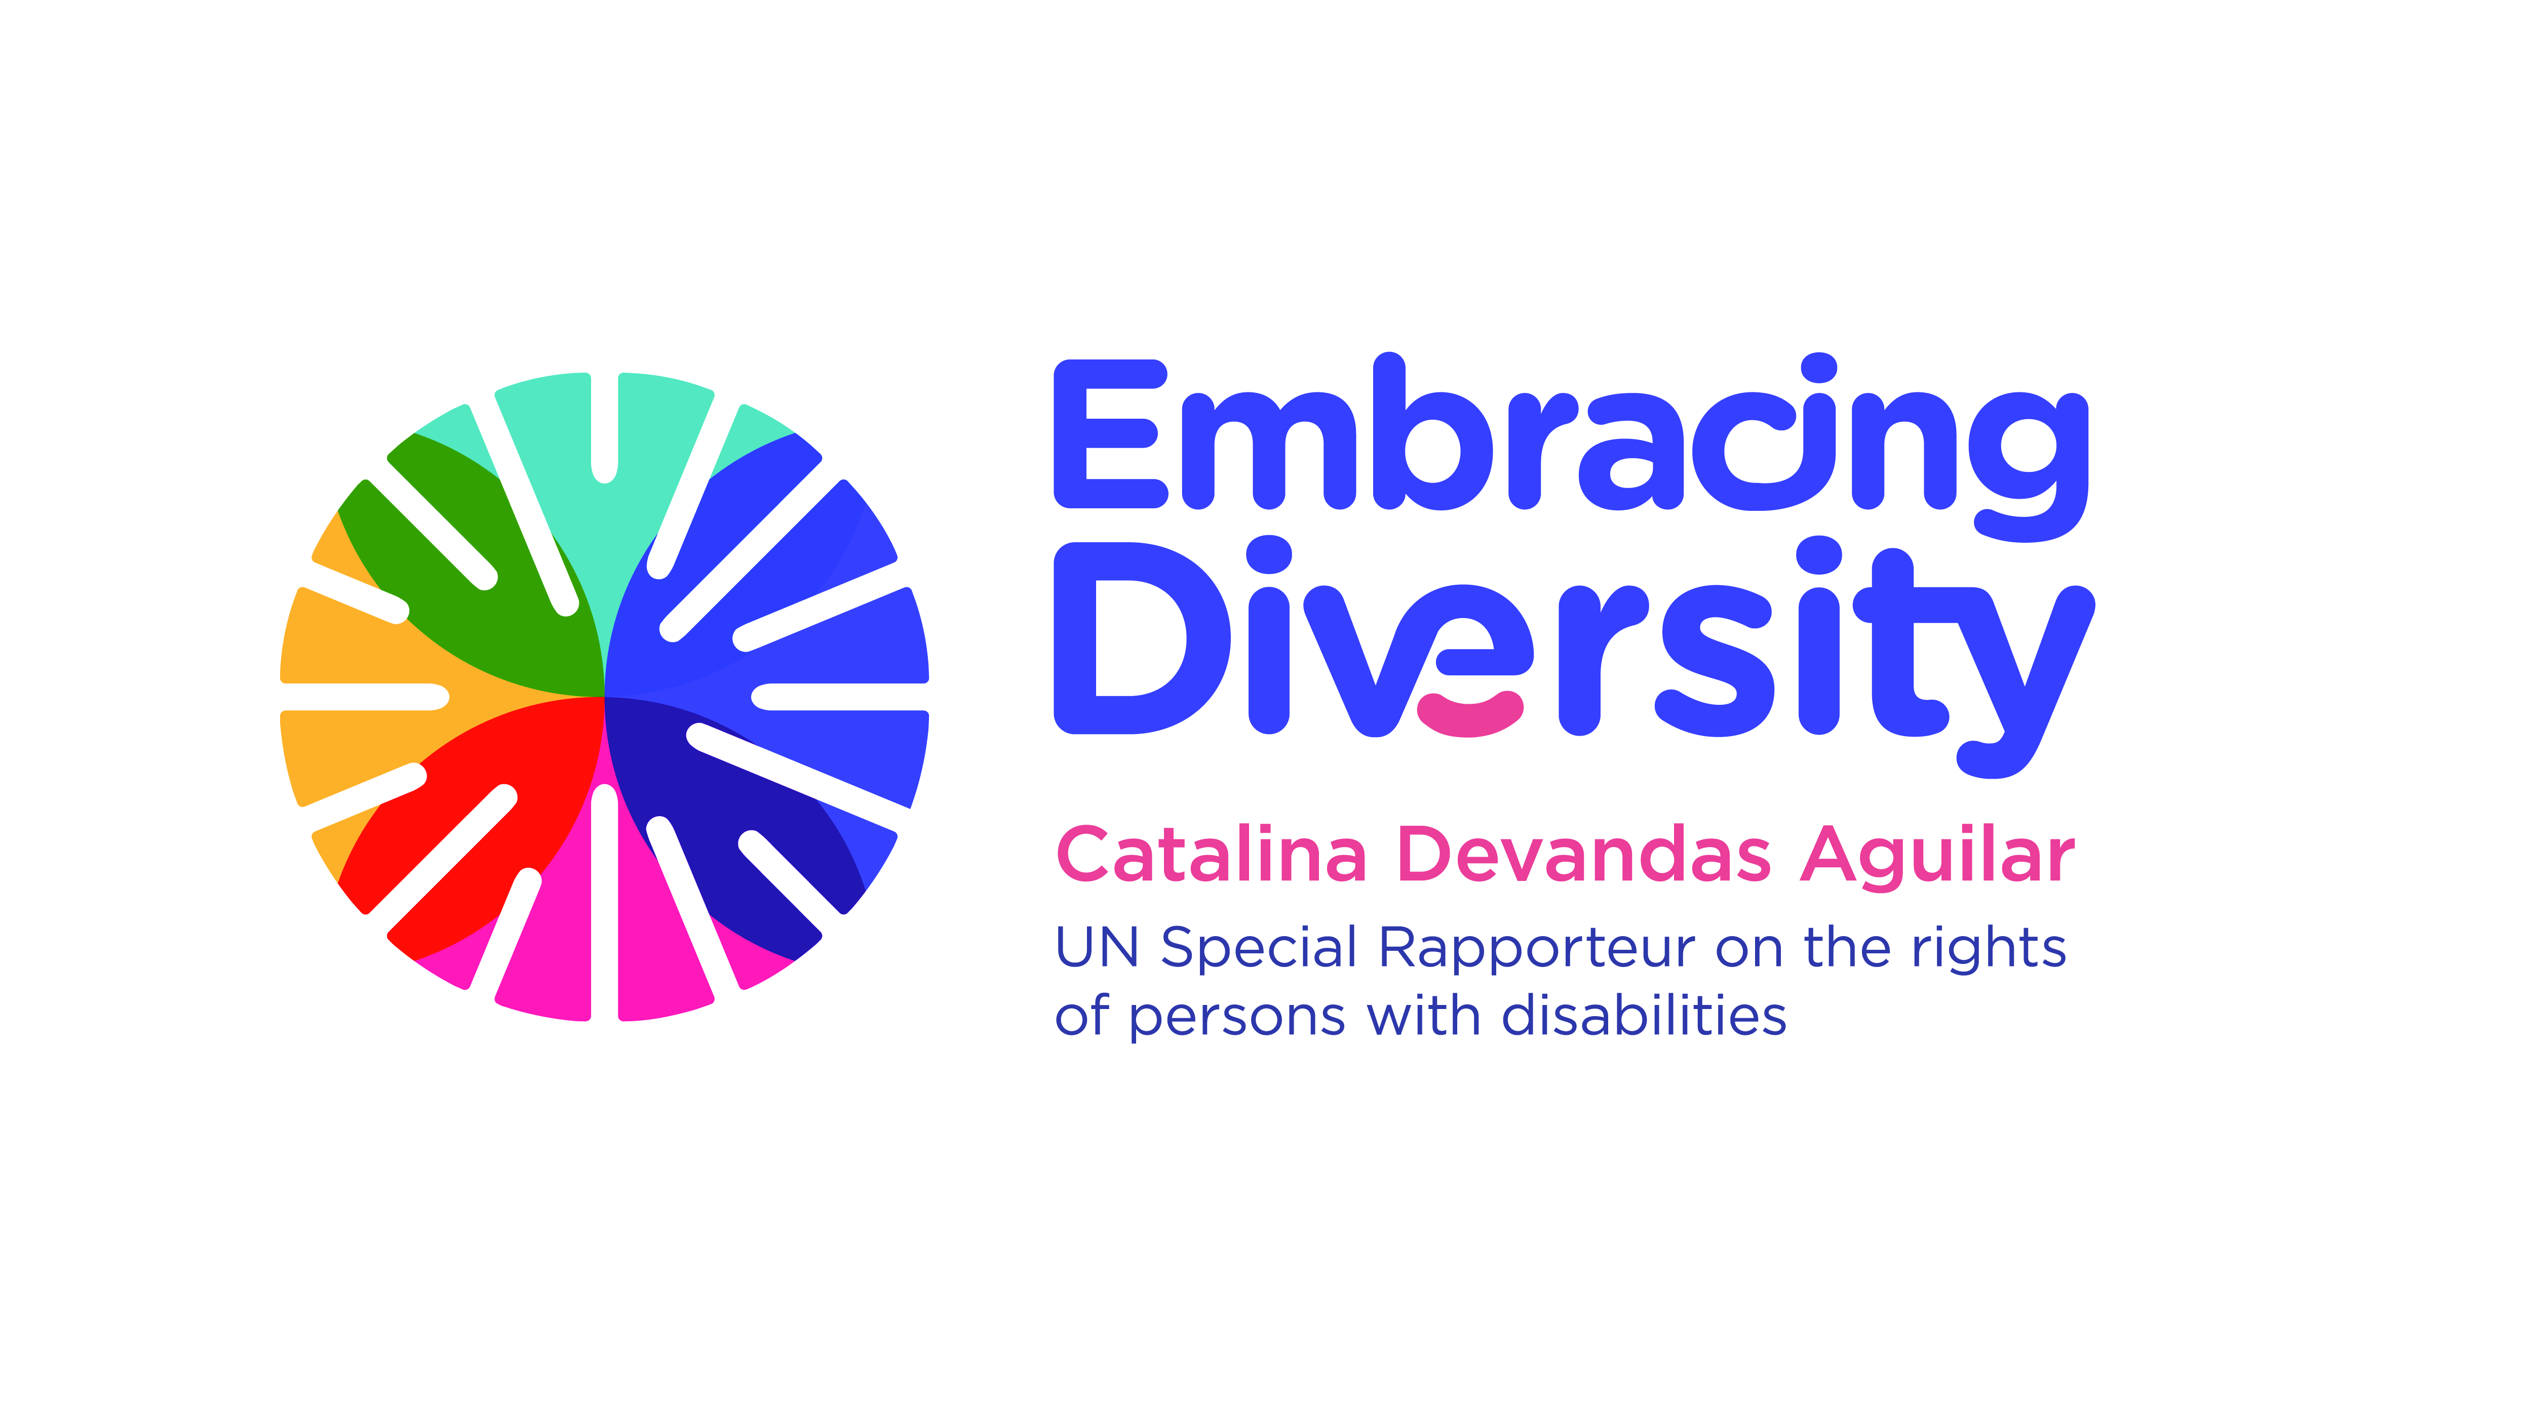

Expert Consultation on
Access to justice of persons with disabilities

21 February 2020
OHCHR- Motta, Room RI-14
Avenue G. Motta, Geneva, Switzerland

List of participants

- Ms. Catalina DEVANDAS AGUILAR, Special Rapporteur on the rights of persons with disabilities
- Ms. María del Carmen BARRANCO AVILES, Director, Instituto de Derechos Humanos Bartolomé de las Casas, Universidad Carlos III, Madrid
- Ms. Julinda BEQIRAJ, Senior Research Fellow, British Institute of International and Comparative Law
- Ms. Shatikha S. CHIVUSIA, Commissioner, Kenya National Commission on Human Rights
- Ms. Muriel DECOT, Secretary, European Commission for the efficiency of justice, Council of Europe
- Mr. Anselm ELDERGILL, Judge, Court of Protection, London, UK
- Mr. Francisco Javier FORCADA MIRANDA, General Council of the Judiciary of Spain
- Mr. Guillermo GARCÍA FERNÁNDEZ, Attaché, Permanent Mission of Spain
- Mr. Klaus LACHWITZ, Secretary General of the International Disability Alliance
- Ms. Victoria LEE, Programme Manager, OHCHR-Geneva
- Mr. Mikko JORONEN, Human Rights Centre of Finland
- Ms. Cristina MICHELS, Human Rights Officer, OHCHR Special Procedures (Disability mandate)
- Ms. Catriona MOLONEY, Lecturer in Disability Law, Centre for Disability Law and Policy, NUI Galway

- Ms. Dianah MSIPA, Consultant, Disability and Human Rights Law and Policy, South Africa

- Mr. Andrés PÉREZ, Human Rights Officer, OHCHR Rule of Law and Democracy Section
- Mr. Matt POLLARD, Senior Legal Adviser & UN Representative, International Commission of Jurists

- Mr. Markus SCHEFER, Member of the Committee on the Rights of Persons with Disabilities
- Ms. Sue SWENSON, President, Inclusion International, and Member, International Disability Alliance
- Ms. Azin TADJDINI, Associate Human Rights Officer, OHCHR Special Procedures (Disability mandate)
- Mr. Alberto VASQUEZ ENCALADA, Research Coordinator, Office of the Special Rapporteur
- Ms. Carla VILLARREAL LOPEZ, Office of the Special Rapporteur

