To the attention of:

Ms. Catalina Devandas Aguilar
Special Rapporteur on the rights of persons with disabilities
c/o Office of the High Commissioner for Human Rights
United Nations Office at Geneva
Ch-1211 – Geneva 10
Switzerland
Vienna, 12 May 2015
Ref: 2013-outgoing-000762

Subject: study of the Special Rapporteur on the rights of persons with disabilities on the right of persons with disabilities to social protection

Dear Ms. Devandas Aguilar,

I am pleased to provide you with the EU Agency for Fundamental Rights’ (FRA) contribution to the above-mentioned study.

2. Involvement of persons with disabilities in social protection programmes
In 2013 and 2014, FRA developed 28 human rights indicators on the right to political participation of persons with disabilities. One of these indicators focuses on the involvement of disabled persons organisations (DPOs) in the development of laws and policies which concern them. DPOs are consulted and involved in the development of laws and policies concerning persons with disabilities in the majority of EU Member States, either through mechanisms established by law (13 Member States) or through systematic procedures (11 Member States).
3. Difficulties and good practices on social protection programmes
- Conditions of accessibility and provision of reasonable accommodation
FRA is currently implementing a multi-annual project on the right to independent living from which the Special Rapporteur could draw evidence. Human rights indicators on the implementation of Article 19 of the CRPD, developed by FRA in cooperation with key stakeholders, will be available in summer 2015. These indicators cover issues including non-discrimination and reasonable accommodation, as well as availability and accessibility of support services. Indicators will also cover quality standards, budget allocation, complaints and redress mechanisms, awareness raising measures and training. FRA is currently collecting data to apply some of these indicators in the 28 EU Member States.
FRA’s report on the legal protection of persons with mental health problems under non-discrimination law looks at how the duty to provide reasonable accommodation in the field of employment is applied in the EU Member States (p. 25). Information in this report was later updated in March 2015 with FRA focus paper on the implementation of the CRPD providing an overview of legal reforms to date in EU Member States (p. 7). Some EU Member States have broadened the obligation to provide reasonable accommodation beyond employment. For instance, discrimination in access to goods and services is prohibited by law in Slovenia, whereas in Spain reasonable accommodation mechanisms encompasses areas including telecommunications and information society; transport; goods and services; relations with public administration; justice; and cultural inheritance.
FRA’s human rights indicators on the right to political participation of persons with disabilities cover the accessibility of buildings and information. Media providers in 16 EU Member States are under a statutory obligation to make their information and communications accessible to persons with disabilities. Similarly, data show that the majority of EU Member States (15) have mandatory accessibility standards for national and local authority buildings. However, no or little data is available on the proportion of public buildings that are accessible for persons with disabilities in the EU in practice.
- Specific needs of persons with disabilities and difficulties in accessing social protection programmes
In 2012, FRA published the report Choice and control: the right to independent living, which examines how persons with disabilities experience the principles of autonomy, inclusion and participation in their day-to-day lives. The report provides in-depth understanding of some of the barriers experienced by persons with disabilities and their families in accessing social protection programmes, including eligibility determination (p. 35 and p. 57). The findings highlight difficulties in providing social protection programmes linked to lack of resources (p. 31 and p. 52) or discriminatory attitudes (p. 25 and p. 46).
FRA’s indicators on Article 19 CRPD will also cover issues of access and transferability of support services, user control and eligibility for community support services.
- Consideration of age, gender and race or ethnic-based differences
In 2013, FRA published the report Inequalities and multiple discrimination in access to and quality of healthcare, which considers the intersections of different grounds of discrimination, including disability, age, gender, race or ethnicity. It highlights that language barriers and lack of information about healthcare services can hinder diagnosis and treatment, while stigma attached to certain types of impairment can discourage people with disabilities from seeking healthcare.
- Restrictions in exercising rights of people with disabilities
FRA’s report on legal capacity of persons with mental health problems and persons with intellectual disabilities analyses current standards and safeguards concerning legal capacity in each of the 28 EU Member States. Almost all EU Member States allow for restrictions of legal capacity (p. 29).
Issues related to legal capacity and guardianship are also covered in FRA’s Choice and control report (p. 57). Around half of the research respondents with intellectual disabilities had wholly or partially been deprived of their legal capacity and provided accounts of how their legal guardians exercised control over different aspects of their lives (p. 35).
- Allocation of grants to personal budget
In addition to FRA’s indicators on Article 19 CRPD which will be available in summer 2015, the Choice and control report addresses the issue of personal budgets for persons with intellectual disabilities and mental health problems (p. 32 and p. 53).
- Disability-sensitive training and awareness-raising
FRA’s indicators on Article 19 of the CRPD will cover training and retraining for civil servants and external partners, as well as awareness of support and services in the public and private sector.
- Complaint or appeal mechanisms
FRA’s report on Access to justice in cases of discrimination in the EU identified factors obstructive effective remedies, including the complexity of the complaints system and a lack of tailored legal advice.
The human rights indicators on political participation cover complaint mechanisms concerning the right to political participation of persons with disabilities (p. 57). FRA findings show that in nearly half of EU Member States information on how to complain is not accessible to persons with disabilities.
Additionally, the Choice and control report indicates that many persons with disabilities refrain from lodging complaints due to fear of retribution and that the complaint would not be taken seriously (p. 40 and p. 63).
FRA’s project on the implementation of Article 19 in the EU will include indicators on mechanisms and remedies that persons with disabilities can use to challenge barriers to exercising the right to live independently.
5. Eligibility criteria to access social protection programmes
FRA’s report on the legal protection of persons with mental health problems under non-discrimination law shows that the majority of EU Member States define disability in terms of an impairment or limitation which can be physical or intellectual/mental, and which is long-lasting and so severe as to restrict the full participation of the individual in daily life or in employment (p.24). However, there is still a lack of clarity in national legislation on whether the definition of disability includes persons with mental health problems.
Information on eligibility determination, including income thresholds, will be available through the forthcoming indicators on Article 19 of the CRPD.
I enclose a list of FRA publications on the rights of persons with disabilities for your information. Should you need any further information, please consult the thematic page on our website and do not hesitate to contact me.

Yours sincerely,

Martha Stickings
Equality & Citizens’ Rights Department
European Union Agency for Fundamental Rights (FRA)

cc: Jan Jařab, Regional Representative for Europe, Office of the United Nations High Commissioner for Human Rights
Facundo Chávez Penillas, Human Rights & Disability Advisor, Office of the United Nations High Commissioner for Human Rights

Annex of FRA publications on the rights of persons with disabilities

FRA publications |  | Short description | Languages  (available  in 2015)
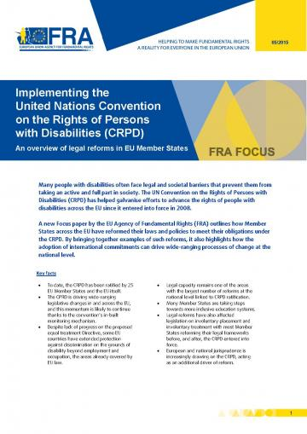 | Implementing the UN CRPD: An overview of legal reforms in EU Member States  May 2015 | The UN Convention on the Rights of Persons with Disabilities (CRPD) has helped galvanise efforts to advance the rights of people with disabilities across the EU since it entered into force in 2008. The focus paper outlines how Member States across the EU have reformed their laws and policies to meet their obligations under the CRPD. | en
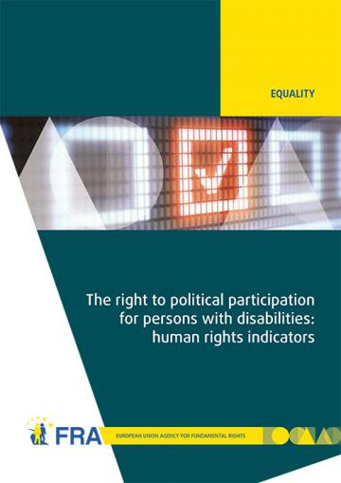 | The right to political participation for persons with disabilities: human rights indicators  May 2014 | The opportunity to be involved in political life, whether by standing for elected office, joining a political party, or following political news stories in the media, is at the heart of what it means to live in a democratic society. The report analyses data on the situation of political participation of persons with disabilities collected from across the 28 EU Member States by the FRA and the European Commission-funded Academic Network of European Disability Experts (ANED).  Data visualisation of the 28 human rights indicators on the right to political participation of persons with disabilities is also available online. | en
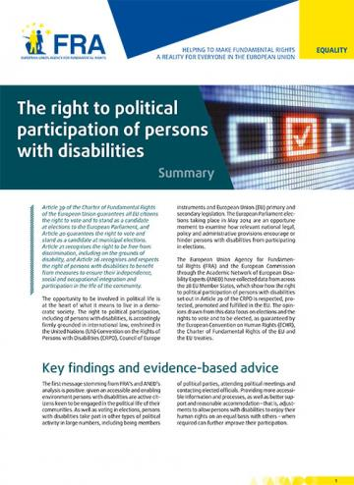 | Summary report:  The right to political participation of persons with disabilities  May 2014 | The human rights indicators presented in the report show that legal and administrative barriers, inaccessible processes and information, and a lack of awareness about political rights can deny persons with disabilities the opportunity to participate in the political lives of their communities. | en  (bg - cs - da - de - et - el - es - fr - hr- it - lv - lt - hu - nl - pl - pt - ro - sk - sl - fi - sv)
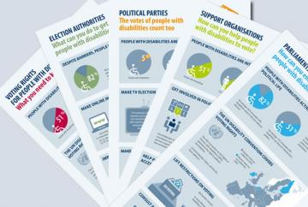 | Infographics on voting rights of people with disabilities  September 2014 | FRA has developed a family of five infographics to help raise awareness of the voting rights of people with disabilities. Each infographic targets a different audience and draws on FRA evidence on the right to political participation of people with disabilities. | en  (bg - cs - da - de - et - el - es - fr - hr- it - lv - lt - hu - nl - pl - pt - ro - sk - sl - fi - sv)
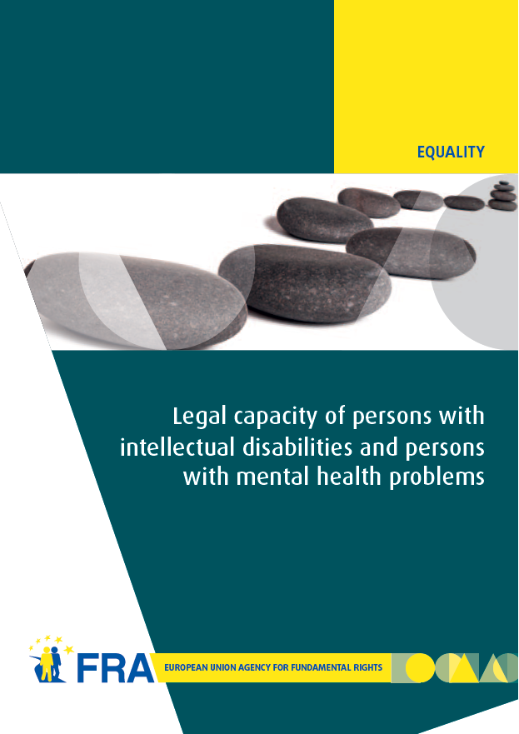 | Legal capacity of persons with intellectual disabilities and persons with mental health problems  July 2013 | Equal recognition of persons before the law is a long-established human rights principle. Nevertheless, legal frameworks in many European Union (EU) Member States allow for the legal capacity of persons with intellectual disabilities and persons with mental health problems to be restricted or removed under certain conditions.  This report analyses existing legal standards on legal capacity across the EU, set against the backdrop of the experiences of interviewees who have had their legal capacity removed or restricted. The FRA report reveals the gap between the promise of the CRPD and the reality those with disabilities face in the EU every day, and, by so doing, hopes to contribute to closing it. | en – fr – de
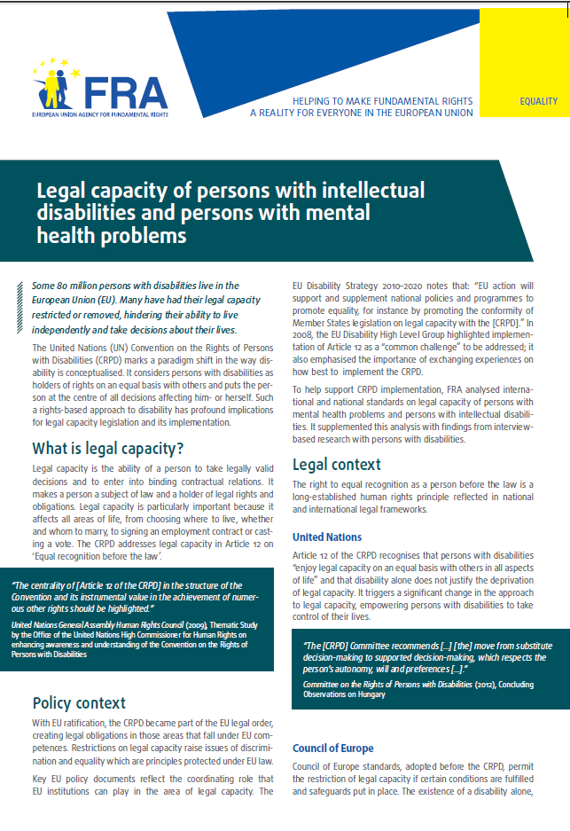 | Factsheet:  Legal capacity of persons with intellectual disabilities and persons with mental health problems  October 2013 | This factsheet presents the key challenges identified by the FRA report on Legal capacity of persons with intellectual disabilities and persons with mental health problems.  The entry into force of the CRPD has prompted discussions about existing legal frameworks governing legal capacity in the EU Member States, aiming at developing models based on supported decision making that promote the independence and autonomy of persons with disabilities. | bg - cs - da - de - en - et - el - es - fr - hr- it - lv - lt - hu - nl - pl - pt - ro - sk - sl - fi - sv
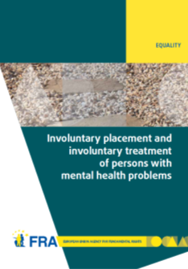 | Involuntary placement and involuntary treatment of persons with mental health problems  June 2012 | Involuntary placement and involuntary treatment of persons with mental health problems affects the most fundamental of rights, including the right to liberty and the right to freedom from torture. Strict safeguards at United Nations and European level attempt to limit undue interference with such rights.  This report analyses the shifting legal panorama and, informed by fieldwork in nine EU Member States on the actual experiences of those involuntarily placed and treated and other stakeholders, points to the need for a renewed discussion of compulsory placement and treatment in the EU. | en - fr - de
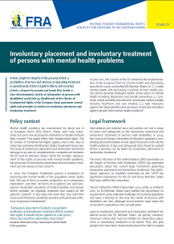 | Factsheet:  Involuntary placement and involuntary treatment of persons with mental health problems  June 2012 | This factsheet presents the key challenges identified by the FRA report on Involuntary placement and involuntary treatment of persons with mental health problems. Mental health problems are experienced by about one in 10 European Union (EU) citizens. Many seek help voluntarily, but some may be placed in institutions or treated without their consent. This might affect their fundamental rights. | en - bg - da - de - el - fr - hu - lv - ro - sv
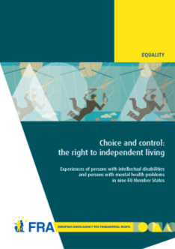 | Choice and control: the right to independent living  June 2012 | Article 19 of the United Nations Convention on the Rights of Persons with Disabilities establishes the right to live independently and be included in the community. Drawing on the findings of interview-based research with persons with mental health problems and persons with intellectual disabilities, this report examines how they experience the principles of autonomy, inclusion and participation in their day-to-day lives. | en  (fr - de)
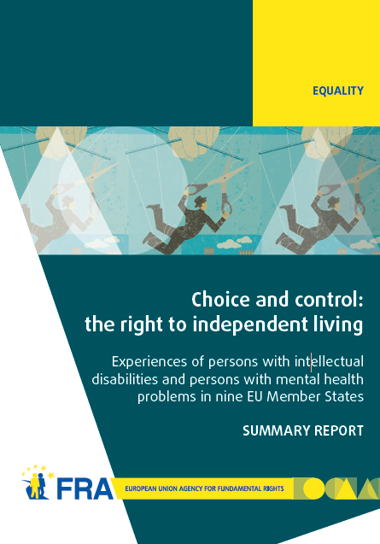 | Summary report: Choice and control: the right to independent living  June 2012 | This summary report presents the key findings identified in the FRA report on Choice and control: the right to independent living. The results show that although much has been done, more efforts are needed to ensure that persons with mental health problems and persons with intellectual disabilities have more choice and control over their lives and are included in the community on an equal basis with others. | en – da – el
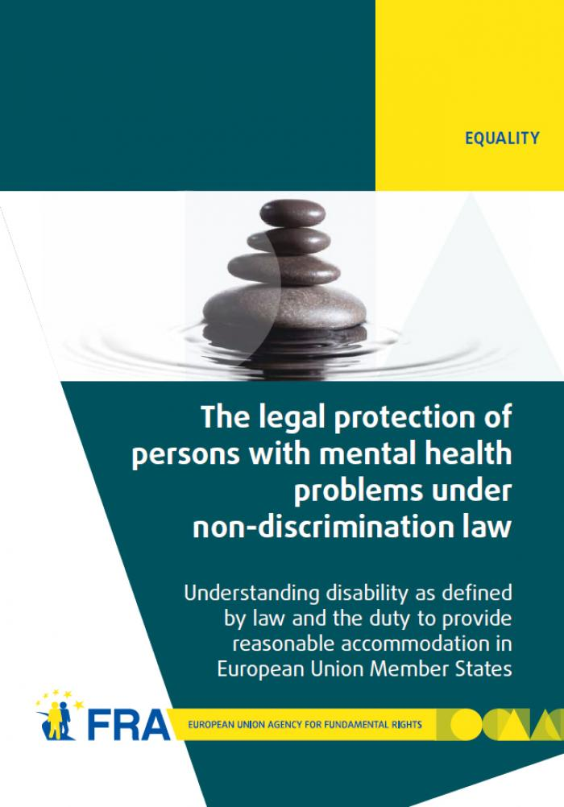 | The legal protection of persons with mental health problems under non-discrimination law  October 2011 | The report examines how disability is defined in international and European law and then explores the obligation to provide reasonable accommodation as contained in international and European standards. The report's findings show that in almost all EU Member States non-discrimination legislation does indeed protect persons with mental health problems. In most cases persons with mental health problems also benefit from reasonable accommodation measures, or other protection measures, in the employment context. | en - de - fr - da
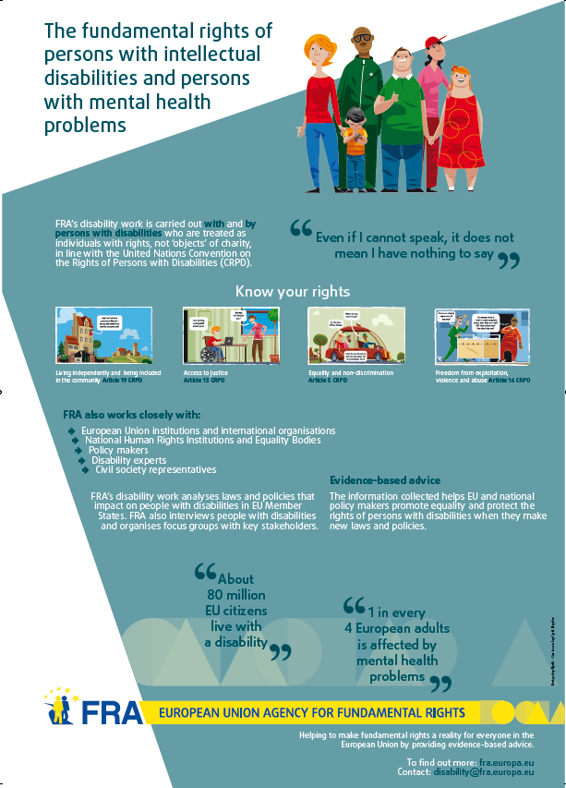 | FRA work on disability: postcards  September 2011 | Under the CRPD, people with disabilities are no longer considered unable to play an active role in society. Instead of viewing people with disabilities as the problem, the barriers they face are clearly recognised as the source of the problem. FRA calls this approach the enabling model of disability. This postcard illustrates the two opposing views with easily understandable examples. | en  bg - cs - da - de - et - el - es - fr - it - lv - lt - hu - nl - pl - pt - ro - sk - fi - sv
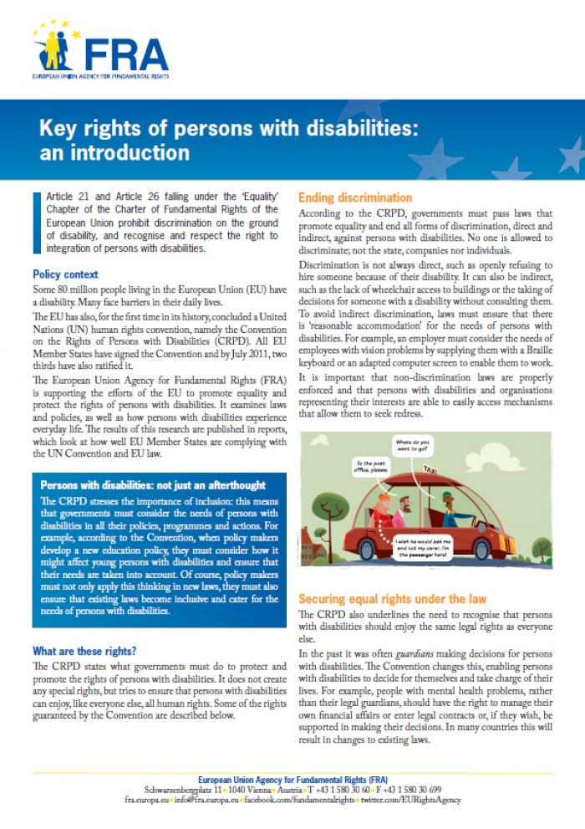 | Factsheet:  Key rights of persons with disabilities: an introduction  August 2011 | This factsheet describes some of the existing rights of people with disabilities, as set out under the UN Convention on the Rights of Persons with Disabilities (CRPD). The factsheet focuses in particular on ending discrimination, equal recognition by law, access to justice, the prevention of inhumane treatment, independent living and the right to political participation. | en - bg - de - el - fr - hu - lv - ro - sv
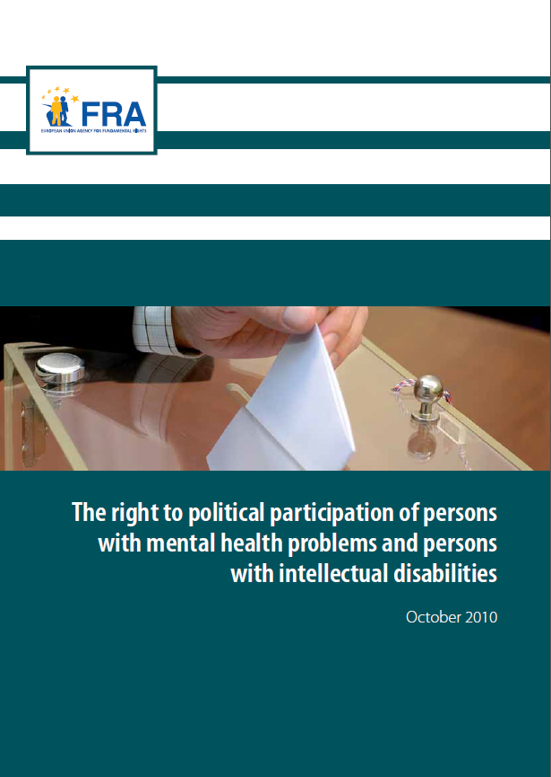 | The right to political participation of persons with mental health problems and persons with intellectual disabilities  November 2010 | This report provides the first results from a legal study carried out by the European Union Agency for Fundamental Rights in the context of its project on the "Fundamental rights of persons with intellectual disabilities and persons with mental health problems". The report first recalls the international and European standards favouring the full participation of persons with intellectual disabilities and persons with mental health problems in the electoral process. The comparative law analysis then highlights the diverse approaches adopted in the EU Member States. In a majority of these, persons who have lost their legal capacity are automatically deprived of their right to political participation. | en  de - fr  non-verified language versions:  bg - cs - da - et - el - es - ga - hr- it - lv - lt - hu - mt - nl - pl - pt - ro - sk - sl - fi - sv
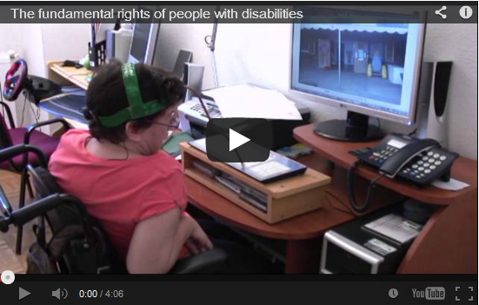 | VIDEO  Fundamental rights of persons with disabilities  June 2012 | This video looks at the topic of the fundamental rights of people with disabilities.  It also examines their right to choice and control over their daily life, on which subject the FRA published a report in June 2012. | en  (audio and subtitles)
 | EASY READ  Laws about being able to make important decisions for yourself  October 2013 | This summary in easy read format provides information about FRA’s work on the right to equal recognition before the law. | en  (de - fr)
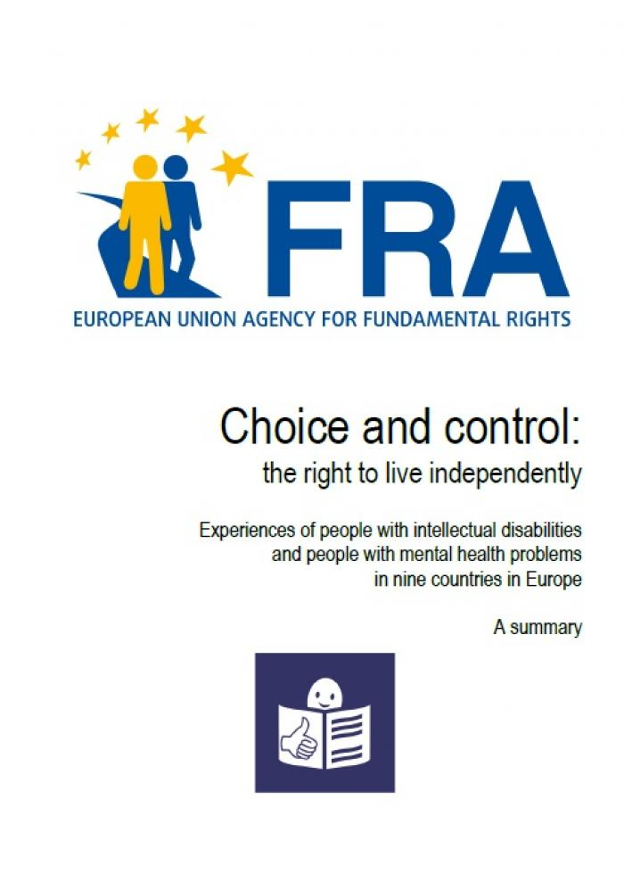 | EASY READ  Choice and control: the right to live independently - Experiences of people with intellectual disabilities  June 2012 | This summary in easy read format provides information about FRA’s work on the right to live independently. | en
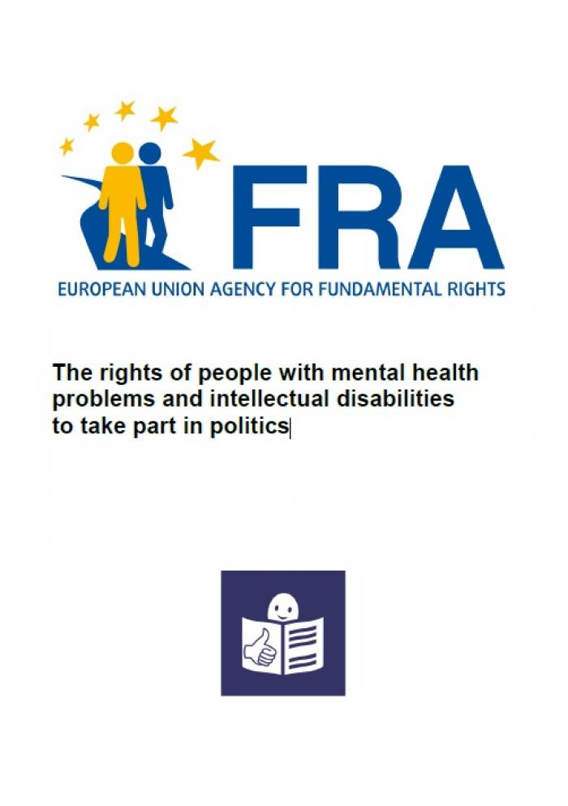 | EASY READ  The rights of people with mental health problems and intellectual disabilities to take part in politics  November 2010 | This summary in easy read format provides information about FRA’s work on the right to vote of persons with intellectual disabilities. | en
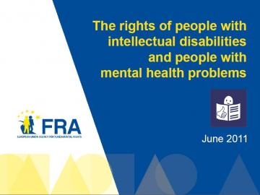 | EASY READ  The rights of people with intellectual disabilities and people with mental health problems  November 2010 | This presentation in easy read provides information about the FRA and the project on fundamental rights of persons with intellectual disabilities and persons with mental health problems. | en

