
OFFICE OF THE HIGH COMMISSIONER FOR HUMAN RIGHTS
Response to the call for input on human rights challenges experienced by countries in responding to the COVID-19 pandemic

March 2021, Geneva, Switzerland
Submission by:

ADF International
Rue du Pré-de-la-Bichette 1
1202 Geneva, Switzerland

Web: www.ADFinternational.org
Email: UN@ADFinternational.org

ECOSOC Special Consultative Status (2010)

Introduction
- ADF International is a faith-based legal advocacy organization that protects fundamental freedoms and promotes the inherent dignity of all people before national and international institutions.
- In response to the Office of the High Commissioner for Human Rights’ call for inputs on human rights challenges experienced by countries in responding to the COVID-19 pandemic, this report addresses the impact of public health measures on the enjoyment of the right to freedom of religion or belief, as well as trends of religious discrimination in their development and implementation. By identifying examples of good practice in the area of cooperation, this written submission also advocates for stronger inclusion of faith-based actors in the decision-making concerning the health response to COVID-19 at both the local and national levels.
- While the issue of increasing levels of religious hatred, intolerance and discrimination following the COVID-19 outbreak has received some attention in the UN context, the challenges faced by states in guaranteeing non-discrimination against people of faith as part of their public health responses to the ongoing pandemic have largely been overlooked. In this regard, ADF International wishes to draw attention to a number of worrying trends.
- The impact of public health measures on freedom of religion or belief
- A widespread challenge faced by states during the ongoing public health crisis has been to guarantee the proportionality of lockdown measures interfering with the exercise of the human right to freedom of religion or belief.
- On 1 November 2020, the Council of State of Geneva imposed a de facto ban on public worship in the Swiss canton of Geneva as part of a package of emergency regulations adopted amidst a surge in COVID-19 cases. The prohibition of all religious gatherings – with the exception of small funerals and weddings – has been the subject of a legal challenge before the Constitutional Chamber of the Geneva Court of Justice. On 3 December 2020, the judicial body granted interim measures suspending the effect of the ban. The court recognized the measure as posing “a serious problem of proportionality”, stressing that less incisive measures – such as those concerning other public gatherings – would be able to achieve the intended purpose without causing such a considerable interference with fundamental rights. The Constitutional Chamber of the Geneva Court of Justice is expected to hand down its final judgment on the ban by April 2021.
- On 6 January 2021, the Scottish Government introduced regulations requiring a person responsible for a place of worship to close the place of worship, except for certain limited purposes. Those purposes did not include regular congregational worship. The effect of the regulations is that no-one in Scotland may lawfully leave home to attend a place of worship for the purpose of regular congregational worship. On 11 and 12 March, these regulations were challenged by 28 Church leaders before Scotland’s Supreme Civil Court. They argued, firstly, that the regulations contravene the historic freedom of churches under the Scottish constitutional settlement and, secondly, that the regulations have a disproportionate impact upon freedom of worship guaranteed under relevant human rights law. The challenge focused on the evidential basis for the blanket ban on worship and noted, in particular, the scarcity of evidence provided by the government to suggest that the virus was spread due to places of worship remaining open. A judgment is still pending at the time of writing.
- Moreover, the deliberate targeting of minority faith communities under the guise of “genuine” health measures reveals a disturbing trend of human rights violations related to states’ responses to the COVID-19 pandemic. In these cases, the health crisis has been used by government authorities as a justification to adopt measures aimed at harassing, discriminating, or even suppressing religious minority groups that are perceived as a threat or hostile to the state.
- In China, dozens of church crosses were forcibly removed during the coronavirus lockdown. In the northeastern Heilongjiang province, a government employee has claimed that the symbols were “too eye-catching” and would lead people to violate social distancing rules. Reports also indicate that government officials in the Henan province told believers that, “it is the Communist Party that gives you food and money, not God” to justify their order to remove the cross from the Ranfang Church in Gushi county.
- Worryingly, restrictions to the exercise of the right to freedom of religion on grounds of public health have been extended beyond the mere banning of in-person religious gatherings. In January 2021, the United Front Work Department of the Shandong Provincial Party Committee issued a notice prohibiting live broadcasts and the online distribution of Christian video or audio materials. In Algeria – where a trend of unjustified church closures exists since before the pandemic –, while mosques were reopened in February to reopen in accordance with reasonable regulations, Christian places of worship were denied the same treatment.
(b) Religious discrimination and violence in relation to the COVID-19 health response
- The climate of growing hostility towards religious minorities has had an adverse impact on the implementation of the health measures adopted by many governments across the world. In particular, persons belonging to religious minorities have been particularly vulnerable to discrimination, marginalization and exclusion in terms of access to food and medical aid as part of the COVID health response.
- In some instances, aid has been effectively denied to people belonging to religious minorities. In India, an estimated 115,000 Christians were reportedly prevented from receiving government aid in 2020 due to their religious affiliation. In Nigeria’s Kaduna State, Christians have claimed to have received six times smaller rations from the local government than their neighboring Muslim families.
- In other cases, the impact of discrimination on aid distribution has been less direct. Where lockdown measures have disrupted the operations of local faith-based networks and charities, those who are most vulnerable such as widows, orphans, victims of violence and internally displaced persons, have been left isolated and without proper access to basic needs, such as food, water and healthcare. With gatherings restricted, many church leaders who rely heavily on offerings collected during regular worship services now find themselves unable to provide for their families, as they are simultaneously prevented from working while also not being eligible for economic and other relief from the government due to their religious affiliation.
- A related trend involves the exacerbation of pre-existing patterns of religious persecution as a result of the measures adopted in response to the pandemic, and the failure of state authorities to tailor their responses to the aggravated challenges faced by members of religious minority communities.
- In the most extreme cases, this exacerbation is an indirect result of restrictions to freedom of movement adopted by governments in response to the spread of COVID-19. Extremist groups have taken advantage of the situation to engage in attacks against religious minorities at an even larger scale than pre-pandemic. In Nigeria, the number of Christians killed in 2020 rose to 3530, almost three times higher than the previous year. The majority of attacks took place during the lockdown months, when the victims were effectively trapped indoors while militants roamed freely.
- On another note, entrenched attitudes of societal intolerance also have led to the scapegoating of religious minorities during the pandemic, with little to no action taken to challenge hateful rhetoric and misinformation, as well as to identify and hold those responsible to account. In India, the already stigmatized Muslim minority has become the victim of a nationwide scapegoating campaign, with even high-ranking government officials publicly blaming Muslim seminars and gatherings for the spread of the virus. In Pakistan, Shiite and Ahmadi Muslims, Hindus and Christians have likewise been blamed as outsiders for the spread of COVID-19, and denied rations, refused hospital treatment, and exposed to increased violence, discrimination and social exclusion.
(c) Good practices for preventing religious discrimination in the context of the COVID-19 health response
- In response to the human rights challenges confronting members of religious minorities as a result of the public health responses to the COVID-19 pandemic, ADF International has identified a number of good practices in the area of cooperation with faith actors – including religious leaders and humanitarian aid organizations – at local, national and international levels.
- As states develop or update their pandemic response and post-recovery plans, the engagement of local religious leaders is a simple but effective tool to not only develop solutions to protect faith‑based communities from the direct and indirect human rights impacts of COVID-19, but also to address the vulnerability factors that lie at the root of the specific challenges they face. For example, in September 2020, South African President Cyril Ramaphosa hosted an online consultation with interfaith leaders aimed at discussing the implementation of health measures and hearing their concerns and proposals in this regard.
- Rather than curbing religious freedom, setting up partnerships with faith community leaders and grassroots organizations has proved to be vital for disseminating trusted health information in the COVID-19 response and effectively promoting life-saving and other helpful practices. This helps to combat the stigma of religious discrimination and exclusion at the same time. The government of Bangladesh, with support from UNICEF, has partnered with local imams to provide critical information on the virus and preventive measures. This initiative has been especially effective in rural areas and refugee camps, where access to communication technologies and health facilities is often limited. With the support of Afghanistan’s Ministry of Haji and Religious Affairs and the World Health Organization, World Vision trained 60 religious leaders on COVID-19 risk education, prevention and risk communication, equipping them to conduct awareness campaigns in camps for internally displaced persons across the country.
(d) Conclusion
- This report has highlighted a number of problematic trends of human rights violations in the context of states’ health responses to the COVID-19 pandemic. Not only has the ongoing crisis taken a disproportionate toll on persons and groups who are marginalized and suffer discrimination based on their religion, but also regrettably, measures designed to mitigate both the spread of the virus and its economic and social impact have often had the effect of restricting the enjoyment of freedom of religion beyond the permissible limitations laid down in international law. Furthermore, they fail to cater to the aggravated vulnerability of people belonging to religious minorities to human rights violations.
- As the international community continues the ongoing fight against the coronavirus crisis, ADF International wishes to stress that emergency measures shall in no case be used to disproportionately restrict the exercise of the human right to freedom of religion, nor to target religious minorities – neither in their purpose nor in their effects. The need to protect the rights and safety of people of faith – especially those living in vulnerable situations – must be fully taken into account in the development of health responses to control COVID-19. In this regard, the good practices identified above clearly show that active engagement of, and partnerships with, faith actors have the potential to both ensure a more effective implementation of COVID-19-related public health measures, and increase the protection of religious minorities against human rights violations in the context of the ongoing pandemic.
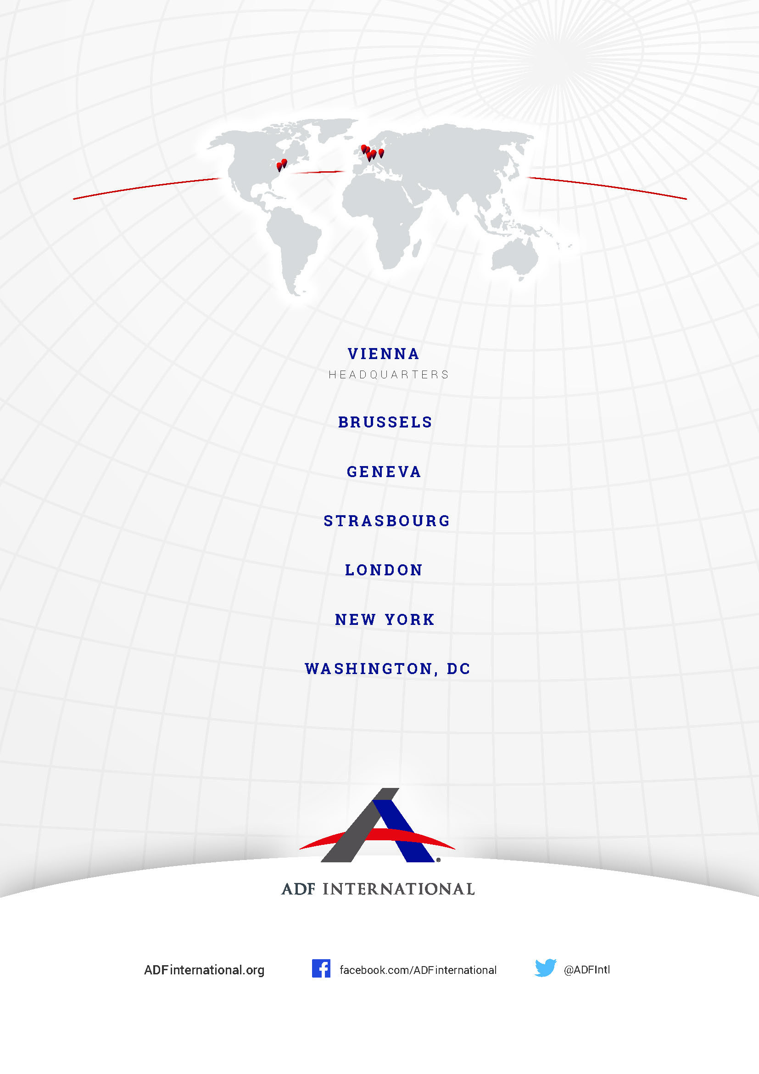

OHCHR ‘UN expert warns against religious hatred and intolerance during COVID-19 outbreak’ (22 April 2020) <https://www.ohchr.org/en/NewsEvents/Pages/DisplayNews.aspx?NewsID=25814&LangID=E>; UN News ‘Defeat COVID-19 and put an end to hate and discrimination: UN chief’ (22 August 2020) <https://news.un.org/en/story/2020/08/1070802>.
Constitutional Chamber of the Geneva Court of Justice, Brunisholz et al. v Conseil d'Etat, No. ACST/40/2020, 3 December 2020, 6(a).
Petition of Reverend Dr. William J. U. Philip and others for the Judicial Review of the closure of places of worship in Scotland (28 January 2021), available at https://christianconcern.com/wp-content/uploads/2018/10/CC-Resource-Misc-Church-Lockdown-Scotland-Petition-210128.pdf; see also M. Williams ‘Glasgow priest Canon Tom White takes legal action against ministers to stop UK divide on lockdown right to worship’ The Herald (17 February 2021) <https://www.heraldscotland.com/news/19096949.glasgow-priestcanon-tom-white-takes-legal-action-ministers-stop-uk-divide-lockdown-right-worship>.
L. M. Klett, ‘China: Crosses 'higher than the national flag' removed from churches amid COVID-19’ (13 April 2020) Christian Post <https://www.christianpost.com/news/china-crosses-higher-than-the-national-flag-removed-from-churches-amid-covid-19.html>.
China Aid ‘Shandong Province orders: Do not publish audios and videos of preaching from online gatherings/services’ (5 February 2021) <https://www.chinaaid.org/2021/02/shandong-province-orders-do-not-publish.html>.
International Christian Concern ‘Algerian Churches Remain Closed Amidst Pandemic’ (18 February 2021) <https://www.persecution.org/2021/02/18/algerian-churches-remain-closed-amidst-pandemic/>.
D. Chandler ‘Extremists, Governments Leverage COVID-19 Limitations to Ramp Religious Persecution’ (13 January 2021) Baptist Press <https://www.baptistpress.com/resource-library/news/world-watch-list-2021-extremists-governments-leverage-covid-19-limitations-to-ramp-religious-persecution/>.
L. Lowry ‘Violence and Covid-19 Turn African Christians into ‘Endangered Species,’ (28 July 2020) Open Doors <https://www.opendoorsusa.org/christian-persecution/stories/violence-and-covid-19-turn-african-christians-into-endangered-species/>.
Ibid.
Leah Marie & Ann Klett ‘India: Christians Struggle to Survive Amid Covid-19 Lockdown’ (1 May 2020) Christian Post <https://www.christianpost.com/news/india-christians-face-growing-persecution-amid-covid-19-lockdown.html>.
L. Lowry (n8).
L. Kelly ‘COVID 19 and the rights of members of belief minorities’ (6 November 2020) K4D Helpdesk <https://opendocs.ids.ac.uk/opendocs/bitstream/handle/20.500.12413/15891/908_covid_and_religious_minorities.pdf?sequence=3&isAllowed=y>, 11-13.
Ibid., 13-15.
South Africa Government News Agency ‘Government, interfaith leaders commit to fight COVID-19, corruption’ (3 September 2020) <https://www.sanews.gov.za/south-africa/government-interfaith-leaders-commit-fight-covid-19-corruption>.
UNICEF ‘Religious leaders play key role in battle against COVID-19’ (24 May 2020) <https://www.unicef.org/rosa/stories/religious-leaders-play-key-role-battle-against-covid-19>.
World Vision ‘Faith Leaders educate community representatives on how to protect themselves and others from COVID-19’ (13 May 2020) <https://www.wvi.org/stories/afghanistan/faith-leaders-awareness-sessions-about-covid-19>.

