BASIC INFORMATION
1. Name of Individual, Organization, Institution, Agency or State:
Rede Despejo Zero Brasil ( Zero Evictions Brazil / No Evictions Brazil).
Type of Entity*
☐ National Government or federal governmental ministry/agency
☐ Inter-governmental organization or UN agency
☐ Local or regional government, agency, representative or mayor
☐ Association, tenant union or housing cooperative
☐ NGO network, umbrella organization
☐ Community-based NGO
☐ Academia
☐ Foundation
☐ National human rights organization, ombudsperson
☐ Real estate, urban planning or construction
☐ Real estate investor or investment fund
☐ Trade Union
X Other: Zero Eviction Campaign

2. Categorization of your Work
Please select one or more responses, as appropriate.
☐Public administration
X Advocacy
☐Funding
X Legal Assistance
X Networking
☐ Policy
☐Research
X Technical Assistance
☐Training
☐N/A
☐Other:

3. City/Town:
It's a nationwide network, hence, it covers all Brazilian municipalities.

4. State/Province:
Brazilian states

5. Country (please indicate your region or “international” if focus the work of your organization covers multiple countries);
Brazil

HOUSING DISCRIMINATION

7. What specific forms of de facto or legal discrimination or barriers towards equal enjoyment of the right to adequate housing do the following groups face in your country (please provide evidence with examples, studies, reports and relevant statistical information):
- People of African Descent, or Roma
- Racial, caste, ethnic, religious groups/minorities or other groups
- Migrants, foreigners, refugees, internally displaced persons
- Women, children or older persons
- Indigenous peoples
- Persons with disabilities
- LGBTQ persons
- Low income persons, including people living in poverty
- Residents of informal settlements; persons experiencing homelessness
- Other social groups, please specify

According to João Pinheiro Foundation (FJP), Brazil has a deficit of, at least, 6 million houses. Families headed by single black women are the most affected group. The FJP methodology is based on three major components: (i) precarious housing, (ii) involuntary cohabitation, consisting of different families living in a same house, and (iii) rent burden, consisting of low-income families that pay more than 30% of their income in rent.

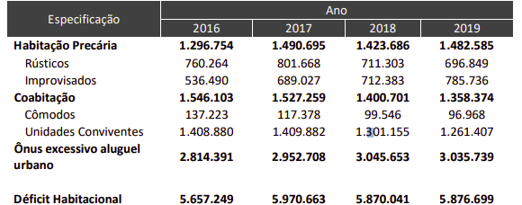
Table 1 Brazilian Housing Deficit (2016 - 2019). Source: FJP, 2021

At least since 2016, the high price of rent is responsible for more than 50% of the Brazilian housing deficit. This means that there is an unbalanced relationship between the income of most Brazilian families and the housing costs.
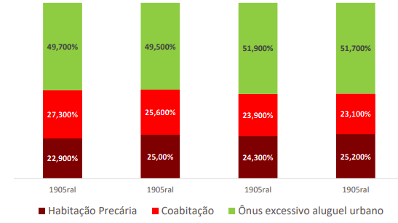
Figure 1 Brazilian housing deficit components (2016-2019). Source: FJP,2021

Women are the most affected group in all components of the housing deficit, especially when it comes to rent burden (62%) and precarious housing (59%).

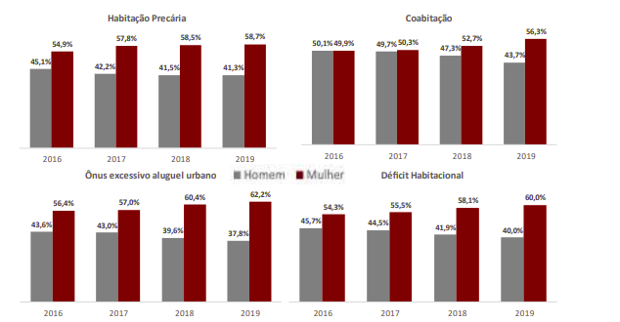
Figure 2. Gender distribution on Brazilian housing deficit components (2016-2019). Source: FJP,2021

23% of families facing rent burden are headed by single mothers and 20% are headed by women without any child.
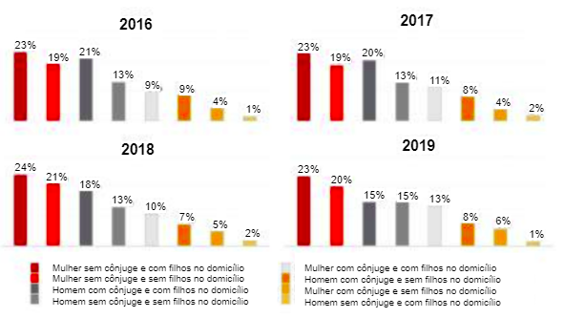
Figure 3 High rent component divided by gender (2016-2019) Source: FJP, 2021

Families with lower income, that earn less than 3 minimum wages per month, are the main group struggling with the rent price.
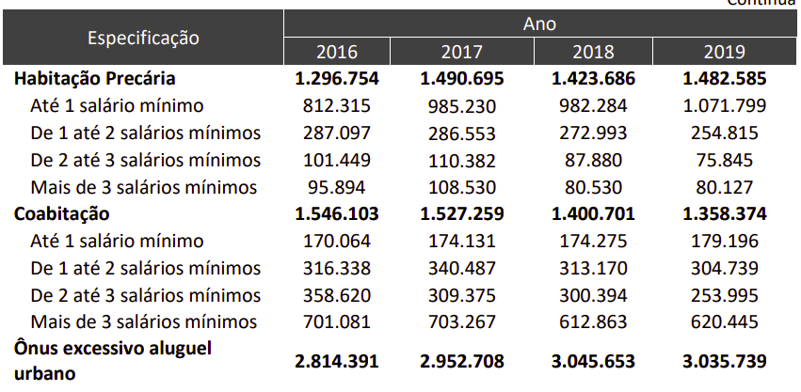
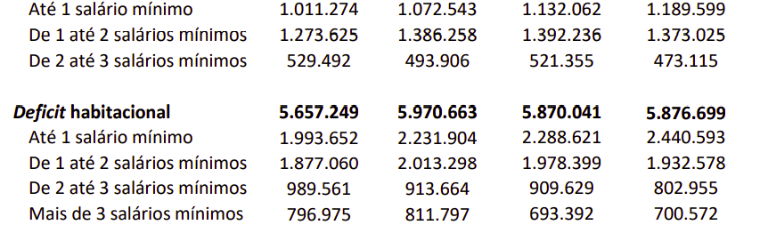
Table 2. Brazilian housing deficit components according to the number of minimum wages per month (2016-2019). Source: FJP,2021
Although the FJP data does not consider race in the analysis, recent data from the Brazilian Institute of Geostatistics (IBGE) point out that 61% of Brazilian single mothers are black. In addition, 63% of households headed by black women with children under the age of 14 are below the poverty line and earn approximately US $ 5.5 per capita per day.
This is more than twice the national average percentage, where 25% of Brazilian population is below the poverty line. For white women with children, the proportion of households below the poverty line is 39.6%
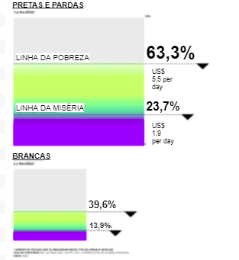
Figure 4 percentage of women under poverty and extreme poverty line in Brazil by race. Source: Genero e Número, 2021. http://www.generonumero.media/casas-mulheres-negras-pobreza/

Thus, it is concluded that the right to housing in Brazil is selective and that it systematically excludes single-parent households headed by black women with children and with an income of up to one minimum wage. In the current context, there are three factors that make this scenario even more critical: the pandemic crisis, the forced evictions and the absence of national public housing policies.

The effects of the Covid-19 pandemic on income
In 2019, a year before the coronavirus pandemic, Brazil had 51 million people living in poverty, 13.8 million in extreme poverty (MADEUSP, 2021) and the unemployment rate was 11.9% (PNAD, 2019). Bolsa Família was the main social security program and benefited more than 13.5 million people.
In 2020, among the various effects of the COVID-19 pandemic in Brazil, there was a worsening of the context of the economic and social crisis that the country had been facing since 2016. Unemployment rates rose reaching 14.2% (PNAD, 2021), and millions of families reported that they lost income. There was also an increase in the basic food basket price, rent price and other costs, further compromising the already insufficient income of many Brazilian families to make ends meet.
The Emergency Aid approved by the federal government in April 2020, after strong pressure from social movements, played a key role in not only dampening the effects of the pandemic on household income, but also in reducing the level of poverty and extreme poverty in Brazil.
In July 2020, the number of families living in poverty fell from 51.9 million in 2019 to 43 million. Families in extreme poverty fell from 13.9 million to 5 million (MADEUSP, 2021). In October of the same year, with the reduction in the amount paid for Emergency Aid, the number of people living in poverty and extreme poverty jumped to 52.1 million and 10.9 million, respectively.
Without the Emergency Aid, the devastation would have been even greater: 66.4 million Brazilians would be living in poverty and 22.6 million in extreme poverty. The Brazilian Federal government announced that in 2021 the values ​​of Emergency Aid were reduced again and the study by MADEUSP (2021) points out that, with this new value, 61.1 million families will be living in poverty in Brazil and 19.3 million in extreme poverty in July 2021.
In these conditions, the increase in the number of families living in poverty and extreme poverty in Brazil has a direct effect on housing. First, because it reduces the viability of many families to afford housing costs. Secondly, in the absence of protective policies to control rent prices and stop forced evictions during the pandemic, the evictions number is likely to rise.
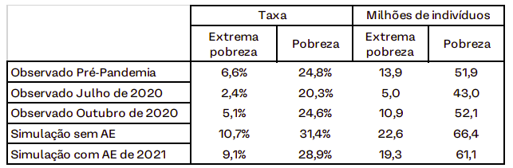
Table 3 Poverty and extreme poverty rates in Brazil, Source: MADE,2021

In all the scenarios observed by MADEUSP, black people, especially black women, are the majority in situations of poverty and extreme poverty. Black women are also the majority group among families in a housing deficit and, therefore, the discriminatory boundaries of the right to housing in Brazil are evident, excluding, above all, black and low-income women.
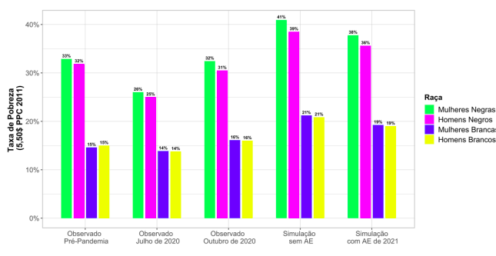
Figure 5 Poverty rates by gender and race in Brazil, Source: MADE,2021

Forced evictions aggravate the situation
The eviction crisis in the country predated the pandemic, but, in many ways, the COVID situation put many Brazilians at risk of losing their homes. The record levels of unemployment, the reduction of wages for middle-class and low-income families in Brazil, the increase in the prices of the basic food basket affects the most vulnerable groups in their capacity to bear the housing costs.
Since April 2020, there are a few legislation projects to temporarily ban evictions during the pandemic crisis at Brazilian Parliament, but they have not yet been approved. Thus, since July 2020, more than 12.570 Brazilian families were evicted and more than 72.169 are threatened with eviction.
A recent study published at nature communications relates the effects of evictions on SARS-CoV-2 epidemics and shows that policies to stop evictions are a warranted and important component of COVID-19 control.
In mid-December 2020, the covid case numbers in Brazil started rising and daily death tolls shot above 700, often surpassing 1,000. Public and Private hospitals at the major cities such as Rio de Janeiro, São Paulo, Belo Horizonte and Manaus are often operating nearly to their full capacity. Now people are not only dying because of COVID but also because they lack access to care. In this tragic scenario, forcefully evicting people from their homes is not only a violation of their housing rights, but it is a threat to their life.

The lack of a national housing policies in Brazil
Brazil does not have an effective housing policy that addresses the complexity of the housing needs of most Brazilian families. Although an advanced institutional framework was developed during the 1990s and 2000s, with the formulation of public policies and urban instruments that subsidized the expansion of the right to housing and the city, the practice of the national housing policy was essentially limited to two programs: the Growth Acceleration Program (PAC) and the Minha Casa Minha Vida Program (PMCMV).
The PAC was created in 2007 and allocated substantial resources to three strategic axes of economic and urban development in the country: (i) logistics, (ii) energy; (iii) social and urban infrastructure (sanitation, housing, subways, water resources, slum upgrading etc.). If, on one hand, it was the very first time that the federal government invested massive resources in urbanization of slums, on the other, the actions of the 3 axes promoted forced evictions without guaranteeing that all families had access to new housing units.
The PMCMV was created in 2009 and ended in 2020. It was an anti-cyclical program, to deal with the 2008 subprime crisis, and it was structured on the mass production of standardized private housing units, disregarding logics and regional and cultural specificities. Between 2009 and 2020, 5,162,407 homes were produced (SISHAB, 2021).
The only way to access this production was buying the housing units. The federal government destined massive resources to subsidize low-income families in this process, but it was not enough. Many families struggle to bear all the housing costs and the number of defaulting families is high. Clearly, the private property model is not the ideal for these families.
Although the urbanization of slums and the production of houses are, in fact, important in Brazil, there isn't a wider range of programs that effectively addresses the different needs of Brazilian population. Currently, with the end of MCMV and PAC programs, the only one available is the newly created Casa Verde e Amarela Program (created in 2020) and which, so far, has promoted only 173,012 housing units in the country (SISHAB, 2021).
In April 2021, the Bolsonaro administration vetoed the only budget earmarked for housing and approved by Congress in the 2021 budget, falling from R$ 1.5 billion to R$ 27 million (representing a cut of almost 98%). The initial amount was already negligible and was intended only to proceed with projects that were stopped and that had already been previously contracted. In other words, in addition to the fact that there is no housing policy that addresses the current needs of almost 6 million units, the current management further aggravates the situation by cutting funds and paralyzing housing projects.

8. Discrimination in housing can affect various dimensions of the right to adequate housing and other human rights. Could you provide more details regarding the specific areas in which housing discrimination is experienced? Below are examples of various forms of discrimination that can be experienced in relation to different dimensions of the right to adequate housing:
The violation of the right to adequate housing in Brazil permeates all 7 points established by the UN. However, this report highlights four of them that are more prominent in the current Brazilian scenario.

Accessibility
Discrimination in relation to access to land, including water and natural resources essential for habitation;
- About 35 million Brazilians do not have access to water, according to the National Sanitation Information System - SNIS 2019.
  - According to the Trat Brazil Institute (2018) 14.28% of women and 16.6% of men did not have access to water.
  - the rates of access to water are worse at territories of non-white population, such as slums, tenements and other low-income territories.
  - Even where water is available, the problem of shortages is recurrent. The lack of water occurs, mainly, in the regions that present High and Very High Vulnerability, according to (Fundação Seade, 2013) and where areas of slums are located, most of the time. There are systematic interruptions in the water supply, with intermittent shortages occurring for more than 1 year.
  - metropolises with a large number of non-white people are the most affected ones such as Macapá (61% without water), Belém (29.7% without water), Salvador (9% without water) and Manaus (8.6% without water).
Discrimination in relation to housing for rental or for acquisition or in accessing public or social housing;
- The main condition to access a housing unit in Brazil is having enough income to purchase or to rent it. Although more than half of the Brazilian population lives with less than one minimum wage, the Casa Verde e Amarela Program, the only national housing program, dedicated more than 80% of the housing units produced in 2020 to families with an income above 1.5 minimum wages.
- According to the João Pinheiro foundation, more than 3 million Brazilian families committed more than 30% of their income with payment of rent. 62% of these families were headed by women.

Habitability
Discrimination in relation to housing conditions, overcrowding or housing maintenance;
- Housing precariousness reached almost 1.5 million families in 2019 (FJP, 2021). 58.7% of these households were headed by women and 72.29% by families with an income of up to one minimum wage.
Exposure to health risks within the home, including lack of ventilation, heating or insulation, exposure to fire or housing collapse risk, unhealthy building materials, or other unhealthy housing covered by the WHO Guidelines on housing and health.
- According to IBGE 2010, approximately 8.3 million people live in risk areas in 872 of 5,561 municipalities in the country. In Salvador (BA) the situation reached 45,5% of the total of inhabitants of the city, making a total of 1.2 million people, which add up to another 674 thousand in São Paulo (SP), 444 thousand in Rio de Janeiro (RJ), 389 thousand in Belo Horizonte (BH) and 206 thousand in Recife (PE), composing the ranking of the five cities with the highest contingent in risk areas.
In the national panorama, the study identified that, among the monitored municipalities, 26.1% of the population that lives under these conditions do not have adequate sanitation.
One of the research highlights is the regional inequalities. The national average of people in risk areas with inadequate water supply is 6.54%, but in the North, the index reaches 26.35%. About inadequate sanitation, the north region's average reaches 70.75% - well above the 26.1% of the national average.

Children and the elderly
Also highlighted in the study is the percentage of children or the elderly (people aged 60 or over) living in risk areas: the two groups together represent 17.8%. Acre (19.8%), Pará (19.2%) and Amazonas (19.2%) are the states with the greatest prominence in this index.
Such segments are identified as the most vulnerable to the different problems caused by these conditions, such as floods and landslides, for example.

Affordability
Discrimination related to housing and service costs, housing related fees, litigation or taxation;
- At least since 2016, the high price of rent it´s responsible for more than 50% of Brazilian housing deficit. 62% of the families affected are headed by women.

Security of tenure
Discrimination in relation to evictions, resettlement
- At the very beginning of the pandemic situation in Brazil, some politicians wrote at least one legislation project to temporarily ban evictions during the pandemic crisis. Unfortunately, it has not yet been approved. Thus, since July 2020, more than 12.570 Brazilian families were evicted and more than 72.169 are threatened with eviction.

9. Are there any particular current laws, policies or practices in your country, region or town/community that contribute to or exacerbate discrimination in relation to the right to adequate housing?
The Land Law of 1850 marks the beginning of private property in Brazil. At that time, Brazil was still a slave monarchy, and was facing international pressure to change the work regime and abolish slavery. Therefore, it was important to those in power to maintain the discrimination of access to land regardless of the employment regime. With the Land Law of 1850, the powerful ones manage to consolidate the latifundium as the structure land model and prevent the free workers to access it, especially enslaved, ex-enslaved and indigenous people. This was a particularly important law to structure such an inequal society as the Brazilian one.
Since the 1988 Constitution, some regulatory frameworks have been set to reduce inequalities. In the scope of urban and housing policy, the emphasis was:
- on the approval of the City Statute, which has expanded the application of Special Zones of Social Interest, ZEIS, for urbanization and full land regularization of settlements of informal origin;
- Creation of the Ministry of Cities,
- Creation of the National Council of Cities;
- Conducting the City Conferences, from the municipalities to the national, aiming at the formulation of urban policy based on participatory processes;
- Construction of a title on land regularization in the law of the Minha Casa Minha Vida Program, Law No. 11977/2009, which advanced in relation to what was established in the City Statute;
- Implementation of the Urbanization, Regularization and Integration of Precarious Settlements Program.
However, as of 2016, the coup d'état was followed by the dismantling of public policies, directly affecting the right to adequate housing. Highlights include:
- Approval of Law No. 13,465 / 2017 that stimulates the commercialization of the land, turning as options the links with the Master Plan, ZEIS and other democratic principles at land tenure regularization policy.
- Emptying of the National Council of Cities and extinction of Sectorial Councils.
- Approval and sanction of Law 14,026, of July 15, 2020. This Law institutionalized the private monopoly in the water supply and sewage sector to facilitate and expand private participation in the sector. It represents a major setback for the basic sanitation sector in the country when prioritizing the commercialization of water, compromising principles of universalization, seriously affecting the population in a situation of social vulnerability.
- The extinction of the Ministry of Cities, which, among other consequences, disrupted instruments and mechanisms for interaction between Municipalities and the Federal Government. Especially the smaller municipalities, with up to 20 thousand inhabitants, which correspond to 70% of the Brazilian municipalities are severely affected, due to the low capacity for implementation and formulation of public policies.
  - The aggravating factor is that these municipalities are hosting large projects, such as dams and renewable energy plants, which directly impact the most vulnerable groups. According to the report of the National Human Rights Council, in the construction and operation of dams in Brazil, at least 16 rights are systematically violated, including the right to land and the right to housing (https://mab.org.br/lutas /)
Therefore, the current scenario is set on violation a of rights and discrimination towards the right to adequate housing, based on a land policy based on the economic function of the land affecting especially low-income families and traditional communities.

SPATIAL AND RESIDENTIAL SEGREGATION

12. What forms of spatial segregation along racial, caste, ethnicity, religion, nationality, migration status, heritage, economic status/income or other social grounds can be observed in urban and urban-rural contexts in your country?
Brazilian cities were designed to segregate people by combining class, race and gender identity markers. Which means that there is a combination of well-structured territories - with the best indicators of mobility, higher income, higher education levels and that hosts mostly white people with white men as the heads of households – and poorly structured territories that hosts mainly black people.
Although Brazil has never had a law that explicitly discriminate these different social groups, such as the apartheid law in South Africa or the Jim Crown law in the United States of America, public policies such as housing, for example, fulfill this role.
The two largest housing programs in Brazilian history - the National Housing Bank (1964-1986) and the Minha Casa Minha Vida Program (2009-2020) - had together produced more than 10 million houses and acted as important agents of the segregation.
Almost 70% of the beneficiaries of social housing fostered by the MCMV Program are black and most of the houses were built in urban peripheries, reinforcing structural racism and the inferior place of blacks in society and in urban space.
The two maps below show the correlation between race and income in the metropolitan region of São Paulo, one of the most segregated in Brazil. The first map shows the white territories in blue, the black territories in yellow and the Asian territories in red.
The second map shows, in red, the areas that concentrate the highest number of high-income households and, in beige, the lowest-income territories. In the comparative analysis between the two maps, it is evident that the high-income territories are mostly white, and the low-income territories are mostly black.

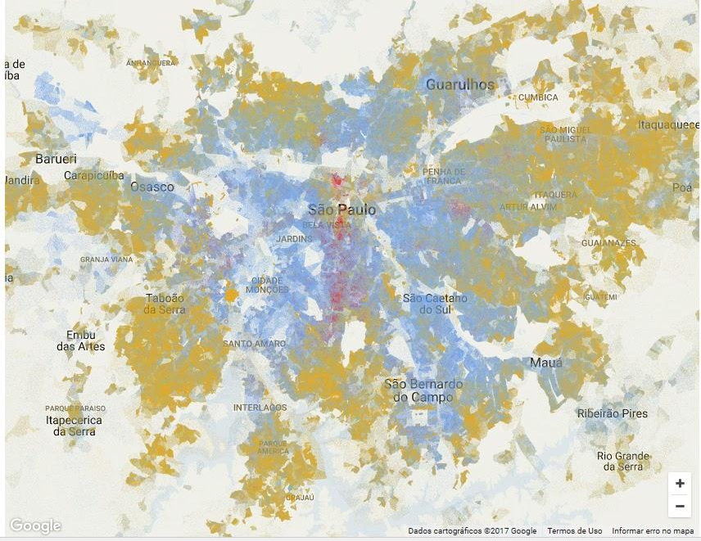
Map 1 Race segregation at São Paulo Metropolitan Region. Source: Nexo, 2015. Disponível em: https://www.nexojornal.com.br/especial/2015/12/16/O-que-o-mapa-racial-do-Brasil-revela-sobre-a-segrega%C3%A7%C3%A3o-no-pa%C3%ADs
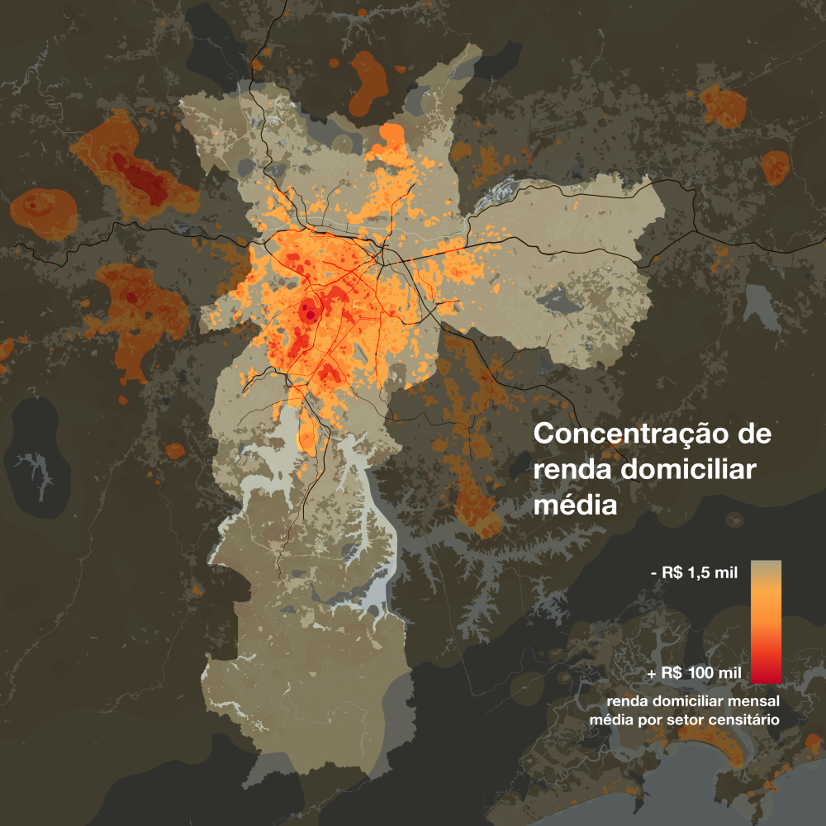
Map 2 Wage segregation at São Paulo Municipality. Source: LabCidade, 2017 Disponível em: http://www.labcidade.fau.usp.br/category/observasp/

13. What impacts do these forms of spatial and residential segregation have on affected communities? Please point to indicators such as rates of poverty, un-employment and under-employment; prevalence rates of malnutrition; disparities in access to services and facilities (such as access to schooling, health care or other public benefits); disparities in access to infrastructure (lack of and/or poor quality provision of water, sanitation, transportation, energy, waste collection and other utility services); rates of exposure to environmental health risks (poor air quality, flooding, toxic ground exposure, etc.).
Spatial segregation has numerous consequences. This document highlights two them. The first shows the differences in the average age to die in the city. The Jardim Paulista District, which hosts mostly white and high-income people, has the oldest age in the municipality: 81.5 years. At the opposite side, Jardim Angela District, that essentially hosts black and low-income families, has the lowest rate in the city at 58.3 years. In other words, there is a difference of almost 30 years between the two regions of the same city.
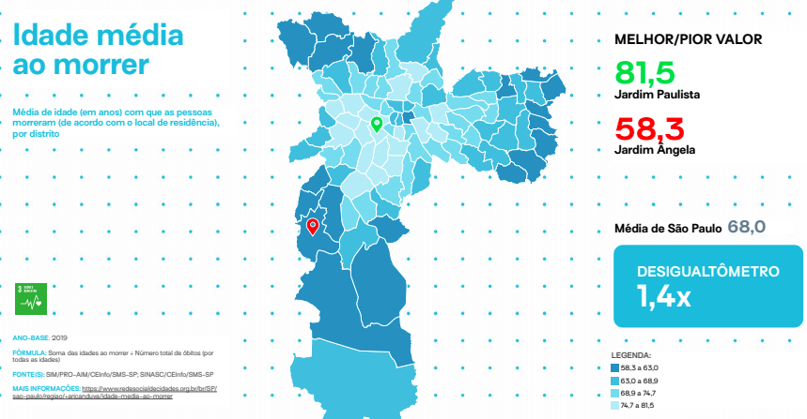
Map 3 average age at moment of death by district in São Paulo Municipality. Source: Mapa da Desigualdade, 2020. https://www.nossasaopaulo.org.br/wp-content/uploads/2020/10/Mapa-da-Desigualdade-2020-MAPAS-site-1.pdf
The second information shows deaths by covid-19 in the city of São Paulo. Again, it is noted that the territories mostly formed by black and low-income people are the most affected.
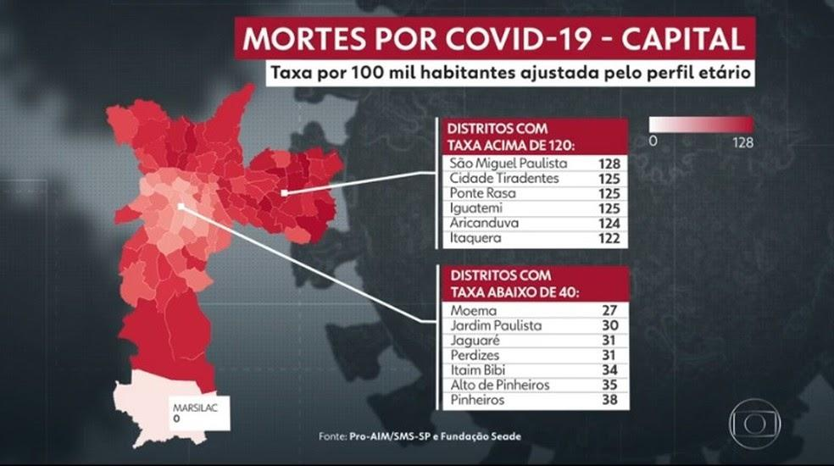
Map 4 Death by COVD-19 by district in São Paulo Municipality. Source: G1, 2021. https://g1.globo.com/sp/sao-paulo/noticia/2021/04/20/moradores-da-periferia-de-sp-tem-3-vezes-mais-risco-de-morrer-de-covid-19-do-que-pessoas-que-vivem-em-bairros-mais-ricos.ghtm

MEASURES AND GOOD PRACTICES TO CURB DISCRIMINATION AND REDUCE SEGREGATION

24. What is the role of the media, as well as other non- governmental organizations, of religious and governmental institutions, in fostering a climate that reduces or exacerbates discrimination in relation to housing and segregation?
In Brazil, the public opinion and the conservative press sees with prejudice homeless people and families that live in favelas, occupations, and other popular territories. However, there are many NGOs that defend Human Rights to housing and to the City. The Zero Eviction Campaign gathers a part of these NGOs.
The Campaign was funded in 2020 and is composed by more than 100 entities, social movements, and organizations. The Campaign works monitoring and advocating for the policy of ZERO EVICTION in Brazil and it also offers legal assistance and technical assistance.
Since July 2020, the campaign has already identified more than 80 cases of eviction during the pandemic, affecting more than 9.156 families. The main excuses were ownership repossessions and conflicts with owners, as well as the impact due public works.
Until now, the Zero Eviction Campaign also accounts for 275 cases of eviction threats, impacting more than 64.546 families. At least 53 cases affect communities where black are the majority.

Although other research institutes also calculate the Brazilian housing deficit, the João Pinheiro Foundation's methodology is officially adopted by the federal government.
http://www.generonumero.media/casas-mulheres-negras-pobreza/
https://madeusp.com.br/wp-content/uploads/2021/04/NPE-010-VF.pdf
https://agenciadenoticias.ibge.gov.br/agencia-noticias/2012-agencia-de-noticias/noticias/26741-desemprego-cai-para-11-9-na-media-de-2019-informalidade-e-a-maior-em-4-anos#:~:text=A%20taxa%20m%C3%A9dia%20de%20desocupa%C3%A7%C3%A3o,hoje%20(31)%20pelo%20IBGE.
http://mds.gov.br/area-de-imprensa/noticias/2019/setembro/bolsa-familia-atende-mais-de-13-5-milhoes-de-beneficiarios-em-setembro
https://brasil.elpais.com/economia/2021-04-15/explosao-do-igp-m-traz-aumento-desproporcional-do-aluguel-e-revela-indice-que-envelheceu.html
https://www.dieese.org.br/analisecestabasica/2021/202102cestabasica.pdf
https://brasil.elpais.com/economia/2021-04-15/explosao-do-igp-m-traz-aumento-desproporcional-do-aluguel-e-revela-indice-que-envelheceu.html
Law Nº 13.982, April 2, 2020
https://www.campanhadespejozero.org/
https://www.nature.com/articles/s41467-021-22521-5.pdf
http://sishab.mdr.gov.br/
http://sishab.mdr.gov.br/
Although the study “Sanitation deficiencies and Covid-19: case study on lack of water, social vulnerability and deaths in the municipality of São Paulo” addresses the case of São Paulo, deficiencies in water supply also occurs in other cities in the country. Source: https://observatoriodasaguas.org/deficiencias-no-saneamento-e-a-covid-19-estudo-de-caso-sobre-falta-de-agua-vulnerabilidade-social-e-obitos-no-municipio-de-sao-paulo
The study covers the municipalities listed by the National Center for Monitoring and Natural Disaster Alerts (Cemaden) as locations that have a history of disasters, so it does not include all 5,561 municipalities in the country.
https://www.campanhadespejozero.org/
https://ondasbrasil.org/analise-dos-efeitos-da-abertura-de-capital-das-empresas-operadoras-dos-servicos-de-agua-e-esgoto-no-pais

