Additional information to:
Utrecht: Enhancing the quality of life by localizing universal human rights

Up to 5 photos that best illustrate the initiative (.jpeg at 72 dpi, 500 x 700 px max). Please embed this material in two (2) A4 pages with titles.

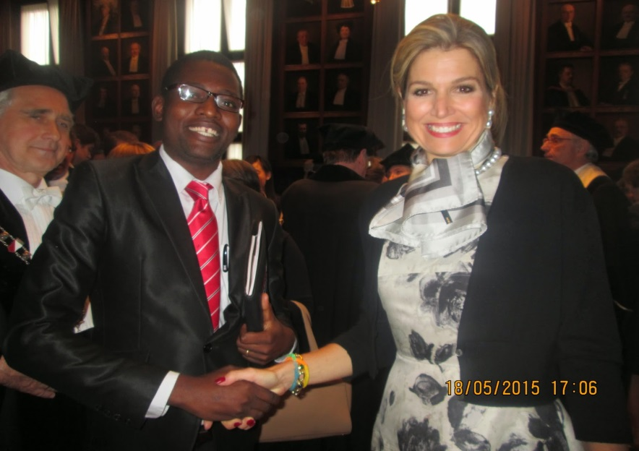

Welcoming Utrecht Shelter City Guest, Nkoslathi Moyo, by Queen Maxima

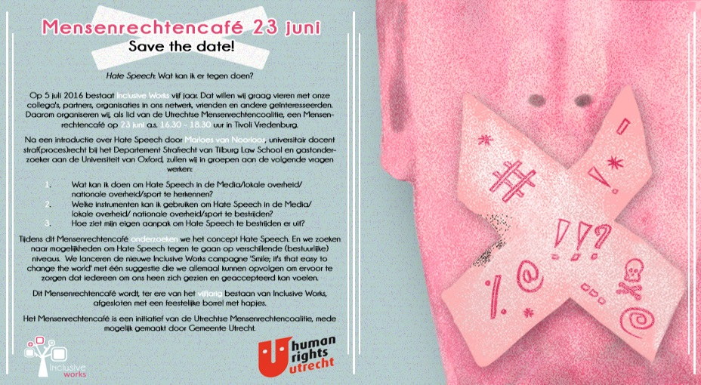

Invitation for one of the regular thematic Human Rights Café’s

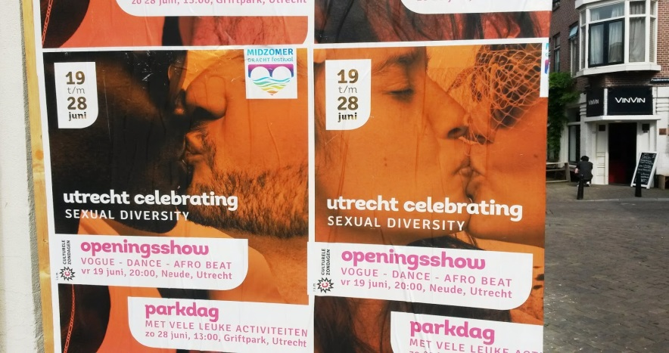

Street campaigns with attention for Human Rights Issues in Utrecht
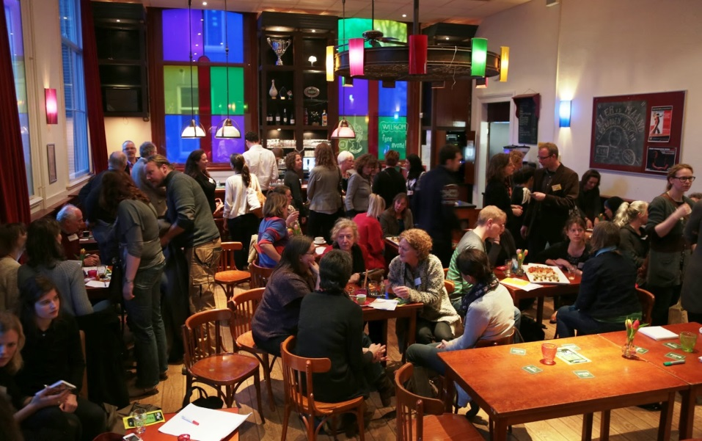
Impression of a regular Human Rights Café in Utrecht

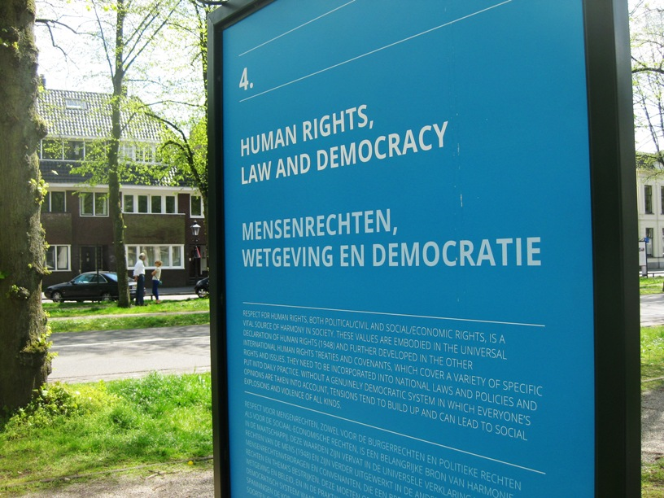
Open Air exhibition with information about universal Human Rights

Up to 5 press clippings or copies of covers and tables of content of reports published on the initiative. Please embed this material on A4 pages.

