 |  | 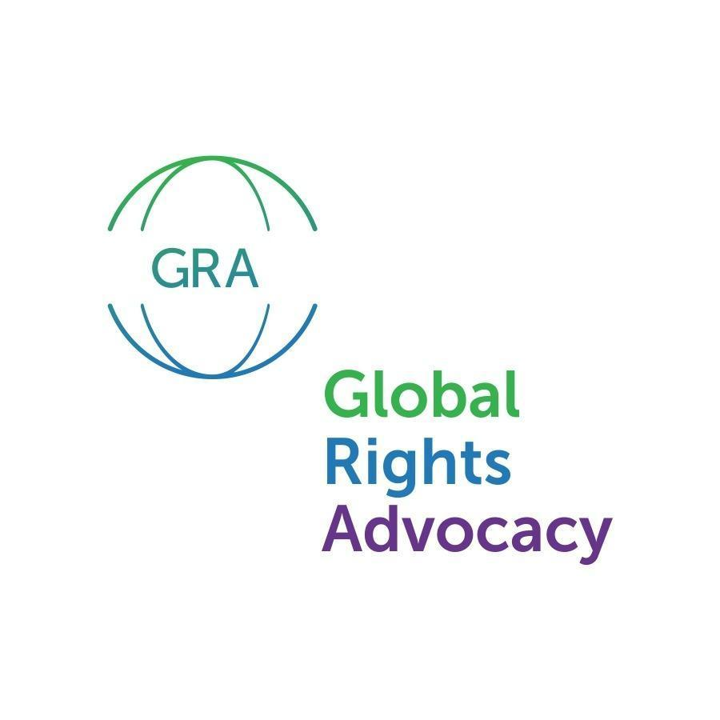

Felipe Gonzalez Morales
United Nations Special Rapporteur on the rights of migrants

June 14th, 2021

Re: Detained Migrants at Northwest Processing Center
Submission for his Report to the 78th Session of the UNGA
Dear Rapporteur:

Alejandra Gonza, Executive Director of Global Rights Advocacy (“GRA”), Thomas Antkowiak, Director of the International Human Rights Clinic at Seattle University School of Law (“the Clinic”), and Maru Mora Villalpando, leader of La Resistencia, write to you regarding the lack of serious measures by the United States of America and GEO Group in the context of immigration detention, “to minimize health risks associated with the COVID-19 transmission by reducing migrants’ detention and opting for alternatives to detention. We will update you particularly about the Northwest Processing Center (NWPC or NWDC), which was object of several United Nations communications and currently has precautionary measures adopted by the Inter-American Commission of Human Rights’ (“IACHR”). We also would like to request a meeting with your office during the time you are presenting your report to the UNGA regarding the lack of compliance and meaningful engagement of the United States Government with international human rights bodies, implementing recommendations on this matter. We also request you organize a side event regarding immigration detention during the Pandemic, to hear the voices of the undocumented community directly.
The United States has failed to protect the rights to life, personal integrity and health of the migrants who are detained at the NWDC. The US failed to adopt the measures recommended by the UN and the IACHR during COVID and failed to ensure the exceptionality of detention and availability of non-custodial and non-punitive options for immigration. The United Nations Secretary General and UN Experts highlighted the Pandemic as an opportunity to “reimagine human mobility”, halt deportations and close centers. Instead, people in detention have reported inadequate measures to manage COVID, alarming instances of use of force by guards, inadequate medical attention, punitive quarantine environments and inhumane deportations. Releases have been difficult to obtain and traumatizing. As the following updates will illustrate, the release of those in custody at the NWDC, remains imperative.
No reduction of immigration detention numbers and COVID cases: Since March 2020, the US has kept a cumulative number of 179,930 immigrants in ICE jails nationally with 17,377 tested positive. Currently 25,238 immigrants are in ICE jails, distributed all over the country. 80% of these detention centers are run by private corporations, which deny their responsibility to protect health at their facilities. This number is a sharp increase from March 2021 when 14,216 immigrants were in custody. Many of these ICE jails have already COVID within their walls.
Around 2,000 immigrants in total were at the NWDC cumulatively since March 2020 until today, with 41 testing officially COVID positive. Around 20 GEO guards and several ICE employees working at the NWPC also tested positive. From March 2nd, 2020 to June 14th, 2021 at least 1,336 immigrants from the NWDC were deported from Yakima airport and 353 immigrants were brought in. Since the new administration took power in January 2021, despite promises to defend immigrants and compelling public requests to wear masks, social distance, and avoid all non-essential travel and gatherings, we reported at least 18 deportation flights out of Yakima, with 228 immigrants deported or transferred out. As reported by ICE to Congress, no Covid test was required for deportation. Since January 2021 also 328 incoming immigrants were brought to the NWPC, most of them asylum seekers coming from the southern border, 262 of those last week alone. According to testimonies and reports, the population will increase again. Some tested positive of COVID at arrival to the Center. 82 of the asylum seekers housed at the NWPC were identified as at the at-risk category in documents provided by ICE in domestic litigation. ICE did not have capacity to test all the incoming immigrants and department of health is requesting judges not to release them until testing is done, which place them in extreme vulnerability.
Many of those deported were ill and no safeguards were taken to ensure their right to life and health. During the fire smoke emergency in the State, deportation flights continued, including taking two men who had to be helped up the steps with agents holding both their arms to support them. The only time flights were cancelled was due to snow. One wheelchair and one walker were loaded on the plane along with the baggage. ICE also deported Anonymous 26, an elderly person with high blood pressure and diabetes, who is blind, and who spent over a year in segregation.Many more admissions, however, may be coming from transfers by bus or local arrests. By constantly bringing new immigrants into the NWDC, the United States failed to comply with the IACHR’s and UN recommendation to stop “placing any new such persons at the NWDC” and to suspend enforcement to protect global health. In one instance, an immigrant was placed in solitary upon arrival to the NWDC and signed his deportation papers due to fear of getting the virus. He was transferred for deportation, kept in an airport overnight and in solitary in a different detention center, only for ICE to transfer him back to Tacoma due to the cancellation of his flight, where again he was placed in solitary confinement. Weeks later, he was finally deported. Moreover, there are reports of hundreds of formerly detained immigrants testing positive in the countries to which they were deported.
No release plan for civil detention and lack of legal resources for releases: The US Government deferred the decision to release immigrants to ICE, an agency that considers immigrants a danger. Furthermore, the United States failed to provide as requested by the IACHR “proper, speedy and accessible access to the appropriate remedies without unnecessary burdens, to assess the continuity of their detention in light of the threat caused by the COVID.” The US has no reasonable explanation on its reluctance to adopt a quick release plan for immigrants detained. Currently there are four main ineffective legal avenues immigrants are trying to get released due to COVID. First, a Fraihat complaint: in April 2020, a federal court ordered ICE to conduct custody redeterminations for all class members (people in the at-risk category) in the class action Fraihat v. ICE. At the end of November, 2020 the NWDC reported that was holding 358 immigrants and has recognized that 156 of them were a subclass member of Fraihat for custody redeterminations, almost 56% of the NWDC population. People at risk who requested release before, had to refile a new request under Fraihat. Unfortunately, because of ICE’s slow, unfair, and bureaucratic process, and the practical need to have representation to request release, by December 2, 2020, 33 of those at risk had already been deported without safeguards to their life and health (those numbers could be higher now) and many more afterwards. There was information that ICE has only released 52 people as a result of its judicial mandate to review. That means that at least 115 people of those then identified by ICE as at-risk remained detained at the NWDC or were eventually deported. Courts are not mandating ICE to release those identified at risk but instead created a burdensome process for migrants detained. This comes at a time when NWDC has severely restricted legal visits. Many Fraihat requests have been denied, even for clients with very serious health vulnerabilities, including multiple co-morbilities. Second, in the federal courts, in May 2020 NWIRP filed a class action case on behalf of those who are medically vulnerable. Multiple requests for temporary restraining orders were denied and the case remains pending. In March 2021, a motion for class certification was granted, for all medically vulnerable people detained at the Northwest Detention Center. ICE did not object that the number of medically vulnerable people detained at the Northwest Detention Center met the standard of "numerosity", although there is not a current specific count. At this point, we do not have any certainty on an end date for resolution of the case and, if they were we to succeed in their claims, the federal district court would set up another process for consideration of release of those who are medically vulnerable, and will not order their release, so technically not a release remedy. Courts are not protecting immigrants at the NWDC. On December 18, 2020, a federal court in the Western District of Washington denied a request for injunctive relief to expedite release determinations, despite evidence that NWDC staff were violating the facility’s own policies and placing immigrants at risk. Several other local litigation efforts have also been unsuccessful. Comparatively, in Switzerland, the Swiss Supreme Court held that, due to limitations because of COVID on the ability of the state to deport people, the status of “detention pending removal” was unlawful. Third, a new Case Review Process was announced on March 5th, 2021 after ICE issued memos on January 20th and February 18th on immigration enforcement priorities. Those policies have not resulted, and will not result, in meaningful change for those currently detained. Several organizations have letters to ICE regarding the little impact any policy reforms have had on immigrants detained, including complaints regarding systemic problems in the new revision process. Rather than holistic consideration, the process also appears to automatically disqualify anyone with criminal records. Forth, bond process in the immigration courts. Medically vulnerable people have tried to include evidence and arguments as to the dangers they face from COVID-19 in detention. However, the immigration court has rejected consideration of those arguments, saying that those are not proper factors to consider in a bond decision.
Discrimination against immigrants compared to criminal detention: Some criminally convicted in WA -- and around the nation were released due to COVID. For example, the adult jail population in King County Jail in downtown Seattle has been reduced by more than 550 people to mitigate COVID. Governor Inslee's directive in April, Washington released about 1,100 incarcerated people without violent or sexual offenses and who were nearing the end of their sentences as an effective COVID mitigation measure. Nevertheless, no similar measure was considered in Washington for immigrants. Instead for immigrants, burdensome processes were created and many deportations preceded decisions. In fact, according to Washington State’s Department of Corrections, between February 29 and September 30, 2020 51 people who benefited from release from state jail and prison facilities were transferred to the NWDC. The Governor has refrained so far from exercising supervisory authority, including regulatory authority over GEO, which is a private corporation operating within the state. He also did not exercise his broader emergency powers during the COVID pandemic, which allows him to prohibit activities he “reasonably believe[s] should be prohibited to help preserve and maintain life, health, property or the public peace.” These powers also allow the Governor “in the event of disaster beyond local control,” to “assume direct operational control over all or any part of the emergency management functions within this state.” The “emergency management” authority empowers the Governor to act to “mitigate, prepare for, respond to, and recover from emergencies and disasters, and to aid victims suffering from injury or damage, resulting from disasters caused by all hazards, whether natural, technological, or human caused . . ..” Despite invoking these provisions to take a number of steps aimed at preventing the spread of COVID in the State, he did not do it to take care of immigrants at the NWDC and instead relied on ICE, the Department of Health, and GEO to manage the situation.
Hunger strikes and retaliation: Due to the lack of appropriate remedies without significant burdens, the hurdles to discretionary release from ICE, a lack of safe and nutritious food, and incidents of use of force, immigrants have carried several hunger strikes this year. Most recently, in June 11th 2021 an asylum seeker is requesting the release of everyone that has been recently transferred from the southern border. Victor Fonseca — an immunocompromised immigrant from Venezuela who faces potentially indefinite detention due to US relations with his home country — did a the longest hunger strike, was taken to the emergency room where he presented weak vital signs. He was demanding that ICE release him and everyone else with medical conditions that increase their vulnerability to COVID. He has been put into isolation and has been threatened with force-feeding. He submitted several requests for release due to be at high risk. Other strikers protest the lack of a nutritious diet, and hygiene at kitchen where individuals have tested positive.
Inhumane releases: ICE's reluctance to quickly release people who were identified in the high-risk category showed new levels of inhumanity with instances of botched deportations for people that publicly campaigned for their release, traumatizing them. One of them, after being first taken to an airport for hours and was told they were deporting her, but was suddenly release with no explanation. She tested positive of COVID and spent almost 40 days at the hospital. Another was released in the middle of the night, without warm clothing to endure the cool weather overnight in the remote industrial zone where the detention center is located. According to UN recommendations “[r]eleases should be accompanied with protocols to ensure that those released have access to adequate healthcare, hygiene, and housing to maintain their health following release.” Several at-risk people remain in detention.
No effective reaction from health departments: On June 24, 2020, La Resistencia reported to the Environmental Public Health Division with an Office of Environmental Public Health Sciences in charge of Pesticide Illness Monitoring & Prevention Program cases of the use of pesticides as cleaners, asking for an investigation. The same complaint was filed with the Department of Agriculture, requesting to launch an investigation into the use of pesticides for cleaning and disinfecting. The Compliance Branch of the Washington State Department of Agriculture has the power to launch an investigation into GEO Group and ICE for the use of pesticides as disinfectants to combat COVID at the NWDC, pursuant to the Department of Agriculture’s authority under the Washington Pesticide Control Act and the Washington Pesticide Application Act. Pesticides has caused at least 20 detainees to experience skin rashes, eye irritation, coughing and nose bleeds. Unfortunately, the Department has not exercised its authority, because they “had a difficult time accessing the facility,” “did not conduct a site visit or collect samples,” and referred the case back to EPA Region X “because the case met the criteria as a “Significant Case.” There has not been a response from EPA. Recently, the EPA issued the report about the improper use of pesticides and toxic chemicals in Adelanto. Despite the consequences to immigrants' health, they issued to GEO Group only a warning notice, showing elusive accountability. The detention center’s major problems continue, with complaints about the ventilation system, lack of adequate circulation of clean air inside, lack of prolonged access to open air spaces.
Quarantines are extra punitive:. The Government touts its medical isolation strategy as a cornerstone of its outbreak prevention plan. Yet, this overlooks what the strategy is: placing people in conditions that the NWDC has long used as a form of punishment. The NWPC holds in solitary confinement longer than any other dedicated ICE facility (an average of 70 days), and regularly uses segregation to intimidate and punish those on hunger strike. Since the COVID pandemic began, at least one unit has been in quarantine every month. In these conditions, immigrants’ access to courts is limited, they are not allowed to clean, to go to the library, and several have complained of extreme anxiety related to the facility’s lack of transparency regarding the presence of the virus. Some people have been in unit-wide quarantines three times, in addition to a period of over a week in September when people were not allowed to go outside at all during severe wildfires. As of June 2021 immigrants detained report that the state of constant quarantine is exhausting and is evidence of many incidents of exposure. Many come out of medical observation and isolation itchy, with headaches, and psychologically distressed.
Closing the NWPC: On April 29, 2021, the WA legislature passed HB1090 which would ban the signing of contracts with private companies in the state, effectively setting a countdown for the facility’s closure within the next four and a half years. GEO filed a lawsuit claiming that the law is unconstitutional because it violates intergovernmental immunity and that it is preempted by federal laws. House Bill 1090 should help shut down the center immediately. GEO claims that if Washington forces it to close the NWDC, it would lose nearly $264 million in revenue from September 28, 2021 through September 27, 2025. On a more local side, on August 4, 2020, the City of Tacoma Mayor and City Council adopted Resolution No. 40636, denouncing the NWDC’s long history of medical negligence, poor sanitation, and arbitrary detention of immigrants. The resolution called for the release of detainees during the COVID pandemic and investigation into the NWDC’s health and medical services. Washington is falling behind. CA requires private detention facilities to uphold contracted health and safety standards, and provides a state law cause of action that allows people to sue private detention facility operators for failing to comply with the standards of care in the facility’s contract and to collect “reasonable” costs and attorney’s fees.
Reflecting the Special Rapporteur and the IACHR’s and other international bodies’ longstanding commitment to alternatives to civil detention of immigrants, our requests join nationwide calls from immigrants, advocacy groups, and representatives to shutdown detention centers and “embrac[e] a presumption of liberty for all immigrants” by abolishing mandatory immigration detention, ending the use of detention for migration processing, and eliminating detention and for-profit detention facilities.
Respectfully yours: Alejandra Gonza, Maru Mora Villalpando, Thomas Antkowiak

See UN OHCHR, Covid-19 and the Human Rights of Migrants, OHCHR.org, Apr. 7, 2020, available at https://www.ohchr.org/Documents/Issues/Migration/OHCHRGuidance_COVID_Migrants.pdf.
https://www.vera.org/tracking-covid-19-in-immigration-detention; US Immigration & Customs Enf’t, ICE Guidance on COVID-19, ICE.gov, updated Jan. 5, 2020, https://www.ice.gov/coronavirus.
https://www.vera.org/tracking-covid-19-in-immigration-detention
ICE is not reporting employees or GEO guards numbers.
Id.
Id.
Exhibits: Statement from [Anonymous 26].
IACHR Resolution 41/2020 at 12, para. 38a (July 27, 2020).
Exhibits: Statement from [Anonymous 31].
Id.
Id.
Amnesty Intn’l et al., Explainer on U.S. Deportations and Expulsions During the COVID-19 Pandemic, Amnestyusa.org, May 21, 2020, https://www.amnestyusa.org/wp-content/uploads/2020/05/Explainer-on-Deportations-and-Expulsions-During-the-COVID-19-Pandemic-1.pdf; Daniel Gonzalez, 'They were sending the virus': Guatemala reels after U.S. deports hundreds of deportees with COVID-19, Azcentral.com, Oct. 28, 2020, https://www.azcentral.com/story/news/politics/immigration/2020/10/28/hundreds-deported-by-us-to-guatemala-during-pandemic-had-covid-19/5902239002/.
IACHR Resolution 41/2020 at 12, para. 38a (July 27, 2020).
Fraihat v. U.S. Immigration & Customs Enf't, 445 F. Supp. 3d 709, 718 (C.D. Cal. 2020), order clarified, No. EDCV1546JGBSHKX, 2020 WL 65494 (C.D. Cal. Oct. 7, 2020), available at https://casetext.com/case/fraihat-v-us-immigration-customs-enft.
Information provided by NWIRP in regard to ongoing litigation in the Western District of Washington.
Idem
US Immigration & Customs Enf’t, ICE Guidance on COVID-19, ICE.gov, updated Jan. 5, 2020, https://www.ice.gov/coronavirus. No more information is public anymore so we don’t know numbers.
Nina Shapiro, New COVID case reported at Northwest detention center; activists seek release of vulnerable detainees, The Seattle Times, Dec. 11, 2020, https://www.seattletimes.com/seattle-news/new-covid-case-reported-at-northwest-detention-center-activists-seek-release-of-vulnerable-detainees/.
Avendaño v. Asher, No. C20-0700JLR-MLP, 2020 WL 7427058, at *9 (W.D. Wash. Dec. 18, 2020), available at https://casetext.com/case/avendano-v-asher (“The court cannot find at this time that reports of some individuals’ failure to follow procedures render Respondents’ measures unreasonable”).
See De Jesus Lopez v. ICE Field Office Dir., No. C20-1341-RSM, 2020 WL 7075213 (W.D. Wash. Dec. 3, 2020); Dawson v. Asher, No. C20-0409JLR, 2020 WL 6799009 (W.D. Wash. Nov. 19, 2020).
Global Detention Project, COVID-19 Global Immigration Detention Platform - Switzerland, Globaldetentionproject.org, Dec. 2, 2020,
RCW 43.06.010 (6).
RCW § 43.06.220(1)(h).
RCW § 38.52.050(1) .
RCW § 38.52.010(8).
Barrett et al., Missed Opportunities: State and Local Authority to Regulate the Northwest Detention Center, (University of Washington School of Law, 2020).
IACHR Resolution 41/2020 at 12, para. 38a (July 27, 2020).
Statement from hunger striker
Id.
Id.
Id.
Exhibits: Statement from [Anonymous 1].
Exhibits: Statement from [GIG].
Statement from Maru Mora Villalpando, Democracy Now!, Dec. 16, 2020, available at https://www.nationofchange.org/2020/12/16/rights-groups-demand-biden-reverse-trump-immigration-changes-as-covid-surges-in-ice-jails/.
Communication to the United States of America from the UN Special Procedures, May 13, 2020, JAL USA 10/2020, p. 6.
RCW 15.58.020
RCW 17.21.010
Exhibits: Statements from [GPP, GIG, Anonymous 12, NL, A, Anonymous 34].
Email to la Resistencia.
Exhibits: Statement from [Anonymous testimony from October 7th Facebook Live People’s Inspection].
US Resp. to the IACHR at 2 (Sept. 3, 2020).
Univ. of Wash. Ctr. for Human Rights, Conditions at the Northwest Detention Center: Solitary Confinement (The Henry M. Jackson School of International Studies, University of Washington, 2020).
La Resistencia Press Release, Dec. 10, 2020, available at https://www.facebook.com/LaResistenciaNW/posts/3667999609927559.
Exhibits: Statements from [Anonymous 23, GIG, Anonymous 8].
Exhibits: Statement from [DJL].
Exhibits: Statement from [Anonymous 23].
Castaneda Juarez v. Asher, No. C20-0700JLR-MLP, 2020 WL 3163208, at *2 (W.D. Wash. June 12, 2020).
Id,
Tacoma City Council Resolution 40636, available here.
Id. at 5-6.
Calif. Assembly Bill No. 3228.
Roadmap to Freedom, Proposed resolution in the House of Representatives.

