Side events:

Celebrate UN Social Forum 2018 with a special film



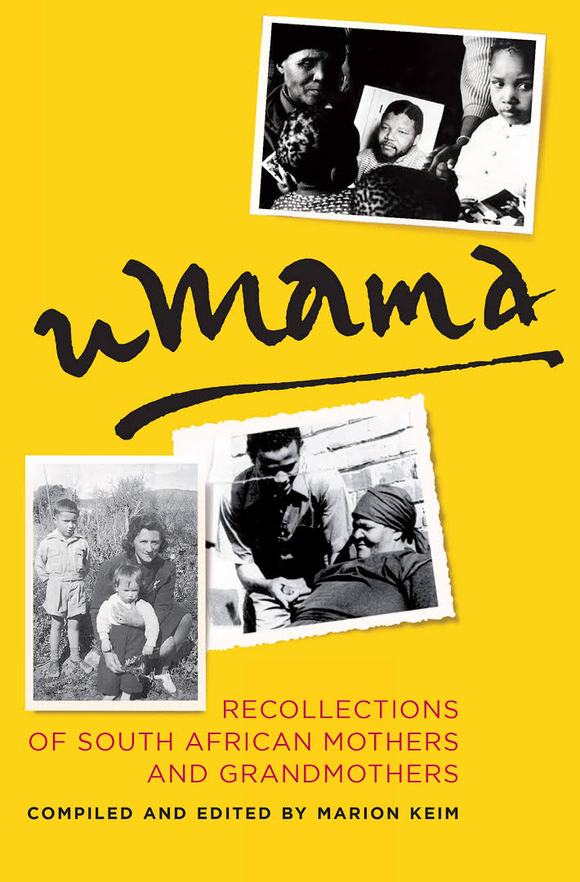

uMama The uMama documentary is about preserving stories of mothers and grandmothers who influenced the lives of remarkable leaders such as Nelson Mandela, Winie Madikizela- Mandela, Archbishop Tutu and Chester Willimas, Elana Meyer, Miriam Makeba and others.
The themes emanating from the stories are about the values passed on by mothers and grandmothers such as respect for self and others, integrity, tolerance, perseverance, human dignity, the importance for education, health, family faith and the importance of community to name a few.
These are the same core values which were highlighted and discussed on 25 November 2017 when , the Deputy Secretary-General of the United Nations, Amina J Mohammed, delivered the 15thNelson Mandela Annual Lecture in Cape Town with the topic “Centering Gender: Reducing Inequality Through Inclusion”.
In her lecture she said that Madiba’s profound legacy contains the inspiration we need, to reduce gender inequality through inclusion and sustainability.“To reach across borders is to transcend differences, protect our core values and combat all that threatens our humanity. Today, our world needs this more than it has ever done. The fabric of our society is fast losing its vibrancy and strength.”
The film seriesu uMama deals exactly with theses core values and the challenges of indifference. It consists of three episodes of a portfolio of interviews of selected leaders.
People who make positive contributions to society are typically driven by a clear set off values that they adhere to and which are expressed in their good work. Those values are often rooted in deeper family histories.
In conversations with great South African leaders about their mothers and grandmothers, Marion Keim has discovered the values these women have instilled in them and which shaped their character and the country.
What are our shared values and family values today?
How committed are we to Love, Respect, Compassion, Diversity, Human dignity, Education and Community spirit?
Do we believe that the wellbeing of others is as important as our own?
The powerful stories captured in Umama of mothers and their courage, endurance and the triumph of love are an inspiration for us all. They show us the importance of defining our values and nurturing them in our children.

