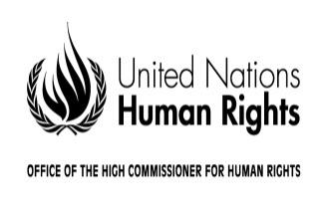
REGISTRATION FORM

Regional consultation on draft guidelines on the effective implementation
of the right to participate in public affairs
Beirut
21-22 December 2017

Mr. or Ms.
Last name _________________________________________________________________________
First name_________________________________________________________________________
Official position_______________________________________________________________________
Country/organization/institution__________________________________________________________
Passport number_______________________________Nationality______________________________
Phone ______________________________Email__________________________________________

Attends the meeting as: (please check only one box)
Expert
Government representative
Representative of a United Nations agency, fund or programme
Representative of an intergovernmental organization
Representative of a regional organization
Representative of an international non-governmental organization
Representative of a national/regional non-governmental organization
Representative of a national human rights institution

Date ______________________________ Signature __________________________________
Note: Please return this form, duly filled in, to fmorvay@ohchr.org by 16 November 2017. For further information please contact Ms. Federica Morvay at fmorvay@ohchr.org

