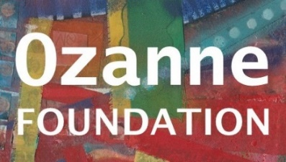
Council of Reference: Revd Dr Tina Beardsley, Nadia Bolz-Weber, Ben Bradshaw MP, Steve Chalke MBE, Sara Gillingham, Revd Ruth Gilson-Webb, Baroness Harris of Richmond, Very Revd Dr Jeffrey John, Jeremy Marks, Very Revd Prof Martyn Percy, Brandan Robertson, Prof Robert Song, Revd Dr Winnie Varghese
Trustees: Rt Revd Paul Bayes (Chair), Very Revd Dr David Ison (Vice-Chair), Anthony Archer, Philip Baldwin, Colin Blakely, Howard Dellar, Anne Foreman, Revd Canon Rosie Harper, Joy Madeiros

Victor Madrigal-Borloz
Independent Expert on Sexual Orientation and Gender Identity
December 21st 2019

Please find below my Foundation’s responses to questions (1-5) of your call for input regarding the impact of so-called “conversion therapy”.

These responses are based on the results from our 2018 UK Faith & Sexuality Survey, which generated over 4613 responses of whom 458 identified as having gone through such “therapy” in trying to change their sexual orientation. This research was overseen by an influential Advisory Board consisting of some of the most senior statistical, religious and healthcare professionals in the UK:
Dr Jamie Harrison, Chair of the House of Laity, Church of England
Rabbi Laura Janner-Klausner, Senior Rabbi to Reform Judaism
Martin Pollecoff, Chair of UK Council of Psychotherapists
Teddy Prout, Director of Community Services Humanists UK
Khakan Qureshi, Founder of Birmingham South Asian LGBT – Finding a Voice
Professor Sir Bernard Silverman, Former President of the Royal Statistical Society
Rt Revd Dr David Walker, Bishop of Manchester
The full set of results can be downloaded https://ozanne.foundation/faith-sexuality-survey-2018/

- What different practices fall under the scope of so-called “conversion therapy” and what is the common denominators that allow their grouping under this denomination?

Our results show that the term “conversion therapy” is used by individuals to cover a broad umbrella of terms – that range from private forms of action (such as prayer) through to criminalized forms of actions by others (such as forced rape).

The common denominator is “any action that is taken to try and change one’s sexuality (or indeed self-determined gender) based on a premise that who the individual believes that they intrinsically are is wrong and/or unacceptable”. In a substantial number of cases, in which there are religious practices are involved, this definition can be extended to include “sinful”.
It is therefore important to understand why people go through “conversion therapy” – either voluntarily or forced – as that shows the mindset/belief that is the premise for their actions.

Our research showed that of the respondents who gave reasons to explain why they had attempted to change their sexual orientation, nearly three quarters (72%) said it was because "I believed my desires were 'sinful’", whilst nearly two-thirds (63%) said it was "because I was ashamed of my desires". Over a half (50.8%) admitted that they "had wanted to live as a straight person" and even more (54.3%) said that it was because "my religious leader disapproved".
A quarter (25.5%) of those who responded admitted that they "did not want to be associated with LGBT people or their lifestyle" and just under a quarter (23.6%) explained that "it is not acceptable in my culture to be anything other than straight". Two out of five stated that it was because their "friends and family disapproved" (43.2%) and a similar number (43.8%) explained that they "thought it would be easier in a married <marriage> to someone of the opposite gender". Over a quarter (26.9%) had "wanted to have children with someone of the opposite gender". Worryingly, over one in nine (11.7% or 43 respondents) indicated they were "given no choice and had to undergo it".
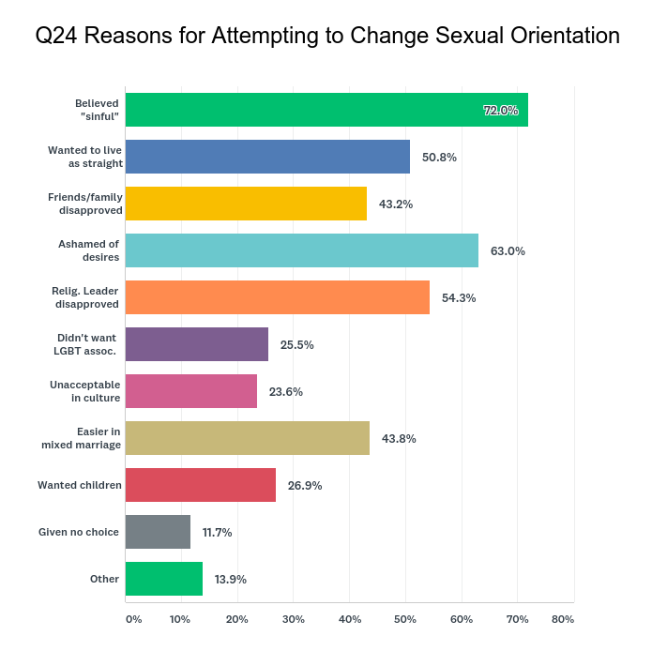
In terms of what practices respondents had undergone, the results show that tree quarters of those with experience of attempting to change their sexual orientation had tried “private prayer to change” (75.0%) while over a quarter (28.6%) had tried “prayer with friends to change”. Nearly half had tried “plea bargaining with God” (45.5%).
A variety of other activities were tried by a similar amount of people: such as various forms of "deliverance ministry" (44.4%), "emotional healing" (43.1%), forms of “psychotherapy/ counselling” (42.2%) and “voluntary sexual activity with someone of the opposite sex” (39.8%)
Of greatest concern is the fact that 6.0% of respondents to Q28 (22 people) reported that they had had “forced sexual activity with someone of the opposite gender”.
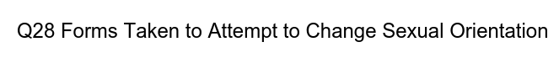
- Are there definitions adopted and used by States on practices of so-called “conversion therapy”? If so, what are those definitions and what was the process through which they were created or adopted?

When I led the 2017 debate within the Church of England that resulted in the General Synod (the Church of England’s legislative body) condemning conversion therapy and calling on the UK government to ban it, the definition that we used was taken from the 2017 UK Memorandum of Understanding, signed by a wide range of UK healthcare professionals, as follows:

“Conversion Therapy is the term for therapy that assumes certain sexual orientations or gender identities are inferior to others, and seeks to change or suppress them on that basis.”

- What are the current efforts by States to increase their knowledge of practices of so-called “conversion therapy”? Are there efforts to produce information and data on these practices?

The various versions of the UK Memorandum of Understanding organised by the UK Memorandum of Understanding Coalition against Conversion Therapy are a helpful start.
However, far more needs to be done to involve religious organisations to ensure that they are also aware of the dangers inherent in these practices. The most significant threat is posed by those religious organistions that practice various forms of healing and/or deliverance ministry. This is often done by religious leaders or “lay ministry” members - most of whom are self-taught or people who claim to have changed their own sexual orientation using conversion therapy. They therefore have little or no training in this highly sensitive area.
- What kinds of information and data are collected by States to understand the nature and extent of so-called “conversion therapies” (e.g. through inspections, inquiries, surveys)?

None that I am aware of as yet.

- Has there been an identification of risks associated with practices of so-called “conversion therapy”?

The UK Government have committed to ending conversion therapy in their 2018 LGBT Action Plan (Page 2). I declare an interest as I am part of the government’s LGBT Advisory Panel that is tasked with helping advise on the implementation of this Action Plan. This work is ongoing.

From my Foundation’s research, which was conducted with the knowledge of the Government’s Equalities Office, the following risks were identified:

i) For the vast majority, this “therapy” does not work
Just under three quarters (74% or 267 people) who attempted to change their sexual orientation said that "it did not work for me and I do not believe it works for others". A further one in six (16.6% or 60 people) said "that it seemed to work for a while but then it wore off". A total of 13 (3.6%) said that "it worked completely" and another 13 (3.6%) said that while "it did not work for me but I do believe it works for others". A couple stated they were "still undergoing "attempts to change their sexual orientation”.

ii) The practice has lasting detrimental impact on people’s lives
Of those respondents with experience of attempting to change their sexual orientation, less than a third (30.1%, 109 people) said they had "gone on to live a happy and fulfilled life". Nearly half (46.1%, 167 people) stated that "I have found it hard to accept myself for who I am".
While over half (51.1%, 185 people) said "I have gone on to have a relationship with someone of the same gender", one in seven (14.4%, 52 people) said that they had "actively chosen to remain celibate" and one in eight (12.7%, 46 people) said they had "been able to have a relationship with someone of the opposite gender”.
One in five (19.6%, 71 people) admitted that following their attempts at change they had "found it hard to have a relationship with someone of the same gender".
Significantly, well over half (58.8%, 213 people) had "suffered from mental health issues" and nearly a third (31.2%, 113 people) said "I have sought counselling to help me recover from it".
Nearly half (46.1%, 167 people) stated "I had to leave/change the faith group I was part of" and over a quarter (27.9%, 101 people) said "I had to step down from various duties within the faith group I was part of”.
Many wrote in depth under "Other" about the impact on their mental health, relationships and religious belief.
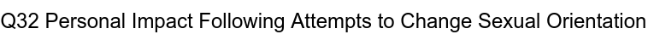

iii) The practice causes severe mental health problems
Those who indicated they had suffered from mental health issues (281 people), were asked what form(s) this had taken.
Of grave concern is that nearly a third (32.4% or 91 people) had "attempted suicide". This was more common amongst women who said they had mental health issues (34%) than men who said they had mental health issues (28.5%). In addition, two-thirds of those with mental health issues (68.7% or 193 people) said they had had "suicidal thoughts".
Two in five (40.2% or 113 people) had "self-harmed" and a quarter (24.6% or 69 people) had suffered from "eating disorders". Over half of female respondents (54.7% or 58 people) said they had "self-harmed”, which was significantly more common than male respondents (26.6% or 42 people).
The most frequent response under "Other" was the fact that respondents had been diagnosed with “Post Traumatic Stress Disorder".
iv) It has impact on people’s religious belief
When questioned about their religious belief (using a scale 1 = strongly disagree to 5 = strongly agree), those with experience of attempting to change their sexual orientation scored just as highly as those who had no experience in relation to their current levels of faith. This is because both groups scored similarly on the statements "religion/belief plays a central part in my life" (3.93 vs 4.03) and "religion/belief is a source of strength to me" (3.95 vs 3.99).
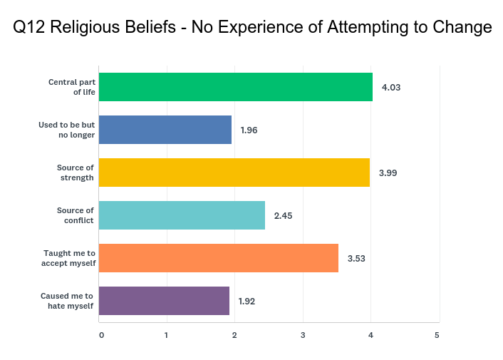
There were however four areas of significant difference. The most polarised related to the strength of agreement to the statements that "religion/belief has been a source of conflict in my life given my sexual orientation" (4.01 vs 2.45) and "my religion/belief has caused me to hate myself for being who I am" (3.13 vs 1.92). There were also significant differences in the level of agreement to the statements "my religion/belief used to play a central part in my life, but no longer does" (2.36 vs 1.96) and "my religion belief has taught me to accept myself for who I am" (3.05 vs 3.53).
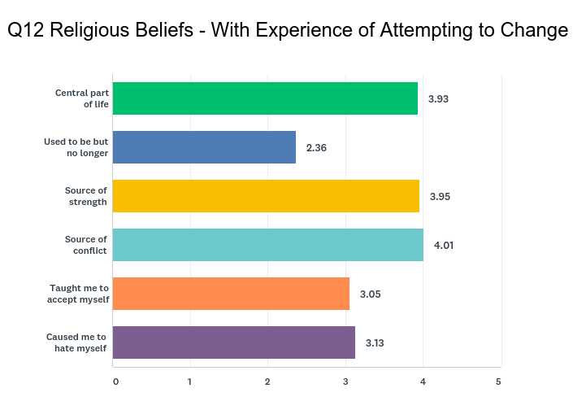

v) It has impact on people’s overall wellbeing
All respondents were asked to rate aspects of their well-being using a scale from 1 = very poor to 5 = very good. The mean scores for the group of LGBQ+ respondents for both "mental health" (3.5 vs 3.88) and "emotional health" (3.5 vs 3.87) were significantly lower than amongst heterosexual correspondents.
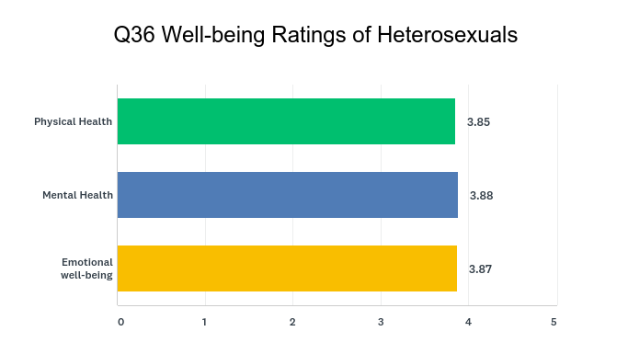
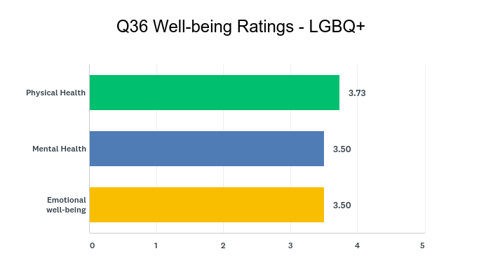

All three well-being scores were lower still amongst LGBQ+ respondents with experience of attempting to change their sexual orientation compared to those who had not attempted to change it. This was again significant for scores relating to respondents’ "mental health" (3.19 vs 3.57) and "emotional health" (3.21 vs 3.57).
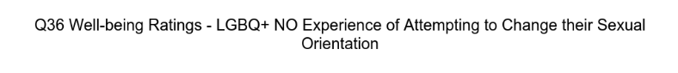
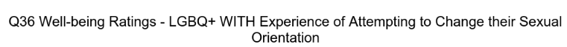
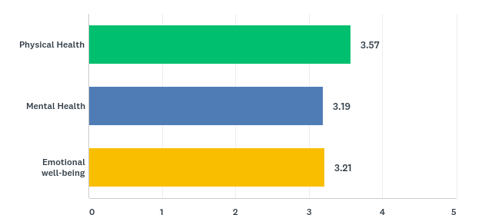
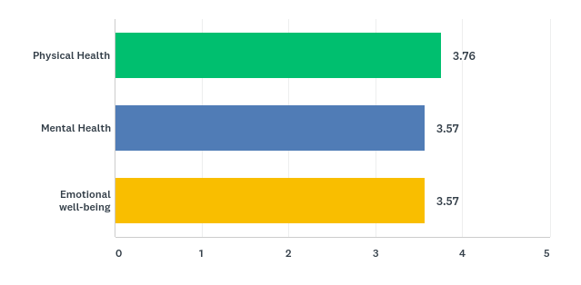

Similar differences in results were found when comparing ratings for "satisfaction of religious or spiritual life nowadays", which used a scale from 1 = very unsatisfied to 5 = very satisfied. Heterosexuals scored significantly higher (3.93) than the sexual minority groups, "gay" (3.7) and "lesbian" (3.62).
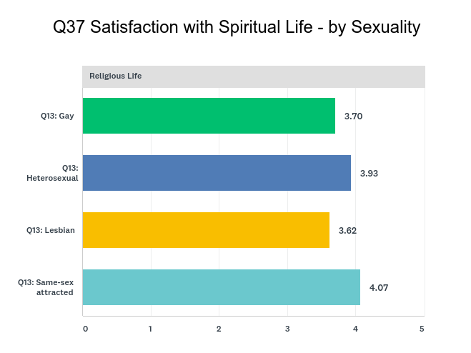
LGBQ+ respondents with experience of attempting to change their sexual orientation scored significantly lower than LGBQ+ respondents who had no experience of attempting to change their sexual orientation (3.55 vs 3.74), which itself was significantly lower still than the average heterosexual rating (3.74 vs 3.93).
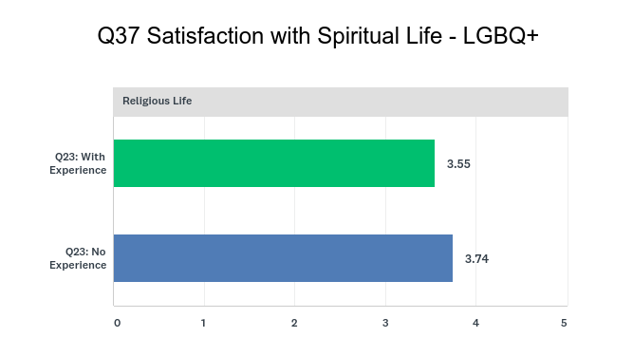

I hope that this input is useful to you. Please do not hesitate to contact me if you would like us to provide any further information, either from the UK 2018 Faith & Sexuality Survey, or our work tackling prejudice and discrimination amongst religious organisations around the world.

Yours sincerely

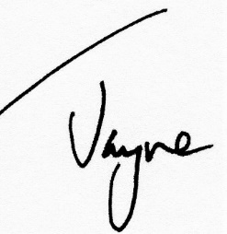

Jayne Ozanne
Director, Ozanne Foundation
jayne@ozanne.foundation
Tel +44 7944 194 691

