A/HRC/45/CRP.3
5 October 2020

English only
Human Rights Council
Forty-fifth session
14 September–7 October 2020
Agenda item 4
Human rights situations that require the Council’s attention
“There is nothing left for us”: starvation as a method of warfare in South Sudan*
Conference room paper of the Commission on Human Rights in South Sudan
Summary
Since December 2013, the armed conflict in South Sudan has provoked a dire humanitarian crisis which has led to the displacement of nearly 4 million women, men, and children. Around 1.67 million people are currently displaced internally, languishing in camps that barely meet their basic needs and subsisting on rapidly diminishing humanitarian aid. South Sudan enjoys the unenviable status of representing the third largest refugee crisis in the world, with over 2.2 million people having fled abroad as refugees and asylum seekers. At present, 7.5 million residents now require humanitarian assistance, and 1.3 million children under the age of five years are predicted to suffer from malnutrition, which is the highest rate of child malnutrition in the past four years. On-going armed conflict in Central Equatoria, Jonglei, Lakes, Unity, Western Bahr el Ghazal, and Warrap States, as well as in the Greater Pibor Administrative Area, continues to obstruct the work of humanitarian actors struggling to ameliorate the crisis. Coinciding with the outbreak of the COVID-19 pandemic in South Sudan on 5 April 2020, prices for staple foods and basic commodities have also escalated drastically, further rendering vulnerable civilians food insecure.
Over the past seven years, the brutal armed conflict has impacted mainly on the civilian population, resulting in acute food insecurity and malnutrition across South Sudan which is manifested by several causes, including both intentional and indirect factors. There has been a spike in food insecurity in Western Bahr el Ghazal and Jonglei States which is linked directly to the conflict and therefore almost entirely human-induced. Pervasive human rights violations, as well as deliberate strategies on the part of both Government and opposition forces to use starvation of civilians as a method of warfare, amounting to acts constituting war crimes, have contributed to the food insecurity in Western Bahr el Ghazal, Jonglei, and Central Equatoria States.
Recognising the need to address the crisis, signatories to the Revitalised Agreement on the Resolution of the Conflict in South Sudan largely dedicated Chapter III to humanitarian aid and, on 1 October 2019, launched a plan for the return and reintegration of internally displaced persons and refugees titled “the National Framework on Return, Resettlement and Reintegration”. Despite these commitments, the Commission notes with grave concern that implementation remains a challenge for the Government and non-State armed groups, both of which are largely ineffectual in addressing the shocking levels of hunger faced by the citizens of South Sudan.
Contents
Page
I. Introduction 4
II. Mandate 9
III. Methodology 10
IV. Applicable law 10
V. Western Bahr el Ghazal State (2016-2019) 14
VI. Jonglei State (2014-2020) 24
VII. Non-State armed groups 32
VIII. The situation of internally displaced persons 33
IX. The gendered impact of acute food insecurity 34
X. Conclusions 36
XI. Recommendations 37
Annexes
I. Map 1: The Republic of South Sudan 39
II. Map 2: Western Bahr el Ghazal State 40
III. Map 3: Locations of attacked villages in Wau Triangle 41
IV. Map 4: Jonglei State 42
V. Map 5: Flood-related cereal production losses, November 2019 43
VI. Map 6: Food security outlook update, August-September 2020 44
VII. Map 7: Protection of civilian displacement sites 45
VIII. Infographic 1: Interlinkages and impacts of malnutrition over the life cycle 46

I. Introduction
1. After decades of systematic victimisation, marginalisation, and exploitation dating back to the 19th century slave-raiding, southern Sudan has seen conflict almost constantly since the independence of Sudan in January 1956. The war of liberation was characterised by horrendous abuses, including the deliberate targeting of civilians, the denial of their means of livelihood, and the deliberate starvation of the population, all of which contributed to the South’s overwhelming vote for secession from Sudan in July 2011. A highly militarised and traumatised country and society emerged, however, and led the Sudan People’s Liberation Movement (SPLM) – a highly divided movement with limited governance experience. Intense political competition and factionalism mobilised along ethnic lines led to the fratricidal conflict that broke out in 2013, which has worsened South Sudan’s cleavages. The economy, society, and lives of the population, particularly women, have been negatively impacted as some of the worst methods of warfare and repression from the past have been replicated in South Sudan.
2. In the absence of governance and without adequate systems of accountability, South Sudan’s predatory and extractive leadership and elite have failed to rise to the challenge of nation and state building and have instead stoked divisions and diverted South Sudan’s vast oil wealth and other national resources for personal gain and for sustaining parallel political and security systems. The Government has invested disproportionally in a pervasive and repressive national security architecture, routinely curtailing political space and freedoms in order to maintain its hold on power. The formation of the Revitalised Transitional Government of National Unity (R-TGoNU) in February 2020 now provides an opportunity to fully implement the Revitalised Agreement for the Resolution of the Conflict in South Sudan (R-ARCSS). The Revitalised Agreement provides a roadmap for the challenging task of rebuilding South Sudan and reversing its deep crisis and culture of impunity, including by ensuring accountability and reparation for the violations and abuses that have characterised South Sudan’s recent conflicts.
3. Since December 2013, the armed conflict in South Sudan has provoked a dire humanitarian crisis which has led to the displacement of nearly 4 million women, men, and children. Around 1.67 million people are currently displaced internally, languishing in camps that barely meet their basic needs and subsisting on rapidly diminishing humanitarian aid. South Sudan enjoys the unenviable status of representing the third largest refugee crisis in the world, with over 2.2 million people having fled abroad as refugees and asylum seekers. On-going surges in the armed conflict accompanied by protracted insecurity have obstructed the work of humanitarian actors struggling to ameliorate the crisis.
4. Prior to the outbreak of the conflict in December 2013, more than 1.5 million people across South Sudan amounting to 17 per cent of the population faced acute food insecurity and were classified as being “in Crisis” (IPC Phase 3). At the time of writing (August 2020), an estimated 5.29 million people, accounting for more than 45 per cent of people countrywide – mainly women and children – are classified as being “in Crisis” (IPC Phase 3), or worse. Among them, an estimated 1.11 million are facing “Emergency” (IPC Phase 4) levels of acute food insecurity, while some 40,000 people in the recently flood-affected counties of Jonglei State are classified as being in “Catastrophe” (IPC Phase 5) (see paras. 117-122, below). The situation is particularly critical for children, with more than 290,000 children across South Sudan currently suffering from severe acute malnutrition, and more than one 1 million children suffering from moderate acute malnutrition. Some 352,000 pregnant and lactating women are also suffering from acute malnutrition.
5. Due to severe food shortages, malnutrition regularly compromises the natural immunity of South Sudanese women, men, and children, and increases their susceptibilities to infection and severe episodes of communicable disease, including measles, malaria, diarrheal diseases, and tuberculosis. Such diseases first affect the most vulnerable, including children, the elderly, and parturient mothers, many of whom have perished as a result of preventable deaths. At present, the Human Development Index, which measures basic dimensions of human development, ranked South Sudan as the fourth worst nation state in which to reside, at 186 out of 189 countries.
6. Over the past seven years, acute food insecurity and malnutrition across South Sudan have been the outcome of several causes, including both intentional and indirect factors. There has been a discernible spike in food insecurity in Western Bahr el Ghazal and Jonglei States which is linked directly to the conflict and therefore almost entirely human-induced. Pervasive human rights violations, including deliberate strategies on the part of both Government and opposition forces to use starvation as a method of warfare, have contributed to the food insecurity in Western Bahr el Ghazal, Jonglei, and Central Equatoria States. The historical legacy of decades of conflict in Sudan were similarly marked by pervasive human rights violations which triggered hunger and severe food insecurity, including a famine in Bahr el Ghazal in 1998. Based on the historical patterns and their consequences, parties to the current conflict should therefore have been aware that the continued perpetration of such violations would certainly again lead to the starvation of civilians.
7. In the present report, food insecurity and the lack of access to adequate nutrition are examined primarily in the context of starvation as a method of warfare, which should be understood as being distinct from situations of hunger more generally. Starvation as a method of warfare encompasses the intentional deprivation not only of food or water, but also of other goods indispensable to the survival of a civilian population. Illicit methods of warfare include depriving individuals of their ability to obtain food, degrading public health, disrupting access to clean water, and the deliberate denial of food or access to food to weaken the opposition and those populations perceived to be loyal to them. Starvation as a method of warfare consists of deprivation of the indispensable objects with the intention of starving civilians as a method of warfare. There is no requirement that anyone should have died of starvation as a result of these acts. In the words of one expert study: ‘There is no requirement that the belligerent must be seeking to attain a military advantage or advantage on the battlefield therefrom. Using starvation in order to achieve other objectives, such as “ethnic cleansing” of an area or simply to annihilate or weaken the population would fall within the prohibition’.
8. Hunger, on the other hand, could result from numerous factors (see para. 12, below). It is worth noting that a failure to fulfil the right to food or freedom from hunger does not automatically constitute starvation as a war crime, in particular if there was no deprivation of indispensable objects or where an individual did not intend to starve civilians as a method of warfare. Nevertheless, the Republic of South Sudan has international obligations under the African Charter on Human and Peoples’ Rights to respect, protect, and fulfil the right to food for all in South Sudan (see paras. 39-41, below).
9. In Western Bahr el Ghazal State, between January 2017 and November 2018, Government forces intentionally deprived the Fertit and Luo communities living under opposition control of critical resources, thereby violating the rule which protects civilians from starvation and the rule prohibiting collective punishment, and destroying their social fabric and livelihoods. Through brutal campaigns waged by then-SPLA commanders that were directed primarily against civilians residing in Wadhalelo payam, Mboro town, Ngozili, and Ngo Pere, Ngoko, and Tagoti Vimoi villages, SPLA commanders authorised their soldiers to reward themselves by pillaging objects indispensable to the survival of these rural populations, including harvests such as sorghum, cassava, and okra, and livestock including chicken, cattle, and goats. The Commission notes with concern that the timing of certain attacks and seasonality of organised violence during planting and harvest periods exacerbated the situation and led to additional months of food insecurity. Government forces further dispossessed and forcibly displaced ancestral communities of farmers and cultivators from rural lands rich in agriculture that were then expropriated to benefit communities loyal to the forces.
10. The Commission remains concerned that proxy militias under the command and control of Government forces continued this systematic pattern of attack in Western Bahr el Ghazal State. Between the signing of the Revitalised Agreement on the Resolution of the Conflict in South Sudan in September 2018 and November 2018, these proxy militias were responsible for acts that targeted and drove the displacement of communities perceived to support the opposition during attacks relating to cattle-raiding. Some of these incidents largely mirrored the pattern of attacks carried out by Government forces between January 2017 and November 2018 (see A/HRC/43/56, Annex II, paras. 13-25).
11. In Jonglei State, already by August 2014, nearly half of the 1.5 million residents were classified as “severely food insecure”. Government forces systematically denied humanitarian actors access to Akobo and Pibor Counties in Jonglei between 2017 and 2019, depriving thousands of civilians living under opposition control of objects indispensable to their survival and denying them access to food. Compounding their suffering, the residents of both locales are currently suffering the overwhelming effects of recent flooding, including extensive crop and livestock devastation (Annex V).
12. In addition to the deliberate use of starvation as a method of warfare, indirect or incidental factors contributing to the hunger of millions of South Sudanese women, men, and children primarily revolve around environmental or climatic-induced challenges (bifurcated weather seasons in a subsistence economy), including the delayed onset of seasonal rains, heavy flooding, and drought leading to poor harvests. Flooding across South Sudan in late 2019, for example, was the worst ever recorded, weakening the resilience of millions of civilians already suffering the effects of protracted armed conflict. Based on an assessment in November 2019 by the Food and Agriculture Organization of the United Nations, flooding across eight States in South Sudan has damaged 74,157 Ha out of 480,120 Ha of cultivated land and led to the loss of 72,611 tons of cereals. It is estimated that some 3 million livestock are also likely to be affected (see Annex V). While flooding in late 2019 was the most devastating on record, South Sudan has experienced periods of heavy flooding every year since 2005.
13. Moreover, due to the more recent severe flooding in August 2020, the humanitarian situation remains dire, with heightened levels of food insecurity and severe acute malnutrition across South Sudan, particularly in Jonglei and the Greater Pibor Administrative Area where over 200,000 residents have been displaced. As seasonal rains this year began earlier than last year, the situation is only expected to worsen over the coming months.
14. Beyond environmental and climactic factors, other indirect factors contributing to acute food insecurity across South Sudan include the onset of COVID-19, poor macroeconomic conditions, years of asset depletion, and large-scale conflict-induced displacement. Coinciding with the outbreak of the COVID-19 pandemic in South Sudan on 5 April 2020, prices for staple foods and basic commodities have escalated drastically. In March 2020, one month before the first confirmed case of COVID-19, the price of a 50-kilogram bag of maize grain in markets, a staple food in South Sudan, had already reportedly increased by 36 per cent. After the spread of COVID-19, the price of a kilogram of maize in Juba shot up from 159 South Sudanese Pounds (SSP) in April 2019 to 298 SSP in April 2020. These price increases have been met with demonstrations, including in Bor town (Jonglei State) by civilians who blame traders for taking advantage of the pandemic.
15. Moreover, up to 95 per cent of the South Sudanese population depends on farming, fishing, or herding to meet their food and income needs. The consequences of conflict-induced displacement and COVID-19 have had a particularly catastrophic effect on food security countrywide, in particular for agro-pastoralists whose activities are shaped by planting and growing seasons. Humanitarian actors moreover continue to face countless challenges to access communities in need, due in part to a lack of infrastructure and poor road conditions, limited connections between roads, limited food storage capacity, high transport costs including those for aid delivered by air, and persistent economic instability.
16. Recognising the need to address the crisis, signatories to the Revitalised Agreement on the Resolution of the Conflict in South Sudan largely dedicated Chapter III to humanitarian aid and, on 1 October 2019, launched a plan for the return and reintegration of internally displaced persons and refugees titled “the National Framework on Return, Resettlement and Reintegration” (see paras. 136-138, below). Despite these commitments, the Commission notes that implementation remains a challenge on both the side of the Government and non-State armed groups who are largely ineffectual in addressing the shocking levels of hunger faced by the citizens of South Sudan.
17. Over the past two and a half years, the international community has taken a series of important steps to address situations of food insecurity during periods of armed conflict. In May 2018, the United Nations Security Council adopted a thematic resolution on conflict-induced food insecurity. Security Council Resolution 2417 underlined “that using starvation of civilians as a method of warfare may constitute a war crime”, strongly condemned “the use of starvation of civilians as a method of warfare in a number of conflict situations and prohibited by international humanitarian law”, and strongly urged “States to conduct, in an independent manner, full, prompt, impartial and effective investigations within their jurisdiction into violations of international humanitarian law related to the use of starvation of civilians as a method of warfare, including the unlawful denial of humanitarian assistance to the civilian population in armed conflict, and, where appropriate, to take action against those responsible in accordance with domestic and international law, with a view to reinforcing preventive measures, ensuring accountability and addressing the grievances of victims”.
18. Similarly, on 18 December 2019, the United Nations General Assembly adopted Resolution 74/149 on the right to food, noting in part that armed conflicts are among the factors causing or exacerbating famine and severe food insecurity, and stressing the obligation of all States and parties to an armed conflict to protect civilians in accordance with international humanitarian law.
19. In December 2019, a proposal by Switzerland to the Assembly of States Parties to the International Criminal Court to amend the Rome Statute of the Court was adopted, to now include the starvation of civilians as a war crime in non-international armed conflicts (see para. 35, below).
II. Mandate
20. In its resolution 31/20 (2016), the Human Rights Council established the Commission on Human Rights in South Sudan for a period of one year. The Commission submitted its first report to the Council at its thirty-fourth session (A/HRC/34/63).
21. In its resolution 34/25 (2017), the Human Rights Council extended the mandate of the Commission for another year, and requested it to continue to monitor and report on the situation of human rights in South Sudan, to make recommendations to prevent further deterioration of the situation, and to report and provide guidance on transitional justice, including reconciliation.
22. The Human Rights Council also requested the Commission to determine and report the facts and circumstances of, to collect and preserve evidence of, and to clarify responsibility for alleged gross violations and abuses of human rights and related crimes, including sexual and gender-based violence and ethnic violence, with a view to ending impunity and providing accountability. The Council further requested the Commission to make such information available to all transitional justice mechanisms, including those to be established pursuant to Chapter V of the Agreement on the Resolution of the Conflict in South Sudan, including the Hybrid Court for South Sudan, to be established in cooperation with the African Union.
23. In its resolution 37/31 (2018), the Human Rights Council extended the mandate of the Commission for an additional year, and again in its resolutions 40/19 (2019) and 43/27 (2020). The current members of the Commission, appointed by the President of the Council, are Yasmin Sooka (Chair), Andrew Clapham, and Barney Afako.
24. The Commission is supported by a secretariat based in Juba that conducted missions to several locations within South Sudan, including Akobo, Bor, and Pibor (Jonglei), Wau (Western Bahr el Ghazal), and Juba and Yei (Central Equatoria). The Commission met with a range of victims, witnesses, government officials, members of civil society, and other key stakeholders.
25. The Commission took more than 140 detailed individual witness statements and has gathered more than 234 documents, including confidential records, covering incidents related to acute food insecurity and starvation in South Sudan since December 2013. All of the evidence collected is preserved in the Commission’s confidential database and archives.
26. The Commission extends its gratitude to the Government of South Sudan for facilitating its missions. It also appreciates the assistance and contributions of the African Union, the United Nations Mission in South Sudan (UNMISS), United Nations agencies, civil society organisations, and experts.
III. Methodology
27. The Commission submits the present report to the Human Rights Council pursuant to Council resolution 43/27. In the report, the Commission focuses primarily on establishing the facts and circumstances of incidents occurring between December 2013 and April 2020.
28. In the light of the mandate’s emphasis on accountability, the Commission also focused on establishing responsibility for violations and identifying individuals bearing responsibility for those violations and crimes. To clarify responsibility for international crimes, in particular command or superior responsibility under international law, the Commission sought to identify command structures, patterns of conduct, and indicators of control and discipline.
29. Factual determinations on specific incidents and patterns of conduct provided the basis for the legal qualification of human rights violations, crimes under the law of South Sudan and, where appropriate, international crimes, including war crimes and crimes against humanity.
30. The Commission adopted a “reasonable grounds to believe” evidentiary standard. Its work was informed by the requirement to collect and preserve evidence in accordance with a standard that would support future accountability mechanisms, including criminal accountability.
31. Where the Commission found information linking alleged perpetrators to specific violations or to patterns of violations that was sufficient to warrant future criminal investigations or prosecutions, such information was retained on a strictly confidential basis. In some instances, there was insufficient information to identify individuals responsible for violations; in such cases, the armed forces or armed groups to which these individuals belong have been identified as responsible.
32. Evidence gathered and analysed included eyewitness testimony from survivors, humanitarian actors, Government officials, and opposition officials. Evidence in the possession of the Commission also includes satellite imagery from the United Nations Institute for Training and Research - Operational Satellite Applications Program (UNITAR - UNOSAT) denoting the razing of villages.
33. The Commission employed best practices of fact-finding aimed at assuring the safety, security, confidentiality, and well-being of witnesses. Accordingly, information has been included only where sources granted informed consent and where disclosure would not lead to the identification of sources or result in harm. The Commission thanks the victims and witnesses who shared their experiences, and at all times remained guided by the principle of “do no harm”.
IV. Applicable law
34. Protection of the civilian population from starvation is a well-established norm under both treaty and customary international law and binding on all belligerents, including non-State actors. South Sudan is a State Party to the four Geneva Conventions of 1949 and its three Additional Protocols of 1977 and 2005. Of particular relevance to the non-international armed conflict in South Sudan are Common Article 3 to the Geneva Conventions, and Articles 14 and 18 of Additional Protocol II which prohibit the starvation of civilians or rendering useless objects indispensable for their survival, and the diversion of humanitarian assistance. Once the thresholds for the application of international humanitarian law have been reached, the provisions which operate to protect the victims of war continue to apply even when there may appear to be periods of calm.
35. Article 25 of the Universal Declaration of Human Rights guarantees the right to food as part of an adequate standard of living. Further, the Rome Statute of the International Criminal Court was amended in December 2019, and now includes as a war crime in non-international armed conflict intentionally using the starvation of civilians as a method of warfare. Expert studies have concluded that this could constitute a codification of existing customary international law.
36. The term “starvation” should be understood to encompass deprivation not just of food and water but also of other goods essential for survival in a particular context. The crime of starvation does not require that victims die from starvation, only that they should intentionally be deprived of objects indispensable to their survival. This may include depriving individuals of their ability to obtain food, degrading public health, and disrupting access to clean water, or deliberate denial of food and arbitrarily refusing to allow relief operations where the survival of the civilian population is threatened.
37. With regard to such relief operations in non-international armed conflict, the International Committee of the Red Cross (ICRC) Commentary on Article 18 of Additional Protocol II to the Four Geneva Conventions of 1949 states:
The fact that consent is required does not mean that the decision is left to the discretion of the parties. If the survival of the population is threatened and a humanitarian organisation fulfilling the required conditions of impartiality and non-discrimination is able to remedy this situation, relief actions must take place. In fact, they are the only way of combating starvation when local resources have been exhausted. The authorities responsible for safeguarding the population in the whole of the territory of the State cannot refuse such relief without good grounds. Such a refusal would be equivalent to a violation of the rule prohibiting the use of starvation as a method of combat as the population would be left deliberately to die of hunger without any measures being taken. Consequently this would be a violation of Article 14 of the Protocol ‘(Protection of objects indispensable to the survival of the civilian population)’.
38. The primary responsibility for meeting the basic needs of civilians lies with the party that has effective control over them. All parties to the conflict in South Sudan are bound by relevant rules of customary international law applicable in a non-international armed conflict. These include requirements that parties to such conflicts must at all times abide by the principles of distinction, proportionality, and precaution in attack. Belligerents have an obligation to ensure that civilians are humanely treated and must hold criminally accountable those individuals and entities who may be responsible for violations of this obligation.
1. Regional human rights systems and the crime of starvation
39. As a State Party, South Sudan is bound by the provisions of the African Charter on Human and Peoples’ Rights. While there is no express provision in the African Charter that guarantees the right to food, the African Commission on Human and Peoples’ Rights (“African Commission”) has stated that the “Right to food is implicitly protected under the African Charter on Human and Peoples’ Rights through the right to life, the right to health, and the right to economic, social and cultural development”. The African Commission concluded that, “The right to food is inseparably linked to the dignity of human beings and is therefore essential for the enjoyment and fulfilment of such other rights as health, education, work and political participation . . . the minimum core of the right to food requires that the government should not destroy or contaminate food sources”.
40. Addressing the obligation of a State Party to the African Charter and its primary responsibility to respect the right to food, the African Commission has ordered a State Party to cease attacks on its people, to investigate and prosecute those responsible for attacks, and to provide adequate compensation to victims and ensure that those affected have their right to food through livelihood restored. Under the African Commission’s guidelines on the implementation of economic, social, and cultural rights, States are under an obligation to guarantee the right of everyone to be free from hunger and to mitigate and alleviate hunger even in times of natural or other disasters; refrain from and protect against destruction and/or contamination of food sources; and refrain from using access to food as a political tool to reward supporters, punish opponents, or recruit militias.
41. South Sudan as a State Party to the African Charter is under an obligation to ensure that the right to food is respected and protected. The African Commission has further emphasised that States cannot invoke a civil war to justify their inability to guarantee rights protected under the Charter. In an earlier decision on Sudan, the African Commission stated that, “even if Sudan is going through a civil war, civilians in areas of strife are especially vulnerable and the state must take all possible measures to ensure that they are treated in accordance with international humanitarian law”. In a decision on Chad, the African Commission also noted that “the African Charter, unlike other human rights instruments, does not allow for state parties to derogate from their treaty obligations during emergency situations, indicating that even a civil war in Chad cannot be used as an excuse by the state violating or permitting violations of rights in the African Charter”.
42. While South Sudan has not become a party to the Protocol nor to the Amendments to the Protocol on the Statute of the African Court of Justice and Human Rights (“Malabo Protocol”), a decision to join these African Union treaties could start to address the impunity and lack of accountability for gross violations of human rights and international crimes in the country including the crime of starvation as a war crime. The Court, whose Protocol has not yet entered into force, will have international criminal jurisdiction over crimes such as war crimes, crimes against humanity, and genocide. Specifically, in the context of non-international armed conflict – applicable to the situation in South Sudan – the Protocol includes the war crime of “intentionally using starvation of civilians as a method of warfare by depriving them of objects indispensable to their survival, including wilfully impeding relief supplies” (emphasis added).
2. The Hybrid Court for South Sudan
43. The 2015 Peace Agreement in South Sudan (ARCSS) has been replaced by the Revitalised Agreement for the Resolution of Conflict in South Sudan (R-ARCSS) of September 2018, which recommits South Sudan to fully cooperate with the African Union to establish a Hybrid Court for South Sudan in order to prosecute international crimes that may have occurred in the country between 15 December 2013 and the end of the Transition Period. Like the ARCSS, the Revitalised Agreement confers on the Hybrid Court jurisdiction over genocide, crimes against humanity, war crimes, torture, crimes against persons and property, and other serious crimes under international law. Considering the fact that the Hybrid Court is an integral part of the Peace Agreement between warring parties, and its implementation a prerequisite for sustainable peace in South Sudan, the Hybrid Court presents the most realistic and credible chance to address on-going human rights violations in South Sudan, by the issuing of indictments and the conducting of eventual prosecutions for related crimes such as the war crime of starvation and crimes against humanity related to persecution (see paras.47-48, below, for more on the relevant crimes against humanity).
3. The East African Court of Justice
44. At the sub-regional level, South Sudan is a State Party to the Treaty establishing the East African Community (EAC), and its principal judicial organ the East African Court of Justice. While human rights do not comprise the main thrust of the objectives of the East African Community, they do constitute governing principles to achieve the objectives of the EAC Treaty. Article 6 of the Treaty provides for fundamental principles which should be adhered to by member states, and which are necessary for achieving EAC objectives. These objectives include good governance, democracy, the rule of law, accountability, transparency, social justice, gender equality, as well as the recognition, promotion, and protection of human and peoples’ rights in accordance with the provisions of the African Charter on Human and Peoples’ Rights. Among other requirements, Article 7(2) of the EAC Treaty obligates member states to abide by the principles of good governance, including adherence to and maintenance of universally accepted standards of human rights. Collectively, these provisions reflect the implied commitment of the EAC member states to protect and advance human rights.
45. In the case of Katabazi, the Court concluded that “it cannot ‘abdicate’ exercising its interpretive mandate, even if a matter before it contains allegations of human rights”. The Court further noted that national courts have the primary obligation to promote and protect human rights. If human rights abuses are perpetrated against citizens and the State in question shows reluctance, unwillingness, or the inability to redress the abuse, the Court reaffirmed its role to intervene in the wider interests of the EAC Treaty. Consequently, the Court proceeded to determine whether there was a violation of the fundamental principles of the EAC and found that a state party had breached the principle of the rule of law, which is a fundamental principle of the community. It especially noted that, while the principle of the rule of law is not in and of itself a human right, it is a precondition for the protection of human rights. On-going human rights violations in South Sudan, and in particular of the right to food, run counter to the objectives and goals of the EAC Treaty, which South Sudan has undertaken to uphold by becoming a State Party. The East African Court of Justice could therefore provide a potential avenue for victims of starvation to seek redress for violations of the right to food.
4. Transitional Constitution of South Sudan (2011) and national criminal law
46. At the national level, the right to food may be construed by Articles 9(3) and 11 of the Transitional Constitution of South Sudan, which guarantee both the domestic application of international human rights instruments to which South Sudan is a State Party and the right to life and human dignity. The interdependence, indivisibility, and interrelated nature of all human rights form another basis for the recognition of the right to food. The rights to life and physical integrity are also protected by South Sudan’s criminal law in several provisions of the Penal Code Act (2008), as amended by the Penal Code (Amendment) Bill (2015). The SPLA Act also grants jurisdiction to civilian courts against military personnel accused of crimes against civilians or civilian properties.
5. Crimes against humanity
47. The Draft Statute of the Hybrid Court includes the following relevant crimes against humanity when committed as part of a widespread or systematic attack directed against a civilian population: (i) deportation or forcible transfer of population; (ii) persecution against any identifiable group or collectively on political, racial, national, ethnic, cultural, religious, gender or other grounds that are universally recognised as impermissible under international law; and (iii) other inhumane acts of a similar character intentionally causing great suffering, or serious injury to body or to mental or physical health.
48. The draft legislation pending before the National Legislative Assembly would add a Section 206B to the Penal Code thereby allowing for the trial and punishment of certain crimes against humanity at the national level.
V. Western Bahr el Ghazal State (2016-2019)
1. Background to conflict and food insecurity
49. For more than seven years, Western Bahr el Ghazal State has been marred by persistent ethnic tensions that have triggered on-going armed insurgencies between Government and Sudan People’s Liberation Army in Opposition (pro-Riek Machar) (SPLA-IO (RM)) forces, induced mass displacement, and generated acute levels of food insecurity for tens of thousands of vulnerable South Sudanese women, men, and children. Prior to the outbreak of national conflict on 15 December 2013, the population of Western Bahr el Ghazal State comprised primarily the Balanda Boor (Fertit) and Luo ethnic groups, both of which represent minority communities generally perceived by the Government of South Sudan as being aligned with opposition forces.
50. Not long after South Sudan gained independence in 2011, the Government of President Salva Kiir made the controversial decision on 19 October 2012 to transfer the administrative headquarters of Wau County from Wau town to Baggari – a town 20 kilometres southwest of Wau – despite fierce objections by Fertit and Luo citizens in Wau town who were not consulted on the process. The transfer represented a significant step in the ensuing conflict in Western Bahr el Ghazal State, and was the first of a series of deliberate acts on the part of President Kiir’s Government to attempt to wrest control over, and appropriate indigenous land throughout the State belonging to other ethnic communities, effectively marginalising and displacing them. The move further emboldened neighbouring Dinka cattle keepers from Tonj (Warrap State) to migrate across the lands of Fertit and Luo communities and allow their cattle to graze on unharvested crops, rendering many among the local population food insecure (para. 57, below).
51. In response to the transfer of the administrative headquarters from Wau town to Baggari, Fertit and Luo civilians in Wau town began peaceful protests in October 2012, including on the main road between Wau and Baggari. Demonstrations lasted for two months and, as they intensified, State police shot and killed a Luo boy on 8 December 2012. The following day, civilians in Wau organised another demonstration to protest his murder. Demonstrators marched from the area surrounding the central bank in Wau towards the Government secretariat, prompting a disproportionate response by SPLA soldiers who responded with lethal force by shooting and killing at least 11 civilians.
52. Over the next six years, as SPLA-IO (RM) forces established bases throughout Western Bahr el Ghazal to protect the Fertit and Luo communities from Dinka cattle keepers and the encroachment of SPLA forces, the security situation throughout the State deteriorated considerably.
53. Conflict erupted in Wau town on 24 June 2016 with the arrival of SPLA soldiers. Witnesses described how the soldiers systematically looted the town including “everything from the door frames to window bars”, and then burned down civilian homes (tukuls). Most victims of the violence in Wau town were members of the Fertit ethnic group. The battle for Wau Town was further characterised by attacks which included sexual violence, arbitrary arrests, and murder perpetrated by members of the SPLA. The escalating violence displaced civilians who fled and sought shelter in the Wau protection of civilians site (Annex VII), as well as in other collective sites for internally displaced persons including Nazareth and Lokoloko Church in Wau. At the time, Government forces had also erected checkpoints around the area to prevent civilians from selling their wares such as sorghum and groundnuts in the market, and to extort monies from them, including at Taban checkpoint. In other instances, civilians transporting charcoal reported having to pay SPLA soldiers money or a bag of charcoal to pass checkpoints.
54. The following year, and to oust the SPLA-IO (RM) between January 2017 and November 2018, SPLA forces carried out a series of attacks (Annex III) in which they continued to perpetrate numerous violations, including the pillage of food and livestock indispensable to the survival of the local population, and the destruction and dispossession of civilian property, including the burning down of civilian homes (tukuls).
55. The cumulative effect of these brutal policies and attacks resulted in the deliberate displacement of thousands of civilians and was the primary cause of their acute food insecurity. At the time of writing (August 2020), the security situation and levels of hunger and malnutrition in Western Bahr el Ghazal State remain precarious, with tensions among ethnic groups, particularly between the Fertit and Dinka, continuing to remain high.
2. Wadhalelo payam, Jur County (January to June 2017, and June 2018)
“I do not intend to return to Wadhalelo because it is not safe and there is nothing left there for me or my family. No house, no possessions, no food. Also, the SPLA soldiers are still in the town harassing any civilians who return. Here in Wau, things are also very difficult. We do not receive any assistance from the NGOs, but at least we have been able to plant a few crops which we harvest for food.”
–Luo woman, aged 20, from Wadhalelo (October 2018).
a. January to June 2017
56. Wadhalelo payam is situated 38 kilometres southeast of Wau, to the east of the Busseri River and the west of the Jur River. The payam comprises four bomas, namely Akana, Alweno, Aturo, and Wadhalelo. During the conflict in Western Bahr el Ghazal State, Wadhalelo served as the first opposition base in greater Baggari and, consequently, the first major locale to have been attacked by Government forces. Prior to the outbreak of conflict in Wadhalelo in January 2017, the payam was home to some 6,500 civilians, the majority of whom were ethnic Luo.
57. Tensions in Waldhalelo preceded the current conflict, when Dinka cattle keepers from Tonj (Warrap State) allowed their livestock to graze on the unharvested crops of the native Luo community. As friction between the two communities escalated, a Dinka cattle keeper shot and killed a 17-year-old Luo boy. Though the reason for his murder is unknown, the incident led to Luo community members complaining to the SPLA-IO (RM) leadership that they no longer felt safe in Waldhalelo. In January 2015, SPLA-IO (RM) forces responded by setting up a base just outside of the payam.
58. For two years, between January 2015 and January 2017, civilians in Waldhalelo recalled benefitting from SPLA-IO (RM) presence and protection, and described being able to freely cultivate their land without the interference of Dinka cattle keepers. During that time, local children were also enrolled in school.
59. Safety and food security in Wadhalelo quickly deteriorated beginning late January/February 2017 with then-SPLA soldiers deployed to oust the opposition forces. The arrival of the SPLA was characterised by brutal violent attacks in which they targeted civilians, including through the pillage of their food and livestock, the destruction of property, rape and gang-rape of girls as young as 12 years old, and the deliberate displacement of thousands of civilians who fled to the bush.
60. Over the next two months, hundreds of women, men, and children remained hiding in the bush where they were deprived of access to adequate food, potable water, and shelter until SPLA members left Wadhalelo in March 2017. Government soldiers returned the following month, however, and succeeded in driving SPLA-IO (RM) forces out of Wadhalelo in April. For several days thereafter, they “looted the entire town”, stealing goats, chickens, motorcycles, bicycles, and grains, including sorghum which adversely impacted on the availability of livestock feed and effectively ensured that displaced civilians would have nothing to return to. Credible information received by the Commission indicated that the SPLA 5th Division commander was in control of these offensives.
61. After looting the payam for one week, SPLA soldiers next stationed at a base in Kubri Gedim, situated approximately 18 to 20 kilometres from Wadhalelo. Displaced civilians who returned to Wadhalelo in March 2017, however, were unable to rebuild their lives as their homes (tukuls) had been deliberately burned down by SPLA forces and their harvests destroyed and livestock looted.
62. Despite having again left Wadhalelo in March 2017, SPLA soldiers in groups of 15 or more regularly returned between April and May from Kubri Gedim to conduct what civilians referred to as “patrols”, during which time soldiers went from house to house “looting any property they could find.” SPLA soldiers raped at least four girls aged 12 to 15 years during these patrols, three of whom were gang-raped by three soldiers, and the fourth gang-raped by five soldiers. Also during the patrols, SPLA soldiers forced boys to carry sacks of sorghum back to their base in Kubri Gedim, later shooting and killing some of the boys after they had delivered the food items.
63. In response, enraged and desperate civilians who had returned to Wadhalelo increasingly began volunteering to join the SPLA-IO (RM) “as the only means to defend their community”. By May 2017, residents requested the assistance and protection of SPLA-IO (RM) forces, who in turn set up a base in the Wadhalelo primary school. According to one woman, the situation in Wadhalelo payam calmed thereafter, and SPLA-IO (RM) forces remained in Wadhalelo until June 2018.
b. June 2018
64. Renewed fighting broke out in Wadhalelo in June 2018, when SPLA forces deployed from their base in Umbili and crossed the river. Terrified civilians comprising primarily women and children began fleeing on foot, leaving all of their possessions behind including objects indispensable to their survival, such as goats, chickens, harvested crops of sorghum, groundnuts, as well as clothes, and shoes. In a pattern mirroring that of the January to June 2017 offensive, SPLA members again looted these and other objects, and again burned down all civilian homes (tukuls), many of which had been rebuilt after the January to June 2017 offensive. One displaced farmer recalled how she had a farm in Wadhalelo where she had grown groundnuts, sorghum, maize, okra, cassava, and beans, and had a successful harvest. “Now I lost everything,” she reflected. Another man displaced from Wadhalelo believed, “They want to control this area, that is why this attack happened.” Wadhalelo was officially recaptured by SPLA forces on or about 11 June 2018.
65. By 22 June 2018, SPLA forces had set up a base in Wadhalelo primary school, where the SPLA-IO (RM) were previously stationed (para. 63, above). Civilians recalled how Government forces were suspicious of the local community and used spies to report on their neighbours. As one woman explained, “When a house was pointed out [by a spy], the Government soldiers would go there, loot all of the possessions, and burn it down. Any children or family members remaining in the house were usually flogged”. In one instance, SPLA soldiers pillaged nine goats, 30 chickens, and household items from a Luo woman and her family, rendering them destitute. After pillaging the items, the soldiers began beating her, her children, and her grandmother with pieces of wood. “I was beaten so severely that my arms were all swollen, and I had scars on my back and my buttocks”, she recalled. In addition to pillaging their property and beating the civilians, on 25 June 2018 SPLA soldiers also raped a woman aged in her late 30s.
66. As of result of these attacks, hundreds of civilians were forced to flee from Wadhalelo and were displaced to a settlement in Hai Mesna in Wau where they endured inadequate living conditions and insufficient access to food and medical care, in particular those who had arrived with conflict-related injuries. Discussing the prospect of her ever returning to Wadhalelo payam, one woman noted, “If I return, and I start growing things, the soldiers will just come and take everything away again and then we need to flee again”.
3. Mboro town and Ngozili (June, August, and September 2018)
a. June 2018
67. Almost immediately after overtaking Wadhalelo payam, on 28 June 2018 Government soldiers attacked neighbouring Mboro town – inhabited primarily by Fertit civilians – with both heavy and light weaponry. As in Wadhalelo, the offensive was also reportedly led by the SPLA 5th Division commander. While some of the attackers wore SPLA uniforms, others wore civilian clothes.
68. Pro-Government forces carried out a strikingly similar pattern of attack in Mboro as they had in Wadhalelo, whereby armed soldiers did not discriminate between SPLA-IO (RM) fighters and civilians, pillaged objects indispensable to the survival of the civilian population including sacks of grain from civilian homes (tukuls), and then set the tukuls on fire. Satellite imagery analysis showed that at least 200 structures scattered across Mboro town were either damaged or destroyed during the offensive. Civilians including women and children recalled having to flee to the bush to hide.
69. In a deliberate tactic designed to weaken the community, SPLA soldiers also stole pumps that were used by locals in Mboro town to pump water from boreholes, depriving them of access to water for both consumption and sanitation. The Commission received credible information that boreholes were targeted systematically, with the vast majority destroyed or dismantled by SPLA soldiers. Proximity to roads and the fact that the SPLA knew the locations of these boreholes meant that the local population was too afraid to approach any boreholes that may have still been left intact.
70. Only days after taking over Mboro town, Government authorities declared peace in the area and announced that displaced civilians were returning to the town from Wau. In reality, however, civilian returnees – although they were originally from Mboro – had not been displaced by the recent fighting, but had been living in Wau for years, including some for decades. The authorities were staging the return of ethnic Dinkas into an area historically populated by the Fertit community. The Commission received credible information that many of these Dinka returnees were in fact relatives of Government-aligned politicians and military forces.
71. After displacing the local Fertit community and in order to prioritise the needs of the recent arrivals who were Government loyalists, Government authorities began exerting pressure on humanitarian organisations to assist the staged population movement and to provide new arrivals with food. Coupled with attacks against civilians and civilian objects in Mboro town, the ploy by the Government to relocate sympathetic populations to Mboro evinced a clear intent to displace and dispossess local Fertit communities and reengineer the ethnic demographics of the town.
72. The Commission notes with grave concern that attempts by the Government to coerce humanitarians into distributing food to certain populations and privileging them over others, including by prioritising the feeding of military members, were designed to create incentives for – and gain legitimacy in the eyes of – sympathetic populations. These actions were part of a broader, systematic strategy to prioritise the economic, social, and cultural rights of populations politically aligned with the Government at the expense of those displaced (see paras. 93-95, below).
b. August and September 2018
73. As a result of the previous attacks, numerous civilians deliberately displaced from Mboro town fled between August and September 2018 into the bush to a place called Ngozili. After hiding in Ngozili for approximately one month, Government soldiers carried out attacks against Ngozili, forcing women, men, and children who had been displaced from Mboro town to flee deeper into the bush to hide.
74. Beginning in June 2018, humanitarian organisations were constrained from moving around freely with extremely limited access in and around the Wau Triangle area, in part due to active fighting though mainly due to an intricate web of checkpoints erected by Government forces. Direct operational interference was particularly notable in Baggari, Bisselia, Bazia, and Gedi where SPLA forces turned back humanitarian convoys at checkpoints for more than two months between mid-June and late August 2018, depriving up to 28,000 people of humanitarian aid. During this period, an estimated 28,000 people in the area were in dire need of food, water, health, sanitation, and hygiene and were left without any support. After SPLA forces attacked Mboro town, around 2,000 civilians originally from Mboro fled to Ngo Pere village for safety, while others fled into the bush.
4. Ngo Pere village (September 2018)
75. After securing control over Mboro town, Government forces next deployed to Ngo Pere village in late September 2018, situated between Mboro and Ngoko village. Prior to being attacked, Ngo Pere had inhabited some 1,000 residents from the Ngolo tribe and was sheltering approximately 2,000 civilians who had fled Mboro. Residents from Ngo Pere village described to the Commission the richness of their agricultural land and 2018 harvests, in particular groundnuts. One woman recalled how she and her husband had collected over 50 kilograms of groundnuts by October 2018 which they had kept inside of their home, and which SPLA forces had pillaged. Describing the reason that SPLA soldiers attacked Ngo Pere village, she stated “I believe that’s the main reason they came to Ngo Pere, to take our harvest”. “Everyone knows they do this. There were no rebels in Ngo Pere; the SPLA wants to capture these areas and take the harvests that the civilians have gathered”.
76. Concerning the day of the attack, another resident recalled how she was asleep in her home (tukul) with her husband and five children when they were awoken by the sound of gunshots, military vehicles, and Land Cruisers at approximately 6.00 a.m. on an October morning. SPLA soldiers began “shooting at people” and “firing into people’s homes.” Two of her sons aged 7 and 10 years were killed by what she described to be a “bomb blast”, and at least one other 5-year-old boy was killed by indiscriminate gunfire.
77. The attacks forced the displacement of hundreds of civilians to Lokoloko IDP camp in Wau town, where they lacked access to adequate food and shelter. By October 2018, 9,101 individuals and 513 households had arrived in the Lokoloko IDP camp, including those displaced from Ngo Pere.
5. Ngoko village (October 2018)
78. Continuing their pattern of systematic attacks in the preceding months, SPLA soldiers next attacked Ngoko village on 3 October 2018, having come from the direction of Mboro town and Ngo Pere village. Residents described how Ngoko was a civilian area, with no opposition presence.
79. In Ngoko, SPLA soldiers also burnt down houses, pillaged the year’s harvest, and set fire to the neighbouring bush to where civilians had fled. They also burnt to the ground the local market in Ngoko, which had served as the last sizeable market in the area of Greater Baggari. Items looted from civilian homes by SPLA soldiers included objects indispensable to their survival, such as farming products and foodstuffs including honey and cassava. Many residents from Ngoko fled to Ngo Villa, some 28-30 kilometres away, while others fled into the bush and to Wau town. Discussing the reason for the attack, one man displaced from Ngoko noted, “I believe the attacks on places like Ngoko were because the SPLA wanted to get their hands on the harvest. We saw them bringing back looted bags with groundnuts and other agricultural products into Wau”.
80. Hundreds of civilians displaced by the foregoing attacks fled to a makeshift shelter at Toby Primary School in Wau. Over 10 days, between 7 and 17 October 2018, the number of IDPs from Ngoko, Ngo Pere, and Mboro sheltering in the Toby primary school in Wau increased from 80 to 620.
6. Tagoti Vimoi village (November 2018)
81. Tagoti Vimoi is a small village in Western Bahr el Ghazal State which comprised roughly 500 inhabitants prior to having been attacked on 5 November 2018. The village was mostly comprised of civilians from the Fertit ethnic group. It is located between Birinji, Baggari town, and Ngo Baggari, to the southwest of Busseri. The area is very rich agriculturally, with usual crops including tomatoes, sweet potatoes, “sim sim” grain, sorghum, and groundnuts. Residents recalled harvesting the crops for both consumption and sale.
82. Two days prior to the attack by SPLA soldiers, approximately 16 soldiers were deployed to Tagoti Vimoi village on 3 November 2018 to conduct reconnaissance. SPLA soldiers dressed in green uniforms bearing the flag of South Sudan entered Tagoti Vimoi and approached a woman, asking her where her husband was. After telling her “We know you are all married to rebels”, they began beating her with their rifles until she bled. The soldiers also stole 12,000 South Sudanese Pounds from her and some of her clothing. They next took her baby’s clothing off and, when they saw she was a girl, they returned her to her mother exclaiming that they would have killed her child if she had been a boy.
83. Following the reconnaissance missions, SPLA soldiers launched their attack on Tagoti Vimoi between approximately 5.00 and 7.00 a.m. on 5 November 2018. The Commission was told that there were no opposition fighters in the village at the time of the attack. Witnesses recalled hearing heavy vehicles preceding the attack, forcing some residents to flee into the bush.
84. As they fled, one witness recalled hearing soldiers screaming, “'Shoot them, catch them! Shoot them, catch them!” Some men and a woman were apprehended by SPLA soldiers and taken to a Government base in Ngo Baggari. At least one woman and a deaf man were shot and killed during the attack.
85. In order to deter civilians attempting to flee on bicycles and motorbikes, soldiers in uniform were stationed along the road leading from Bagarri to Tagoti Vimoi and they looted the civilians’ motorbikes and any possessions that they were carrying. Those who were able to flee described hiding behind a hill and watching SPLA soldiers go in and out of tukuls and collecting sacks of harvested crops, including groundnuts and dried okra, and laying them on the ground outside. They also stole dozens of chickens and goats. After plundering civilian possessions, they ransacked the village setting “each of the tukuls on fire,” and carried the plundered sacks of grain and other possessions to a location near a stream close to the village.
86. Displaced civilians recalled trekking through the bush for two days before arriving at the Lokoloko IDP settlement in Wau, where living conditions were totally inadequate to meet their basic needs. For example, one displaced woman at Lokoloko described how, despite an international humanitarian organisation providing modest amounts of porridge flour, she still did have not access to food for days at a time. In order to generate money to purchase their own food and support their families, many of the displaced women in Lokoloko were forced to collect firewood and grass which they sold near the entrance of the settlement.
87. Underscoring the level of pillage of foodstuffs that occurred in Tagoti Vimoi village, one resident displaced to Lokoloko told the Commission, “Even here at Lokoloko in Wau, we regularly see Government military vehicles coming from the direction of Tagoti Vimoi and Baggari, laden with sacks of food items, including sweet potatoes and grain. Where do they get these food items from? Do the soldiers cultivate and harvest these crops? Do they have farms?”
7. Violations and alleged crimes: findings
88. The Commission has reasonable grounds to believe that Government forces systematically attacked, pillaged, destroyed, and rendered useless objects indispensable to the survival of the population in Western Bahr el Ghazal. Denying access to food was used as an instrument to target and punish communities perceived to be non-aligned and supportive of the SPLA-IO (RM) forces (i.e., the Fertit and Luo communities), while rewarding Government soldiers by allowing them to retain provisions stolen and looted from these communities.
89. Specifically, these acts were contrary to Article 14 of Additional Protocol II which prohibits the starvation of civilians as a method of combat, Article 18 which guarantees civilians access to humanitarian relief, and could constitute crimes under Article 8(2)(e)(xix) of the Rome Statute of the International Criminal Court which now includes as a war crime in non-international armed conflict intentionally using starvation of civilians as a method of warfare. Although South Sudan is not party to the Rome Statute, war crimes could still be prosecuted through a Security Council referral, or in those States which already include a similar war crime of starvation in their national criminal law.
90. These acts were further contrary to Article 25 of the Universal Declaration of Human Rights which guarantees a right to food as part of an adequate standard of living. While there is no express provision in the African Charter on Human and Peoples’ Rights which guarantees the right to food, the African Commission on Human and Peoples’ Rights has stated that the “Right to food is implicitly protected under the African Charter on Human and Peoples’ Rights through the right to life, the right to health, and the right to economic, social and cultural development”.
91. At the national level, the right to food may be construed by Articles 9(3) and 11 of the Constitution which guarantee both the domestic application of international human rights instruments to which South Sudan is a state party and the right to life and human dignity.
92. Based on the evidence in its possession, the Commission concludes that sufficient evidence exists to hold members of Government forces accountable under international and national laws for the crime of starvation of civilians used as a method of warfare by depriving them of objects indispensable to their survival.
93. The Commission also finds reasonable grounds to believe that these violations formed part of a widespread or systematic attack directed against the civilian population in Western Bahr el Ghazal State. Sustained attacks carried out against numerous towns and villages across Western Bahr el Ghazal State over the course of a number of years resulted in significant numbers of deaths, rapes, and the destruction, arson, and looting of properties. The resultant physical and food insecurity left civilians with no alternative and compelled them to flee to safety elsewhere.
94. As such, these crimes may also amount to the crime against humanity of deportation or forcible transfer under Article 3(d) of the Draft Statute of the Hybrid Court for South Sudan. Furthermore, the targeted nature of the attacks, along ethnic lines, due to perceived support for the opposition, may amount to the crime against humanity of persecution along political and/or ethnic grounds under Article 3(h) of the Draft Statute of the Hybrid Court for South Sudan.
VI. Jonglei State (2014-2020)
1. Background to conflict and food insecurity
95. Fighting in Jonglei State erupted almost immediately after the armed conflict had broken out in Juba on 15 December 2013. Within days, on 18 December, opposition forces reportedly led by the SPLA 8th Division Commander attacked Panpandiar and Malual-Chaat military camps near the Jonglei State capital of Bor town. Days later, on 22 December at approximately 4.00 a.m., Government forces arrived in Bor. Civilians split along ethnic lines, with the Nuer fleeing to the protection of civilians site at the compound of the United Nations Missions in South Sudan (UNMISS) (Annex VII). Dinka residents fled to Goluar, while some Lou Nuer youth (“White Army”) descended upon Bor and began organising themselves to coordinate a counterattack.
96. By approximatively 8.00 a.m. on 22 December 2013, the Lou Nuer youth defeated Government soldiers, forcing their retreat to Gut-Makur village, home to Dinka Bor cattle camps. The clashes displaced tens of thousands of civilians who consequently fled to the UNMISS protection of civilians site. By 22 December 2013, more than 20,000 civilians had been displaced from Jonglei State to neighbouring Lakes State, where most lacked access to adequate food, potable water, shelter, and medicine. At around the same time, SPLA soldiers reinforced by the Ugandan People’s Defence Forces defeated the Lou Nuer youth in Bor.
97. The Commission received credible information that, on or about 21 February 2017, SPLA Division 1 forces led by the Lieutenant General launched an attack in northern Jonglei, including against Yuai town (Uror County). SPLA forces embarked on a brutal campaign in Yuai town, attacking the civilian population and destroying the town including through the pillage and destruction of civilian property. As recalled by one witness, “When the soldiers were raiding the town, they didn’t differentiate between the humanitarians, civilians, or soldiers”. SPLA Division 1 soldiers set fire to civilian homes (tukuls) and razed maize and millet that civilians had harvested and stored. They also looted cattle, killed civilians, and raped at least two women.
98. Owing to the scale and severity of the attacks, civilians fled en masse towards Mwot Tot and Pieri, with those who were “willing to side with the Government” remaining behind. As they fled, Government soldiers in armoured personnel carriers with machineguns mounted on top chased them towards Mwot Tot, and fired at them.
2. Waat village, Uror County (April 2017)
“People in Waat are not engaging in meaningful agriculture because Government soldiers are stationed in the area”.
—Male farmer, aged 48 years, from Waat village (September 2019)
99. Coinciding with the arrival of Government forces in Yuai town, fighting in then-opposition controlled Waat village also began in February 2017. Government forces entered the village in vehicles and opened fire on residents, forcing fearful civilians to flee “in every direction”. Some civilians fled to Akobo County and sought shelter near the Commissioner’s residence before being transferred to the protection of civilians site in Bor.
100. The battle for control over Waat lasted approximately two months, before Government soldiers were finally able to capture the village in April 2017. Recalling the devastation wrought upon Waat, one man noted that Government forces “destroyed everything”. Attacks against civilian property included attacking the compounds of at least four international non-governmental organisations. These operations were further characterised by the looting of these and other properties, including of generators, vehicles, and food stores from humanitarian compounds such as nutritional items from an international non-governmental organisation warehouse. Government forces also destroyed hospitals, medicine stores, and beds. Speaking to the devastation, one woman recalled, “All houses and crop stocks were burnt and destroyed”. In April 2017, Government soldiers also looted the warehouse of an international organisation in Akobo West.
101. In complete violation of the obligation under the Cessation of Hostilities Agreement of December 2017, which required parties to facilitate unfettered access for humanitarian assistance and to guarantee the safety and security of all humanitarian personnel, and the reiteration of these commitments in the Revitalised Agreement on the Resolution of the Conflict in South Sudan of September 2018, 760 incidents or violations of humanitarian access were reported to the United Nations Office for the Coordination of Humanitarian Affairs (OCHA) in 2018, 134 of which occurred in Jonglei State, including incidents involving targeted violence against humanitarian personnel and assets.
3. Akobo County (2014-2020)
“As soon as the peace is back, everybody will go back home and start cultivating”.
—Nuer man, aged 58 years, from Akobo (December 2019)
102. Bordering Ethiopia, Akobo County is approximately 450 kilometres from Juba. One of the 11 counties that make up Jonglei State, Akobo County comprises the Akobo East and Akobo West geographic divisions. Prior to the onset of armed conflict in December 2013, businesspersons and traders were able to freely move goods into Akobo County. Goods including vital foodstuffs were imported from neighbouring Ethiopia by boat, however, given the poor road conditions, which also made it difficult to connect Akobo to more urban hubs such as Bor, Juba, and Malakal. Akobo County fell under opposition control in 2014, and has been an SPLA-IO (RM) stronghold since that time.
103. Beginning in early 2014, and as conflict and insecurity escalated throughout various pockets of Jonglei State, civilians residing in Akobo and its environs relocated to the centre of the County and, as the population numbers swelled, access to adequate food correspondingly declined. Given the poor condition of the roads surrounding Akobo County and the influx of people increasing the number of residents, civilians described to the Commission how businesspersons and traders began marking up the prices of food items to cover their import and transport expenses, making it difficult for many residents to afford even basic dietary staples (see para. 108, below). In response to the crisis, a succession of aid organisations began providing humanitarian assistance, though Government forces have systematically and arbitrarily denied them access to civilians in Akobo since at least April 2017 (see para. 107, below).
104. At the time of writing (August 2020), civilians in Akobo County suffer from two levels of food insecurity. Akobo East is designated under the Integrated Food Security Phase Classification (IPC) as Phase 3, denoting that civilians are suffering from “Crisis” levels of food insecurity, and that households suffer from high or above-usual acute malnutrition. As per the IPC, food was to be delivered by international actors to Akobo East every 90 days. When Government forces attacked northern Jonglei, however, they also looted food items which led to a decision by the United Nations agency to deliver food to Akobo East every six months, instead of every three months, though deliveries are often further delayed. The situation in Akobo West is more dire, and therefore food is delivered there on a monthly basis. One reason for this difference is that Akobo East borders the Sobat River which provides modest access to fishing.
105. The Commission heard from numerous residents throughout Akobo that for years Government forces had been arbitrarily denying residents access to vital foodstuffs. In September 2016, for example, a trader attempted to take commodities from Juba to Akobo by air, including 20 bags of sugar, 10 bags of rice, 10 bags of salt, and 15 cartons of oil. Five National Security Service (NSS) officers armed with AK-47s and pistols stopped him at Juba International Airport, and told him that he was “prohibited from transporting goods to a rebel-controlled territory”. They further threatened to kill him if he did not leave his supplies with them.
106. Similarly, in July 2019, a man from Akobo attempted to bring medicine from Juba to Akobo to sell in the local market when NSS officers confiscated the medicine at Juba International Airport. Also in 2019, another trader from Akobo attempted to bring goods including sugar, salt, oil, millet, and onions from Juba to Akobo. He was stopped by Government soldiers in Potap, located between Bor and Yuai, and accused by the soldiers of being “the enemy”. The soldiers looted all of goods. In September 2019, another trader travelled to Juba to bring goods to Akobo. After he converted his money from South Sudanese Pounds to United States Dollars, NSS officers stole $1,800 USD from him, making it impossible for him to return to Akobo with any food items.
107. Aside from blocking traders and businesspersons from transporting vital foodstuffs and medicine into Akobo, Government forces have also systematically restricted humanitarian actors from bringing food into Akobo via road. In April 2017, for example, Government forces stopped a convoy that was transporting food to Akobo and looted the food on-board. The Commission received credible information that members of the SSPDF Division 8 were responsible for blocking the roads leading into Akobo, and preventing humanitarian vehicles from Juba passing through Bor to deliver food to Akobo. In April 2018, a United Nations agency convoy was bringing food to Akobo when SPLA Division 8 soldiers stopped it at the Thardiok checkpoint in Yuai County. The soldiers ordered the humanitarians to offload some of the food and forced the convoy to turn around. Between February and March 2018, as the convoy of a non-governmental organisation was attempting to transport beans, oil, and sorghum from Juba to Akobo, Government soldiers refused to let the convoy proceed to Akobo once it had passed Bor.
108. Traders who are able to obtain commodities do so by travelling long distances by road to get food into Akobo, and in turn have been forced to charge residents exorbitant prices to recover their expenses. For example, civilians described how, prior to the conflict, sugar in Akobo used to cost 6,000 to 7,000 South Sudanese Pounds (SSP), and currently costs 15,000 SSP. A tin of powdered milk used to cost 150 SSP, and now costs 10,000 SSP. A cup of tea in the local market used to cost 3 SSP, and now costs 60 SSP. When available, the prices of other basic commodities such as oil, rice, and sorghum have also increased. 50 kilograms of sorghum now costs 15,000 SSP. Beyond vital foodstuffs, one head of cattle cost 1,000 SSP in 2014, and has now skyrocketed to 80,000 SSP a head.
109. Due to the unlawful restrictions placed by Government forces on food and supplies, civilians in Akobo described having to rely on food delivered from Ethiopia, though it regularly arrives with three to four-month delays given the use of boats. Bags of sorghum, for example, are delivered via boat and enter Akobo through the Ethiopian corridor. One international non-governmental organisation supplies food from Djibouti, which is first flown to Ethiopia and then arrives in Akobo via the Sobat River. Other locations in Jonglei State have received food in a more timely manner as a result of the use of humanitarian airdrops, including in Kaikwai and the areas up to Uror and Nyirol Counties. When food is airdropped in Government-controlled areas, however, civilians from opposition-held areas in Jonglei State have been killed by Government forces when they attempted to access it. At the time of writing (August 2020), most households in Akobo have resorted to consuming only one meal per day.
110. Beyond access restrictions, numerous civilians described to the Commission how residents in Akobo County stopped cultivating their land due to insecurity and fear of conflict. As one man noted, “There is no food at all because of fear to cultivate. People are displaced and have no place to do so. They are depending only on humanitarian aid. Besides, the Government does not accept food to come to [opposition] controlled areas”.
111. Acute food insecurity throughout Akobo County has created thousands of refugees and persons internally displaced, many who had fled to the protection of civilians site in Bor operated by UNMISS, which currently hosts over 1,920 displaced persons (Annex VII). Civilians internally displaced explained to the Commission how acute food insecurity and insecurity due to conflict are preventing them from returning to their homes. One man noted that, “We are concerned that if this peace does not hold, the Government will work hard to capture Akobo again”.
112. Furthermore, given unusually high levels of flooding in Jonglei State (Annex V), numerous humanitarian projects were put on hold. Flooding has also caused the death of numerous cattle, destroyed crops, and driven displacement. Numerous other civilians have fled from Akobo to refugee camps in Ethiopia due to conflict and food insecurity. As described by one man, “Civilians have no choice but to try to go to the refugee camps for food.
4. Lokomai payam, Pibor County (November 2018)
113. The Commission notes that Government forces have not been the sole party responsible for violating the rights of vulnerable civilians to access humanitarian aid (see paras. 128-131, below). On 25 November 2018, for example, a United Nations agency organised a delegation to Lokomai payam in Pibor County to distribute food. After successfully delivering the food, members of the Murle community from Lekuongole payam attacked the convoy, killing 27 people including local staff contracted by the agency. They also looted food items from the convoy, including sorghum, flour, oil, and beans.
114. The Commission received credible information that David Yau Yau, former Governor of the “Greater Pibor Administrative Area” and himself a member of the Murle community, supplied Murle civilians in Jonglei State with weapons including AK-47s (“Kalashnikovs”), PK machine guns (PKMs), rocket-propelled grenades (RPGs), and ammunition. After the 25 November 2018 incident, humanitarian actors have been reticent to service Lokomai.
5. Pibor County (2019-2020)
“There is almost no food in Pibor”.
—Woman, aged 35 years, from Pibor town (23 January 2020)
115. Pibor County lies to the southeast of Akobo County near the border with Ethiopia and is situated some 340 kilometres from Juba. It is amongst the most underdeveloped areas of South Sudan. Owing to the unlawful humanitarian access restrictions by Government forces beginning in 2014, an international non-governmental organisation deployed staff to Pibor beginning in 2015, to cover Pibor centre, Pibor North (Manuandekel), Pibor South (Kulugur and Tangajon), and Verteth, Gumuruk, and Lekuongole payams. While the organisation does not have physicians on the ground, its staff have the capacity to intervene in matters regarding malnutrition. Also since 2015, nutrition programmes funded by one United Nations agency have provided assistance to children and lactating mothers who exhibited symptoms of severe acute malnutrition.
116. The population of Pibor South comprises approximatively 5,000 households, while Pibor HQ County is made up of some 600 households. As acute food insecurity deepened between 2014 and 2018, residents in Pibor South began receiving food and supplies from international humanitarian aid organisations in 2018, though the provisions have been insufficient to meet their needs, including between January and March 2019, for example. Residents in Pibor South did not receive any aid deliveries between May and July 2019.
117. Exacerbating the catastrophic situation in Jonglei State, devastating floods between August and October 2019 which included some of the worst ever recorded in South Sudan affected at least 11 counties in Jonglei and had an adverse effect on the already fragile situation of food insecurity throughout the area, including throughout Pibor County (Annex V). Due to abnormally heavy rains and high levels of seasonal flooding, President Salva Kiir declared a state of emergency on 29 October 2019 which covered 30 counties, including in Jongeli State. After concluding a visit to Pibor, on 8 November 2019, the United Nations Humanitarian Coordinator in South Sudan made an appeal for $61.5 million USD which was “urgently required to save lives, ensure the continuity of the response following the peak period and protect humanitarian gains made in 2019 from being lost”.
118. One farmer described to the Commission his life before and after the floods, noting, “I usually cultivated vegetables like tomatoes, okras, amaranths, greens, onions, and eggplants at Pibor Kengen River during dry seasons, and at home during rainy seasons. The small money I gained fed my family and [I was able to send my] children to school. During the flood, I lost it all”. Another farmer made destitute by the floods echoed this sentiment.
119. Residents in Pibor County also described to the Commission how humanitarian assistance has been completely inadequate to address the crisis caused by the floods, with one resident having described how “NGO assistance is very slow in food distribution”. At the time of writing (August 2020), communities in Pibor are being assisted by a local health service which lacks adequate medicine and is therefore too constrained to serve other areas in need. Elevated levels of hunger and the loss of livestock due to the flooding in late 2019 are further driving incidents of cattle-raiding, including in Pibor North and South, and drove incidents of looting by local communities of humanitarian organisations in October 2019.
120. By August 2019, Jonglei State had the highest concentration of individuals across South Sudan estimated to be in “Crisis” (IPC Phase 3) or worse acute food insecurity, involving around 1.25 million people. Cases of malnutrition throughout Bor, for example, had become so recurrent and pervasive that specialised clinics funded by international non-governmental organisations and United Nations agencies were set up to address the crisis. Even though children with severe acute malnutrition are examined in these clinics every morning and their weights recorded and monitored, dozens of boys and girls have died in Bor from underlying malnutrition-related causes.
121. By late January 2020, levels of severe acute malnutrition had arisen among children, parturient mothers, and lactating mothers in Pibor, increasing the susceptibility to infant mortality. Also by late January 2020, numerous communities throughout Pibor town lost their homes due to the flooding and were living outdoors under trees. As farmers ceased cultivating due to the floods, the prices of food products including basic commodities skyrocketed in the Pibor market due both to their unavailability within Pibor, and because the transportation of vital foodstuffs from Juba was only possible by air. One kilogram of sugar in Pibor town now costs 1,000 SSP, compared with 300 SSP prior to the flooding. One kilogram of beans is now 1,500 SSP compared to 500 SSP before, while a small cup of tea has tripled in price to 300 SSP from 100 SSP. There is, moreover, a severe shortage of oil, flour, sugar, and salt.As described by one man, “The whole community including the youth are starving”. In late January 2020, a mother similarly complained, “I am starving now with five children because there is no food in Pibor”. Compounding civilian suffering, nearly 25 per cent of livestock in Jonglei State are estimated to be affected by the floods (Annex V).
122. The flooding has also damaged water points essential for the survival of civilians throughout Pibor County. The lack of potable water throughout the County has driven residents to drink water directly from the Pibor River, increasing their susceptibility to communicable disease. Moreover, in Pibor town, floodwaters contain the floating corpses of bloated dogs. The most prevalent communicable diseases currently affecting residents in Pibor include malaria, pneumonia, typhoid, and tuberculosis.
6. Violations and alleged crimes: findings
123. The Commission has reasonable grounds to believe that Government forces deliberately and systematically attacked, destroyed, and rendered useless objects indispensable to the survival of the civilian population in Jonglei State. The denial of access to food and essential services was used as an instrument to target and punish non-aligning communities and in particular those deemed to support the SPLA-IO (RM) forces.
124. Under international law, deliberately impeding the passage of humanitarian aid or diverting such aid may amount to a war crime or, depending on circumstances, a crime against humanity. Based on the evidence in its possession, the Commission has reasonable grounds to believe that access restrictions and denials followed a consistent pattern whereby civilians were deliberately denied humanitarian aid in Jonglei State, amounting to the war crime of making persons or objects involved in humanitarian assistance the object of attack, and using the starvation of civilians as a method of warfare by depriving them of objects indispensable to their survival, including by impeding relief supplies.
125. The actions taken by the Government forces were also contrary to customary international humanitarian law which requires parties to the conflict to “allow and facilitate rapid and unimpeded passage of humanitarian relief for civilians in need, which is impartial in character and conducted without any adverse distinction, subject to their right of control.” All parties to an armed conflict are under a legal obligation to allow and facilitate the unimpeded passage of humanitarian aid.
126. Article 18(2) of Additional Protocol II, applicable in the South Sudan context, provides that “If the civilian population is suffering undue hardship owing to a lack of the supplies essential for its survival, such as foodstuffs and medical supplies, relief actions for the civilian population which are of an exclusively humanitarian and impartial nature and which are conducted without any adverse distinction shall be undertaken subject to the consent of the High Contracting Party concerned”. This consent must not be arbitrarily withheld.
127. Based on the information collected, the Commission has reasonable grounds to believe that sufficient evidence exists to hold to account members of Government forces under international and national laws who have pursued policies and actions amounting to starvation as a method of warfare in Jonglei State. In addition, there are commanders who could be held accountable under international law for failing to prevent or punish the international crime of starvation of the civilian population as a method of warfare.
VII. Non-State armed groups
128. The Commission underscores that both Government and SLPA-IO (RM) forces have deliberately and intentionally interfered with the capability of international humanitarian aid organisations to deliver vital foodstuffs to communities in need, including through the arbitrary detention of humanitarian aid workers. Across South Sudan, at least 117 humanitarian actors were detained for prolonged periods in 2018. Two such incidents occurred in Central Equatoria in March and April 2018, both involving SPLA-IO (RM) forces. In March 2018, a humanitarian convoy of three vehicles was stopped and seven aid workers detained for almost three weeks. The following month, another convoy involving four non-governmental organisations and two United Nations agencies was intercepted on the Yei-Tore road and 10 humanitarian aid workers were detained by SPLA-IO (RM) forces for six days. In both instances, the convoys had obtained relevant clearances from both the SPLA and the SPLA-IO prior to travel, though were detained by SPLA-IO (RM) forces who accused them of spying for or collaborating with the Government.
129. Throughout 2018, at least 15 humanitarian aid workers were also killed while delivering assistance, including by non-State armed groups, adding to the totality of deaths of around 97 aid workers since the onset of conflict in December 2013. Moreover, more than 575 humanitarian staff were relocated due to insecurity. Bureaucratic and operational interference continues, including in areas under the control of non-State armed groups, hampering the delivery of critical health and nutrition services.
130. Based on the evidence in its possession, the Commission has reasonable grounds to believe that both of the previous incidents were in violation of customary international humanitarian law which requires parties to the conflict to “allow and facilitate rapid and unimpeded passage of humanitarian relief for civilians in need, which is impartial in character and conducted without any adverse distinction, subject to their right of control”.
131. The Commission further has reasonable grounds to believe that sufficient evidence exists to hold to account members of the SPLA-IO (RM) under international and national laws for the crime of starvation of civilians used as a method of warfare by arbitrarily denying humanitarian aid to populations in need in Central Equatoria, including by arbitrarily denying objects indispensable to their survival.
VIII. The situation of internally displaced persons
132. Chapter III of the Revitalised Agreement on the Resolution of the Conflict in South Sudan lays out broad provisions concerning humanitarian assistance and reconstruction. The Government of South Sudan, however, continues to outsource its responsibilities towards internally displaced persons – citizens of South Sudan – to humanitarian aid organisations and international donors, offering limited and in many instances no assistance to address the devastating humanitarian crisis it has created. Non-State armed groups including SPLA-IO (RM) forces have similarly done little to provide support to displaced persons, while in many instances actively and deliberately hindering the work of humanitarian organisations and harassing their staff.
133. At the time of writing (August 2020), more than 1.67 million people remain internally displaced across South Sudan. Civilians displaced at the start of the conflict in December 2013 are now entering their eighth year of displacement, many of whom have experienced multiple displacements. As at June 2020, the United Nations Mission in South Sudan was sheltering 181,231 internally displaced persons in its protection of civilian sites in Bentiu (Unity State), Juba (Central Equatoria State), Malakal (Upper Nile State), Bor (Jonglei State), and Wau (Western Bahr el Ghazal State), of which Bentiu is by far the largest (Annex VII).
134. Those residing in protection of civilian sites generally face grim living conditions, as these sites are overcrowded, with civilians having limited options to earn an income. Adverse weather conditions related to rainy seasons, and epidemics and communicable diseases such as measles and cholera further exacerbate their struggles. Infrastructure is often ill-suited for encamped residents with disabilities. Moreover, after over six years in protection of civilian sites, women and girls have been made to walk farther and farther into the bush to collect firewood to eke out a modest income or for cooking, greatly increasing the risk of sexual assault.
135. The Commission notes with concern that numerous civilians displaced in protection of civilian sites are increasingly lamenting the fact that humanitarian aid to these sites has been diminishing, particularly in Bor (Jonglei State). Decreases in humanitarian aid in Jonglei State are due in part to donor fatigue. The situation in the protection of civilian sites is even more difficult for those most vulnerable such as children, elderly persons, persons with disabilities, and single mothers.
136. On 1 October 2019, in an effort to set out the needs of displaced persons concerning both aid and their return and reintegration, the Ministry of Humanitarian Affairs of the Government of South Sudan launched a plan titled the “National Framework on Return, Resettlement and Reintegration”. The plan acknowledges that between January and March 2018 seven million South Sudanese women, men, boys, and girls – comprising over half of the population – were in need of assistance countrywide. It also notes that, throughout 2018, 6.3 million individuals were food insecure; 1.3 million girls and boys were affected by acute malnutrition; and 4.8 million individuals were in need of humanitarian health services.
137. Moreover, on 20 February 2020, the Director General of Multilateral Affairs of South Sudan, Ambassador Luate Samuel Lominsuk, delivered a statement to the Human Rights Council in Geneva, Switzerland, noting in pertinent part that “the President of the Republic of South Sudan issued a standing order by which all humanitarian agencies are allowed to deliver humanitarian assistance to affected areas and populations”.
138. While the Commission welcomes these two developments, it notes that there has been no implementation of the plan thus far and calls on all parties including key actors under the Revitalised Transitional Government of National Unity to abide by these commitments in good faith, with a view to alleviating the chronic levels of hunger and acute malnutrition experienced by internally displaced persons residing both inside and outside of protection of civilian sites countrywide.
IX. The gendered impact of acute food insecurity
139. Acute malnutrition and food shortages have a particularly gendered effect. As noted above, displaced women and girls who have been made to search for food, water, or firewood have been caught by both Government and SPLA-IO (RM) soldiers and other armed men and raped, gang-raped, and otherwise sexually assaulted. Searching for firewood and making charcoal to earn a modest income and sustain livelihoods is usually undertaken by women and girls to support their families. Women are often the sole breadwinners as the men encamped in protection of civilian sites fear to venture out because they might be perceived to belong to the opposition and killed. Women and girls who have been raped or otherwise sexually assaulted when leaving protection of civilian sites increasingly fear leaving the sites and are thus left without an often-vital source of income.
140. Food scarcity has a disproportionately adverse impact on women because gender constructs in household and social relationships incline women to prioritise feeding their children and the men over themselves, thereby exacerbating their own malnutrition. Societally, women and girls in South Sudan are primarily responsible for the organisation of food and the preparation of the meals. One study found that women and girls were more likely than men and boys to eat less food. Women also report suffering from depression as a result of being unable to care for their children and assure their health. In instances where there is not enough food for the household, women have been blamed and physically assaulted by their spouses for not serving meals, thus the stresses of food insecurity also fuel conflicts within the household, triggering domestic violence. Furthermore, food insecurity puts women at risk of turning to transactional sex in exchange for food or money, which has the additional effect of increasing their risk of being exposed to sexually transmitted diseases including HIV/Aids.
141. Early marriage has increased in South Sudan during the conflict, not only because families seek security and protection for their girl children, but also for economic reasons as girls’ families are able to obtain a bride price, and the girls then go to live with the husband’s family. Women with husbands have explained to the Commission how, when faced with acute food insecurity, the patriarchs of the family expect their young daughters to marry early in exchange for cattle, often with the threat or use of force. Early marriage is in violation of the right of health as it places young girls at greater risk of death or ill-health as a result of early pregnancy and childbirth. Their children also face significantly higher perinatal infant mortality and morbidity rates. More generally, security and structural barriers impede women’s access to maternal healthcare services. While some reasons are directly linked to the conflict, relating mainly to security concerns, others are structural and relate to the availability and quality of care provided, and associated costs, especially in public health facilities. Traditional social norms also contribute to some women being hesitant to seek pregnancy related health care.
142. Undernutrition often begins in utero and continues through childhood and adolescence into adulthood. The pernicious effects of malnutrition can also be multigenerational, as maternal undernutrition can restrict foetal growth and preterm birth, increasing the risk of both maternal and infant mortality (see Annex VIII).
143. The Commission notes that South Sudan is obligated under the Convention on the Elimination of all Forms of Discrimination Against Women (CEDAW) to ensure access to health services for all women, including reproductive health. Women and girls across South Sudan, however, continue to be affected disproportionately by the lack of access to health care. This is even more critical given the high level of gender and sexual violence and the high mortality rate associated with pregnancy and birth in the country.
X. Conclusions
144. On the basis of its findings, the Commission has reasonable grounds to believe that, between January 2017 and November 2018, Government forces of South Sudan intentionally deprived the Fertit and Luo communities living under opposition control of critical resources, thereby violating the rule which protects civilians from starvation, and the rule prohibiting collective punishment. This conduct also destroyed the social fabric and livelihoods of these communities. Through brutal campaigns that were directed primarily against civilians residing in Wadhalelo payam, Mboro town, Ngozili, and Ngo Pere, Ngoko, and Tagoti Vimoi villages, SPLA commanders also authorised their soldiers to reward themselves by pillaging objects indispensable to the survival of these rural populations.
145. The Commission also has reasonable grounds to believe that Government forces systematically attacked, pillaged, destroyed, and rendered useless objects indispensable to the survival of the civilian population in Western Bahr el Ghazal. Denying access to food was used as an instrument to target and punish communities perceived to be non-supportive or supportive of the SPLA-IO (RM) forces (i.e., the Fertit and Luo communities). Government soldiers were rewarded by being allowed to retain provisions stolen and looted from these communities. The Commission also finds reasonable grounds to believe that these violations formed part of a widespread or systematic attack directed against the civilian population in Western Bahr el Ghazal State. The resultant physical and food insecurity left civilians with no alternative and compelled them to flee to safety elsewhere. These crimes may amount to the crime against humanity of deportation or forcible transfer under Article 3(d) of the Draft Statute of the Hybrid Court for South Sudan, and persecution along political and/or ethnic grounds under Article 3(h) of the Draft Statute of the Hybrid Court for South Sudan.
146. The Commission further has reasonable grounds to believe that Government forces deliberately and systematically attacked, destroyed, and rendered useless objects indispensable to the survival of the civilian population in Jonglei State. The denial of access to food and essential services was used as an instrument to target and punish non-aligned communities and in particular those deemed to support the SPLA-IO (RM) forces. Based on the information collected, the Commission has reasonable grounds to believe that sufficient evidence exists to hold to account members of Government forces, under international and national laws, who have pursued policies and actions amounting to intentionally using starvation of civilians as a method of warfare in Jonglei State. In addition, there are commanders who could be held accountable under international law for failing to prevent or punish the international crime of starvation of the civilian population as a method of warfare.
147. Finally, the Commission has reasonable grounds to believe that sufficient evidence exists to hold to account members of the SPLA-IO (RM) under international and national laws for the crime of intentionally using starvation of civilians as a method of warfare by arbitrarily denying humanitarian aid to populations in need in Central Equatoria, including by arbitrarily denying objects indispensable to their survival.
XI. Recommendations
148. The Commission recommends that the Government of South Sudan:
(a) Prevent, investigate, and punish those responsible for starvation related crimes in accordance with the Geneva Conventions Act 2012, and other relevant laws of South Sudan;
(b) Allow humanitarians unhindered access in the delivery of items essential to human life;
(c) Ensure that all communities have rapid, unhindered, and sustained access to humanitarian aid, prioritising the acute needs of civilians in the Greater Upper Nile and Bahr el Ghazal regions, and take measures to hold accountable State agents as well as individuals from the opposition non-State armed groups who obstructed or unlawfully diverted humanitarian assistance;
(d) Take urgent measures to address the malnutrition of children, including by investing in infrastructure to facilitate access to treatment, ensuring the availability of potable water, and adopting adequate measures concerning communicable disease surveillance and prevention;
(e) Include starvation as a method of warfare as an explicit war crime in the Draft Statute of the Hybrid Court;
(f) Deposit with the Secretary-General, without delay, instruments of accession to the International Covenant on Civil and Political Rights and the International Covenant on Economic, Social and Cultural Rights and the first Protocols thereto, which have been ratified by the Transitional National Legislature;
(g) Realign spending priorities and commit resources towards fulfilling citizens’ needs, including ensuring freedom from hunger and other economic, social, and cultural rights, and improving standards of living, including by providing and ensuring access to remote and hard-to-reach areas in particular where women and girls are affected by the lack of access to adequate food.
149. The Commission recommends that the African Union:
(a) Ensure that South Sudan as a member of the African Union is held accountable for acts and omissions related to access to food which amount to a violation of the African Charter on Human and Peoples’ Rights and for arbitrary displacement used as collective punishment in violation of the African Union Convention for the Protection and Assistance of Internally Displaced Persons in Africa (Kampala Convention);
(b) Engage with the Government of South Sudan and support it in taking the steps necessary to establish the Hybrid Court and other transitional justice mechanisms and processes, and establish a timeline for the process.
150. The Commission recommends that the United Nations and international partners engage and support stakeholders at both the national and subnational levels to build the legal and policy frameworks necessary to support transitional justice institutions, particularly the Hybrid Court.
151. The Commission recommends that UNMISS and non-governmental organisations:
(a) Increase, in conjunction with humanitarian actors, protection for women, girls, and boys during their movements outside the camps to collect water and firewood, ensuring the training of men and boys to assist with the “protection” of women, girls, and boys and promoting establishment of mixed sex and age watch groups, as well as movement in bigger groups;
(b) Bolster investigations into national staff members detained or killed in connection with their employment, including humanitarian aid workers, and provide their families with support, including psychosocial support and compensation;
(c) Continue to support the implementation of transitional justice mechanisms under Chapter V of the Revitalised Agreement on the Resolution of the Conflict in South Sudan, in accordance with best practices and standards.

Annex I
Map of the Republic of South Sudan
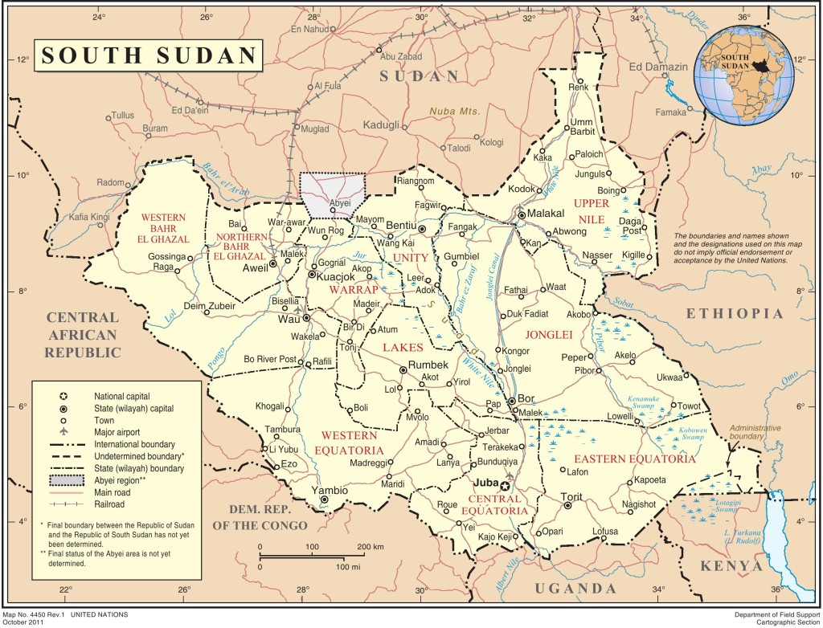

Annex II
Map of Western Bahr el Ghazal State
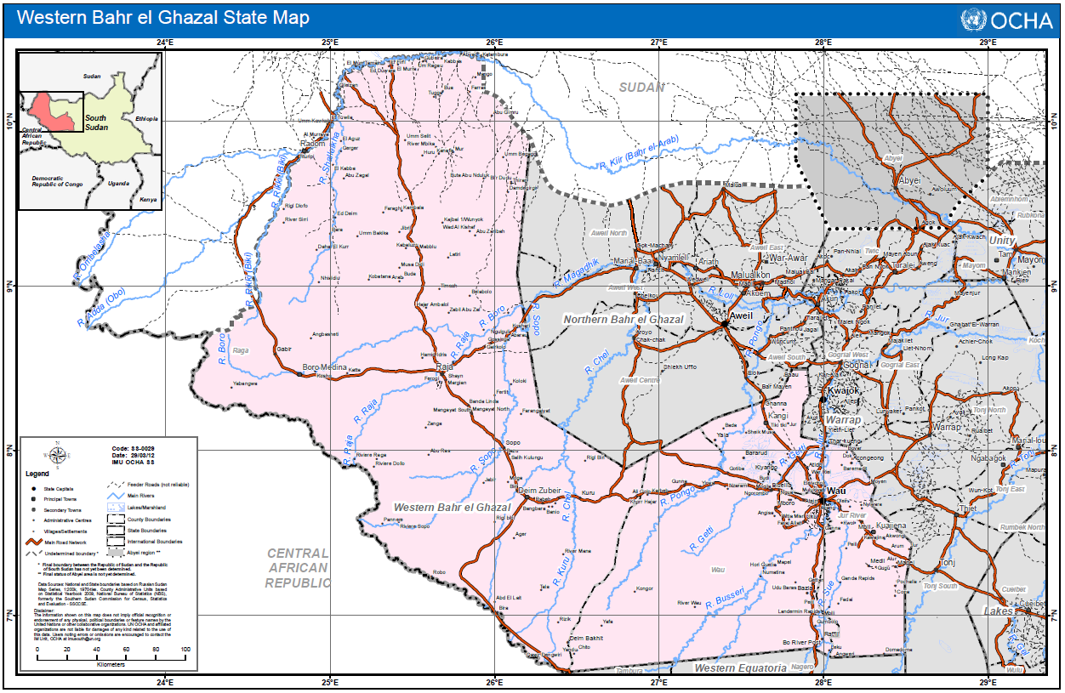

Annex III
Locations of attacked villages in Wau triangle
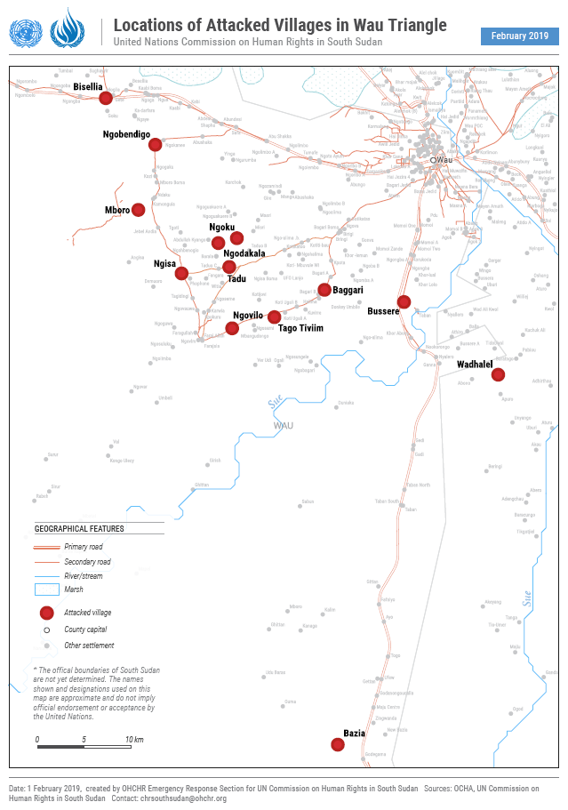

Annex IV
Map of Jonglei State
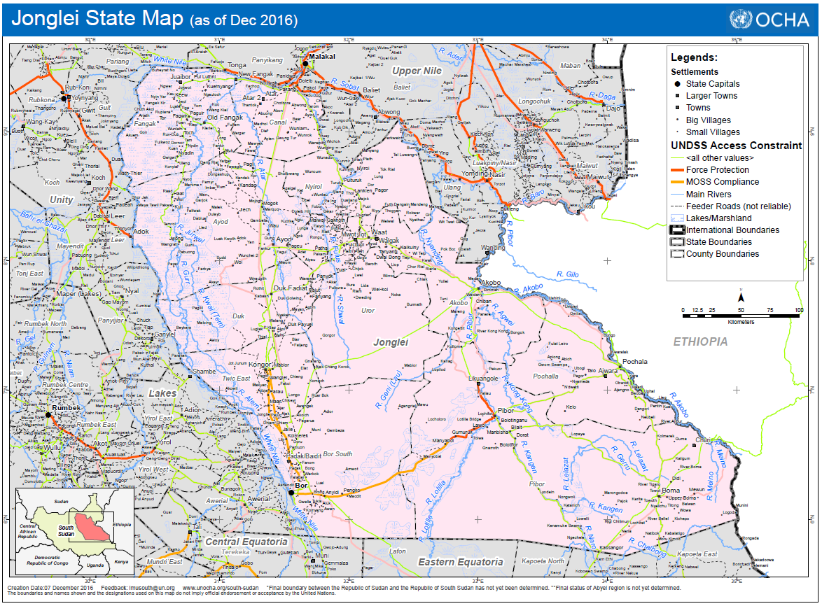

Annex V
Map of flood-related cereal production losses, November 2019
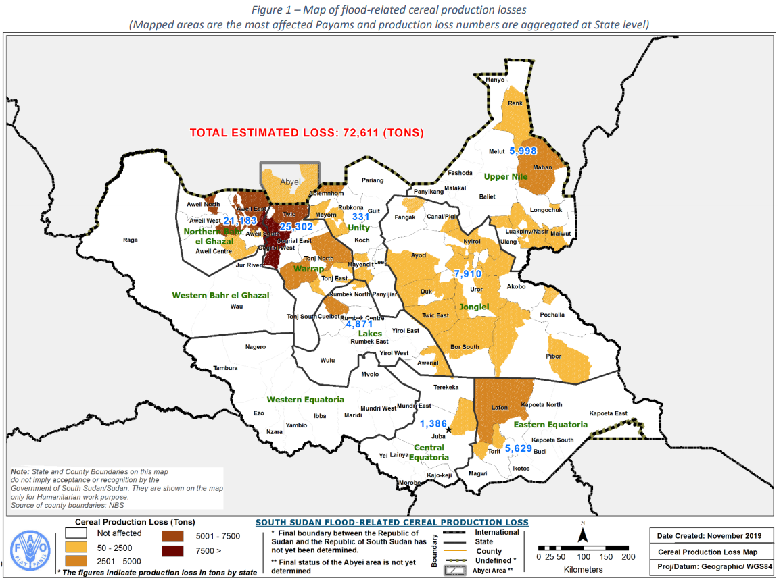
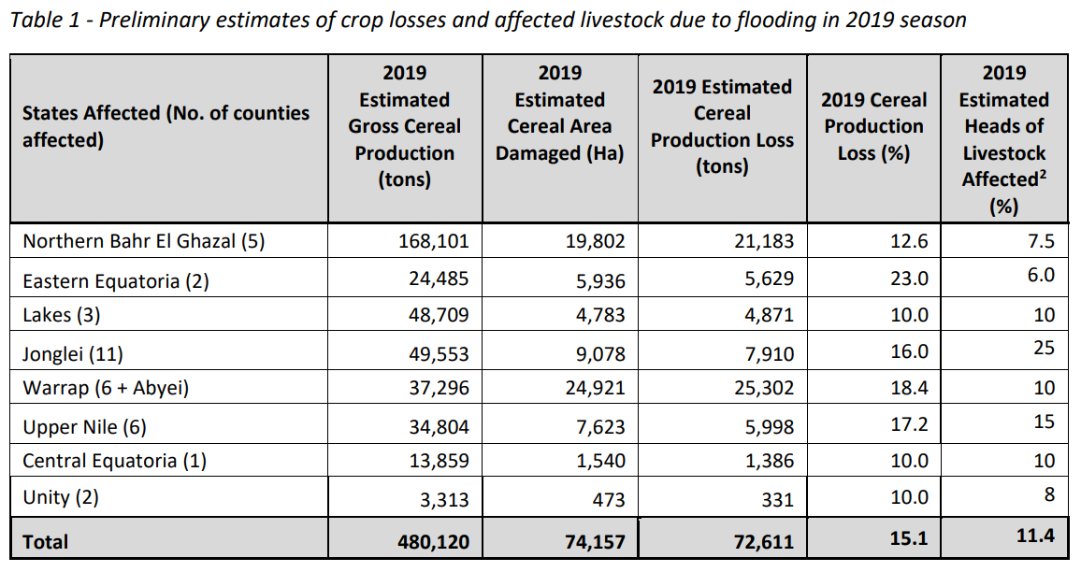

Annex VI
Food security outlook update, August-September 2020
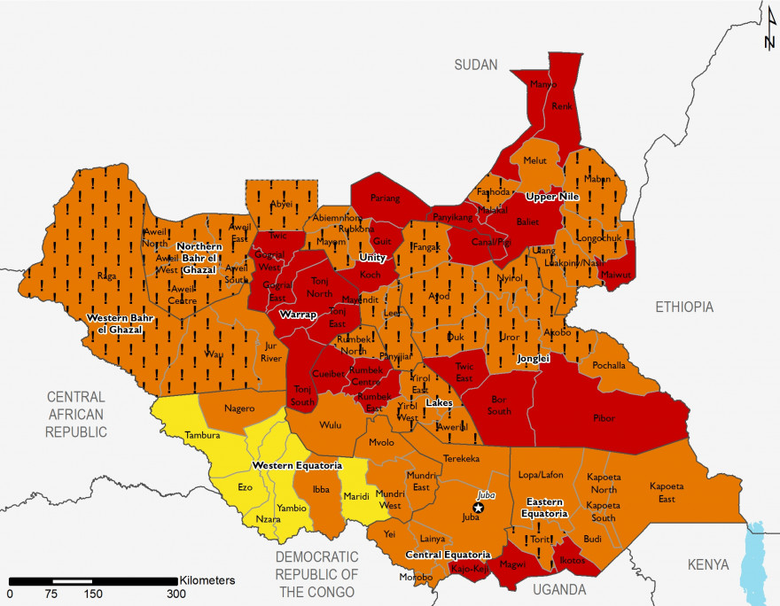
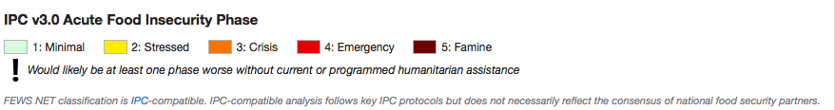

Annex VII
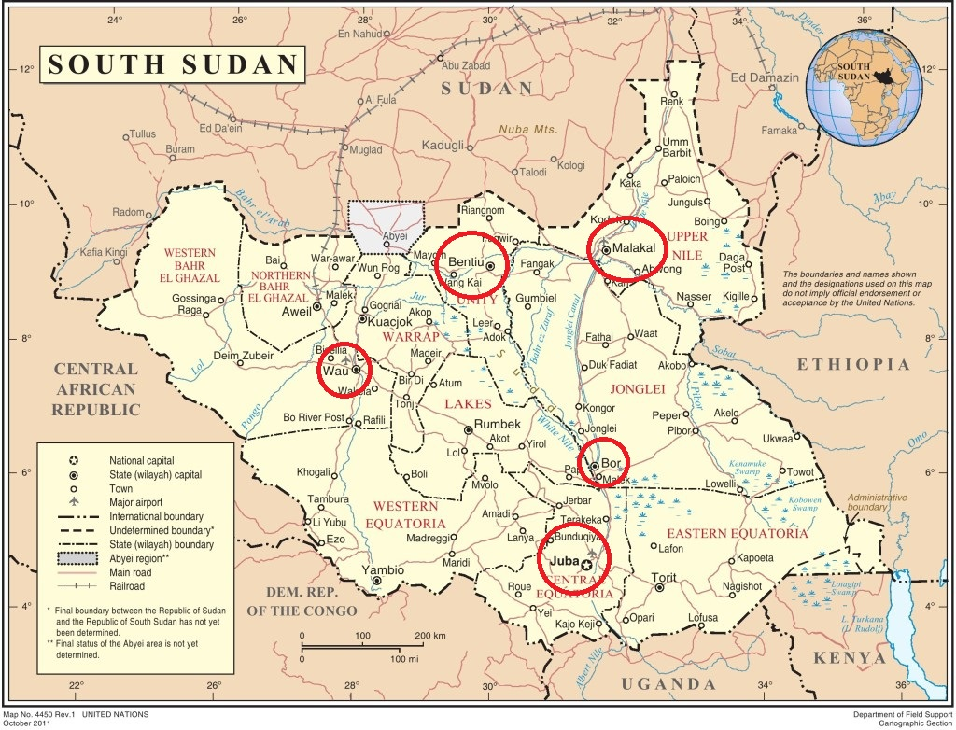
Protection of civilian displacement sites

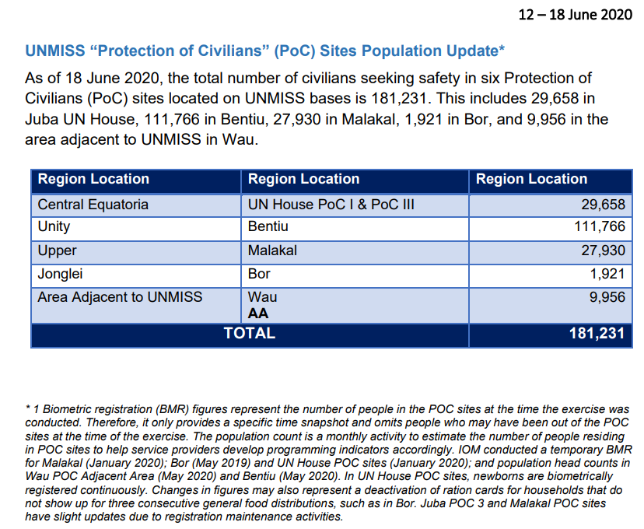
Annex VIII
Interlinkages and impacts of malnutrition over the life cycle

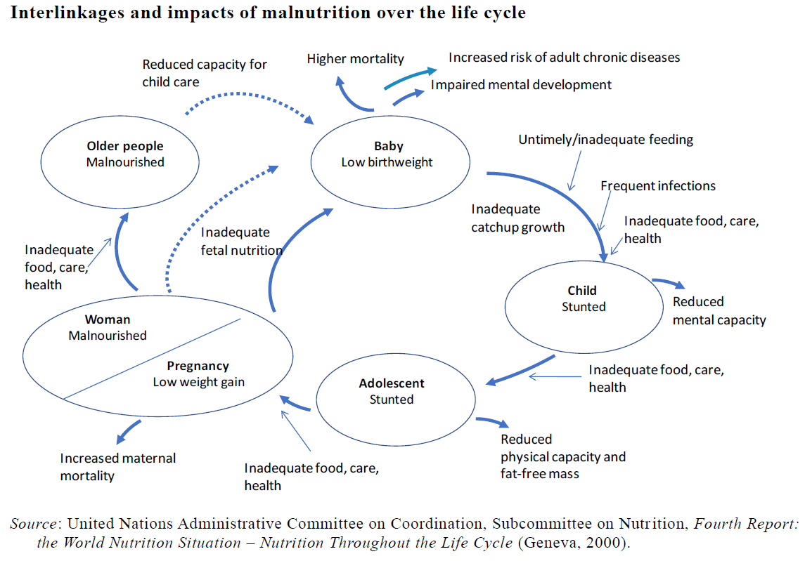

* The information contained in the present document should be read in conjunction with the report of the Commission on Human Rights in South Sudan (A/HRC/43/56).
See generally Report of the Commission on Human Rights in South Sudan, A/HRC/43/56, 31 January 2020, at paras. 33-44, available at https://www.ohchr.org/Documents/HRBodies/HRCouncil/CoHRSouthSudan/A_HRC_43_56.docx.
South Sudan emergency, United Nations High Commissioner for Refugees (UNHCR), as at 31 August 2019, available at https://www.unhcr.org/south-sudan-emergency.html.
South Sudan Situation, Operational Update, United Nations High Commissioner for Refugees (UNHCR), 15 July 2020, available at https://reliefweb.int/sites/reliefweb.int/files/resources/77822.pdf; Confidential meeting, 6 December 2019.
South Sudan emergency, United Nations High Commissioner for Refugees (UNHCR), as at 31 July 2020, available at https://www.unhcr.org/south-sudan-emergency.html.
The IPC Acute Food Insecurity classification rates hunger levels from one to five and provides information to decision makers by focusing on short-term objectives to prevent, mitigate, or decrease severe food insecurity. See http://www.ipcinfo.org/ipcinfo-website/ipc-overview-and-classification-system/ipc-acute-food-insecurity-classification/en. See also Acute Food Insecurity Situation Overview: The Republic of South Sudan, Integrated Food Security Phase Classification (IPC), 30 July 2013 to 30 October 2013, 29 July 2013, available at http://www.ipcinfo.org/fileadmin/user_upload/ipcinfo/docs/IPC_SouthSudan_AcuteFI_Situation_2013JulOct_Proj.pdf.
South Sudan: Acute Food Insecurity and Acute Malnutrition Situation January 2020 and Projections for February - April 2020 and May - July 2020, Integrated Food Security Phase Classification (IPC), available at http://www.ipcinfo.org/ipc-country-analysis/details-map/en/c/1152422.
Acute Food Insecurity and Acute Malnutrition Analysis, January 2020 - July 2020, Integrated Food Security Phase Classification (IPC), issued February 2020, available at http://www.ipcinfo.org/fileadmin/user_upload/ipcinfo/docs/IPC_SouthSudan_AFI_AMN_2020Jan2020July.pdf, at p. 7.
See, e.g., Communicable diseases and severe food shortage situations, United Nations World Health Organization (WHO), 25 August 2005, available at https://www.who.int/diseasecontrol_emergencies/guidelines/Severe_food_shortages.pdf.
It is estimated that 1.3 million children in South Sudan will suffer from acute malnutrition in 2020. See Hunger threatens over half of the population in South Sudan, United Nations World Food Programme (WFP), 20 February 2020, available at https://www.wfp.org/news/hunger-threatens-over-half-population-south-sudan.
South Sudan Human Development Indicators, United Nations Development Programme (UNDP), 2019, available at http://hdr.undp.org/en/countries/profiles/SSD.
See, e.g., Famine in Sudan, 1998: The Human Rights Causes, Human Rights Watch, 8 February 1999, available at https://www.hrw.org/reports/1999/sudan/SUDAWEB2.htm#P374_19682.
See K. Dörmann, L. Doswald-Beck, and R. Kolb, Elements of War Crimes under the Rome Statute of the International Criminal Court: Sources and Commentary (Cambridge: Cambridge University Press, 2003), at p. 364.
D. Akande and E.-C. Gillard, Conflict-induced Food Insecurity and the War Crime of Starvation of Civilians as a method of Warfare: The Underlying Rules of International Humanitarian Law, J. Int. Crim. Just., Vol. 17:4, September 2019, pp. 753-79 at p. 765 (footnote omitted).
Additional Protocol II, Article 4(2)(b). International Committee of the Red Cross (ICRC), Customary International Humanitarian Law, 2005, Volume I: Rules [hereinafter “ICRC Rules”], at Rule 103. Collective punishment is a war crime under Art. 4(b) of the Draft Statute of the Hybrid Court for South Sudan. The Appeals Chamber of the Special Court for Sierra Leone addressed this war crime in the Fofana and Kondewa case: “The Appeals Chamber emphasises that a ‘punishment’ for the purposes of the crime of collective punishments is an indiscriminate punishment imposed collectively on persons for omissions or acts for which some or none of them may or may not have been responsible. As such, a ‘punishment’ is distinct from the targeting of protected persons as objects of attack. The targeting of protected persons as objects of war crimes and crimes against humanity may not necessarily be predicated upon a perceived transgression by such persons and therefore does not constitute collective punishments. Thus, the mens rea element of collective punishments represents the critical difference between this crime and the act of targeting. While targeting takes place on account of who the victims are, or are perceived to be, the crime of collective punishments occurs in response to the acts or omissions of protected persons, whether real or perceived. The targeting of protected persons who are residents of a particular village, for instance, is therefore distinct from the collective punishment of protected persons in a given village who are perceived to have committed a particular act, such as providing rebel forces with shelter”. SCSL-04-14-A, 28 May 2008, at para. 223.
On 2 October 2018, President Salva Kiir issued Republican Order No. 18/2018 changing the name of the South Sudan People’s Liberation Army (SPLA) to the South Sudan People’s Defence Forces (SSPDF). For purposes of the foregoing report and for battles waged by Government forces prior to 2 October 2018, the Commission designates such forces as the “SPLA”.
The situation is exacerbated by the fact that soldiers are often not properly remunerated or able to support themselves and are encouraged to loot as a means of sustaining themselves. See, e.g., A/HRC/40/CRP.1, at para. 145.
Livelihood kit beneficiaries in Jonglei State - South Sudan, Food and Agriculture Organization of the United Nations (FAO), August 2014, available at http://www.fao.org/emergencies/resources/photos/photo-detail/en/c/240957.
Due to abnormally heavy rains and high levels of seasonal flooding in late 2019, President Salva Kiir declared a state of emergency on 29 October 2019 which covered 30 counties in Greater Bahr el Ghazal, Greater Upper Nile, and Greater Equatoria.
Impact of floods on crop production and livestock, Food and Agriculture Organization of the United Nations (FAO), 13 November 2019, available at https://fscluster.org/sites/default/files/documents/fao_-south_sudan_flood_impact_report_-_13_nov_2019_-_summary.pdf.
South Sudan’s devastating floods: why they happen and why they need a coherent national policy, Weekly Review, The SUDD Institute, 15 November 2019, available at https://reliefweb.int/sites/reliefweb.int/files/resources/5df0aae65dca2_SouthSudansDevastatingFloodsWhyTheyHappen_Full.pdf.
South Sudan: Floods - Aug 2020, ReliefWeb, August 2020, available at https://reliefweb.int/disaster/fl-2020-000193-ssd.
South Sudan’s food imports in the time of COVID-19, Rift Valley Institute, Briefing Paper, April 2020, available at http://riftvalley.net/sites/default/files/publication-documents/South%20Sudan%27s%20food%20system%20in%20the%20time%20of%20COVID-19%20by%20Edward%20Thomas%20-%20RVI%20X-Border%20Project%20%282020%29.pdf (internal citations omitted), at p. 1.
FAO in South Sudan: South Sudan at a Glance, Food and Agriculture Organization of the United Nations (FAO), available at http://www.fao.org/south-sudan/fao-in-south-sudan/south-sudan-at-a-glance/en.
See, e.g., ERN 103643 – 103647, para. 13.
S/RES/2417 (2018).
A/RES/74/149 (2019).
In pursuance of its mandate, the Commission collects and preserves evidence that it stores in a database and that it catalogues by a unique evidence registration number (ERN). Reference is made to these numbers throughout the report so that States may use them when requesting to consult the evidence.
ERN D116708 – D116714.
South Sudan ratified the Four Geneva Conventions and their Additional Protocols on 25 January 2013; they entered into force for South Sudan on 25 July 2013.
The International Committee of the Red Cross (ICRC) 2016 Commentary on the First Geneva Convention (Cambridge, Cambridge University Press, 2016) on the criteria of intensity and organisation required for Article 3 to be applicable, at p. 141, para. 387; pp. 174-175, paras. 414-444, 484. See also Gabriella Venturini, The Temporal Scope of the Conventions, in A. Clapham, P. Gaeta, and M. Sassòli, (eds.), The 1949 Geneva Conventions: A Commentary, (Oxford, Oxford University Press, 2015) pp. 51-66, at p. 61.
Article 8(2)(e)(xix) of the Rome Statute of the International Criminal Court.
Manuel J. Ventura, Prosecuting Starvation under International Criminal Law: Exploring the Legal Possibilities, J. Int. Crim. Just., Vol. 17:4, September 2019, at pp. 812-14.
Y. Sandoz, C. Swinarski, and B. Zimmermann (eds.), Commentary on the Additional Protocols of 8 June 1977 to the Geneva Conventions of 12 August 1949 (Geneva/Dordrecht: ICRC/Nijhoff, 1987), at para. 4885.
155/96: Social and Economic Rights Action Center (SERAC) and Center for Economic and Social Rights (CESR) / Nigeria, at para. 64-65.
Ibid., at para. 65.
Ibid., at para. 66.
Principles and Guidelines on the Implementation of Economic, Social and Cultural Rights in the African Charter on Human and People’s Rights, African Commission on Human and Peoples’ Rights, 2011, p. 48, para. 86, available at https://archives.au.int/bitstream/handle/123456789/2063/Nairobi%20Reporting%20Guidelines%20on%20ECOSOC_E.pdf.
Amnesty International & Others v Sudan (2000) AHRLR 297 (ACHPR 1999), para 50.
Commission Nationale des Droits de l’Homme et des Libertés v Chad (2000) AHRLR 66 (ACHPR 1995), para 21.
Article 28D(e)(xvi).
Draft Statute of the Hybrid Court for South Sudan, 10 August 2017, at Art. 1(1).
Ibid., at Arts. 2-6.
Article 27(2) of the EAC Treaty confers the power upon the Council of Ministers to adopt a protocol that would extend the current jurisdiction of the EACJ.
EAC Treaty, Art. 6(d).
James Katabazi and 21 Others vs. Secretary General of the East African Community and Attorney General of the Republic of Uganda, Reference No. 1 of 2007, 31 October 2007, at para. 39.
Ibid.
Sitenda Sebalu v Secretary-General of the EAC & Others, Ref 1 of 2010, EACJ First Instance Division 50.
SPLA Act, Art. 37(4).
Draft Statute of the Hybrid Court for South Sudan, at Arts. 3(d), (h), and (j).
Article 206B Crimes Against Humanity: “Whoever directs widespread or systematic attack against any civilian population, with intent of killing or extermination or enslavement or deportation or forcible transfer of population or imprisonment or other severe deprivation of physical liberty in violation of fundamental rules of international law or torture or rape or sexual slavery or pregnancy or enforced sterilization or any other form of sexual violence or comparable gravity or prosecution against any identifiable group or collectively on political or racial or national or ethnic or cultural or religious or gender or enforced disappearance of persons or crime of apartheid or any other inhuman acts of similar character commits an offences of crimes against humanity and upon conviction shall be sentenced to death or life imprisonment.”
ERN 101930 – 101935, para. 6. See also South Sudan president Kiir backs relocation of Wau county headquarters, Sudan Tribune, 24 December 2012, available at https://www.sudantribune.com/spip.php?article44974.
ERN 101828 – 101835, para. 5.
ERN 101930 – 101935, para. 6.
ERN 101930 – 101935, para. 7.
ERN 101930 – 101935, para. 7.
ERN 101930 – 101935, para. 7.
ERN 103834 – 103839, para. 11.
ERN 103834 – 103839, para. 12.
ERN 103834 – 103839, para. 10.
ERN 103834 – 103839, para. 11.
ERN 103834 – 103839, para. 12.
ERN 101836 – 101841, para. 13.
Confidential document, ERN D113942 – D113947.
ERN 101577 – 101581, para. 4.
Confidential document, ERN D113942 – D113947.
ERN 101828 – 101835, para. 5.
ERN 101828 – 101835, para. 6.
ERN 101828 – 101835, para. 6.
ERN 101828 – 101835, paras. 5-6; ERN 101577 – 101581, para. 6.
ERN 101828 – 101835, paras. 5-6; ERN 101577 – 101581, para. 6.
ERN 101836 – 101841, para. 6.
ERN 101577 – 101581, para. 5.
ERN 101836 – 101841, para. 7.
ERN 101836 – 101841, para. 7.
ERN 101828 – 101835, para. 8; ERN 101886 – 101890, para. 7.
ERN 101587 – 101592, para. 20.
ERN 101828 – 101835, para. 9.
ERN 101828 – 101835, para. 10.
ERN 101828 – 101835, para. 10.
ERN 101828 – 101835, para. 11.
ERN 101828 – 101835, para. 11.
ERN 101886 – 101890, paras. 6-8; ERN 101828 – 101835, para. 6; ERN101799 – 101803, para. 6; Confidential document, D113892 – D113900; Confidential document, D113942 – D113947.
ERN 101828 – 101835, para. 12.
ERN 101886 – 101890, paras. 6-8; ERN 101828 – 101835, para. 6; ERN 101799 – 101803, para. 6; Confidential document, D113892 – D113900; Confidential document, D113942 – D113947.
ERN 101828 – 101835, para. 13.
The soldiers were identified as being part of the SPLA 5 Division, in part by the elephant logo on their uniforms which is the 5 Division logo. ERN 101799 – 101803, para. 6.
ERN 101577 – 101581, para. 7.
ERN 101836 – 101841, para. 9; ERN 101886 – 101890, paras. 8-10; ERN 101836 – 101841, para. 9.
ERN 101577 – 101581, para. 7; ERN 101828 – 101835, para. 16; ERN 101828 – 101835, para. 17.
ERN 101577 – 101581, para. 8.
ERN 101582 – 101586, para. 4.
ERN 101577 – 101581, para. 7.
Military Movement and Offensive Military Operations in the Wau Area, Report 2018/24, Ceasefire and Transitional Security Arrangements Monitoring Mechanism in South Sudan (CTSAMM), 26 July 2018, at p. 1, available at https://jmecsouthsudan.org/index.php/reports/ctsamm-violation-reports/99-ctsamm-report-2018-24-military-movement-and-offensive-military-operations-in-the-wau-area/file.
ERN 101828 – 101835, para. 16.
ERN 101828 – 101835, para. 16.
ERN 101828 – 101835, para. 16.
ERN 101886 – 101890, para. 11.
ERN 101886 – 101890, para. 12.
ERN 101828 – 101835, para. 18.
Military Movement and Offensive Military Operations in the Wau Area, Report 2018/24, Ceasefire and Transitional Security Arrangements Monitoring Mechanism (CTSAMM), 26 July 2018, at para. 4.1, available at https://jmecsouthsudan.org/index.php/reports/ctsamm-violation-reports/99-ctsamm-report-2018-24-military-movement-and-offensive-military-operations-in-the-wau-area/file.
ERN 101799 – 101803, para. 12.
ERN 101582 – 101586, para. 13.
ERN 101788 – 101793, para. 6.
South Sudan: Soldiers Attack Civilians in Western Region, Human Rights Watch, 24 October 2018, available at https://www.hrw.org/news/2018/10/24/south-sudan-soldiers-attack-civilians-western-region.
ERN 101788 – 101793, para. 7.
Iron sheets used as roofs for some of the houses were also pillaged. See ERN 101788 – 101793, para. 7.
ERN 101788 – 101793, para. 7.
ERN D116708 – D116714.
ERN 101788 – 101793, para. 6.
ERN 101788 – 101793, para. 8.
Confidential document, D120831 – D120833.
Confidential document, D120831 – D120833.
Confidential document, D120831 – D120833.
Confidential document, D120831 – D120833.
ERN 101788 – 101793, para. 10.
South Sudan: Humanitarian Access Review (January – June 2018), United Nations Office for the Coordination of Humanitarian Affairs, 15 August 2018; South Sudan: Humanitarian Access Snapshot (July 2018), United Nations Office for the Coordination of Humanitarian Affairs (OCHA), 13 August 2018; see also South Sudan: Humanitarian Access Snapshot (August 2018), United Nations Office for the Coordination of Humanitarian Affairs (OCHA), 12 September 2018.
South Sudan: Humanitarian Access Review (January – December 2018), United Nations Office for the Coordination of Humanitarian Affairs (OCHA), at p. 1.
South Sudan: Humanitarian Access Review (January – June 2018), United Nations Office for the Coordination of Humanitarian Affairs (OCHA), 15 August 2018.
ERN 101557 – 101561, para. 12.
ERN 101557 – 101561, para. 4.
ERN 101557-101561, para. 12.
ERN 101557 – 101561, para. 17.
ERN 101876 – 101880, para. 5.
ERN 101876 – 101880, para. 6.
ERN 101557 – 101561, para. 9.
ERN 101557 – 101561, para. 6.
ERN 101876 – 101880, para. 5.
ERN 101557 – 101561, para. 7.
ERN 101876 – 101880, para. 8.
Confidential document, D115898 – D116021.
ERN 101925 – 101929, para. 8.
ERN 101925 – 101929, para. 8.
ERN 101925 – 101929, para. 9.
Confidential document, D120831 – D120833.
ERN 101587 – 101592, para. 23.
Confidential document, D120831 – D120833.
ERN 101930 – 101935, para. 18.
ERN 101788 – 101793, para. 5.
Confidential document, D115749 – D115897.
ERN 101909 – 101913, para. 4.
ERN 101870 – 101875, para. 5.
ERN 101920 – 101924, paras. 6 and 15; ERN 101909 – 101913, para. 4; ERN 101783 – 101787, para. 5; ERN 101870 – 101875, para. 6; ERN 101864 – 101869, paras. 5 and 10.
ERN 101870 – 101875, para. 5.
ERN 101909 – 101913, para. 7; ERN 101920 – 101924, para. 8.
ERN 101909 – 101913, para. 7; ERN 101920 – 101924, para. 8.
ERN 101920 – 101924, para. 8; 101909 – 101913, para. 7.
See, e.g., ERN 101870 – 101875, para. 6; ERN 101864 – 101869, para. 5; ERN 101783 – 101787, para. 5.
See, e.g., ERN 101864 – 101869, para. 8.
ERN 101870 – 101875, para. 8.
ERN 101870 – 101875, para. 8.
ERN 101864 – 101869, para. 11.
ERN 101909 – 101913, paras. 9-10; ERN 101870 – 101875, para. 9.
ERN 101870 – 101875, para. 8.
ERN 101783 – 101787, para. 6; ERN 101864 – 101869, paras. 6-7; ERN 101864 – 101869, para. 13; ERN 101909 – 101913, para. 12.
ERN 101920 – 101924, para. 6.
ERN 101783 – 101787, para. 6.
ERN 101864 – 101869, para. 12.
ERN 101864 – 101869, para. 14; see also ERN 101870 – 101875, para. 13.
ERN 101870 – 101875, para. 13.
ERN 101870 – 101875, para. 11.
Rome Statute, Art. 8(2)(e)xix: Intentionally using starvation of civilians as a method of warfare by depriving them of objects indispensable to their survival, including wilfully impeding relief supplies.
155/96: Social and Economic Rights Action Center (SERAC) and Center for Economic and Social Rights (CESR) / Nigeria, paras. 64-65
The Conflict in Jonglei State, Human Security Baseline Assessment for Sudan and South Sudan, 31 March 2014, available at http://www.smallarmssurveysudan.org/facts-figures/south-sudan/conflict-of-2013-14/the-conflict-in-jonglei.html.
ERN 102918 – 102924, para. 5.
ERN 102918 – 102924, para. 5. As a self-defence group, the Lou Nuer youth community mobilised to protect their land from attack. See, e.g., ERN 102918 – 102924, para. 12. Also known as the “White Army”, this group has its own command structure and operates without orders from the SPLA-IO. ERN 103701 – 103714, para. 9.
ERN 102918 – 102924, para. 6.
ERN 102918 – 102924, para. 6.
ERN 102918 – 102924, para. 6.
Lakes state hosts over 20,000 displaced from Jonglei, Sudan Tribune, 22 December 2013, available at https://www.sudantribune.com/spip.php?article49293.
ERN 102918 – 102924, para. 7.
ERN 103353 – 103357, para. 7.
ERN 103353 – 103357, para. 8.
ERN 103353 – 103357, para. 8.
ERN 103353 – 103357, para. 8.
ERN 103353 – 103357, para. 9.
ERN 103332 – 103335, para. 9.
ERN 102930 – 102934, para. 7.
ERN 103413 – 103419, para. 5.
ERN 103566 – 103570, para. 9.
ERN 103566 – 103570, para. 9.
ERN 103701 – 103714, para. 32.
ERN 102930 – 102934, para. 8.
ERN 103407 – 103412, para. 13.
Agreement on Cessation of Hostilities, Protection of Civilians and Humanitarian Access, 21 December 2017, at Art. 8.
R-ARCSS, Article 2.1.2.
South Sudan: Annual Humanitarian Access Review (January - December 2018), United Nations Office for the Coordination of Humanitarian Affairs (OCHA), 25 February 2019, available at https://reliefweb.int/report/south-sudan/south-sudan-annual-humanitarian-access-review-january-december-2018.
ERN 101870 – 101875, para. 16.
ERN 103560 – 103565, para. 5.
ERN 103560 – 103565, para. 5.
ERN 103371 – 103376, para. 5; ERN 103701 – 103714, para. 34.
ERN 103566 – 103570, para. 6.
ERN 103371 – 103376, para. 5.
ERN 103399 – 103406, para. 5.
Or that households are “marginally able to meet minimum food needs but only by depleting essential livelihood assets or through crisis-coping strategies”. See Integrated Phase Classification, Famine Early Warning Systems Network (FEWS Net), available at https://fews.net/IPC. See also note 5, supra.
ERN 103399 – 103406, para. 6.
ERN 103399 – 103406, para. 7.
ERN 103399 – 103406, para. 8.
ERN 103399 – 103406, para. 6.
See, e.g., ERN 103234 – 103239, para. 9; ERN 103371 – 103376, para. 5; ERN 103413 – 103419, para. 13; ERN 103566 – 103570, para. 8; ERN 103701 – 103714, para. 28.
ERN 103560 – 103565, para. 6.
ERN 103560 – 103565, para. 7.
ERN 103560 – 103565, para. 8.
ERN 103371 – 103376, para. 7.
ERN 103371 – 103376, para. 8.
ERN 103701 – 103714, para. 29.
ERN 103371 – 103376, para. 10.
ERN 103445 – 103448, para. 18.
ERN 103701 – 103714, para. 28.
ERN 102918 – 102924, para. 10.
ERN 103445 – 103448, para. 18.
ERN 103371 – 103376, para. 6.
ERN 103701 – 103714, para. 33.
ERN 103371 – 103376, para. 6.
ERN 103566 – 103570, para. 7.
ERN 103371 – 103376, para. 6.
ERN 103445 – 103448, para. 18.
ERN 103566 – 103570, para. 8.
ERN 103555 – 103559, para. 11.
ERN 103332 – 103335, para. 10.
ERN 103566 – 103570, para. 7.
ERN 103445 – 103448, para. 17.
ERN 102944 – 102949, para. 18.
See, e.g., ERN 103328 – 103331, para. 8.
ERN 103413 – 103419, para. 5.
ERN 103413 – 103419, para. 16.
ERN 103445 – 103448, para. 18.
ERN 103701 – 103714, para. 34.
ERN 103407 – 103412, para. 14.
ERN 103399 – 103406, para. 15; ERN 103413 – 103419, para. 7.
ERN 103234 – 103239, para. 12.
ERN 103445 – 103448, para. 14; ERN 103413 – 103419, para. 8.
ERN 103413 – 103419, para. 8.
ERN 103610 – 103613, para. 8.
Potentially identifying information has been withheld subject to the principle of “do no harm”.
ERN 103643 – 103647, para. 5.
ERN 103643 – 103647, para. 6.
ERN 103626 – 103629, para. 3.
ERN 103626 – 103629, para. 3.
ERN 103626 – 103629, para. 4.
SOUTH SUDAN: Humanitarian Coordinator visits flooded areas, calls for $61 million to respond to immediate needs, United Nations Office for the Coordination of Humanitarian Affairs (OCHA), 8 November 2019, available at https://reliefweb.int/sites/reliefweb.int/files/resources/20191108_press_release_south_sudan_hc_visits_flooded_areas_calls_for_funding.pdf.
ERN 103680 – 103683, para. 6.
ERN 103680 – 103683, para. 7.
ERN 103659 – 103662, paras. 3 and 6.
ERN 103648 – 103652, para. 10.
ERN 103626 – 103629, para. 4.
ERN 103626 – 103629, para. 6.
ERN 103648 – 103652, para. 8.
ERN 103635 – 103638, para. 8.
South Sudan: Acute Food Insecurity and Acute Malnutrition Situation for August 2019 – April 2020, Integrated Food Security Phase Classification, 11 September 2019, available at https://reliefweb.int/report/south-sudan/south-sudan-acute-food-insecurity-and-acute-malnutrition-situation-august-2019.
Confidential Meeting, 7 December 2019.
Confidential Meeting, 7 December 2019.
ERN 103643 – 103647, para. 7.
ERN 103653 – 103658, para. 12; ERN 103648 – 103652, para. 5.
ERN 103643 – 103647, para. 7; ERN 103663 – 103667, para. 2.
ERN 103663 – 103667, para. 3; ERN 103663 – 103667, para. 5.
ERN 103653 – 103658, para. 12; ERN 103626 – 103629, para. 4. Cf. ERN 103648 – 103652, para. 12; ERN 103663 – 103667, para. 4; ERN 103635 – 103638, paras. 6-7.
ERN 103653 – 103658, para. 12.
ERN 103663 – 103667, para. 2.
ERN 103653 – 103658, para. 12.
ERN 103630 – 103634, para. 9.
ERN 103648 – 103652, para. 5; ERN 103648 – 103652, para. 12.
ERN 103648 – 103652, para. 5.
ERN 103626 – 103629, para. 7; ERN 103620 – 103625, para. 13.
From one crisis to another, United Nations Children’s Fund, 15 November 2019, available at https://www.unicef.org/stories/south-sudan-one-crisis-another.
ERN 103648 – 103652, para. 9; ERN 103626 – 103629, para. 6.
ICRC Rule 55.
See also paras. 90-91, supra.
Protocol Additional to the Geneva Conventions of 12 August 1949, and relating to the Protection of Victims of Non-International Armed Conflicts (Protocol II), 8 June 1977, at Art. 18(2).
South Sudan: Annual Humanitarian Access Review (January - December 2018), United Nations Office for the Coordination of Humanitarian Affairs (OCHA), 25 February 2019, available at https://reliefweb.int/report/south-sudan/south-sudan-annual-humanitarian-access-review-january-december-2018.
Confidential Document, ERN D113581 – D113586.
Confidential Document, ERN D113587 – D113589.
South Sudan: Annual Humanitarian Access Review (January - December 2018), United Nations Office for the Coordination of Humanitarian Affairs (OCHA), 25 February 2019, available at https://reliefweb.int/report/south-sudan/south-sudan-annual-humanitarian-access-review-january-december-2018.
ICRC Rule 55.
South Sudan Situation, Operational Update, United Nations High Commissioner for Refugees (UNHCR), 15 July 2020, available at https://reliefweb.int/sites/reliefweb.int/files/resources/77822.pdf.
See, e.g., ERN 103146 – 103150, paras. 9-10.
See, e.g., ERN 100625 – 100636; ERN 103328 – 103331, para. 7; ERN 102318 – 102323, paras. 6-8; ERN 102308 – 102312, paras. 7-10.
See, e.g., ERN 102930 – 102934, para. 9; ERN 102930 – 102934, para. 10.
Confidential meeting, 6 December 2019.
Confidential document, ERN D120766 – D120773. Chapter 3 (Article 1.2.1.) of the Agreement on the Resolution of Conflict in South Sudan provides for the institution of programmes for relief, protection, repatriation, resettlement, reintegration, and rehabilitation of persons internally displaced and returnees, in coordination with the United Nations and other relief and humanitarian agencies.
Confidential document, ERN D120766 – D120773.
Statement of the Government of the Republic of South Sudan at the 43rd Session of the Human Rights Council, Delivered by Amb. Luate Samuel Lominsuk, Director General of Multilateral Affairs, Geneva, Switzerland, 26 February 2020, Check Against Delivery.
See, e.g., ERN 100625 – 100636.
Adolescent Girls in Crisis: Voices from South Sudan, Plan International, 2018, available at https://plan-uk.org/file/plan-uk-voices-from-south-sudan-reportpdf/download?token=D7xsjaUV.
Catherine Huser, Conflict and Gender Study – South Sudan: Addressing Root Causes Programme, Agency for Co-Operation and Research in Development, January 2018; Nimule Conflict and Leadership Mapping Report, Together We Can: Supporting Local Peace Efforts in Nimule, Search for Common Ground, November 2016.
No Safe Place: A Lifetime of Violence for Conflict Affected Women and Girls in South Sudan, Main Results Report, The George Washington University, Global Women’s Institute, 2017.
Adolescent Girls in Crisis: Voices from South Sudan, Plan International, 2018, available at https://plan-uk.org/file/plan-uk-voices-from-south-sudan-reportpdf/download?token=D7xsjaUV.
ERN 103674 – 103679, para. 5.
See, e.g., Talking points: Child marriage and maternal and child health, Girls Not Brides: The Global Partnership to end Child Marriage, internal citations omitted, available at https://www.girlsnotbrides.org/wp-content/uploads/2014/04/Child-marriage-and-maternal-health-Girls-Not-Brides-Updated-27-May-2013.pdf.
“This old Man Can Feed Us, You will Marry Him”: Child and Forced Marriage in South Sudan, Human Rights Watch, March 2013, available at https://www.hrw.org/sites/default/files/reports/southSudan0313_forinsertWebVersion_0.pdf; NS Mugo et al., “The system here isn’t on patient’s side” - perspectives of women and men on the barriers to accessing and utilizing maternal healthcare services on South Sudan, BMC Health Services Research, 2018, 18:10, available at https://www.ncbi.nlm.nih.gov/pubmed/29316933; S. Gee et al., “We need good nutrition but we have no money to buy food”: sociocultural context, care experiences, and newborn health in two UNHCR-supported camps in South Sudan, BMC International Health and Human Rights, 2018, 18:40, available at https://bmcinthealthhumrights.biomedcentral.com/articles/10.1186/s12914-018-0181-3; S. Kane et al., Too afraid to go: fears of dignity violations as reasons for non-use of maternal health services in South Sudan, Reproductive Health, 2018, 15:51, available at https://reproductive-health-journal.biomedcentral.com/articles/10.1186/s12978-018-0487-6; G. Vincent and F.M. Alemu, Factors contributing to, and effects of, teenage pregnancy in Juba, South Sudan Medical Journal, Vol. 9, No. 2. May 2016, pp. 28-31, available at http://www.southsudanmedicaljournal.com/archive/may-2016/factors-contributing-to-and-effects-of-teenage-pregnancy-in-juba.html.
Population, food security, nutrition and sustainable development, Report of the Secretary-General, E/CN.9/2020/2, 16 January 2020, at para. 27.
Convention on the Elimination of All Forms of Discrimination against Women, New York, 18 December 1979, at Art. 12.

