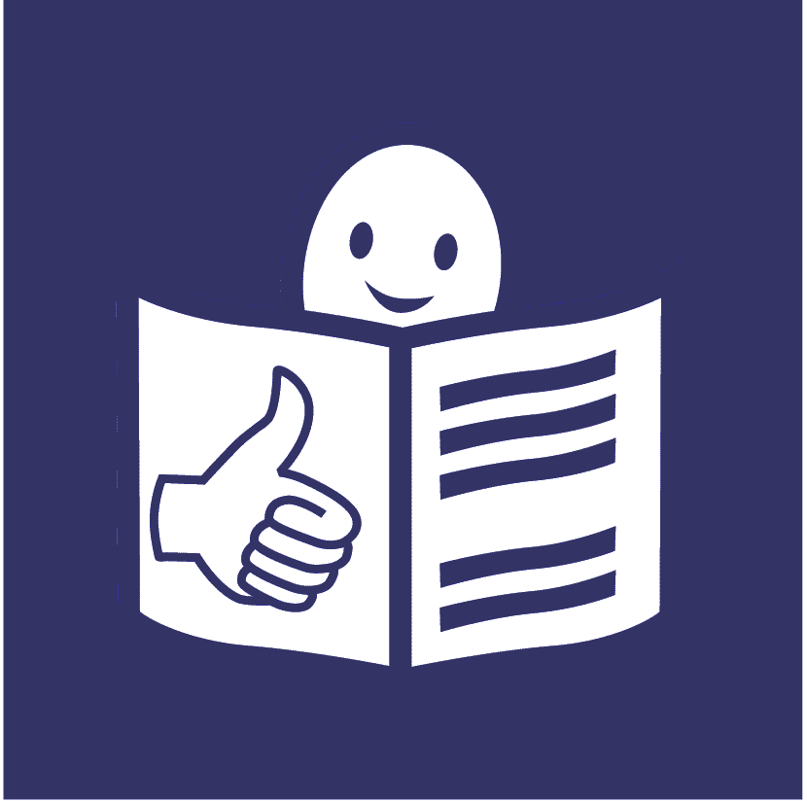
United Nations Human Rights Council
United Nations High Commissioner for
Human Rights.

Making sure that people with disabilities can take part in sport and physical activity

Sport includes all types of sport. Physical activity can be many things like walking, cycling, keeping fit and visiting places.

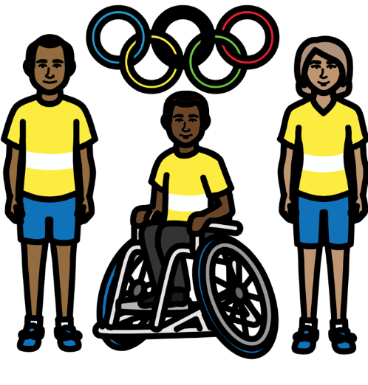

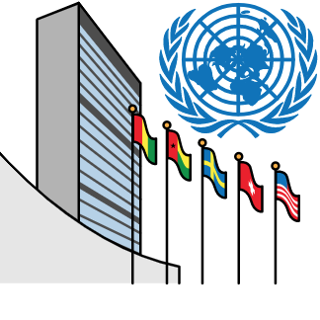
About us

We are part of the United Nations (UN).
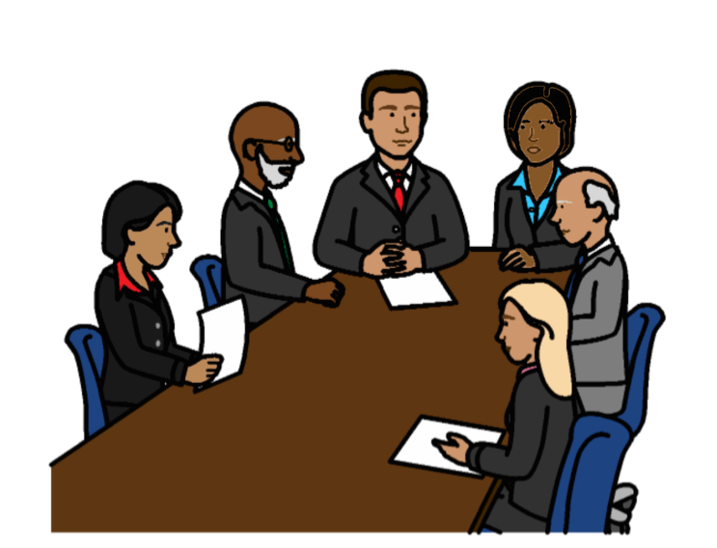

The United Nations is a group of countries that work to make the world better and safer.

About this report

This report is about the right of people with disabilities to take part in sport and physical activity.

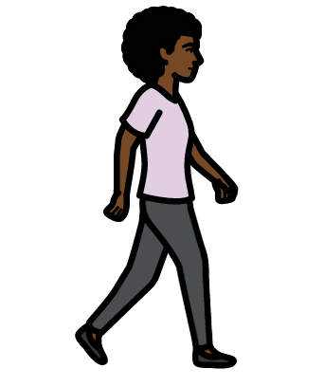
Physical activity can be many things, like:
- Going for walks
- Going to the gym and keeping fit
- Dancing
- Cycling
- Playing together with other children
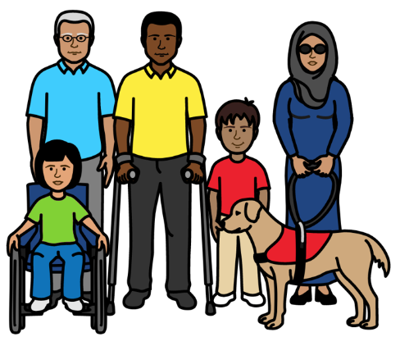
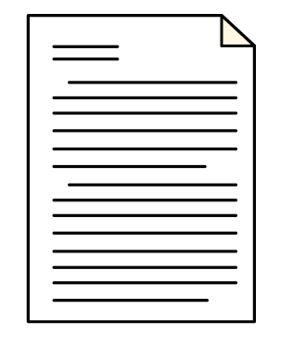
There is an important document about the rights of all people with disabilities in the world.

It is called the Convention on the Rights of Persons with Disabilities.

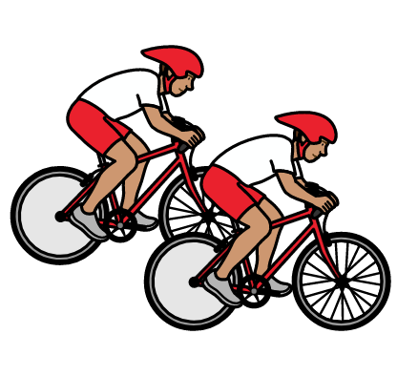

The document says that people with disabilities have a right to take part in sport and physical activity.
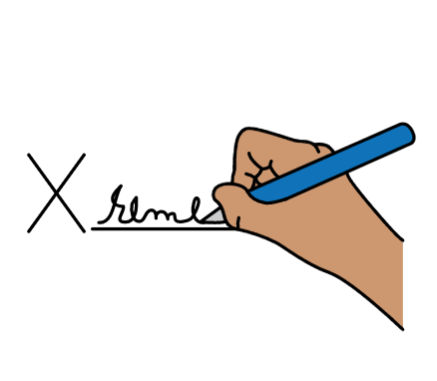
They should not be left out.

Many countries have promised to do what the document says.

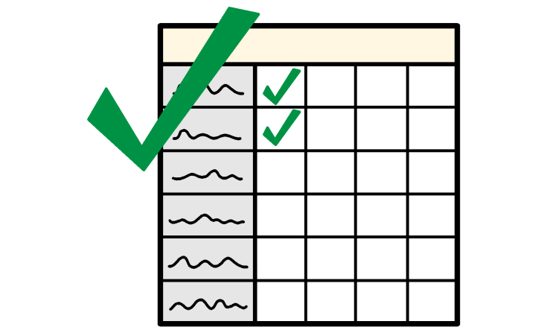
This report is about:
- What countries must do to make sure that people with disabilities can take part in sport and physical activity

- Some good work that countries told us they are doing

What is happening at the moment

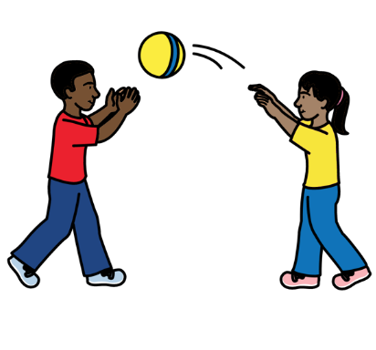

Sport and physical activity is very important.

It can help people to:

- Be happy

- Be healthy

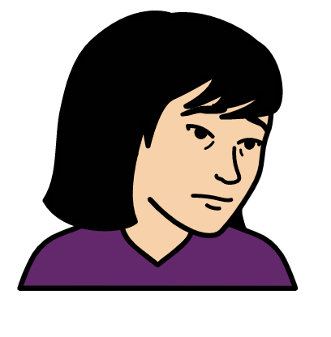
- Take part in the community

But it is hard for many people with disabilities to take part in sport and physical activity.

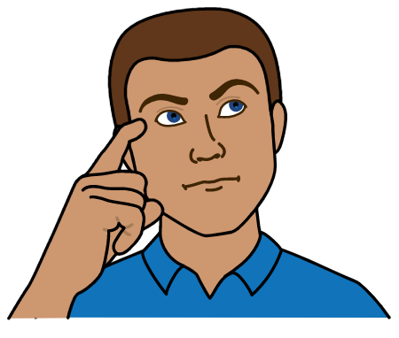
For example:

People often have unfair ideas about people with disabilities.

They might think that people with disabilities cannot do sport.
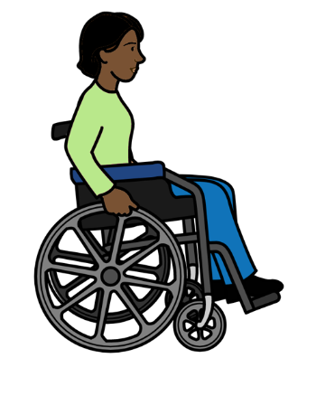
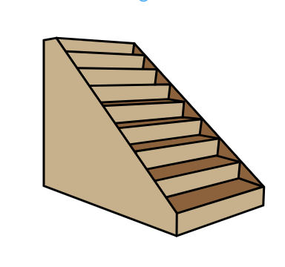
Many sport and activity places are hard for people with disabilities to enter and move around in.
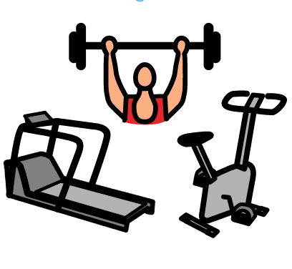

Sports equipment is often hard for people with disabilities to use.

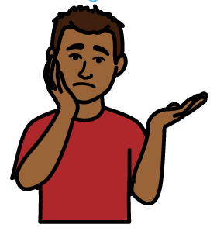

Many people with disabilities do not get the right support to take part in sport and physical activity.
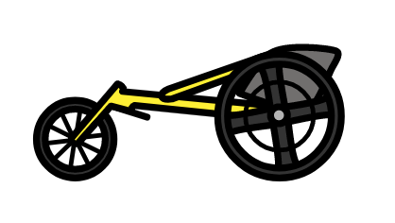

For example, many people cannot get the wheelchairs or equipment they need.

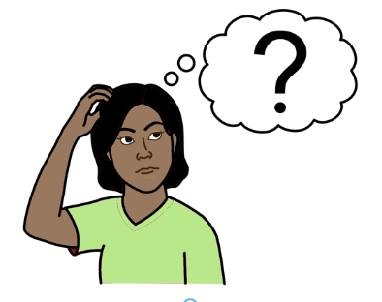

People who run activities might not know how to support people with disabilities.

Information about sport and physical activity is often hard to understand.
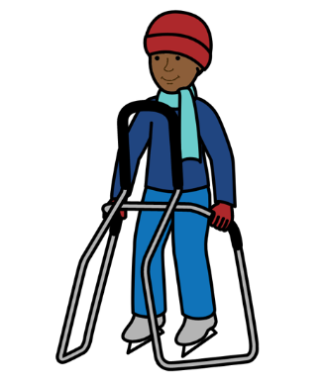
What countries must do

Countries must make sure that all people with disabilities can take part in sport and physical activity where possible.

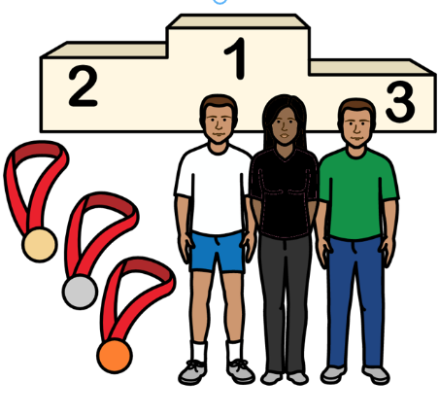

People with disabilities should not be left out.

They should have the same chances as everyone else to take part and do well.

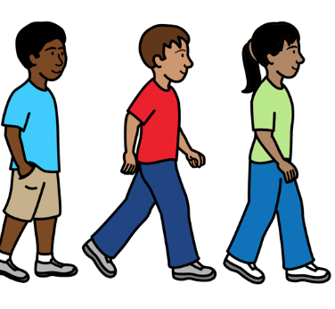
People with disabilities should be able to take part in:

- Sport and physical activity for everyone

- Sport and physical activity just for people with disabilities

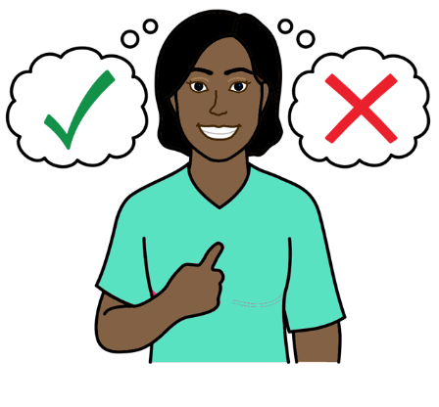
But people with disabilities should not be forced to take part in things that are only for people with disabilities.

They should have a choice about what to take part in.

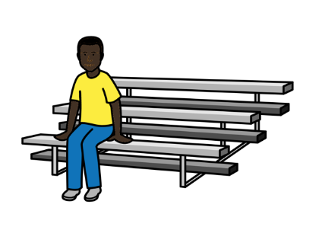

People with disabilities should also be able to take part in other ways.

For example:

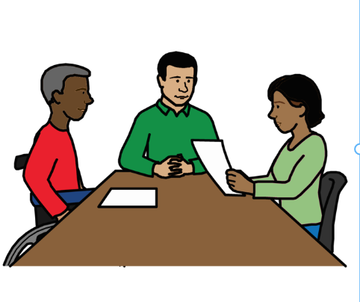
- Watching sport and activities

- Working for sports and other organizations. And helping them to make decisions
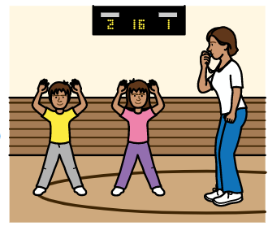

- Teaching other people to do sport and physical activity

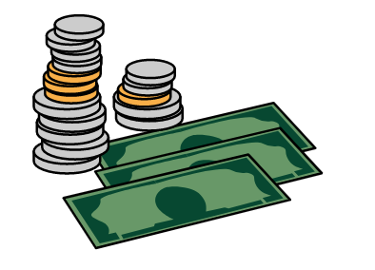
People with disabilities should get the support they need to take part in sport and physical activity.

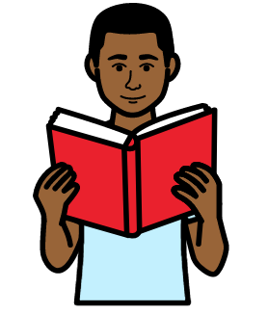
This includes:
- Enough money to live on
- Information they can understand about sport and physical activity
- Wheelchairs and other equipment
- Training

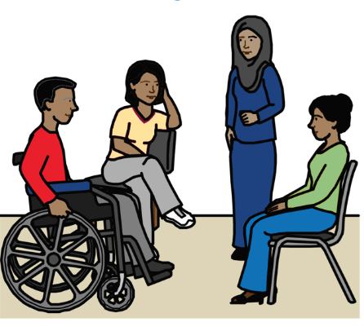

Countries should work with adults and children with disabilities:

- To make laws and plans about sport and physical activity

- To check how the laws and plans are working for people with disabilities

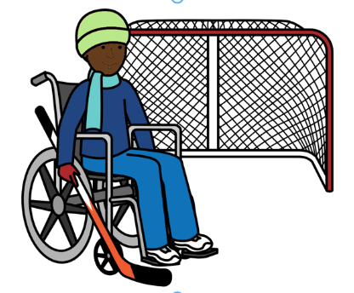

Countries must help women and girls with disabilities to take part in sport and physical activity.

For example, by working to stop violence that happens to women and girls while they are doing sport.
Countries must work to make public places easy for people with disabilities to use.
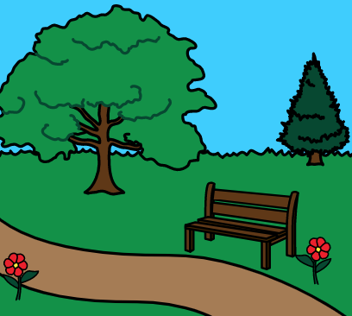
For example:
- Gyms and sports clubs
- Buildings and places that many people visit
- Parks and beaches
- Paths

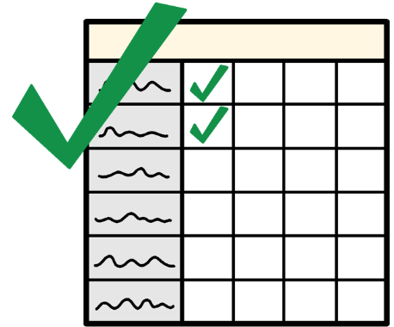

There should be rules for organizations about making
public places easy for everyone to use.

Countries should check that organizations are following the rules.

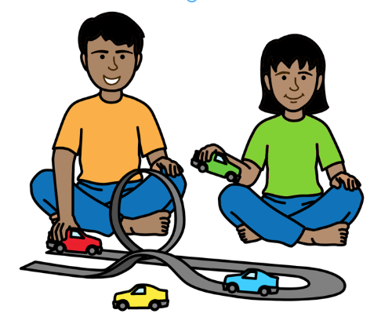

Countries must make sure that children with disabilities can play and do sports with children without disabilities.

This could be in school or other places.
Staff who run sports and activities should get good training about people with disabilities.

People with disabilities should help run the training.

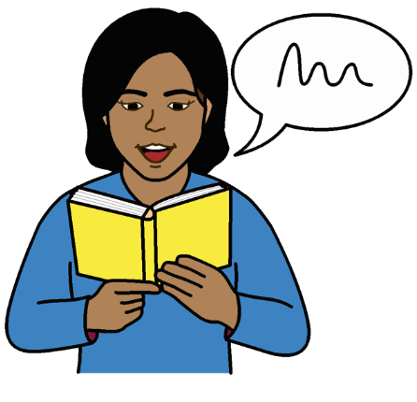

Countries should tell people with disabilities and their families about their rights to do with sport and physical activity.

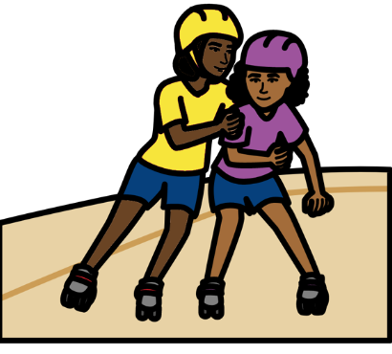
For example:

- Why sport and physical activity is good

- Where people with disabilities can do sport and physical activity

- Extra support they can get

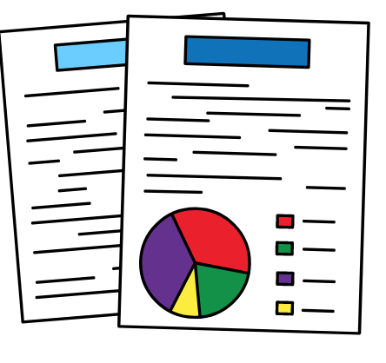
Countries should get information about how people with disabilities are taking part in sport and physical activity.

This will help countries know what to do and how their plans are working.

Countries should give organizations money and support to help them include people with disabilities.

This includes private organizations.

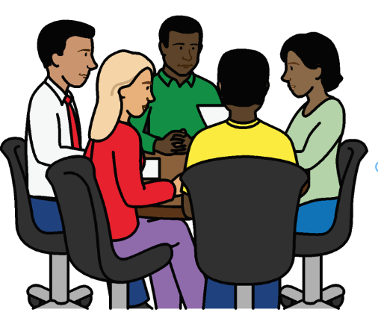

Countries should help organizations work together on sports and physical activity for people with disabilities.

This includes different countries working together.

For example, countries can give money and support and share ideas.

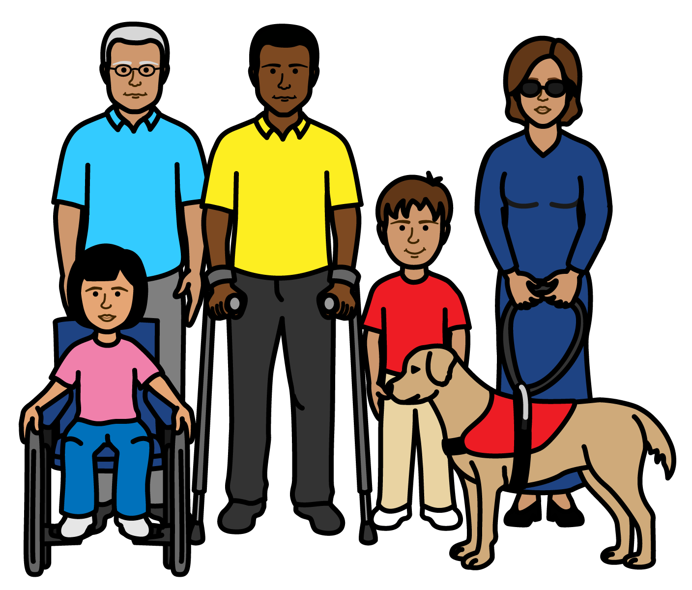
Some good work that countries are doing

A law about helping people to visit Uruguay includes people with disabilities.

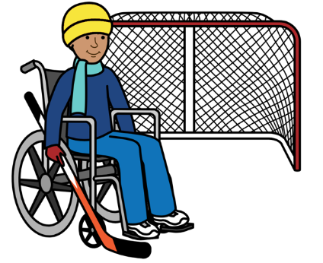

A project in Finland is helping more girls with disabilities to take part in physical activity.

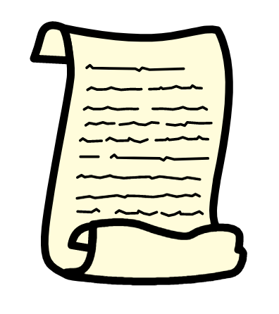

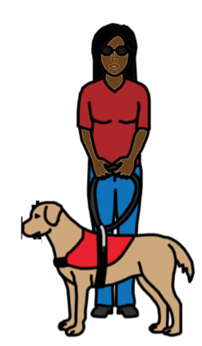

Mexico and Australia have laws to stop people with disabilities being treated unfairly.

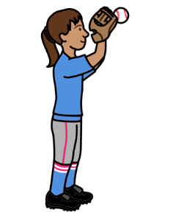

The UK has rules to help keep children with disabilities safe when they do sport.

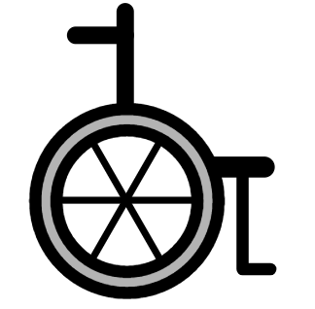
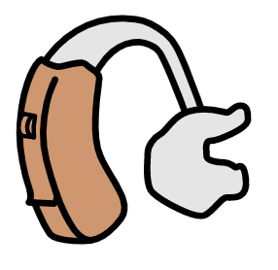
Chile is making it easier to bring equipment for people with disabilities into the country.
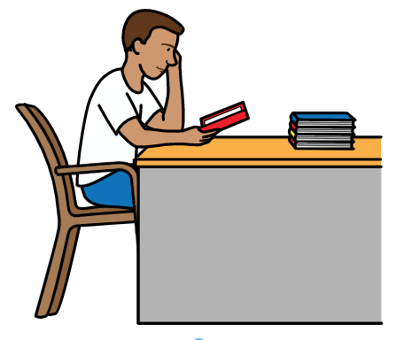

People who are training to be sports teachers in Lithuania learn about people with disabilities.

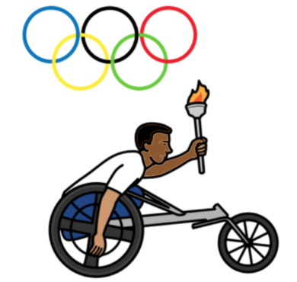

Argentina and Australia give money to some sports people with
disabilities to buy equipment.

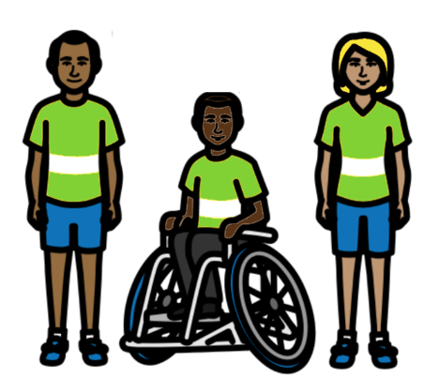

Australia gives money to projects that help people with disabilities to take part in local sports.

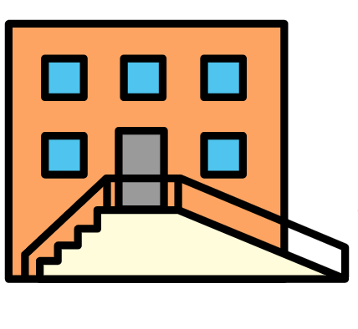

Russia built places for a big sports event that people with disabilities can use.

Pictures by The Picture Communication Symbols ©1981–2016 by Mayer-Johnson LLC a Tobii Dynavox company. All Rights Reserved Worldwide. Thousands of resources available for free at www.boardmakeronline.com
Document checked by Hackney People First. © European Easy-to-Read Logo: Inclusion Europe. More information at www.easy-to-read.eu.

