
United Nations Human Rights Council
United Nations High Commissioner
for Human Rights

Easy to read

What people said at a meeting about climate change and the rights of people who might already be left out and treated unfairly

Climate change is about the earth getting warmer and the problems that it is causing for people and the planet we live on

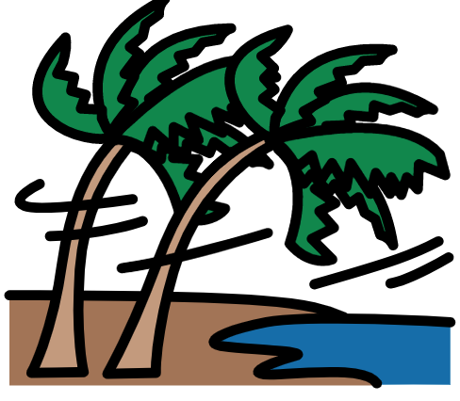
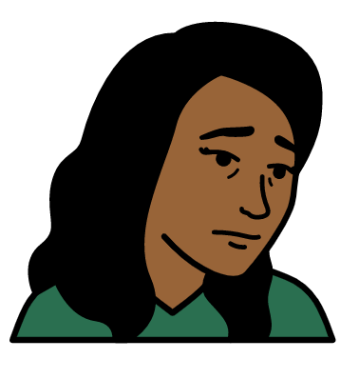

About us
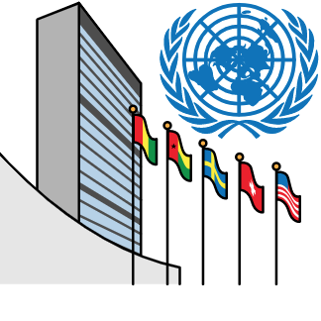

We are called the Office of the High Commissioner for Human Rights.

We are part of the United Nations (UN).

The United Nations is a group of countries that work to make the world better and safer.
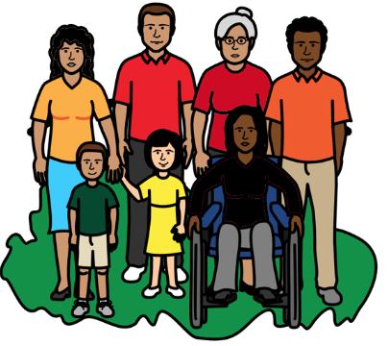

Our job is to make sure that
everyone in the world is treated fairly and gets their human rights.

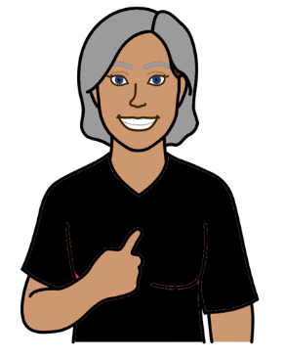

Everyone has human rights.

Human rights are about what should happen to everyone.

For example, everyone has the right to work, go to school and be healthy.

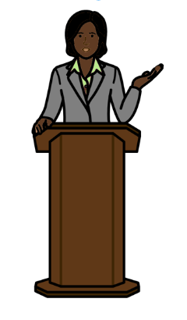
About this report

This report is about a meeting we had
about climate change and the problems it is causing for some people.

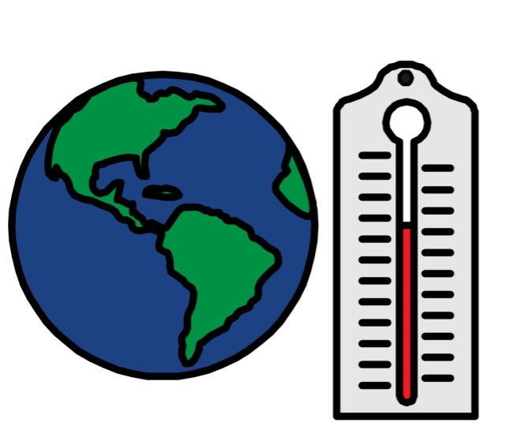

Climate change is about changes to the earth we live on.

The earth is getting warmer.

This is causing big problems for people and the planet we live on.

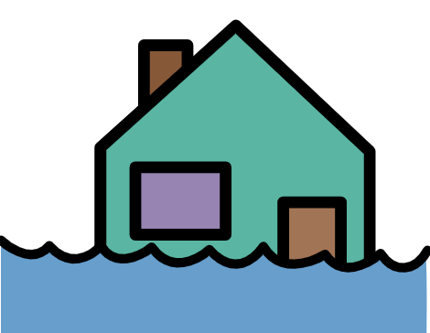

For example, climate change can cause weather problems like floods, too much heat and bad storms.

It can also cause problems for animals and plants.


The meeting we had was on 28 June 2022.
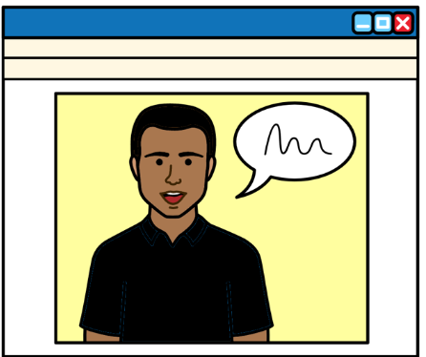
People from different countries and organizations talked at the meeting.

That includes people who speak up about climate change problems in their countries.

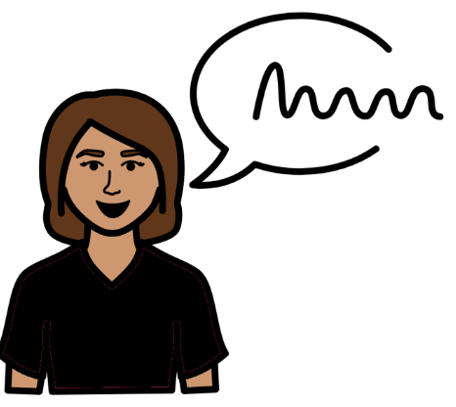

People at the meeting talked about:

- Climate change and the problems it is causing for people who might already be treated unfairly.

- What countries and organizations should do about it.

The main things that people said at the meeting
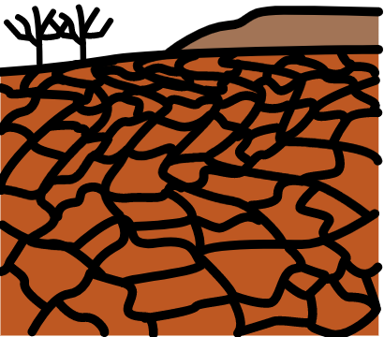

Climate change is a problem for everyone.

For example, there have been bad storms, big floods and too much heat in many parts of the world.
But some groups of people are having worse problems because of climate change.
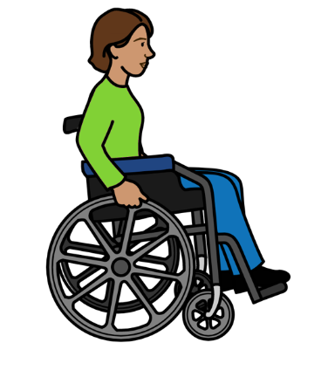
That includes:
- People with disabilities.
- Women and girls.
- Children and older people.
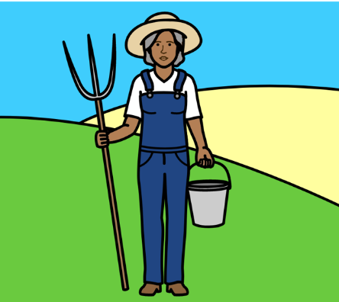
- People who do not have much money.
- People who live in the countryside and work on the land.
- People who live on small islands or in very dry places.
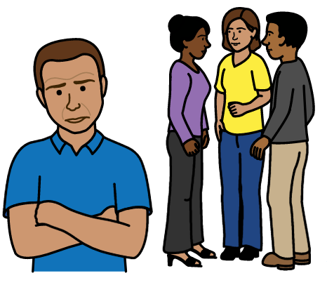
- Some people who have lived on their land for a very long time.

Climate change can be worse for these people because they are often already left out and treated unfairly.

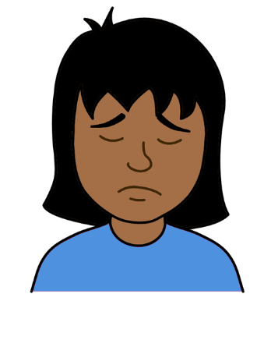

For example, many people are already poor.

That includes many women and children and people with disabilities.

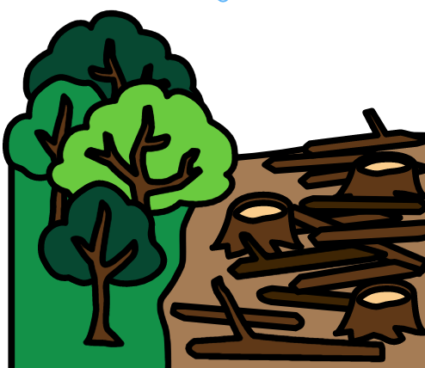

Some groups of people are having their land and their rights taken away from them.

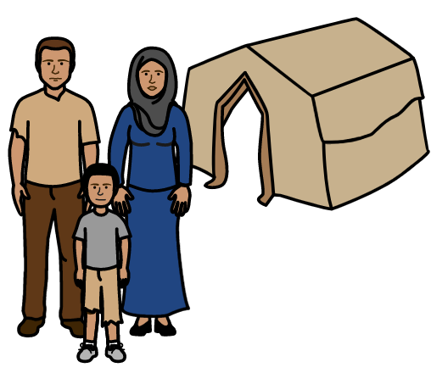
Climate change has often made problems like that worse.

For example, many people are having to leave their homes because of floods and other weather problems.

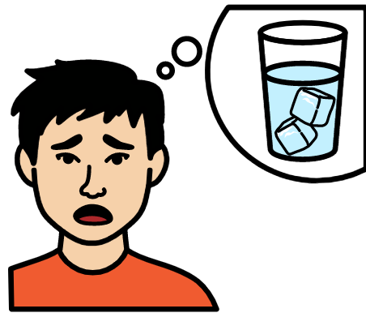
This is happening more and more.

Many people cannot get enough food or clean water to drink because of climate change.
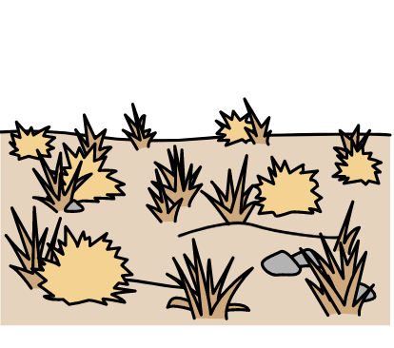
Many people cannot use their land for things that are important to them and their communities.

For example, too much heat can stop people from growing food to eat or sell.



These problems are often worse in poorer countries.

That includes many small islands.

They are in big danger because of floods and storms and the sea getting too high.

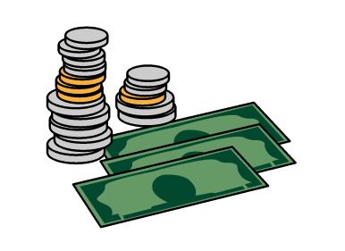

Many poorer countries do not have enough money to deal with climate change problems.

That is unfair because most climate change problems are caused by richer countries.

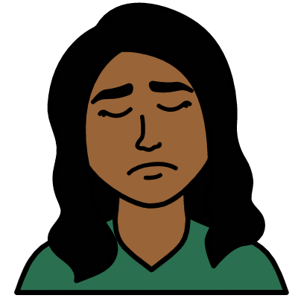
Many women and girls might be more unsafe because of climate change problems.

For example, they might lose their homes, jobs and support.

And they might be more at risk of violence.

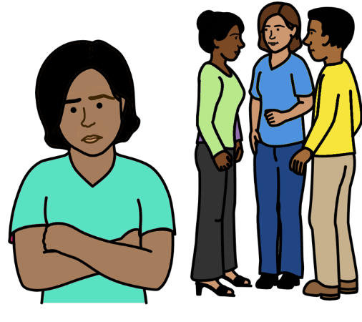
Many people are left out of plans and decisions about climate change.

That includes many groups of people who know a lot about their land and the local area.

They often have good ideas and know what to do.

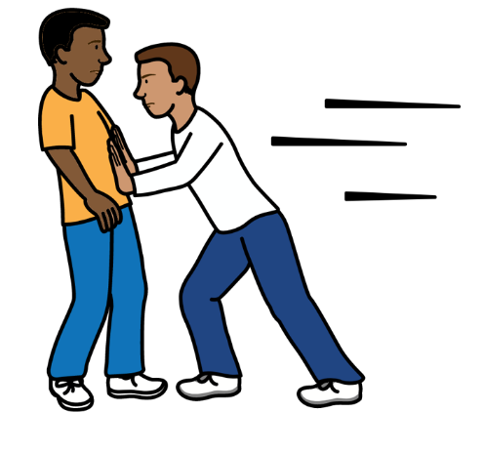
But people who make decisions might not listen to their ideas.

Some people have been hurt or killed for speaking up about climate change.

Some good work that is already happening
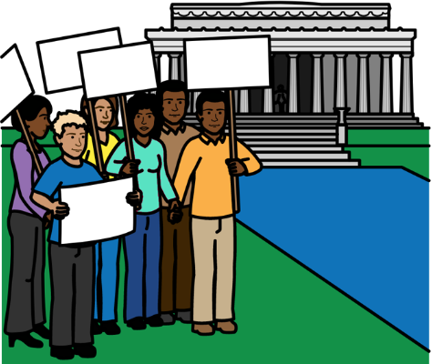

Many people around the world are having their say about climate change.

That includes groups of people who have often been left out and treated badly.

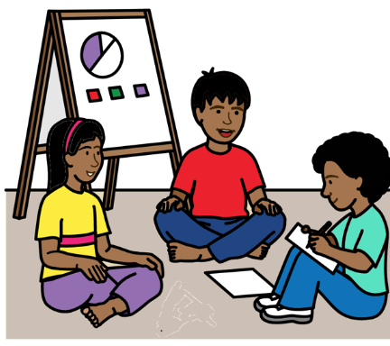

A group of young people in Australia are getting together to keep their land and communities safe from climate change.

Some groups of people in Peru have made their own plan about how to keep safe from climate change.
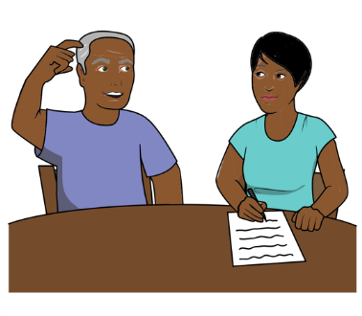

Fiji is making sure that people who need most support can take part in making decisions about climate change.

But much more needs to be done.
What people at the meeting said should happen next
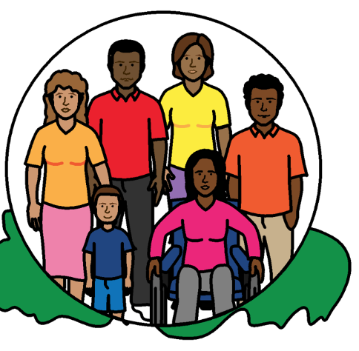

Everyone has the right to live in a healthy world.

That means countries must work together straight away to stop climate change problems and keep people safe.

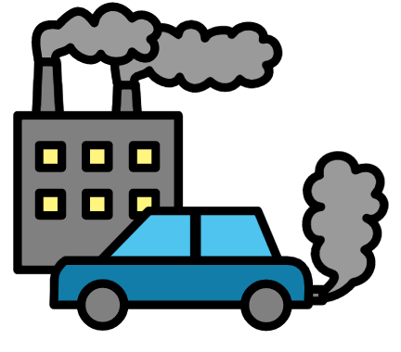

Countries who cause most climate change problems should work harder to stop climate change getting worse.

That means using less coal, gas and oil and other things that damage the earth.

Companies must also work in a better way to stop climate change.

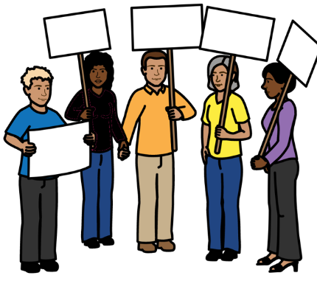
Human rights should be part of all work on climate change.

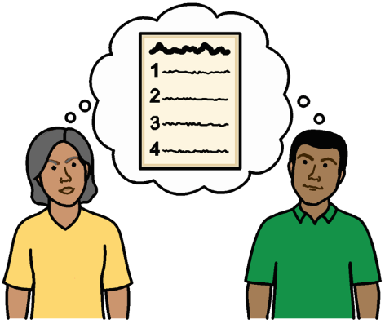

Countries should make plans to solve all the problems that different people have because of climate change.

The plans should also support local people to solve climate change problems themselves.

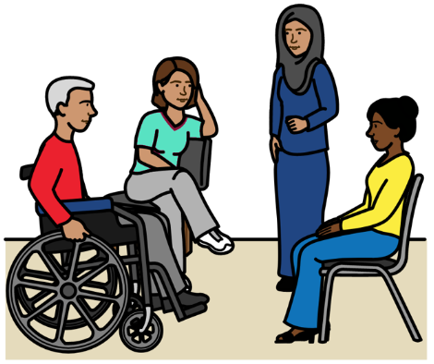

Countries should work with people who are often left out to make plans and decisions about climate change.

Countries should listen to what people want and need.

That includes people with disabilities, women, young people and older people.


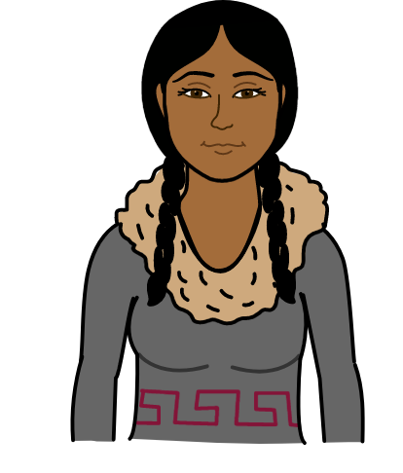
Countries should also work with groups of people who know a lot about their land and the local area.

They often know good ways to solve climate change problems.

And they have important rights to do with their land and their way of life.

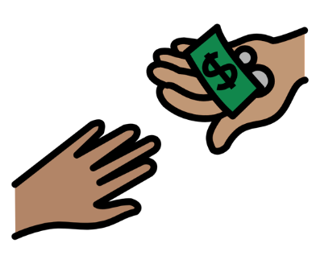

Poorer countries should get more money and support to deal with climate change and the damage it causes.

Richer countries have promised to give them money and support.

Poorer countries should not have to pay that money back.
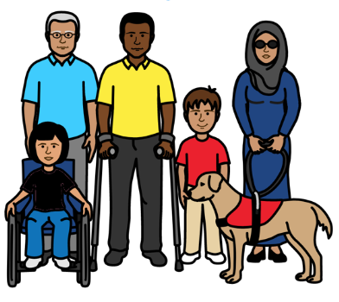

The money and support should go to people who need it most.
That will help people to deal with climate change now and in the future.

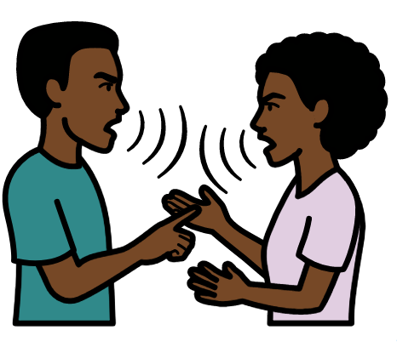
The money and support will also help to stop bigger problems happening.

For example, wars and fighting can start if there is not enough land or clean water for everyone.

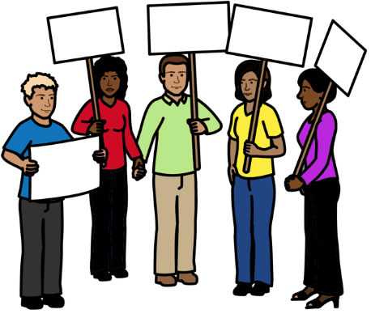

There should be better support for people who want to speak up about climate change problems.

It should be safe for them to speak up.

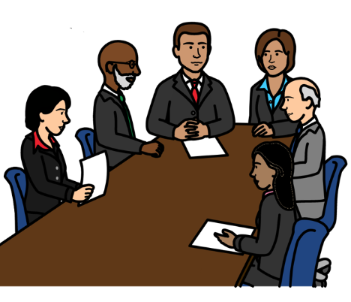

The United Nations could also do more.

For example, they could make sure that human rights are a big part of all work on climate change.
Most pictures by The Picture Communication Symbols ©1981–2016 by Mayer-Johnson LLC a Tobii Dynavox company. All Rights Reserved Worldwide. Thousands of resources available for free at www.boardmakeronline.com

