
United Nations Human Rights Council
United Nations High Commissioner
for Human Rights

Easy to read

What people said at a meeting about countries taking control of other countries in the past and the problems that is still causing for people and their human rights

When countries take over other countries and control them in this way it is called colonialism.

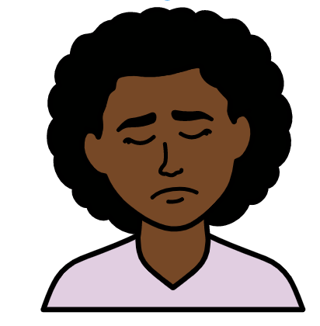

About us
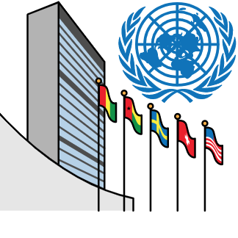

We are called the Office of the High Commissioner for Human Rights.

We are part of the United Nations (UN).

The United Nations is a group of countries that work to make the world better and safer.
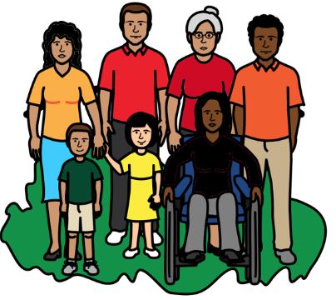

Our job is to make sure that
everyone in the world is treated fairly and gets their human rights.

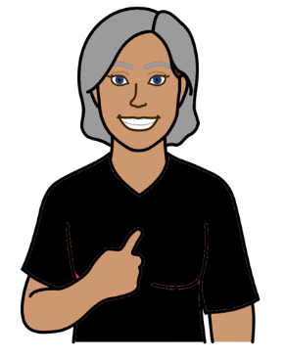

Everyone has human rights.

Like the right to work, go to school and be healthy.

That is what should happen in everyone’s lives.

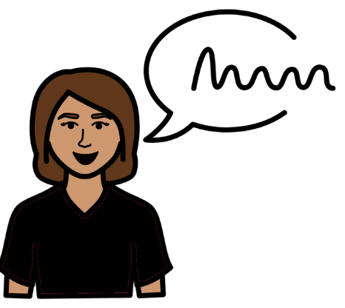
About this report

This report is about a meeting we had at the United Nations on 28 September 2022.

Different countries and organizations talked at the meeting.

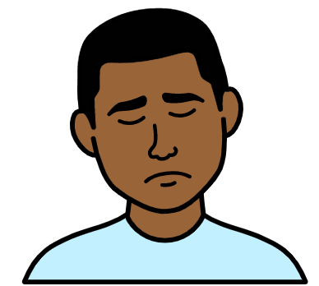

The meeting was about:

- Some countries taking over other countries in the past and controlling them.

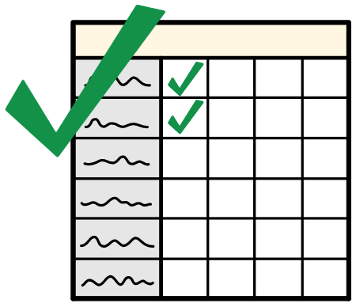
- How that is still causing problems for many people and their human rights.

- Ideas for what should happen next.

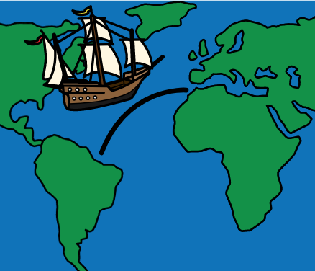

When countries take over other countries like that it is called colonialism.

But we will just talk about countries taking over other countries and controlling them in this report.

The main things that people talked about at the meeting

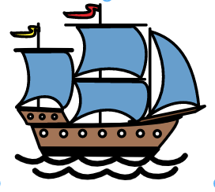
What happened when countries took over other countries

Some countries starting taking over other countries in the past.

For example, some countries in Europe went to other countries in the world and took them over.
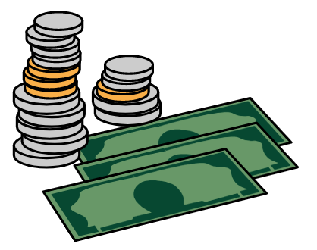

They usually did that to get more money and power.
For example, by making money from things that the other country had.
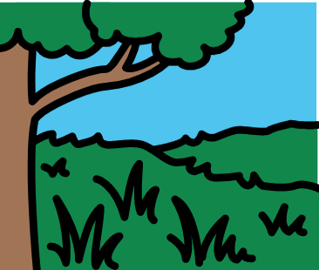

Countries treated some groups of people very badly when they took over.
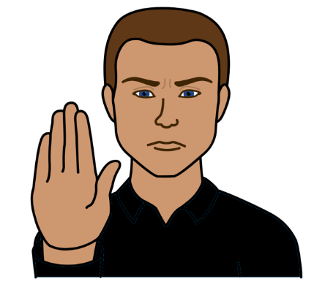
For example, they often took land and other things away from people already in the country.
And they often forced people in the country to change their language, religion and way of life.
Some countries also did very bad things to many people from Africa.

For example, some countries forced many people from Africa to leave their homes.

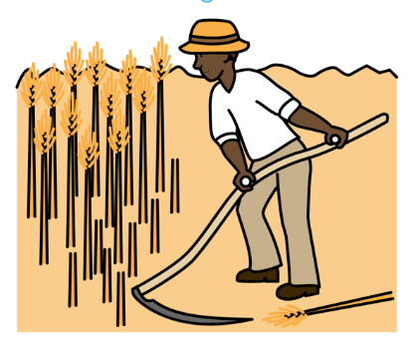
The people from Africa were taken to other countries far away.

They were forced to work for free.

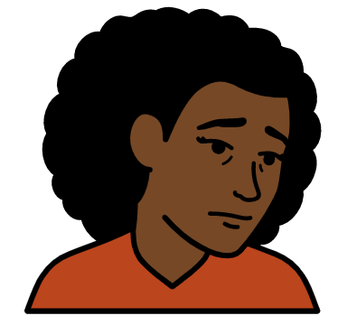

The people from Africa were treated very badly.

They did not have the same rights as other people.


Countries used the people from Africa to get more money and power for themselves.
Problems for people and their human rights now
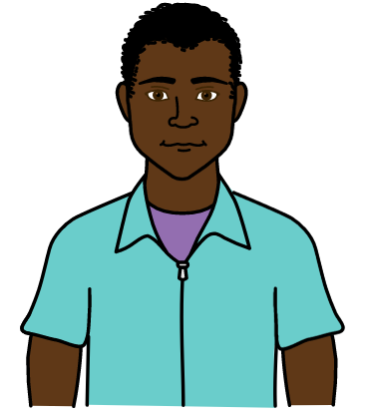
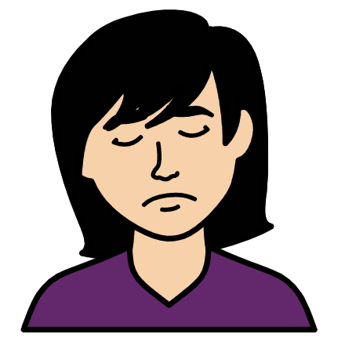
Some groups of people are still treated very badly because of what happened in the past.

They are treated badly because of the color of their skin.

That includes many African people and Asian people.
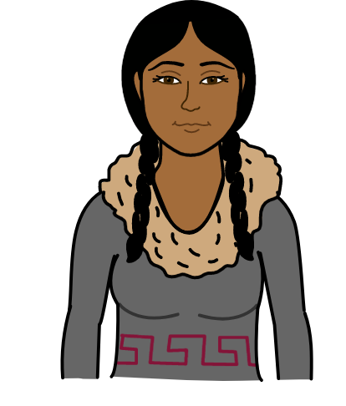
And people whose families came from Africa and Asia.

It also includes groups of people who had lived in their countries for a long time before other people took over.

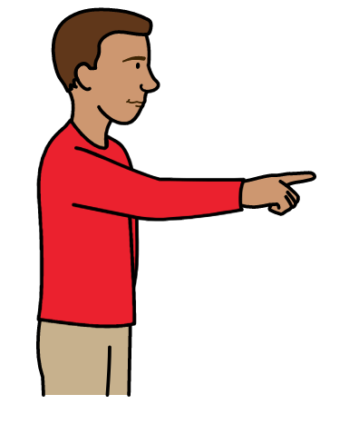

These groups of people are often still hurt or treated badly by other people.

They might also be blamed for problems in the country.

For example, many Asian people were blamed for problems with a big illness in the world called Covid-19.

Many of these groups of people are often poorer than other people.

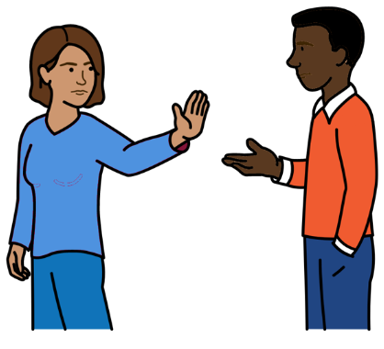

Many people find it hard to get the things they need to have a good life.

Like good health care, education and jobs.

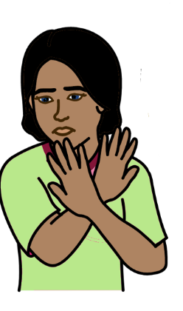

More violence can happen to some of these groups of people.

That can be even worse for women and girls and some other people.

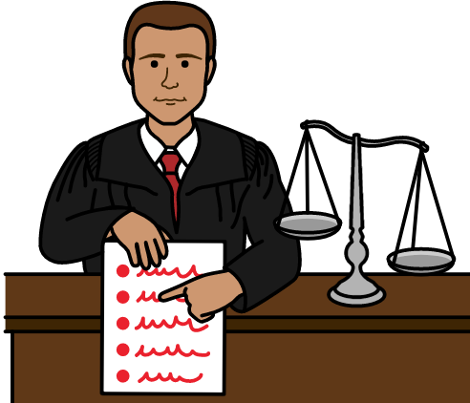

This is happening because many of the problems from the past are still there.

That includes unfair laws and rules that make life worse for some groups of people.

It also includes wrong ideas that people might have about some groups of people.
Like the idea that some groups of people are better or more important than others.
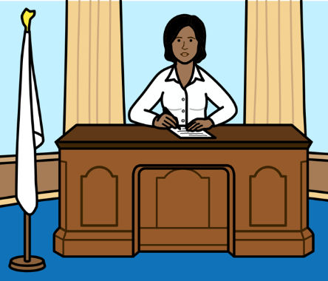
Problems for countries that have less money

Countries and people have the right to have their own government and decide how their countries are run.

But that is still not happening for all countries.

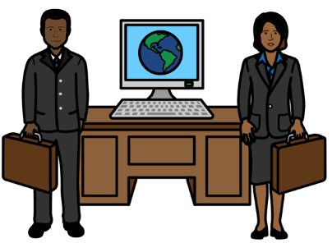

Many countries that were taken over in the past have less money now. They are in the south of the world.

These countries also have the right to grow and do well.

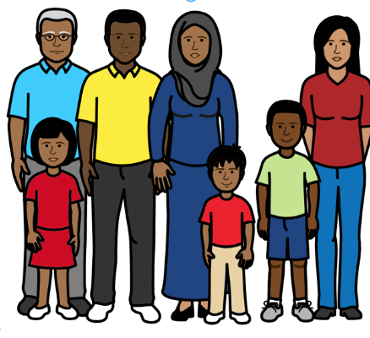

That means everyone in the country also has the right to do well.

That is very important for people’s human rights.
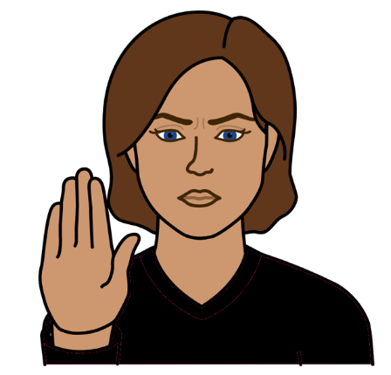

But richer countries are often stopping countries with less money from doing well.
For example, by making it harder for them to borrow money and pay it back.
- What people said should happen next

Many countries have more money and power because they took over other countries in the past and
treated some groups of people badly.

These countries should now start solving the problems they caused.

There are some things below for these countries to do:

Make sure that all countries can have their own government and be in charge of making their own decisions.

Countries should not be controlled by other countries.

Make sure that countries with less money get their right to grow and do well.

That means everyone in those countries should be able to do well and get their human rights.
That means doing more to help countries with less money to do well.

For example:

Giving more money and support to countries with less money.

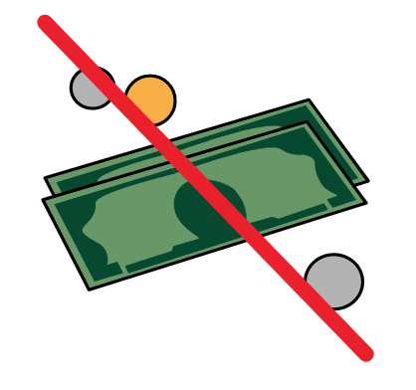
Changing unfair decisions and rules that stop countries with less money from doing well.

For example, changing unfair rules about buying and selling things.

And making sure that countries with less money don’t have to pay money back that they owe.

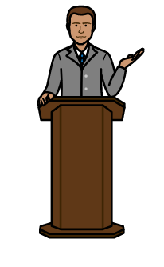

Saying sorry and working to make things better

Some countries have started to say sorry and try to make things better for people they have treated badly.

Now other countries should do the same.
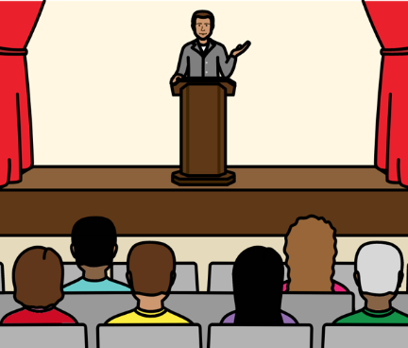
For example, countries could
say what they have done wrong in the past when they took over other countries.

They could say sorry in public.

They could make sure they tell the truth about what happened.

They could give money and support to people who were hurt.

And they could give things back to countries that they took from them in the past.
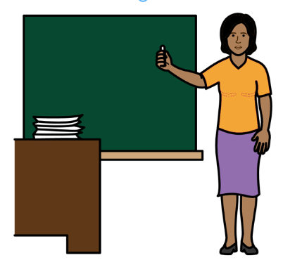

Countries could help people to learn more about the problems from the past.
For example, at school.

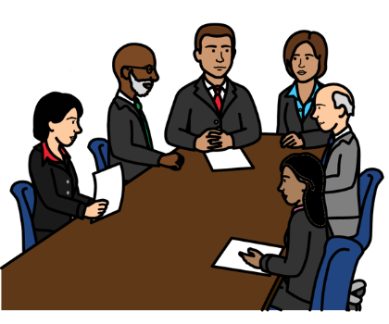

They could look into human rights problems from the past and how they were allowed to happen.
They could take action to stop the same things happening again.
Things for all countries to do
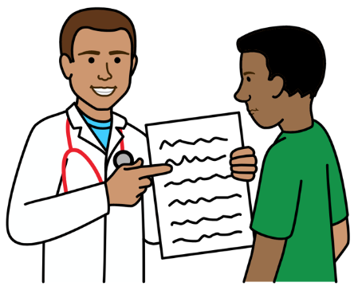

All countries should make sure that everyone is treated fairly and can get the things they need.

Like education, health care and help from the police and courts.

Certain groups of people should not be treated worse than others.

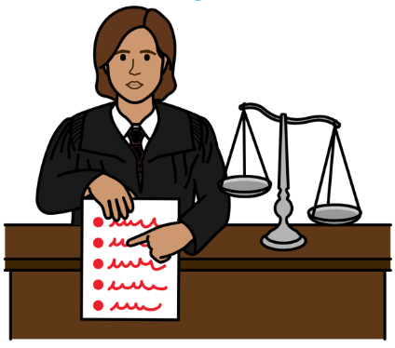

Countries should work to change unfair laws, rules and ideas that are still there about some people.

For example, ideas that some groups of people are better than others.



Countries should follow important laws and documents they have made about human rights.
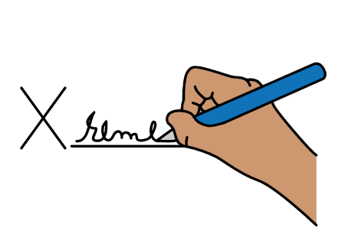
That includes laws about stopping certain groups of people from being hurt and treated badly.
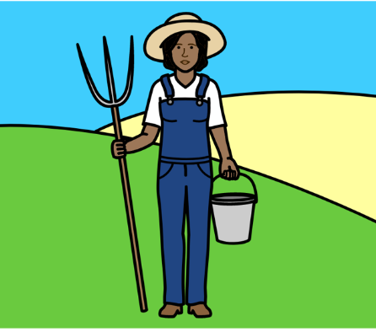
There are also laws to make sure that certain groups of people get their human rights.

That includes groups of people who lived in their country for a long time before other people took over.

They have important rights about things like making their own decisions and owning land.

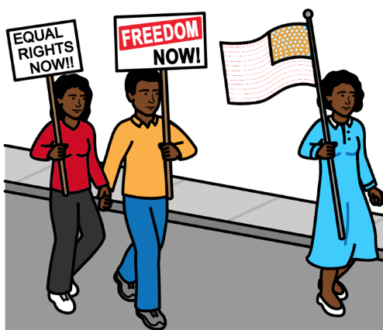

Countries should also make sure that people can speak up safely about their human rights.

At the moment some people are hurt or treated badly if they try to speak up.

Countries should do what the United Nations tells them to do in their reports.

Countries should also come to other meetings to talk about the things in this report.
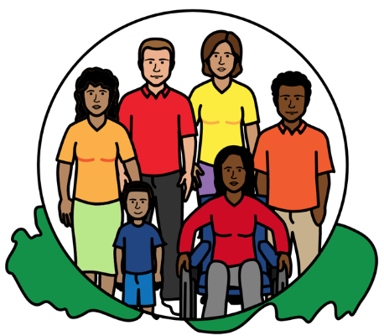
This will help everyone to be treated fairly and to get their human rights.

It will also help countries to make the future better and more peaceful for everyone.

Most pictures by The Picture Communication Symbols ©1981–2016 by Mayer-Johnson LLC a Tobii Dynavox company. All Rights Reserved Worldwide. Thousands of resources available for free at www.boardmakeronline.com

