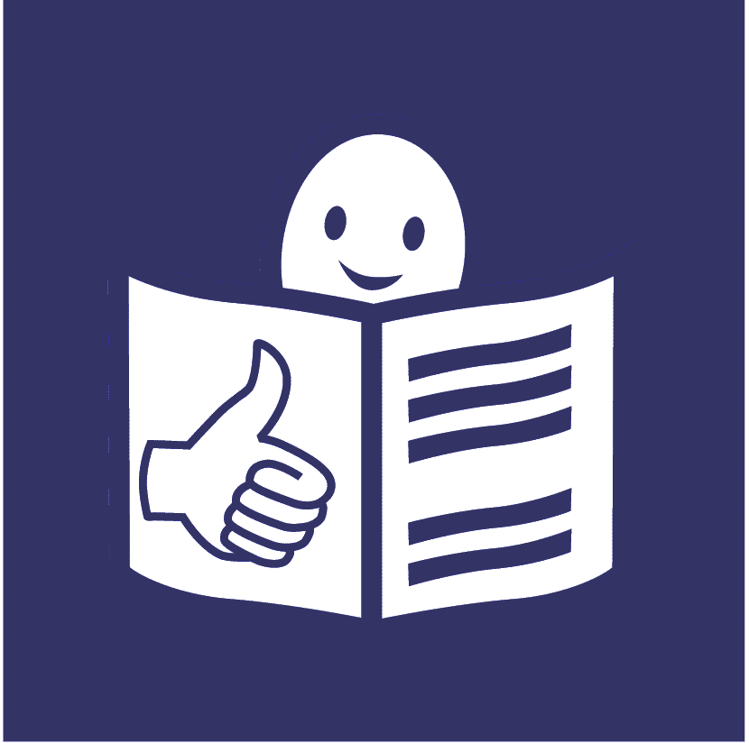
United Nations Office of the
High Commissioner for Human Rights
Easy to read
What our part of the United Nations has done to include people with disabilities in 2022

This is about our work on the United Nations plan to include people with disabilities
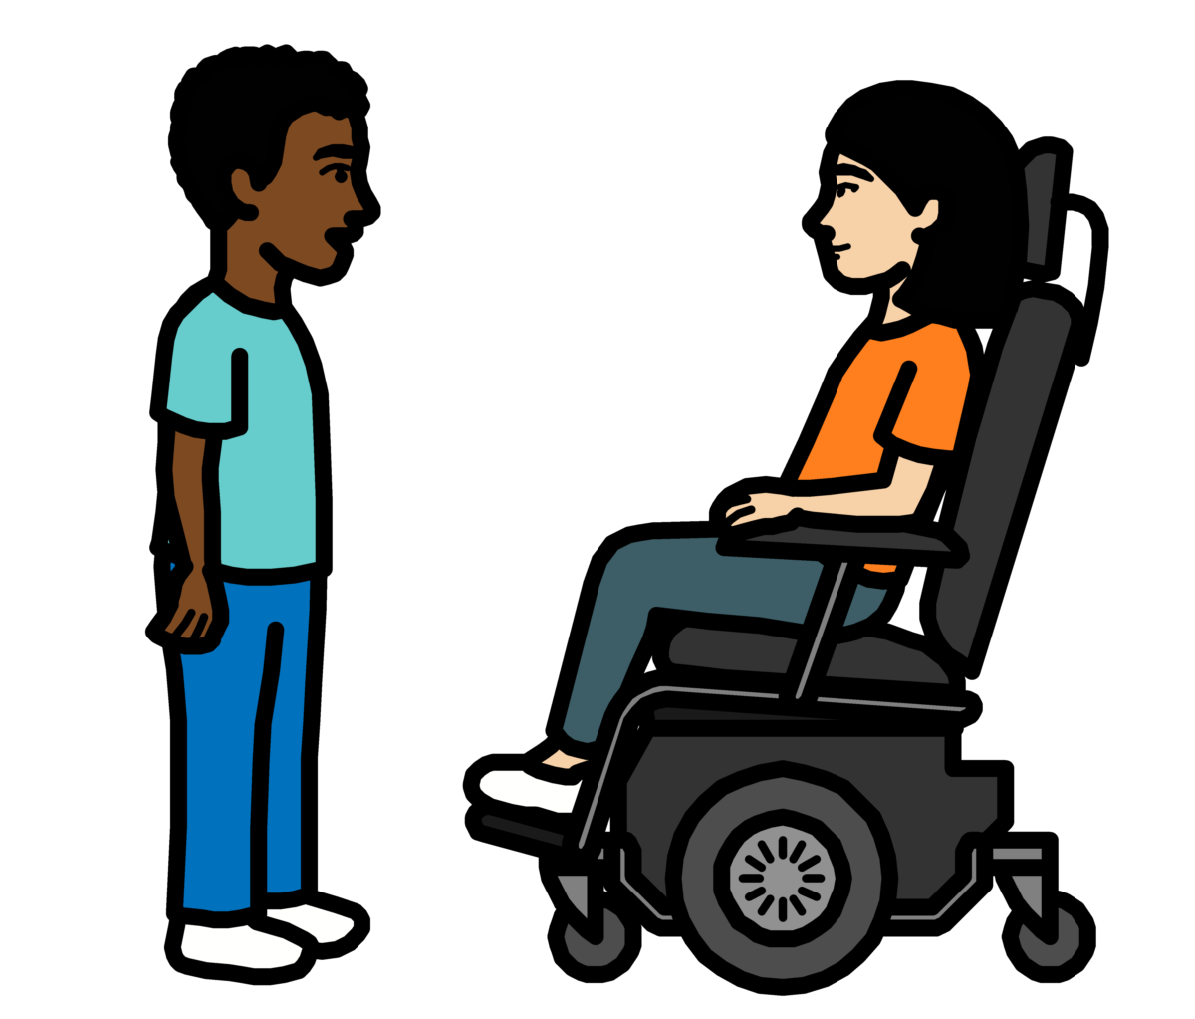

Progress report on the UN Disability Inclusion Strategy

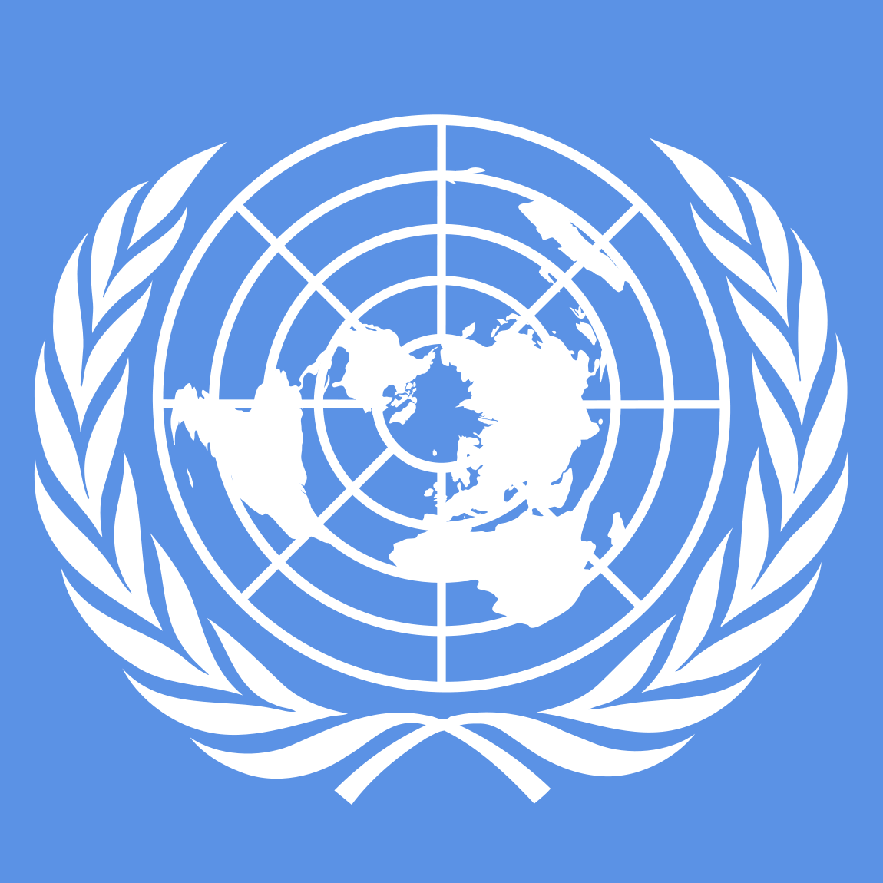
About us

We are called the Office of the High Commissioner for Human Rights. Or OHCHR for short.

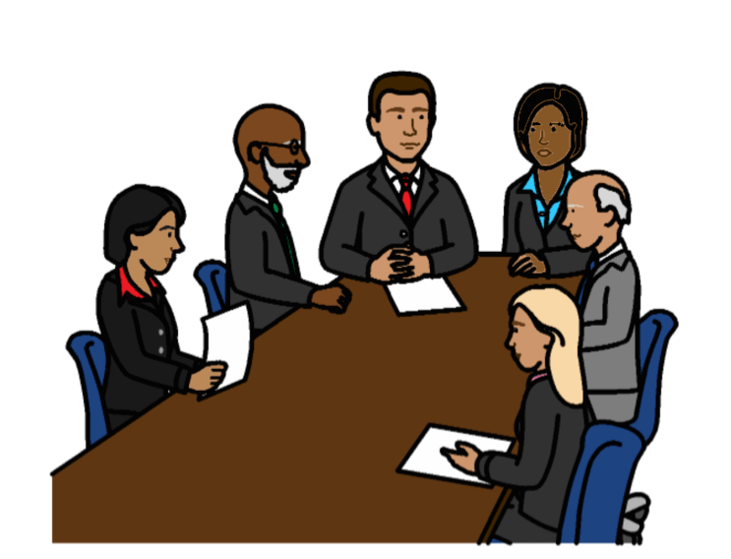

We are part of the United Nations (UN).

The United Nations is a group of countries that work to make the world better and safer.

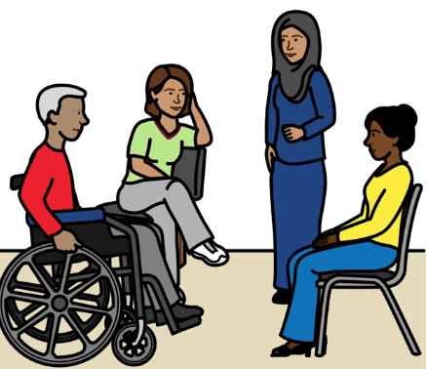
About this report

The United Nations wants people with disabilities to be part of everything it does.

That means people with disabilities should not be left out.
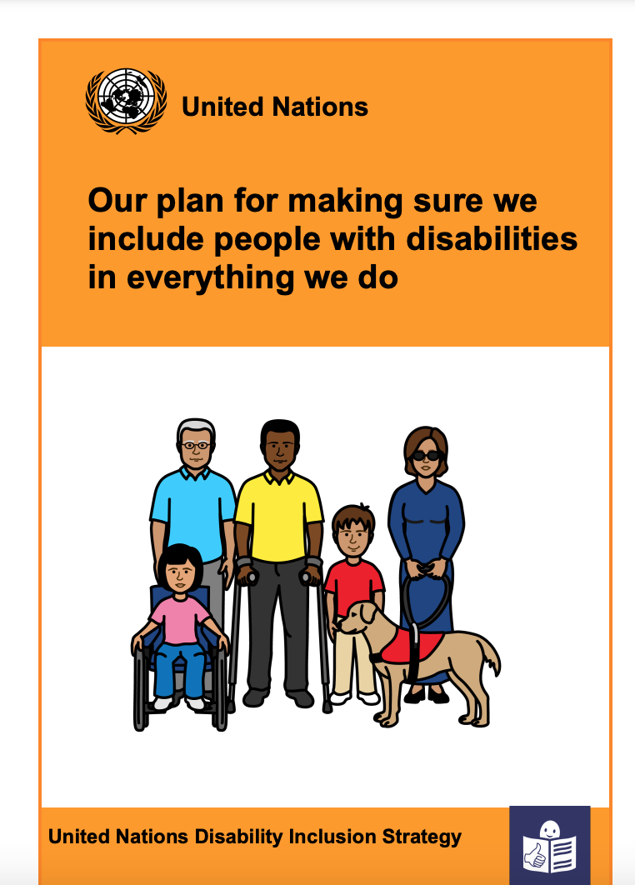

The United Nations has a plan about how to include people with disabilities.

The plan is called the
Disability Inclusion Strategy.


The plan is on this website:
https://www.un.org/en/content/disabilitystrategy/assets/documentation/Easy_to_Read.pdf

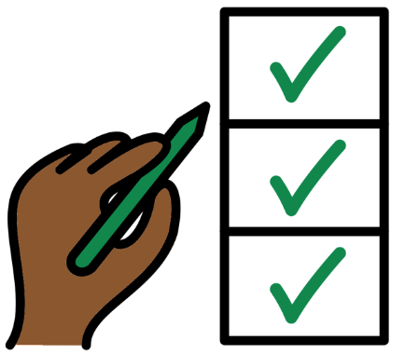

Different parts of the United Nations should say how they are doing with the plan every year.

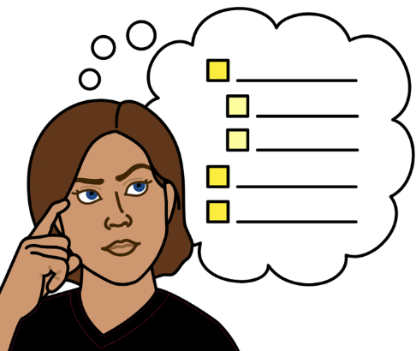
This report tells you what we have done to include people with disabilities
in 2022.

There are 15 areas of work that we had to look at.
We had to say how well we are doing on each area that we work on.

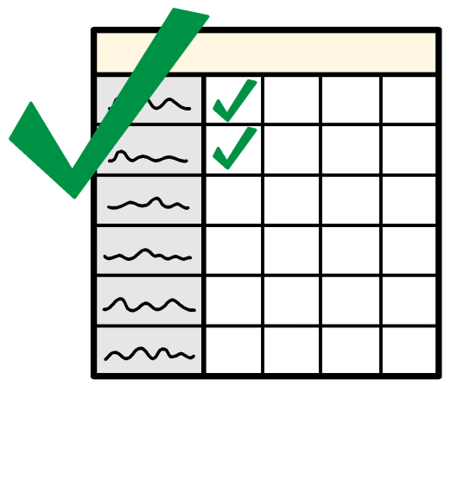

This report tells you more about what we are doing well on.

And what we need to do more on in 2023.
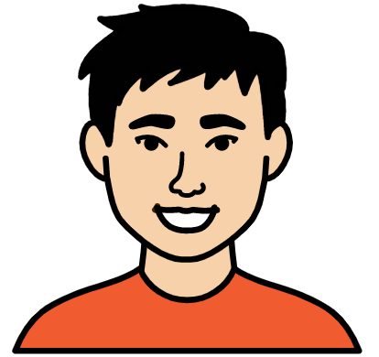
How we are doing so far to include people with disabilities

- We are doing even better than we need to on some things
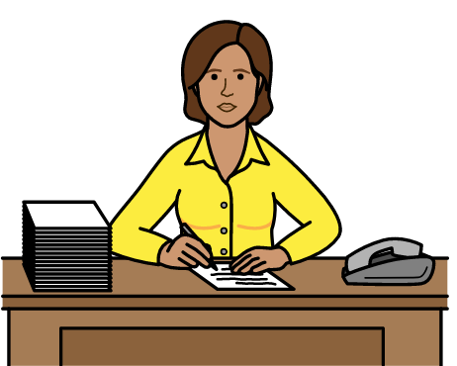
We are doing even better than we need to on the areas of work below:

Making sure that senior managers make the United Nations plan about people with disabilities happen.
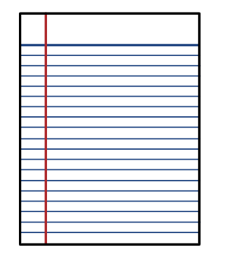
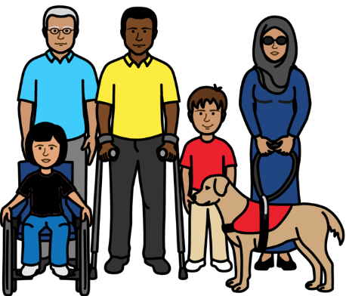

Making sure that we have a plan about how to include people with disabilities.

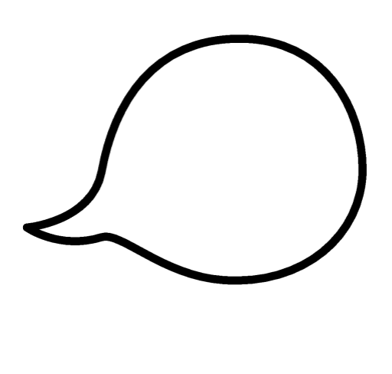
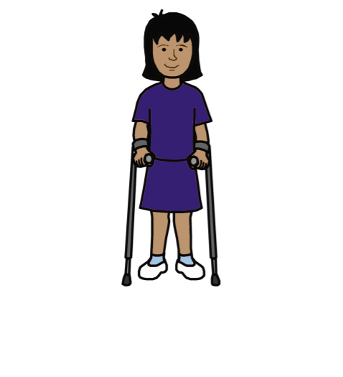

Making sure that people with disabilities get the right support to take part and have their say.

Working with other parts of the United Nations to include people with disabilities.
Some examples of our work:

We made a plan in 2020 about how we will include people with disabilities.

The plan includes work that our senior managers have to do.

We will make the plan a bigger part of our work in 2023.
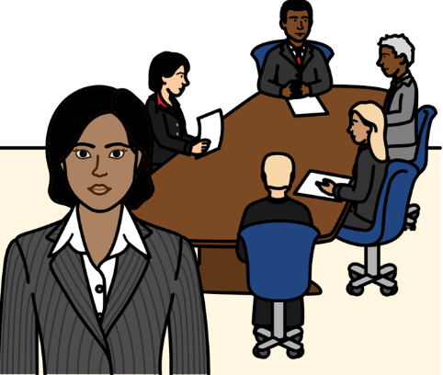

We have senior people in charge of human rights work for the United Nations.

They are doing a lot to support our work about people with disabilities.

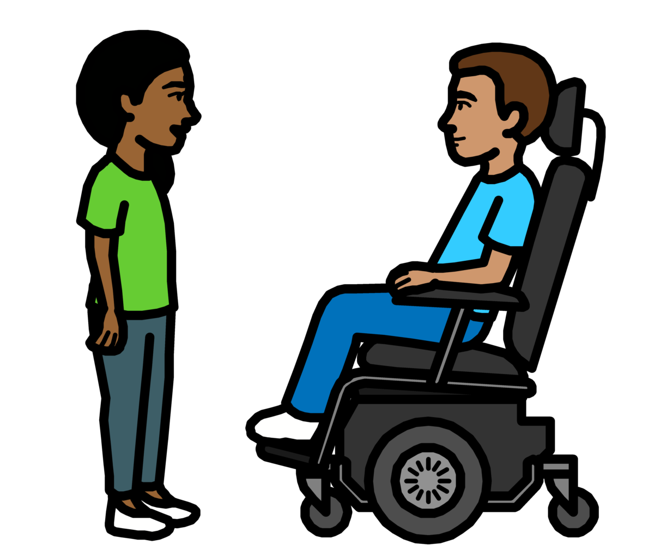

For example, they helped to check our plan to include people with disabilities to see what needed to change.

And they met with some groups of people with disabilities in Bosnia and Herzegovina.

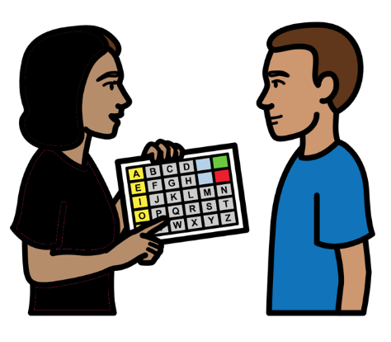
We already have a plan about how to give extra support to people with disabilities who need it.

For example, people might need equipment or support to travel.

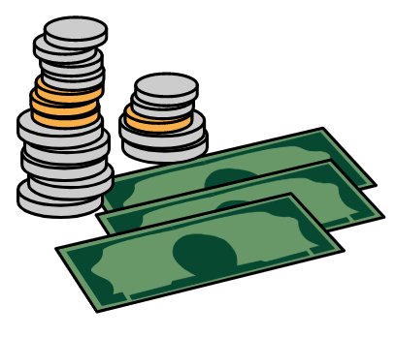

In 2021 we started a new way to give people with disabilities this extra support.

We are also making sure that we have money to give people extra support.

We have worked a lot with the United Nations and other organizations on the rights of people with disabilities.

For example, we were part of a project about care and support and the rights of people with disabilities.

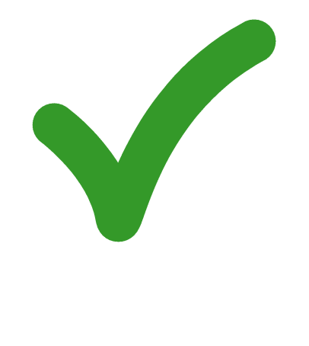
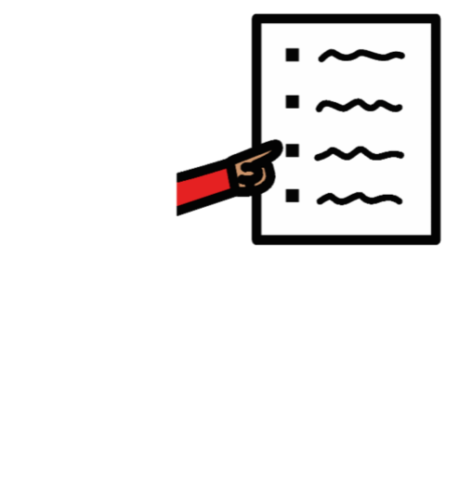
2. We are doing everything we need to on some things

We are doing everything we need to on the areas of work below:
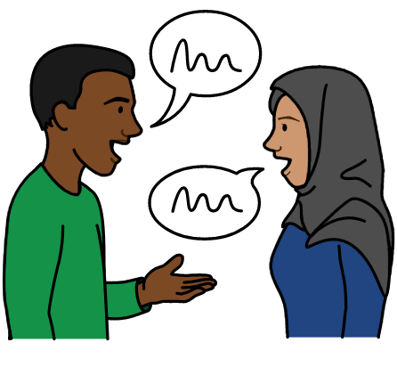

Making sure there are people who know about disability and human rights.

And making sure that people can meet to talk about disability.
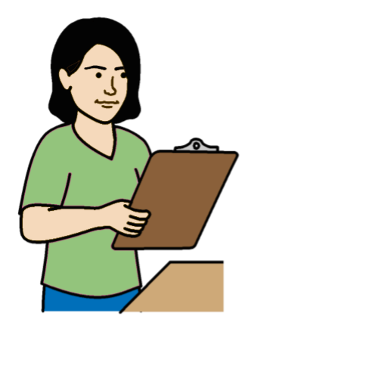

Making sure that people check how projects are working for people with disabilities and their rights.

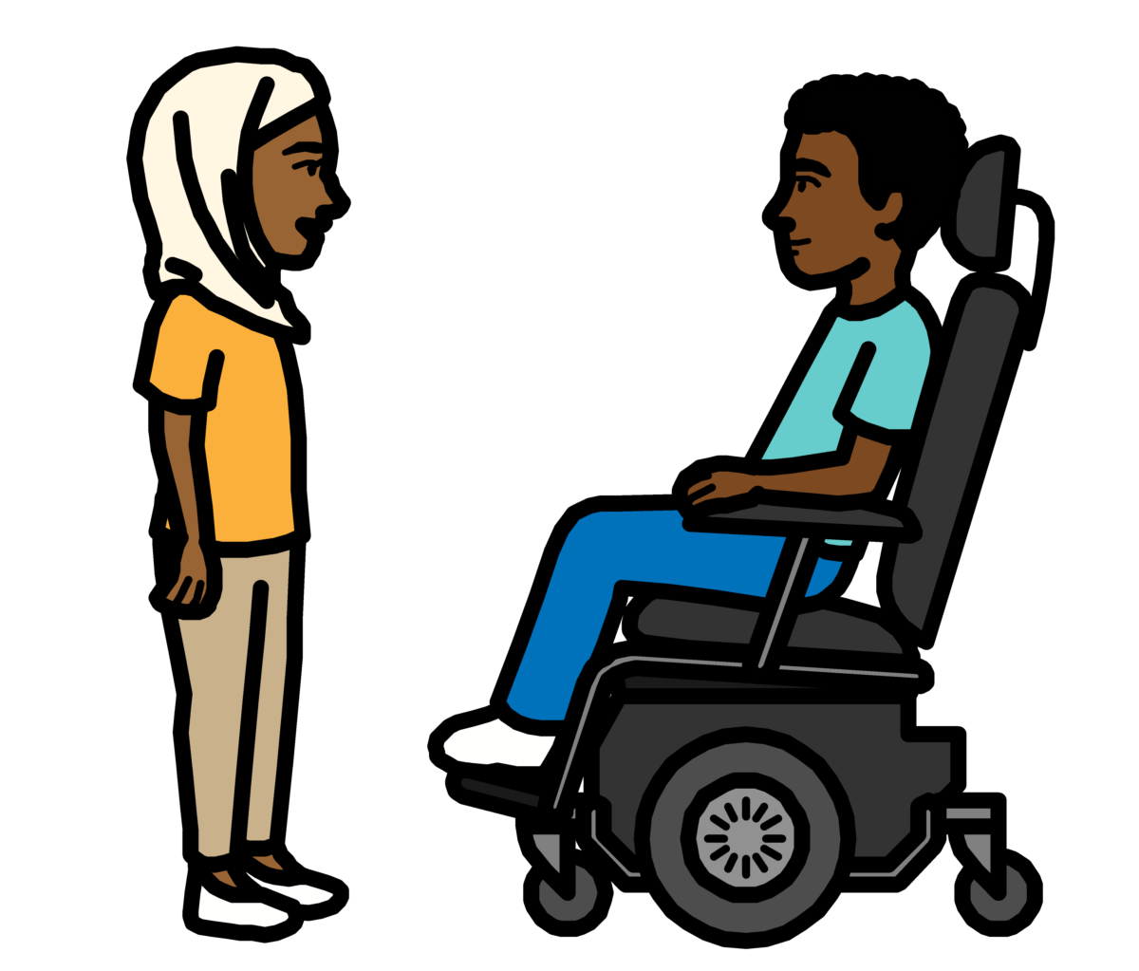
Some examples of our work:

We have 2 people to make sure that we include people with disabilities in our work.

They work with the United Nations, people with disabilities, governments and other organizations.

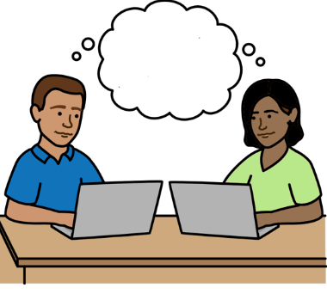
We set up a new way for the United Nations to work together to include people with disabilities.

It means people can share information and training on the rights of people with disabilities.

We will do more work on that in 2023.

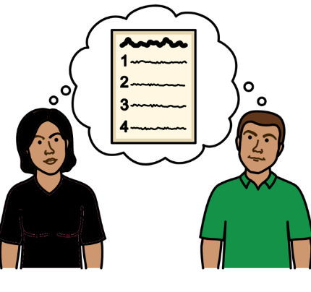

In 2022 we looked at how some of our projects in different countries are working for people with disabilities.

We will do more of that in 2023.

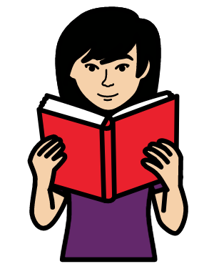

We made some rules about how to check if projects are working for people with disabilities.

We want our staff to be using the rules by the end of 2023.

The rules will also help other parts of the United Nations to know what to do.

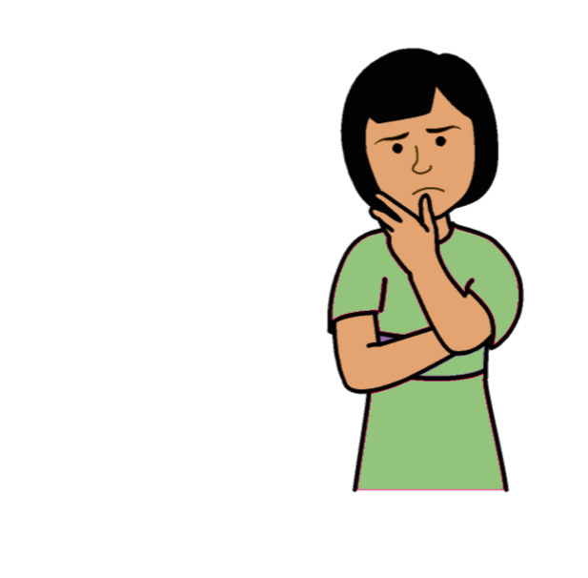
3. We are not doing everything we need to yet on some things

We are not doing everything we need to yet on the areas of work below:
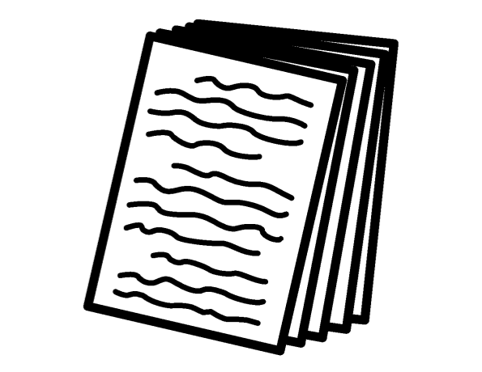
Making sure that the main plan about our work talks about people with disabilities and their rights.
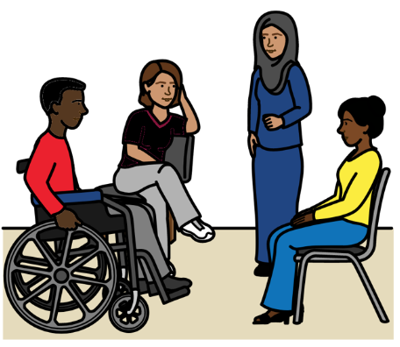

Working with people with disabilities and making sure they can have a say.

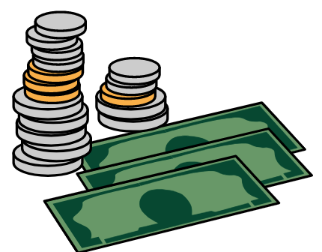

Making sure that new services
and things that we buy work well for people with disabilities.
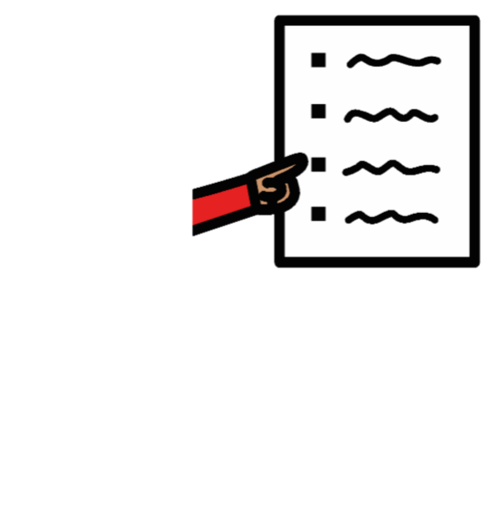
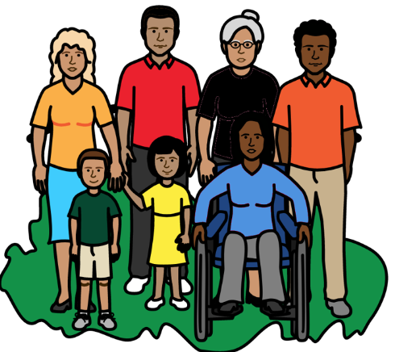

Making sure that projects include the rights of people with disabilities and what they need.
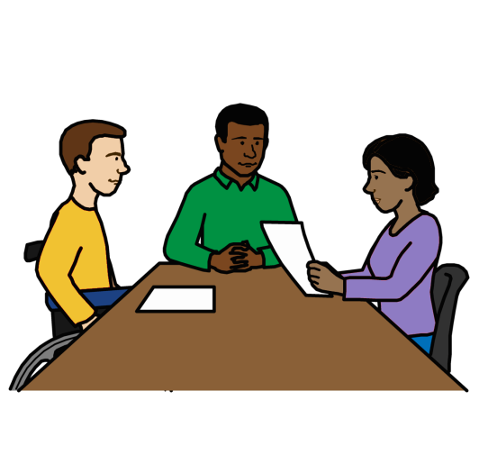

Helping more people with disabilities to work for the United Nations and do well.
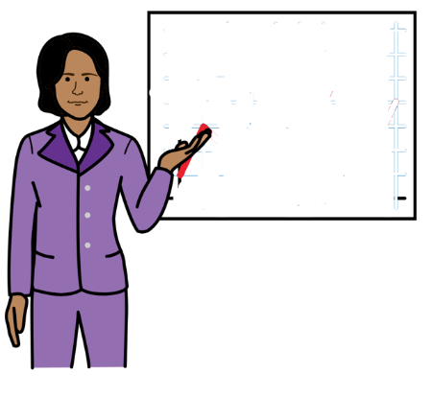
Making sure that staff get information and training about how to include people with disabilities.

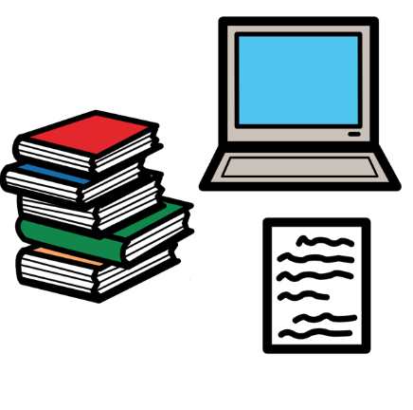
Making sure that the United Nations:
- Talks about people with disabilities in the right way.

- Helps people to know about people with disabilities and their rights.

Some examples of our work:

We are looking more closely at the rights of people with disabilities in our work in different countries.

The main plan about our work talks a lot about people with disabilities and their rights.

That includes the rights of women and young people with disabilities.

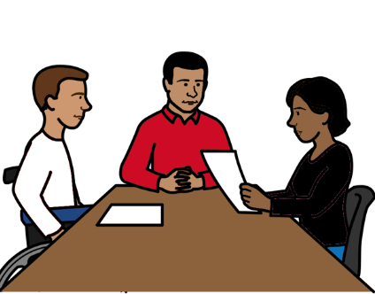
Some staff set up a group to talk about disability in the United Nations.
They are staff with disabilities and staff who support people with disabilities.
Our senior managers met the group to find out what is important to them.

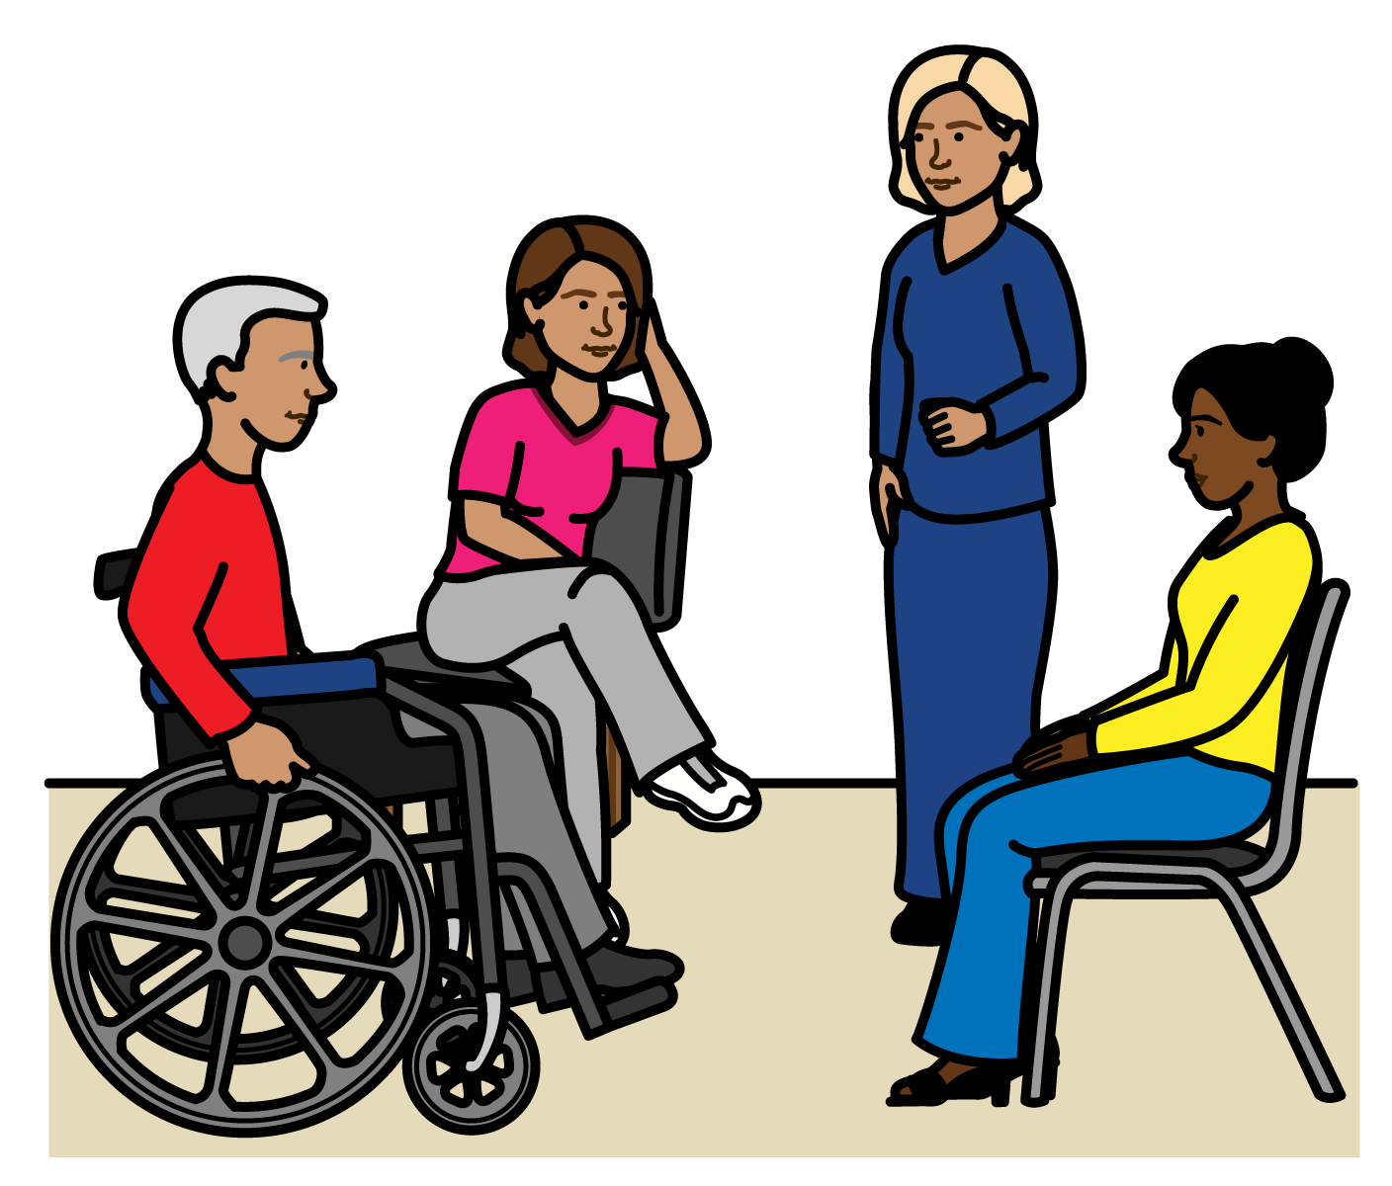
We often work with people with disabilities to find what they think about things to do with disability.

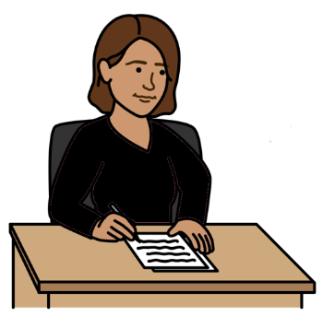

We made some new information about how to include people with disabilities when we ask for money for our projects.

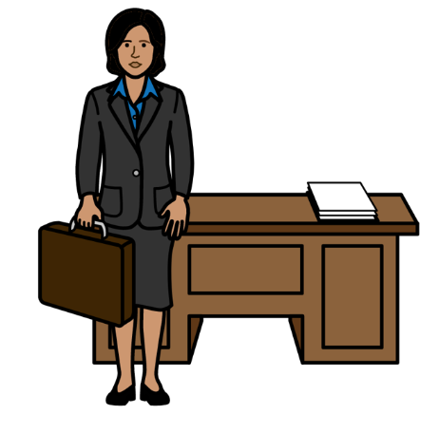

We want many different groups of people to work for us, learn new skills and do well.

That includes people with disabilities.

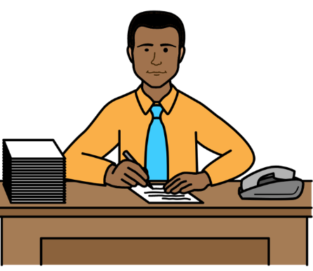
We will have a new person to help us know how to include different groups of people.

We also made a plan about the work we need to do to include people.

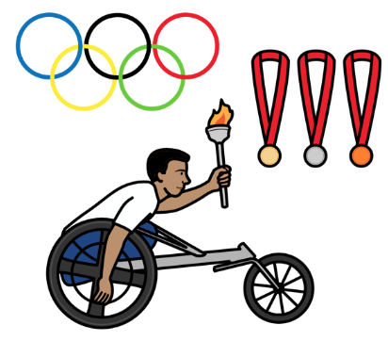
We are working on a project with a big sports organization about people with disabilities and their rights.

We made some training about the rights of people with disabilities and what organizations need to do.

The training is on our website.

But there is more that we need to do in 2023.
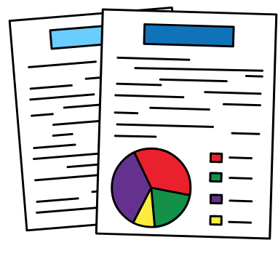

For example:

We will work with other parts of the United Nations to get better information about people with disabilities.
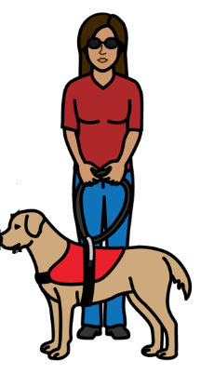
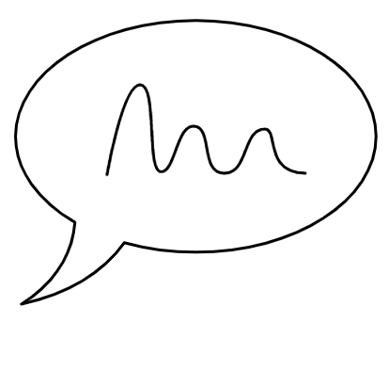
We will find a better way to check how people with disabilities are having a say in our work.

We will look at how to make sure that everything we buy works well for people with disabilities.

We will make that part of our plan about people with disabilities in 2024.

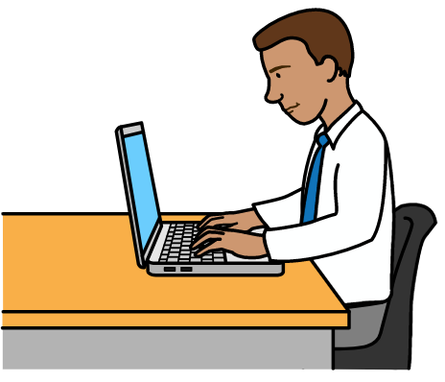

We will give staff more training about how to include people with disabilities in 2023.

All our staff will have to do some training on the internet about how to include people with disabilities.
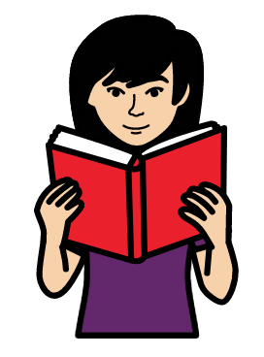
We will check to make sure that happens.

We will look at how to make our information better for people with disabilities and their rights.


4. We are not doing enough work on some things at the moment

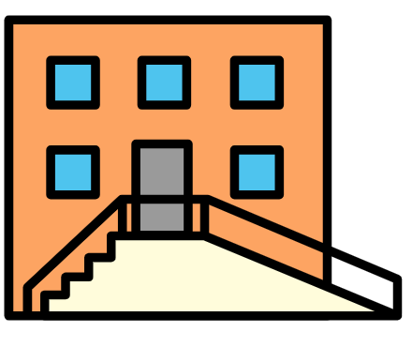
We are not doing enough on the areas of work below:
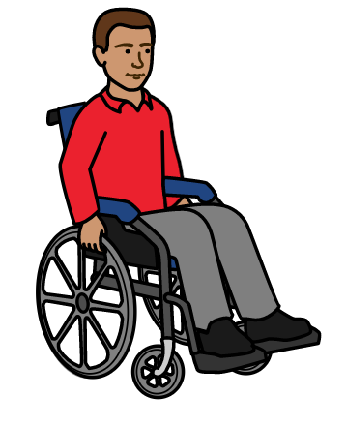

Making sure that everything is easy for people with disabilities to use and take part in.

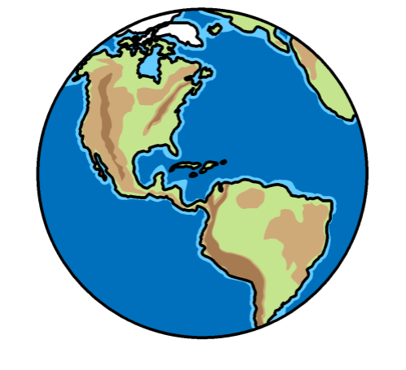

Making sure that we include people with disabilities in our work in different countries.

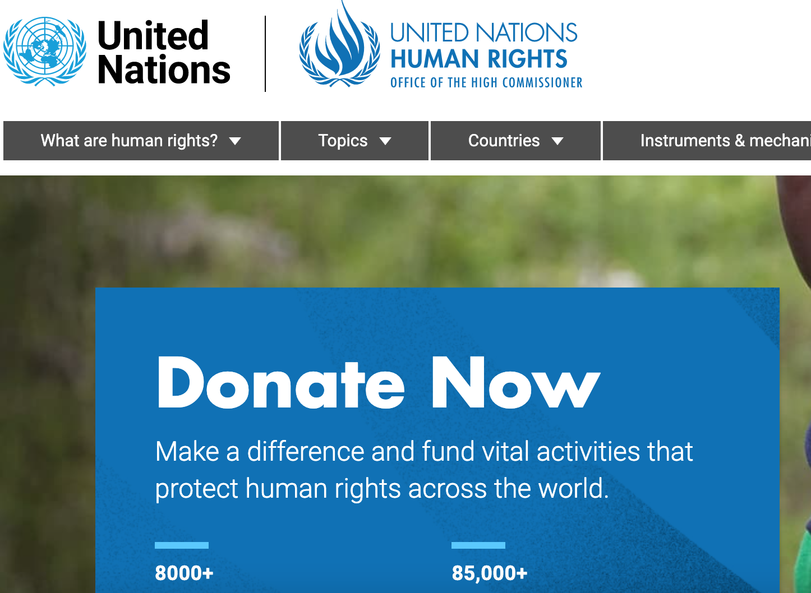
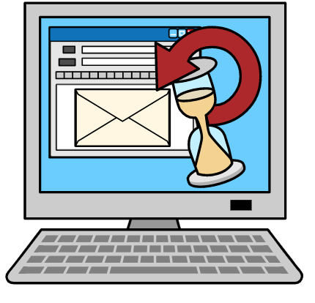
Some examples of our work:

We are making more of our documents easier for people with disabilities to read and understand.

That includes many documents on our website.

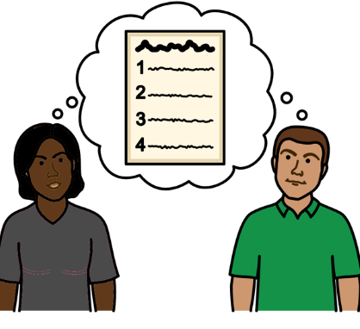
We have a plan about how to make our information easier for people with disabilities to understand.

We check this plan to see what needs to change.

But there is more that we need to do in 2023.
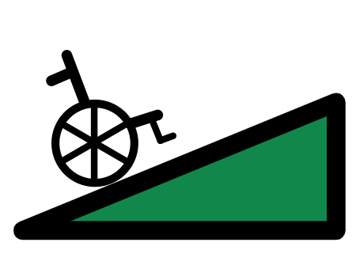

For example:

We will look at what else we should do to make things easier for people with disabilities to use and take part in.
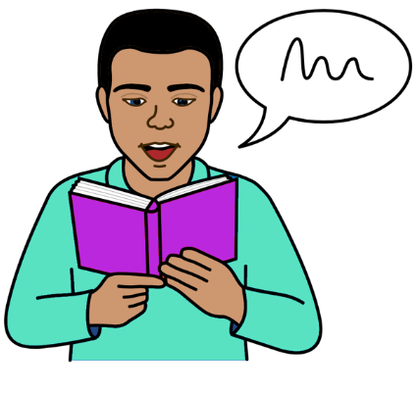

We will look at how to make more documents easier for people with disabilities to understand.

For example, we will look at how to get more money for that work.

We will make new rules to make sure that our projects in different countries work well for people with disabilities.

We will work with other parts of the United Nations on the new rules.
The Picture Communication Symbols ©1981–2016 by Mayer-Johnson LLC a Tobii Dynavox company. All Rights Reserved Worldwide. Thousands of resources available for free at www.boardmakeronline.com

