
United Nations General Assembly

Easy to read

A report about women and girls who are forced to get married and what should be done to stop it



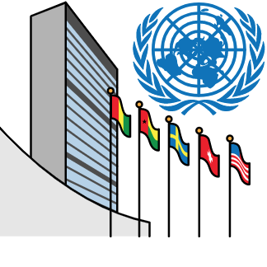
About us

We are part of the United Nations (UN).
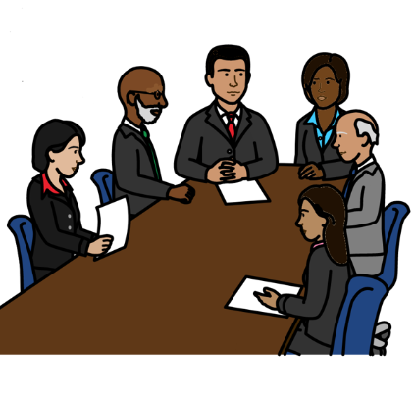

The United Nations is a place for 193 countries to meet and work together.

They are working to make the world better, fairer and safer.

About this report

This report is about children and adults who are forced to get married.

That means they have to get married even if they do not want to.

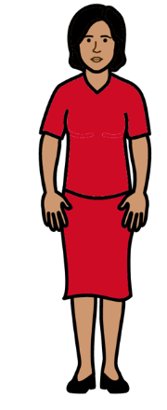
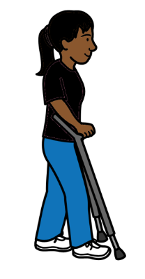
We will call it forced marriage in this report.

Forced marriage usually happens to women and girls.

Girls means children under 18 years old.

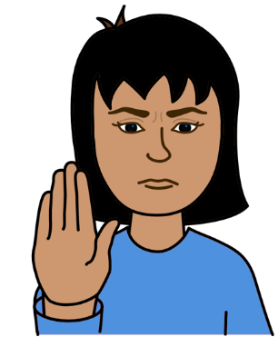
Forced marriage is wrong.

It can stop women and girls from having a good life and getting their human rights.

Everyone has human rights. Like the right to be treated fairly and to go to school.

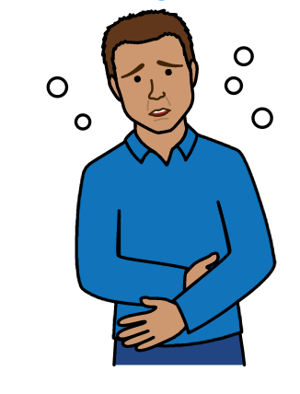

We have written reports before about forced marriage.

This report looks at the time from June 2020 to May 2022.

That was when a big illness had started in the world called Covid-19.



This report looks at:

- How Covid-19 has made it harder to stop forced marriage.

- Some good work that countries have done to help stop forced marriage.

- What countries and organizations should do next to stop forced marriage.

Different countries and organizations gave us their ideas for this report.
How Covid-19 has made forced marriage worse

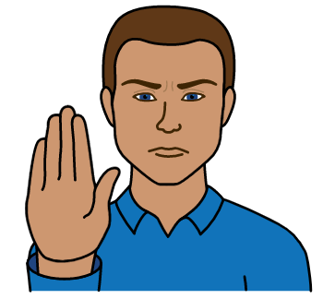
Countries had started some good work before Covid-19 to stop women and girls being forced to get married.

But countries have not done enough to stop it.

And Covid-19 has made that worse.


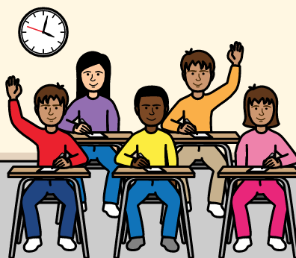
Problems with education

Covid-19 made it harder for many girls to stay at school and get an education.

For example, many schools had to close during Covid-19.



But many girls could not carry on learning at home when schools closed.

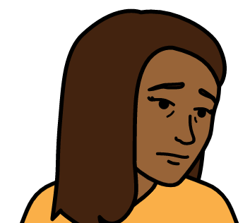
That is because they did not have computers or the internet to learn at home.

Some girls might have left school because of that.
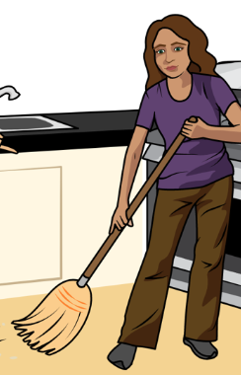
Some girls also had to leave school to help their families or to earn money.

For example, some girls had to leave school if their families lost their jobs because of Covid-19.

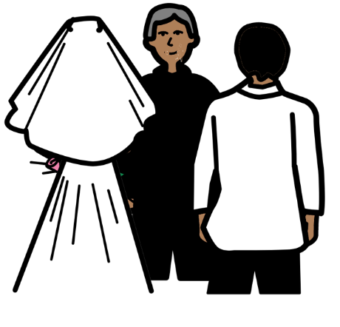

Some girls who are not in school might be forced to get married instead.

That means they often have to leave school and stop their education.

That can stop them from having a good life later on.


Problems with money and jobs

Many people lost their jobs or could not earn money during Covid-19.

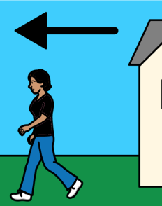
That made more people poor and hungry.

Some families who are poor might make their daughters get married to help solve their money problems.

For example, families might save money if a daughter leaves home to get married.
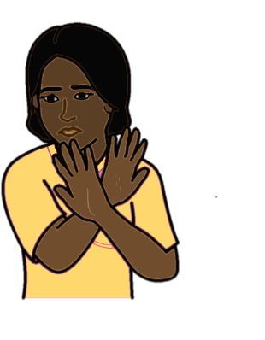
Problems with violence

More violence happened to women and girls during Covid-19.

That includes violence where women and girls are forced to have sex or do sexual things.


For example, many people had to stay at home more during Covid-19.

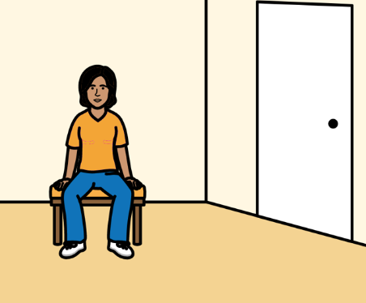

Many women and girls might have lost their usual support because of that.

Like support from their school or family.

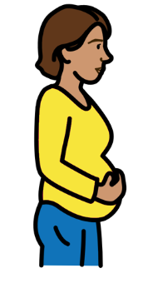

That made it easier for some people to be violent to women and girls.

Some women and girls might be forced to get married if violence happens to them.

For example, if they get pregnant because they are forced to have sex.
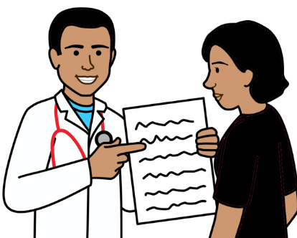
Problems getting the right support

If women and girls get the right support it can help to stop forced marriage.


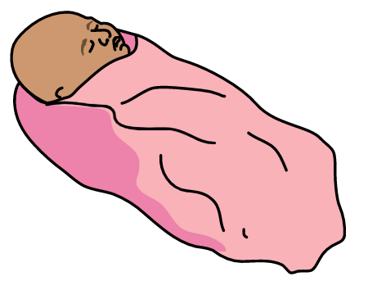
For example, support to do with safe sex and relationships can help to keep women and girls safe.

But Covid-19 made it even harder for many women and girls to get the health care and support they need.
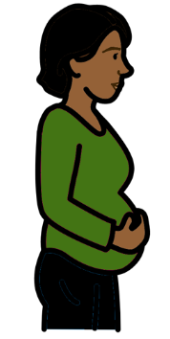

Some girls might have got pregnant because they did not get this support.

They might have been forced to get married because they were pregnant.

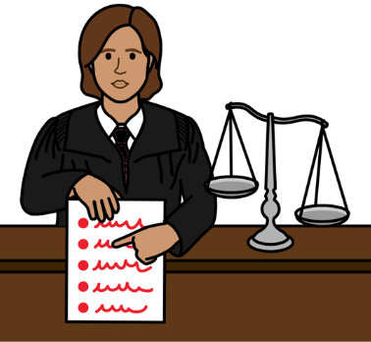

Not enough help from the law

Many countries have laws that say people must be over 18 years old to get married.

But many girls might be forced to get married anyway.
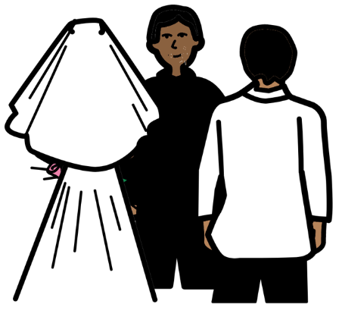
That might have got worse during Covid-19.

For example, many things stopped or closed during Covid-19.

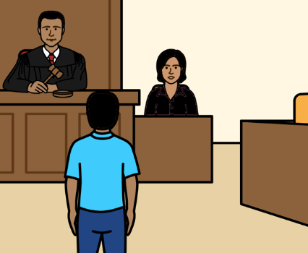
That made it easier for women and girls to be married in secret.

And it made it harder for women and girls to get help from the courts if someone was forcing them to get married.

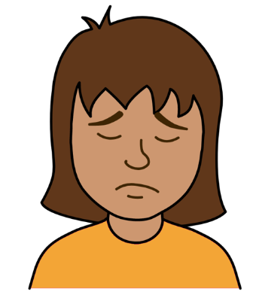
What should happen next

Covid-19 has made it harder to stop women and girls being forced to get married.

That can be even worse for women and girls who are poor or who live in the countryside.
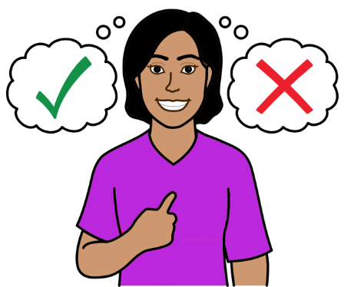

But countries must work to solve those problems.

They must make sure that women and girls get their human rights at all times.
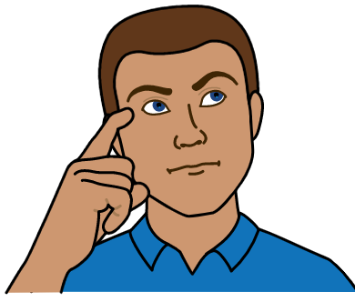
The things below are for governments and organizations to do:

Work to change the things that cause forced marriage.

For example, work to change ideas
that women and girls are less important than men and boys.

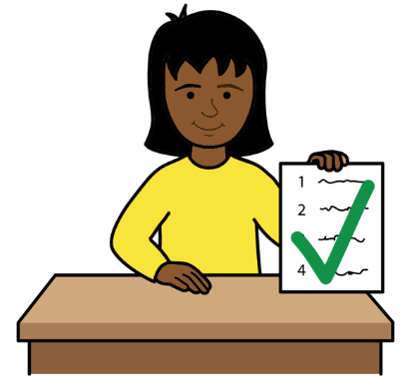

Make sure that plans to make the country better after Covid-19 work well for women and girls.

And make sure there is enough money to spend on stopping forced marriage.



Give more support to women and girls to stop them being poor.

That includes women and girls who might be forced to get married.

And women and girls who have already been forced to get married.


For example, some countries have given money and support to women, girls and families.

That can help to stop many girls getting married too young.

And it can support women and girls who are already married to have a better life.

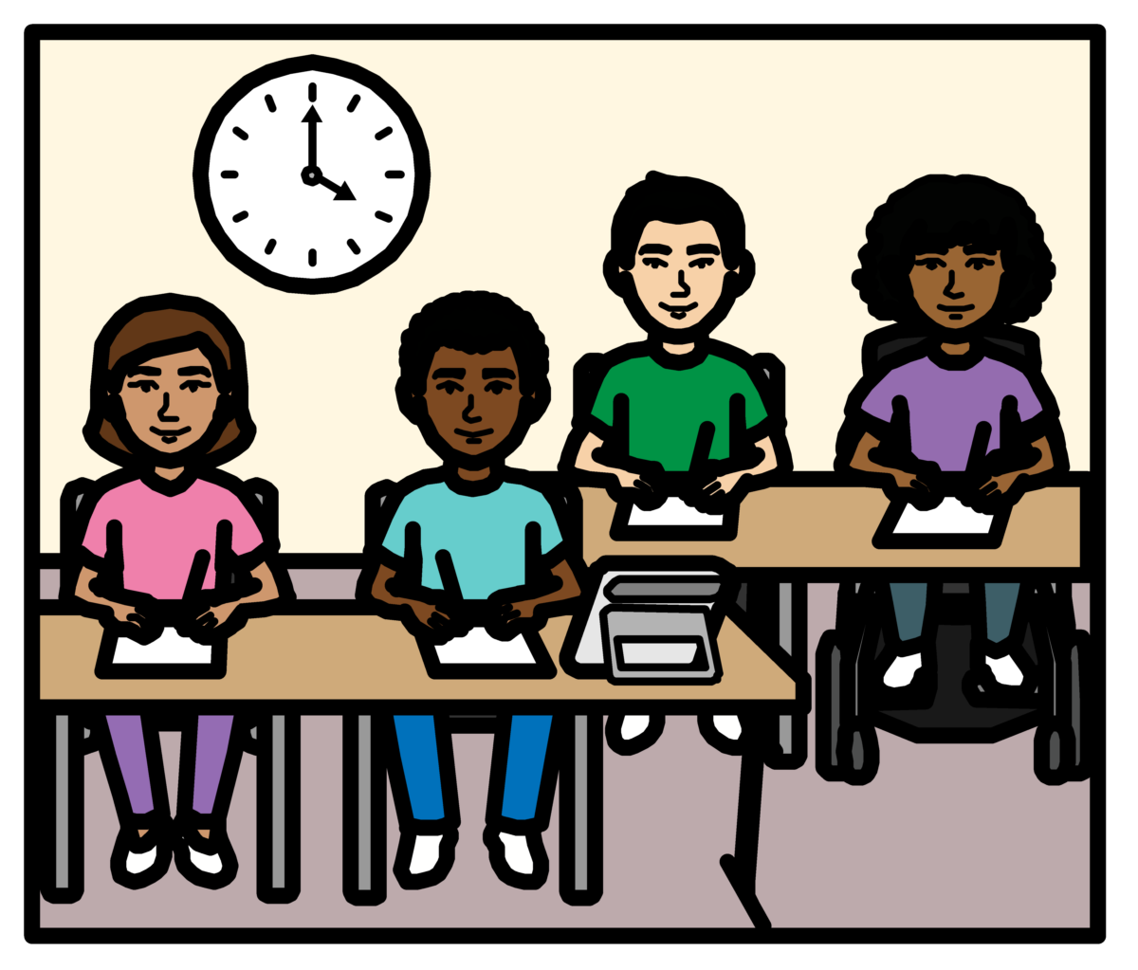

Make sure that women and girls are treated fairly and can do well in life.

For example, make sure they can get a good education.

And make sure they can learn good skills and earn enough money.
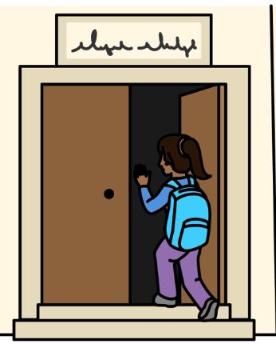

Start new ideas to make sure that girls can go to school and stay at school.

Even when there are big problems in the country.

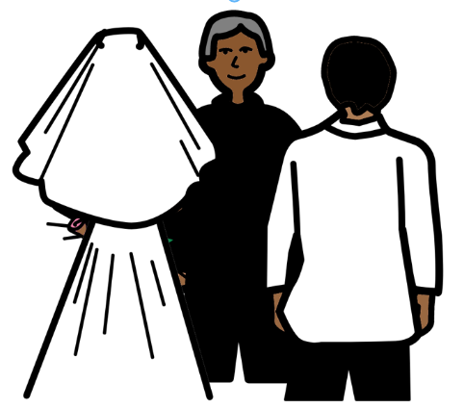
That includes girls who might be forced to get married.

And girls who have already been forced to get married.

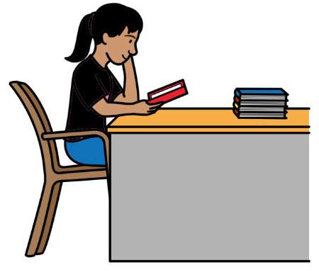
For example, some countries did things during Covid-19 like:

- Finding new and easy ways for girls to learn at home if schools closed.

- Giving money to children and families to help them to keep learning or come back to school.

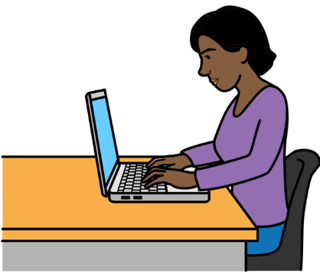
- Supporting girls who are pregnant or have children to stay at school.

Make sure that all women and girls can use the internet.

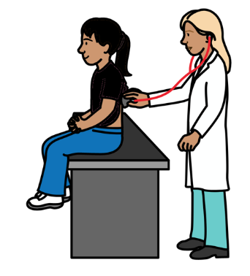

Make sure that women and girls can get the health care and information they need.

That includes health care and advice about safe sex and having children.
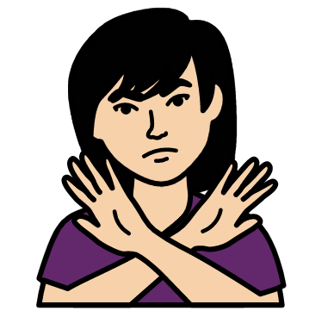
Give women and girls better support if they have been forced to get married.

Or if someone has been violent to them.

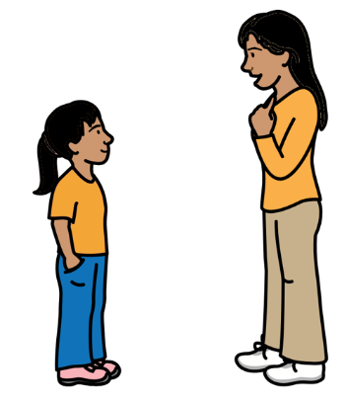
For example, some countries have started support like:

- Phone numbers that women and girls can call for help if someone is violent to them.

- Mental health support for women and girls who might feel very sad or worried.

- Safe places for women and girls to go if someone is violent to them.
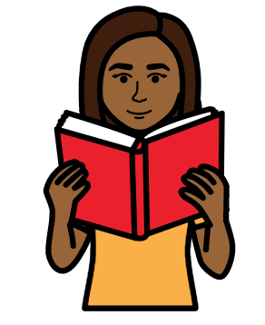

Give women and girls good information to help them know their rights.

For example, some countries have given people information and support on the internet or on mobile phone apps.


That includes information about forced marriage, safe sex and having children. And advice about the law.
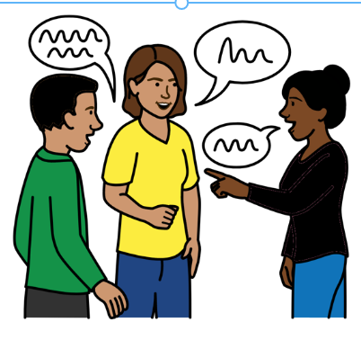
Tell more people about why it is wrong to force women and girls to get married.

And give more support to parents to help them know how to treat girls fairly.

This can help parents, children and local communities to know why forced marriage is wrong and how to change it.

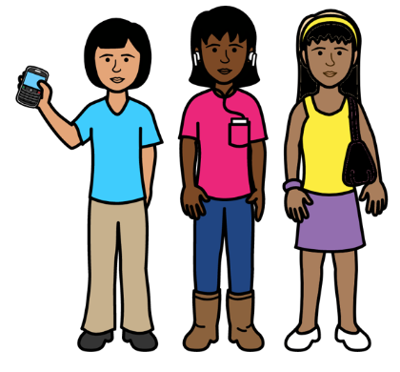

Make sure that girls and boys can take part in work to stop forced marriage.

For example, some countries have supported young people to get together and speak up about forced marriage.
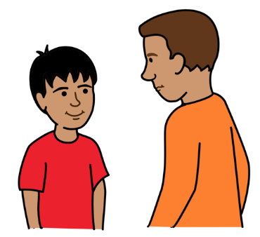

And there has been support for boys to know how they can stop forced marriage.
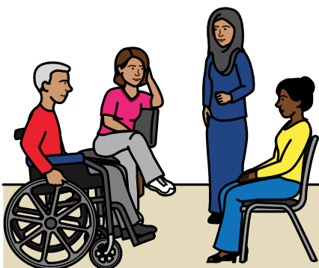

Support different organizations to work together to make sure that women and girls are treated fairly.

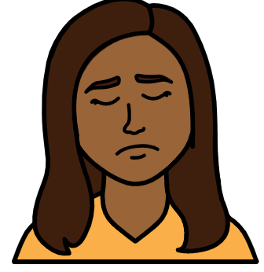
Get better information to show what is being done to stop forced marriage and how that is working.

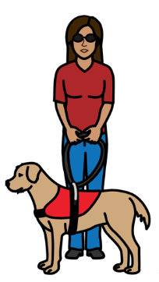



All of this will help to stop forced marriage and make life better for women and girls.

Pictures by The Picture Communication Symbols ©1981–2016 by Mayer-Johnson LLC a Tobii Dynavox company. All Rights Reserved Worldwide. Thousands of resources available for free at www.boardmakeronline.com

